When a ‘child’ becomes a ‘parent’
Maintaining CDIS client records
OFFICIAL
Contents
Child vs Adult Records 1
Qualifying a child vs adult record 1
Closing a childhood record 3
Merging 4
Merging – ‘Relationships’ 5

Child vs Adult Records
In complying with record-keeping legislation clients should have 2 separate CDIS health records.
- CDIS ‘Child’ Clients - Children should ideally only have one child CDIS record, which transfers across MCH services with the child if they move location.
- CDIS ‘Caregiver’ Clients - Caregivers should ideally only have one adult CDIS record, that can be maintained across their time within the MCH service. e.g., where an adult has a record as a parent, and then subsequently has involvement as a grandparent, this should all be recorded in the same adult CDIS record.
Given these guidelines, this practice note will explain how to maintain this consistently in CDIS to ensure.
- When a child becomes a caregiver a new caregiver CDIS record is created
- When a caregiver becomes a grandparent or other, maintaining an existing caregiver CDIS record and updating the relationships rather than creating a new record

Qualifying a child vs adult record
Evaluation of the CDIS record should help clarify whether it is a child or a parent record:
- Undertake a state-wide search prior to creating a new adult record. Refer to CDIS birth notification process for tips on searching for client accuracy
- If an existing record is found, transfer the CDIS records to your Council/Service Provider prior to use to ensure that the CDIS record is an adult record and not a child record
- Ascertain if the CDIS record is a childhood record by looking at the relationships attached to the CDIS record. If it is a childhood record, the relationships should show that there is an existing mother/father relationship for this CDIS individual.
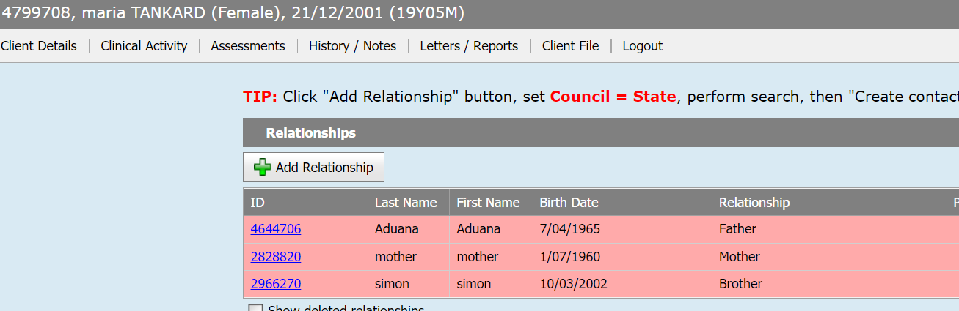
Diagram 1 - Relationships Screen

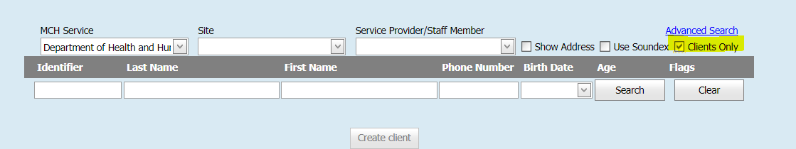
Diagram 2 - Search Screen

*Hint: If the record is closed it may be an old child record – a search by ‘clients only’ may assist with this.
*Hint: If the CDIS number begins with a 1 then it may be an old child record

If you realise that you have inadvertently been using an old child record for a new parent, cease utilisation of this record immediately.
- Copy & paste any associated adult notes into a newly created parent record.
- A note should be added stating that the notes have been copied from an old childhood record.
- Close the old child record as below & disconnect any new relationships that were added (i.e. the new child).

Closing a childhood record
Old childhood records of current adults/carers should be closed to avoid the risk of them incorrectly being recorded in.
- When an old childhood record is closed document this in the edit section, along with your initials
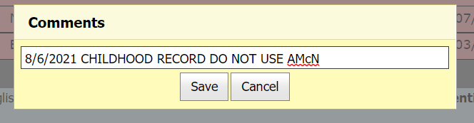
Diagram 3 – Adding comments to a Health Record (accessed via the edit hyperlink at the top)

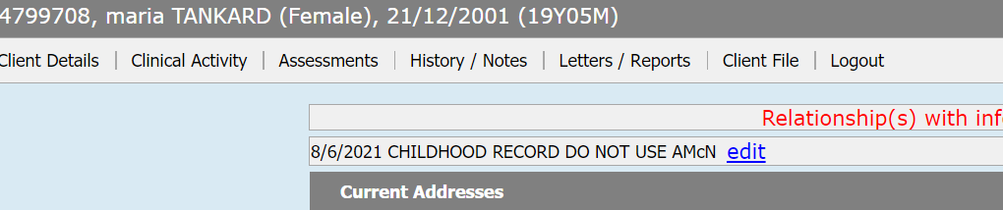
Diagram 4 – Comments added to a Health Record (accessed via the edit hyperlink at the top)

- Go to Client Details > Open/Change/Close Client. Close with reason ‘childhood record’.
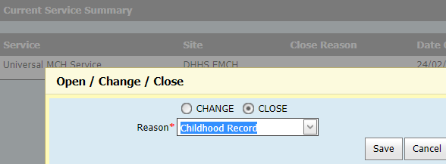
Diagram 5 – Open/Change/Close Screen

*Hint: If you do not tick ‘Clients Only’ when searching for a CDIS record, both records of clients open for service and closed for service, will appear in your search results. You will be unable to differentiate which is the closed child record and which is the parent record without looking at each CDIS client record.

*Hint: If you accidently transfer in a childhood record make contact with the LGA it was transferred from and aske them to transfer the record back and close it as it is a childhood record.

Merging
Duplicate records of a child, or adult/carer, should be merged creating a single child or single adult/carer record.
Prior to merging records, you must identify that you are merging the correct records for each child or adult/carer who has duplicate records. It is recommended that two (2) staff members with appropriate access undertake the merging process together. Ensure you follow your individual Service Provider requirements. If merged incorrectly it is very costly to unmerge a file.

There are some rules associated with merging which you must meet. These are:
- Obtain permission of the parent/carer of a child before transferring CDIS records to your Council/Service Provider
- Transfer the duplicate CDIS records of an adult/carer to your Council/Service Provider to ensure that the CDIS record is an adult record and not a child record
- Do not merge an old CDIS childhood record with a now adult/carer record. These should remain 2 separate CDIS files.
- Only merge CDIS records of children who are actively engaged in the MCH service (i.e. <6 years of age)
- Do not transfer the CDIS record of children over the age of six (6) years of age from another provider – you are able to create a relationship without transferring a CDIS record
STEPS:
- Always merge the mother/Primary Carer first before merging any children.
- CDIS will highlight in green the fields which will be kept for the merged record. Press the ‘use button’ to select which information is accurate to be kept on the main record – confirm with the client before merging if unsure as this information will be overwritten once merged.
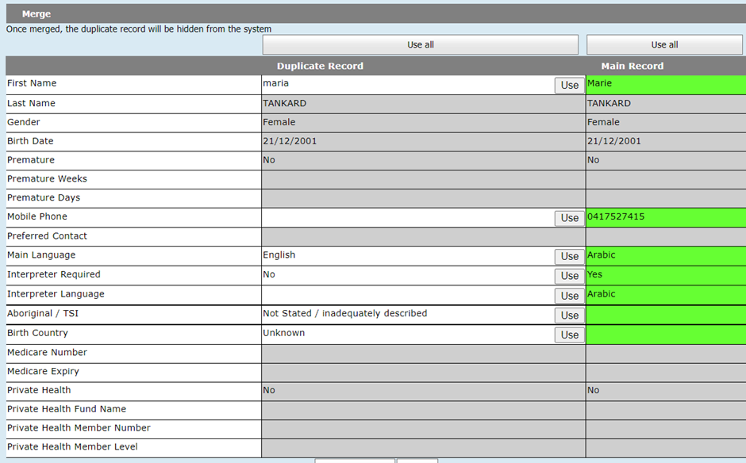
Diagram 6 – Merge Screen

Merging – ‘Relationships’
When the merge is completed, all relationships associated with each client will show up in ‘relationships’. This often results in duplicates in the merged records relationships.
If these clients have the same CDIS number, they are simply a relationship double-up and the double-up can be deleted by clicking on the red X icon, leaving only one. If any of the relationships are no longer correct they can be disconnected by clicking on the red X icon.
An adult’s relationships should be kept current in CDIS, and old relationships (ie ex-partners) that are no longer relevant/active, should be disconnected by clicking on the red X icon. Deleted relationships can always be viewed by selecting the ‘Show deleted relationships’ checkbox in the Relationships screen
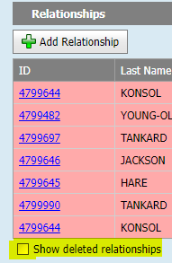
Diagram 7 – Relationships Screen; show deleted relationships checkbox

If there is a duplicate client in the Relationships screen with two different CDIS numbers, the CDIS records need to be checked and merged as above if identified as two records for the same child or adult/carer.
I.e., as per the example below, one of Oakley Jacksons duplicates may be simply deleted from the relationship section as it is the same CDIS number. Whereas, upon discussion with the mother, it is confirmed that ‘BB of Marie, DOB 14/4/2019’ is also the same child, therefore this record can be merged with Oakley’s record.
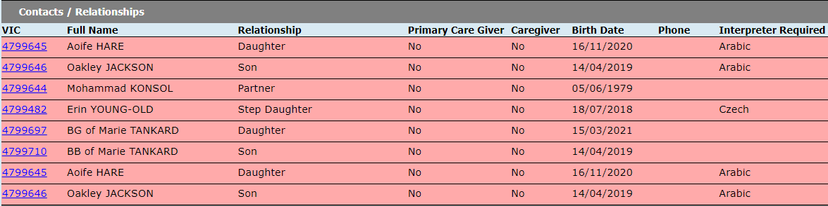
Diagram 8 – List of Contacts/Relationships on the Client’s Health record

Do not create or link relationships (such as other caregiver or sibling) without the mother/carer permission.

To receive this document in another format, phone 1300 650 172, using the National Relay Service 13 36 77 if required, or email Community Based Health Services, Policy & Improvement Branch <mch@health.vic.gov.au>.
Authorised and published by the Victorian Government, 1 Treasury Place, Melbourne.
© State of Victoria, Australia, Department of Health, April 2023.

Except where otherwise indicated, the images in this document show models and illustrative settings only, and do not necessarily depict actual services, facilities or recipients of services. This document may contain images of deceased Aboriginal and Torres Strait Islander peoples.
In this document, ‘Aboriginal’ refers to both Aboriginal and Torres Strait Islander people. ‘Indigenous’ or ‘Koori/Koorie’ is retained when part of the title of a report, program or quotation.
ISBN 978-1-76131-157-4 (pdf/online/MS word)
Available at health.vic – Child Development Information System <https://www2.health.vic.gov.au/primary-and-community-health/maternal-child-health/child-development-information-system>

