Stakeholder pack
Early Parenting Centre recruitment

Introduction
The Victorian Government is opening seven new Early Parenting Centres (EPCs) across Victoria from late 2023 to 2025.

EPCs are a free primary health service that provide specialist support for Victorian families with children from birth to 4 years of age. They deliver flexible, targeted services that aim to enhance the parent-child relationship and support parents with strategies to achieve their parenting goals.

Each EPC will require a multidisciplinary team of child and family health professionals. The Department of Health has developed resources for stakeholders to support the recruitment effort.

Included in this pack is content that can be shared across various channels to reach potential candidates.

Copy samples
You can use the copy below to guide your messaging. Feel free to use as is or to adjust for your audience

Long form (e.g., Email/newsletter)
Help Families Thrive - Join the Early Parenting Centre team
Want to work with families and make a real difference in the lives of our youngest Victorians?
Victoria’s new Early Parenting Centres (EPCs) are seeking Maternal and Child Health Nurses, Registered Midwives, Registered and Enrolled Nurses and early parenting professionals to join their team.
EPCs are a free service that provides specialist support for Victorian families with children from birth up to 4 years of age.
The Victorian Government is opening seven new EPCs across Victoria from late 2023 to 2025 with state-of-the-art facilities and professional development opportunities.
Applications are now open for:
- Maternal and Child Health Nurses
- Registered Nurses and Enrolled Nurses
- Registered Midwives
- Early Parenting Practitioners
- Allied health professionals
About you:
- Relevant qualifications in one of the above-mentioned fields
- Experience working with infants, young children, and families
- Understanding of family and child health
- Strong communication and interpersonal skills
- Proof of vaccination, satisfactory Police Check and Working with Children Check
- Passionate about early childhood development
Apply now to build your career and help families thrive!
Short form (e.g., social media)
Are you passionate about child and family health? Victoria’s new Early Parenting Centres are seeking experienced Maternal & Child Health Nurses, Early Childhood Educators, and a range of other health professionals to join their team.

Support young families, grow your career, and make a positive impact on the community.

Apply now and take the first step towards helping families flourish.

Assets
We have a range of visual assets that you can use across your internal and external communication channels. You can download these assets as a package from this link: EPC recruitment assets

Email banners: 600 x 300 px | 600 x 120 px
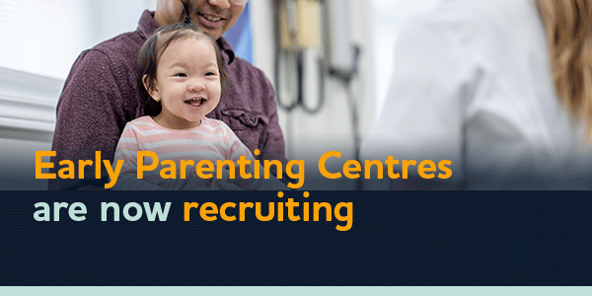
Social images: 1080 x 1080 px | 1080 x 1920 px
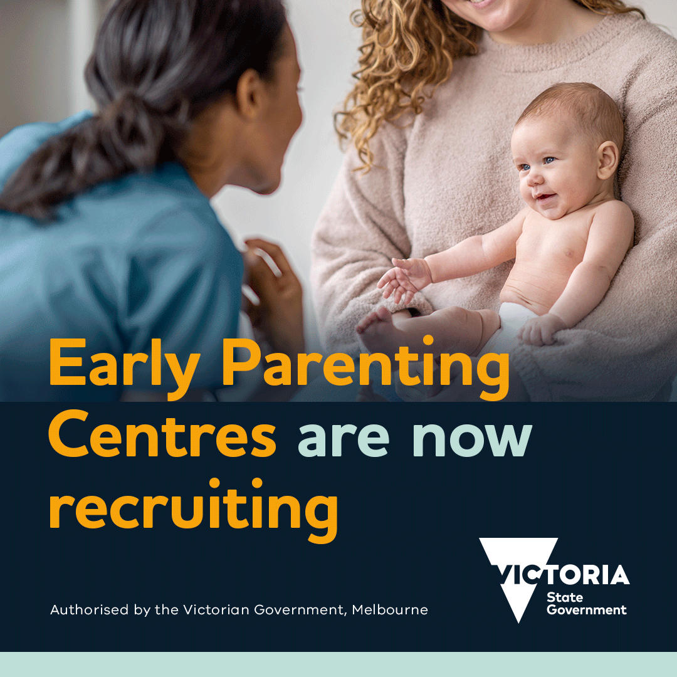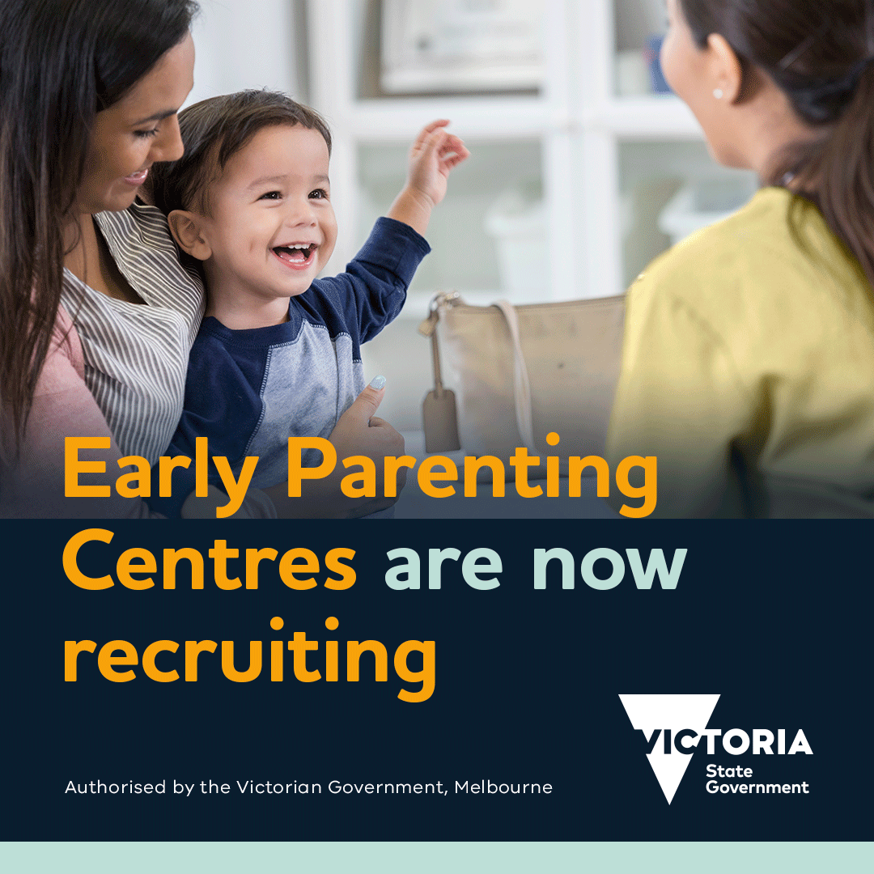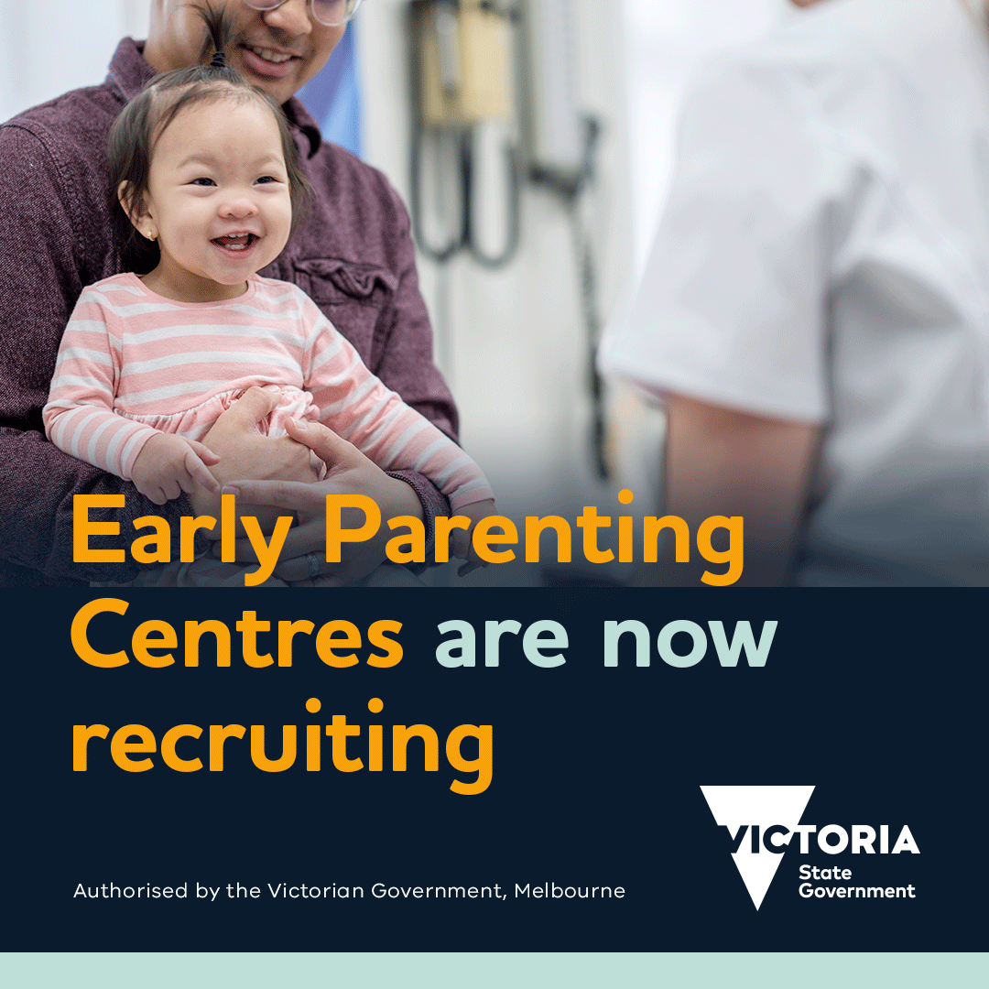

Social videos: 1080 x 1080 px | 1080 x 1350 px | 1080 x 1920 px
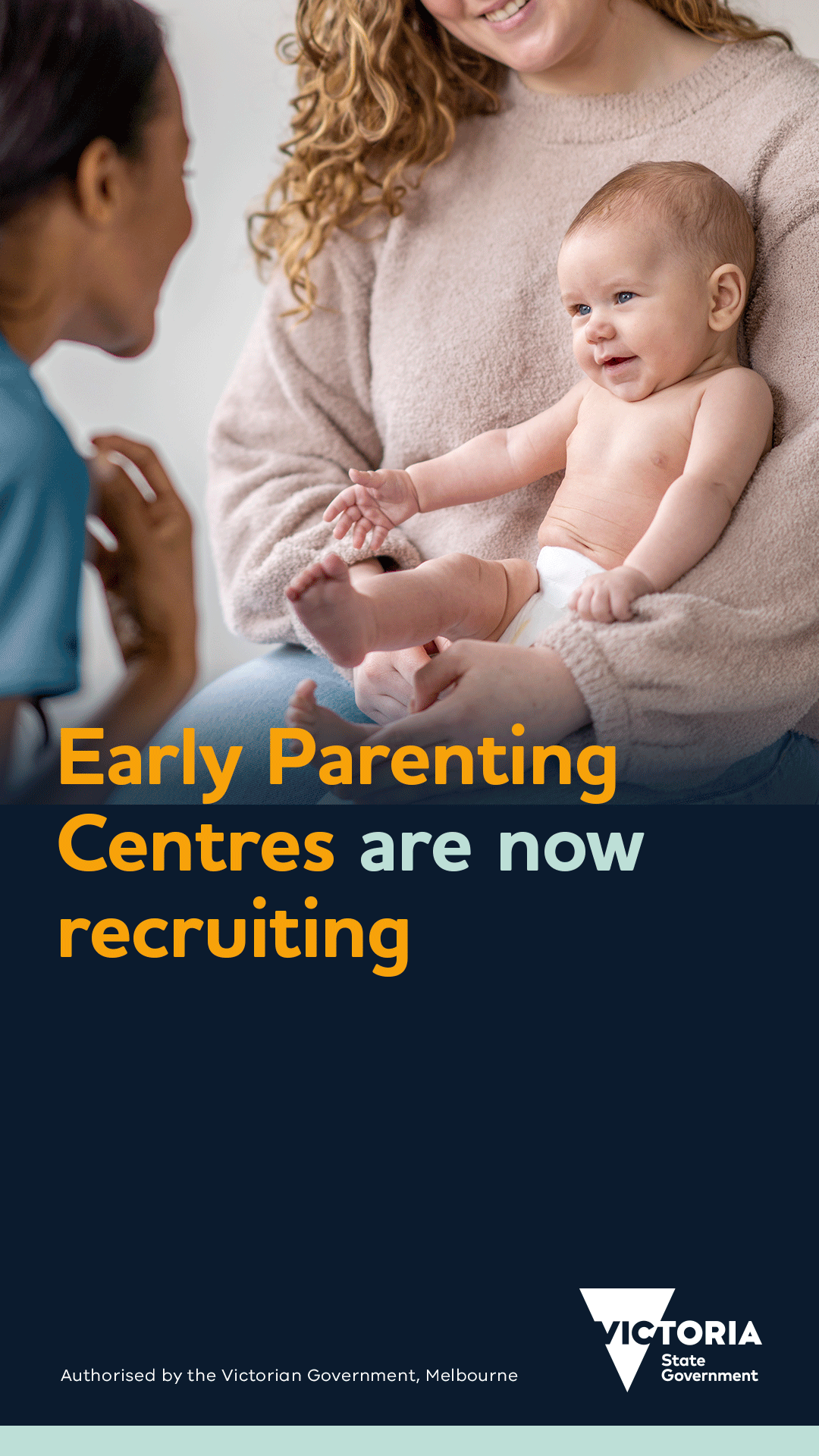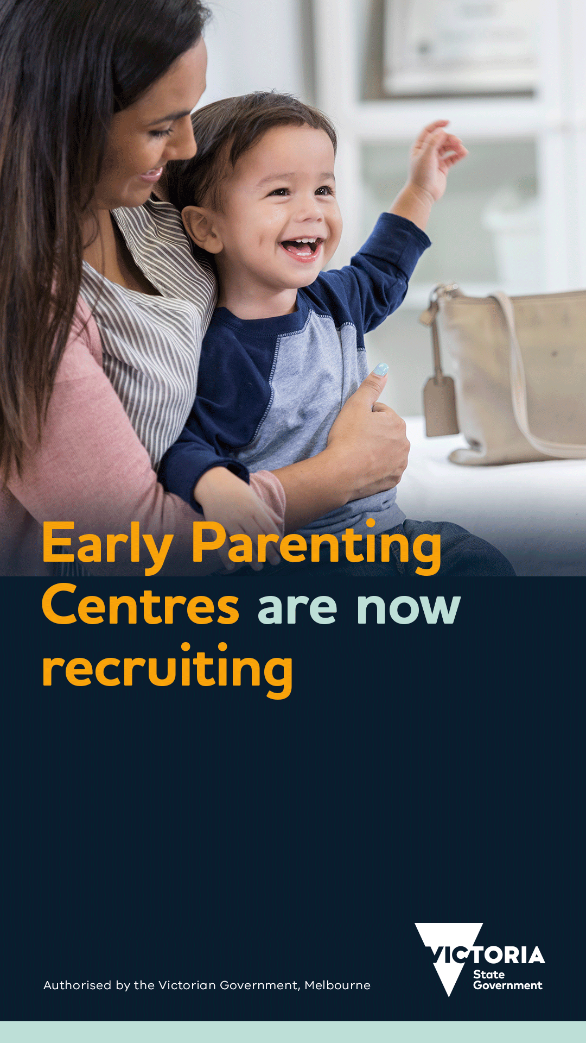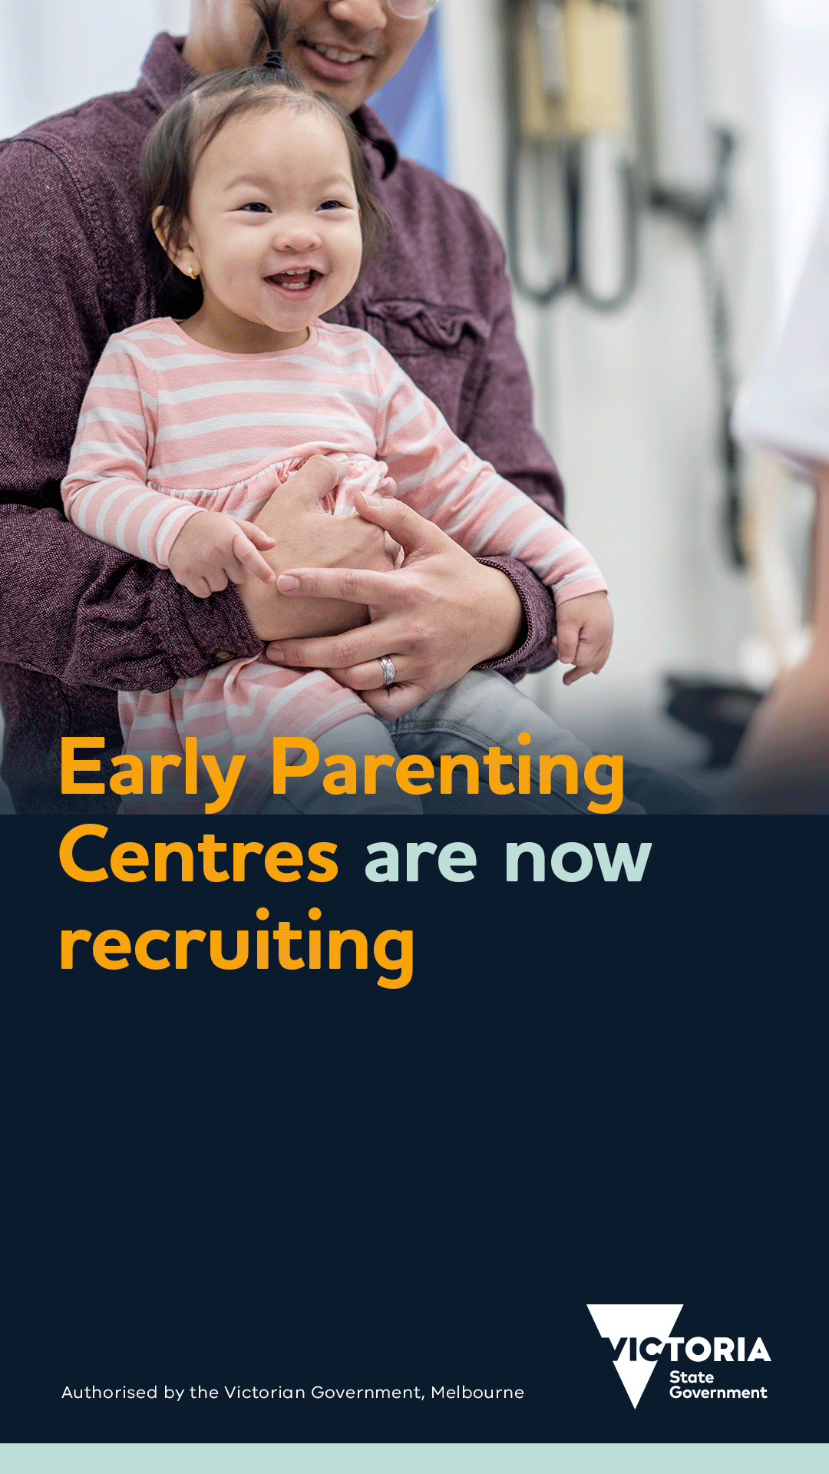
Print: A4 poster
