Ban on smoking and vaping at certain Victorian Government buildings
Factsheet for occupiers

By law, smoking and the use of e-cigarettes (vaping) is banned within four metres of an entrance to certain Victorian Government buildings.

Where does the ban apply?
Smoking and vaping is banned within four metres of entrances (pedestrian access points) to Victorian Government buildings occupied either wholly or in part by:
- Parliament, but not electorate offices
- Victorian courts
- Supreme Court
- County Court
- Magistrates’ Court
- Children’s Court
Coroners Court
- public service bodies²
- Victorian Government departments
- Victorian Public Sector Commission
administrative offices
- special bodies.

What are the administrative offices?
There are eight administrative offices within the meaning of the Public Administration Act 2004.
Administrative offices
Environmental Protection Authority
Local Government Investigations & Compliance Inspectorate
Office of the Chief Parliamentary Counsel
Office of the Governor
Public Record Office Victoria
Regional Rail Link Authority
Victorian Government Architect
Victorian Government Solicitor’s Office
Family Safety Victoria
Latrobe Valley Authority
Level Crossing Removal Authority
Melbourne Metro Rail Authority
North East Link Authority
Office of Projects Victoria
Safer Care Victoria
Victorian Agency for Health Information
Western Distributer Authority

What are the special bodies?
There are fifteen special bodies within the meaning of the Public Administration Act 2004.
Special bodies
Department of the Parliament of Victoria
Electoral Boundaries Commission
Mental Health Complaints Commissioner
Mental Health Tribunal
Office of the Health Complaints Commissioner
Office of the Ombudsman
Office of the Victims of Crime Commissioner
Office of the Victorian Information Commissioner
Victorian Civil and Administrative Tribunal (VCAT)
Victorian Auditor-General’s Office
Victorian Electoral Commission
Victoria Police (including all Victorian Police Stations)
Independent Broad-based Anti-Corruption Commission
The Commission for Children and Young People
The Victorian Inspectorate

Why does the ban exist?
The purpose of the smoking and vaping ban is to:
- protect the community from exposure to second-hand tobacco smoke and the aerosol from e-cigarettes.
- further de-normalise smoking and vaping in the community. The more people see smoking and vaping in public places the more they will tend to think smoking and vaping is okay, rather than harmful.
- support people who have quit or are trying to quit smoking and/or vaping.

What is a pedestrian access point?
A pedestrian access point means a door or gate by which a person can enter or exit the premises.
It does not include an emergency exit that is locked to entry.
It does include shared doors or gates. For example, where a building is occupied by a Victorian Government department as well as other organisations, such as private businesses, any shared entrances that are used to access both areas of the building would be subject to the smoking and vaping ban. Any entrances which lead only to premises not included in the smoking and vaping ban, such as the private offices, would not be subject to the smoking and vaping ban. See diagram below, which shows an example of where the smoking and vaping ban applies.
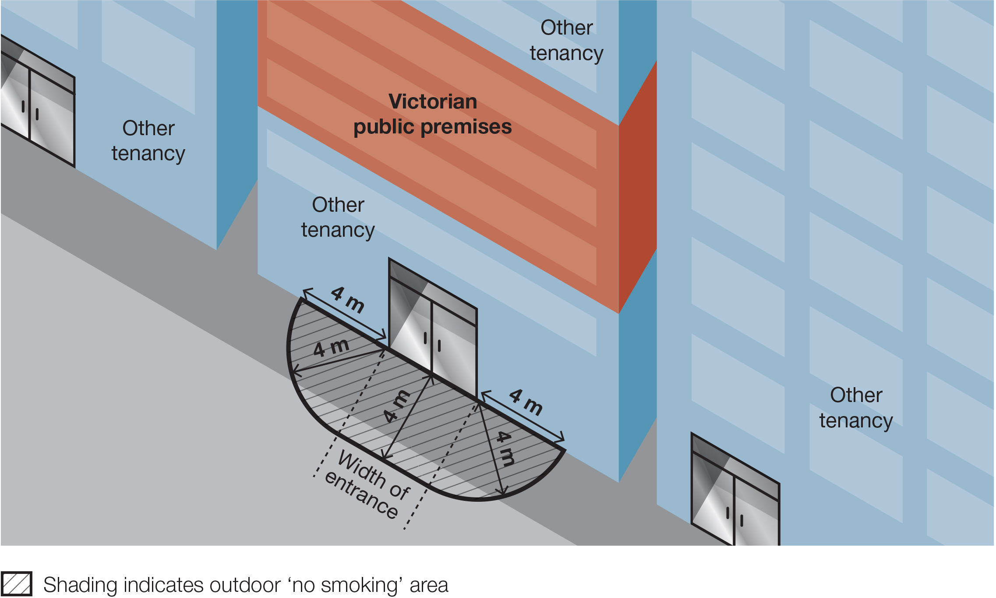
The diagram below shows an example of where the ban would apply to the pedestrian access points at a police station.
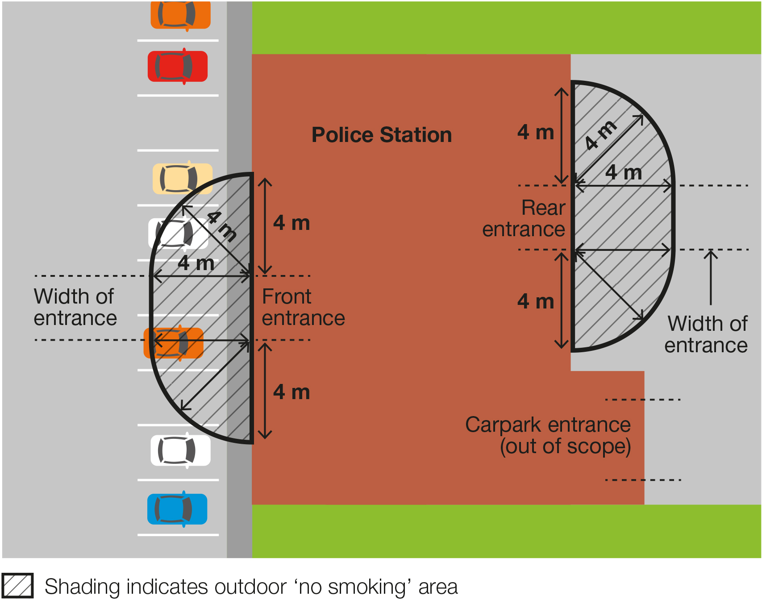

Where does the ban not apply?
The ban does not apply:
- to entrances of Commonwealth Government buildings, such as Centrelink or Medicare offices
- to entrances of Local Government buildings, such as municipal libraries
- to an emergency exit that is locked to entry
- to a person walking through the smoke-free and vape-free area
- to a person in a motor vehicle that is driving or being driven through the smoke-free and vape-free area
- to a person in an area that is separated from the smoke-free and vape-free area by a road
- to a person in an outdoor drinking area located within the smoke-free and vape-free area
- to a person at a residential premises (at privately owned homes and land).

How will people know about the ban?
You are required to display ‘No Smoking’ signs in the smoke-free and vape-free area (see below). Use of the ‘No Smoking or Vaping’ signage is voluntary.

Am I or my staff expected to enforce the ban?
No. Occupiers are not expected to enforce the ban and are not empowered to do so.
Compliance with the ban is expected to occur through public education and changed community expectations.
Consultation undertaken by the Department of Health shows strong community support for banning smoking and vaping at public places.
These factors are likely to result in high levels of voluntary compliance with the smoking and vaping ban.

How will the ban be enforced?
There is strong community support for banning smoking and vaping at public places. This means most people will voluntarily comply with the smoking and vaping ban and expect others to do so.
Inspectors authorised under the Tobacco Act 1987 may provide information about and, when necessary, enforce the ban. The first, priority of the inspector is to make sure smokers and vapers understand the ban.
Inspectors may not be available to respond to every complaint but, where circumstances allow, may attend in response.
You and your staff can assist to raise awareness of the ban by providing staff and visitors access to promotional resources.

What penalties might apply?
The maximum penalty for someone breaking this law is five penalty units, with an infringement penalty of one penalty unit.

What resources are available to promote the ban?

Signage
Occupiers are required by law to install acceptable ‘No smoking’ signs at entrances (pedestrian access points) to their premises. Signs are available to order free-of-charge from tobacco reforms website <www.health.vic.gov.au/public-health/tobacco-reforms>
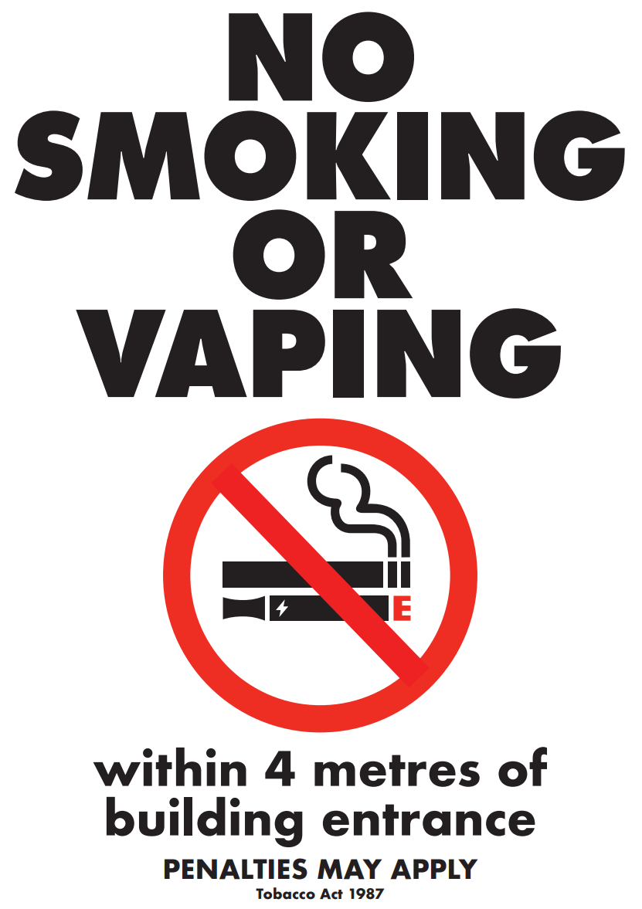
Electronic versions of the signs can also be downloaded and printed from the website above.

Posters
Occupiers can request posters to help educate and inform staff, visitors and the general public of the new ban. Posters are available to order free-of-charge from the tobacco reforms website <www.health.vic.gov.au/public-health/tobacco-reforms>

Definitions of ‘occupier’
Under the Tobacco Act 1987, an occupier in relation to an area or premises, means:
- a person who appears to be of or over the age of 16 years and who is or appears to be in control of the area or premises, whether or not, the person is present in the area or on the premises; or
- a body corporate that is or appears to be in control of the area or premises.

How can I find out more?
For more information:
- visit the tobacco reforms website <www.health.vic.gov.au/public-health/tobacco-reforms>
- call the Tobacco Information Line on 1300 136 775

To view the legislation visit the Victorian Government’s legislation website <www.legislation.vic.gov.au> and search Tobacco Act 1987.

DISCLAIMER: Please note that any advice contained in this factsheet is for general guidance only. The Department of Health does not accept any liability for any loss or damage suffered as a result of reliance on the advice contained in this factsheet. Nothing in this factsheet should replace seeking appropriate legal advice.
To receive this document in another format, phone 1300 136 775, using the National Relay Service 13 36 77 if required, or email tobacco.policy@health.vic.gov.au
Authorised and published by the Victorian Government, 1 Treasury Place, Melbourne.
© State of Victoria, Australia, Department of Health, November 2023.
Except where otherwise indicated, the images in this document show models and illustrative settings only, and do not necessarily depict actual services, facilities or recipients of services.
ISBN 978-1-76131-085-0 (pdf/online/MS word)
Available at tobacco reforms website <www.health.vic.gov.au/public-health/tobacco-reforms>

Section 5RH(1) of the Tobacco Act 1987.
Within the meaning of the Public Administration Act 2004.
For current penalty unit values, visit the Department of Treasury and Finance website <www.dtf.vic.gov.au/financial-management-government/indexation-fees-and-penalties>

