Ban on smoking and vaping at certain Victorian Government buildings
Factsheet for visitors

By law, smoking and the use of e-cigarettes (vaping) is banned within four metres of an entrance to public hospitals and registered community health centres in Victoria.

Where does the ban apply?
Smoking and vaping is banned within four metres of entrances (pedestrian access points) to public hospitals and registered community health centres.
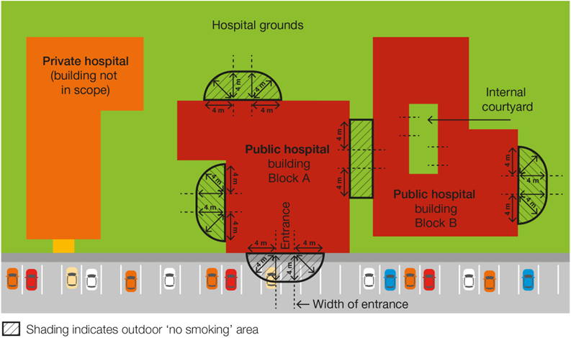
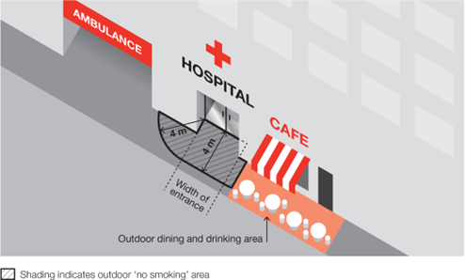
The diagrams below show examples of where the smoking and vaping ban applies at a hospital.
Public hospitals or registered community health centres may also have policies in place which further limit smoking and vaping in outdoor areas. Such a policy would apply in addition to the legislative ban.

Why does the ban exist?

The purpose of the smoking and vaping ban is to:
- protect the community from exposure to second-hand tobacco smoke and the aerosol from e-cigarettes
- further de-normalise smoking and vaping in the community. The more people see smoking and vaping in public places the more they will tend to think it is okay, rather than harmful
- support people who have quit or are trying to quit smoking and vaping.

Where does the ban not apply?
The ban does not apply:
- to an entrance to a private hospital, unless the entrance also provides access to a public hospital
- to an emergency exit that is locked to entry
- to a person walking through the smoke-free and vape-free area
- to a person in a motor vehicle that is driving or being driven through the smoke-free and vape-free area
- to a person in an area that is separated from the smoke-free and vape-free area by a road
- to a person in an outdoor dining or drinking area located within the smoke-free and vape-free area
- to a person at a residential premises (at privately owned homes and land).

How will people know about the ban?
Signs will be displayed in the smoke-free and vape-free area.

How will the ban be enforced?
There is strong community support for banning smoking and vaping at public places. This means most people will voluntarily comply with the smoking and vaping ban and expect others to do so.
Inspectors, authorised under the Tobacco Act 1987, may provide information about and, when necessary, enforce the ban. The first priority of the inspector is to make sure smokers and vapers understand the ban.
Inspectors may not be available to respond to every complaint but, where circumstances allow, may attend in response.

What penalties might apply?
The maximum penalty for someone breaking this law is five penalty units, with an infringement penalty of one penalty unit.

How can I find out more?
For more information:
- visit www.health.vic.gov.au/tobaccoreforms
- call the Tobacco Information Line on 1300 136 775
To view the legislation visit http://www.legislation.vic.gov.au/ and search Tobacco Act 1987.

DISCLAIMER: Please note that any advice contained in this factsheet is for general guidance only. The Department of Health does not accept any liability for any loss or damage suffered as a result of reliance on the advice contained in this factsheet. Nothing in this factsheet should replace seeking appropriate legal advice.

To receive this document in another format, phone 1300 136 775, using the National Relay Service 13 36 77 if required, or email tobacco.policy@health.vic.gov.au
Authorised and published by the Victorian Government, 1 Treasury Place, Melbourne.
© State of Victoria, Australia, Department of Health, November 2023.
Except where otherwise indicated, the images in this document show models and illustrative settings only, and do not necessarily depict actual services, facilities or recipients of services.
ISBN 978-1-76131-439-1 (pdf/online/MS word) Available at tobacco reforms website <www.health.vic.gov.au/public-health/tobacco-reforms>

Section 5RH(1) of the Tobacco Act 1987.
For current penalty unit values, visit the Department of Treasury and Finance website <www.dtf.vic.gov.au/financial-management-government/indexation-fees-and-penalties>

