Smoke-free and vape-free outdoor dining
Factsheet for organisers of food fairs and events

Under the Tobacco Act 1987, smoking and the use of e-cigarettes (vaping) is banned in outdoor dining areas.
This factsheet provides a summary of the smoking and vaping ban in outdoor dining areas at food fairs and other organised events.
Further detailed information is available in the Smoke-free outdoor dining guide available on the tobacco reforms website <www.health.vic.gov.au/public-health/tobacco-reforms>.

Outdoor dining areas
An outdoor dining area at a food fair is the entire outdoor area.
At other organised events, it is the area within 10 metres of a food stall or food vendor.

Food fairs
A food fair is an organised event at which the principal activities are the sale or supply of food for consumption at the event, and the consumption of that food.

Determining the ‘principal activity’
To determine if your event is a food fair, consider:
- the name and purpose of the event
- the type and number of food stalls and food vendors in comparison to other stalls and activities.
An example could include an international food festival at a park.

How the ban applies to food fairs
The smoking and vaping ban applies to all public outdoor areas at a food fair. That means the entire food fair must be smoke-free and vape-free.
In many cases, a food fair will have a clearly marked boundary such as a fence indicating the perimeter of the food fair.
Where there is no clearly marked boundary, food fair organisers or managers should take a common-sense approach to determining where a food fair exists by:
- checking the allocated area permitted by a council or other entity
  - considering where it is reasonably expected food purchased at the event will be consumed.
Figure 1: Smoking and vaping ban at a food fair
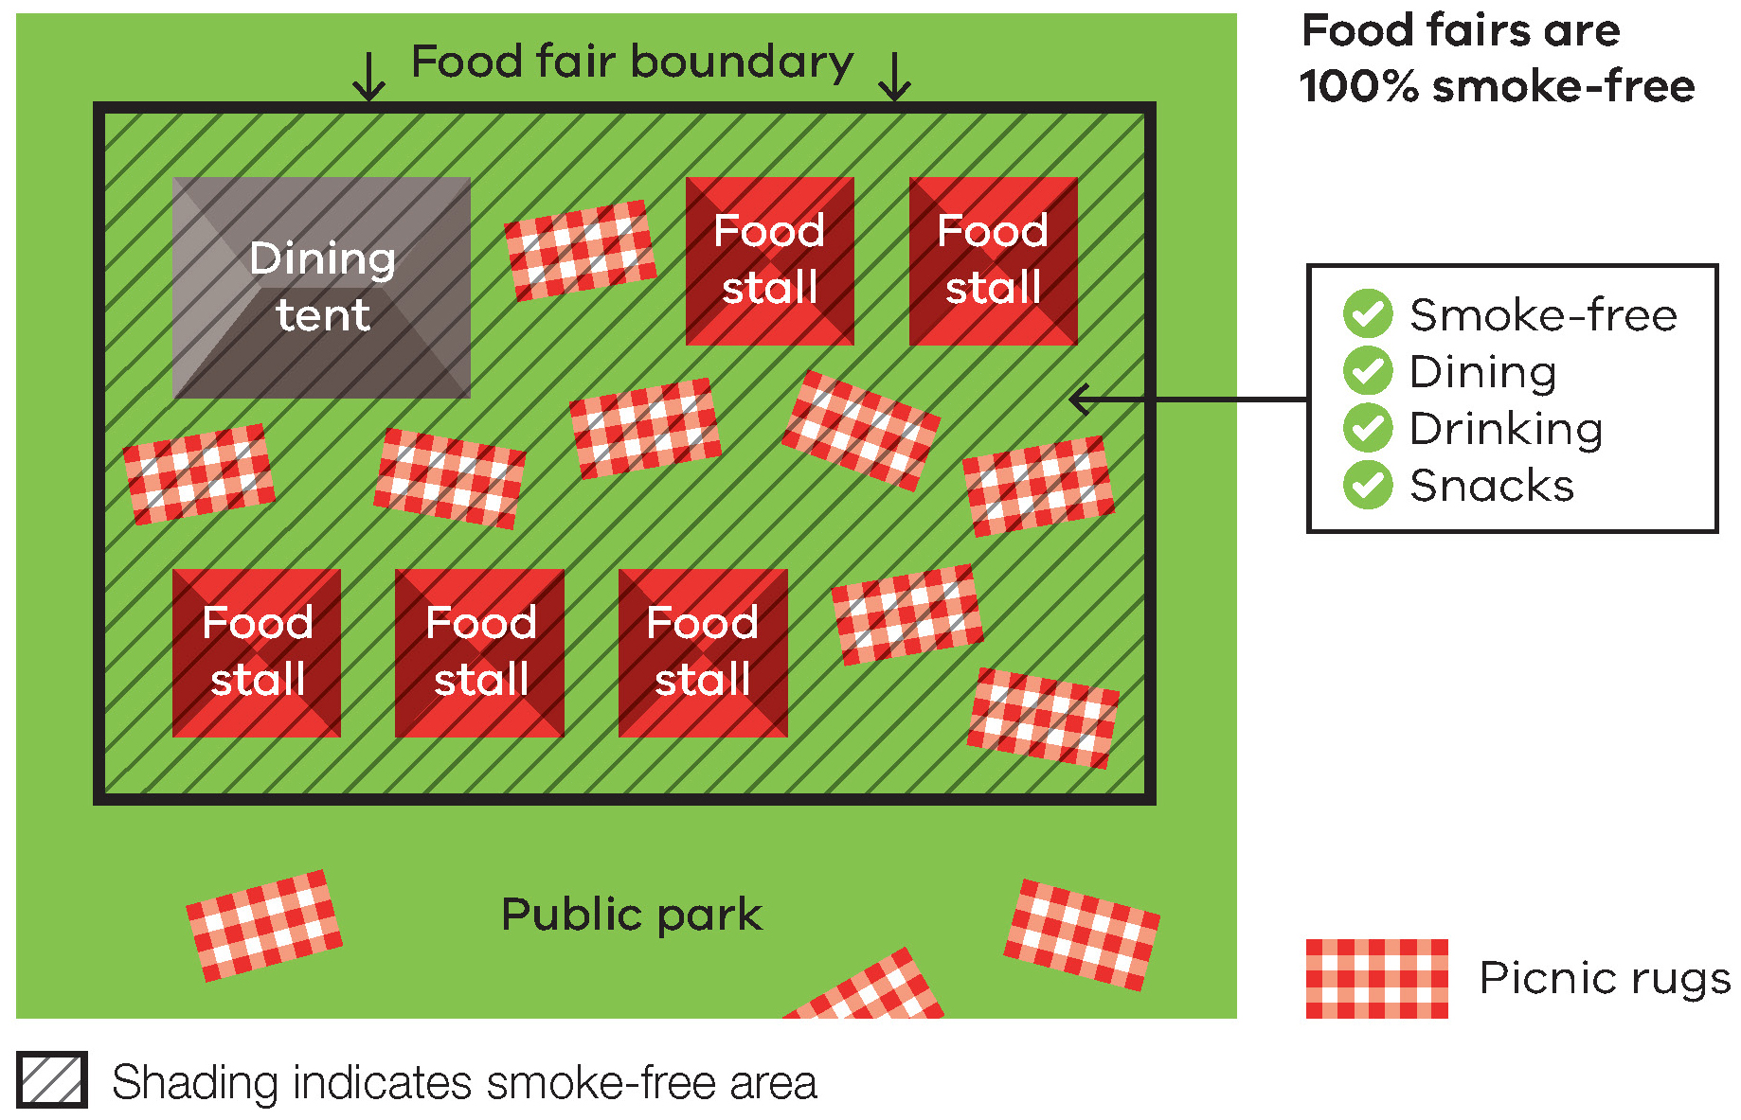
Responsibility for compliance with the ban
Both food fair organisers or managers as well individuals are responsible for compliance with the smoking and vaping ban.

Organised events
While the Tobacco Act does not define an ‘organised event’, it is considered to be any public event that is planned and organised in advance, and has a community, sporting, arts, cultural or volunteer focus. It may be a one-off event or part of a series of events.
Organised events generally have an event organiser or manager who permits and organises a range of activities, stalls and vendors.
Organised events include:
- street and cultural festivals
- music festivals
- small, medium and large-scale community events such as church fetes, sausage sizzles and multicultural festivals
  - small, medium and large-scale sporting events.

How the ban applies to organised events (other than food fairs)
At organised events, smoking and vaping is banned in outdoor areas within 10 metres of a food stall or food vendor, such as a barbeque or food van.
The ban does not apply to a stall or vendor selling only drinks and/or snacks. For example, coffee or sealed jars of jams.
The ban does not apply to the entire event. However, at under-age sporting events and events at schools, a further overarching smoking and vaping ban is applicable.
Please see the information about these events in this fact sheet.
Figure 2: Example of how the smoking and vaping ban will apply to a food stall at an open-aged sporting carnival
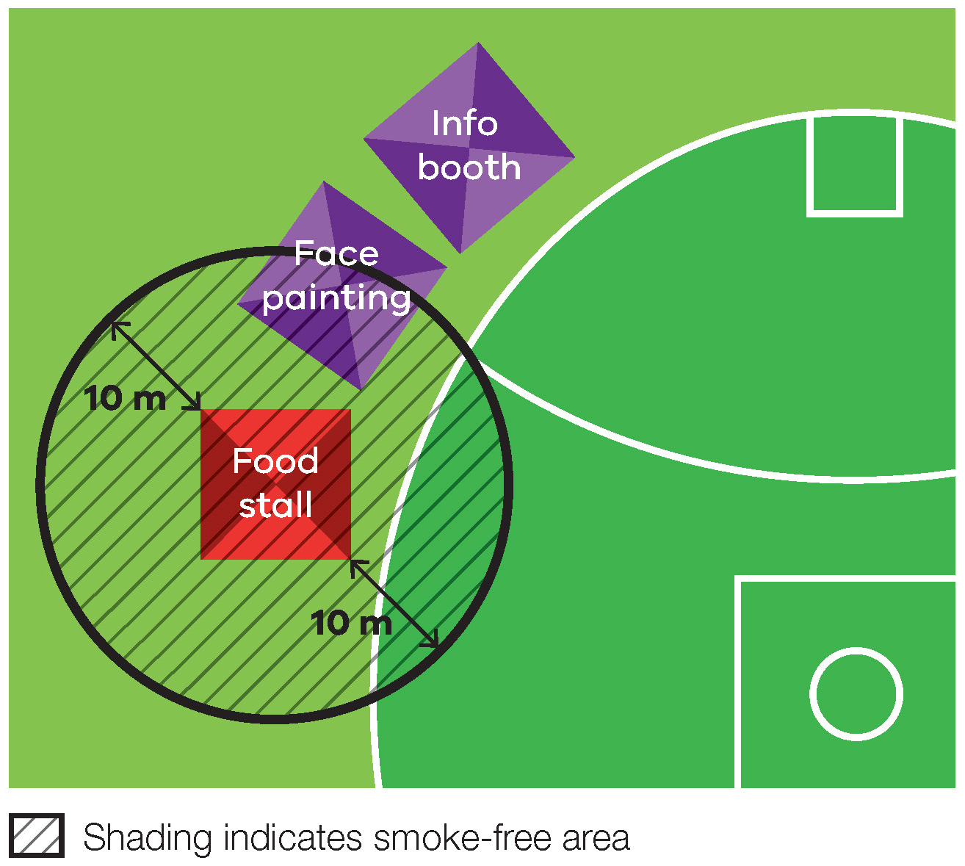Figure 3: Example of how the smoking and vaping ban will apply at a street festival
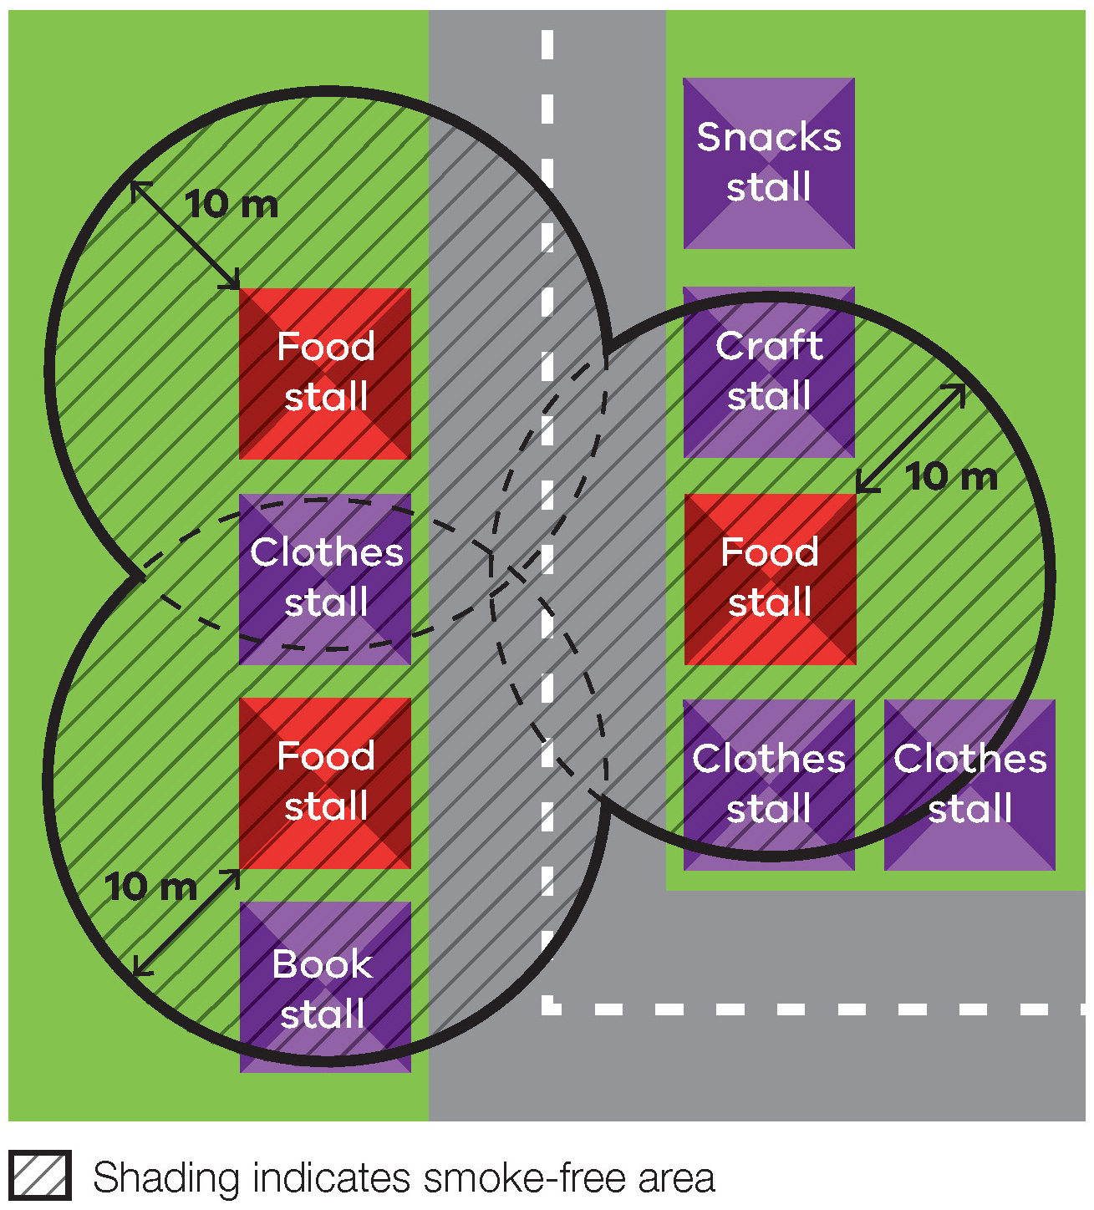

Layout of food stalls and food vendors
Event organisers could cluster food stalls and food vendors in groups to make it easier to comply with the smoking and vaping ban.

Responsibility for compliance with the ban
Both the person who has control over the outdoor dining area and individuals are responsible for compliance with the smoking and vaping ban.
Generally, the event organiser or venue manager has control over the outdoor dining areas at their event.
For example:
- a grassed public area
  - tables and chairs for customers to eat food purchased from a range of stallholders.
However, there may be some situations where a food stallholder has control over the outdoor dining area within 10 metres of their stall.
For example, a food stallholder who provides their own tables and chairs for customers to eat food purchased from their stall.

Smoke-free and vape-free policies at events
Smoke-free and vape-free policies at events are becoming increasing popular and reflect changed community attitudes towards smoking and vaping.
They are usually initiated by the event organiser or venue manager.
Smoke-free and vape-free policies at outdoor events may further restrict smoking and vaping in outdoor areas and would apply in addition to the legislative ban.
While the purpose of the law is to create smoke-free and vape-free areas where food is commercially sold and eaten, event organisers are encouraged to make their event entirely smoke-free and vape-free.

Under-age sporting events
Smoking and vaping is banned at, and within, 10 metres of an outdoor sporting venue during an organised under-age sporting event.
This means that the entire venue must be smoke-free and vape-free during the event, whether or not there are food stalls and vendors.
For further information about this specific ban, please visit the tobacco reforms website <www.health.vic.gov.au/public-health/tobacco-reforms>.

Events at schools
Smoking and vaping is banned within the grounds of, and within 4 metres of an entrance to, primary and secondary schools.
This means that the entire premises and areas near entrances must be smoke-free and vape-free, whether or not there are food stalls and vendors.
For further information about this specific ban, please visit the tobacco reforms website <www.health.vic.gov.au/public-health/tobacco-reforms>.

Signage
The occupier of an outdoor dining area must display acceptable ‘No smoking’ signs to indicate smoke-free and vape-free areas. It is a key aspect of smoke-free and vape-free outdoor dining.
‘No smoking’ signs must be displayed so customers can see a sign when entering, or within, the outdoor dining area.
Event organisers and managers should evaluate the layout of the food fair or organised event and decide where signs should be displayed.
Multiple signs in different locations may be necessary depending on the size and layout of the food fair or organised event.
For example, signs can be placed at the main entrance and at any designated eating areas such as tables and chairs.
At organised events (other than food fairs), organisers and managers could distribute signs to food stalls and food vendors and request that they be displayed.
Use of the ‘No Smoking or Vaping’ signage is voluntary.

Enforcement
There is strong community support for banning smoking and vaping in outdoor dining areas. This means most people will voluntarily comply with the smoking and vaping ban and expect others to do so.
Inspectors, authorised under the Tobacco Act 1987, may provide information about the ban and enforce it when necessary. The first priority of the inspector is to make sure smokers, vapers and business owners/occupiers understand the ban.
Inspectors may not be able to respond to every complaint but, where circumstances allow, may attend in response.
An on-the-spot fine of one penalty unit may apply to an individual who smokes in an outdoor dining area (maximum court penalty is five penalty units).
An on-the-spot fine of two penalty units may apply to a business owner or occupier (maximum court penalty is 10 penalty units for an individual or 50 penalty units for a company).

Further information and resources
Event organisers and managers can order signs to help educate and inform staff and the community about the ban.
To access the signs and for more information:
- visit the tobacco reforms website <www.health.vic.gov.au/public-health/tobacco-reforms>
- call the Tobacco Information Line on 1300 136 775.
To view the exact wording of the law, visit the Victorian Government’s legislation website <www.legislation.vic.gov.au> and search Tobacco Act 1987.

1300 136 775 using the National Relay Service 13 36 77 if required, or email tobacco.policy@health.vic.gov.au
Authorised and published by the Victorian Government, 1 Treasury Place, Melbourne.
© State of Victoria, Australia, November 2023.
Except where otherwise indicated, the images in this publication show models and illustrative settings only, and do not necessarily depict actual services, facilities or recipients of services.
Please note that any advice contained in this publication is for general guidance only. The Department of Health does not accept any liability for any loss or damage suffered as a result of reliance on the advice contained in this publication. Nothing in this publication should replace seeking appropriate legal advice.
ISBN 978-1-76131-103-1 (pdf/online/MS word)
Available at the tobacco reforms website <www.health.vic.gov.au/public-health/tobacco-reforms>.

The exact wording in the Tobacco Act is ‘an area that is part of an outdoor area in a public place at which an organised event (other than a food fair) is held; and is within 10 metres of a place at the outdoor area at which food is provided on a commercial basis by, or with the permission of, the occupier of the outdoor area’.
A snack is a pre-packaged shelf-stable food that: - is sealed in the container or package in which the manufacturer intended it to be sold, and - does not require any preparation prior to serving.
For current penalty unit values, visit the Department of Treasury and Finance website <www.dtf.vic.gov.au/financial-management-government/indexation-fees-and-penalties>

