CDIS - Victorian Infant Hearing Screening Program (VIHSP) risk factor update
Victorian Maternal and Child Health (MCH)
Child Development Information System (CDIS)
Feb 2024
OFFICIAL
Contents
Purpose 1
Background 1
Process 2

Purpose
This practice note was developed to guide the documentation process for the 2-week VIHSP Newborn hearing screen and the 8-month VIHSP Hearing Follow-up in CDIS Assessments and in the VIHSP Community Audiology Referral form.

Background
In 2020, following consultations with paediatricians, neonatologists, and other newborn hearing screening programs nationally, one of the risk factors for hearing loss was updated. The change in the risk factor was to the duration in the use of Ototoxic medication, that is from 3 days or more to three (3) or more consecutive doses.
The Green Book documents the new risk factor in the 2-week VIHSP Newborn hearing screen and the 8-month VIHSP Hearing Follow-up as:
- “Ototoxic medication (e.g., vancomycin, gentamicin or other aminoglycoside antibiotics) for three or more consecutive doses,” shown in Image 1 and Image 2.
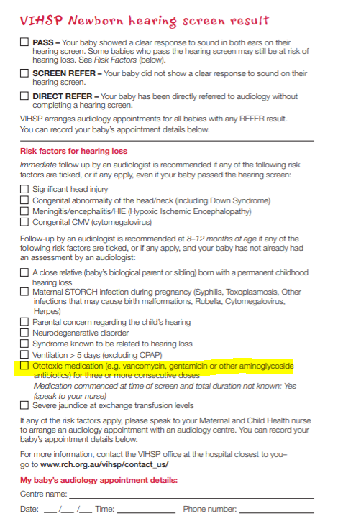 | 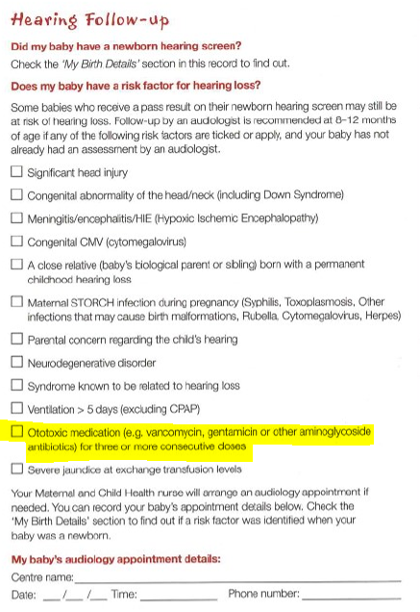
Image 1: 2-week VIHSP Newborn hearing screen | Image 2: 8-month VIHSP Hearing Follow-up

The updated risk factor was made available in the CDIS Assessments from 5th February 2024, but has not been updated on the VIHSP Community Audiology Referral form located on the RCH web site.
As a result, the form on the RCH web site reflects the 2019 risk factor definition, as shown below.
- “Aminoglycoside antibiotics (e.g., gentamicin) administered for 3 days or more”

Process
Until the risk factor description is changed on the VIHSP Community Audiology Referral form, please follow the following documentation process:
- If the risk factor “Ototoxic medication (e.g., vancomycin, gentamicin or other aminoglycoside antibiotics) for three or more consecutive doses” is identified, do not tick the description risk factor “Aminoglycoside antibiotics (e.g., gentamicin) administered for 3 days or more’,
instead
- Tick ‘Other’ in the VIHSP Audiology Referral form and type in/cut and paste the new risk factor “Ototoxic medication (e.g., vancomycin, gentamicin or other aminoglycoside antibiotics) for three or more consecutive doses”, as per Image 3.
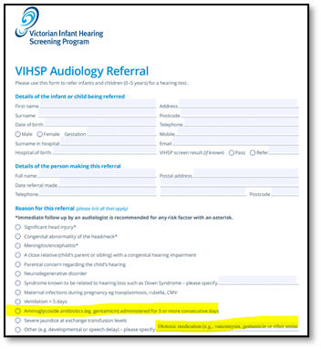
Image 3: Example of documentation for the VIHSP Audiology Referral form

You will be advised when the risk factor is updated on the VIHSP Community Audiology Referral form.
If you have any questions regarding these changes, please contact mch@health.vic.gov.au.

To receive this document in another format, phone 1300 650 172, using the National Relay Service 13 36 77 if required, or email Maternal and Child Health and Early Parenting Unit <mch@health.vic.gov.au>.
Authorised and published by the Victorian Government, 1 Treasury Place, Melbourne.
© State of Victoria, Australia, Department of Health, April 2024.
Except where otherwise indicated, the images in this document show models and illustrative settings only, and do not necessarily depict actual services, facilities or recipients of services. This document may contain images of deceased Aboriginal and Torres Strait Islander peoples. In this document, ‘Aboriginal’ refers to both Aboriginal and Torres Strait Islander people. ‘Indigenous’ or ‘Koori/Koorie’ is retained when part of the title of a report, program or quotation.
ISBN 978-1-76131-577-0 (pdf/online/MS word)
Available at health.vic – Child Development Information System <https://www2.health.vic.gov.au/primary-and-community-health/maternal-child-health/child-development-information-system>

