CDIS: Recording KAS and/or Additional consultations by telephone, video link or face to face
Victorian Maternal and Child Health (MCH) Child Development Information System (CDIS)
December 2020

Contents
Contents 1
Overview 1
Schedule KAS appointment 1
Telephone 1
Video link 2
Face to Face 2
KAS consultation: telephone or video link location 2
Additional consultation – KAS completion: face to face 3

Overview
The Department of Health and Human Services (the department) has introduced changes to CDIS to support the MCH Service providers and workforce to accurately and flexibly record consultations whist operating an alternative model of service delivery.
The department recommends that MCH service providers continue to implement alternative service delivery models, supplemented by short face-to-face consultations for weight checks, physical examination, breastfeeding support and developmental checks in line with current COVID-19 updates for:
- Maternal and Child Health service providers in Local Government Areas (LGAs) in metropolitan Melbourne, and
- Maternal and Child Health service providers in regional and rural Local Government Areas (LGAs)
https://www2.health.vic.gov.au/primary-and-community-health/maternal-child-health
The introduced changes include:
- Location – option to select video link
- Additional consultation reason - KAS completion
- Assessments/Interventions - all assessment tools are now available for Additional Consultations

Schedule KAS appointment

Telephone
- Schedule KAS appointment on the calendar
- Location: Select telephone
- Consultation and Mode: Phone
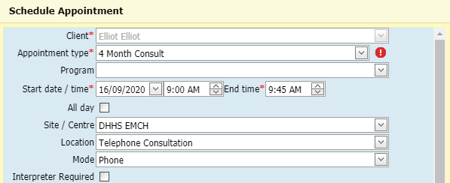

Video link
- Schedule KAS appointment on the calendar
- Location: Select Video link
- Consultation and Mode: Webcam/Skype

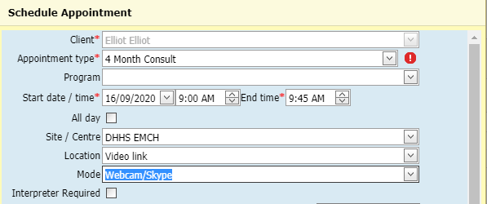

Face to Face
Schedule appointment for 30 minutes to reflect 15 minutes face to face and 15 minutes for indirect service inclusive of cleaning.

KAS consultation: telephone or video link location
Open KAS/Additional consultation as usual (Clinical Activity > Consultation) and click on the appointment hyperlink

Enter the following information:
- Did the client attend this appointment: Select Yes
- Location: Telephone Consultation or Video link (This will appear by default as Telephone consultation or video link if already selected in calendar booking.)
- Tick appropriate box for Family present
- Weight and growth assessed: No and choose Telephone Consultation or Video link as the Reason
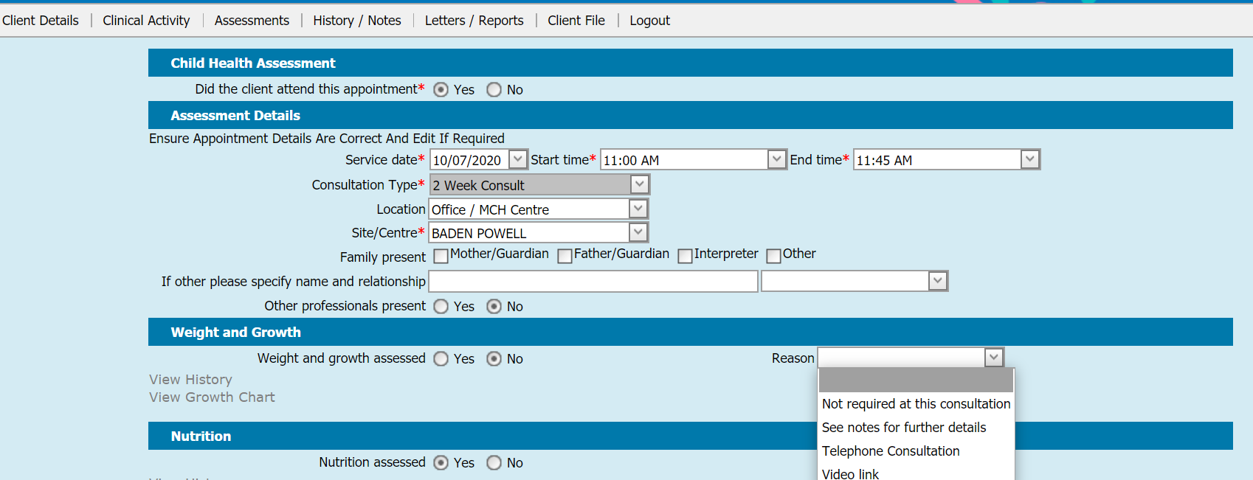

Enter in notes relevant statement:
Consultation via phone due to COVID-19 – baby/child not sighted or
Consultation via video link platform (e.g. Health direct) - baby/child not sighted or
Consultation via video link platform (e.g. Health direct) - baby/child sighted…….(e.g. throughout consultation, intermittently during consultation)

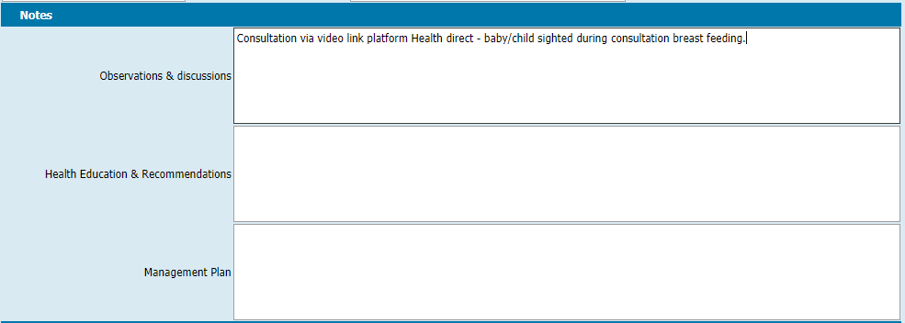
Complete notes for consultation.

Additional consultation – KAS completion: face to face
To support MCH services when delivering KAS consultations in two parts
- Schedule KAS appointment or Additional consultation on the calendar
- Please note Additional consultation reason - KAS completion from the consultation screen
Open KAS/Additional consultation as usual (Clinical Activity > Consultation) and click on the appointment hyperlink
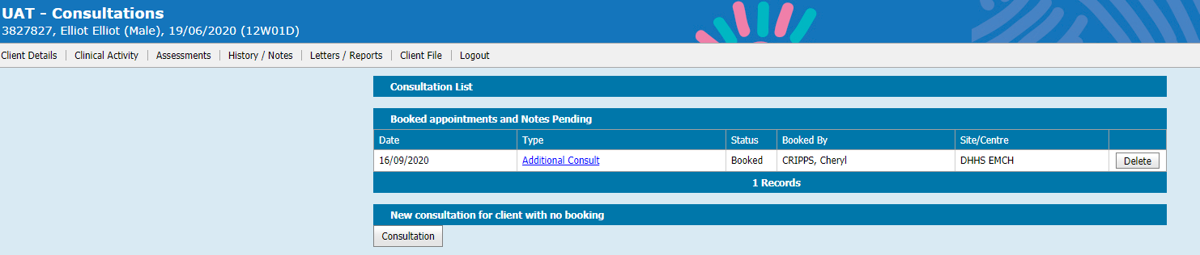
Complete
- Did the client attend this appointment: Yes
- Location: Office/MCH Centre, Clients Home,
- Select KAS completion from reason field

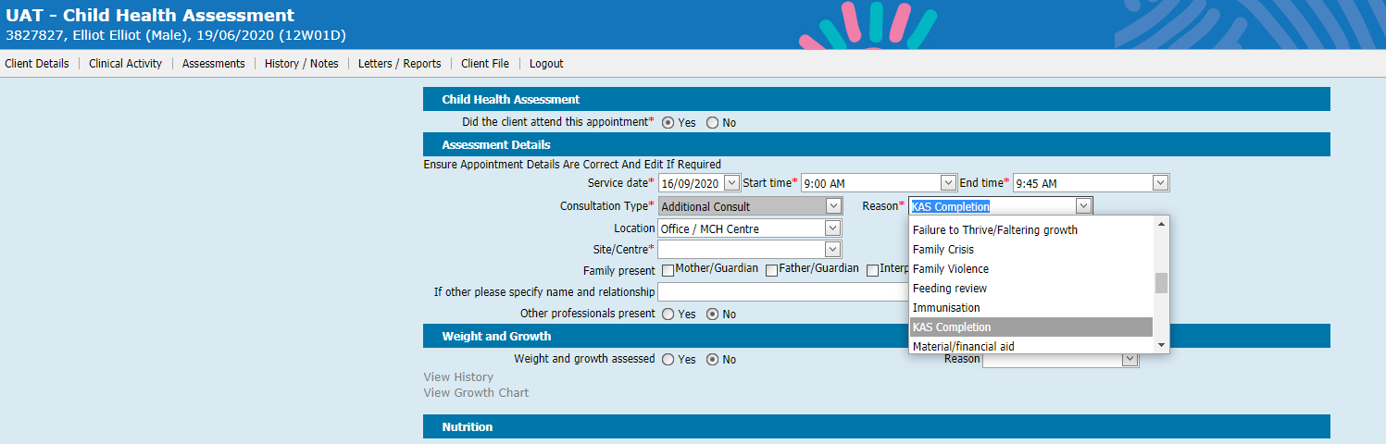Assessments/Interventions
Select and complete from Assessments/Interventions field. Please note all assessment tools are now available for Additional Consultations.

To receive this publication in an accessible format phone 1300 650 172, using the National Relay Service 13 36 77 if required, or email mch@ddhs.vic.gov.au
Authorised and published by the Victorian Government, 1 Treasury Place, Melbourne.
© State of Victoria, Australia, Department of Health and Human Services September 2020.
Available at https://www2.health.vic.gov.au/primary-and-community-health/maternal-child-health/child-development-information-system

