CDIS User update
Victorian Maternal and Child Health (MCH) Child Development Information System (CDIS)
December 2020

Contents
Contents 1
Overview 1
Delivered hours 1
New assessment tools 2
New groups 2
Sleep and settling related changes 2
Enhanced MCH related changes 2
Support for Enhanced MCH 2
Regarding IRIS 3
Support for Sleep and Settling - Outreach 3
Closing programs for transferring clients 3
Warning screen for direct program enrolments 3
Reporting impacts 3

Overview
As of December 2020, a number of changes have been made to CDIS, including:
- Update to how delivered hours are recorded
- New assessment tools
- New groups
- New capabilities to support Enhanced MCH and Sleep & Settling – Outreach programs
- Closing programs for transferred clients
- Warning screen for direct program enrolments
There are also some impacts on reporting.

Delivered hours
On all Consultation and Client Not Present screens, CDIS now mandates the collection of time data, to record the amount of time that each activity has taken to deliver.
Time is collected across three different categories:
- Direct – defined as time spent with client, either face-to-face or over-the-phone
- Indirect – defined as note-taking and other non-client time
- Travel – defined as travel time to-and-from an appointment
Users are obligated to complete these fields with as much accuracy as possible. Please do not simply enter the standard time allocation for the consultation you are delivering. Accurate data will improve service-wide understanding of the real time and cost of MCH service delivery.
For more information see CDIS Delivered hours guide - Dec 2020

New assessment tools
Three new assessment tools have been added to CDIS:
- Parent and carers psychosocial assessment
- Parent-child interactions scale - Infant and toddler (Brigance III)
- Sleep Pathways Assessment form (this tool replaces the infant sleeping tool)
For more information see CDIS Additional assessment tools - Dec 2020

New groups

Sleep and settling related changes
New Group Types
- Sleep and Settling – newborn group
- Sleep and Settling – baby group
- Sleep and Settling – toddler group
New Activity/Topic type
- The First Time Parent Group (FTPG) group now includes an activity/topic type called Sleep and settling – newborn
For information on these new groups and sessions, see Sleep and settling model of care (2019).

Enhanced MCH related changes
New Group Types
- Enhanced MCH group
For information on this group, see Enhanced maternal and child health program guidelines (reissued 2019).

Support for Enhanced MCH
The existing Enhanced MCH program in CDIS has been renamed Old Enhanced MCH Program. It still contains all currently active Enhanced MCH clients and can continue to be used under its new name.
A new program called Enhanced MCH has been added to CDIS. This new program has been enabled with a range of additional capabilities to support the Enhanced MCH Program. For information on how these capabilities work, see CDIS Enhanced MCH guide.
For information on how to migrate Old Enhanced MCH enrolments across to the new Enhanced MCH Program, see CDIS Enhanced MCH migration guide.
Note: Users are not required to immediately start using the (new) Enhanced MCH program, and can initially continue to use the original program, now call Old Enhanced MCH. Users will be supported to transition to the new program over time.

Regarding IRIS
The introduction of these new capabilities in CDIS is an important step forward towards being able to stop entering Enhanced MCH data into IRIS. However, in the short term, users will need to continue entering data into IRIS as per current practice. The Department of Health and Human Services (DHHS) is committed to ending the use of IRIS for the Enhanced MCH program by the end of this financial year at the latest, and potentially earlier if possible.

Support for Sleep and Settling - Outreach
CDIS has been enabled with a range of additional capabilities to support the Sleep and Settling – Outreach Program.
For more information see CDIS Sleep and settling - outreach guide

Closing programs for transferring clients
When transferring in a client, the ‘Transfer Client’ screen will now list all programs that the client is currently active in. These enrolments will all end upon transfer.
Take note of any actions to be taken regarding program enrolment once the transfer has been completed. For example, if the client was active in a program at their former provider, they may require a referral into the same program at their new provider.

Warning screen for direct program enrolments
CDIS currently supports over a dozen different programs. For most programs it is normal practice that an internal referral must be created in order to enrol a client. However in some circumstances for some programs it may be accepted practice to directly add a client to a program (without referral), via the Programs screen.
Whenever a user attempts to directly add a client to any program without a referral, a warning screen will now appear first. This is to help prevent inadvertent direct enrolments. If the program enrolment should be occurring via referral, users can Go back from this screen. If direct enrolment is allowed, users can Continue.
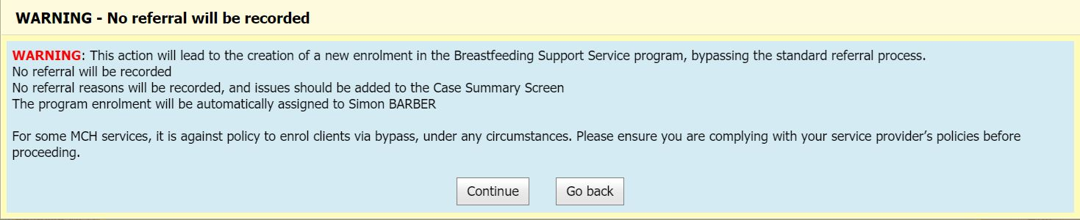

Reporting impacts
As a result of some of these and other recent changes to CDIS, some fields in existing reports will not count new data as expected. For more information see CDIS Reporting update – Dec 2020
The Programs Active List previously included an ‘Hours’ column. This column has been removed. For more information see CDIS Programs Active List update – Dec 2020

To receive this publication in an accessible format phone 1300 650 172, using the National Relay Service 13 36 77 if required, or email Commissioning Performance and Improvement Aged and Community Based Health Care and Cancer Services <mch@dhhs.vic.gov.au>
Authorised and published by the Victorian Government, 1 Treasury Place, Melbourne.
© State of Victoria, Australia, Department of Health and Human Services December 2020.
Except where otherwise indicated, the images in this publication show models and illustrative settings only, and do not necessarily depict actual services, facilities or recipients of services. This publication may contain images of deceased Aboriginal and Torres Strait Islander peoples.
In this document, ‘Aboriginal’ refers to both Aboriginal and Torres Strait Islander people. ‘Indigenous’ or ‘Koori/Koorie’ is retained when part of the title of a report, program or quotation.
ISBN 978-1-76096-230-2 (pdf/online/MS word)
Available at health.vic – Child Development Information System <https://www2.health.vic.gov.au/primary-and-community-health/maternal-child-health/child-development-information-system>

