HDSS Bulletin
Issue 241: 11 December 2020
Contents
Global update 1
241.1 Circulars 1
241.2 Postcode locality reference data update 1
Agency Information Management System (AIMS) 2
241.3 Daily Elective Surgery Activity 2
241.4 Daily Capacity and Occupancy Register 2
241.5 COVID positive pathways care 2
COVID Testing clinic data 2
Christmas / New Year Reporting for Daily COVID Reports 2
Victorian Admitted Episodes Dataset (VAED) 3
241.7 Changes to effect of validations 319 and 712 3
2021-22 Annual Changes 3
Non-Admitted Data Reporting 4
241.8 Non-admitted Data Expansion project update 4
241.9 AIMs vs VINAH reconciliation 4
National Funding Approach 4
241.10 National funding approach implementation - 1 July 2021 4
Contact details 5

Global update

Circulars
Access private hospital circulars at: Private hospital circulars <https://www1.health.gov.au/internet/main/publishing.nsf/Content/health-phicirculars2020-index1 >
Access hospital circulars at: Hospital circulars <https://www2.health.vic.gov.au/about/news-and-events/hospitalcirculars>

Postcode locality reference data update
The following postcode locality combinations have recently been added to our reference data.
Postcode | Locality
3150 | BRANDON PARK
3170 | WAVERLEY GARDENS

Agency Information Management System (AIMS)

Daily Elective Surgery Activity
Submission timelines changes
Due to recent changes to caps on elective surgery in Victorian hospitals, the department has relaxed the timelines for reporting daily elective surgery activity data through HealthCollect.
Effective 26 November, health services are required to submit data for each week (Monday to Sunday) by 1pm on the following Tuesday. A form must be completed for each day of the week; only the requirement to complete the form daily has been removed. Health Services can choose to continue daily submissions, or change their reporting frequency as desired, whilst ensuring to meet the Tuesday deadline.
Health Services will now receive a reminder email on Monday, and then a compliance email on Tuesday at 1:30pm if the reporting deadline has not been met. Changes to the automated emails are expected to be operational by Monday 7 December.

Daily Capacity and Occupancy Register
No change to reporting timelines
Timelines for reporting to the Daily Capacity and Occupancy Register (DCOR) have not changed. Health Services should continue to report DCOR data according to the established timeline.
The Daily Capacity and Occupancy Register must be completed each weekday by 11:00am for the previous day, recording bed spaces and occupancy as at midnight. Data for Friday, Saturday and Sunday must be reported each Monday morning (one form per day).

COVID positive pathways care
In response to the zero COVID-19 case numbers in Victoria, this process will transition to a reporting by exception basis, effective immediately. Should any Pathways program have any active cases in future, reporting will be required twice weekly.

COVID Testing clinic data
Effective Friday 18 December 2020, health services will no longer be required to report COVID-19 testing clinic activity data to the department in the VEMD or in the UCC: COVID-19 Pandemic form on HealthCollect.
Instead health services are expected to report testing clinic data in the Retrieval and Critical Health (REACH) information system. Any health service not currently reporting testing clinic data in REACH must organise to commence reporting in REACH immediately.

Christmas / New Year Reporting for Daily COVID Reports
Daily Reporting Expectations
The department is aware that staff leave between Christmas and New Year will have an impact on maintaining daily reporting. While there is no change to reporting requirements for the daily reports introduced this year, compliance follow-up will be relaxed in the period between 24 December and 4 January; however the department’s automated emails will continue to be sent during this period.
The table below outlines the expected reporting dates over the Christmas/New Year period. Health services unable to report in this period must ensure their data is up to date for each collection by 4 January 2021.
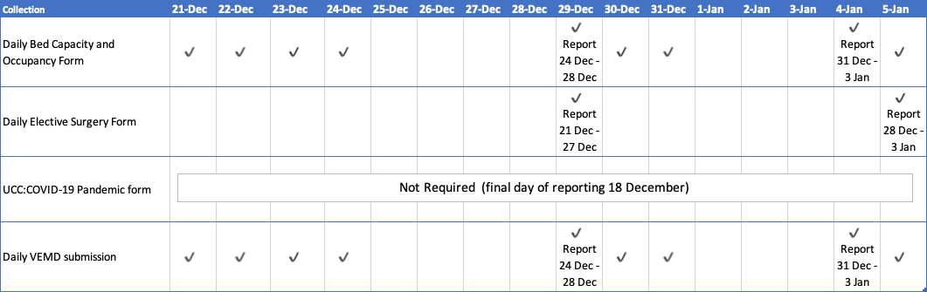

Victorian Admitted Episodes Dataset (VAED)

Changes to effect of validations 319 and 712
VAED validations 319 and 712 were relaxed to allow episodes with mechanical or non-invasive ventilation duration to accept in VAED without ICU/CCU hours, effective for separations on or after 1 January 2020. This change was made to facilitate reporting of episodes where health services had converted general wards to provide ICU care as part of the COVID-19 response. All ICU/CCU hours had to be captured in house and submitted later to the VAED.
Effective for separations on or after 1 December 2020, VAED validations 319 and 712 will revert to Rejections.

319 MV duration but no ICU stay
Effect | Warning REJECTION
Problem | The X5 Diagnosis Record has a Duration of Mechanical Ventilation but no Duration of Stay in ICU. To be counted in this field, mechanical ventilation must be provided in ICU.
Remedy | Check Duration of Mechanical Ventilation and Duration of Stay in ICU amend as appropriate and re-submit the X5/Y5.  - If the patient received mechanical ventilation in a combined ICU/CCU, report the ICU/CCU hours in the ICU field, not the CCU field.  - If the patient received mechanical ventilation during a contracted service in ICU at another hospital, include that period of ICU.

712 NIV duration but no ICU stay
Effect | Warning REJECTION
Problem | The X5 Diagnosis Record has a Duration of Non-invasive Ventilation (NIV) but no Duration of Stay in ICU. To be counted in this field, NIV must be provided in ICU.
Remedy | Check Duration of NIV and Duration of Stay in ICU, amend as appropriate and re-submit the X5/Y5.

2021-22 Annual Changes
Specifications for changes to the VAED, VEMD, ESIS, VINAH and AIMS will be published on the HDSS website by 31 December 2020.
Due to the deferment of most changes intended to be implemented in 2020-21, the Specifications will be available in two parts:
- Part A: Changes originally scheduled for implementation in 2020-21 that were deferred due to the COVID-19 response. These documents are available now.
- Part B: Changes resulting from the 2021-22 annual changes process. These documents will be available by 31 December 2020.
A summary of all changes to be implemented in 2021-22 (deferred and new) and any deferred until 2022-23 will be published on the HDSS website.

Non-Admitted Data Reporting

Non-admitted Data Expansion project update
The Non-admitted Data Expansion (NADE) project continues to progress towards ensuring all non-admitted health service activity in scope for national reporting is reported at patient level by July 2021. While most non-admitted in scope activity in Victorian health services is currently reported at patient level in VINAH, a small amount of activity continues to be reported in aggregate form only in AIMS.
Soon some health services will receive an email that outlines the programs which are currently only being reported as aggregate data. It is anticipated that health services will use this information to confirm plans are in place to ensure patient level data will be available by 1 July 2021. This email will be directed to Health Information Mangers and staff involved in VINAH reporting.

AIMs vs VINAH reconciliation
As part of the NADE project AIMS vs VINAH reporting for all health services is being reviewed. Where variations are identified, health services will be contacted via email and given an opportunity to investigate and address any inconsistencies.
Any queries about the NADE project should be directed to the HDSS Helpdesk

National Funding Approach

National funding approach implementation - 1 July 2021
Health service CEOs were notified recently that Victoria will implement a national funding approach (National Weighted Activity Unit), to apply from 1 July 2021, for acute and sub-acute admitted and non-admitted activity, and emergency department funded services as the mechanism by which health services activity will be funded.
For Small Rural Health Services (SRHS), the department will not be adopting the national funding approach; block funding will continue at this time. However, as the WIES / SWIES model will not continue in 2021-22, the department will be reporting SRHS activity using the NWAU model.
Health Services Data are working through the impact of this change on our data collections and will provide further information when it is available.
Queries regarding the national funding model approach should be directed to the National Funding Model email –
NationalFundingModel@dhhs.vic.gov.au

Contact details
The Data Collections unit manages several Victorian health data collections including:
- Victorian Admitted Episodes Dataset (VAED)
- Victorian Emergency Minimum Dataset (VEMD)
- Elective Surgery Information System (ESIS)
- Agency Information Management System (AIMS)
- Victorian Integrated Non-Admitted Health Minimum Dataset (VINAH)
  - F1 data collections (technical support)
The HDSS Bulletin is produced at intervals to provide:
- answers to common questions recently directed to the HDSS help desk
- communication regarding the implementation of revisions to data collection specifications, including notification of amendments to specified data collection reference tables
- feedback on selected data quality studies undertaken
  - information on upcoming events
Website
HDSS website <https://www2.health.vic.gov.au/hospitals-and-health-services/data-reporting/health-data-standards-systems>
HDSS help desk
Enquiries regarding data collections and requests for standard reconciliation reports
Email HDSS help desk <HDSS.helpdesk@dhhs.vic.gov.au>
Other Victorian health data requests
VAHI Data Request Hub < https://vahi.freshdesk.com/support/home>
Email HOSdata <Hosdata.frontdesk@vahi.vic.gov.au>

To receive this publication in another format email HDSS help desk <HDSS.helpdesk@dhhs.vic.gov.au>
Authorised and published by the Victorian Government, 1 Treasury Place, Melbourne.
© State of Victoria, Department of Health and Human Services, December 2020
Available at HDSS Bulletins < https://www2.health.vic.gov.au/hospitals-and-health-services/data-reporting/health-data-standards-systems/hdss-communications >

