Epidemic thunderstorm asthma campaign
Toolkit information sheet

What’s in the toolkit?
This toolkit includes the following resources that can be used to promote epidemic thunderstorm asthma information to the community and health professionals during the grass pollen season:
- Newsletter and website content for public audiences
- Newsletter and website content for health professionals
- Social media tiles and suggested posts for public audiences
- Social media tiles and suggested posts for health professionals
- 4 steps of asthma first aid poster (also available to order)
- Protect yourself from thunderstorm asthma poster (also available to order)
- What is thunderstorm asthma? brochure (also available to order)

Digital resources
Information for the public: www.betterhealth.vic.gov.au/thunderstormasthma
Information for health professionals: https://www2.health.vic.gov.au/public-health/environmental-health/climate-weather-and-public-health/thunderstorm-asthma
Epidemic thunderstorm asthma forecast: http://emergency.vic.gov.au/prepare/#thunderstorm-asthma-forecast

Printed resources
The following resources can be ordered in community languages at no cost using the online order form.

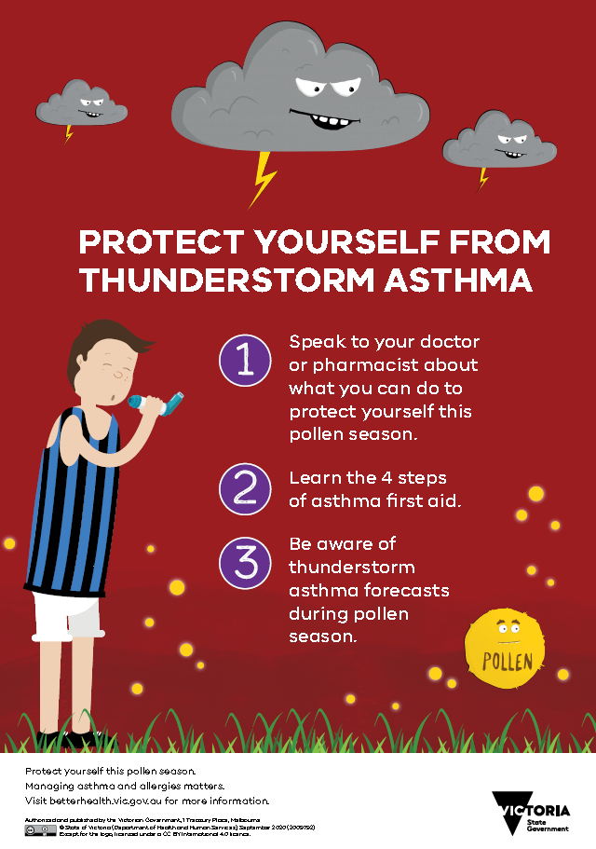 | 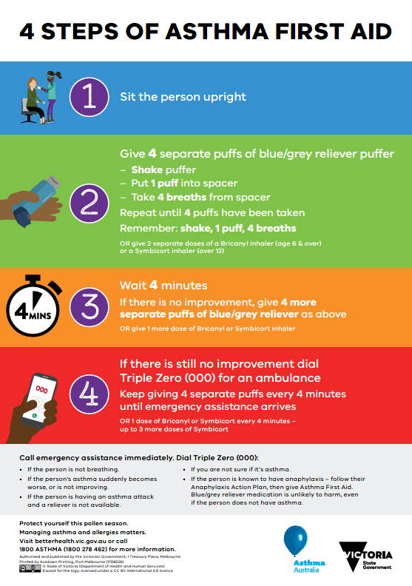
Protect yourself from thunderstorm asthma poster | 4 steps of asthma first aid poster | What is thunderstorm asthma? brochure

Translated resources
The following resources are available to download from the Multicultural resources page: https://www2.health.vic.gov.au/public-health/environmental-health/climate-weather-and-public-health/thunderstorm-asthma/thunderstorm-asthma-multicultural-resources
- 4 steps of asthma first aid poster
- Protect yourself from thunderstorm asthma poster
- What is thunderstorm asthma? brochure
- Epidemic thunderstorm asthma fact sheet
- Social media posts

Tips for promoting the message

It’s better to be prepared
An epidemic thunderstorm asthma event is an uncommon phenomenon where a large number of people experience asthma over a short period of time. The department has been working with the Bureau of Meteorology and a number of partner organisations to develop the Victorian epidemic thunderstorm asthma forecasting system. The risk of epidemic thunderstorm asthma is forecast each year during grass pollen season (1 October to 31 December).
The forecasting system is available on the VicEmergency website at: http://emergency.vic.gov.au/prepare/#thunderstorm-asthma-forecast

Time the release of your message
Consider what events are planned over the course of the grass pollen season and plan the distribution of your messages to coincide with them. For example, if your organisation is planning an outdoor event during grass pollen season, consider whether there is potential for it to be impacted by an epidemic thunderstorm asthma event.

Watch for advice and warnings
On a high-risk day or when an epidemic thunderstorm asthma event is occurring, advice will be issued through the Vic Emergency website at: http://emergency.vic.gov.au/

Localise your message
Use your local knowledge to make your messages more meaningful to your audience. Also, think about using a range of community leaders as spokespeople. A number of resources are available in community languages.

Know your stakeholders
It might seem like an obvious statement but get to know who you need to work with in your organisation. Communications, community liaison, emergency management and environmental health staff need to work together to avoid duplication of effort to get the best community outcome, so make some time for a catch up with a colleague.

Consider your channels
The following tips will assist you to promote epidemic thunderstorm asthma and your health messages with local media:
- Think about targeting groups that are vulnerable, particularly CALD communities. A large number of translated resources are available to support the epidemic thunderstorm asthma campaign. People with asthma (or that have had asthma in the past), people with hay fever (especially people who experience wheezing or coughing with their hay fever) and people with undiagnosed asthma or hay fever are most at risk of thunderstorm asthma.
- Explore submitting articles to school newsletters, church noticeboards, sporting clubs and venues.
- Order posters to place in public places and community buildings.
- Consider social media. It’s an important channel for some audiences.
  - Finally, don’t worry about repeating messages. The best messages are simple and repeated again and again. The average number of times a person needs to hear a message in order to recall it is 3-5 times. So say it, then say it again.

Contact
Thank you for supporting this important campaign. Please let us know if there is anything you would like to see in the toolkit next year.
Climate and Health, Environmental Health Policy and Risk Management
Department of Health
50 Lonsdale Street
Melbourne VIC 3000
Email: environmental.healthunit@health.vic.gov.au | Phone: 1300 761 874
For advice related to COVID-19 restrictions please go to https://www.dhhs.vic.gov.au/coronavirus

To receive this document in another format email environmental.healthunit@health.vic.gov.au <environmental.healthunit@health.vic.gov.au>
Authorised and published by the Victorian Government, 1 Treasury Place, Melbourne.
© State of Victoria, Australia, Department of Health, August 2021.
Available at Epidemic thunderstorm asthma campaign toolkit <https://www2.health.vic.gov.au/public-health/environmental-health/climate-weather-and-public-health/thunderstorm-asthma/toolkit>

