Check you are using the correct MMR containing vaccines
National Immunisation Program age recommendations for different vaccine brands
Use this resource in conjunction with the Immunisation schedule Victoria <https://www2.health.vic.gov.au/public-health/immunisation/immunisation-schedule-vaccine-eligibility-criteria/immunisation-schedule-victoria>

M-M-R-II® or Priorix®  Measles-Mumps-Rubella | 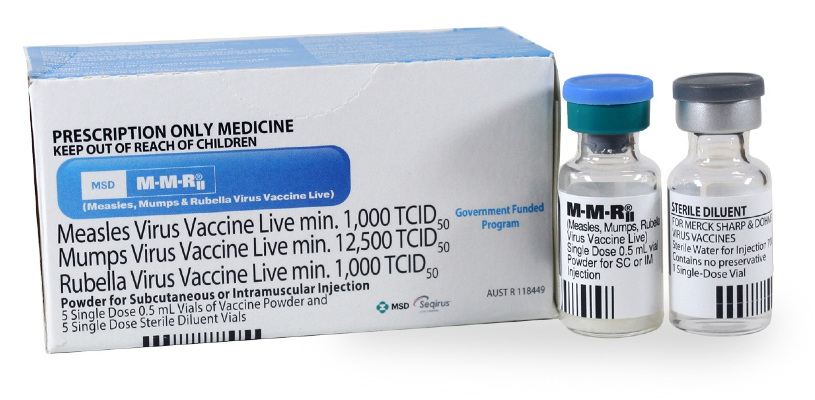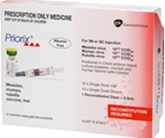
Age recommendation | Notes
- Infants from 6 months and before 11 months prior to travel overseas  - 12 months  - Catch-up from 13 months  - Persons born since 1966 with no evidence of MMR protection | - Syringe of diluent or vial of diluent + vial with pellet  - Live attenuated virus vaccines  - Contraindicated in immunocompromised individuals  - MMR must be administered as the 1st dose for children <4 years of age  - Women with low or negative rubella antibody levels who are planning pregnancy or shortly after delivery  - Vaccinated women should avoid pregnancy for 28 days after vaccination
PriorixTetra® or ProQuad®  Measles-Mumps-Rubella-Varicella | 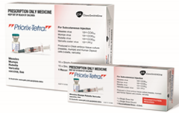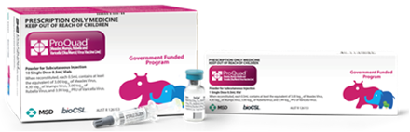
Age recommendation | Notes
- 18 months  - 19 months to 13 years – Catch-up | - Syringe of diluent + vial with pellet  - Live attenuated virus vaccines  - Contraindicated in immunocompromised individuals  - Must be administered as the 2nd MMR dose for children <4 years of age due to the risk of febrile seizure if MMRV is given as a 1st dose.

Reference – The Australian Immunisation Handbook https://immunisationhandbook.health.gov.au/
Material adapted from the Australian Immunisation Handbook, Australian Government Department of Health.
Images of packaging reproduced with permission.
To receive this publication in an accessible format email Health Protection <immunisation@dhhs.vic.gov.au>.
Authorised and published by the Victorian Government, 1 Treasury Place, Melbourne.
© State of Victoria, Australia, Department of Health and Human Services, October 2020.
Available on Health.vic – Immunisation factsheets, consent templates and mature minor information
https://www2.health.vic.gov.au/public-health/immunisation/immunisation-provider-information/immunisation-resources-for-providers/vaccine-preventable-diseases-immunisation-fact-sheets
(2009810 graphics)

