Check you are using the correct Varicella containing vaccines
National Immunisation Program age recommendations for different vaccine brands
Use this resource in conjunction with the Immunisation schedule Victoria <https://www2.health.vic.gov.au/public-health/immunisation/immunisation-schedule-vaccine-eligibility-criteria/immunisation-schedule-victoria>

Varivax®  Varicella - zoster (Chickenpox) | 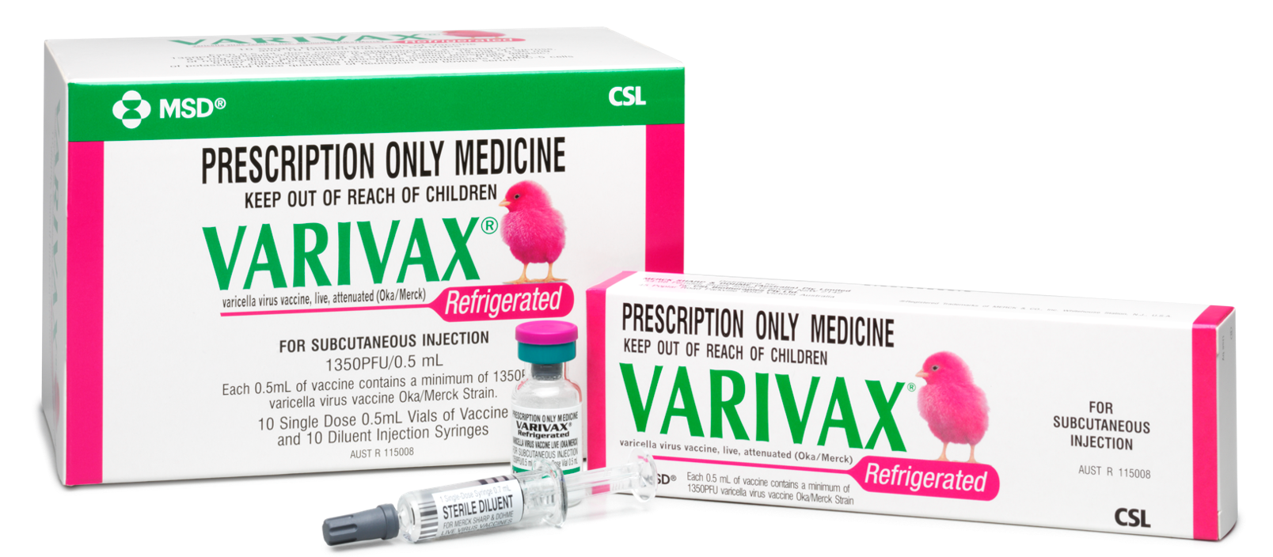
Age recommendation | Notes
Catch-up  - From 19 months  - From 14 years to <20 years | - Syringe of diluent + vial with pellet  - 14 years and older – 2 dose course, a minimum of 4 weeks apart  - Live attenuated virus vaccine  - Contraindicated in immunocompromised individuals
Zostavax®  Herpes - zoster (Shingles) | 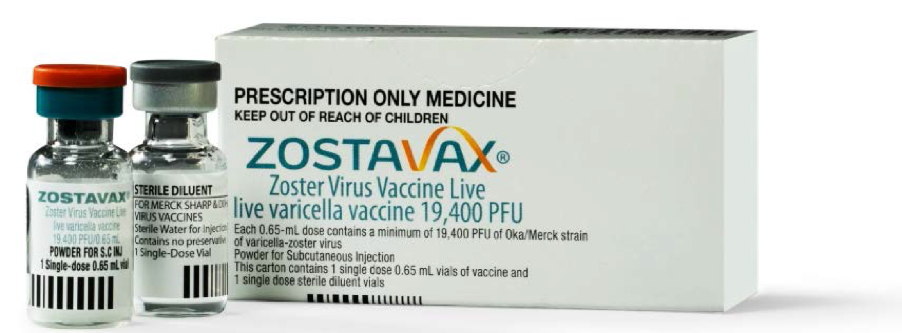
Age recommendation | Notes
- 70 years  - 71 - 79 years – Catch-up | - Vial of diluent + vial with pellet  - Catch-up program ceases October 2021  - Live attenuated virus vaccine  - Contraindicated in immunocompromised individuals  - If unsure use the Zostavax GP decision aid <https://mvec.mcri.edu.au/wp-content/uploads/ 2017/08/Zostavax-GP-Decision-Aid.pdf>  - Not to be used in patients with compromised immune function Zostavax vaccine TGA Safety advisory <https://www.tga.gov.au/alert/zostavax-vaccine>
PriorixTetra® or ProQuad®  Measles-Mumps-Rubella-Varicella | 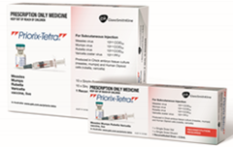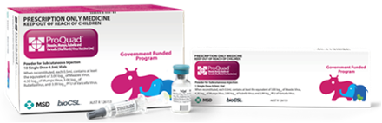
Age recommendation | Notes
- 18 months  - 19 months to <14 years – catch-up | - Syringe of diluent + vial with pellet  - Live attenuated virus vaccine  - Contraindicated in immunocompromised individuals  - Must be administered as the 2nd MMR dose for children <4 years of age due to the risk of febrile seizure if MMRV is given as a 1st dose.

Reference – The Australian Immunisation Handbook https://immunisationhandbook.health.gov.au/
Material adapted from the Australian Immunisation Handbook, Australian Government Department of Health.
Images of packaging reproduced with permission.
To receive this publication in an accessible format email Health Protection <immunisation@dhhs.vic.gov.au>.
Authorised and published by the Victorian Government, 1 Treasury Place, Melbourne.
© State of Victoria, Australia, Department of Health and Human Services, October 2020.
Available on Health.vic – Immunisation factsheets, consent templates and mature minor information
https://www2.health.vic.gov.au/public-health/immunisation/immunisation-provider-information/immunisation-resources-for-providers/vaccine-preventable-diseases-immunisation-fact-sheets
(2009810 graphics)

