Check you are using the correct Meningococcal vaccines
National Immunisation Program age recommendations for different vaccine brands
Use this resource in conjunction with the Immunisation schedule Victoria <https://www2.health.vic.gov.au/public-health/immunisation/immunisation-schedule-vaccine-eligibility-criteria/immunisation-schedule-victoria> and Where should I inject vaccines? <https://www2.health.vic.gov.au/about/publications/factsheets/where-should-i-inject-vaccines-poster>

Nimenrix®  Meningococcal ACWY vaccine | 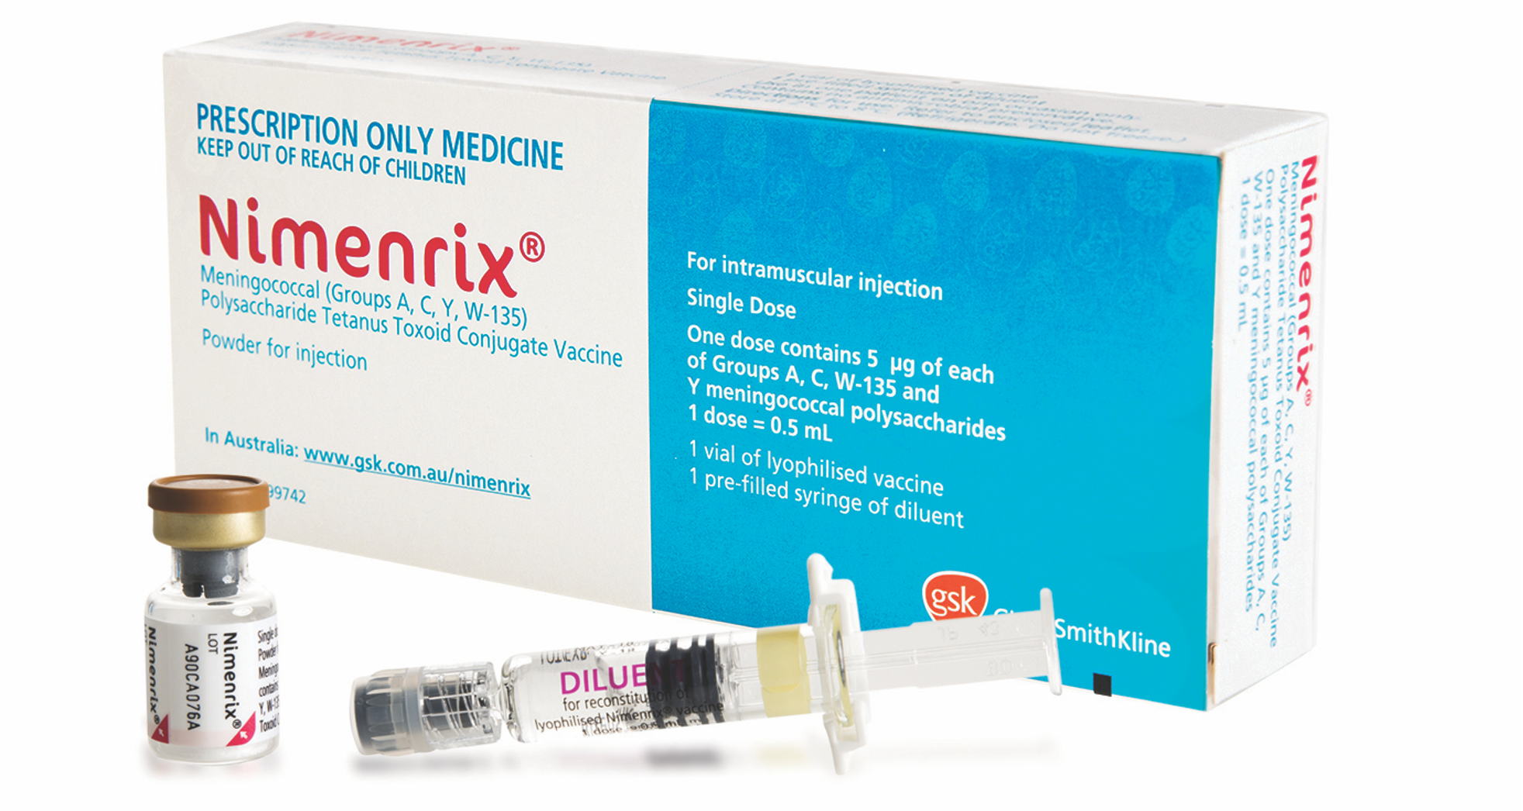
Age recommendation | Notes
- 12 months  - Year 10 of Secondary school or  15-16 years of age  - Catch-up <20 years  - Any age – Risk condition | - Syringe of diluent + vial  - Specified medical conditions associated with increased risk of invasive meningococcal disease <https://immunisationhandbook.health.gov.au/resources/handbook-tables/list-specified-medical-conditions-associated-with-increased-risk-of>
Bexsero®  Meningococcal B vaccine | 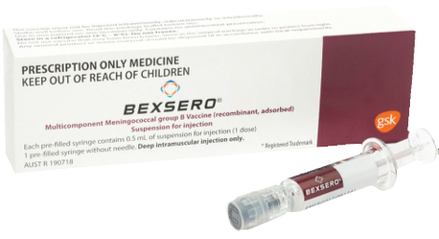
Age recommendation | Notes
Aboriginal and Torres Strait Islander children  - 2, 4 & 12 months  - Catch-up <2 years of age  - <2 years  - Any age – Risk condition | - Pre-filled syringe  - Catch-up program ceases 30 June 2023  - Specified medical conditions associated with increased risk of invasive meningococcal disease <https://immunisationhandbook.health.gov.au/resources/handbook-tables/list-specified-medical-conditions-associated-with-increased-risk-of>

Reference – The Australian Immunisation Handbook https://immunisationhandbook.health.gov.au/
Material adapted from the Australian Immunisation Handbook, Australian Government Department of Health.
Images of packaging reproduced with permission.
To receive this publication in an accessible format email Health Protection <immunisation@dhhs.vic.gov.au>.
Authorised and published by the Victorian Government, 1 Treasury Place, Melbourne.
© State of Victoria, Australia, Department of Health and Human Services, October 2020.
Available on Health.vic – Immunisation factsheets, consent templates and mature minor information
https://www2.health.vic.gov.au/public-health/immunisation/immunisation-provider-information/immunisation-resources-for-providers/vaccine-preventable-diseases-immunisation-fact-sheets
(2009810 graphics)

