Check you are using the correct Pneumococcal vaccines
National Immunisation Program age recommendations for different vaccine brands
Use this resource in conjunction with the Immunisation schedule Victoria <https://www2.health.vic.gov.au/public-health/immunisation/immunisation-schedule-vaccine-eligibility-criteria/immunisation-schedule-victoria>

Prevenar 13®  Pneumococcal conjugate (13vPCV) | 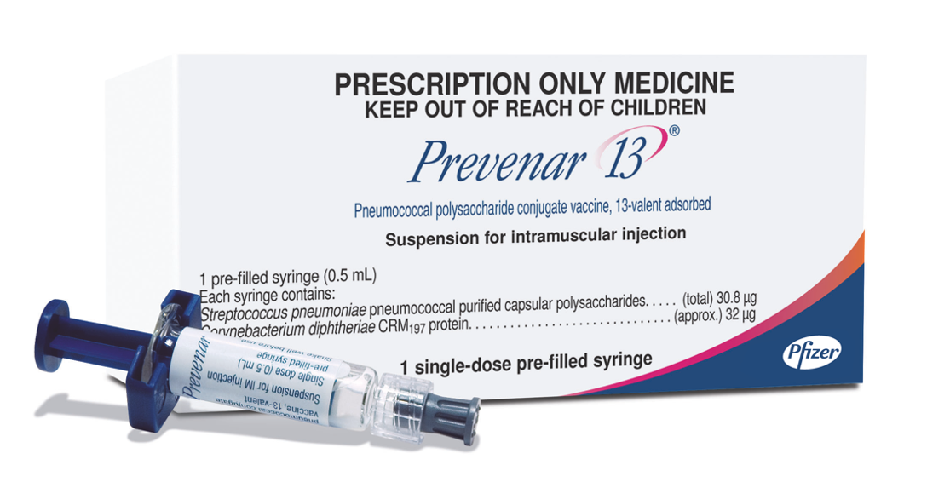
Age recommendation | Notes
- 2 (from 6 weeks), 4 & 12 months  - From 6 months - Risk condition  - Catch-up from 13 months to <5 years  - From 50 years – Aboriginal and Torres Strait Islander people  - From 70 years Non-Indigenous people | - Prefilled syringe  - Pneumococcal clinical decision tree <https://www.health.gov.au/resources/publications/national-immunisation-program-pneumococcal-vaccination-schedule-from-1-july-2020-clinical-decision-tree-for-vaccination-providers>
Pneumovax23®  Pneumococcal polysaccharide (23vPPV) | 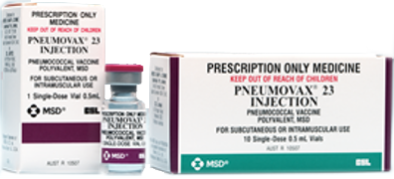
Age recommendation | Notes
- From 50 years – Aboriginal and Torres Strait Islander people  - From 4 years and older – Risk condition | - Vial of liquid  - Maximum of 2 lifetime doses spaced by a minimum 5 years  - Pneumococcal clinical decision tree <https://www.health.gov.au/resources/publications/national-immunisation-program-pneumococcal-vaccination-schedule-from-1-july-2020-clinical-decision-tree-for-vaccination-providers>Pneumococcal risk conditions

Reference – The Australian Immunisation Handbook https://immunisationhandbook.health.gov.au/
Material adapted from the Australian Immunisation Handbook, Australian Government Department of Health.
Images of packaging reproduced with permission.
To receive this publication in an accessible format email Health Protection <immunisation@dhhs.vic.gov.au>.
Authorised and published by the Victorian Government, 1 Treasury Place, Melbourne.
© State of Victoria, Australia, Department of Health and Human Services, October 2020.
Available on Health.vic – Immunisation factsheets, consent templates and mature minor information
https://www2.health.vic.gov.au/public-health/immunisation/immunisation-provider-information/immunisation-resources-for-providers/vaccine-preventable-diseases-immunisation-fact-sheets
(2009810 graphics)

