Code Brown Guidelines
State Health Emergency Response Arrangements

Date effective: 01 October 2017

Introduction
The Code Brown Guidelines have been developed to help health services and facilities prepare their Code Brown plans by providing some information about the purpose of a Code Brown plan.
The guidelines support the effective functioning of the State Health Emergency Response Plan, 4th edition by highlighting some of the key steps to take before, during and after a Code Brown emergency.
The Code Brown Guidelines and SHERP4 form part of the State Health Emergency Response Arrangements, the framework through which the Victorian Government and partner agencies work together in order to meet the health needs of Victorians during emergency events.
This document should be read in conjunction with SHERP4.

Key Audience
The primary audience for this document encompasses all Victorian Health Services and facilities, and private hospitals. Other audiences are the Department of Health and Human Services (Emergency Management Branch) and Emergency Management Victoria.

What is a ‘Code Brown’?
Health services and facilities use a nationally recognised set of response colour codes for both internal and external emergencies. These are detailed in Australian Standard (AS) 4083-2010 Planning for emergencies – health care facilities.
Code Brown is used to plan, prepare, respond and recover from an external emergency.
In Victoria, the most common external emergencies requiring activation of Code Brown plans are transport accidents, chemical spills and natural emergencies such as fire and flood. More recently, thunderstorm asthma has reminded us of the significant impact that external health emergencies can have on the health system.

How health services and facilities use Code Brown
A Code Brown is called by a health service or facility when additional capability and capacity needs to be mobilised within that facility to receive an influx of patients due to an external emergency.
The activation triggers are specific to each facility but will be based on a larger than normal increase in patients presenting at the facility in a short space of time, or the type of patients presenting to the facility. In these circumstances, a greater than normal demand for particular resources such as the emergency department, intensive care or operating theatres can be addressed by implementing the facility’s Code Brown plan.

How the health system uses Code Brown
As health system manager, the Department of Health and Human Services may also request that one or more facilities activate their Code Brown plan in emergencies of widespread demand that are likely to impact multiple health services and/or the entire health system.
The request will be made by the State Health Coordinator or relevant Regional Health Coordinator. Activation of Code Brown plans will facilitate communication, enable a coordinated health system response and statewide escalation when required. For example, Code Brown activation will facilitate information sharing to support effective decision making on matters such as which facilities will continue receiving patients by ambulance and whether other service providers need to be activated, such as private hospitals.

Before an emergency: Code Brown planning considerations
Each health service and facility is required to have a site-specific Code Brown plan to manage a significant surge in demand in emergency presentations resulting from an external emergency.
The Code Brown plan should use the all emergencies approach, being a single set of emergency management arrangements that can be applied when escalating the response for any external emergency.
Following are some the considerations to be addressed in planning for a code brown emergency.
- identifying a governance structure, including incident management roles and responsibilities
- health service emergency operations centre, job cards and maintaining a record of all issues
- processes for escalation
- notification internally and externally
- risk assessment
- intelligence gathering (websites, chief health officer alerts)
- patient tracking and secondary transfer of patients
- developing partnerships
- staff training and exercising
- communication (communication plan, media, incident briefings).

Risk assessments
Health services and facilities should be familiar with Victorian emergency risks. This includes the likelihood, impact and consequence on the health service and facilities. These risks could be from the local area (such a transport incident) or be state wide (such as an extreme heat event of epidemic thunderstorm asthma event). Information is available from local, regional and state emergency management committees, networks and websites. Processes for monitoring health specific advisories and alerts should also be in place, and should include key staff subscribing to receive this information.

Hospital Incident Management Team (HoIMT) roles and responsibilities
The HoIMT receives and manages all operational information related to the incident within the hospital. If an incident is going to extend beyond one shift change, the HoIMT will implement a roster system with a minimum of two equally capable and knowledgeable teams so rest breaks can be taken. The Hospital Commander leads the Hospital Incident Management Team (HoIMT).
For the purposes of SHERP, the term Hospital Commander is used to identify the chief executive officer or delegated member of staff who leads the health service response under Code Brown plan. Hospital Commanders are responsible to their organisation’s chief executive and board but also have a reporting relationship to the Regional Health Coordinator during an incident.

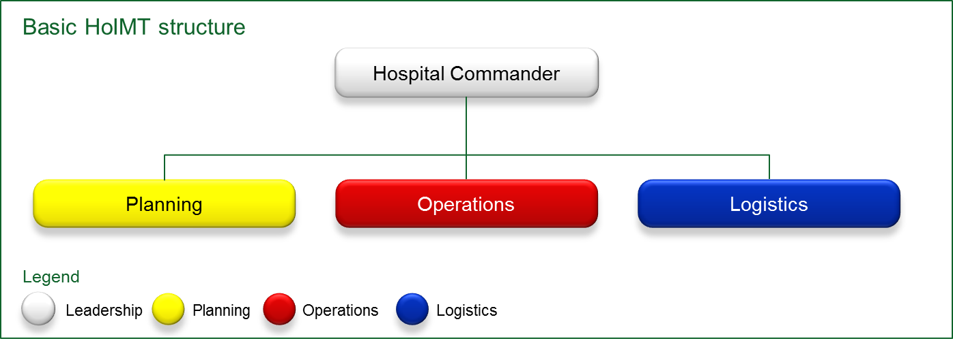

The location of the Health Service emergency operations centre
Health service Code Brown plans should specify a room that can be used as an emergency operations centre (EOC) or similar. This area will be used for additional administration, coordination and communication functions.
A secondary location should be identified in case the EOC is unavailable or unsuitable.

During an emergency: declaring a Code Brown
It is expected that a health service or facility would call a Code Brown when the triggers identified in their Code Brown plan are reached. The department recognises that the triggers may vary for each facility.
Health services and facilities may be alerted to an external emergency from a number of sources. This may include walk-in presentations to the Emergency Department or notification from Ambulance Victoria. It may become apparent to a health service or facility that activation of a Code Brown is required when a surge of patients arrive and early information regarding an external emergency is emerging. Activation of a Code Brown plan is not dependent on notification from the department.
Health services and facilities should maintain situational awareness during an emergency. They can do this through sources of information such as the VicEmergency website at https://emergency.vic.gov.au/respond/, social media, radio and television. Further information about these is available on the VicEmergency website.

Notifying the department
Health services and facilities are required to notify the Department of Health and Human Services via a telephone call, as part of activating their Code Brown response.
For rural and regional health services and facilities - call your division’s emergency contact number:
North division | 1300 080 829
East division | 1300 576 518
West division | 1800 780 354
South division | 1300 528 951
For metropolitan health services and facilities - call the department’s central emergency contact number: 1300 790 733

The purpose of notifying the department is to enable the department to coordinate a broader health system response if required and to ensure the department is able to fulfil its responsibilities as system manager.

Notifications and alerts from the department
When the department is alerted to an actual or potential health system impact from a level 2 (major impact) or level 3 (severe impact) incident, in accordance with the State Health Emergency Response Plan a ‘first wave’ notification will be sent to the health sector via email. Notification may also be provided to health services and facilities via SMS.
The notification may include a request for health services to activate their Code Brown plans.
Refer to the DHHS First Wave Notifications Protocol for further information about first wave alerts.
Each health service must provide the department with a ‘hospital single contact point’ for emergency management purposes, comprised of the following contact points, all of which are monitored 24 hours, 7 days per week:
- a mobile telephone number service capable of receiving SMS
- an email address; and
- a land line.

Escalation process
Code Brown plans should include the triggers for activation, escalation and scaling down of resources during the emergency response.
Generally, triggers will be determined by the number of patients presenting to the facility, the nature of their injuries and resources available.

After an emergency: debriefing and continuous improvement
After an emergency and a Code Brown activation, it is important that health services and facilities conduct a debrief with relevant staff and update their Code Brown plan if appropriate. Improvements and updates to Code Brown plans should be practiced, by health service staff, through training and exercises. The department would be pleased to receive a brief report from health services and facilities about their experience and learnings following a Code Brown activation.
All staff participating in an emergency response should be offered access to the employee psychosocial support program.

Related documents
- State Health Emergency Response Plan, 4th Edition
- Australian Standard (AS) 4083-2010 Planning for emergencies – health care facilities
- DHHS First Wave Notifications

Further information
Useful websites for information on emergency management and situational information:
VicEmergency - https://emergency.vic.gov.au/respond/
Chief Health Officer health alerts and advisories including subscription - www2.health.vic.gov.au/about/news-and-events/healthalerts
Extreme heat and heatwave alerts including subscription - www2.health.vic.gov.au/public-health/environmental-health/climate-weather-and-public-health/heatwaves-and-extreme-heat
Bureau of Meteorology weather warnings for Victoria - www.bom.gov.au/vic/warnings/

Policy review

Review period
These guidelines should be reviewed following an incident or emergency where multiple health services have activated code brown plans, or after 12 months (October 2018).

Revision history
Version | Date | Revisions | Status
1.0 | February 2017 | Released version | Endorsed
1.1 | 8 September 2017 | Revised draft to align with SHERP4 | Not approved
1.2 | 15 September 2017 |  | Submitted for approval
2.0 | 29 September 2017 | Final version

