Example AIR statement for enrolment – do enrol
A resource of the Immunisation enrolment toolkit for early childhood education and care services in Victoria
OFFICIAL

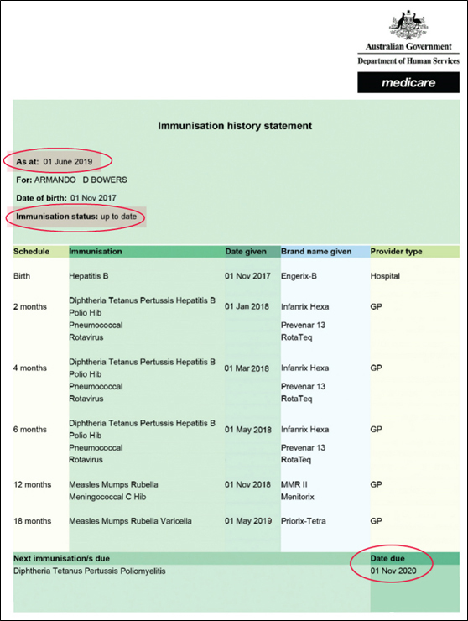

Components of the statement
Note: this example is for illustrative purposes only and may not reflect the current immunisation schedule.
This is an example of an immunisation history statement issued by the Australian Immunisation Register (AIR).
It is made up of the following components:
- Header: displays the Australian Government Department of Human Services – Medicare logo on the right.
- As at: this highlighted section shows the date the statement was issued by AIR (1 June 2019 in the example)
- For: this shows the name of the child (in this case, Armando D Bowers)
- Date of birth: the date of birth of the child (here, ‘01 August 2015’)
- Immunisation status: this highlighted section shows the immunisation status of the child at the date the statement was issued (this example shows the status as up to date)
- Immunisation history table: the table shows the details of scheduled immunisations the child has received. lists the immunisation schedule point, type of immunisation, date given, brand name of the vaccine and provider type (such as. Birth, Hepatitis B, 1 November 2017, Engerix-B, Hospital)
- Next immunisation/s due table: shows the name of the next vaccine that the child is due to receive and the date when it is due. In this example, the next immunisation due is for Diphtheria Tetanus Pertussis Poliomyelitis on 1 November 2020.

Should enrolment proceed?
In this example, Armando’s planned start date is 12 June 2019.
For enrolment to proceed, the date of his next immunisation should be on any date from two months before his start date onwards.
His next immunisation is due on 1 November 2020, so enrolment can proceed.

To receive this document in another format, email the Immunisation Unit, Public Health Division, Department of Health <immunisation@health.vic.gov.au>.
Authorised and published by the Victorian Government, 1 Treasury Place, Melbourne.
© State of Victoria, Australia, Department of Health, August 2021.
Available at: <https://www2.health.vic.gov.au/public-health/immunisation/vaccination-children/no-jab-no-play>

