Mass Casualty and Pre-hospital Operational Response Plan
State Health Emergency Response Arrangements
Version 1 – October 2017

Department of Health

Contents
Revision History 4
1 Introduction 5
1.1 Primary Audiences 5
2 Actions for those first on the scene 6
2.1 Role of community members in health response 6
2.2 How to get health and medical specialists on scene 6
3 Incident tier roles and structure 7
3.1 Incident Health Commander 7
3.2 Hospital Commander 7
3.3 Incident tier Health Incident Management Team 7
3.4 Multiple/complex sites 8
4 Incident Response 9
4.1 Notification 9
4.2 Scene management 10
4.3 Receiving facilities 17
4.4 Transport 18
4.5 Documentation 19
5 Review period 20
6 Related documents 20
Appendix A: Key SHERP Pre-hospital organisations 21

Revision History
Version | Date | Revisions | Status
0.1 | 15/09/2017 | Initial Draft | Not approved
1.0 | 27/09/2017 | Version 1 | Endorsed

Introduction
This Mass Casualty and Pre-hospital Operational Response Plan Operational Response Plan supports the effective functioning of the State Health Emergency Response Plan, Edition 4 (SHERP4) by providing further detail about the pre-hospital response during emergencies, This plan focusses primarily on managing health emergencies at the incident tier.
The Mass Casualty and Pre-hospital Operational Response Plan and SHERP4 form part of the State Health Emergency Response Arrangements, the framework through which the Victorian Government and partner agencies work together in order to meet the health needs of Victorians during emergency events.
This document should be read in conjunction with SHERP4

Primary Audiences
The following organisations are identified as the primary audiences for this Operational Response Plan
- Ambulance Victoria
- Department of Health and Human Services
- Field Emergency Medical Officers
- Victorian Medical Assistance Teams
- St John Ambulance Australia
- Life Saving Victoria
- Chevra Hatzolah
- Metropolitan Fire Brigade – Emergency Medical Response Program
- ARV – Adult Retrieval Victoria
- PIPER, incorporating:
    - PETS – Paediatric Emergency Transport Service
    - NETS – Newborn Emergency Transport Service
    - PERS – Perinatal Emergency Referral Service

Additional organisations can be found in Appendix A: Key SHERP organisations

Actions for those first on the scene
Community members, paramedics, first aid agencies, police, firefighters or other emergency officers will often be the first people at the scene of an emergency incident.

Role of community members in health response
The community plays a vital role in life-threatening emergencies. Concepts such as the ‘chain of survival’ in response to cardiac arrest demonstrate that immediate community response increases the chances of saving lives.
In a mass casualty setting the community response can be critical to good patient outcomes.

What can a community member do in response to a health emergency?
- Ensure they and those around them are safe.
- Call triple zero for further assistance for life-threatening emergencies.
- Render assistance to the best of their ability.
- Hand over care for the patient to health response agencies when they arrive.
  - Assist the health response agencies if requested.

What if they already have some training or are a healthcare professional?
- They must tell the health responders of their training.
- They must be prepared to verify their credentials.
  - They must take direction from the health responders

How to get health and medical specialists on scene
SHERP provides a range of health and medical specialists to be responders to an incident.
The Incident Health Commander is responsible for requesting these specialists by notifying the Regional and/or State Health Commander.
If an Incident Health Commander has not yet arrived, those at the scene should inform the Ambulance Communications Centre of any special needs of the incident. The public can do this by calling triple zero (000).
Health and medical specialists come from a range of nominated agencies (see Appendix A) and include:
- health commanders
- paramedics
- first aiders
- medical practitioners
- medical teams
- public health workers
  - psychological support staff.

Incident tier roles and structure

Incident Health Commander
The Incident Health Commander is a nominated ambulance manager (unless otherwise appointed by the State Health Emergency Management Coordinator). They report to the Regional Health Commander and are responsible for overseeing and directing the operational health response to an emergency.
The Incident Health Commander may form an Incident tier Health Incident Management Team (I-HIMT) and liaise with Hospital Commanders to coordinate a whole-of-health response to an emergency at the incident tier.
Incident Health Commanders work with the Incident Controller and the Incident Emergency Management Team to develop the health strategy and contribute to the incident strategy.

Hospital Commander
For the purposes of SHERP the term Hospital Commander is used to identify the chief executive officer or delegated member of staff who leads the health service response under their site-specific response plan for external emergencies (known as a Code Brown plan). The Hospital Commander leads the Hospital Incident Management Team (HoIMT).
Hospital Commanders are responsible to their organisation’s chief executive and board but also have a reporting relationship to the Regional Health Coordinator during an incident. Hospital Commanders will also participate as a member of the I-HIMT and liaise directly with the Incident Health Commander.
Additional information about hospital emergency management functions can be found in the Code Brown Guidelines

Incident tier Health Incident Management Team
At the incident tier, the Incident Health Commander will form an I-HIMT composed of themselves and Hospital Commanders from affected facilities.
Consistent with IMS principles, as an incident increases in size or complexity the Incident Health Commander may choose to delegate the functions of operations, planning and logistics to appropriate personnel available at the incident tier.
In the health setting, the operations function will be formed with each of the health functions required at the incident. Generally, each function will be represented by the Commander of the agency providing the function (see Figure 1).
The I-HIMT may also have a liaison from the Control Agency’s IMT logistics team (or medical services unit) to ensure a joined-up approach to health delivery across the incident site.
For smaller incidents, all IMS functions may be undertaken by the Incident Health Commander. The I-HIMT may operate remotely through telecommunications, or within a facility or a mobile health command post.
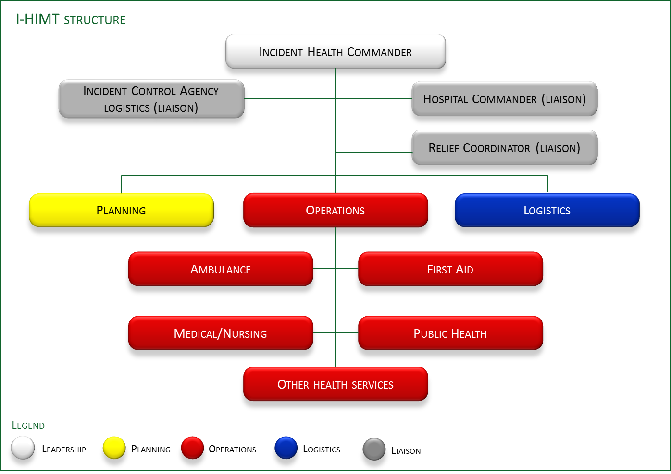
Logistics
Planning
I-HIMT structure
Leadership
Planning
Operations
Logistics
Legend
Liaison
Incident Control Agency logistics (liaison)
Hospital Commander (liaison)
Relief Coordinator (liaison)
Other health services
Public Health
Medical/Nursing
Ambulance
First Aid
Incident Health Commander
Operations
Figure 1 - Example I-HIMT

Multiple/complex sites
The HIMT must also consider the ‘span of control’ of single or multiple sites (or functions).
Span of control is the practical limit of the resources and issues that one person can effectively manage.
It may be necessary to appoint Sector or Divisional Health Commanders to support the Incident Health Commander if an incident has a number of sites or a number of health functions. For example:
- a complex terrorist attack with multiple sites
- a widespread flood affecting a number of health facilities
  - a mass casualty incident involving many health agencies.
In such cases the Incident Health Commander will be in close contact with the Incident Controller and the EMT. Each Sector/Divisional Health Commander will inform the Incident Health Commander of the specific requirements of each site or function, to ensure appropriate targeting of health resources (Figure 2).
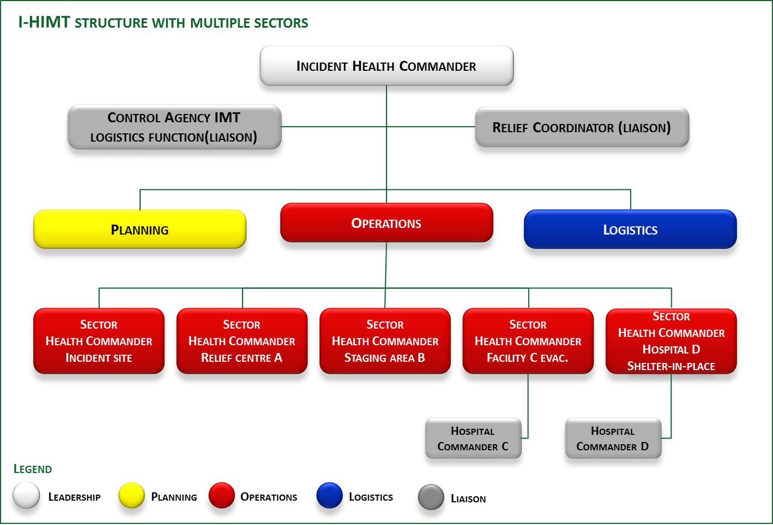
Figure 2 – Example I-HIMT structure with multiple sectors

Incident Response

Notification

Format of notification
All notifications, requests for assistance and updates within SHERP should follow the format described by the mnemonic ‘ETHANE’:
- Exact location
- Type of incident
- Hazards
- Access and egress
- Number of patients
- Emergency services at scene or required.

Notification for Health Commanders
When notified of an incident, Ambulance Victoria will make an assessment of the incident based on the available information and deploy an Incident Health Commander to the scene if necessary. As part of this process the Regional Health Commander will be notified and, for significant incidents, the State Health Commander.

Scene management

Safety
By their nature, incident sites may have a range of hazards. Safety is paramount.
As a general rule, all health responders are responsible for their own personal safety and, where possible, that of people under their care. Each agency or organisation is also responsible for ensuring the safety of their personnel and people under their care.
In addition the Incident Health Commander has overall responsibility for the safety of health responders and the people under their care. The Incident Health Commander will work with the Incident Controller and the EMT to ensure the safety of all those at the scene.
Of particular note to health responders is the issue of contamination and correct use of personal protective equipment. For further information on decontamination see the DHHS’s Decontamination guidance for hospitals.

People management
Incident sites can be chaotic, with numbers of dead, injured and uninjured people. Three key groups are evident:
- people with physical injuries (including the dead)
- people with little or no physical injuries but who may be affected by the event
  - people electing to leave the scene prior to the arrival of emergency services or during the triage process. These people may self-present at hospitals or general practitioners’ clinics, or simply return to their community.
Note that the deceased are left in situ for the coroner (or Victoria Police acting on behalf of the coroner) to process.

Triage
Triage ensures that limited patient management resources are directed to achieve the greatest good for the most number of people. It seeks to prioritise patients by clinical severity and optimise outcomes during times of severe resource constraints. Triage is a continuous process that needs to be repeated frequently. It also provides pre-hospital personnel with guidelines for assigning treatment and transport priorities. Initial triage by health responders will ‘sieve’ people into the following priorities:
Triage priority | Code |  | Comment
Priority 1 | Red |  | Transport priority; move to a casualty clearing point
Priority 2 | Yellow |  | Delayed transport; move to a casualty clearing point
Priority 3 | Green |  | Walking wounded, potential to discharge at scene; move to a casualty clearing point
Survivor | Grey |  | Not injured, potential for psychological support; move to a relief centre
Dead | Black |  | No treatment; leave in place for the coroner

Following initial triage and movement to a casualty clearing point, a secondary triage is undertaken (when resources allow) to ‘sort’ patients based on a more detailed physiologic assessment. Most triage systems result in most children being triaged higher – that is, more serious – than their physiological conditions warrant. In situations where a small number of children are affected, this will result in them being removed from the scene faster and is considered good practice. However, where scenes involve a large number of children, the triage method needs to be modified to prioritise among them.
Some people may elect to leave the scene prior to triage and it may be difficult to contact them for further follow-up, if required. Where possible, agencies should emphasise the importance of the triage and registration process for all people affected by the incident.

Casualty clearing point
An effective way of organising a scene is to establish a casualty clearing point where patient management activities can be aggregated. For large or complex scenes, multiple casualty clearing points may be required.
Establishing casualty clearing points is the responsibility of the Incident Health Commander.
Some key principles are listed below:
- Ensure the site is located safely away from the hazard.
- Provide sufficient space.
  - Minimise the exposure of low-priority patients to the dead and severely injured.
Figure 3 describes the flow of people from an incident site to appropriate receiving facilities.
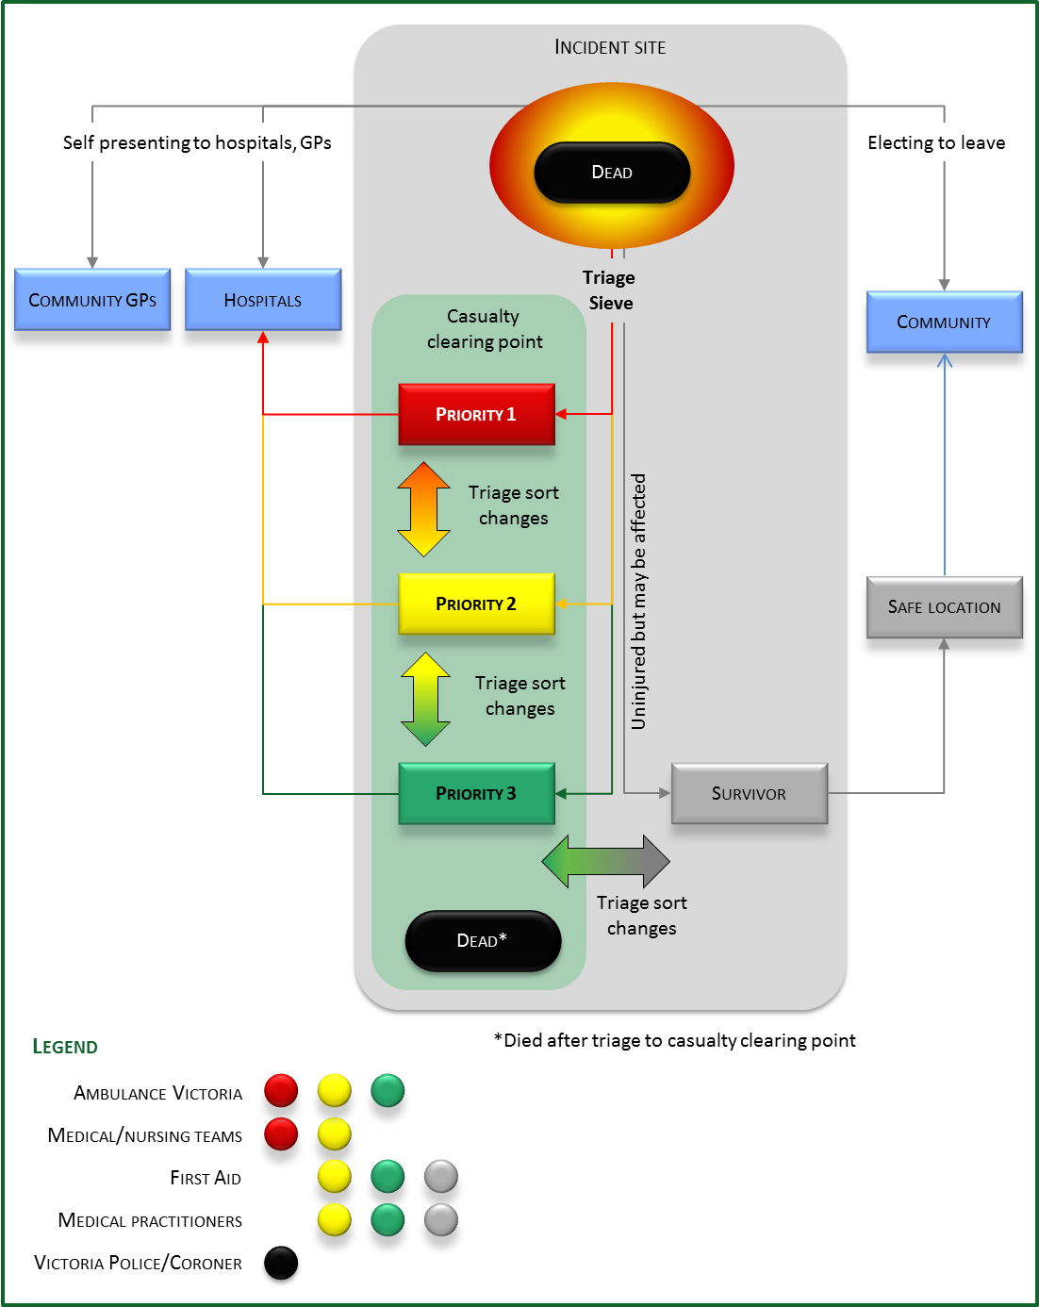
Figure 3 - Scene management

Psychosocial response

Introduction
Emotional reactions are a normal response to the distress and trauma associated with an emergency. They can occur regardless of whether an individual sustains any physical injuries. The stress associated with an emergency event equally affects children and adults and any response needs to include working with children. Some people may be at risk of serious, long-term psychological disorders, and research suggests lack of post-event support may be a significant risk factor in these outcomes. The literature stresses the need for immediate psychosocial support alongside and integrated with the incident response.

Responders’ role
Everyone involved in responding to an emergency can have a positive impact on helping people’s emotional and physical recovery by using the proven psychological support principles, which are: ensuring people feel safe; helping people to help themselves, keeping families and groups together; being calm and hopeful; preserving privacy and dignity; and facilitating early access to physical, emotional support. Through the use of these simple actions, health and medical responders will help people positively recover and reduce the likelihood of longer-term psychological impacts.
Whenever possible, people who are not triaged for medical treatment should be directed to a safer area, away from exposure to the immediate noise and direct viewing of the incident scene. They should not be left unattended. As resources become available, personal support teams should be activated to provide psychological support and other forms of personal support. Providing psychosocial support is as important for the uninjured as it is for the injured.

Activation arrangements for personal support, including psychological support
Personal support and psychological support arrangements are documented within municipal emergency management plans as a part of the local relief and recovery arrangements. At both the regional and the state levels, these arrangements are documented in section 4 of the EMMV.
Relief and recovery plans describe a range of services that can be activated in response to an event to assist with relief and recovery. Emergency relief can help to provide shelter, water, food and psychological support. The local municipal emergency management plan will detail the agencies responsible for providing personal support.
Health and medical personnel at the scene of the emergency should alert the Incident Health Commander as soon as they identify the need for personal support and psychological support. Providing early access to personal support is vital and it should be activated early if it is likely the event scene will not be quickly settled.
The Incident Health Commander should liaise with the Incident Controller, who has the primary responsibility for activating emergency relief services. The Municipal Emergency Response Coordinator (Victoria Police) will liaise with the Municipal Emergency Resource Officer or the Municipal Recovery Manager to coordinate relief services at the site if it is safe to do so, or at a nearby location.
The Emergency Response Coordinator is responsible for transporting individuals from the scene to an established emergency relief centre if this is required.
For patients who are transported to hospital it is important that hospitals recognise and plan for responding to the psychosocial support needs of the uninjured family or friends who may attend the hospital as well as attending to the health and emotional needs of the admitted patients.
Local governments will work with response agencies to ensure community relief needs are identified and recovery plans are developed to address the psychosocial support needs of individuals and communities in the short, medium and longer term.

Personal support and psychological support
A key focus of psychosocial support in the early stages of an emergency is providing personal support to affected individuals. Personal support is the provision of information, practical assistance, emotional support, assessment of immediate needs and referral to other support agencies and services as required. Relief agencies such as Red Cross and non-government organisations including the Victorian Council of Churches (VCC) have volunteers trained in psychological support who can be activated through municipal emergency management plans. Red Cross and the VCC can be deployed at short notice to relief centres or incident sites where it is safe to do so. Agency personnel undertake roles as defined in the municipal emergency management plan, which include providing psychological support and other emergency relief services.

Management of trauma
The Victorian state trauma system4 facilitates the management and treatment of major trauma patients in Victoria. The system aims to:
- reduce preventable death and permanent disability
  - improve patient outcomes by matching the needs of the injured patient to an appropriate level of treatment in a safe and timely manner.
The system works to have ‘the right patient delivered to the right hospital in the shortest time’.
Early activation of the trauma system is required to optimise response capacity.
The Victorian Trauma triage guidelines provide direction and criteria for all health workers involved in assessing patients against the definition of a major trauma patient, and the necessary action required.
Where resources permit, all trauma casualties at SHERP incidents should be treated according to these guidelines.
Specialist medical and nursing field responses should be used if it is likely transfer of major trauma patients will be delayed, or if specialised intervention is required. Any practitioners deployed should have appropriate qualifications, experience, training and be credentialed.

Management of burns
Optimal care for severe burn injuries is best delivered in specialist burns units. Victoria has two specialist burns units: at The Alfred (adults) and The Royal Children’s Hospital (paediatric). The Trauma triage guidelines provide direction and criteria for all health workers involved in assessing patients with burns, and the necessary action required.
Incidents involving multiple burn casualties follow the underlying principles of the state trauma system. The initial assessment and stabilisation of burns patients should follow the Victorian state burns clinical practice guidelines in consultation with the on-call Major Trauma Service Burns Consultant.
If the incident involves multiple burn casualties, burns patients should be stabilised and transferred to specialist burns units as soon as practicable.
Specialist medical field responses should be used if it is likely that transfer of major trauma patients will be delayed, or if specialised intervention is required.
If five or more severe burn casualties are anticipated, activate the systems described in the Multiple Burn Casualties Protocol as early as possible to ensure limited burns management resources are used effectively.

Management of children
Children have different physiological, psychological and developmental needs and the type of care they require in an emergency will depend on their stage of life. The priorities in managing children in emergencies are to protect them from further harm, treat injuries, minimise psychological trauma and where possible prevent their separation from family.
The availability of paediatric professionals, equipment and drugs, and the appropriate triaging of children, should be a priority when planning for medical emergency response. There are different approaches to triage depending on the number and proportion of injured children.
Immediate psychological support is required for children affected by an emergency. Contributing factors for psychological distress in emergencies can include: displacement; death within the immediate family and friends; house damage; and distressing sights and sounds directly or through the media.
Separation from family significantly increases the psychological impact on children. The level of vulnerability increases in children and young people if the adults who support them are also affected by the emergency. It is important to keep children with their families if possible. If children are separated from their families or guardians, they should be reunited as quickly as possible.
During mass casualty incidents involving large numbers of children, ensure the needs of children are considered and given priority within the health incident strategy. This should include improving the wellbeing of children at the incident by providing direct care and promoting the needs of children and those children with special needs.

Management of evacuation/relocation

Evacuation
The Incident Controller is responsible for issuing a recommendation to evacuate communities and the Evacuation Manager from Victoria Police is responsible for managing the planning and operational aspects of community evacuation during an emergency as described in the evacuation guidelines in the EMMV.
The role of the Incident Health Commander is to work with the Incident Controller, Evacuation Manager and Hospital Commanders to:
- provide health and medical strategic advice to the Incident Controller and Evacuation Manager
- oversee health and medical support to evacuating communities
- oversee health and medical support at emergency shelters (including emergency relief centres)
- manage the withdrawal and return of identified vulnerable people from health and aged care facilities
  - support the withdrawal and return of identified vulnerable people who have health-related needs.

Facility relocation, shelter in place and evacuation
The chief executive officer or person with delegated authority for health services, hospitals and residential aged care services is responsible for determining the decision to relocate, shelter in place or evacuate the facility.
These services must work with the Incident Controller, Evacuation Manager, Incident Health Commander and Regional Health Coordinator (or State Health Coordinator in metropolitan areas) to decide on the appropriate course of action for their facility. They will notify their decision to the Regional Health Coordinator (or State Health Coordinator in metropolitan areas)
Once the decision is made and notified, services will then work with the Incident Health Commander to implement their plan.
Health services, hospitals and residential aged care services should have an emergency management plan. They should make sure it can be activated and implemented onsite so it can inform decisions to relocate, shelter in place or evacuate. The emergency management plan should be reviewed and updated regularly with the involvement of local emergency service organisations.
Residential aged care services have a responsibility under Commonwealth legislation and are accountable to the Australian Government Department of Social Services to have emergency management plans in place, to exercise informed decision making and to take responsibility to protect the health and safety of residents and staff.
For further information please see the EMMV Part 3 and Part 8 Appendix 9, which provides details on the evacuation process and also the Relocation, shelter in place and evacuation guidance note

Field resources

Managing spontaneous volunteers
When health agencies arrive at an incident, spontaneous volunteers may already be actively assisting patients. Once they have handed over their care to responders, spontaneous volunteers may be able to assist in a range of activities, with or without specific qualifications. Spontaneous health and medical volunteers are not part of any agency response and will require registration and checking of credentials before assisting in the health response.
Victoria Police is responsible for volunteer registration and the Incident Health Commander (or delegate) will be responsible for checking credentials and task deployment. Volunteers will be specifically tasked under the command of a health agency within the HIMT.

Ambulance
Ambulance services will usually be the first health agency on the scene and provide immediate triage, treatment and transport. They will also coordinate communications between different parts of the health response.
The role of ambulance is to:
- provide appropriate skills and equipment for various health emergencies, including mass casualty and complex incidents
- triage casualties and provide first aid and advanced treatment
- provide the most effective transportation for casualties to appropriate medical care
- assist with coordinating medical teams
- provide health support to other agencies, where appropriate
  - provide medical support to casualties undergoing decontamination.
A description of role of Ambulance Victoria may be found in the Agency and role statements appendix

First aid
First aid agencies under SHERP provide trained first aid teams at incident sites, casualty clearing points and relief centres – or as otherwise directed by the Incident Health Commander. Their role is to provide initial treatment and basic care at these sites.
Services and resources provided may include:
- trained first aid officers to assist with site triage, initial treatment and resuscitation of casualties and ongoing care
- trained advanced-level first aid officers, capable of providing defibrillation, oxygen resuscitation and limited drug therapy
  - portable first aid supplies and other patient care equipment that is easily transported in a vehicle, trailer and kit form, for establishing first aid posts.
A list of SHERP first aid agencies may be found in the Agency and role statements section.

Medical and nursing
A range of medical and nursing resources are available to be deployed to an incident site. The Incident Health Commander will assess the requirement for medical support and resources. This assessment should be based on the clinical needs of those affected and the clinical skillsets available onsite and their ability to meet the Trauma triage guidelines.
Medical and nursing resources are required at a scene where:
- transport will be delayed and extended care is required in the field
- a patient is unable to be moved and specialist clinical skills are required
- the Incident Health Commander requires support in undertaking patient distribution
- there are large numbers of patients who require specialist expertise (such as children)
  - there are large numbers of low-acuity patients who could be discharged from the scene after medical assessment.
The options available include:
- organised, experienced emergency clinicians
- organised medical teams containing a range of medical and nursing personnel
  - local medical practitioners.
A list of SHERP medical and nursing programs may be found in the Agency and role statements section.

Public health
Public health is concerned with maintaining the health of the population and seeking to reduce the incidence of disease, premature death and disability.
When DHHS is not the incident Control Agency, early involvement of this support may help protect health and contribute to risk communication strategies for the community.
A public health officer may attend an incident in support of SHERP to provide public health expertise to the HIMT and EMT. The public health officer can provide technical advice and community support without attending the incident, and can advise on recovery processes.
The public health arrangements may be activated by the Regional or State Health Coordinator in liaison with the Health Commander.

Emergency relief
Emergency relief may be needed at the site of the emergency to provide safety, shelter, water, food and psychological support. It may also include registering affected individuals, which is the responsibility of Victoria Police and Red Cross.
Emergency relief is time-critical and health and medical responders must consider the need for relief services at the scene and alert the Incident Health Commander when it is required. If necessary, the Incident Health Commander will activate relief arrangements through the Incident Controller.
Local governments will work with response agencies to ensure community relief needs are identified and appropriately met.
The Emergency Response Coordinator is responsible for transporting individuals from the scene to an established emergency relief centre if this is required.

Registration and information collection
Two separate registration and information collection processes can be established in an emergency, each with a distinct purpose. Health agencies must be prepared to accommodate these processes. The information gained may also inform any ongoing psychosocial support programs.
Register Find Reunite
Reconnecting people with family and friends affected by an emergency is facilitated through the Register Find Reunite service (formally known as the National Registration and Inquiry System or NRIS). Victoria Police is responsible for activating the service; Red Cross manages and operates the system. Registration commences during the response phase of an emergency, continues through relief efforts, and can be used to inform recovery.
Registration can occur at an emergency relief centre, online at the Red Cross website or via a call centre (State Inquiry Centre). The service can also operate at an emergency site/staging area or, in some cases, at a hospital. Register Find Reunite collects information about an individual’s home address, contact details and their intended destination.
For planning purposes, further information on this service can be obtained from the Emergency relief handbook: a planning guide.
Relief centre registration
When establishing an emergency relief centre, municipal councils may set up a system for recording the details of everyone who attends the relief centre. Contact details and preliminary information about the person’s relocation plans will be collected. The council will use this information to develop a recovery plan including scheduling outreach visits to affected communities and for individual follow-up.
Register Find Reunite and relief centre information collection should be coordinated to reduce the need for people to repeat basic personal information to different agencies.

Receiving facilities

Primary healthcare
Local medical practitioners (including general practitioners) play an important support role in Victoria’s overall ability to respond to emergencies. Medicare Locals may also be involved. Within clinics/practices medical practitioners:
- may assist hospitals in managing clinical surge demands as a result of an emergency
- provide clinical care for self-presenters resulting from an emergency, such as walking wounded and individuals who have no physical injuries but have psychological trauma or distress
- provide primary treatment and care for their local community
  - provide clinical assistance with patients referred from hospital to home-based care.

Short-term clinics
Additional general practice and nursing services may be provided in affected areas to help support people affected by emergencies. These services are established by the practitioners themselves and are not necessarily linked to the government response efforts.
General practitioners and nurses providing these valuable services are urged to link in with the Incident Health Commander to ensure coordination. Clinics are also advised to link in with coordinating bodies, such as Rural Workforce Agency Victoria (RWAV), General Practice Victoria (GPV), Medicare Locals, the Royal District Nursing Service (RDNS) or the Australian Government Department of Social Services, to ensure appropriate services are provided. This coordinated effort will also form part of discussions between state and Commonwealth governments in planning appropriate responses.

Field primary care clinics
In major emergencies, communities may have reduced access to primary healthcare due to medical infrastructure damage, incapacity of usual medical practitioners, increased demand for medical services, loss of personal transport or limited capacity to leave the immediate vicinity.
If additional primary healthcare is needed, a field primary care clinic (FPCC), or a Community Health Assessment Centre (CHAC) can be established and staffed by registered medical practitioners, nurses and paramedics.
The State Health Emergency Management Coordinator is responsible for authorising the activation of an FPCC or CHAC.
Once authorised by DHHS, the S-HIMT is responsible for the operational deployment of the FPCC. The ambulance section will deploy infrastructure and supporting logistical resources. The primary care section will supply health professionals.
Management of an FPCC or CHAC is the responsibility of the Incident Health Commander, who may appoint a Sector Health Commander to manage an FPCC or CHAC. Clinics will operate within appropriate safety and clinical governance guidelines.

Hospitals and health services
The health service will appoint a Hospital Commander who will oversee all aspects of the incident and establish a key contact point for all incoming and outgoing communications.
Public health services may also form partnerships with private hospitals to assist in such functions as emergency decanting of patients. Additional requests for assistance from the private hospital sector will be coordinated through the Regional or State HIMT.

Transport

Patient distribution from a scene
Under normal circumstances, healthcare workers have established, autonomous methods determining appropriate definitive care and patient referral. In order to maximise the effectiveness of patient transport services and minimise the impact across the health network, patient distribution needs to be managed by the Incident Health Commander with support from the I-HIMT.
The Ambulance Victoria State Communications Centres have routine, direct communication with hospital emergency departments. For smaller level 1 and 2 incidents, they can provide the Incident Health Commander and I-HIMT with information on hospital capacity and capability for use in planning and distribution. The medical and nursing section of the I-HIMT may also be tasked with gathering information on hospital capacity and capability.
For level 3 incidents at the state tier, the Health incident consequence tool may be activated to support the state HIMT in determining high-level patient distribution. It is important that there is good coordination and transition of hospital information from the Ambulance Victoria State Communications Centre to the HIMT at the incident, regional and/or state tiers.
For level 2 and 3 incidents, medical practitioners, short-term clinics and FPCCs should also be considered in patient distribution.
The following criteria are taken into account when distributing patients:
- patient numbers and complexity
- percentage occupancy at the destination hospital
- time to the destination
- transport resources
- type of injuries
  - special needs patients.

Secondary transfer between health service
Secondary transfer occurs if a patient is admitted to a hospital from the scene but is then transferred to another hospital. The three main reasons for requiring secondary transport are:
- to increase capacity
- to provide patients with critical care facilities
  - to provide patients with specialist medical expertise.
If this situation occurs, the hospital will follow its normal procedures for inter-hospital transfers.
Where specialist medical expertise is required, the following agencies may be engaged:
- ARV – Adult Retrieval Victoria
- Paediatric Infant Perinatal Emergency Retrieval (PIPER), comprising –
    - PETS – Paediatric Emergency Transport Service
    - NETS – Newborn Emergency Transport Service
    - PERS – Perinatal Emergency Referral Service.
If an emergency incident is likely to impact on multiple health services and there is more than one patient for inter-hospital transfer, the decision-making process will be coordinated by S-HIMT in collaboration with the specialist services listed above. This will take into consideration the capacity and capabilities within Victoria and other jurisdictions, as well as available specialist transport.
During a mass casualty incident, there can be a range of extraordinary issues that hinder the normal modes of patient transportation and this can affect the timely discharge of patients to home or to a neighbouring facility. The extent of the issues will be determined by the nature of the incident but may include road closures, traffic congestion and lack of ambulance vehicles. Plans for transport vehicles to access and exit from the hospital should also be determined to mitigate congestion.

Documentation

Logs
A full contemporaneous record of events, decisions and actions taken is essential for managing the incident, handover between teams, debriefing, and for inquiries after the incident. It is essential that incident logs are maintained by those managing the incident.
Logs:
- keep a record of all issues
- maintain a date and time record of all actions, requests and decisions made
- communicate key issues – outstanding and completed
  - provide a record of the incident response that may be used after the incident.

Situation reports and action plans
Situation reports and incident action plans are used to manage information and ensure actions meet the overall incident objectives.
Health services may need to submit a situation report to the Department of Health that describes health service capacity and bed status to inform development of the state health incident strategy.

Review period
This Operational Response Plan should be reviewed following a significant health incident or emergency response, or after 3 years

Related documents
- State Health Emergency Response Plan, Edition 4
- Multiple Burn Casualties Protocol
- Trauma Triage Guidelines
- Regional Health response Operational Response Plan
- Victorian Medical Assistance Team Policy
  - Victorian Medical Assistance Team Protocol

Appendix A: Key SHERP Pre-hospital organisations
Function | Organisation
State Health Emergency Coordination | Department of Health and Human Services
Health Command | Ambulance Victoria
Health coordination | Department of Health and Human Services
Public Health Command | Department of Health and Human Services
Ambulance | Ambulance Victoria
Medical and nursing – command | Field Emergency Medical Officer (FEMO)
Medical and nursing – teams | Victorian Medical Assistance Teams (VMAT)
Medical and nursing –other personnel | Medical practitioners and nurses as credentialled by FEMO onsite
First aid | St John Ambulance Australia  Life Saving Victoria  Chevra Hatzolah  Metropolitan Fire Brigade – Emergency Medical Response Program  Country Fire Association
Psychological support | Department of Health and Human Services  Local Government Authorities
Public health | Department of Health and Human Services  Local government authorities  Water Authorities
Emergency relief | Emergency Management Victoria  Department of Health and Human Services
Hospitals | Public health services  Private hospitals
Secondary transfer ARV – Adult Retrieval Victoria | PIPER, incorporating:  • PETS – Paediatric Emergency Transport Service  • NETS – Newborn Emergency Transport Service  • PERS – Perinatal Emergency Referral Service

Organisation Ambulance Victoria – Health Co

Organisation | Ambulance Victoria – Health Commander
Functional area | Health Commander
Reports to | - Higher tier Health Commander - within SHERP  - Controller - through the Emergency Management Team  - Emergency Response Coordinator - through the Emergency Management Team
Subordinates | - Health Incident Management Team  - Subordinate Health Commander(s)
Activation | - Primary response - usually via triple zero 000
Resilience activity summary | - Support the Department of Health in resilience activities as required
Response summary | - Deploy a Health Commander to direct the operational health response, assemble and lead the Health Incident Management Team  - Represent health as a member of the Emergency Management Team  - Activate other key SHERP position holders or mobile specialist teams  - Initially notify casualty-receiving hospitals  - Support the Evacuation Manager in evacuating vulnerable people
Recovery summary | - Support the Controller as requested  - Support other agencies tasked with recovery, where appropriate
Incident tier role | - Operates to support the Incident Controller  - Is a member of the Incident tier Emergency Management Team (IEMT) as the Functional Commander for pre-hospital response  - Provides regular situation reports to the Regional Health Commander including requests for activating health support agencies, including:  - ambulance personnel and equipment  - medical, nursing and first aid personnel  - patient, personnel and equipment transport vehicles  - notifying hospitals  - Assesses the requirement for emergency relief, including psychological support at the scene and notifies the Incident Controller through the IEMT to activate  - Assumes command of the health and medical function of the emergency at the incident tier  - Forms and provides leadership for the Incident tier Health Incident Management Team (I-HIMT)  - In consultation with the I-HIMT, develops the health strategy for inclusion in the incident strategy via the IEMT  - Oversees (with police assistance) registration and deployment of spontaneous health volunteers  - Is responsible for distribution of casualties  - Monitors practices relating to occupational health and safety of all responding health personnel involved in the emergency
Regional tier role | - Refer to the Regional Health response Operational Response Plan
State tier role | - Refer to SHERP4

Organisation | Ambulance Victoria
Functional area | Ambulance
Reports to | - Health Commander
Subordinates | - Ambulance personnel
Activation | - Primary response - usually via triple zero (000)
Resilience activity summary | - Provide appropriate pre-hospital leadership, skills and equipment through planning for various health emergencies, including mass casualty incidents  - Active participation and representation in emergency management forums and exercises to maintain a high level of preparedness for all emergencies, including mass casualty incidents  - Promote community resilience through community education programs
Response summary | - Respond to requests for pre-hospital emergency care  - Triage casualties and determine treatment priority  - Transport casualties to appropriate medical care  - Provide health support to other agencies, where appropriate  - Provide health support to casualties undergoing decontamination
Recovery summary | - Support the Controller as requested  - Support other agencies tasked with recovery, where appropriate
Incident tier role | - Provides management resources to take on the health command role - see organisational statement ‘Ambulance Victoria – Health Commander’)  - Is a member of the Incident tier Health Incident Management Team (I-HIMT)  - Provides leadership for the ambulance function  - Provides ambulance advice to the I-HIMT  - Assesses credentials and manages spontaneous ambulance volunteers  - Provides assistance with determining an appropriate distribution of casualties  - Triages casualties and determines treatment priority  - Provides pre-hospital care  - Transports casualties to appropriate medical care  - Provides health support to other agencies, where appropriate  - Provides health support to casualties undergoing decontamination
Regional tier role | - Refer to the Regional Health response Operational Response Plan
State tier role | - Refer to SHERP4

Organisation | Chevra Hatzolah
Functional area | First aid
Reports to | - Health Commander
Subordinates | - Nil
Activation | - Primary response – via contact to the Hatzolah emergency number (03) 9527 5111  - In support, via the State health Incident Management Team - usually via the State Health Commander in consultation with the State Health Coordinator
Resilience activity summary | - Ensure all Hatzolah personnel are provided with the skills and expertise necessary to provide first aid services at a major incident  - Promote community resilience through community education program
Response summary | - Be a support agency for providing first aid services to the public  - Provide response, resources and first aid teams at incident sites, casualty collection posts and relief centres as directed by the Incident Heath Commander
Recovery summary | - Support the Incident Health Commander as requested
Incident tier role | - Provides pre-hospital care  - Provides first aid teams to assist at incident sites, casualty clearing posts and relief centres as directed by the Incident Health Commander
Regional tier role | - Supports the Regional Health Commander
State tier role | - Supports the State Health Commander

Organisation | FEMO
Functional area | Medical and nursing
Reports to | - Health Commander – all tiers
Subordinates | - Subordinate FEMOs  - Medical assistance teams  - Medical practitioners  - Other medical and nursing personnel
Activation | - State Health Incident Management Team - usually via the State Health Commander in consultation with the State Health Coordinator
Resilience activity summary | - Engage local medical and nursing resources in preparation and planning  - Maintain awareness of local medical and nursing capacity, capability and availability  - Facilitate training and exercise of local medical and nursing personnel
Response summary | - Health Incident Management Team member  - Provide command role for medical and nursing function  - Provide information on local medical and nursing resources - including health services)  - Provide clinical advice
Recovery summary | - Support the Health Commander as requested.
Incident tier role | The FEMO:  - is a member of the Incident tier Health Incident Management Team (I-HIMT), reporting to the Health Commander  - provides leadership for the medical and nursing function  - provides advanced medical and clinical advice to the I-HIMT  - assesses the need for additional medical and nursing support to the incident  - advises on local medical and nursing resource capability, capacity and availability  - assesses credentials and manages spontaneous health and medical volunteers  - provides assistance with determining an appropriate distribution of casualties  - may provide advanced medical care to patients  - may refer casualties to alternative care options.
Regional tier role | The FEMO:  - is a member of the Regional Health Incident Management Team (R-HIMT), reporting to the health services section  - provides leadership for the medical and nursing function  - provides advanced medical and clinical advice to the R-HIMT  - assesses the need for additional medical and nursing support at the regional level  - advises on regional medical and nursing resource capability, capacity and availability  - provides assistance with determining appropriate destinations for casualties.
State tier role | The FEMO:  - is a member of the State Health Incident Management Team (S-HIMT), reporting to the health services section  - provides leadership for the medical and nursing function  - provides advanced medical and clinical advice to S-HIMT  - assesses the need for additional medical and nursing support at the state level  - advises on state medical and nursing resource capability, capacity and availability  - provides assistance with determining a strategy for distributing casualties.

Organisation | Life Saving Victoria LSV
Functional area | First aid
Reports to | - Health Commander
Subordinates | - LSV volunteer lifesavers  - LSV employed lifeguards  - Westpac lifesaver rescue helicopters
Activation | - State Health Incident Management Team (usually via the State Health Commander in consultation with the State Health Coordinator) via the LSV State Duty Officer (13 7873)
Resilience activity summary | - Provide minimum and approved first aid equipment standards for all services  - Provide technical and reference manuals, texts, resources and newsletters on water safety, lifesaving, life guarding, CPR and first aid  - Provision of information and education displays at tradeshows and community events  - Provide vocational education and training programs such as lifeguard, first aid, oxygen equipment, and specialist areas such as automatic external defibrillation (AED), pain management, and aquatic and dry spinal injury management
Response summary | Make both paid and volunteer lifesavers and lifeguards available  to support events statewide  • Services proactively provided from 68 locations across Port Phillip  Bay, the Victorian coastline and Mildura (Murray River)  • Provide emergency evacuation centres at the lifesaving  club clubrooms  - • Provide Westpac lifesaver rescue helicopter services statewide
Recovery summary | - Support other agencies as requested, where appropriate
Incident tier role | - Supports the Incident Health Commander in providing first aid and emergency care trained personnel, equipment and facilities
Regional tier role | - Supports the Regional Health Commander
State tier role | - Supports the State Health Commander

Organisation | Metropolitan Fire Brigade
Functional area | First aid
Reports to | - Health Commander via MFB Senior Officer on scene
Subordinates | - Nil
Activation | - Primary response (usually via triple zero)  - State Health Incident Management Team (usually via the State Health  - Commander in consultation with the State Health Coordinator)
Resilience activity summary | - Ensure all MFB first responders have the training, skills and expertise necessary to provide first aid services on a daily basis and at a major incident  - Provide the necessary equipment to enable MFB first responders to provide first aid on a daily basis and at a major incident  - Ensure all MFB first responders are trained in incident management and emergency management  - Skills maintenance in place through providing continuing education sessions held by Ambulance Victoria  - Promote community resilience with awareness of MFB EMS capability through community education programs
Response summary | - Provide emergency medical response to life-threatening emergencies on a daily basis  - Provide teams from 1700 professional firefighters who are trained as first responders with skills in advanced first aid, oxygen therapy and defibrillation  - Provide strategically located MFB primary vehicles that are fully equipped with first aid kits, oxygen therapy kits and semi-automatic external defibrillators  - Support agency for providing advanced first aid services to the public  - Surge capacity to provide triage and emergency medical response in the event of a major incident
Recovery summary | - Support the Health Commander as requested  - Support other agencies as requested and where appropriate
Incident tier role | - Support agency to the Incident Health Commander by providing first aid  - Provides assistance with site triage and additional shelters  - Provides assistance with people management and evacuation  - Command of MFB resources as required
Regional tier role | - Command of MFB first-responder resources to support the Regional Health Commander
State tier role | - Command of MFB first-responder resources to support the State Health Commander

Organisation | St John Ambulance Australia (Victoria)
Functional area | First aid
Reports to | - Health Commander
Subordinates | - St John Ambulance personnel
Activation | - State Health Incident Management Team (usually via the State Health  - Commander in consultation with the State Health Coordinator)  - Via local arrangements with local government authorities
Resilience activity summary | - Promotion and provision of community first aid training through public education in schools, workplaces and to the public  - Improve community readiness through marketing appropriate and cost-effective first aid kits  - Provide onsite consultations with workplaces and community groups to include first aid component within first aid management plans for the prevention of minor injuries  - Provide advice to event organisers with the planning of first aid and medical service delivery at local and major events  - Provide first aiders, first responders and health professionals through a planned and structured response  - Participate in multi-agency emergency management exercises and meetings, maintaining a high level of first aid preparedness for deployment
Response summary | - Support agency for providing first aid services to other emergency service agencies and public  - Provide various levels of trained first aid support statewide  - Provide response and resources within the scope of the first aid support (such as mobile first aid vehicles, first aid/first-responder trained teams
Recovery summary | - Support the Health Commander as requested
Incident tier role | - Reports to the Incident Health Commander  - Provides assistance with site triage  - • Provides first aid care  - • Supports the Incident Health Commander and the community
Regional tier role | - Supports the Regional Health Commander
State tier role | - Supports the State Health Commander

Organisation | VMAT
Functional area | Medical and nursing
Reports to | - Field Emergency Medical Officer (FEMO)
Subordinates | - Nil
Activation | - State Health Incident Management Team - usually via the State Health Coordinator
Resilience activity summary | - Participation in training and exercises  - Maintenance of VMAT clinical equipment  - Maintenance of VMAT personal protective equipment (PPE)  - Maintenance of VMAT deployment process
Response summary | - FEMO will recommend the scale of VMAT response required based on clinical requirements  - Nominated health services will supply a team of up to six medical and nursing personnel with PPE and clinical equipment  - VMAT may provide specialist clinical care to complex trauma patients  - VMAT may provide extended duration care to mass casualties at an incident
Recovery summary | - Support the Health Commander as requested via the FEMO
Incident tier role | - Reports to the Incident tier Field Emergency Medical Officer  - May triage casualties and determine treatment priority  - Provides specialist medical care to individual patients  - Provides extended duration care to mass casualties at an incident  - May refer casualties to alternative care options
Regional tier role | - Nil
State tier role | - Nil

‘Part 12: From science to survival: strengthening the chain of survival in every community’, Circulation 2000;102:I-358-I-370
IMS – incident management system. Part 3 of the EMMV, the State Emergency Response Plan, describes the incident management system used for incident control the IMS principles (management by objectives, functional management and span of control) should be used by all HIMTs
http://www.vicburns.org.au/

