General practice audit of preoperative anaemia report 2019
Blood Matters program

General practice audit of preoperative anaemia 2019

To receive this publication in an accessible format phone 03 9694 0102, using the National Relay Service 13 36 77 if required, or email bloodmatters@redcrossblood.org.au <bloodmatters@redcrossblood.org.au>.
Authorised and published by the Victorian Government, 1 Treasury Place, Melbourne.
© State of Victoria, Australia, Department of Health and Human Services August 2020.
ISBN 978-1-76096-108-4 (pdf/online/MS word)
Available at health.vic.gov.au <https://www2.health.vic.gov.au/hospitals-and-health-services/patient-care/speciality-diagnostics-therapeutics/blood-matters >
(insert design job number in brackets)

Contents
Acknowledgements 6
Background 8
Audit 8
Learning outcomes of audit activity and feedback 8
Method 8
Audit promotion and circulation 9
Results 9
Workshop 11
Discussion 12
References: 13
Appendix 1: Part 1: General practice audit of preoperative anaemia 14
Appendix 2: Part 2: General practice audit of preoperative anaemia 15
Appendix 3: Data collection tool – General practice audit of preoperative anaemia 16
Appendix 4: General practice audit of preoperative anaemia evaluation and QI 17
Appendix 5: Example of results summary provided to reporting GPs 18
Appendix 6: TransfusEd workshop for GPs 22

Acknowledgements
Blood Matters thanks Drs Kunadhasan, Von Wielligh, Esler and Minck for their support and contribution to the audit development and feedback.
We also thank the Victorian Primary Health Networks (PHNs) for their assistance with audit communication by including information in the local PHN newsletters and for running reminder notes, as well as the general practitioners who participated in the audit.
The Australian Red Cross Lifeblood Transfusion Policy and Education Unit made a substantial contribution in their effort to develop the TransfusEd workshop for GPs: ‘Anaemia in primary care’.
Introduction
Anaemia is the most common blood disorder in the world, affecting almost a third of the population (Kassebaum 2016). The prevalence in Australia is between 10–20 per cent, increasing with age (Kassebaum 2014). Even mild anaemia is associated with increased risk of morbidity, hospitalisation and all-cause mortality (Riva et al. 2009). However, it is often overlooked and untreated. A US study found that only 15 per cent of those with anaemia received any treatment, the most common being a blood transfusion (Nissenson 2005), which is also associated with increased morbidity and mortality (Marik and Corwin 2008). Appropriate treatment of anaemia is associated with decreased hospital length of stay and costs (Nissenson 2005, Froessler et al. 2018).
International data consistently shows that approximately 30 per cent of patients scheduled for major elective surgery have preoperative anaemia. Australian data from more than 12,000 patients undergoing elective gastrointestinal, orthopaedic and gynaecology procedures found that 88 per cent were assessed for anaemia, with 4.4 per cent occurring in general practice. Management of this anaemia occurred in 22 per cent, and of these, 13.6 per cent in general practice. Iron studies were performed in 46 per cent of patients (none recorded in general practice), and of those identified with iron deficiency, 49 per cent were managed, 15.5 per cent of these in primary care (ACSQHC 2017).
Patient blood management (PBM) improves patient outcomes by ensuring the focus of the patient’s medical and surgical management is optimising and conserving the patient’s own blood, thus minimising unnecessary blood transfusion. The National Blood Authority (NBA) PBM guidelines module 2: perioperative (2012) reinforces the importance of appropriate preoperative anaemia assessment and management. PBM is now incorporated in the Australian Commission on Safety and Quality in Health Care (ACSQHC) National Safety and Quality Healthcare Standards.
General practitioners (GPs) have an integral role to play in recognising, investigating and treating anaemia and iron deficiency in the community, including for patients considered for major surgery where there is risk of substantial blood loss (Minck et al. 2013). Such patients need to be investigated for iron deficiency and to have iron stores replenished to replace haemoglobin lost during surgery. Approximately 30 per cent of patients referred for major elective surgery will have preoperative anaemia.
Minck et al. (2013) developed a guide outlining the ways in which GPs can contribute to patient blood management. This included promoting awareness, identification, investigation and management of patients with or at risk of anaemia, and assessing the adequacy of iron stores in patients undergoing planned procedures in which substantial blood loss is anticipated. The article included a template based on the NBA PBM guidelines module 2, clearly detailing the preoperative tests required to assist with the assessment and management of preoperative anaemia and suboptimal iron stores.

Background
Through the Blood Matters Advisory Committee, concern was expressed over the perceived lack of patient preparation in the community prior to surgery. The article published by Le Calvé et al. (2017) looks at GP attitudes to anaemia and transfusion. In the past, the Blood Matters program has found GPs a challenging group to engage directly. However, as we had support from clinicians with both GP and education experience, it was decided the program would undertake an audit due to the importance of the topic and this specific support.
A working group was formed, consisting of members from Blood Matters, a haematologist with a background as a practicing GP, an anaesthetist with a specific interest in PBM, and two GPs with experience in education. An audit was developed to determine current practice in assessing and optimising a patient’s haemoglobin and iron stores prior to major surgery with significant anticipated blood loss.
To encourage participation in the audit, we applied for and received 40 Category 1 quality improvement (QI) points in the Royal Australian College of General Practitioners (RACGP) Quality Improvement and Continuing Professional Development (QI and CPD) 2017–2019 triennium. The audit consisted of two parts: demographics, and retrospective review of medical notes of patients referred for elective surgery.
In addition, the Blood Matters team worked with the Australian Red Cross Lifeblood (Lifeblood previously Blood Service) Transfusion Policy and Education (TPE) team to develop a workshop for GPs: ‘Anaemia in primary care’.

Audit
Objective

To assess primary healthcare uptake of iron deficiency screening and treatment for patients with planned elective major surgery.

Learning outcomes of audit activity and feedback
By the end of the audit activity, participants will be able to:
- screen for iron deficiency with/without anaemia in preoperative patients due to undergo major elective surgery
- evaluate and interpret full blood count (FBC), iron studies and C-reactive protein (CRP) to assess adequacy of iron stores in preoperative patients due to undergo major elective surgery
- manage preoperative iron deficiency and anaemia in alignment with the Preoperative haemoglobin assessment and optimisation template (as per PBM guidelines module 2: perioperative).

Method
The audit was in two parts:
- Part 1: Demographics and awareness of preoperative anaemia guidelines and patient information (Appendix 1)
- Part 2: Clinical audit of 10 patients in your practise who you have referred for elective major surgery for which substantial blood loss is anticipated (Appendix 2). A data collection tool was also provided (Appendix 3).
The audit was open from 1 April to 31 May 2019.
To obtain the RACGP 40 QI points, full audit participation and completion of the evaluation and QI form was required (Appendix 4).

Inclusions
Adult patients older than 18 and less than 110 years of age, referred for elective surgery where substantial blood loss is anticipated.

Audit promotion and circulation
Promotion of the audit and the allocation of QI points was made through the GP Primary Health Network (PHN) across Victoria (n = 6). Each PHN was contacted to request publication of a short article in their respective newsletters. Figure 1 shows examples of the published articles. Five PHNs placed at least one article in their newsletter, with one not approving the content ‘because the training does not relate to PHN-related activities’.
Figure 1: Audit promotion in Gippsland and Murray PHN
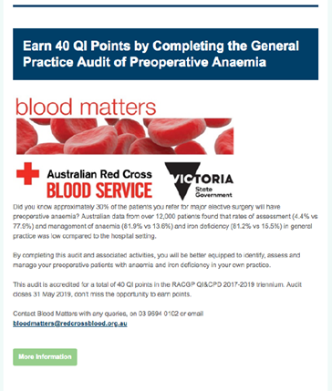 | 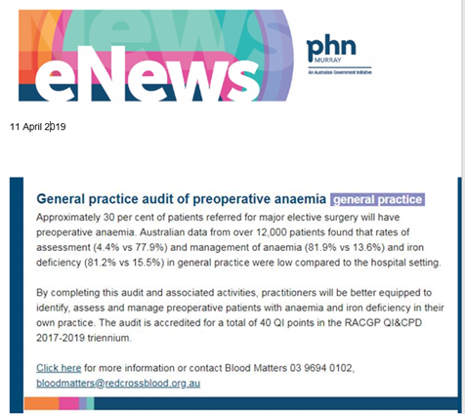
Potentially 4,168 Victorian GPs were reachable via the involved PHNs through the local newsletters.

Results
Two GPs completed the audit and the follow-up evaluation. A total of 20 patients were reported and the results are shown in the following tables.
While all reported patients had a full blood count taken, other tests as described in the NBA PBM guidelines and by Minck et al. (2013) were less thoroughly completed. Only one patient (5 per cent) received complete preoperative testing according to the NBA PBM preoperative haemoglobin assessment and optimisation template (Table 1).
Table 1: Preoperative tests reported
Test type | Number n = 20 (%)
Full blood count | 20 (100%)
Iron studies | 7 (35%)
Renal function | 18 (90%)
C-reactive protein | 2 (10%)
Complete preoperative testing | 1 (5%)
Four patients’ test results (20 per cent) indicated anaemia, with two of these being diagnosed (50 per cent) (Table 2) and two not diagnosed.
Table 2: Anaemia status
Anaemia status | Number n = 20 (%)
Patient not anaemic | 16 (80%)
Patient anaemic and diagnosed | 2 (10%)
Patient anaemic, but not diagnosed | 2 (10%)
Percentage of anaemic patients and reported as diagnosed | 2 of 4 (50%)
Table 3 highlights the iron status of those patients tested. Thirteen patients (65 per cent) had no ferritin reported.
Table 3: Iron status
Iron status | Number n = 20 (%)
Patient not iron deficient | 4 (20%)
Patient iron deficient and diagnosed | 2 (10%)
Patient iron deficient, but not diagnosed | 1 (5%)
Unknown due to no ferritin reported | 13 (65%)
Percentage of iron deficient patients and reported as diagnosed | 2 of 3 (67%)
Two patients were diagnosed as iron deficient, and both were reported to be managed according to guidelines, although they did not receive patient information (Table 4).
Table 4: Management of iron deficiency and patient information
Management | Number
Number of patients diagnosed with iron deficiency anaemia | 2 (10%)
Percentage of iron deficiency anaemia only patients reported as managed according to guidelines | 2 (100%)
Percentage of iron deficiency anaemia only patients reported as receiving written information | 0 (0%)
On completion of the audit, a feedback report summarising overall results and alignment with the PBM Module 2 template, as well as links to Minck et al. (2013) article, were provided to each submitting GP. An example of the report is available in Appendix 5.
GPs participating in the audit were also required to provide an evaluation of the activity (Table 5).
Table 5: Evaluation – feedback
 | Not met | Partially met | Entirely met
Please rate the degree to which the audit’s learning outcomes were met
- Screen for iron deficiency with/without anaemia and in preoperative patients due to undergo major elective surgery | 1 | 1
- Evaluate and interpret FBC, iron studies and CRP to assess adequacy of iron stores in preoperative patients due to undergo major elective surgery |  | 1 | 1
- Manage preoperative iron deficiency and anaemia in alignment with the ‘Preoperative haemoglobin assessment and optimisation template’ (as per PBM guidelines module 2: perioperative) |  | 1 | 1
Please rate the degree to which your personal learning needs were met |  | 1 | 1
Please rate the degree to which this activity is relevant to your practice |  | 1 | 1
One GP felt that they had become more aware of appropriate preoperative care for the patient and intends to communicate more with the surgeon involved.

Workshop
To round out the audit, we planned to run a workshop specifically for GPs on anaemia management in primary care. This workshop was planned for metropolitan Melbourne in October 2019, to be run by Lifeblood TPE unit (Appendix 6).
The TransfusEd workshop for GPs ‘Anaemia in primary care’ was promoted through Lifeblood communications and through Victorian PHN newsletters. The workshop had been accredited for 40 Category 1 points (activity 162212) and 12 Category 2 points (activity 162220) in the RACGP QI and CPD 2017–2019 triennium.
Unfortunately, the workshop was cancelled due to very low registrations.

Discussion
The very limited response from GPs indicates there is work to be done on improving the process in preparing patients for elective surgery by assessing and managing preoperative anaemia, where appropriate.
This was the first time Blood Matters had sought to work directly with GPs. The expertise of those with prior experience working as a GP and those currently active in GP education were involved to provide guidance to best implement the audit. Unfortunately, despite using GP communication channels and offering QI and CPD points, we were unable to engage the interest of GPs to participate in the audit or the workshop.
It is difficult to know at what point disengagement occurred. We are unable to determine the number of GPs who accessed and read the PHN newsletters, and if they did, whether the audit topic was perceived as low relevance to their practice.
The evaluation from the participating GPs was positive, and the audit increased their awareness of preoperative care, the importance of test follow up and communication with surgeons.
Between 2015 and 2017, the National Patient Blood Management Collaborative took place, and supported the development and trialling of strategies in clinical practice and health services to enhance PBM and the effective use of the NBA’s PBM guidelines. It was expected that a collaboration between GPs and public and private hospitals would occur. Health services have reported on their achievements in engaging GPs (ACSQHC 2017), and it is somewhat unexpected that some of these GPs did not contribute to the audit to highlight their practice.
Due to the disappointing engagement, Blood Matters will work with the Blood Matters Advisory Committee and Lifeblood TPE unit to consider options of how to engage further with GPs.

References:
Australian Commission of Safety and Quality in Health Care 2020, ‘National Patient Blood Management Collaborative (the Collaborative)’, <https://www.safetyandquality.gov.au/national-priorities/pbm-collaborative/>.
Australian Commission on Safety and Quality in Health Care 2017, Resources for improved patient blood management, ACSQHC, Sydney, <https://www.safetyandquality.gov.au/sites/default/files/migrated/National-Patient-Blood-Management-Collaborative-NPBMC-Resource-Booklet-November-2017.pdf>.
Froessler B, Rueger AM, Connolly MP 2018, ‘Assessing the costs and benefits of perioperative iron deficiency anemia management with ferric carboxymaltose in Germany’, Risk Manag Healthc Policy, vol. 11, pp. 77–82.
Kassebaum NJMD 2016, ‘The global burden of anemia’, Hematology/Oncology Clinics of North America, vol. 30, no. 2, pp. 247–308.
Kassebaum NJ, Jasrasaria R, Naghavi M, Wulf SK, Johns N, Lozano R, et al. 2014, ‘A systematic analysis of global anemia burden from 1990 to 2010’, Blood, vol. 123, no. 5, pp. 615–24.
Le Calvé S, Somme D, Prud’homm J and Corvol A 2017, ‘Blood transfusion in elderly patients with chronic anemia: a qualitative analysis of the general practitioners' attitudes’, BMC Family Practice, vol. 18, doi:10.1186/s12875-017-0647-8.
Marik PE, Corwin HL 2008, ‘Efficacy of red blood cell transfusion in the critically ill: a systematic review of the literature’, Crit Care Med., vol. 36, no. 9, pp. 2667–74.
Minck S, Robinson K, Saxon B, Spigiel T, Thomson A 2013, ‘Patient blood management - the GP's guide’, Aust Fam Physician, vol. 42, pp. 291–7.
Nissenson AR, Wade S, Goodnough T, Knight K, Dubois RW 2005, ‘Economic burden of anemia in an insured population’, J Manag Care Pharm., vol. 11, no. 7, pp. 565–74.
Riva E, Tettamanti M, Mosconi P, Apolone G, Gandini F, Nobili A, et al. 2009, ‘Association of mild anemia with hospitalization and mortality in the elderly: the Health and Anemia population-based study’, Haematologica, vol. 94, no. 1, pp. 22–8.

Appendix 1: Part 1: General practice audit of preoperative anaemia
Download the audit document <https://www2.health.vic.gov.au/hospitals-and-health-services/patient-care/speciality-diagnostics-therapeutics/blood-matters/~/link.aspx?_id=E2BB7BBE5CD44961AB89F8F1D94E0D97&_z=z>.

Appendix 2: Part 2: General practice audit of preoperative anaemia
Download the audit document <https://www2.health.vic.gov.au/hospitals-and-health-services/patient-care/speciality-diagnostics-therapeutics/blood-matters/~/link.aspx?_id=E2BB7BBE5CD44961AB89F8F1D94E0D97&_z=z>.

Appendix 3: Data collection tool – General practice audit of preoperative anaemia
Download the data collection tool <https://www2.health.vic.gov.au/hospitals-and-health-services/patient-care/speciality-diagnostics-therapeutics/blood-matters/transfusion-audits>.

Appendix 4: General practice audit of preoperative anaemia evaluation and QI
GP audit of preoperative anaemia – evaluation and QI
Please rate the degree to which the audit’s learning outcomes were met | Not met | Partially met | Entirely met
- Screen for iron deficiency with/without anaemia and in preoperative patients due to undergo major elective surgery | ☐ | ☐ | ☐
- Evaluate and interpret FBC, iron studies and CRP to assess adequacy of iron stores in preoperative patients due to undergo major elective surgery | ☐ | ☐ | ☐
- Manage preoperative iron deficiency and anaemia in alignment with the Preoperative haemoglobin assessment and optimisation template (as per Patient Blood Management Guidelines Module 2 Preoperative) | ☐ | ☐ | ☐

Please rate the degree to which your personal learning needs were met | Not met | Partially met | Entirely met
 | ☐ | ☐ | ☐

Please rate the degree to which this activity is relevant to your practice | Not relevant | Partially relevant | Entirely relevant
 | ☐ | ☐ | ☐

What changes did you implement in your practice as a result of this activity?

How do you monitor these changes?

What evaluation process do you use to monitor these changes?

Thank you for your feedback.

Appendix 5: Example of results summary provided to reporting GPs

Appendix 6: TransfusEd workshop for GPs
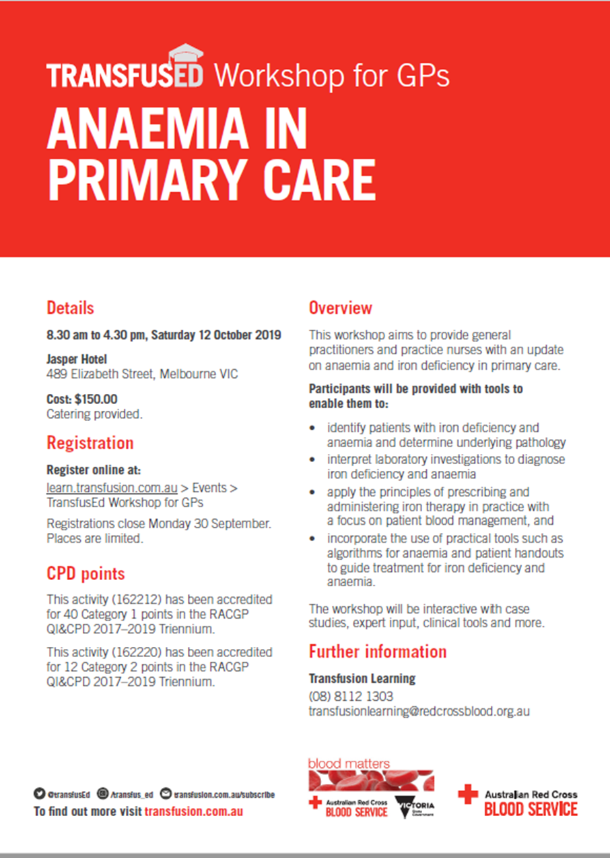
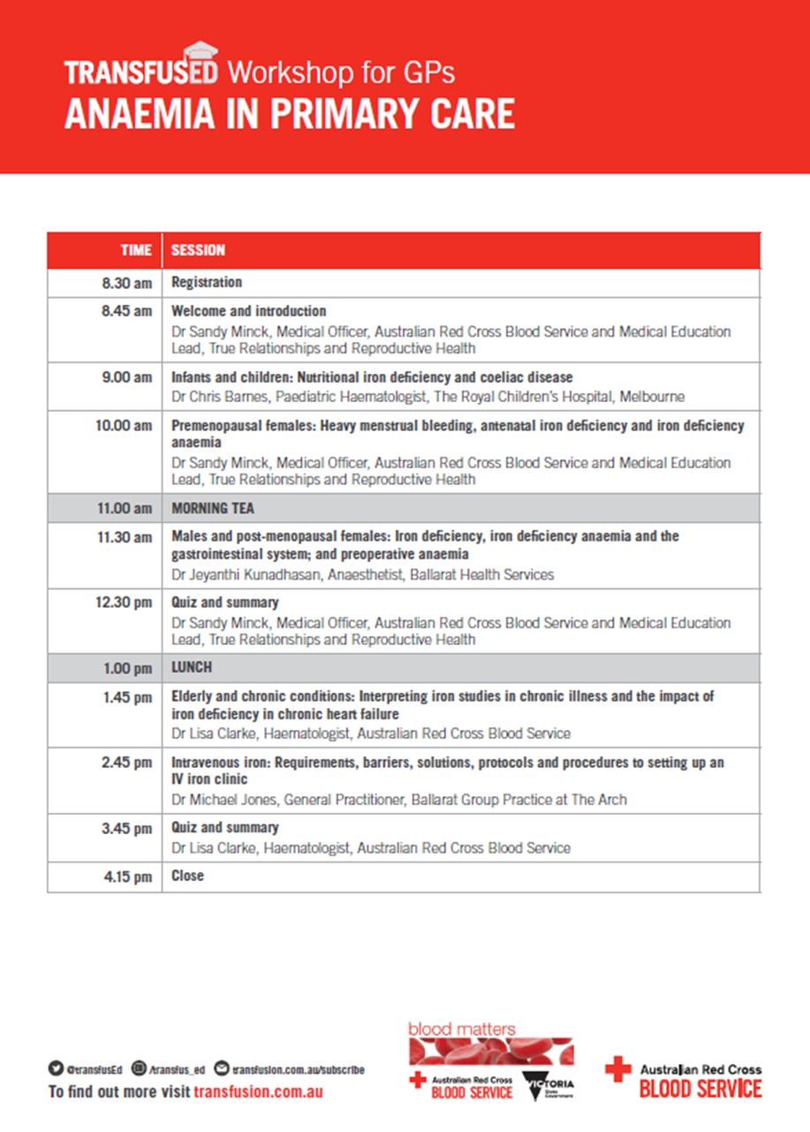

It should be noted that while guidelines and algorithms such as NBA PBM Module 2 template are valuable tools to guide best practice, they must be interpreted in light of an individual patient’s clinical circumstances.
It should be noted that while guidelines and algorithms such as NBA PBM Module 2 template are valuable tools to guide best practice, they must be interpreted in light of an individual patient’s clinical circumstances.
It should be noted that guidelines and algorithms such as NBA PBM Module 2 template are valuable tools to guide best practice, however, it must be noted the importance of interpreting in the light of an individual patient’s clinical circumstances.

