

|  |
| --- |
| Head and neck cancer in Victoria  Optimal care pathway data summary report 2018 |
|  |

Department of Health

|  |
| --- |
| Head and neck cancer in Victoria  Optimal care pathway data summary report 2018 |
|  |

|  |
| --- |
|  |
| To receive this publication in an accessible format phone (03) 9096 2136, using the National Relay Service 13 36 77 if required, or [email Cancer Strategy and Development](mailto:cancerplanning@dhhs.vic.gov.au) <cancerplanning@health.vic.gov.au>.  Authorised and published by the Victorian Government, 1 Treasury Place, Melbourne.  © State of Victoria, Department of Health, February 2021.  **ISBN** 978-1-76069-238-4 **(pdf/online/MS word)**  Available from the [Cancer Strategy and Development webpage](http://www.health.vic.gov.au/cancer) <www.health.vic.gov.au/cancer>. |
|  |

# Foreword

This report provides a summary of the data analyses prepared for the Head and Neck Cancers Summit meeting, which took place on 12 October 2018.

The Victorian Tumour Summits are clinician-led forums to identify unwarranted variation in tumour-based clinical practice and cancer outcomes across the state. We were thrilled to be able to co-chair the Head and Neck Cancers Summit Working Group that was convened to guide the analyses of statewide routine datasets to understand current patterns of care for Victorians with this disease. This work has highlighted areas of care requiring further investigation and action that will hopefully reduce variation and improve experiences and clinical outcomes for head and neck cancer patients across Victoria.

We want to emphasise the vital importance of this tumour summit program in bringing together the clinical community to identify and discuss where we can collectively make changes to improve care for our patients. The Head and Neck Cancers Summit was attended by 101 participants, the largest meeting of any summit to date. This highlights the keen interest within our clinical community to better understand and improve care for our patients.

We would like to acknowledge and thank our colleagues on the working group and all those who attended the summit for their time, effort and active contributions to make the meeting such a success. A special thanks to Ella Stuart, who undertook the data analyses, and the tumour summit project team for their support throughout the process.

We look forward to engaging further with statewide colleagues to focus on the opportunities for improvement that this process has identified and seeing how those efforts can benefit all our patients.

 

|  |  |
| --- | --- |
| **Mr Stephen Tudge**  **Co-chair, Head and Neck Cancers Summit** | **Dr Andrew Coleman**  **Co-chair, Head and Neck Cancers Summit** |

Contents

Foreword 4

List of figures vi

List of tables vi

Acknowledgements 8

Introduction 1

More information 1

Data sources 2

Linked dataset 2

Other data sources 2

At a glance 4

Key findings 4

Key variations for action 6

Incidence and demographics 7

Disease spread at diagnosis and survival 9

Surgery and radiotherapy volume 11

Patient movement across ICS 12

Treatment planning 14

Timeliness of treatment 16

Time from diagnosis to first treatment – surgery 16

Time from diagnosis to first treatment–definitive radiotherapy or chemoradiation 18

Time from surgery to adjuvant therapy 20

Emergency admission following radiotherapy 23

Malnutrition 25

Treatment and survival–oral cavity cancer 27

Treatment and survival –oropharynx cancer 29

Abbreviations 31

Victorian Integrated Cancer Services 31

Glossary 32

Supplementary material 33

Codes 33

# List of figures

Figure 1: Head and neck cancer age-standardised incidence rate per 100,000 population and number of new cases over time (diagnosed 1982–2016) 7

Figure 2: Oropharynx cancer age-standardised incidence rate per 100,000 population by sex (diagnosed 2008–2016) 7

Figure 3: Number of head and neck cancers diagnosed in Victoria between 2012 and 2016 by subsite and ICD-10-AM code 8

Figure 4: Victorian hospital average yearly head and neck cancer surgical volume (2016–2017) 11

Figure 5: Victorian radiotherapy centre average yearly head and neck cancer radical radiotherapy volume (2016–2017) 11

Figure 6: Proportion of head and neck cancer patients with a multidisciplinary team meeting documented in their medical record, by ICS of treatment (2017) 14

Figure 7: Proportion of head and neck cancer patients who had a prospective multidisciplinary team meeting, by ICS of treatment (2017) 15

Figure 8: Boxplots of time from diagnosis to surgery for head and neck cancer patients, by ICS of surgery hospital (diagnosed 2012–2016) 17

Figure 9: Funnel plot for the proportion of surgical head and neck cancer patients who received surgery within eight weeks of diagnosis, by hospital (diagnosed 2012–2016) 17

Figure 10: Boxplots of time from diagnosis to definitive RT/CRT for head and neck cancer patients, by ICS of RT/CRT centre (diagnosed 2012–2016) 19

Figure 11: Funnel plot for the proportion of definitive RT/CRT head and neck cancer patients who started treatment within eight weeks of diagnosis, by RT/CRT centre (diagnosed 2012–2016) 19

Figure 12: Boxplot of time from surgery to adjuvant therapy for head and neck cancer patients, by ICS of surgery hospital (diagnosed 2012–2016) 20

Figure 13: Boxplot of time from surgery to adjuvant therapy for head and neck cancer patients, by ICS of RT/CRT centre (diagnosed 2012–2016) 21

Figure 14: Funnel plot of the proportion of head and neck cancer patients whose adjuvant therapy started within six weeks of surgery, by surgery hospital (diagnosed 2012–2016) 21

Figure 15: Funnel plot of emergency admissions to hospital in the 12 weeks following radical RT for head and neck cancer patients (diagnosed 2012–2016) 23

Figure 16: Funnel plot of emergency admissions to hospital in the 12 weeks following radical CRT for head and neck cancer patients (diagnosed 2012–2016) 24

Figure 17: Prevalence of malnutrition for head and neck cancer patients, by ICS of treatment (2016) 25

Figure 18: Proportion of head and neck cancer patients receiving dietetics care, by ICS of treatment (2016) 25

Figure 19: Treatment pathways within one year of oral cavity cancer diagnosis (diagnosed 2012–2016) 27

Figure 20: Treatment pathways within one year of oropharynx cancer diagnosis (diagnosed 2012–2016) 29

Figure 21: Risk of death for oropharynx cancer patients by treatment type, adjusted for age, sex and comorbidity count (diagnosed 2012–2016) 30

Figure 22: Risk of death for oropharynx cancer patients following radical chemoradiation by ICS of chemoradiation, adjusted for age, sex and comorbidity count (diagnosed 2012–2016) 30

# List of tables

Table 1: Proportion of patients presenting with lymph node negative cancer, lymph node positive cancer or distant metastases by head and neck cancer subsite (diagnosed 2012–2016) 9

Table 2: One- and five-year survival for head and neck cancers by subsite (diagnosed 2012–2016) 9

Table 3: Head and neck cancer patient flow for first surgery, by treatment ICS (diagnosed 2012–2016) 12

Table 4: Head and neck cancer patient flow for radical radiotherapy, by treatment ICS (diagnosed 2012–2016) 13

Table 5: Proportion of head and neck cancer patients whose first treatment was surgery, who had surgery within eight weeks of diagnosis, by ICS of residence and ICS of treatment (diagnosed 2012–2016) 16

Table 6: Proportion of head and neck cancer patients whose first treatment was definitive RT/CRT, who started treatment within eight weeks of diagnosis, by ICS of residence and ICS of treatment (diagnosed 2012–2016) 18

Table 7: Neck dissection and adjuvant therapy (radical RT/CRT) use in oral cavity cancer surgical patients (diagnosed 2012–2016) 28

Supplementary Table 1: Head and neck cancer diagnosis codes 34

Supplementary Table 2: Surgical procedures codes used to identify patients who underwent a head and neck cancer resection 34

Supplementary Table 3: Minor surgical procedures codes used to identify patients who underwent a head and neck cancer resection 36

Supplementary Table 4: Procedure codes used to identify patients who had a neck lymph node dissection 36

Supplementary Table 5: Diagnosis, procedure and DRG codes used to identify patients who received chemotherapy 36

# Acknowledgements

The data, analysis and commentary provided in this report represent a joint effort by numerous key contributors from the following groups.

**Head and Neck Cancers Summit Working Party**

|  |  |
| --- | --- |
| Dr Alam (Muhammad) Alamgeer | Mr Rhys Hughes |
| Dr Stephen Brown | Mr Hari Jeyarajan |
| Dr Andrew Coleman (co-chair) | A/Prof. Bernard Lyons |
| Mr David Deutscher | A/Prof. Paul Mitchell |
| Dr Tsien Fua | Mr Stephen Tudge (co-chair) |
| A/Prof. Hui Gan | Dr Eliza Tweddle |
| Mr Mark Guirguis | Dr Mori Wada |
| Mr Colin Hornby | A/Prof. David Wiesenfeld |

**Data analysis**

|  |  |
| --- | --- |
| Ms Ella Stuart | Dr Luc te Marvelde |

**Victorian Tumour Summits Project Team**

|  |  |
| --- | --- |
| Ms Mirela Matthews | Ms Amy Sercombe |
| Ms Rebecca Miller | Ms Luellen Thek |
| Ms Claire Porter |  |

We also gratefully acknowledge the providers of the Victorian Cancer Registry data, Victorian Admitted Episodes Dataset and the Victorian Radiotherapy Minimum Dataset, as well as the Centre for Victorian Data Linkage for performing the linkages between the Victorian Cancer Registry and administrative datasets. In addition, we acknowledge Jane Harrowfield for providing data from the Malnutrition in Victorian Cancer Services point prevalence study.

To view the Head and Neck Cancers Summit data presentation and related documents, visit the [Head and Neck Cancers Summit meeting webpage](https://www.nemics.org.au/index.php/Improving_cancer_care/summits/headneck/?action=getPageFromName&page=Improving_cancer_care/summits/headneck/) <https://www.nemics.org.au/index.php/Improving_cancer_care/summits/headneck/?action=getPageFromName&page=Improving_cancer_care/summits/headneck/>.

# Introduction

The data presented in this report are a summary of the analyses prepared for the Head and Neck (H&N) Cancers Summit held in Melbourne on 12 October 2018. The H&N Cancers Summit is part of the Victorian Tumour Summits, an initiative of the Victorian Integrated Cancer Services (ICS[1]) delivered in collaboration with the Department of Health (‘the department’) and Cancer Council Victoria. The summits support the broader program of work implementing the optimal care pathways (OCPs).

The H&N Cancers Summit gathered 101 stakeholders from across Victoria to discuss variations in care and identify opportunities for improvement. Data presented focused on the presentation, diagnosis and treatment steps of the H&N cancers OCP. Stakeholders prioritised variations for action based on their potential impact on patient experience and outcomes. Ideas for improvement were also shared. Clinical commentary and recommendations from the summit are included in this report.

## More information

* Find out more about the H&N Cancers Summit from the [NEMICS website](https://www.nemics.org.au/index.php/Improving_cancer_care/summits/headneck/?action=getPageFromName&page=Improving_cancer_care/summits/headneck) <https://www.nemics.org.au/index.php/Improving_cancer_care/summits/headneck/?action=getPageFromName&page=Improving_cancer_care/summits/headneck/>.
  + The H&N cancers OCP can be viewed and downloaded from the [Cancer Council Australia website](http://www.cancer.org.au/OCP) <www.cancer.org.au/OCP>.

# Data sources

## Linked dataset

### Datasets

The Victorian Cancer Registry (VCR) is a population-based cancer registry that collects demographic and tumour details, including diagnosis date and region of residence, for all Victorian residents who are diagnosed with cancer. The department’s Centre for Victorian Data Linkage performs an annual data linkage between the VCR and administrative datasets including the Victorian Admitted Episodes Dataset (VAED), the Victorian Radiotherapy Minimum Data Set (VRMDS) and the Victorian Death Index. Linking the VCR to the VAED provides information captured within the inpatient setting in Victorian public and private hospitals such as patient diagnoses (for example, comorbidities and distant metastases), emergency admissions and cancer treatment, including surgery and chemotherapy (see Glossary). Linking the VCR to the VRMDS provides information on admitted and non-admitted radical and palliative radiotherapy courses provided in Victorian public and private radiotherapy centres. Unless otherwise specified, the data source used for the report analyses was the linked dataset.

### Patient selection

Victorian residents aged 18 years or older with a primary diagnosis of an H&N cancer (Supplementary Table 1) between 2012 and 2016 were identified using the VCR. Patients whose cancer diagnosis was notified to the VCR by death certificate only (*n* = 36) and records for second-incident H&N cancers (*n* = 29: patients with more than one H&N cancer) were included in the ‘Incidence and demographics’ section only.

As a proxy for cancer stage, patients were grouped as having lymph node negative cancer, lymph node positive cancer or distant metastases at diagnosis (see Glossary for more information). Patients who had distant metastases at diagnosis were excluded from the ‘Patient movement across ICS’, ‘Timeliness of treatment’, ‘Emergency admission following radiotherapy’, ‘Treatment and survival – oral cavity cancer’ and ‘Treatment and survival – oropharynx cancer’ sections.

### Data limitations

**H&N cutaneous squamous cell carcinomas:** Cutaneous squamous cell carcinomas of the H&N (excluding the lip–vermillion border) are not reported to the VCR. Therefore, these cases are not included in the linked dataset.

**HRICS:** Victorians with cancer living in HRICS may receive treatment in New South Wales (Albury) hospitals, which is not captured in the VAED. Therefore, variables in this report that are derived using the VAED (comorbidity count, cancer in lymph nodes, distant metastases, emergency admissions, surgery and chemotherapy) are likely to be underestimated for Victorians living in HRICS. Table and figure footnote text highlight where this limitation may apply.

## Other data sources

In addition to the linked dataset, this report includes data from the:

* Victorian Cancer Statistics, [Cancer Council Victoria](http://vcrdata.cancervic.org.au) <http://vcrdata.cancervic.org.au> website – This website includes Victorian H&N cancers incidence data from 1982 to 2016.
* Cancer Services Performance Indicator Medical Record Audit 2017[2] – This audit collected data such as multidisciplinary team meeting (MDM) use and MDM timing (prospective or retrospective to starting treatment) from the medical records of a random sample of cancer patients treated across 50 Victorian hospitals. There were 215 H&N cancer patients audited.
* Malnutrition in Victorian Cancer Services Point Prevalence Study 2016[3] – This study assessed malnutrition prevalence in patients receiving care for cancer across 12 health services in Victoria. There were 109 H&N cancer patients assessed during the study.

# At a glance

## Key findings

### Incidence and demographics

* Incidence of H&N cancers has been decreasing since 1982, with the exception of oropharynx cancer, where incidence for males has been increasing since 2008.
* There were 3,823 H&N cancers diagnosed between 2012 and 2016.
* Of those, median age at diagnosis was 65 years, and 71 per cent were male.
* H&N cancers are a heterogenous group of cancers, with oral cavity and oropharynx cancers the most common.

### Disease spread at diagnosis and survival

* At diagnosis, 70–80 per cent of oral cavity, salivary gland and larynx cancer patients present with lymph node negative disease, whereas 60–70 per cent of oropharynx, nasopharynx and hypopharynx cancer patients present with lymph node positive disease or distant metastases.
* For the period 2012–2016, one-year survival was 84 per cent and five-year survival 63 per cent.
* Survival varied by cancer subsite, being lowest for hypopharynx (five-year = 34 per cent) and highest for salivary gland cancers (five-year = 70 per cent).

### Surgery and radiotherapy volume

* From 2016 to 2017, the average surgical admission volume for H&N cancers in public or private hospitals ranged from one to more than 90 cases per year.
* Fifty-four per cent of public hospitals and 90 per cent of private hospitals performed less than 10 H&N cancer surgeries per year.
* The average yearly radical H&N cancer radiotherapy (RT) course volume over 2016–2017 ranged from one to more than 200.
* Forty-two per cent of public and 88 per cent of private RT centres provided less than 10 courses per year.

### Patient movement across ICS

* Sixty per cent of H&N cancer patients had surgery in their local ICS, and 52 per cent had radical RT in their local ICS between 2012 and 2016.
* Most surgery and radical RT occurred in metropolitan ICS, particularly WCMICS.

### Treatment planning

* Eighty-six per cent of H&N cancer patients had evidence of an MDM in their medical record.
* Evidence of an MDM varied by ICS and was significantly lower for BSWRICS and LMICS but higher in SMICS and WCMICS compared with the state average.
* The proportion of patients with a prospective MDM was 84 per cent and varied by ICS, being significantly lower in LMICS and higher in SMICS compared with the state average.

### Timeliness of treatment

#### Surgery

* Of the H&N cancer patients whose first treatment was surgery, 93 per cent underwent surgery within eight weeks of diagnosis between 2012 and 2016.
* Time to surgery did not vary by ICS of surgery or for patients having treatment in their local ICS versus travelling from regional to metropolitan ICS.
* Four hospitals had a statistically significantly lower proportion of patients receiving surgery within eight weeks compared with the state average.

#### Definitive radiotherapy or chemoradiation

* Of the H&N cancer patients whose first treatment was definitive RT or chemoradiation (RT/CRT), 77 per cent started treatment within eight weeks of diagnosis during 2012–2016.
* Time to RT/CRT varied by ICS, with treatment in SMICS more likely and treatment in BSWRICS and LMICS less likely to begin within eight weeks of diagnosis.
* In addition, a lower proportion of regional residents receiving RT/CRT locally started within eight weeks of diagnosis (66 per cent) compared with regional residents who travelled to a metropolitan hospital (76 per cent).
* Three regional RT centres had a significantly lower proportion of patients who started RT/CRT within eight weeks compared with the state average.

#### Surgery to adjuvant therapy

* Of the H&N cancer patients who received surgery followed by adjuvant RT/CRT, 37 per cent started adjuvant therapy within six weeks of surgery during 2012–2016.
* More patients treated in SMICS and fewer patients treated in BSWRICS and GICS started adjuvant RT/CRT within six weeks of surgery, and there was wide variation in timeliness of adjuvant RT/CRT by surgery hospital.

### Emergency admission following radiotherapy

* Sixteen per cent of H&N cancer patients receiving radical RT alone had an emergency admission within 12 weeks of starting RT.
* Forty-four per cent of H&N cancer patients receiving CRT had an emergency admission within 12 weeks of starting RT.
* There was variation across RT centres, with one regional centre having significantly more patients admitted after CRT (60 per cent) compared with the state average.

### Malnutrition

* A 2016 point prevalence study of a sample of 109 Victorian H&N cancer patients currently receiving cancer care showed that 31 per cent of patients were malnourished.
* Prevalence of malnutrition was similar in metropolitan and regional ICS but higher in H&N cancer patients than the statewide average of 23 per cent for all cancers.
* Seventy-nine per cent of H&N cancer patients were receiving dietetics care at the time of the study, with no variation between ICS.

### Treatment and survival – oral cavity cancer

* The majority (77 per cent) of oral cavity cancer patients diagnosed between 2012 and 2016 received surgery. Of these, 35 per cent had adjuvant therapy.
* The proportion of surgical patients receiving a neck dissection and/or adjuvant therapy was higher in lymph node positive than node-negative cases.
* In node-negative patients, a higher proportion of WCMICS patients had a neck dissection (26 per cent) compared with the state average (21 per cent); while a lower proportion of BSWRICS patients had adjuvant therapy (9 per cent) compared with the state average (22 per cent).
* In node-positive patients, there was no significant difference between ICS regarding use of neck dissection (45 per cent) or receipt of adjuvant therapy (77 per cent).
* Oral cavity cancer survival did not differ by ICS of surgery.

### Treatment and survival – oropharynx cancer

* Half of those with oropharynx cancer diagnosed between 2012 and 2016 received CRT, 30 per cent had surgery with or without adjuvant therapy, and 8 per cent had RT.
* Survival differed significantly by treatment received, being poorer for those receiving RT alone compared with the state average. This was independent of patient age, sex and comorbidity count.
* Survival for oropharynx cancer did not differ by ICS of CRT.

## Key variations for action

At the tumour summit, nine key variations in practice and outcomes were prioritised for discussion and further action:

1. Many centres provide treatment for less than 10 patients per year (39 surgical, 12 RT).
2. Many patients have treatment outside their ICS of residence.
3. The proportion of patients with evidence of an MDM discussion was lower in BSWRICS and LMICS.
4. Fewer regional patients treated locally (66 per cent) start their RT within eight weeks of diagnosis than regional patients treated in metropolitan (76 per cent) and metropolitan patients treated in metropolitan centres (80 per cent).
5. Of all patients having adjuvant RT, only 37 per cent started within six weeks of surgery, with lower rates in BSWRICS and GICS and in one metropolitan and one regional centre.
6. The proportion of patients receiving dietetic care may be lower in regional treatment centres.
7. There was poorer survival for oropharyngeal cancer patients who were treated with RT only compared with other treatment types.

# Incidence and demographics

* The Victorian age-standardised incidence rate for H&N cancers has decreased from 14.5 in 1982 to 10.1 in 2016; however, the overall number of people diagnosed with H&N cancers continues to increase with population growth (Figure 1).
* From 2008 to 2016, the incidence rate of oropharynx cancer has increased in males but not females (Figure 2).
* Between 2012 and 2016 there were 3,823 H&N cancers diagnosed in Victoria. Of those:
  + - The median age at diagnosis was 65 years, and more than two-thirds (71 per cent) of cases were male.
    - Oral cavity and oropharynx cancers accounted for the largest H&N cancer subsites (Figure 3).

Figure 1: Head and neck cancer age-standardised incidence rate per 100,000 population and number of new cases over time (diagnosed 1982–2016)

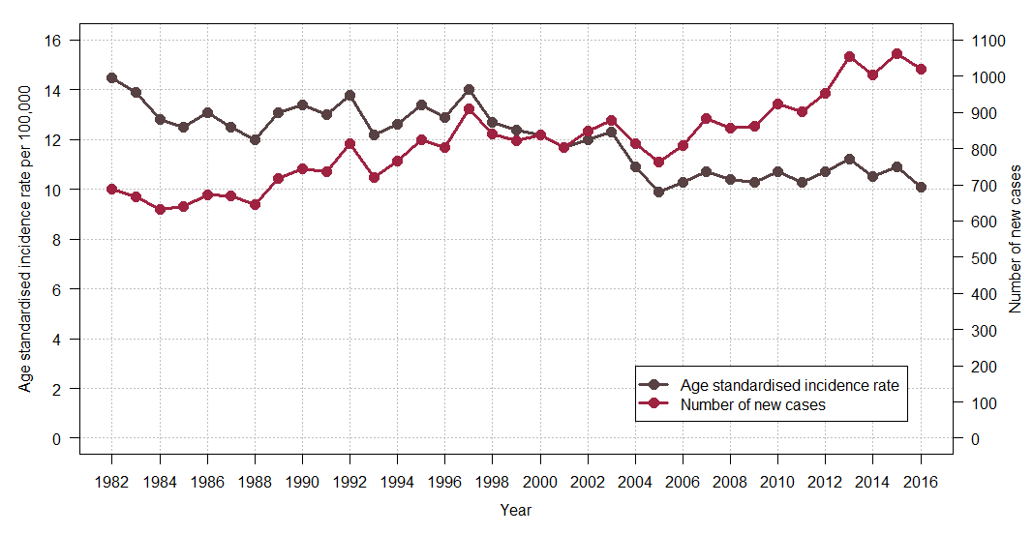

Source: [Cancer Council Victoria](http://vcrdata.cancervic.org.au) <http://vcrdata.cancervic.org.au>

Figure 2: Oropharynx cancer age-standardised incidence rate per 100,000 population by sex (diagnosed 2008–2016)

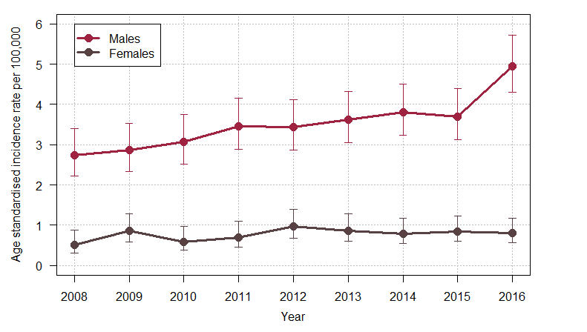

Bars represent 95 per cent CI.

Figure 3: Number of head and neck cancers diagnosed in Victoria between 2012 and 2016 by subsite and ICD-10-AM code

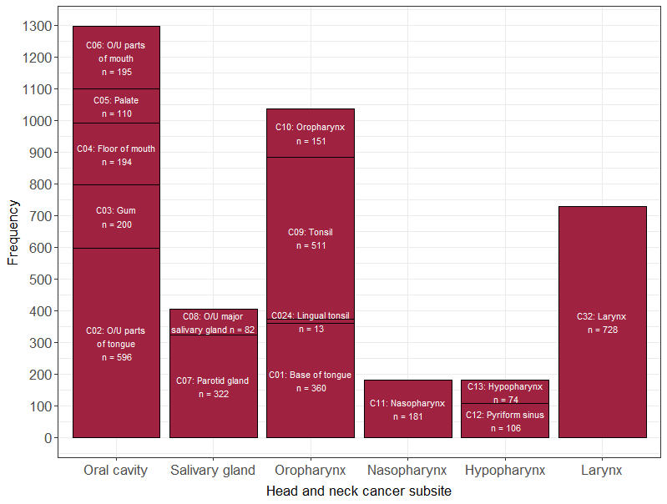

O/U = other/unspecified

### Clinical commentary

The decreasing incidence of H&N cancers is positive to see and may be due to reduced rates of smoking and/or alcohol use. However, H&N cancers are not a homogenous group, and rising incidence of oropharynx cancers in men should be monitored. This group of cancers is likely to be HPV-related and the increase in incidence is consistent with trends seen in developed countries around the world.

# Disease spread at diagnosis and survival[4]

* Between 2012 and 2016, 70–80 per cent of oral cavity, salivary gland and larynx cancer patients presented with lymph node negative disease (Table 1).
* In contrast, 60–70 per cent of oropharynx, nasopharynx and hypopharynx cancer patients presented with lymph node positive cancer or distant metastases.
* For the period 2012–2016, one-year survival was 84 per cent and five-year survival 63 per cent (Table 2).
* Survival varied by cancer subsite, being lowest for hypopharynx cancer (five-year = 34 per cent) and highest for salivary gland cancers (five-year = 70 per cent).

Table 1: Proportion of patients presenting with lymph node negative cancer, lymph node positive cancer or distant metastases by head and neck cancer subsite (diagnosed 2012–2016)

| Patient group at diagnosis | Oral cavity  C02–C06 | Salivary gland  C07, C08 | Oropharynx  C01, C02.4, C09, C10 | Nasopharynx  C11 | Hypopharynx  C12, C13 | Larynx  C32 |
| --- | --- | --- | --- | --- | --- | --- |
| Lymph node negative | 895 (71%) | 280 (70%) | 296 (29%) | 62 (35%) | 63 (36%) | 571 (80%) |
| Lymph node positive | 292 (23%) | 75 (19%) | 624 (61%) | 78 (44%) | 92 (52%) | 109 (15%) |
| Distant metastases | 76 (6%) | 43 (11%) | 110 (11%) | 38 (21%) | 21 (12%) | 33 (5%) |

C02 excludes C02.4.

See Glossary for definitions of patient groups.

Table 2: One- and five-year survival for head and neck cancers by subsite (diagnosed 2012–2016)

| Cancer group | One-year survival  % (95% CI) | Five-year survival  % (95% CI) |
| --- | --- | --- |
| Oral cavity | 83.5 (81.5–85.6) | 62.7 (59.4–66.2) |
| Salivary gland | 89.7 (86.8–92.7) | 70.1 (64.4-76.2) |
| Oropharynx | 86.1 (84.0–88.3) | 69.1 (65.6–72.8) |
| Nasopharynx | 88.8 (84.2–93.5) | 62.6 (54.3–72.2) |
| Hypopharynx | 67.6 (61.0–74.9) | 33.6 (25.4–44.4) |
| Larynx | 82.5 (79.7–85.3) | 57.9 (53.1–63.1) |
| **All head and neck** | **84.2 (83.0–85.4)** | **62.8 (60.9–64.9)** |

CI = confidence interval

### Clinical commentary

A limitation of the data is that we do not have disease stage at diagnosis, and it is difficult to compare treatment and survival across ICS without this variable. As a proxy, clinical diagnosis codes from admitted episodes within four months of diagnosis were reviewed for a diagnosis of cancer in the lymph nodes of the H&N or distant metastases. These results suggest that a higher proportion of patients with oropharynx, nasopharynx or hypopharynx cancer are presenting with cancer having spread to lymph nodes or beyond. Presentation of patients with these cancers at a more advanced stage is likely due to multiple factors, including different lymphatic drainage from each site of the head and neck and that some primary tumours arising in the oropharynx, nasopharynx or hypopharynx do not cause symptoms as early as those from other sites, especially larynx or oral cavity cancers. Poorer survival for hypopharynx cancer patients likely reflects their more advanced disease stage at diagnosis and their more aggressive clinical behaviour.

# Surgery and radiotherapy volume

* From 2016 to 2017, the average yearly number of H&N cancer surgical admissions in Victorian hospitals ranged from one to 98 (Figure 4).
* Thirteen of 24 (54 per cent) public hospitals and 26 of 29 (90 per cent) private hospitals performed fewer than 10 surgeries per year.
* The average yearly radical H&N RT course volume in Victorian RT centres during 2016–2017 ranged from one to 216 (Figure 5).
* Five of 12 (42 per cent) public RT centres and seven of eight (88 per cent) private RT centres provided fewer than 10 courses per year.

Figure 4: Victorian hospital average yearly head and neck cancer surgical volume (2016–2017)

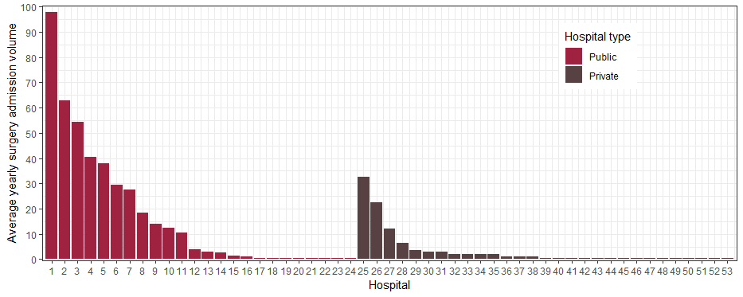

Figure 5: Victorian radiotherapy centre average yearly head and neck cancer radical radiotherapy volume (2016–2017)

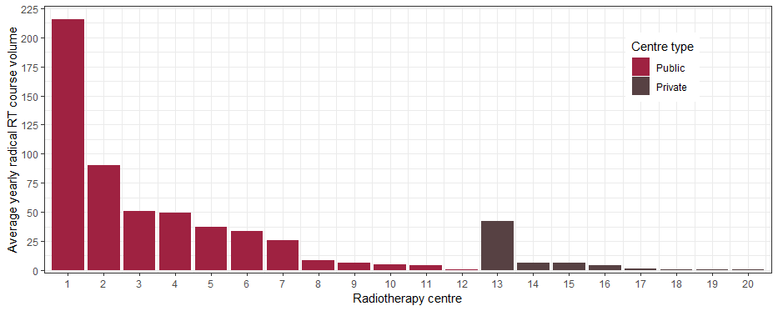

### Clinical commentary

This data shows a long tail of hospitals conducting fewer than 10 H&N cancer surgeries or radical RT courses over 2016 and 2017. It is important to consider the service capability of centres with lower volumes. For example, do they have specialist dietetics and speech pathology? Do they have ward staff with specific training to look after patients who have undergone tracheostomy, laryngectomy or gastrostomy? These supports are critical to ensure optimal patient outcomes.

# Patient movement across ICS[5]

* Between 2012 and 2016, 60 per cent of H&N cancer patients had surgery in their local ICS, and 52 per cent had radical RT in their local ICS (Table 3 and Table 4).
* Most surgery and radical RT occurred in metropolitan ICS, particularly WCMICS.

Table 3: Head and neck cancer patient flow for first surgery, by ICS of residence and ICS of treatment (diagnosed 2012–2016)

| ICS of residence \ ICS of treatment | NEMICS | SMICS | WCMICS | BSWRICS | GRICS | HRICS | LMICS | GICS | Total |
| --- | --- | --- | --- | --- | --- | --- | --- | --- | --- |
| NEMICS | 200  (44%) | 62  (14%) | 197  (43%) |  |  |  |  |  | 459  (100%) |
| SMICS | 15  (3%) | 368  (70%) | 144  (27%) |  |  |  |  |  | 527  (100%) |
| WCMICS | 37  (9%) | 25  (6%) | 359  (85%) | 3  (1%) |  |  |  |  | 424  (100%) |
| BSWRICS | 2  (1%) | 1  (1%) | 12  (8%) | 126  (89%) |  |  |  | 1  (1%) | 142  (100%) |
| GRICS | 6  (5%) | 59  (47%) | 49  (39%) | 2  (2%) | 10  (8%) |  |  |  | 126  (100%) |
| HRICS | 10  (16%) | 8  (13%) | 35  (56%) |  |  | 10  (16%) |  |  | 63  (100%) |
| LMICS | 3  (3%) | 5  (5%) | 59  (55%) |  |  |  | 33  (31%) | 8  (7%) | 108  (100%) |
| GICS | 2  (2%) | 3  (3%) | 24  (28%) | 7  (8%) |  |  | 1  (1%) | 50  (57%) | 87  (100%) |
| Total | 275 | 531 | 879 | 138 | 10 | 10 | 34 | 59 | 1,936 |

Note HRICS data limitation.

Table 4: Head and neck cancer patient flow for radical radiotherapy, by ICS of residence and ICS of treatment (diagnosed 2012–2016)

| ICS of residence / ICS of treatment | NEMICS | SMICS | WCMICS | BSWRICS | GRICS | HRICS | LMICS | GICS | Total |
| --- | --- | --- | --- | --- | --- | --- | --- | --- | --- |
| NEMICS | 200  (44%) | 38  (8%) | 217  (47%) |  |  | 1  (< 1%) |  |  | 457  (100%) |
| SMICS | 5  (1%) | 213  (39%) | 323  (60%) |  | 1  (< 1%) |  |  |  | 542  (100%) |
| WCMICS | 39  (10%) | 27  (7%) | 325  (82%) | 5  (1%) |  |  | 1  (< 1%) | 1  (< 1%) | 398  (100%) |
| BSWRICS |  | 1  (1%) | 10  (7%) | 135  (91%) |  |  |  | 2  (1%) | 148  (100%) |
| GRICS | 2  (2%) | 13  (10%) | 83  (65%) | 1  (1%) | 29  (23%) |  |  |  | 128  (100%) |
| HRICS | 8  (9%) | 4  (4%) | 38  (43%) |  |  | 36  (40%) | 3  (3%) |  | 89  (100%) |
| LMICS | 1  (1%) | 3  (2%) | 89  (70%) |  |  |  | 20  (16%) | 15  (12%) | 128  (100%) |
| GICS | 2  (2%) | 1  (1%) | 16  (17%) | 6  (6%) |  | 1  (1%) |  | 70  (73%) | 96  (100%) |
| Total | 257 | 300 | 1,101 | 147 | 30 | 38 | 24 | 88 | 1,986 |

### Clinical commentary

Surgery and radical RT are fairly centralised to metropolitan hospitals, mostly in WCMICS. There was a significant increase in H&N cancer RT expertise that moved to SMICS in 2016, and future data should reflect this. Whether patients are treated within their region or travel to other regions may have implications for patient experiences of care (such as travel and accommodation costs) and may influence timeliness of care – see the ‘Timeliness of treatment’ section.

# Treatment planning

The H&N cancers OCP states that all newly diagnosed patients should be discussed at an MDM so that a treatment plan can be recommended. There are currently no systems for routinely monitoring the occurrence or skill set of the clinicians participating in MDMs. For this analysis, data from the Cancer Services Performance Indicator Audit 2017 was used where a random sample of newly diagnosed H&N cancer patients (who received treatment) were audited within each ICS. The presence or absence of MDM treatment recommendations in the patient’s medical record was used as a measure of whether an MDM had occurred.

* In 2017, 86 per cent of H&N cancer patients had evidence of an MDM in their medical record.
* Evidence of an MDM varied by ICS of treatment and was significantly lower for patients treated in BSWRICS (50 per cent) and LMICS (25 per cent), and significantly higher for patients treated in SMICS (96 per cent) and WCMICS (94 per cent) compared with the state average (Figure 6).
* Eighty-four per cent of patients had evidence of a prospective (pre-treatment) MDM.
* Evidence of a prospective MDM also varied by ICS, being significantly lower for patients treated in LMICS (0 per cent) and significantly higher for patients treated in SMICS (100 per cent) compared with the state average (Figure 7).

Figure 6: Proportion of head and neck cancer patients with a multidisciplinary team meeting documented in their medical record, by ICS of treatment (2017)

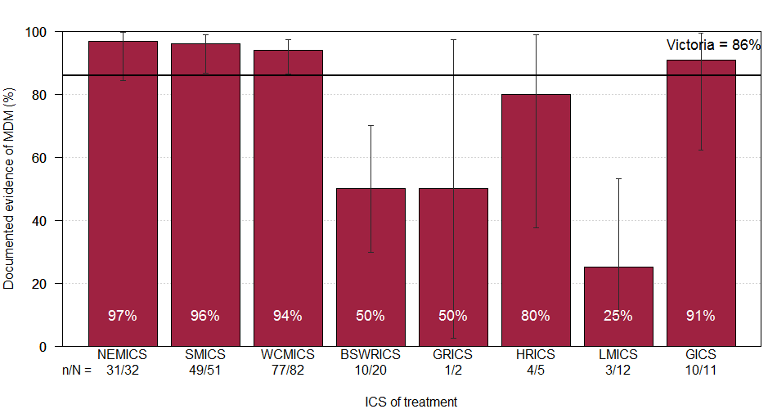

Bars represent 95 per cent CI.

Figure 7: Proportion of head and neck cancer patients who had a prospective multidisciplinary team meeting, by ICS of treatment (2017)

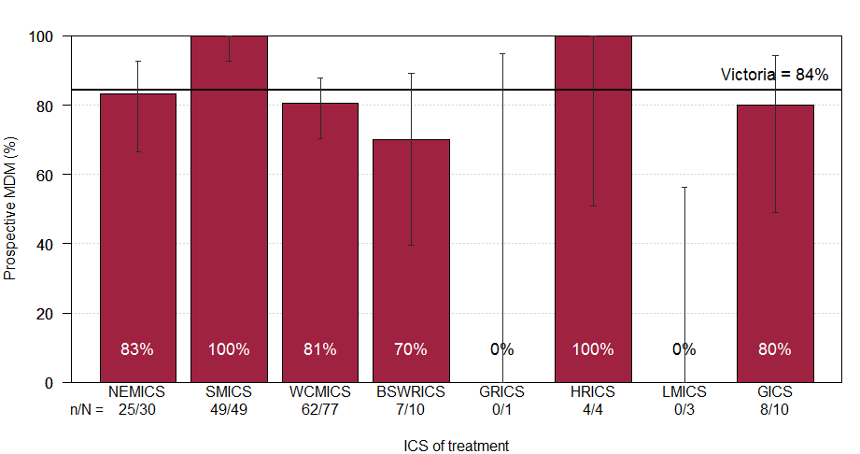

Bars represent 95 per cent CI.

### Clinical commentary

MDM treatment planning is an important and well-recognised standard of care. MDMs should occur before treatment begins to ensure patients are given the most appropriate care. While some areas of the state do this well, there is room for improvement, particularly in some regional ICS. Given that this was a relatively small audit study, findings should be verified via local reviews of patient and service records and strategies put in place to support all H&N cancer patients’ cases being prospectively discussed in MDMs attended by clinicians with subspecialty training and current clinical experience managing a high volume of head and neck cancer cases. Centres that do not have clinicians with this training or experience attending their MDMs in person should develop networks with larger centres with these resources and use teleconference facilities to provide prospective MDM review by clinicians with the desirable level of subspecialty training and experience.

# Timeliness of treatment[6]

The OCP for H&N cancers includes recommended optimal timeframes for patient care. Three intervals were examined for patients diagnosed between 2012 and 2016.

1. Time from diagnosis to first treatment – surgery
2. Time from diagnosis to first treatment – definitive RT/CRT
3. Time from surgery to adjuvant therapy

## Time from diagnosis to first treatment – surgery

* + Of the H&N cancer patients who started treatment within six months of diagnosis and whose first treatment was surgery:
    - The median time from diagnosis to surgery was 17 days.
    - Ninety-three per cent underwent surgery within eight weeks of diagnosis.
* The proportion of patients who had surgery within eight weeks of diagnosis did not vary by whether patients had surgery at their local ICS or travelled from regional to metropolitan ICS (Table 5), nor by ICS of treatment (Figure 8).
  + Four hospitals had a significantly lower proportion of patients undergoing surgery within eight weeks compared with the state average (Figure 9).

Table 5: Proportion of head and neck cancer patients whose first treatment was surgery, who had surgery within eight weeks of diagnosis, by ICS of residence and ICS of treatment (diagnosed 2012–2016)

| ICS residence to ICS of treatment | n/N (%) | *p*-value |
| --- | --- | --- |
| Regional to regional | 219/237 (92) | 0.096 |
| Regional to metropolitan | 235/262 (90) |  |
| Metropolitan to metropolitan | 1,270/1,359 (93) |  |

n = number of patients who had surgery within eight weeks of diagnosis  
N = number of patients whose first treatment was surgery and who started treatment within six months of H&N cancer diagnosis

Figure 8: Boxplots of time from diagnosis to surgery for head and neck cancer patients, by ICS of surgery hospital (diagnosed 2012–2016)

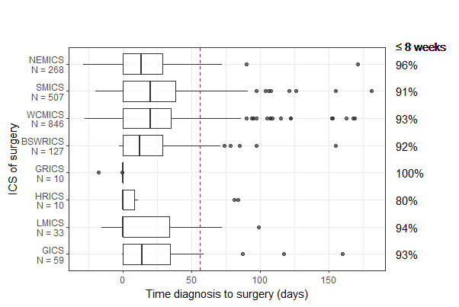

Dashed line = eight weeks (56 days).   
Note HRICS data limitation.   
Pearson’s 𝝌² test for difference in proportion of patients who had surgery within eight weeks of diagnosis between ICS p-value = 0.195.  
Restricted to surgery within six months of diagnosis date.

Figure 9: Funnel plot for the proportion of surgical head and neck cancer patients who received surgery within eight weeks of diagnosis, by hospital (diagnosed 2012–2016)

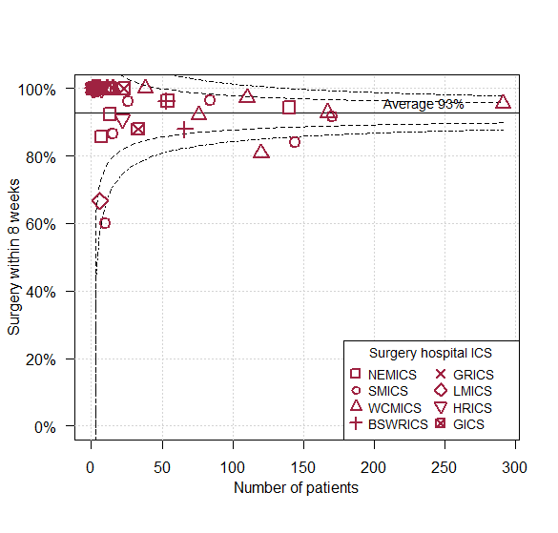

Restricted to surgery within six months of diagnosis date.

## Time from diagnosis to first treatment – definitive radiotherapy or chemoradiation

* Of the H&N cancer patients who started treatment within six months of diagnosis and whose first treatment was definitive RT/CRT:
  + - The median time from diagnosis to starting treatment was 45 days.
    - Seventy-seven per cent started treatment within eight weeks of diagnosis.
* A lower proportion of regional residents who were treated locally started RT/CRT within eight weeks of diagnosis compared with regional residents who travelled to a metropolitan centre and metropolitan patients treated locally (Table 6).
* Compared with the state average, the proportion of patients starting RT/CRT within eight weeks of diagnosis was lower for patients treated in BSWRICS or LMICS and higher for patients treated in SMICS (Figure 10).
* Three regional RT centres had a significantly lower proportion and one metropolitan RT centre had a significantly higher proportion of patients starting RT/CRT within eight weeks of their diagnosis compared with the state average (Figure 11).

Table 6: Proportion of head and neck cancer patients whose first treatment was definitive RT/CRT, who started treatment within eight weeks of diagnosis, by ICS of residence and ICS of treatment (diagnosed 2012–2016)

| ICS residence to ICS of treatment | n/N (%) | *p*-value |
| --- | --- | --- |
| Regional to regional | 95/144 (66) | < 0.001 |
| Regional to metropolitan | 94/123 (76) |  |
| Metropolitan to metropolitan | 466/582 (80) |  |

n = number of H&N cancer patients who started definitive RT/CRT within eight weeks of diagnosis

N = number of H&N cancer patients whose first treatment was definitive RT/CRT and who started treatment within six months of H&N cancer diagnosis

Figure 10: Boxplots of time from diagnosis to definitive RT/CRT for head and neck cancer patients, by ICS of RT/CRT centre (diagnosed 2012–2016)

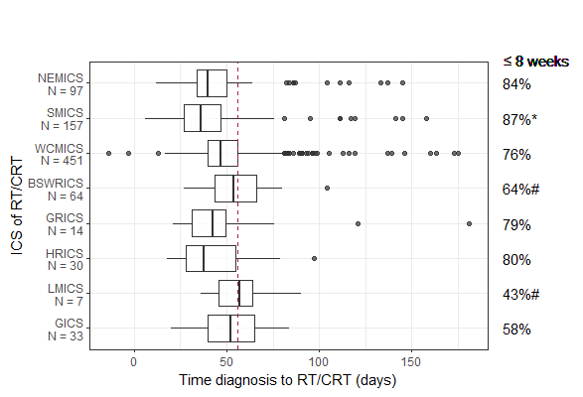

Dashed line = eight weeks (56 days).   
Greater than Victorian average * p < 0.05, ** p < 0.001; Lower than Victorian average # p < 0.05, ## p < 0.001.  
Note HRICS data limitation.   
Restricted to definitive RT/CRT within six months of diagnosis date.

Figure 11: Funnel plot for the proportion of definitive RT/CRT head and neck cancer patients who started treatment within eight weeks of diagnosis, by RT/CRT centre (diagnosed 2012–2016)

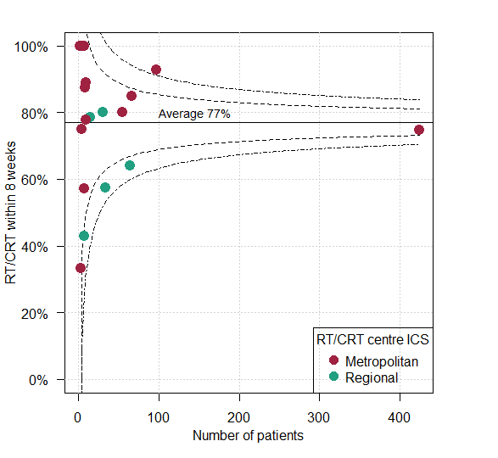

Restricted to definitive RT/CRT within six months of diagnosis date.

## Time from surgery to adjuvant therapy

* Of the H&N cancer patients whose first treatment was surgery followed by adjuvant therapy (radical RT or CRT) within three months of surgery:
  + - The median time from surgery to starting adjuvant therapy was 47 days.
    - Thirty-seven per cent started adjuvant therapy within six weeks of surgery, increasing over the 2012–2016 period from 25 per cent in 2012 to 45 per cent in 2016 (*p* = 0.005).
* Patients who had surgery and adjuvant therapy in BSWRICS and patients who had adjuvant therapy in GICS were less likely to start adjuvant therapy within six weeks of their surgery (Figure 12 and Figure 13).
* Patients who had adjuvant therapy in SMICS were more likely to start adjuvant therapy within six weeks of surgery (Figure 13).
* There was wide variation in the timeliness of adjuvant therapy by surgery hospital (Figure 14):
  + - Four metropolitan hospitals had a significantly higher proportion of patients starting adjuvant therapy within six weeks compared with the state average.
    - One regional and one metropolitan hospital had a significantly lower proportion of patients starting adjuvant therapy within six weeks compared with the state average.

Figure 12: Boxplot of time from surgery to adjuvant therapy for head and neck cancer patients, by ICS of surgery hospital (diagnosed 2012–2016)

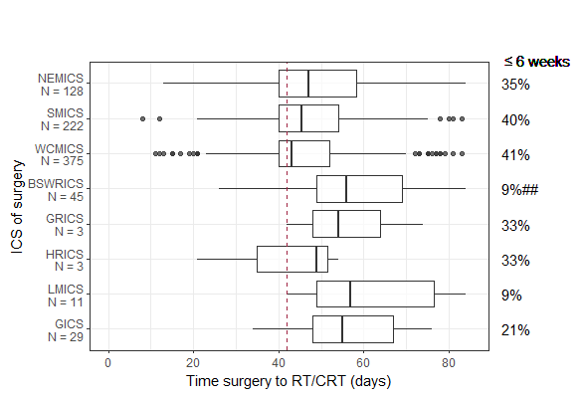

Dashed line = six weeks (42 days).  
Greater than Victorian average * p < 0.05, ** p < 0.001; Lower than Victorian average # p < 0.05, ## p < 0.001.  
Note HRICS data limitation.   
Restricted to adjuvant therapy within three months of surgery date.

Figure 13: Boxplot of time from surgery to adjuvant therapy for head and neck cancer patients, by ICS of RT/CRT centre (diagnosed 2012–2016)

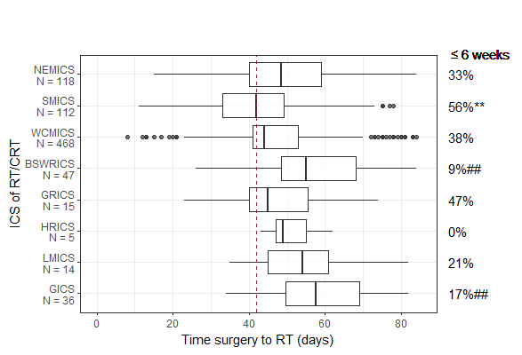

Dashed line = six weeks (42 days).   
Greater than Victorian average * p < 0.05, ** p < 0.001; Lower than Victorian average # p < 0.05, ## p < 0.001.  
Note HRICS data limitation.   
Restricted to adjuvant therapy within three months of surgery date.

Figure 14: Funnel plot of the proportion of head and neck cancer patients whose adjuvant therapy started within six weeks of surgery, by surgery hospital (diagnosed 2012–2016)

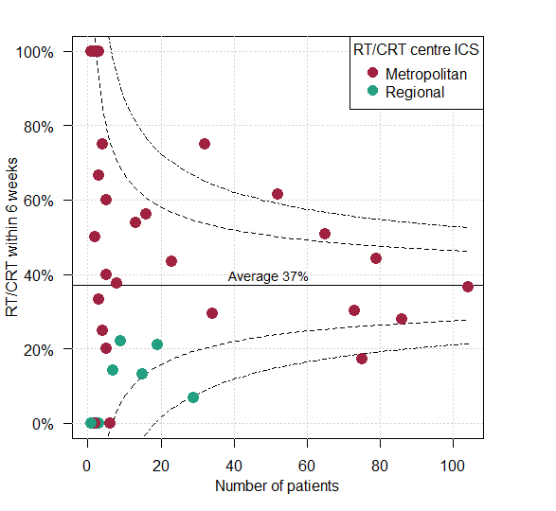

Restricted to adjuvant therapy within three months of surgery date.

### Clinical commentary

The timeliness of treatment commencement for H&N cancer is crucial for ensuring optimal patient outcomes – both for reducing patient anxiety as well as improving clinical outcomes. Although time from diagnosis to surgery did not vary by ICS and a high proportion of patients received care within the eight-week optimal target (93 per cent), some hospitals were not performing as well. This was also the case for time to RT/CRT and adjuvant treatments, with the additional issue of regional–metropolitan differences in achieving interval targets. Most surgical patients who received adjuvant therapy did not start adjuvant treatment within the OCP recommended six-week timeframe. Timeliness of adjuvant therapy has been improving over time; however, there was wide variation across ICS (range: 9–56 per cent), indicating a clear need for further investigation of pathways to address delays. One option may be to examine processes in hospitals that achieve more timely care to identify what they are doing well and what could be translated to other settings.

# Emergency admission following radiotherapy[7]

* Overall 16 per cent of H&N cancer patients diagnosed between 2012 and 2016 who received radical RT had an emergency admission to hospital within 12 weeks of starting their treatment (Figure 15).
* An RT centre in GICS had a significantly higher proportion of patients with an emergency admission following RT compared with the state average.
* Overall 44 per cent of patients receiving radical CRT had an emergency admission to hospital within 12 weeks of starting their treatment (Figure 16).
* An RT centre in GICS had a significantly higher proportion and an RT centre in BSWRICS had a significantly lower proportion of patients with an emergency admission following CRT compared with the state average.

Figure 15: Funnel plot of emergency admissions to hospital in the 12 weeks following radical RT for head and neck cancer patients (diagnosed 2012–2016)

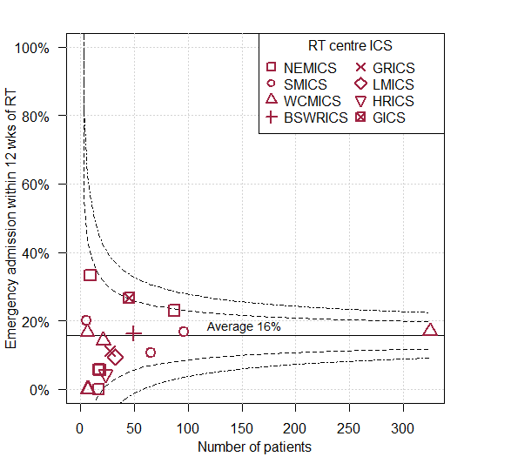

Note HRICS data limitation.

Figure 16: Funnel plot of emergency admissions to hospital in the 12 weeks following radical CRT for head and neck cancer patients (diagnosed 2012–2016)

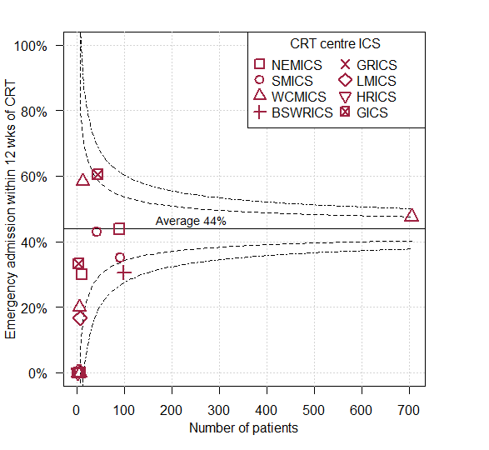

Note HRICS data limitation.

### Clinical commentary

A greater proportion of emergency admissions may indicate suboptimal patient discharge procedures, lack of local services or case-mix differences by hospital. Hospitals with higher rates should interrogate local data to determine reasons for these emergency admissions and identify strategies to reduce such admissions if applicable.

# Malnutrition

Previous studies have shown that malnutrition is under-reported for cancer patients in the VAED.[8] Therefore, for this analysis, data from the Cancer Malnutrition Point Prevalence Study 2016[9] was used. This study assessed malnutrition rates and rates of dietetics care in a sample of cancer patients, including 109 H&N cancer patients, treated in Victorian public hospitals.

* Thirty-one per cent of H&N cancer patients were malnourished; this was higher than the statewide average of 23 per cent for all cancers.
* Prevalence of malnutrition was similar in metropolitan and regional ICS (Figure 17).
* Seventy-nine per cent of H&N cancer patients were receiving dietetics care at the time of the study, ranging from 58 per cent to 87 per cent between ICS (Figure 18).

Figure 17: Prevalence of malnutrition for head and neck cancer patients, by ICS of treatment (2016)

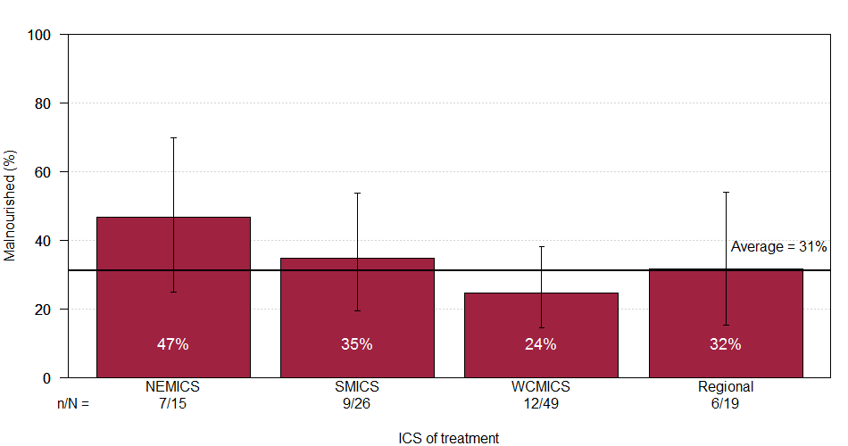

Bars represent 95 per cent CI.

Figure 18: Proportion of head and neck cancer patients receiving dietetics care, by ICS of treatment (2016)

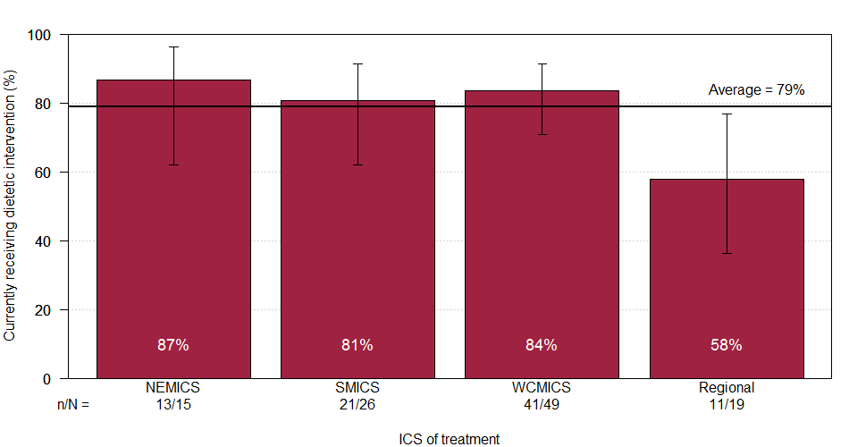

Bars represent 95 per cent CI.

### Clinical commentary

It is well known among clinicians that malnutrition in H&N cancer patients can have a significant adverse impact on outcomes such as infections, treatment response and treatment interruptions, unplanned admissions, length of stay and quality of life. With almost a third of H&N cancer patients experiencing malnourishment, dietetics care is crucial to prevent and address negative impacts. It is worth investigating potentially lower use of dietetics care in regional Victoria, which may indicate poorer access to these services.

# Treatment and survival – oral cavity cancer[10]

* There were 1,187 Victorians diagnosed with oral cavity cancer between 2012 and 2016 who did not present with distant metastases (see Glossary). Of those:
  + - Seventy-seven per cent received surgery, of which 35 per cent had adjuvant therapy (Figure 19).
    - Seven per cent had radical RT or CRT only.
    - Four per cent had palliative treatment.
    - Twelve per cent had no surgery, chemotherapy, RT or CRT.
* The proportion of surgical patients receiving a neck dissection or adjuvant therapy was higher in lymph node positive than node-negative patients (Table 7).
* In node-negative patients:
  + - Twenty-one per cent had a neck dissection and 22 per cent had adjuvant therapy (Table 7).
    - A significantly higher proportion of patients having surgery in WCMICS had a neck dissection (26 per cent).
    - A significantly lower proportion of patients having surgery in BSWRICS had adjuvant therapy (9 per cent).
* In node-positive patients:
  + - Forty-five per cent had a neck dissection and 77 per cent had adjuvant therapy (Table 7).
    - There was no statistically significant variation between ICS of surgery in the proportion of neck dissection or adjuvant therapy.
* After adjusting for age, sex and comorbidities, survival did not differ by ICS of surgery for lymph node negative (*p* = 0.638) or lymph node positive (*p* = 0.598) patients.

Figure 19: Treatment pathways within one year of oral cavity cancer diagnosis (diagnosed 2012–2016)

Treatment pathways within one year of oral cavity cancer diagnosis (diagnosed 2012–2016)

Radiotherapy (RT) or chemoradiation (CRT) refers to radiotherapy with radical intent.   
Refer to Glossary for more information on treatment groups. Tx = treatment.

Table 7: Neck dissection and adjuvant therapy (radical RT/CRT) use in oral cavity cancer surgical patients (diagnosed 2012–2016)

| ICS of surgery | Node-negative neck dissection  n/N (%) | Node-negative adjuvant therapy  n/N (%) | Node-positive neck dissection  n/N (%) | Node-positive adjuvant therapy  n/N (%) |
| --- | --- | --- | --- | --- |
| **NEMICS** | 12/84 (14%) | 17/84 (20%) | 14/32 (44%) | 22/32 (69%) |
| **SMICS** | 37/173 (21%) | 38/173 (22%) | 22/56 (39%) | 46/56 (82%) |
| **WCMICS** | 89/339 (26%)[11] | 85/339 (25%) | 52/112 (46%) | 88/112 (77%) |
| **BSWRICS** | 5/47 (11%) | 4/47 (9%)[12] | 8/15 (53%) | 10/15 (67%) |
| **GRICS** | 0/3 (0%) | 0/3 (0%) | 1/1 (100%) | 0/1 (0%) |
| **HRICS** | 0/4 (0%) | 0/4 (0%) | – | – |
| **LMICS** | 2/18 (11%) | 1/18 (6%) | – | – |
| **GICS** | 2/25 (8%) | 6/25 (24%) | 4/7 (57%) | 5/7 (71%) |
| **Victoria** | **147/693 (21%)** | **151/693 (22%)** | **101/223 (45%)** | **171/223 (77%)** |

Note HRICS data limitation.

### Clinical commentary

As expected, most patients with oral cavity cancer had surgery and a higher proportion of lymph node positive patients had a neck dissection and adjuvant therapy. A small proportion of patients had RT only, CRT only, palliative treatment (palliative RT) or no surgery/RT/CRT. The latter group includes patients who die soon after diagnosis, are too unwell for treatment or who have early stage disease and are treated with a biopsy procedure. Although there was slight variation in the use of neck dissection and adjuvant therapy across ICS, there was no significant difference in survival by ICS of surgery.

# Treatment and survival – oropharynx cancer[13]

* There were 920 Victorians diagnosed with oropharynx cancer between 2012 and 2016 who did not present with distant metastases (see Glossary). Of those:
  + - Forty-nine per cent received radical CRT (Figure 20).
    - Thirty per cent had surgery, of which 66 per cent had adjuvant therapy.
    - Eight per cent had radical RT.
    - Six per cent had palliative treatment.
    - Seven per cent had no surgery, chemotherapy, RT or CRT.
* Survival differed significantly by treatment received, being poorer for those receiving radical RT alone compared with the Victorian average, independent of age, sex and comorbidity count (*p* = 0.004) (Figure 21).
* After adjusting for age, sex and comorbidities, survival following radical CRT did not differ by ICS of CRT (Figure 22).

Figure 20: Treatment pathways within one year of oropharynx cancer diagnosis (diagnosed 2012–2016)

Treatment pathways within one year of oropharynx cancer diagnosis (diagnosed 2012–2016)

Radiotherapy (RT) and chemoradiation (CRT) refer to RT with radical intent.   
See Glossary for more information on treatment groups. Tx = treatment.

Figure 21: Risk of death for oropharynx cancer patients by treatment type, adjusted for age, sex and comorbidity count (diagnosed 2012–2016)

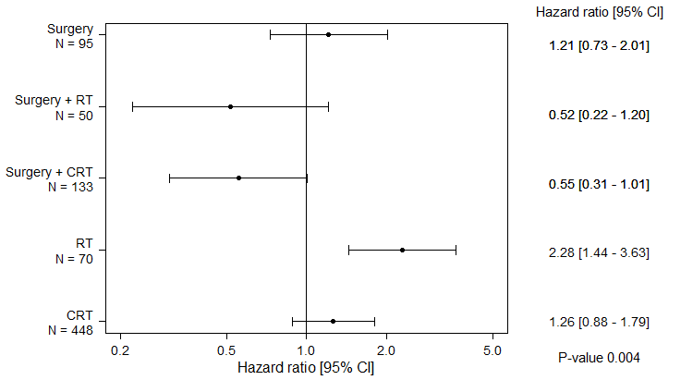

Bars represent 95 per cent CI.

Compared with Victorian average 1.0.

Radiotherapy (RT) and chemoradiation (CRT) refer to RT with radical intent.

See Glossary for more information on treatment groups.

Figure 22: Risk of death for oropharynx cancer patients following radical chemoradiation by ICS of chemoradiation, adjusted for age, sex and comorbidity count (diagnosed 2012–2016)

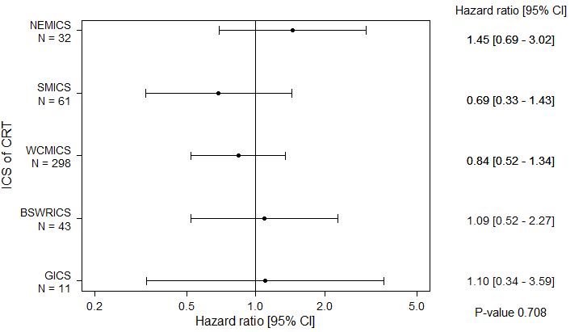

Bars represent 95 per cent CI.

Compared with Victorian average 1.0.

ICS with < 10 patients not included (GRICS = 1; HRICS = 2).

### Clinical commentary

The most common treatment for oropharynx cancer was CRT and, reassuringly, there was no significant difference in survival between ICS of CRT. Patients receiving RT alone had much poorer survival, which was not fully explained by patient age, sex or comorbidity. Other reasons for poorer survival for those receiving RT alone may be due to other unmeasured reasons (such as patient choice).

# Abbreviations

|  |  |
| --- | --- |
| CI | confidence interval |
| CRT | chemoradiation |
| H&N | head and neck |
| ICS | Integrated Cancer Service |
| MDM | multidisciplinary meeting |
| OCP | optimal care pathway |
| RT | radiotherapy |
| VAED | Victorian Admitted Episodes Dataset |
| VCR | Victorian Cancer Registry |
| VRMDS | Victorian Radiotherapy Minimum Data Set |

## Victorian Integrated Cancer Services

|  |  |
| --- | --- |
| NEMICS | North Eastern Melbourne Integrated Cancer Service |
| SMICS | Southern Melbourne Integrated Cancer Service |
| WCMICS | Western and Central Melbourne Integrated Cancer Service |
| BSWRICS | Barwon South Western Regional Integrated Cancer Service |
| GRICS | Gippsland Regional Integrated Cancer Services |
| HRICS | Hume Regional Integrated Cancer Service |
| LMICS | Loddon Mallee Integrated Cancer Service |
| GICS | Grampians Integrated Cancer Service |

# Glossary

|  |  |
| --- | --- |
| **Adjuvant therapy** | **Radiotherapy (radical)** or **chemoradiation** provided within 12 weeks (84 days) of the surgery admission date. |
| **Chemoradiation** | **Chemoradiation** was identified by at least one **chemotherapy** episode in the VAED where the admission date was in the range of the **radiotherapy (radical)** course start and end date. |
| **Chemotherapy** | An admitted episode in the VAED where the admission date was between 30 days prior and one year after the patient’s H&N cancer diagnosis date and included a chemotherapy diagnosis, procedure or diagnosis-related group code (Supplementary Table 5). |
| **Comorbidity count** | A count measuring the number of comorbid conditions a patient has at diagnosis, which may influence their prognosis. Data on patient comorbidities was extracted from diagnosis codes of admitted episodes in the VAED in the year prior to 30 days after the patient’s H&N cancer diagnosis date. Patients without admitted episodes were assumed to have no comorbidities. The comorbidity count was calculated for each patient according to Quan et al.[14] (excluding cancer and metastases) and grouped into four categories (0, 1, 2 and 3+).  Diagnosis codes for comorbidities can only be assigned in the admitted episode when the comorbidities meet criteria for coding in accordance with the Australian Coding Standards.[15] As a result, the identification of comorbidities is underestimated.  Conditions included in the comorbidity count:  AIDS/HIV  congestive heart failure  chronic pulmonary disease  dementia  diabetes with chronic complications  hemiplegia or paraplegia  mild liver disease  moderate/severe liver disease  renal disease  rheumatic disease. |
| **Death certificate only** | A method of cancer notification to the VCR whereby the death certificate provides the only notification of a person’s cancer to the registry. |
| **Definitive radiotherapy or chemoradiation** | **Radiotherapy (radical)** or **chemoradiation** as the first treatment a patient received after diagnosis. |
| **Diagnosis date** | The date of the pathology report or other investigative report where the diagnosis of H&N cancer was first confirmed to the Victorian Cancer Registry. |
| **Distant metastases** | Patients who had distant metastases at diagnosis were identified from the VCR TNM-M variable (non-missing for 3 per cent of H&N cancer patients) and from metastatic cancer diagnosis codes (ICD-10-AM C78 and C79) in admitted episodes in the VAED between 30 days prior to four months after diagnosis date. |
| **Emergency admission** | An admitted episode in the VAED with an emergency admission type ‘C – Emergency admission through Emergency Department at this campus’ or ‘O – Other emergency admission’. |
| **Neck dissection** | An admitted episode in the VAED where the admission date was between 30 days prior and one year after the patient’s H&N cancer diagnosis date and included a neck lymph node dissection procedure code (Supplementary Table 4). |
| **Lymph node negative** | Patients were determined to have lymph node negative cancer at diagnosis if they did not have **lymph node positive** cancer or **distant metastases**. |
| **Lymph node positive** | Patients who had lymph node positive cancer at diagnosis were identified from admitted episodes in the VAED between 30 days prior and four months after diagnosis date that included an H&N cancer diagnosis code (ICD-10-AM C01-C13, C32) and a lymph node cancer diagnosis code (ICD-10-AM C77) but did not have **distant metastases**. |
| **Palliative Tx** | Palliative treatment includes patients treated with **chemotherapy** onlyor **radiotherapy (palliative)** (+/– chemotherapy or surgery). |
| **Radiotherapy (radical)** | Radiotherapy courses in the VRMDS where the *start date* was between 30 days prior and one year after the patient’s H&N cancer diagnosis date, the *primary site* was an H&N cancer code (ICD-10-AM C01-C13, C32), the *target site* was ‘head and neck’, ‘glottis’, ‘sinuses’ or ‘parotid’ and the *treatment intent* was radical. |
| **Radiotherapy (palliative)** | Radiotherapy courses in the VRMDS where the *start date* was between 30 days prior and one year after the patient’s H&N cancer diagnosis date, the *primary site* was an H&N cancer code (ICD-10-AM C01-C13, C32), the *target site* was ‘head and neck’, ‘glottis’, ‘sinuses’ or ‘parotid’ and the *treatment intent* was palliative. |
| **Surgery** | An admitted episode in the VAED where the admission date was between 30 days prior and one year after the patient’s H&N cancer diagnosis date and the episode included at least one non-minor surgical procedure code (Supplementary Table 2). If a patient did not receive treatment (non-minor surgery, radiotherapy (radical/palliative) or chemotherapy) within one year of diagnosis but had an admitted episode between 30 days prior and one year after the patient’s diagnosis date that included a minor surgical procedure code (Supplementary Table 3), the patient was classified as having received surgery. |

# Supplementary material

## Codes

### Diagnosis

Supplementary Table 1: Head and neck cancer diagnosis codes

| ICD-10-AM | Description |
| --- | --- |
| C01 | Malignant neoplasm of base of tongue |
| C02 | Malignant neoplasm of other and unspecified parts of tongue |
| C03 | Malignant neoplasm of gum |
| C04 | Malignant neoplasm of floor of mouth |
| C05 | Malignant neoplasm of palate |
| C06 | Malignant neoplasm of other and unspecified parts of mouth |
| C07 | Malignant neoplasm of parotid gland |
| C08 | Malignant neoplasm of other and unspecified major salivary glands |
| C09 | Malignant neoplasm of tonsil |
| C10 | Malignant neoplasm of oropharynx |
| C11 | Malignant neoplasm of nasopharynx |
| C12 | Malignant neoplasm of piriform sinus |
| C13 | Malignant neoplasm of hypopharynx |
| C32 | Malignant neoplasm of larynx |

### Surgery

Supplementary Table 2: Surgical procedures codes used to identify patients who underwent a head and neck cancer resection

| ICD-10-AM/ ACHI/ACS code | Description |
| --- | --- |
| 3024700 | Total excision of parotid gland |
| 3025000 | Total excision of parotid gland with preservation of facial nerve |
| 3025300 | Partial excision of parotid gland |
| 3025600 | Excision of submandibular gland |
| 3027200 | Partial excision of tongue |
| 3027500 | Radical excision of intraoral lesion |
| 3029401 | Laryngopharyngectomy and plastic reconstruction |
| 3140000 | Excision of lesion of upper aerodigestive tract |
| 3140900 | Excision of parapharyngeal lesion by cervical approach |
| 3141200 | Excision of recurrent or persistent parapharyngeal lesion by cervical approach |
| 4158400 | Partial resection of temporal bone with mastoidectomy |
| 4177901 | Total excision of tongue |
| 4178200 | Partial pharyngectomy |
| 4178500 | Partial pharyngectomy with partial glossectomy |
| 4178501 | Partial pharyngectomy with total glossectomy |
| 4178701 | Uvulectomy with partial palatectomy and tonsillectomy |
| 4178900 | Tonsillectomy without adenoidectomy |
| 4183400 | Total laryngectomy |
| 4183700 | Hemilaryngectomy |
| 4184000 | Supraglottic laryngectomy |
| 4184300 | Laryngopharyngectomy |
| 4186100 | Microlaryngoscopy with removal of lesion by laser |
| 4559600 | Total resection of 1 maxilla |
| 4559700 | Total resection of both maxillae |
| 4559900 | Total resection of both sides of mandible |
| 4560200 | Subtotal resection of mandible |
| 4560201 | Subtotal resection of maxilla |
| 4560500 | Partial resection of mandible |
| 4560501 | Partial resection of maxilla |
| 4561100 | Mandibular condylectomy |
| 4572000 | Osteotomy of mandible, unilateral |
| 4572001 | Osteotomy of maxilla, unilateral |
| 4572002 | Ostectomy of mandible, unilateral |
| 4572003 | Ostectomy of maxilla, unilateral |
| 4572300 | Osteotomy of mandible with internal fixation, unilateral |
| 4572302 | Ostectomy of mandible with internal fixation, unilateral |
| 5212000 | Partial resection of mandible with condylectomy |
| 9013800 | Excision of lesion of salivary gland |
| 9014100 | Local excision or destruction of lesion of bony palate |
| 9014900 | Excision of other lesion of pharynx |
| 9067800 | Partial resection of other facial bone, not elsewhere classified |
| 9067802 | Total resection of other facial bone, not elsewhere classified |

Supplementary Table 3: Minor surgical procedures codes used to identify patients who underwent a head and neck cancer resection

| ICD-10-AM/ ACHI/ACS code | Description |
| --- | --- |
| 4176700 | Removal of lesion of nasopharynx |
| 4178700 | Uvulectomy with partial palatectomy |
| 4180400 | Removal of lingual tonsil |
| 4186400 | Microlaryngoscopy with removal of lesion |
| 4567600 | Other repair of mouth |
| 9013500 | Excision of lesion of tongue |
| 9014101 | Excision of other lesion of mouth |
| 9014400 | Excision of lesion of tonsils or adenoids |
| 9016100 | Excision of other lesion of larynx |

Supplementary Table 4: Procedure codes used to identify patients who had a neck lymph node dissection

| ICD-10-AM/ ACHI/ACS code | Description |
| --- | --- |
| 3142301 | Regional excision of lymph nodes of neck |
| 3143500 | Radical excision of lymph nodes of neck |

### Chemotherapy

Supplementary Table 5: Diagnosis, procedure and DRG codes used to identify patients who received chemotherapy

| Code group | Code | Description |
| --- | --- | --- |
| Diagnosis | Z511 | Pharmacotherapy session for neoplasm |
| Procedure | 9619900 | Intravenous administration of pharmacological agent, antineoplastic agent |
| DRG | R63Z | Chemotherapy |

1. See the Abbreviations for naming of eight Victorian ICS.
2. Cancer Services Performance Indicators – 2017 audit report (unpublished).
3. Peter MacCallum Cancer Centre 2016, [*Malnutrition in Victorian Cancer Services Program*](https://www.petermac.org/research/clinical-research-trials/clinical-research/cancer-allied-research/nutrition-research-0) <https://www.petermac.org/research/clinical-research-trials/clinical-research/cancer-allied-research/nutrition-research-0>
4. Death certificate only; second-incident H&N cancers excluded from this section (see ‘Patient selection’ for more information).
5. Death certificate only; second-incident H&N cancers and patients with distant metastases at diagnosis are excluded from this section (see ‘Patient selection’ and the glossary for more information).
6. Death certificate only; second-incident H&N cancers and patients with distant metastases excluded from this section (see ‘Patient selection’ and the glossary for more information).
7. Death certificate only; second-incident H&N cancers and patients with distant metastases excluded from this section (see ‘Patient selection’ and the glossary for more information).
8. Marshall K, Loeliger J 2012, *Investigating practices relating to malnutrition in Victorian cancer services: summary report*, Department of Health, State Government of Victoria, Melbourne.
9. Peter MacCallum Cancer Centre 2016, [*Malnutrition in Victorian Cancer Services Program*](https://www.petermac.org/research/clinical-research-trials/clinical-research/cancer-allied-research/nutrition-research-0) <https://www.petermac.org/research/clinical-research-trials/clinical-research/cancer-allied-research/nutrition-research-0>
10. Death certificate only; second-incident H&N cancers and patients with distant metastases excluded from this section (see ‘Patient selection’ and the glossary for more information).
11. Greater than Victorian average, *p* < 0.05
12. Below Victorian average, *p* < 0.05
13. Death certificate only; second-incident H&N cancers and patients with distant metastases excluded from this section (see ‘Patient selection’ and the glossary for more information).
14. Quan H, Li B, Couris C, Fushimi K, Graham P, Hider P, et al. 2011, ‘Updating and validating the Charlson comorbidity index and score for risk adjustment in hospital discharge abstracts using data from 6 countries’, *American Journal of Epidemiology*, vol. 173, no. 6, pp. 676–682.
15. Australian Coding Standard ACS 0002 Additional Diagnoses.