STIR Bulletin Number 5
July 2020, updated Dec 2020
Passive transfer of antibodies in patients receiving intravenous immunoglobulin (IVIg)
Background
IVIg is used for a number of inflammatory and immune disorders across multiple specialties, including neurology, haematology, immunology, nephrology, rheumatology, dermatology and ophthalmology. The product is made from over 1,000 pooled donations, and therefore contains a heterogeneous mixture of IgG antibodies, with only trace amounts of IgA and IgM. It is therefore possible for passive transfer of donor antibodies to recipients, which may have implications in test results, such as hepatitis B serology.
There have been documented cases in the literature of positive serology results for Hepatitis A, B and C, Cytomegalovirus (CMV), Varicella Zoster virus (VZV), Epstein Barr virus (EBV), Parvovirus B19, Treponema pallidum, and borrelia following IVIg therapy. Detection of this passive antibody transfer is expected to reduce over time from the last dose of IVIg, as IgG1 has a half-life of 18-23 days.

Hepatitis B serology interpretation and implications
Hepatitis B serology routinely involves 3 components: Hepatitis B surface antigen (HBsAg), Hepatitis B surface antibody (HBsAb), and Hepatitis B core antibody (HBcAb)
The below table summarises the different antigen/antibody test result possibilities
- Those who are HBcAb positive will be tested for HBV DNA
- Those with HBsAg positivity have active infection and are infectious

 | Surface antigen | Surface antibody | Core antibody
Vaccination | - | + | -
Previous Hepatitis B infection | - | + | +
Chronic Hepatitis B infection | + | - | +

For patients planned to undergo transplantation (solid organ or haematopoietic), or immunosuppressive therapy, HBV screening is standard management due to the risk of viral reactivation. The therapies with the highest risk of reactivation are rituximab and haematopoietic stem cell transplantation. Hepatitis B prophylaxis is offered to patients who test positive for HBcAb, and HBV DNA is monitored throughout treatment.
However, if these patients have received IVIg therapy prior to testing, passive transfer of HBsAb and HBcAb can cause a patient to appear to have had previous infection and therapy to reduce the risk of reactivation of disease may be inappropriately implemented.
Passive HBcAb transfer
Bright et al, 2015, tested multiple different IVIg products with 3 different commercially available testing kits for: HBV, syphilis, HIV, ANA, ANCA, HTLV, aCL, dsDNA. They found positive results for HBsAb, HBcAb, and syphilis. Variable weak positive results were obtained for ANCA, ANA, aCL, and dsDNA. HBsAg, HIV and HTLV were uniformly negative. Positive syphilis results were thought to be most likely non-specific reactivity given this was a donor population that had been screened, however they acknowledged that given the low morbidity of therapy and high risk in select cases (e.g. pregnancy), treatment was not unreasonable.
The HBcAb results for each IVIg product with the different test kits are summarised below:
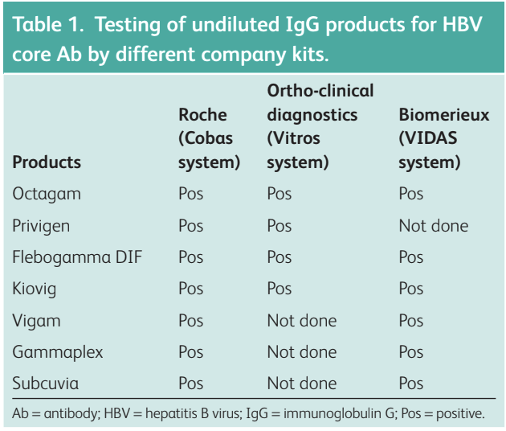
(Reference: Bright PD, Smith L, Usher J, et al. 2015)
Lu et al, 2018 conducted a retrospective analysis of cancer patients at their institution (Texas, US) and found that 15 per cent of patients treated with IVIg became HBcAb positive.
- 18,874 patients were identified, of which, 818 had negative Hepatitis B (HBV) serology prior to receiving IVIg therapy (HBcAb negative)
- Of these 818 patients, 199 were retested for HBV post IVIg therapy and 29 (15%) were found to have a newly detected HBcAb
- All of these 29 patients were negative for both HBsAg and HBV DNA
- 10 of these 29 patients had repeat HBV serology at a later date (timing varied) and were negative for HBcAb
The combination of previously documented negative HBcAb results, negative HBsAg/DNA results, and repeat serology later post IVIG therapy support passive transfer of anti-HBcAb.
The only factor found to be significant in detection of HBcAb was time since IVIg dose, with the likelihood of a positive result reducing over time from 34 per cent at one week, to four per cent at 12 weeks.

Summary and recommendations
- The risk of passive HBcAb transfer post IVIg therapy is estimated at 15 per cent
- Time since IVIg therapy significantly influences the likelihood of detecting passively transferred antibodies
- Correlation with pre-IVIg serology is recommended, however, where this is not available, waiting three – four (3-4) months post IVIg therapy before retesting is recommended if clinically appropriate
- In cases where waiting is not possible, decisions need to be tailored to individuals based on risk of prior HBV exposure, risk of reactivation (rituximab therapy and haematopoietic stem cell transplant convey the highest risk), and risk of adverse effects from HBV prophylaxis.

References
Lu H et al. Passive transfer of anti-HBc after intravenous immunoglobulin administration in patients with cancer: a retrospective chart review. The Lancet Haematology 2018; 5: e474-e478. https://www.sciencedirect.com/science/article/abs/pii/S2352302618301522?via%3Dihub
Bright PD et al. False interpretation of diagnostic serology tests for patients treated with pooled human immunoglobulin G infusion: a trap for the unwary. Clinical Medicine 2015; 15(2): 125-129. https://www.rcpjournals.org/content/clinmedicine/15/2/125
Hui EP. Immunoglobulin therapy and passive transfer of anti-HBc: too often forgotten. The Lancet Haematology 2018;5:e437e438. https://www.sciencedirect.com/science/article/abs/pii/S2352302618301583
Benwell N et al. False positive hepatitis B virus core and surface antibodies due to intravenous immunoglobulin. Internal Medicine Journal 2017; 47: 119-120.
https://onlinelibrary.wiley.com/doi/abs/10.1111/imj.13314

Authorised and published by the Victorian Government, 1 Treasury Place, Melbourne.
© State of Victoria, Australia, Department of Health and Human Services May 2020.
To receive this publication in an accessible format phone 03 9694 0102, using the National Relay Service 13 36 77 if required, or email Blood Matters bloodmatters@redcrossblood.org.au

ISSN 2652-6212 - Online (pdf / word).

