Significant treatment clinical guidelines for the Medical Treatment Planning and Decisions Act 2016
For health practitioners

Department of Health

To receive this publication in an accessible format phone (03) 9096 7498, using the National Relay Service 13 36 77 if required, or email Advance care planning <acp@dhhs.vic.gov.au>.
Authorised and published by the Victorian Government, 1 Treasury Place, Melbourne.
© State of Victoria, Department of Health and Human Services October 2017.
ISBN 978-1-76069-057-1 (print) 978-1-76069-058-8 (pdf/online)
Available at Advance care planning on the DHHS health website <https://health.vic.gov.au/acp>
Printed by Metro Printing, Tullamarine (1708029)

Contents
Introduction 1
When to use these clinical guidelines 3
Role of the medical treatment decision maker 4
Who is the medical treatment decision maker? 4
What if no medical treatment decision maker is available? 4
What if the medical treatment decision maker is refusing significant treatment when the person’s preferences and values are not known? 4
What is significant treatment? 5
Identifying significant distress 5
When do I need to get consent from the Public Advocate? 5
Section 1: Surgical treatments 6
Section 2: Physical (including allied health) treatment 8
Section 3: Pharmaceutical treatment 10
Section 4: Dental treatment 12
Section 5: Investigative and diagnostic 14
Section 6: Mental health treatment 16
Appendix 1: Descriptive text for figures 18
Figure 1: Surgical treatments decision-making pathway 18
Figure 2: Physical (including allied health) treatment decision-making pathway 18
Figure 3: Pharmaceutical treatment decision-making pathway 19
Figure 4: Dental treatment decision-making pathway 19
Figure 5: Investigative and diagnostic decision-making pathway 20
Figure 6: Mental health treatment decision-making pathway 20

Introduction
The Medical Treatment Planning and Decisions Act 2016 requires medical treatment decisions for people without decision-making capacity to be based on what the person would have wanted in the circumstances. The Act allows people to make decisions in advance, through an advance care directive about medical treatment they would or would not want, if they lose decision-making capacity in the future. A person’s informed decision should be respected and given effect to.
The Act also allows a person to appoint a medical treatment decision maker who will make medical treatment decisions on their behalf if they do not have decision-making capacity. The medical treatment decision maker is required to make the decision they reasonably believe the person would have made, if the person had capacity to make a decision. A decision by a medical treatment decision maker has the same effect as if the person had capacity and made the decision themselves, unless a medical treatment decision maker is refusing significant treatment and the health practitioner believes the patient’s preferences and values are not known.
If the health practitioner makes reasonable efforts in the circumstances to locate an advance care directive and/or a medical treatment decision maker, but is unable to locate either, the Act provides a process for proceeding. In such cases the Act requires health practitioners to decide whether medical treatment for people who do not have decision-making capacity is routine or significant.
These are clinical guidelines to help health practitioners determine whether medical treatment for a person without decision-making capacity is routine or significant and accompanies A guide to the Medical Treatment Planning and Decisions Act 2016: for health practitioners.

When to use these clinical guidelines
These clinical guidelines apply if:
- a person does not have decision-making capacity, no instructional directive can be found and no medical treatment decision maker is available; or
  - significant treatment is being refused by a medical treatment decision maker and the health practitioner believes the patient’s preferences and values are not known.
If the medical treatment is significant, the health practitioner must notify the Public Advocate.
These clinical guidelines do not apply if:
- medical treatment is required in an emergency to save the person’s life, prevent serious damage to their health or prevent them from suffering significant pain or distress; or
  - the medical treatment is palliative care.
In these cases, health practitioners may provide treatment without consent to a person who does not have decision-making capacity.
These guidelines detail the distinction between routine and significant treatment.

Role of the medical treatment decision maker

Who is the medical treatment decision maker?
There can only be one medical treatment decision maker at a time. A medical treatment decision maker is the first person listed below that is available, willing, and able to make the decision:
- an appointed medical treatment decision maker
- a guardian appointed by Victorian Civil and Administrative Tribunal (VCAT) with the power to make medical treatment decisions
- the first of the following persons who is in a close and continuing relationship with the person:
      - the spouse or domestic partner of the person
      - the primary carer of the person
      - the oldest available adult child of the person
      - the oldest available parent of the person
      - the oldest available adult sibling of the person.
If a person does not have decision-making capacity, a decision maker must always be used if available regardless of whether the treatment is routine or significant.

What if no medical treatment decision maker is available?
The health practitioner must obtain consent from the Public Advocate before a person can be given significant treatment if:
- there is no instructional directive, and
  - the health practitioner has made reasonable efforts in the circumstances to locate a medical treatment decision maker, but there is none or no one is willing and available.
If the medical treatment is routine, the health practitioner may proceed without consent, but must record this in the clinical record.

What if the medical treatment decision maker is refusing significant treatment when the person’s preferences and values are not known?
The health practitioner must notify the Public Advocate if:
- the medical treatment decision maker is refusing treatment that is significant treatment, and
- the health practitioner reasonably believes the patient’s preferences and values are not known or are unable to be known or inferred.

What is significant treatment?
Significant treatment is any medical treatment of a person that involves any of the following:
- a significant degree of bodily intrusion
- a significant risk to the person
- significant side effects
  - significant distress to that person.
Routine treatment is any treatment that is not significant treatment.

Identifying significant distress
Medical treatment that is otherwise routine may become significant, because of the significant distress it causes the person.
Health practitioners must assess significant distress according to the particular circumstances of the person. Health practitioners must consider the person’s response in light of their ordinary behaviour and their current presentation in order to determine whether the medical treatment will cause significant distress.

When do I need to get consent from the Public Advocate?
If the treatment you intend to provide is:
- surgical go to page 6
- physical (including allied health) go to page 8
- pharmaceutical go to page 10
- dental go to page 12
- investigative and diagnostic go to page 14
  - mental health go to page 16.

Section 1: Surgical treatments
In considering whether a surgical treatment is significant or routine, the health practitioner must recognise that just because they routinely perform a procedure, this does not mean that it is routine treatment.
Where surgery will cause significant distress or significant risk of side effects or harm to the patient, the surgery will be significant, even though it might be an example below of routine treatment.
Any surgical treatment that requires a general anaesthetic will be significant treatment.
Possible examples
Routine treatments | Significant treatments
- local anaesthetic  - needles – subcutaneous / intramuscular / intravenous (cannula)  - suturing a wound  - acupuncture  - drainage or lancing an abscess  - skin lesion removal  - indwelling catheter  - setting a fracture (unless using a general anaesthetic)  - laser treatment  - superficial biopsy – skin  - enemas. | - requiring general anaesthetic  - epidural anaesthetic  - cardiac thoracic surgical procedures such as, coronary artery bypass grafts surgery, valve replacement, cardiac transplant  - abdominal surgery-colectomy, cholecystectomy, pancreatectomy, laparotomy  - ear, nose and throat surgery, including tonsillectomy  - vertebroplasty  - mastectomy with and without axillary clearance  - genitourinary tract surgery, such as nephrectomy, prostatectomy, renal transplant  - respiratory surgery, such as lung transplant, lung resection, tracheostomy  - joint operations  - neurosurgery  - eye surgery, including retina repair, enucleation  - internal biopsy  - cataract surgery.
Health practitioners must obtain consent from the Public Advocate if the medical treatment is significant.
If treatment is routine, the health practitioner may proceed without consent but must record this decision in the person’s clinical record.
If a treatment is ongoing, the health practitioner may record the period over which it is provided in the medical record once.
The health practitioner must record any changes in circumstances that lead to reconsideration as to whether treatment is routine or significant.
If a medical treatment decision maker has refused medical treatment, and the health practitioner considers that the consequences of the refusal are significant and the health practitioner reasonably believes the preferences and the person’s values are not known or are unable to be known or inferred, the health practitioner must notify the Public Advocate. The Public Advocate will determine whether this refusal was reasonable.

If the treatment is not listed in the examples, use the flowchart below to determine whether the treatment is significant or routine. If the treatment is significant, the health practitioner must obtain consent from the Public Advocate.
Figure 1: Surgical treatments decision-making pathway
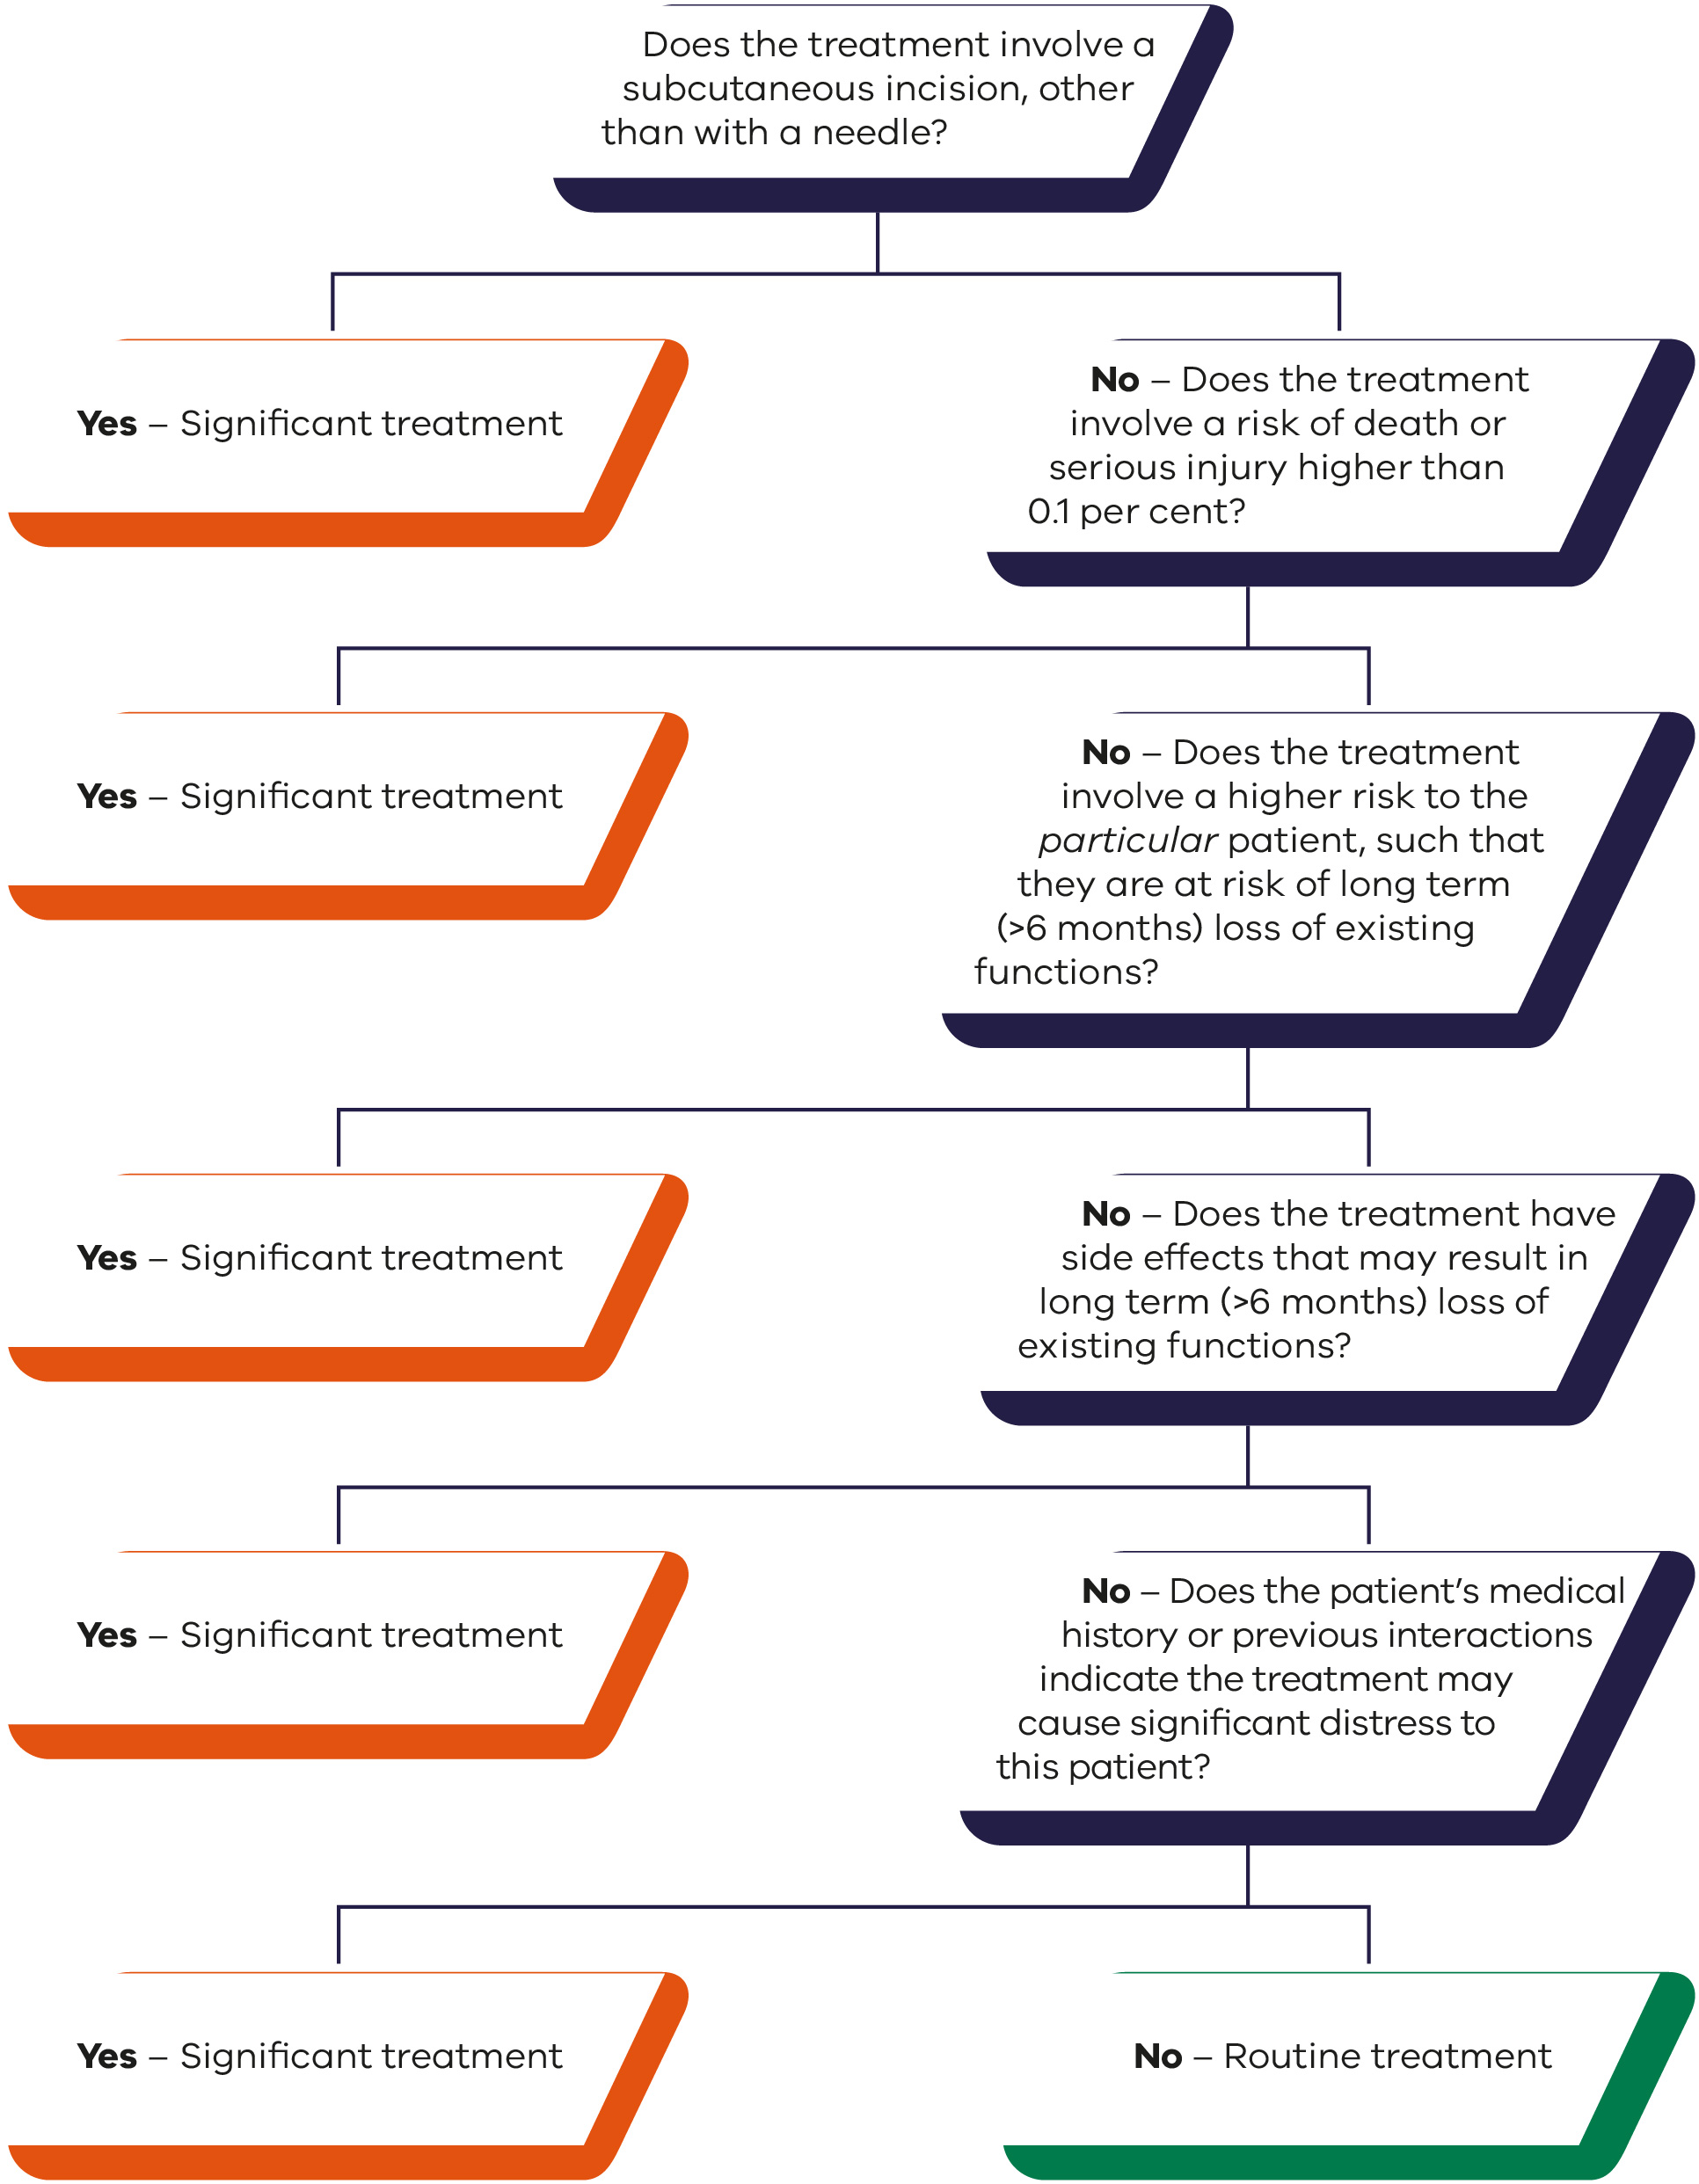

Section 2: Physical (including allied health) treatment
In considering whether a physical treatment is significant or routine, the health practitioner must recognise that just because they routinely perform a procedure, this does not mean that it is routine treatment.
Where physical treatment will cause significant distress or significant risk of side effects or harm to the patient, the treatment will be significant, even though it might be an example below of routine treatment.
Possible examples
Routine treatments | Significant treatments
- visual examination (not treatment)  - dressing a wound  - physical examination (touching the patient)  - rehabilitative exercises, including physiotherapy, occupational therapy and speech pathology  - ear wax removal  - pressure stocking  - orthosis, including ankle foot orthosis and others  - oxygen therapy  - personal care, such as hygiene care. | - spinal manipulation  - vacuum assisted closure (VAC) dressing  - non-invasive ventilation (CPAP/BIPAP)  - external cardiac pacing.
Health practitioners must obtain consent from the Public Advocate if the medical treatment is significant.
If treatment is routine, the health practitioner may proceed without consent but must record this decision in the person’s clinical record.
If a treatment is ongoing, the health practitioner may record the period over which it is provided in the medical record once.
The health practitioner must record any changes in circumstances that lead to reconsideration as to whether treatment is routine or significant.
If a medical treatment decision maker has refused medical treatment, and the health practitioner considers that the consequences of the refusal are significant and the health practitioner reasonably believes the preferences and the person’s values are not known or are unable to be known or inferred, the health practitioner must notify the Public Advocate. The Public Advocate will determine whether this refusal was reasonable.
If the treatment is not listed in the examples, use the flowchart below to determine whether the treatment is significant or routine. If the treatment is significant, consent must be obtained from the Public Advocate.
Figure 2: Physical (including allied health) treatment decision-making pathway
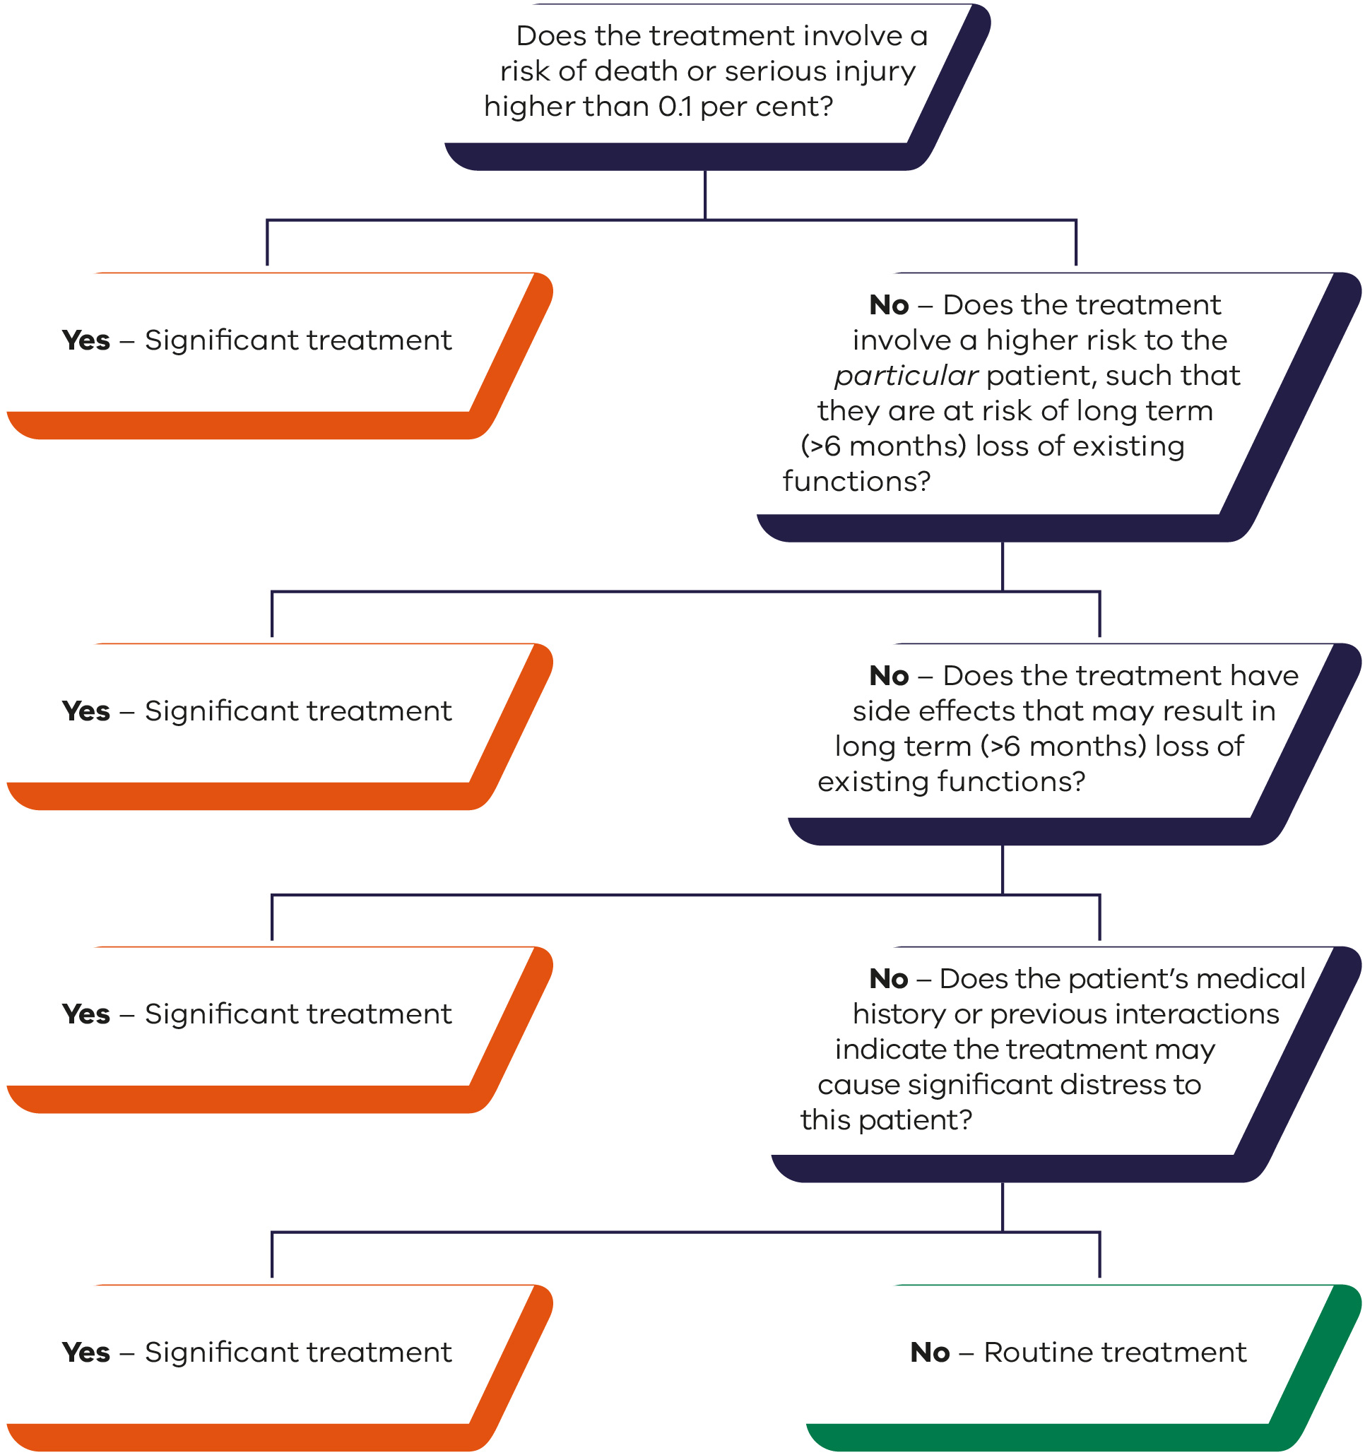

Section 3: Pharmaceutical treatment
In considering whether a pharmaceutical treatment is significant or routine, the health practitioner must recognise that just because they routinely provide the pharmaceutical, this does not mean that it is routine treatment.
Where pharmaceutical treatment will cause significant distress or significant risk of side effects or harm to the patient, the pharmaceutical treatment will be significant, even though it might be an example below of routine treatment.
Possible examples
Routine treatments | Significant treatments
- standard antibiotics  - enema  - analgesic-paracetamol, aspirin  - vaccinations  - anti-platelet therapy  - Ventolin and other inhalers  - Insulin and oral hypoglycaemics  - anti-epileptics  - oral or rectal aperients. | - antibiotics (rarely used, such as for tuberculosis)  - chemotherapy  - general anaesthetic  - antidepressants  - antipsychotics  - epidural or spinal anaesthesia  - immunotherapy  - opioids through intrathecal (continuous infusion)  - insulin pump  - anticoagulants  - radiotherapy  - hormonal implants  - HIV treatment  - PICC line insertion.
Health practitioners must obtain consent from the Public Advocate if the medical treatment is significant.
If treatment is routine, the health practitioner may proceed without consent but must record this decision in the person’s clinical record.
If a treatment is ongoing, the health practitioner may record the period over which it is provided in the medical record once.
The health practitioner must record any changes in circumstances that lead to reconsideration as to whether treatment is routine or significant.
If a medical treatment decision maker has refused medical treatment, and the health practitioner considers that the consequences of the refusal are significant and the health practitioner reasonably believes the preferences and the person’s values are not known or are unable to be known or inferred, the health practitioner must notify the Public Advocate. The Public Advocate will determine whether this refusal was reasonable.
If the treatment is not listed in the examples, use the flowchart below to determine whether the treatment is significant or routine. If the treatment is significant, consent must be obtained from the Public Advocate.
Figure 3: Pharmaceutical treatment decision-making pathway
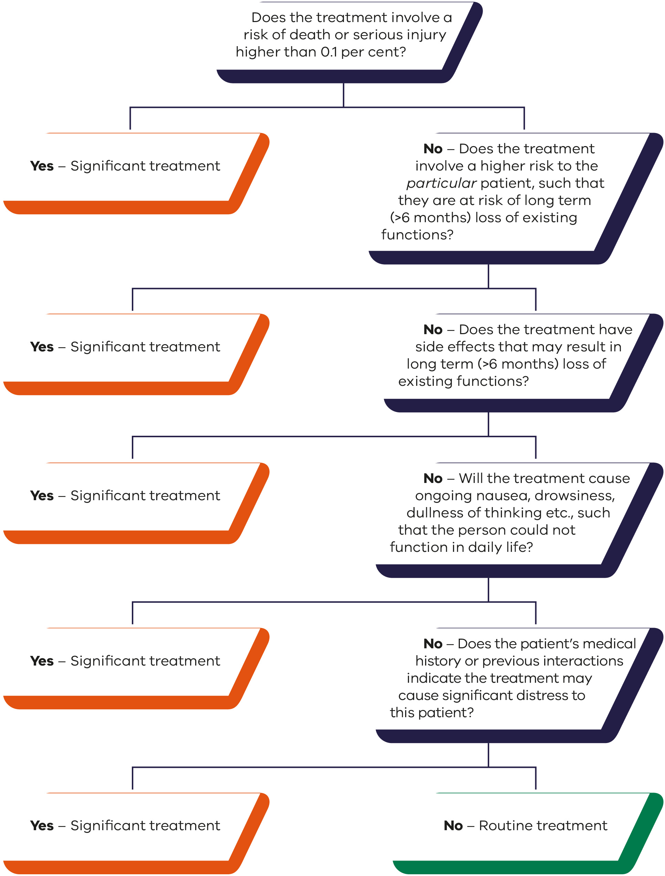

Section 4: Dental treatment
In considering whether a dental treatment is significant or routine, the health practitioner must recognise that just because they routinely provide the dental treatment, this does not mean that it is routine treatment.
Where dental treatment will cause significant distress or significant risk of side effects or harm to the patient, the dental treatment will be significant, even though it might be an example below of routine treatment.
Possible examples
Routine treatments | Significant treatments
- examination  - teeth cleaning  - intra-coronal fillings  - dental radiographic imaging  - simple tooth (uncomplicated) extraction. | - general anaesthetic (any treatment involving)  - surgical tooth extraction  - dental implants  - extra-coronal fillings  - periodontal treatment  - other surgical treatments (for example, odontogenic cysts, tumours, fractures)  - sedation.
Health practitioners must obtain consent from the Public Advocate if the medical treatment is significant.
If treatment is routine, the health practitioner may proceed without consent but must record this decision in the person’s clinical record.
If a treatment is ongoing, the health practitioner may record the period over which it is provided in the medical record once.
The health practitioner must record any changes in circumstances that lead to reconsideration as to whether treatment is routine or significant.
If a medical treatment decision maker has refused medical treatment, and the health practitioner considers that the consequences of the refusal are significant and the health practitioner reasonably believes the preferences and the person’s values are not known or are unable to be known or inferred, the health practitioner must notify the Public Advocate. The Public Advocate will determine whether this refusal was reasonable.
If the treatment is not listed in the examples, use the flowchart below to determine whether the treatment is significant or routine. If the treatment is significant, consent must be obtained from the Public Advocate.
Figure 4: Dental treatment decision-making pathway

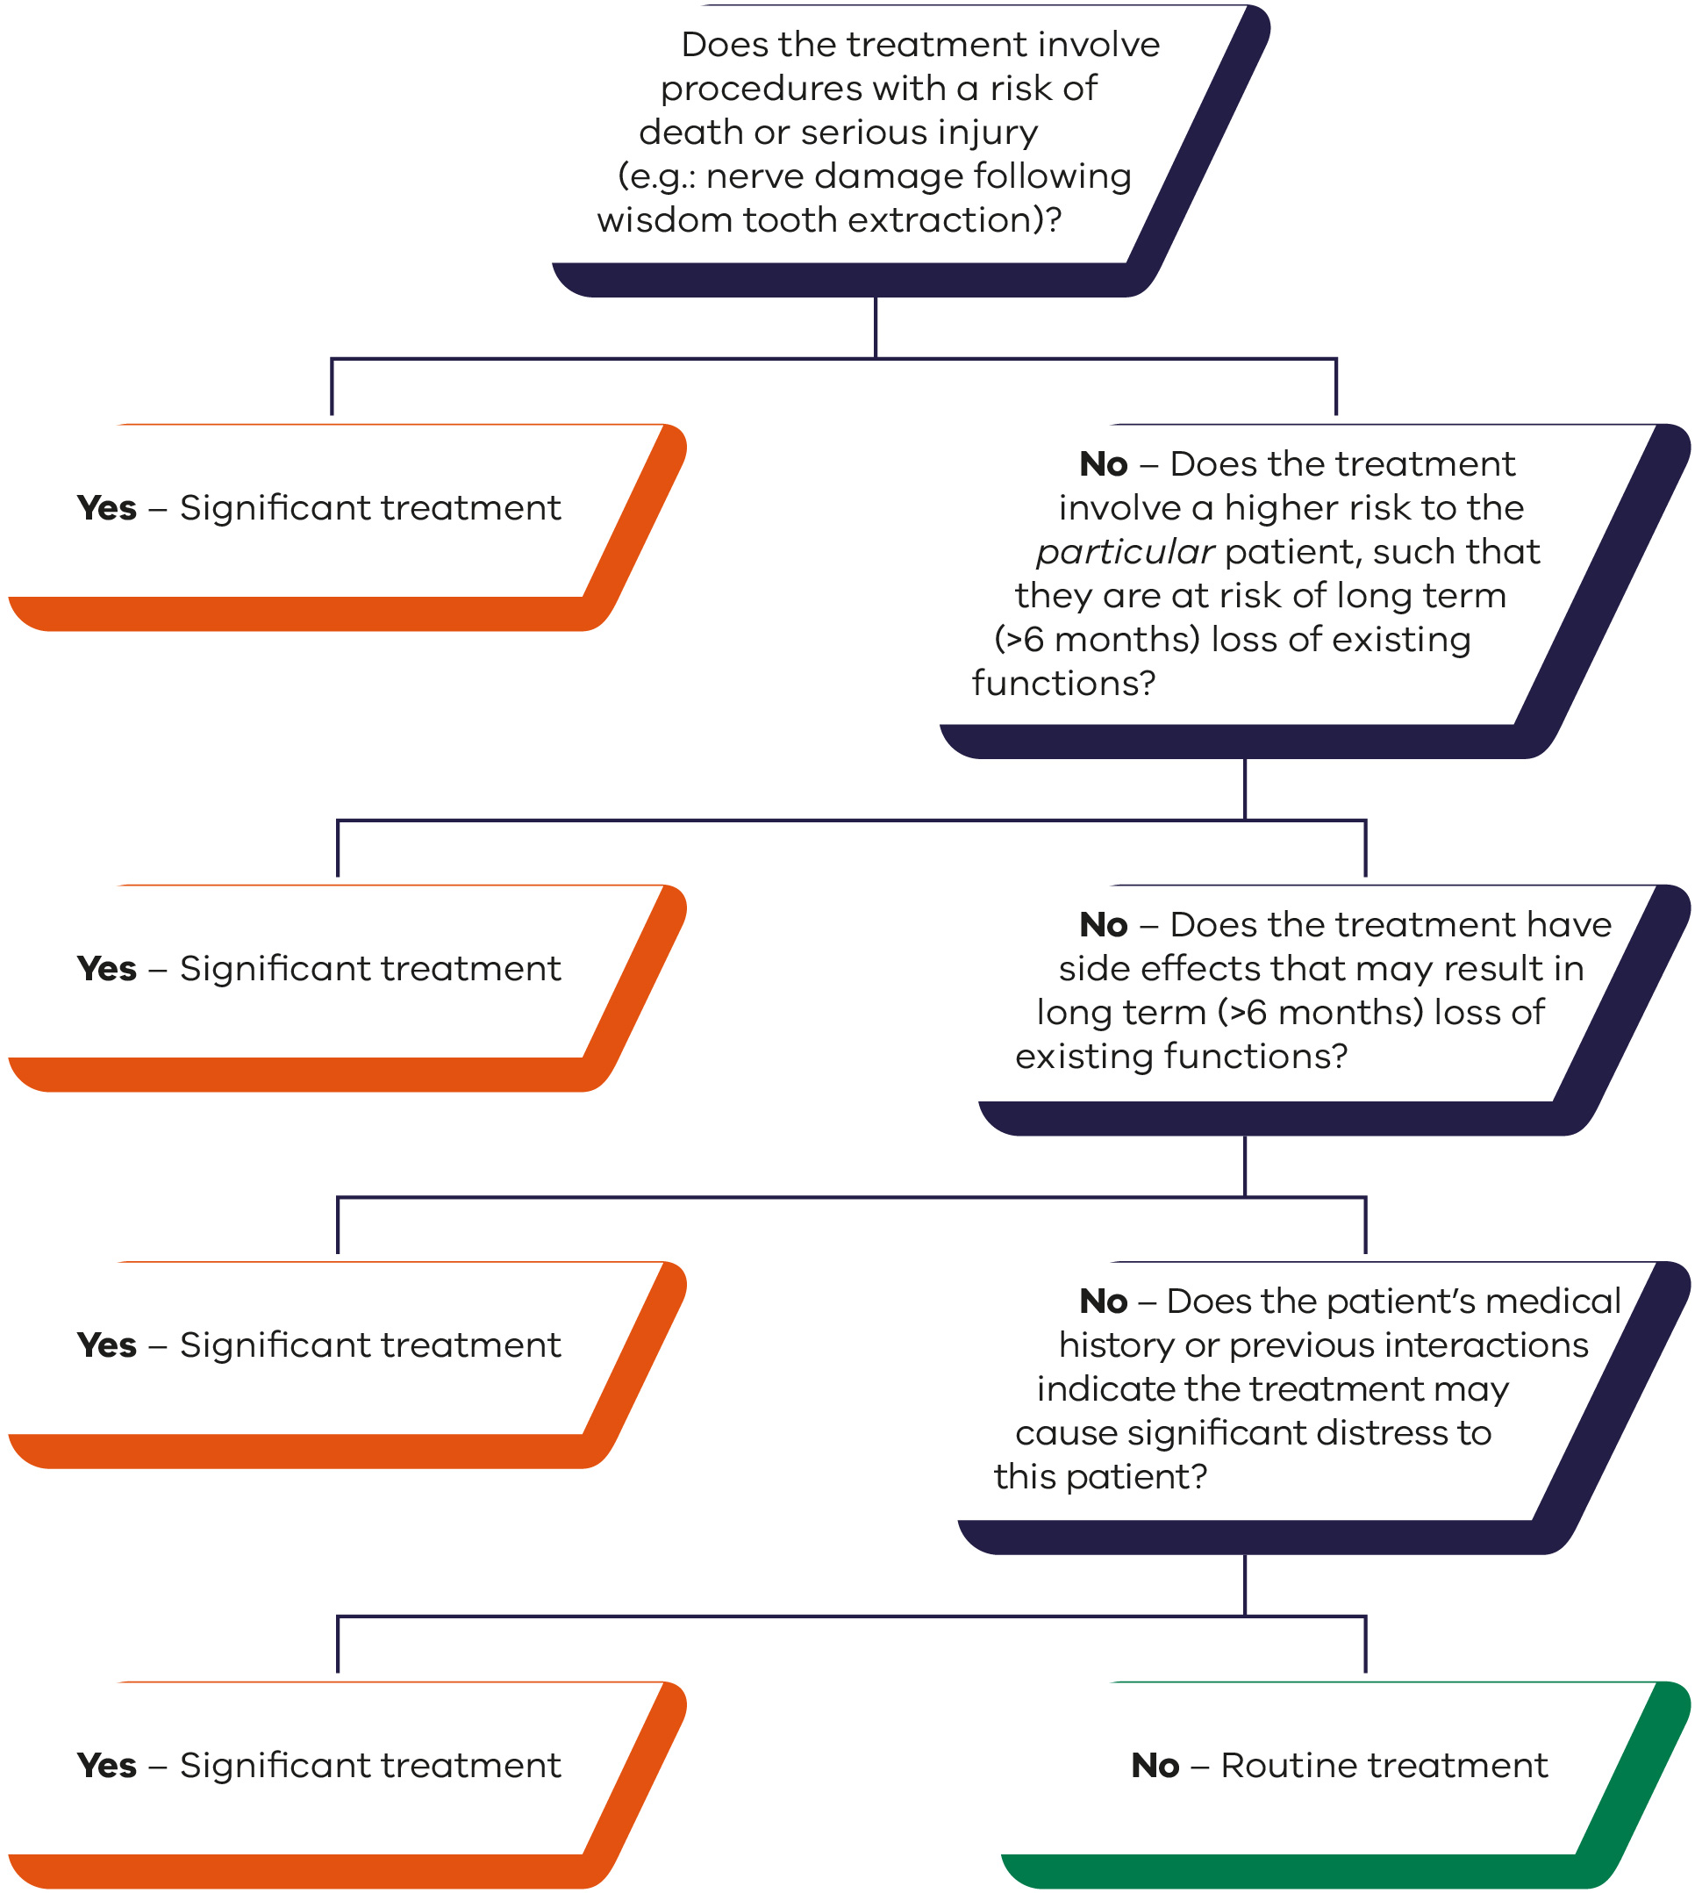

Section 5: Investigative and diagnostic
In considering whether investigative and diagnostic procedures are significant or routine, the health practitioner must recognise that just because they routinely provide the investigative and diagnostic procedures, this does not mean that they are routine treatment.
Where investigative and diagnostic treatment will cause significant distress or significant risk of side effects or harm to the patient, the treatment will be significant, even though it might be an example below of routine treatment.
Possible examples
Routine treatments | Significant treatments
- radiological  - x-rays  - plan radiographs  - Computed tomography scans (CT) - no contrast  - ultrasounds (including of heart)  - dental radiographic imaging  - electroencephalogram (EEG) and electrocardiogram (ECG)  - exercise / stress testing  - respiratory function test  - Tilt table test – cardiac / hypotension  - mammogram  - halter monitors  - bone mineral density  - audiology. | - radiological  - Magnetic Resonance Imaging (MRI)  - Computed tomography scans (CT) - with contrast  - other nuclear medicine  - cone beam computerised tomography (CBCT)  - scope  - bronchoscopy  - colonoscopy  - gastroscopy  - angiogram, for example cardiac  - laparoscopy  - transvaginal ultrasound  - procedure under sedation.
Health practitioners must obtain consent from the Public Advocate if the medical treatment is significant.
If treatment is routine, the health practitioner may proceed without consent but must record this decision in the person’s clinical record.
If a treatment is ongoing, the health practitioner may record the period over which it is provided in the medical record once.
The health practitioner must record any changes in circumstances that lead to reconsideration as to whether treatment is routine or significant.
If a medical treatment decision maker has refused medical treatment, and the health practitioner considers that the consequences of the refusal are significant and the health practitioner reasonably believes the preferences and the person’s values are not known or are unable to be known or inferred, the health practitioner must notify the Public Advocate. The Public Advocate will determine whether this refusal was reasonable.
If the treatment is not listed in the examples, use the flowchart below to determine whether the treatment is significant or routine. If the treatment is significant, consent must be obtained from the Public Advocate.
Figure 5: Investigative and diagnostic decision-making pathway

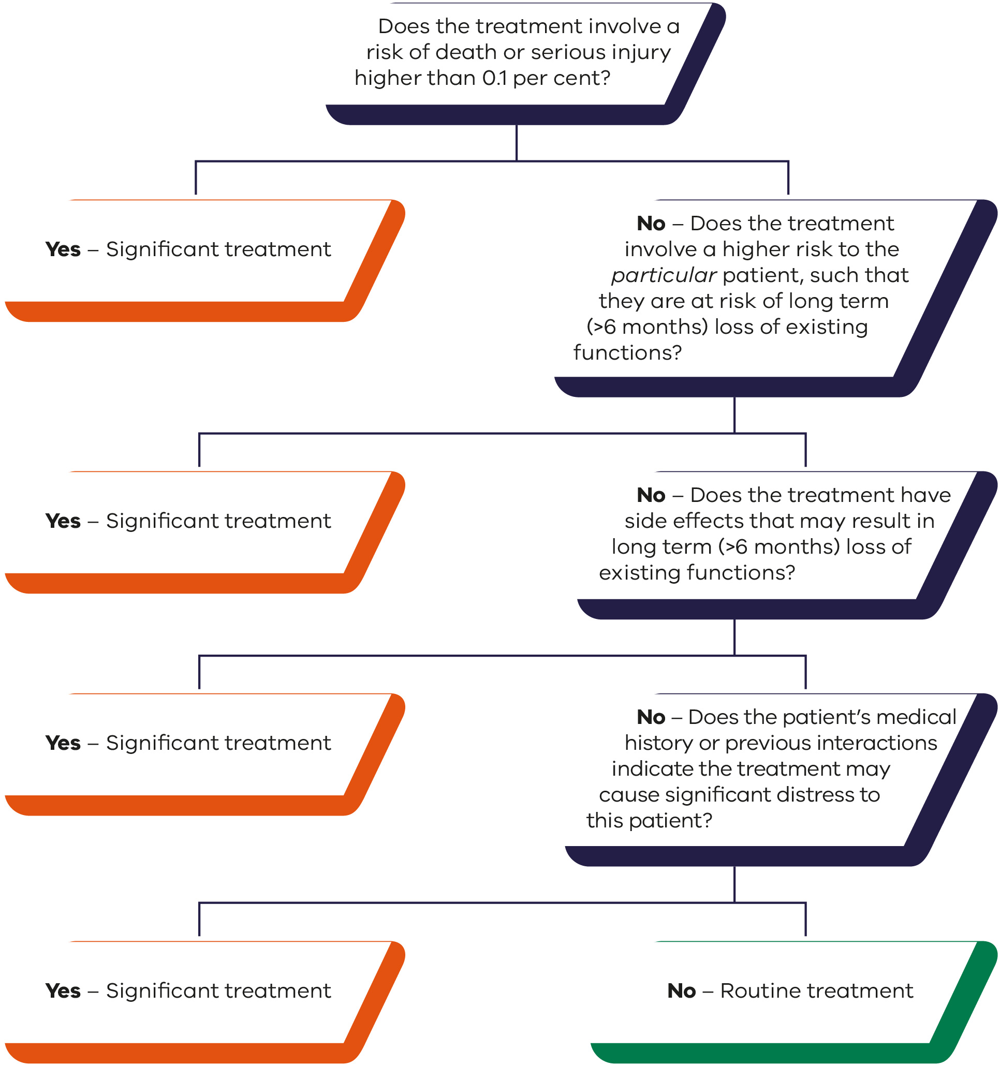

Section 6: Mental health treatment
In considering whether mental health treatment is significant or routine, the health practitioner must recognise that just because they routinely provide mental health treatment, this does not mean that it is routine treatment.
Where mental health treatment will cause significant distress or significant risk of side effects or harm to the patient, the treatment will be significant, even though it might be an example below of routine treatment.
Neurosurgery and Electroconvulsive therapy for mental illness is managed through the Mental Health Act 2014.
Pharmaceutical mental health treatment is included in ‘Section 3: Pharmaceutical treatment’.
Possible examples
Routine treatments | Significant treatments
- psychotherapy to adjust to new circumstances. For example:  - post-stroke psychotherapy  - pre- and post-amputation  - grief counselling. | - psychotherapy for major psychological disorders.
Health practitioners must obtain consent from the Public Advocate if the medical treatment is significant.
If treatment is routine, the health practitioner may proceed without consent but must record this decision in the person’s clinical record.
If a treatment is ongoing, the health practitioner may record the period over which it is provided in the medical record once.
The health practitioner must record any changes in circumstances that lead to reconsideration as to whether treatment is routine or significant.
If a medical treatment decision maker has refused medical treatment, and the health practitioner considers that the consequences of the refusal are significant and the health practitioner reasonably believes the preferences and the person’s values are not known or are unable to be known or inferred, the health practitioner must notify the Public Advocate. The Public Advocate will determine whether this refusal was reasonable.
If the treatment is not listed in the examples, use the flowchart below to determine whether the treatment is significant or routine. If the treatment is significant, consent must be obtained from the Public Advocate.
Figure 6: Mental health treatment decision-making pathway
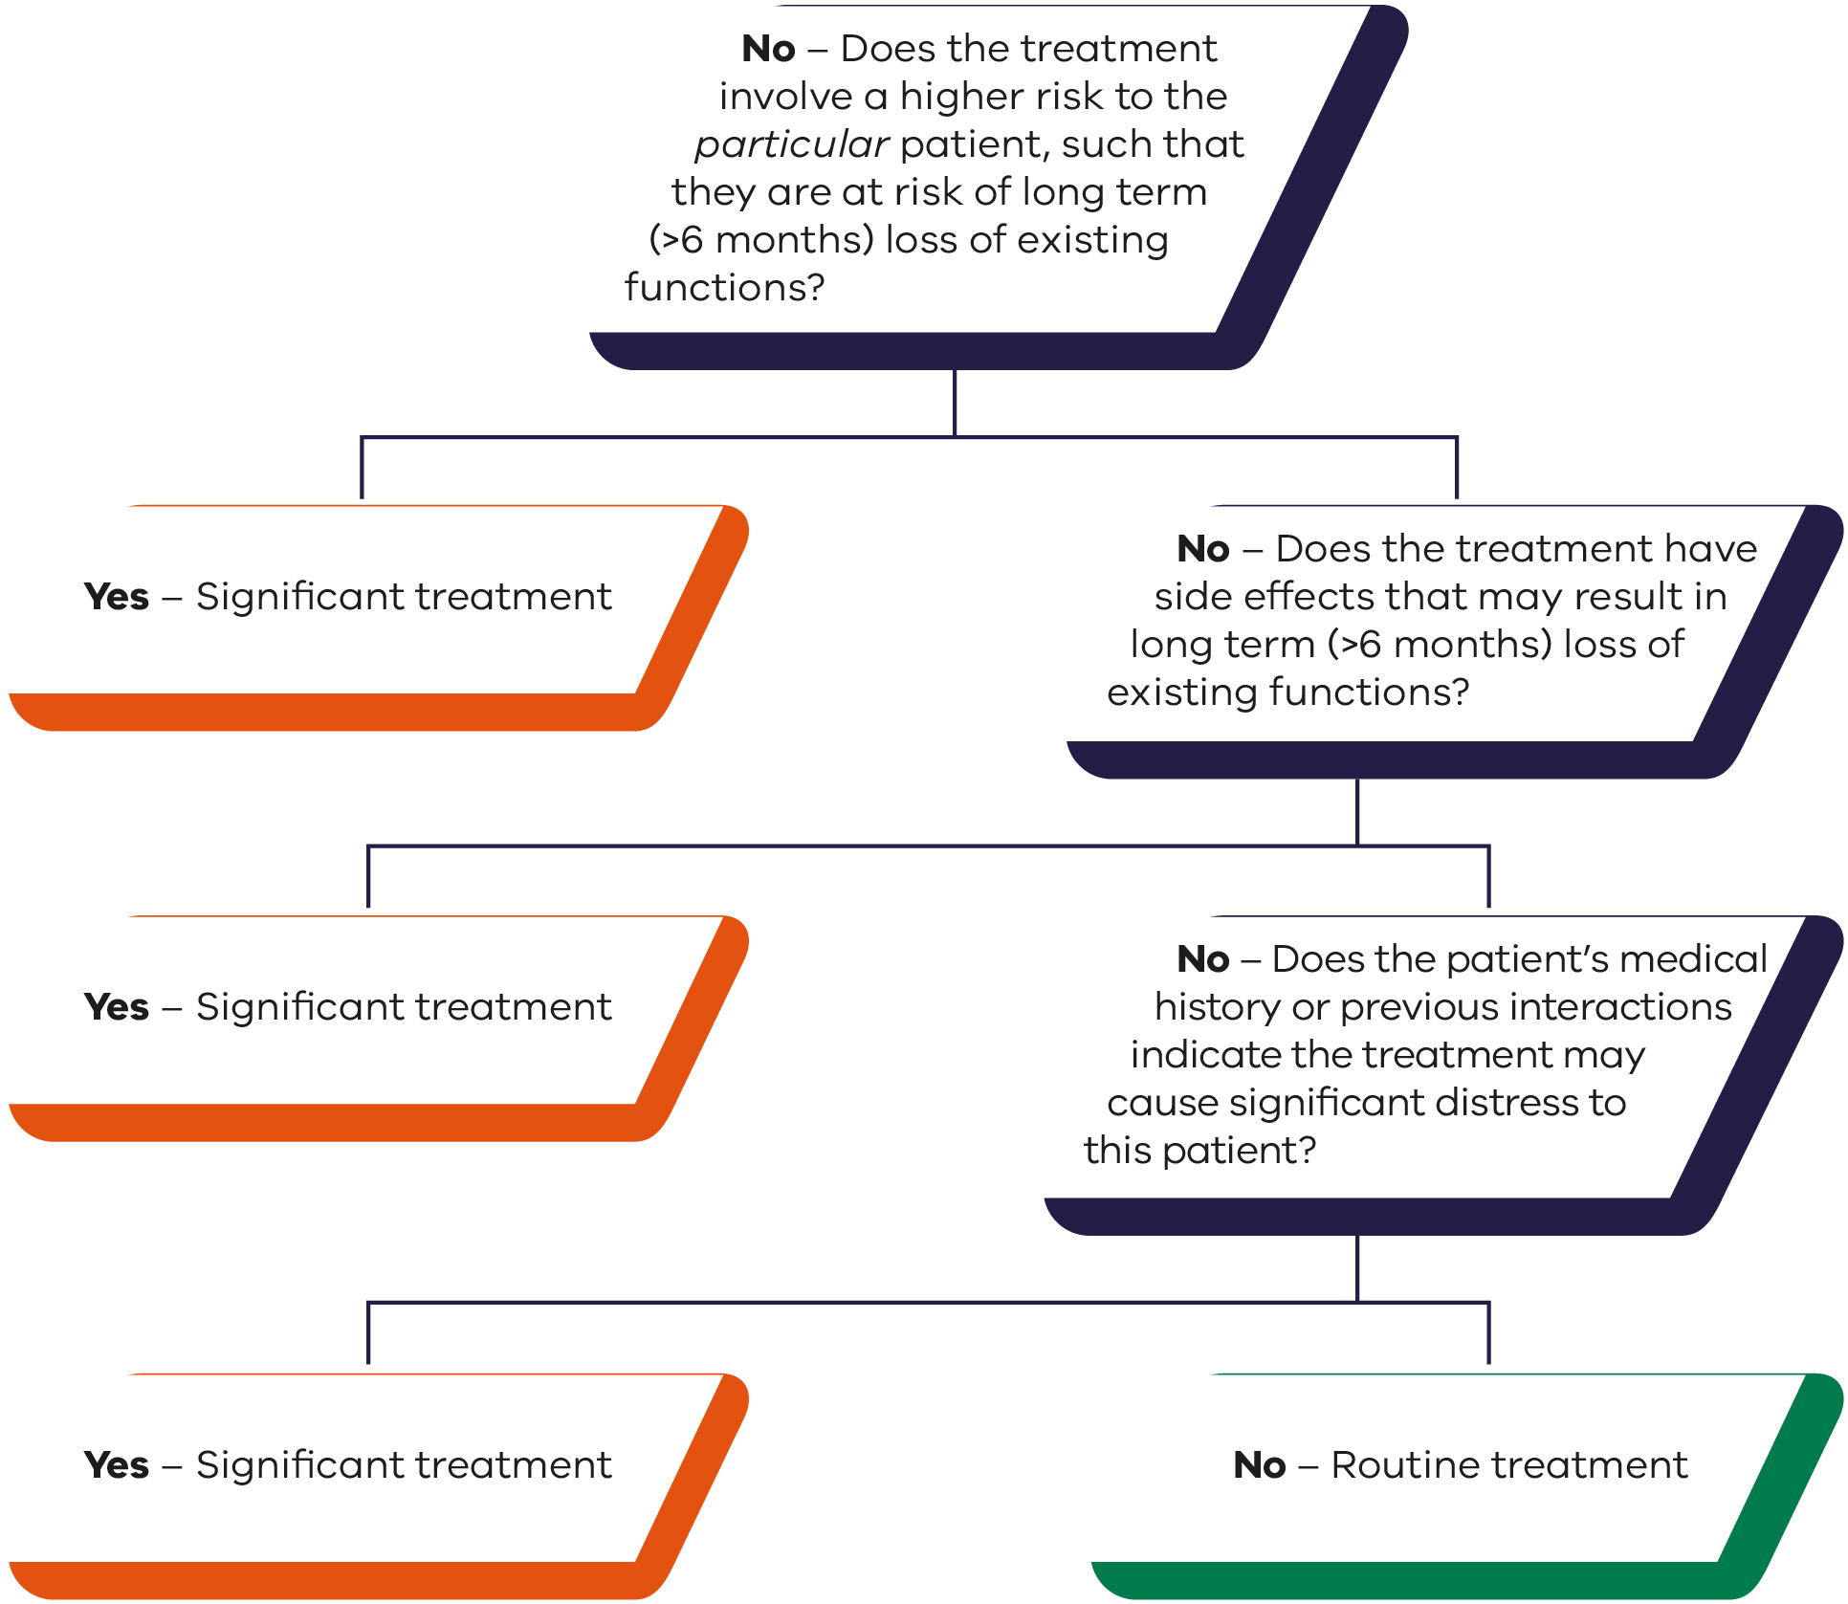

Appendix 1: Descriptive text for figures

Figure 1: Surgical treatments decision-making pathway
See Section 1: Surgical treatments for more information.
Question one: does the treatment involve a subcutaneous incision, other than with a needle?
- If yes, the treatment is significant (end).
  - If no, consider question two.
Question two: does the treatment involve a risk of death or serious injury higher than 0.1 per cent?
- If yes, the treatment is significant (end).
  - If no, consider question three.
Question three: does the treatment involve a higher risk to the particular patient, such that they are at risk of long term (greater than six months) loss of existing functions?
- If yes, the treatment is significant (end).
  - If no, consider question four.
Question four: does the treatment have side effects that may result in long term (greater than six months) loss of existing functions?
- If yes, the treatment is significant (end).
  - If no, consider question five.
Question five: does the patient’s medical history or previous interactions indicate the treatment may cause significant distress to this patient?
- If yes, the treatment is significant (end).
  - If no, the treatment is routine.

Figure 2: Physical (including allied health) treatment decision-making pathway
See Section 2: Physical (including allied health) treatment for more information.
Question one: does the treatment involve a risk of death or serious injury higher than 0.1 per cent?
- If yes, the treatment is significant (end).
  - If no, consider question two.
Question two: does the treatment involve a higher risk to the particular patient, such that they are at risk of long term (greater than six months) loss of existing functions?
- If yes, the treatment is significant (end).
  - If no, consider question three.
Question three: does the treatment have side effects that may result in long term (greater than six months) loss of existing functions?
- If yes, the treatment is significant (end).
  - If no, consider question four.
Question four: does the patient’s medical history or previous interactions indicate the treatment may cause significant distress to this patient?
- If yes, the treatment is significant (end).
  - If no, the treatment is routine.

Figure 3: Pharmaceutical treatment decision-making pathway
See Section 3: Pharmaceutical treatment for more information.
Question one: does the treatment involve a risk of death or serious injury higher than 0.1 per cent?
- If yes, the treatment is significant (end).
  - If no, consider question two.
Question two: does the treatment involve a higher risk to the particular patient, such that they are at risk of long term (greater than six months) loss of existing functions?
- If yes, the treatment is significant (end).
  - If no, consider question three.
Question three: does the treatment have side effects that may result in long term (greater than six months) loss of existing functions?
- If yes, the treatment is significant (end).
  - If no, consider question four.
Question four: will the treatment cause ongoing nausea, drowsiness, dullness of thinking etc., such that the person could not function in daily life?
- If yes, the treatment is significant (end).
  - If no, consider question five.
Question five: does the patient’s medical history or previous interactions indicate the treatment may cause significant distress to this patient?
- If yes, the treatment is significant (end).
  - If no, the treatment is routine.

Figure 4: Dental treatment decision-making pathway
See Section 4: Dental treatment for more information.
Question one: does the treatment involve procedures with a risk of death or serious injury (for example nerve damage following wisdom tooth extraction)?
- If yes, the treatment is significant (end).
  - If no, consider question two.
Question two: does the treatment involve a higher risk to the particular patient, such that they are at risk of long term (greater than six months) loss of existing functions?
- If yes, the treatment is significant (end).
  - If no, consider question three.
Question three: does the treatment have side effects that may result in long term (greater than six months) loss of existing functions?
- If yes, the treatment is significant (end).
  - If no, consider question four.
Question four: does the patient’s medical history or previous interactions indicate the treatment may cause significant distress to this patient?
- If yes, the treatment is significant (end).
  - If no, the treatment is routine.

Figure 5: Investigative and diagnostic decision-making pathway
See Section 5: Investigative and diagnostic for more information.
Question one: does the treatment involve a risk of death or serious injury higher than 0.1 per cent?
- If yes, the treatment is significant (end).
  - If no, consider question two.
Question two: does the treatment involve a higher risk to the particular patient, such that they are at risk of long term (greater than six months) loss of existing functions?
- If yes, the treatment is significant (end).
  - If no, consider question three.
Question three: does the treatment have side effects that may result in long term (greater than six months) loss of existing functions?
- If yes, the treatment is significant (end).
  - If no, consider question four.
Question four: does the patient’s medical history or previous interactions indicate the treatment may cause significant distress to this patient?
- If yes, the treatment is significant (end).
  - If no, the treatment is routine.

Figure 6: Mental health treatment decision-making pathway
See Section 6: Mental health treatment for more information.
Question one: does the treatment involve a higher risk to the particular patient, such that they are at risk of long term (greater than six months) loss of existing functions?
- If yes, the treatment is significant (end).
  - If no, consider question two.
Question two: does the treatment have side effects that may result in long term (greater than six months) loss of existing functions?
- If yes, the treatment is significant (end).
  - If no, consider question three.
Question three: does the patient’s medical history or previous interactions indicate the treatment may cause significant distress to this patient?
- If yes, the treatment is significant (end).
  - If no, the treatment is routine.

