Reducing iatrogenic blood loss – clinical practice guideline template

Table of Contents

Purpose of clinical practice guideline template 2

Background 2

Minimal blood volume strategies to reduce iatrogenic blood loss 3

1) Small-volume phlebotomy tubes 4

2) Closed inline sampling devices 5

3) Frequent evaluation of routine blood sampling orders 6

4) Bundled scheduling of blood sampling 7

5) Non-invasive techniques and point-of-care devices 7

6) Charting of cumulative daily phlebotomy loss 8

Blood sampling collection 9

Staff education and awareness of iatrogenic anaemia 10

Appendix A: Example pilot of small volume tubes in a clinical unit6 11

1. PLAN 11

1.1. The process of acquiring SVTs 11

1.2. Tube specifications 11

1.3. Validation of SVTs 12

1.4. Order of draw 12

1.5. Risks and safety 12

2. DO 12

2.1. Acknowledgement 12

2.2. Education requirements 12

2.3. Timeframe 12

3. STUDY 12

4. ACT 13

Appendix B: Cumulative daily phlebotomy loss tool 14

Appendix C: Infographic 15

References 16

# Purpose of clinical practice guideline template

To provide resources and guiding principles to assist health services include blood conservation strategies within their clinical practice guidelines.

Health service clinical practice guidelines based on, or including information contained in this document, should be developed in accordance with local clinical practice guideline policies, and should be approved/endorsed by the appropriate committee/s. When implemented they should be monitored for compliance with best practice, safety guidelines and all other requirements specific to the health service. Please note that Blood Matters Program does not endorse a particular brand where examples are provided in this guideline.

# Background

Prevention of iatrogenic (or hospital-acquired) anaemia is an important element to support patient blood management (PBM) strategies, in particular pillar two: ‘minimisation of blood loss’, in order to reduce the need for transfusion.1 The volume of blood taken by phlebotomy for laboratory monitoring during hospitalisation is a contributing factor to anaemia in critically-ill patients, especially long-stay ICU patients and children of all ages.2-4 Iatrogenic anaemia occurs due to blood loss from repeated blood sampling for diagnostic testing. Health services should develop and implement policies to promote minimal blood sampling strategies that prevent or reduce phlebotomy-associated iatrogenic blood loss, which is an important PBM issue.5

For every 100 mL of blood withdrawn, there is a decrease of 7 g/L in haemoglobin. A reduction in iatrogenic blood loss reduces the risk of anaemia and potentially the need for blood transfusion.6 (NBA 2018)

Whitehead et al. reviewed the literature on interventions to prevent iatrogenic anaemia including strategies listed below, showing these strategies can reduce iatrogenic anaemia.7 In another study, Jones et al. developed a quality improvement project that increased nursing knowledge regarding iatrogenic anaemia, phlebotomy blood loss and blood conservation strategies. This resulted in an increased use of blood conservation devices.8

According to the Blood Matters 2017 snapshot audit of minimal blood sampling, most health services did not have policies to support minimal blood sampling as a PBM approach.5 This has not changed significantly, according to the 2019 re-audit.9

The 2019 audit highlighted there is significant variation in the cumulative volume of blood samples according to clinical unit. The largest proportion of patients audited were in the clinical area of ICU (46 per cent), and this group also had the highest number of blood draws per day. Blood discard (clearance) rates were highest in the haematology/oncology (haem/onc) clinical group, followed closely by ICU.

From the data reported in the 2019 audit, there is potential concern for iatrogenic anaemia developing in patients in ICU and haem/onc, based on cumulative blood sampling volumes over the study length of stay. The large volumes were due to a combination of longer length of stay, more frequent testing and higher rates of line clearance.

Blood Matters developed and revised these guiding principles that could be used by health services for clinical practice guideline development addressing iatrogenic anaemia.

# Minimal blood volume strategies to reduce iatrogenic blood loss

The following strategies may be considered in a clinical practice guideline to minimise iatrogenic blood losses. The clinical practice guideline may apply to all patients, but especially for groups most at risk such as neonatal and paediatric patients,3 critically-ill adults and geriatric patients who are at risk of iatrogenic anaemia.10-12 Where safe and feasible, the following minimal blood sampling strategies can have an important role to reduce iatrogenic blood loss.3,5

1. Small-volume phlebotomy tubes
2. Closed inline sampling devices
3. Frequent evaluation of routine blood sampling orders
4. Bundled scheduling of blood sampling – rational test ordering
5. Non-invasive techniques and point-of-care devices
6. Charting of cumulative daily phlebotomy loss

Implementing these strategies requires planning and communication with relevant stakeholders such as medical staff, laboratory scientists and nursing staff;1 as well as local infection control, pathology services and quality improvement services.

Health services will need to determine which minimal blood sampling strategy/ies is/are feasible to implement within their organisation. The background/rationale for each minimal blood sampling strategy is outlined below along with recommended key points to consider when developing your clinical practice guideline (CPG).

Following a plan-do-study-act (PDSA) cycle could assist the implementation of any strategies. Figure 1 looks at the implementation or pilot of small volume tubes in a clinical unit (see Appendix A for more information).

*Figure 1: PDSA cycle for the implementation of small volume tubes (SVT) in a clinical area*

## Small-volume phlebotomy tubes

**Background/rationale:**

Blood loss for testing could range between 0.1mL (in NICU[min]) to 111mL (in adult ICU[max]) in the 2019 audit.9 Previous studies in intensive care units (ICU), adult patients lose about 38 mL of blood a day, with lower volumes in paediatrics ICU (9 mL) and neonatal ICU (0.2 mL).11Advances in laboratory analysers have enabled for a small volume for blood sampling as sufficient to generate reliable results.13,14

Implementation of paediatric size tubes resulted in a 47 per cent reduction in the amount of blood volume collected in one institution.10 In Australia, one health service reported a statistically significant (p<0.001) reduction of 21 per cent in blood volume lost due to blood sampling and discard volume after implementation of small volume tubes (SVT) in adult ICU long stay patients.6 Providers of test tubes for blood collection are able to supply smaller tubes (2–5 mL) to help reduce the volume of blood collected.13 It should be noted there is a difference between SVT and paediatric tubes. SVT generally have thick walls so require less volume and can usually fit in any analyser; unlike paediatric tubes which often require manual handling to complete testing. It should be acknowledged that smaller volumes could potentially limit the number of tests that can be done.

**Key points to consider:**

* Promote adherence to minimum sample volumes needed for analysis.3
* Explore the potential to use SVT compatible with current pathology analysers in liaison with pathology and involving pathologists in the discussions.
* Identify the health service population where SVT will be used.
* Use the smallest collection tube size that is practical for the required analysis.
* Outline the type/s of SVT that will be used.
* Include audits to monitor practice according to the CPG.
* In the tender process consider automated laboratory equipment capable of analysing smaller blood samples.3
* SVT may not be appropriate for some patients – for example if a patient has a history of an antibody, the laboratory may require a larger volume of sample for antibody investigation and crossmatching.

## Closed inline sampling devices

**Background/rationale:**

Traditionally, when drawing blood from indwelling devices, the initial blood volume used to clear the line is discarded. In a short survey of Australian critical care professionals, volume of line clearance taken varied, ranging from 1 to 10 mL in adults; cumulatively this can contribute to iatrogenic anaemia.15 The Blood Matters 2019 audit found 0.05-68mL discarded daily, depending on the device used and grouping. Only 1-2 per cent of all venous blood collections had line clearance returned, and 14 per cent of all arterial line clearances were returned.9

Central venous lines tend to have higher overdrawn blood sampling (in excess of laboratory requirements) than indwelling arterial lines, peripheral IV catheters or peripheral draws.3 A balance of risk associated with indwelling vascular lines and the difficulty of obtaining samples via other routes should be taken into account.3

Closed inline sampling devices has been associated with a 50% reduction in diagnostic blood loss. Closed-system sampling (see Figure 2) allows the reinfusion of blood drawn from indwelling devices. Use the device to reinfuse the initial blood taken to ‘clear the line’ (drawback blood). Follow the manufacturer’s instructions when using these devices.

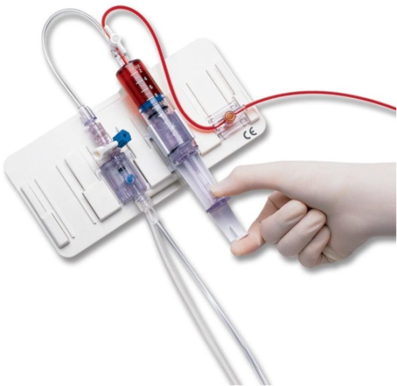 [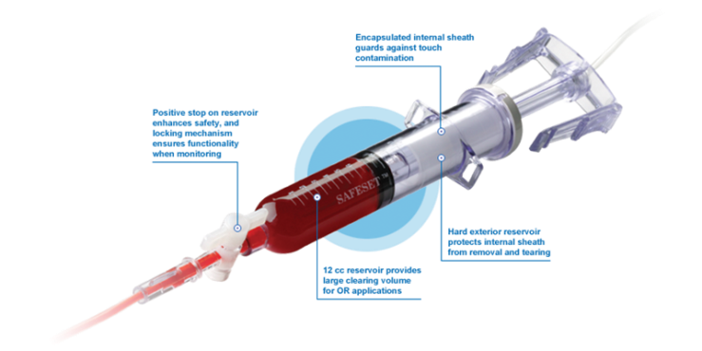](http://www.google.com.au/url?sa=i&rct=j&q=&esrc=s&source=images&cd=&cad=rja&uact=8&ved=0ahUKEwjGs6qB7sHWAhVMlJQKHTQHBjoQjRwIBw&url=http://www.icumed.com/products/critical-care/closed-blood-sampling-and-conservation.aspx&psig=AFQjCNEqbXc6LV8sb_ZUEwcKxCFDHldC_A&ust=1506481198872634)

*Figure 2. Example of a closed-system sampling devices (Venous Arterial Blood Management Protection, Edwards Lifesciences**16* *and SAFESET Blood Sampling System, ICU Medical**1**7)*

**Key points to consider:**

* Efforts should be made to reduce the blood waste by using closed inline flush blood sampling devices.
* Inclusion of clear instructions on the methods of use for the nominated closed sampling device and ongoing education for staff in use and pitfalls.
* If device not used efforts should be made to reduce the ‘discard’ volume when samples are obtained from indwelling lines.
* Avoid blood overdraws and return ‘discard’ volumes to sampling lines to minimise phlebotomy blood losses.
* Judicious use and ‘on time’ or early removal of sampling lines, especially in neonatal and paediatric patients,18 is recommended to avoid blood overdraw.

## Frequent evaluation of routine blood sampling orders

**Background/rationale:**

Understand commonly used laboratory parameters and test ordering behaviour in the clinical unit through audits, interviews or survey evaluation. Determine the behavioural factors which influence test ordering by clinicians on the unit and examine the feasibility of implementing strategies to decrease unnecessary test ordering by these clinicians.

Literature recommends health services to employ as-needed or rationalisation of blood sampling depending on the individual patient’s clinical needs to minimise the volume of blood drawn. Refrain from using pre-packaged orderings.18 The Choosing Wisely Canada ‘Pause the draws’ provides a toolkit that may be helpful to health services when considering this strategy.19

Establish a group of interdisciplinary local experts (e.g. critical care, surgery, general medicine, infectious diseases, neurology, pathology, and nursing staff) to develop a consensus (based upon evidence and expert opinion recommendations) on parameters and frequency of laboratory testing in common situations to guide clinical practice.20

Consider the effect of introduction of electronic medical orders, if ordering groups are used. Without review of need, unnecessary testing may become a problem as busy clinicians order the package without consideration of need for testing.

**Key points to consider:**

* Promote the evaluation of the need for routine or repetitive testing at least daily.21
* Efforts should be made to reduce unnecessary laboratory test and only order essential blood tests rather than routine blood sampling.3
* Education of staff to refrain from drawing extra tubes of blood “in case” additional tests are needed.21 or if uncertain about the tubes required.
* Efforts should be made to reduce sampling for blood culture draws in daily routine and limit to established indications.18
* Consider, will these results affect the patient treatment plan, or is there a change in the patient condition that warrants further assessment

**Example practices:**20,22,23

* Biochemistry profile no more frequently than every 12 hours
* Full blood examination with differentials should only be performed every 36 hours
* In critical care patients, order tests for sodium, potassium, chloride, and full blood examination only once per day
* In critical care patients, analyse arterial blood gas (ABG) measurement only after significant changes in minute ventilation, fall in oxygen saturation, or significant changes in clinical condition
* In critically-ill patients who develop early postoperative fever in the ICU should trigger a careful clinical assessment rather than automatic orders for obtaining blood cultures and imaging tests
* Take into account the half-life and appropriateness of clinical biomarkers; for example, half-life of C-reactive protein (CRP) is 19 hours and is not recommended as an aid to the initiation or discontinuation of any antibiotic in adults

## Bundled scheduling of blood sampling

**Background/rationale:**

Bundled scheduling of blood tests also reduces loss of ‘discard’ volume.11 In addition to the prevention of iatrogenic anaemia, patients will also appreciate fewer painful draws from phlebotomy.18 or the increased risk of infection due to accessing central lines frequently

**Key points to consider:**

* Efforts should be made to schedule blood tests at the same time so that a single sample of blood can be used for multiple tests.21
* Check which tubes are needed and do not add extra tubes, in case
* Ensure you have knowledge of which tests can share a tube and which cannot. Consider if a test is performed in-house in the same department or whether it is sent to an external laboratory for testing.

## Non-invasive techniques and point-of-care devices

**Background/rationale:**

Literature recommends health services to employ non-invasive techniques and point-of-care devices to estimate haemoglobin, coagulation status, blood gases and other analytes.1,3

Optimal use of non-invasive techniques that monitors blood gas and biochemistry has the potential to reduce phlebotomy losses.3 These non-invasive techniques have been studied in neonates and infants, and include: 1) contemporary ventilators that monitor respiratory function; 2) end-tidal carbon dioxide monitoring; and 3) transcutaneous and regional oxygen saturation.

Point-of-care testing devices are capable of accurate and precise measurements of whole blood using small sample volumes; thus, could further reduce the volume of iatrogenic blood loss.10 In contrast to conventional pathology systems, point-of-care devices directly introduce the sample into the device and partially eliminate dead volume requirements of conventional biochemistry analysers.

These may not be cost effective in some health services where minimal testing occurs.

[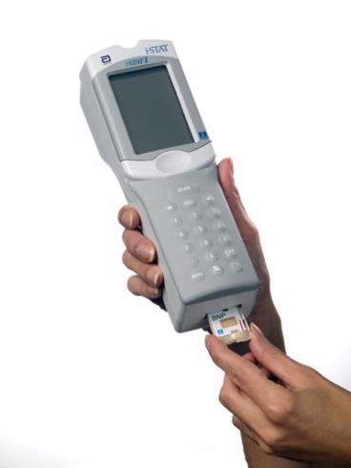](http://www.google.com.au/url?sa=i&rct=j&q=&esrc=s&source=images&cd=&cad=rja&uact=8&ved=0ahUKEwimssyMxOfVAhVLilQKHe7QBJsQjRwIBw&url=http://www.poct.co.uk/product.cfm/pID/169&psig=AFQjCNE-KXkF_2Tbm7AgYYjzlDNICKDoBg&ust=1503377572983554) 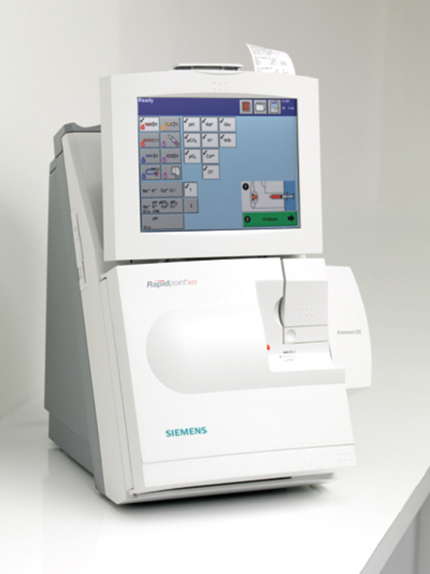

*Figure 3. Examples of point-of-care blood gas analyser (i-STAT, Abbott*24*and Siemens RAPIDPoint 400/405 Systems2**5**)*

Follow the manufacturer’s instructions when using these techniques/devices and ensure standard calibration techniques and operating procedures are in place following local health service policies. The Royal College of Pathologists of Australasia has published a [position statement on the use of point-of-care testing](https://www.rcpa.edu.au/getattachment/49929780-7f4e-47ae-a78a-baec9955fc5e/Point-of-Care-Testing.aspx).26

**Key points to consider:**

* Identify the health service population where non-invasive methods and use of point-of-care testing are feasible.
* Explore the use of non-invasive methods whenever possible (e.g., pulse oximetry rather than arterial blood gas analysis).21
* Efforts should be made to use point-of-care testing with microanalysers rather than traditional laboratory tests when available.21
* Liaise with your pathology laboratory and involve pathologists in the discussions around the proper use of point-of-care testing within your health service, refer to [RCPA position statement: point of care testing](https://www.rcpa.edu.au/getattachment/49929780-7f4e-47ae-a78a-baec9955fc5e/Point-of-Care-Testing.aspx).26

## Charting of cumulative daily phlebotomy loss

**Background/rationale:**

Keeping a record on the frequency and volume of blood drawn for each patient is an informative first step20 to recognise the amount of blood that is lost due to sampling in the unit. This is also a baseline to quantify and compare the effect of minimal blood volume sampling strategies.20

Appendix B is an audit tool to calculate the cumulative daily phlebotomy loss per patient. Health services can use the tool to identify the actual volumes taken from patients. If these blood loss volumes are found to be significant, health services should communicate the results to respective transfusion or blood management committee and then agree on minimal blood volume strategies to reduce iatrogenic blood loss.

**Key points to consider:**

* Identify the health service population to chart cumulative daily phlebotomy blood loss.
* Audit cumulative phlebotomy losses in these selected groups of patients at regular intervals to assess phlebotomy-associated blood losses and compliance with techniques to minimise this.1,3,11
* Keep a running total of phlebotomy blood loss in a prominent place in the patient’s medical record.21

# Blood sampling collection

Efforts should be made to always use optimal sampling technique, labelling and sample handling to minimise rejection of samples by the pathology service3 and preventing additional blood drawn from the patient.

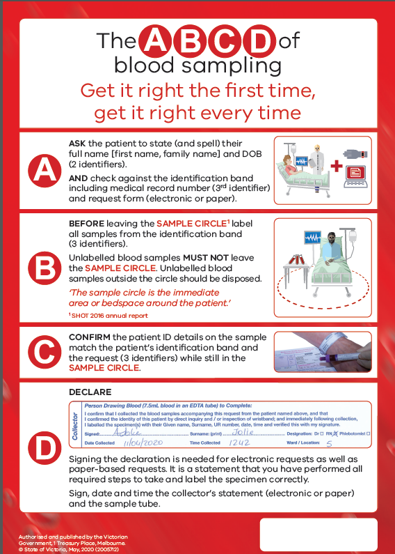

Follow the ABCD of specimen collection for every specimen collected to ensure appropriate treatment for patients.

* + **A**sk the patient to state and spell their name and their date of birth
  + **B**efore leaving the patient, label the specimens
  + **C**onfirm the sample request form, the specimens and patient ID details all match
  + **D**eclaration: Document collector details, signature and date and time of collection on request form.

<https://www2.health.vic.gov.au/about/publications/formsandtemplates/ABCD-Blood-sampling-poster>

# Staff education and awareness of iatrogenic anaemia

Health services should provide regular patient blood management education to include awareness of iatrogenic anaemia. Topics would include:

* An introduction to patient blood management (PBM) <https://bloodsafelearning.org.au/resource-centre/other-resources/videos/>
* PBM strategy: prevention of iatrogenic anaemia
* Summary of Blood Matters audit of minimal volume blood sampling to prevent iatrogenic anaemia 2019 <https://www2.health.vic.gov.au/about/publications/researchandreports/blood-sampling-volume-audit-2019>
  + Download an infographic summary (Appendix C) and complete report from the Blood Matters Program webpage:
  + Minimal blood volume strategies to reduce iatrogenic blood loss
* Techniques in sample collection and laboratory requirements
* Tube guide and correct order of draw. Examples:
  + [Melbourne Pathology – Tube guide](https://www.mps.com.au/media/6566/m1170_tube_guide_update_web_14_6_2018.pdf)
  + [Alfred Pathology Service – Tube guide for common tests](https://www.alfredhealth.org.au/contents/resources/clinical-resources/Tube-Guide-for-Common-Tests-V1.6.pdf)
  + [St Vincent’s Pathology – Order of draw tube guide](http://pathmanual.svhm.org.au/resources/tubeguide.pdf)
  + [Dorevitch Pathology – Paediatric Tube Guide](http://www.dorevitch.com.au/siteassets/home-page/2-practitioners/specimen-collection-guides/dp0291v2-paediatric_tube_guide-web.pdf)
* How to chart cumulative daily phlebotomy loss <https://www2.health.vic.gov.au/hospitals-and-health-services/patient-care/speciality-diagnostics-therapeutics/blood-matters/patient-blood-management/minimal-blood-sampling-strategies> (Appendix B)

Education of staff to change attitudes to reduce iatrogenic blood loss is of great importance to address knowledge gaps, facilitate behaviours, and reduce barriers to implementation.15

## Appendix A: Example pilot of small volume tubes in a clinical unit6

### PLAN

The aim of the pilot is to use small volume tubes (SVTs) to reduce volume of blood collected from an individual patient with a focus of minimising iatrogenic anaemic.

Obtain approval within the health service and agreements amongst health professionals to conduct the pilot implementation.

### The process of acquiring SVTs

Obtain SVTs that are cost neutral to the tubes that are in current use in the pathology. It is essential that SVTs are compatible with existing full blood examination (FBE), biochemistry and coagulation analysers. Consult pathology services and examine SVTs suitability for use. Get permissions to purchase any tube stock changes required.

### Tube specifications

Compare and summarise the standard and SVTs dimensions used for laboratory testing.26 Example below:

|  |  |  |  |  |
| --- | --- | --- | --- | --- |
| Cap colour | Contents | Test | Standard | SVT + fill notes |
| Purple | EDTA | FBE analysis  Drug levels  DAT | 4 mL | 2 mL  Tube will only fill ½ way |
| Blue | Sodium citrate | Routine Coagulation studies  Note: Not for use for APTT in IV heparin monitoring | 3.5 mL | 2 mL  Fill tube to fill line. |
| Green | Lithium  Heparin + gel | Biochemistry profile  Glucose  Drug testing | 9 mL | 2.5 mL  Tube will only fill ½ way |
| Red | Gel fast clotting serum  Clot activator | Tumour markers  B12/Folate serology | 9 mL (16 mm) | 5 mL (12 mm)  Tube will only fill ½ way |
| Pink | EDTA | Transfusion medicine | 9 mL | 6 mL  Fill tube to fill line. |
| Blood gas |  |  | 3 mL | 3 mL |

Note: Refer to SVT manufacturer for accurate volume of tubes and instructions to fill lines.

### Validation of SVTs

Perform a validation study to ensure that SVTs for biochemistry and haematology tests are accurate for your pathology. Comparative results of standard versus SVTs should show samples are linearly related and accurate for haematology (e.g. white blood cell count, red blood cell count, haemoglobin, mean cell volume, platelet count values, etc.) and biochemistry (e.g. sodium, potassium, chloride, creatinine, urea, bicarbonate, glucose, etc.) parameters.

### Order of draw

Adhere to the International Order of Draw (vacutainer use) and local policy to minimise cross contamination of specimen tube.

### Risks and safety

Adhere to routine PPE and infection control according to health service policy and procedures.

Risks associate with SVTs may relate to staff’s sample collection and tube filling techniques. If order of draw, vacutainer collection/transfer and correct patient identification and labelling processes are undertaken then the risk is not different to standard volume tubes.

### DO

Provide education requirements to clinical and pathology staff: SVT types, order of draw, filling, transfer devices (vacutainer), patient benefits and implementation

### Acknowledgement

* Notify all staff to acknowledge changes. Implementation requires communication with relevant stakeholders

### Education requirements

* Background of the pilot implementation
* Correct ABCD blood sample collection
* Correct labelling of SVTs
* Correct vacutainer technique and order of draw
* Types of SVTs and correct filling
* Compulsory fill to line for all SVTs and acknowledge overfilled tubes could not be processed
* Feedback opportunities during implementation phase

### Timeframe

* Replace standard volume tubes to SVTs at the agreed time and date by the unit.
* It would take approximately 4 to 8 weeks from pilot approvals to stock implementation depending on the health service’s ability to complete education and SVT stock changes

### STUDY

* Monitor number of specimen overfill, underfill, clotted, rejected, unlabelled, wrong tube, add-on tests could not be done
* Monitor SVT related events and adverse collections
* Survey staff of SVT use: convenience, ease-of-use, challenges, discard volume
* Chart cumulative daily phlebotomy loss

### ACT

* Feedback to unit adverse collections, rejected sample, overfilled/underfilled data, etc.
* Act on any identified issues
* Identify commonality of issues or causes of issues

## Appendix B: Cumulative daily phlebotomy loss tool

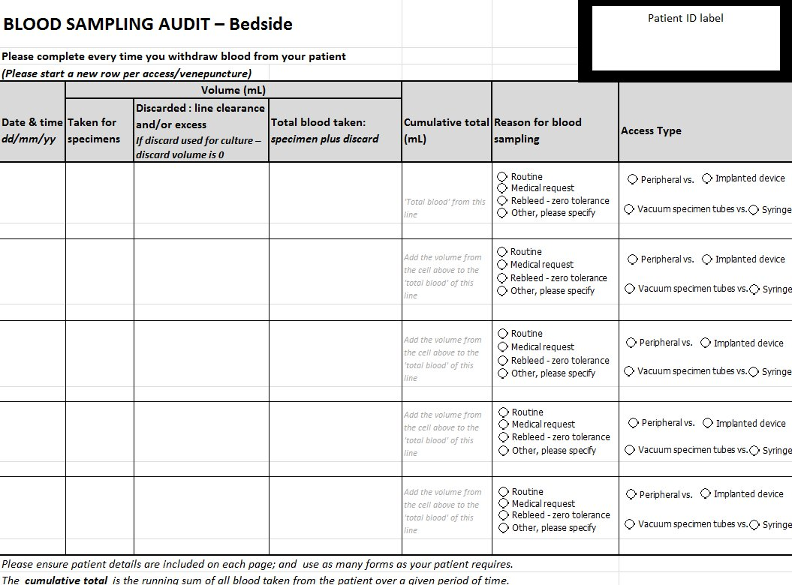

Download the tool from the Blood Matters Program website: <https://www2.health.vic.gov.au/hospitals-and-health-services/patient-care/speciality-diagnostics-therapeutics/blood-matters/patient-blood-management/minimal-blood-sampling-strategies>

## Appendix C: Infographic

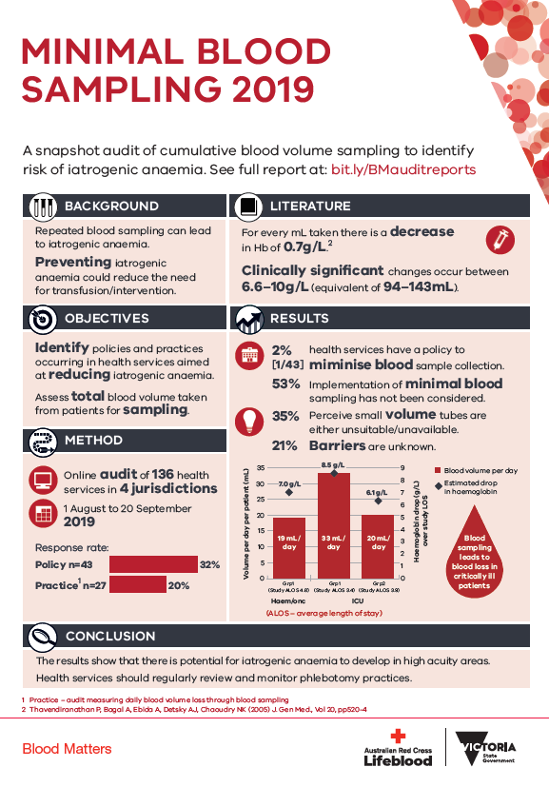

Download the infographic from the Blood Matters Program website: <https://www2.health.vic.gov.au/-/media/health/files/collections/factsheets/b/minimal-blood-sampling-2019_final-web.pdf>

# References

1. National Blood Authority. Patient Blood Management Guidelines – Companions. 2014. (Accessed 08 August 2017, at  [https://www.blood.gov.au/](http://www.blood.gov.au.))

2. Tinmouth AT, McIntyre LA, Fowler RA. Blood conservation strategies to reduce the need for red blood cell transfusion in critically ill patients. CMAJ : Canadian Medical Association journal = journal de l'Association medicale canadienne 2008;178:49-57.

3. National Blood Authority. Patient blood management guidelines: Module 6 Neonatal and Paediatrics. Australia: NBA; 2016.

4. Bell EF. When to transfuse preterm babies. Archives of disease in childhood Fetal and neonatal edition 2008;93:F469-73.

5. Blood Matters Program. Snapshot audit of minimal volume blood sampling to prevent iatrogenic anaemia 2017. Melbourne, Australia: State of Victoria, Department of Health and Human Services; 2017.

6. National Blood Authority. Small volume tubes at Flinders Medical Centre, SA 2018 https://www.blood.gov.au/small-volume-tubes-flinders-medical-centre-sa

7. Whitehead NS, Williams L, Meleth S, Kennedy S, Ubaka-Blackmoore N, Geaghan SM,

Nichols JH, Carroll P, McEvoy MT, Gayken J, Ernst DJ, Litwin C, Epner P, Taylor J and

Graber ML 2019, ‘Interventions to prevent iatrogenic anemia: a Laboratory Medicine

Best Practices systematic review’, Critical Care, vol. 23, p. 278

8. Jones S, Spangler P, Keiser M, Turkelson C 2019, ‘Impact of nursing education on

phlebotomy blood loss and hospital-acquired anemia: a quality improvement project’,

Dimensions of Critical Care Nursing, vol. 38, pp. 13–19

9. Blood Matters Program. Blood sampling volume audit 2019 https://www2.health.vic.gov.au/hospitals-and-health-services/patient-care/speciality-diagnostics-therapeutics/blood-matters/~/link.aspx?_id=219D63C35A3248E79C13E6CA516998F4&_z=z

10. Geaghan S. Diagnostic Test Sample Volume: How Much Is Too Much? Point of Care 2011;10:157-62.

11. Ullman AJ, Keogh S, Coyer F, Long DA, New K, Rickard CM. 'True Blood' The Critical Care Story: An audit of blood sampling practice across three adult, paediatric and neonatal intensive care settings. Australian critical care : official journal of the Confederation of Australian Critical Care Nurses 2015;29:90-5.

12. Vincent JL, Baron JF, Reinhart K, et al. Anemia and blood transfusion in critically ill patients. Jama 2002;288:1499-507.

13. Stefanini M. Iatrogenic anemia (can it be prevented?). Journal of thrombosis and haemostasis : JTH 2014;12:1591.

14. Levi M. Twenty-five million liters of blood into the sewer. Journal of thrombosis and haemostasis : JTH 2014;12:1592.

15. Keogh S, Ullman A. Blood sampling in critical care - every drop counts! The Queensland nurse 2015;34:31.

16. Mukhopadhyay A, Yip HS, Prabhuswamy D, et al. The use of a blood conservation device to reduce red blood cell transfusion requirements: a before and after study. Critical care 2010;14:R7.

17. ICU Medical. SafeSet Blood Sampling System. at https://www.icumed.com/products/critical-care/closed-blood-sampling-and-conservation/safeset)

18. Meybohm P, Richards T, Isbister J, et al. Patient Blood Management Bundles to Facilitate Implementation. Transfusion medicine reviews 2017;31:62-71.

19. Choosing Wisely Canada. Pause the Draws - A toolkit for reducing repetitive routine blood draws in hospitals. https://choosingwiselycanada.org/wpcontent/uploads/2017/10/CWC_BloodDraws_Toolkit.pdf .

20. Fischer DP, Zacharowski KD, Meybohm P. Savoring every drop - vampire or mosquito? Critical care 2014;18:306

21. Shaffer C. Diagnostic blood loss in mechanically ventilated patients. Heart & lung : the journal of critical care 2007;36:217-22.

22. Wang TJ, Mort EA, Nordberg P, et al. A utilization management intervention to reduce unnecessary testing in the coronary care unit. Archives of internal medicine 2002;162:1885-90.

23. O'Grady NP, Barie PS, Bartlett JG, et al. Guidelines for evaluation of new fever in critically ill adult patients: 2008 update from the American College of Critical Care Medicine and the Infectious Diseases Society of America. Critical care medicine 2008;36:1330-49.

24. Abbott i-STAT 1 https://www.pointofcare.abbott/int/en/offerings/istat/istat-handheld

25. RAPIDPoint 400/405 Systems Point-of-care efficiency with central lab accuracy. (Accessed 28 August 2020, at [https://www.siemens-healthineers.com/en-au/point-of-care/blood-gas/rapidpoint-400-500.](http://www.healthcare.siemens.com.au/point-of-care/blood-gas/rapidpoint-400-500.))

26. The Royal College of Pathologists of Australasia. Position statement: Point of Care Testing. Australia: RCPA; 2016:2.