Returning to the nursing and/or midwifery workforce
Factsheet

Getting back into nursing or midwifery
Nursing and midwifery are rewarding careers that offer a variety of roles in many different work environments. Nurses and midwives make a positive and lasting impact on the people they care for and the whole community. A registration in nursing and/or midwifery is a valuable resource that is worth keeping.

If your registration has lapsed, or you are still registered but have had a break from the workforce, we are pleased to provide you with the following information about getting back into nursing or midwifery practice.

About your nursing and midwifery registration

To be able to renew your registration each year, you must meet recency of practice and continuing professional development standards.

You must declare that you have met the following criteria for each registration that you hold:
- maintained your recency of practice of 450 hours within five years
- met your continuing professional development obligation of at least 20 hours per year.

Practising nursing or midwifery includes working in areas such as clinical, coordination, management, education, policy and research. You can find out about the current mandatory requirements for recency of practice at:
http://www.nursingmidwiferyboard.gov.au/Registration-Standards/Recency-of-practice.aspx

Your CPD must be relevant to your area of practice and must be documented. You can find out about the current mandatory requirements for CPD at:
http://www.nursingmidwiferyboard.gov.au/Registration-Standards/Continuing-professional-development.aspx

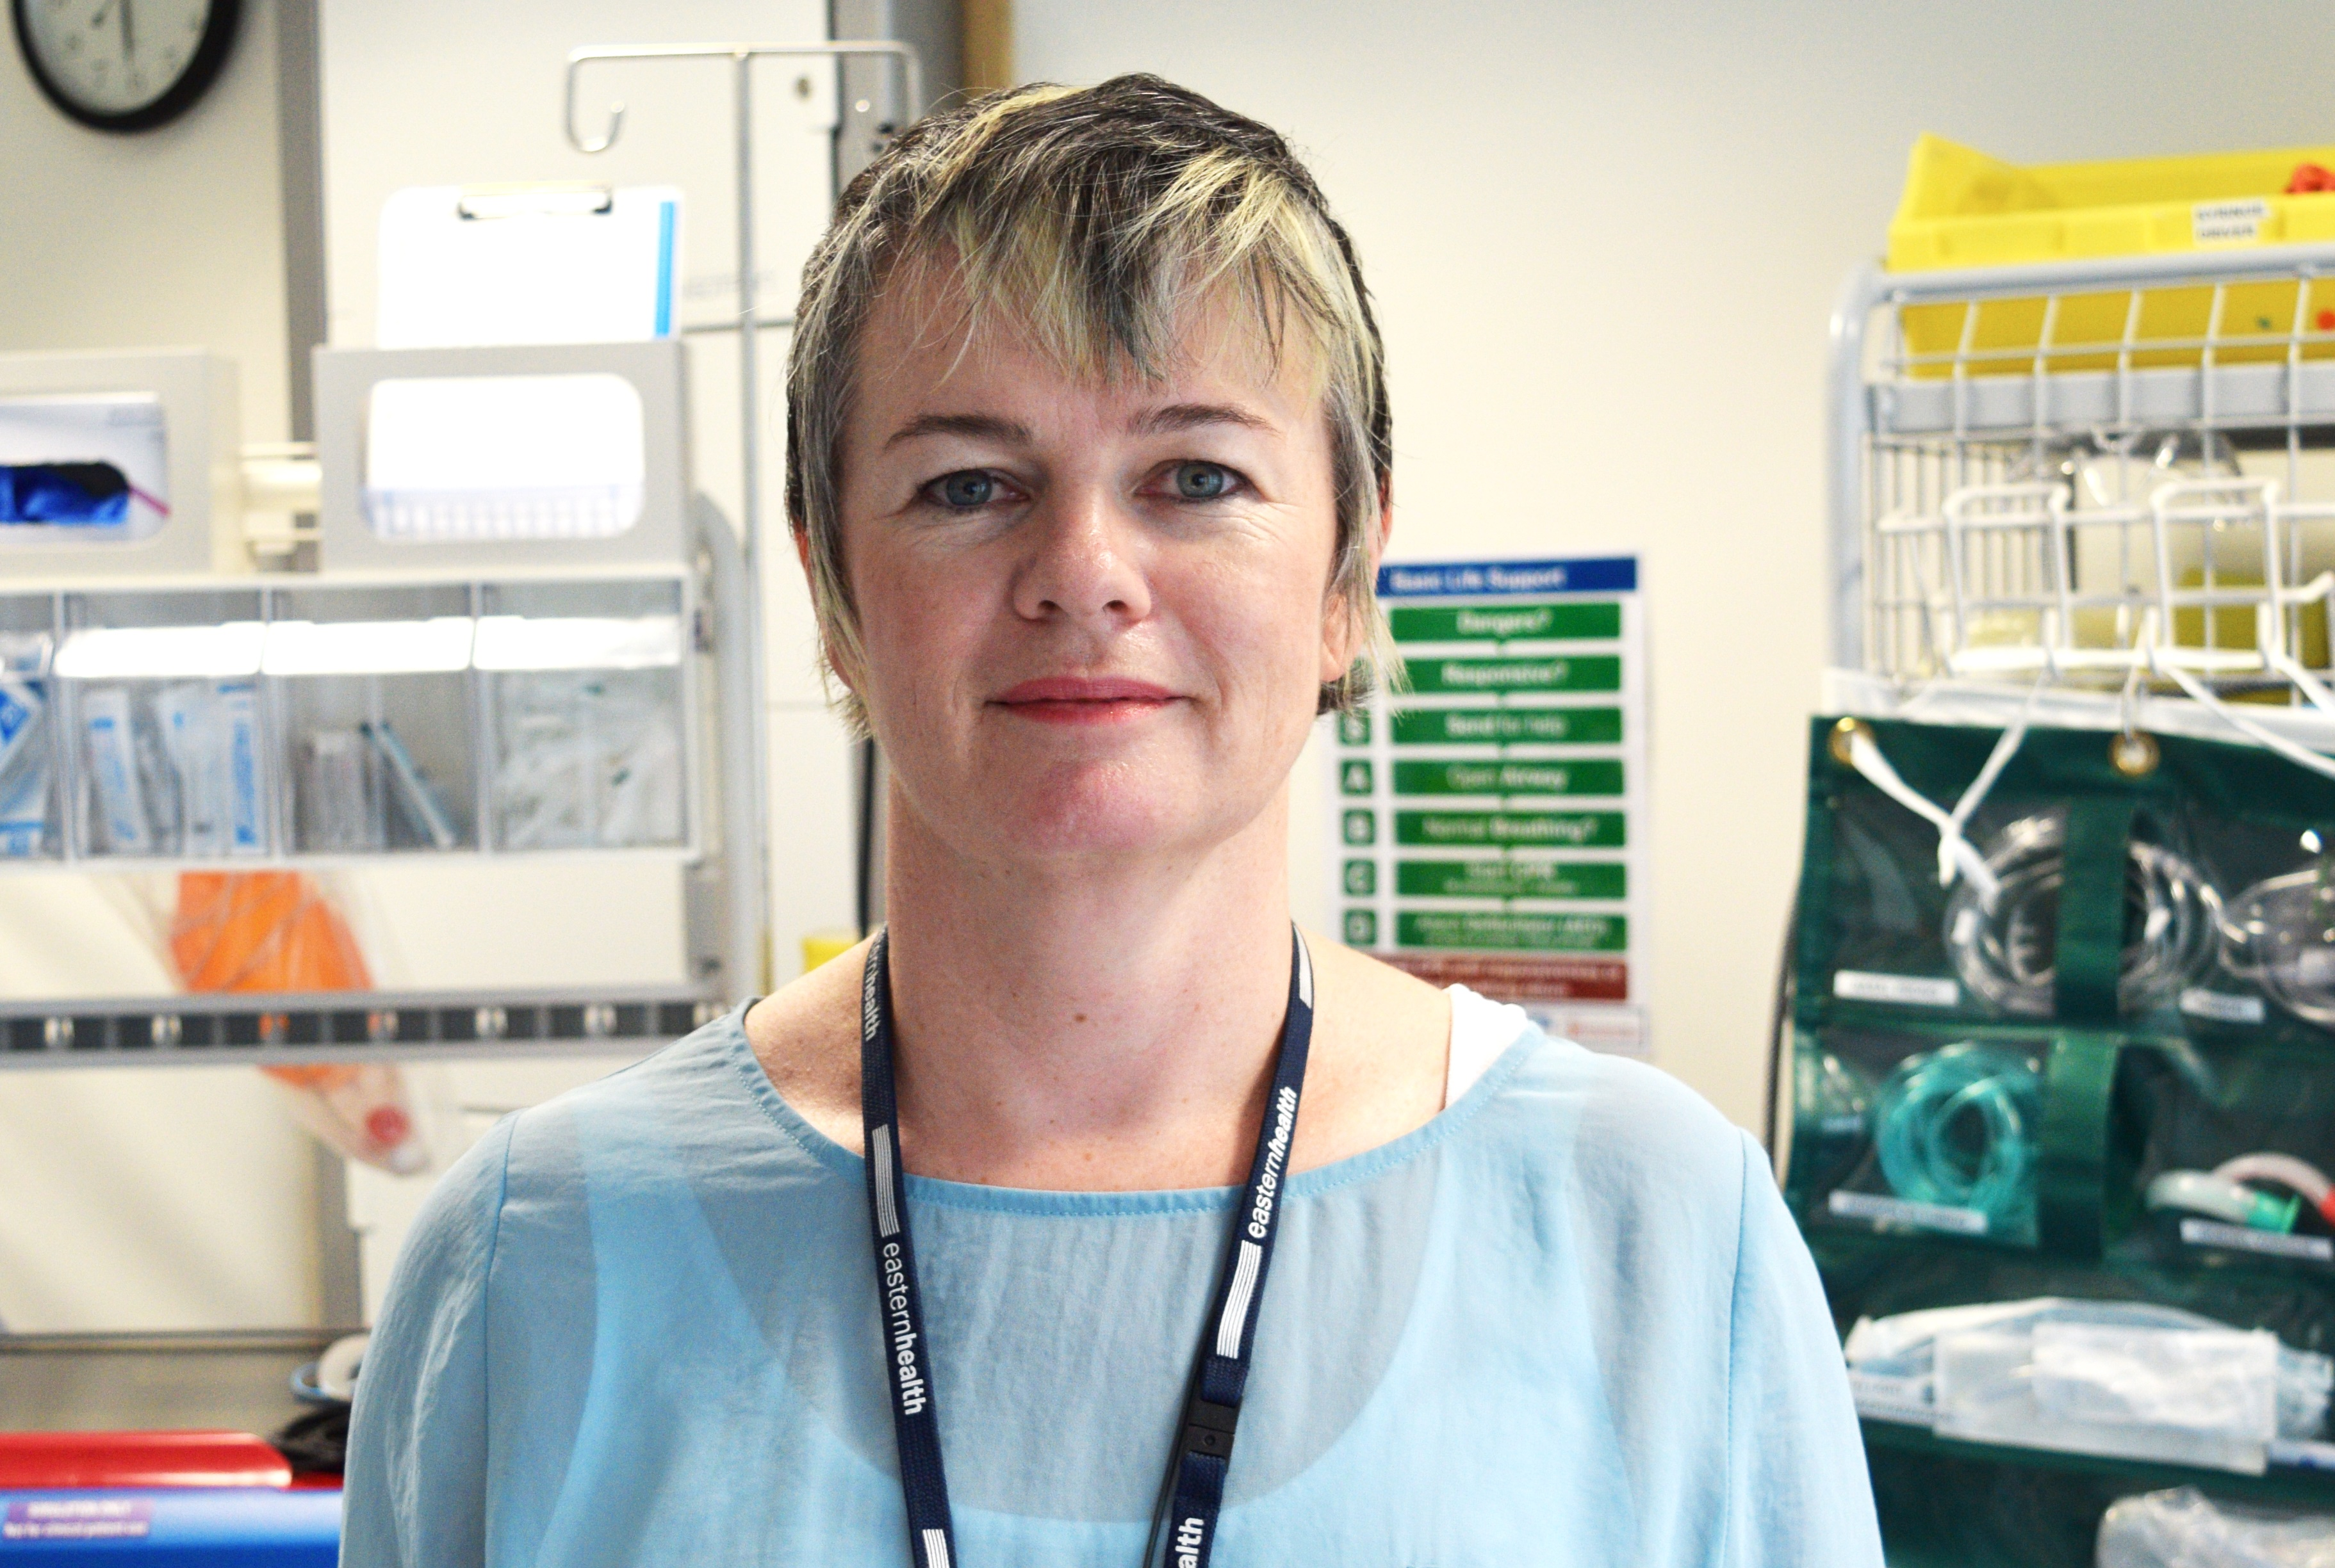
Undertaking a refresher program has meant that Penelope can continue to pursue an exciting career in nursing and support the future nursing workforce.

Thinking of having a break from nursing or midwifery?

To help you make a decision about having a break from the profession or re-entering the profession, here are some things to weigh up:

- make an annual date to update your records and to check the Nursing and Midwifery Board of Australia (NMBA) website for any changes in registration requirements that may affect you
- consider staging your decision to stop work so that you continue to meet the required recency of practice registration standards
- keep up-to-date records of any employment, such as pay slips and position description
- keep up-to-date records of any CPD activities
- keep your resume up to date
- maintain connections to your profession (for example, by joining relevant special interest groups, networks and subscribing to journals or online forums).

Finally, think very carefully before letting your registration lapse. Once your registration has lapsed, or you do not meet registration standards, you are not automatically entitled to registration.

About refresher programs

If you are currently registered in Victoria, but have had a break from practice, or you are shifting from one area of practice to another, you might want to consider a refresher program to update your knowledge and clinical skills.

Some Victorian health services offer refresher programs to nurses or midwives to help fill their vacancies. Depending on the program design, the program may not include paid work, so you may need to be prepared for a period of no income, depending on your situation.

To find out about refresher programs and to prepare yourself to be possible program applicant:
- contact health services to establish whether they offer a refresher program
- compile an updated resume and cover letter, explaining why you would be an asset to an organisation and worth their investment in you
- indicate your willingness to be flexible in terms of program dates, duration and areas of clinical practice and your interest in ongoing employment
- remember that refresher programs can be a way of entering a whole different area of practice in a supported way – a challenge, but a great opportunity to try something new.

If you have let your registration lapse

There are many reasons why nurses and midwives let their registration lapse, such as caring for children and ageing parents, a change of career or illness.

Former nurses and midwives who have not been in
practice for a considerable time may underestimate the requirements of contemporary clinical practice. There may have since been significant changes in the underlying knowledge, skills and roles of nurse and midwife. Unfortunately, getting your registration back and re-gaining employment can take a significant commitment to reskill and can be costly and time consuming.

If you are unsure whether you are still registered, you can check the nursing and midwifery register on the Australian Health Practitioners Regulation Agency (AHPRA) website:
http://www.ahpra.gov.au/Registration/Registers-of-
Practitioners.aspx

About renewing your registration

There are certain requirements to meet to become re-registered, even if you have only been off the register a very short time.

The role of the Nursing and Midwifery Board of Australia (NMBA) is to protect the public by ensuring that anyone who is registered as a nurse and/or midwife is safe and competent to practise. A key requirement is that the nurse and/or midwife is able to demonstrate that he or she meets the relevant NMBA-approved Standards for practice.

The NMBA will assess registration applications on an individual basis, based on professional practice history and length of time away from practising as a nurse and/or midwife.

You may have to complete a re-entry course or period of supervised practice, approved by the NMBA, if you:
- are registered but haven’t maintained recency of practice within the last five years
- haven’t been registered for five to ten years.

About re-entry courses

If the NMBA advises you that you need to undertake a
re-entry course, here are some things you need to know:

- Re-entry courses are formal programs of theory, clinical practice exposure and assessment, to prepare nurses and midwives to re-enter the register. Re-entry focuses on ensuring that the re-entrant meets the relevant NMBA-approved standards for practice.
- The prices of re-entry courses vary.
- Re-entry courses can take between six and 14 weeks (full-time) to complete, which includes theory as well as supervised practice. During the course you are not registered and cannot be employed (and paid) as a nurse or midwife. Courses are generally full-time, so it is likely that your regular income will be affected.
- You may need to consider other costs such as childcare, travel or accommodation, if the program is not local to you.
- Finishing a re-entry course means you are eligible to apply for registration, but you may not be able to work immediately. It may take some time for the NMBA to consider your application for registration. Also, once you gain your registration through the NMBA, you will have to plan for a period in which you apply for jobs and attend interviews.

Finding a re-entry course

- The NMBA maintains a list of approved re-entry courses and providers. For more information, go to: http://www.nursingmidwiferyboard.gov.au/Accreditation/Approved-programs-of-study.aspx
- Course providers may not offer courses regularly throughout a year. For example, courses may be offered between semesters when there is better access to clinical placements.
- Applying for a position in a re-entry course does not guarantee you a place in that course. Re-entry providers assess potential re-entrants for their capacity to meet the realities and requirements of the contemporary clinical environment to be sure they have a good chance of successfully completing the program.
- There could be a waiting list for some courses, so you may need to consider courses offered out of your preferred location.
- When there is relatively high employment, and thus low vacancy rates, employers can be more selective about the skills and experience they seek. You should be prepared that it may take some time to re-gain employment in the nursing and midwifery workforce.

Find out more

For any further information about registration requirements, please contact:

The Nursing and Midwifery Board of Australia
www.nursingmidwiferyboard.gov.au
Ph: 1300 419 495

Undertaking a refresher program has meant that Kylie has the opportunities to continue to make a difference to the life of many.

To receive this publication in an accessible format phone (03) 9096 0131, using the National Relay Service 13 36 77 if required, or email nmw@dhhs.vic.gov.au.
Authorised and published by the Victorian Government, 1 Treasury Place, Melbourne.
© State of Victoria, Department of Health and Human Services, February 2018.
Except where otherwise indicated, the images in this publication show models and illustrative settings only, and do not necessarily depict actual services, facilities or recipients of services.
Available at https://www2.health.vic.gov.au/health-workforce/nursing-and-midwifery/returning-to-nursing-or-midwifery

Disclaimer: Please note that the information within this factsheet is current at the time of publication. Registration requirements and re-entry courses are subject to change and individuals should check with the NMBA about their individual circumstances.

