Digital health capability framework for allied health professionals
Self-evaluation tool

OFFICIAL

To receive this document in another format, phone 1300 650 172 using the National Relay Service 13 36 77 if required, international and interstate callers phone (+613) 9096 9000, or email the Allied Health Workforce team <alliedhealthworkforce@health.vic.gov>.
Authorised and published by the Victorian Government, 1 Treasury Place, Melbourne.
© State of Victoria, Australia, Department of Health, December 2021.
In this document, ‘Aboriginal’ refers to both Aboriginal and Torres Strait Islander people.
Available from the department’s Digital Health webpage <https://www.health.vic.gov.au/quality-safety-service/digital-health>.

About the tool
The Digital Health Capability Framework for Allied Health Professionals identifies the knowledge and behaviours required across a variety of digital health domains. Each subdomain has associated capability statements and there are four capability levels for each statement. The capability levels progress from foundation, consolidation, expert and leader. Figure 1. provides more detail on the expected knowledge and performance across these levels.
The self-evaluation tool can be used with the digital health capability framework for allied health professionals to assess your current level of ability. The self-evaluation tool does not need to be completed all at once, you might find it easier to complete domains or sub-domains separately.

Figure 1: Capability level descriptions
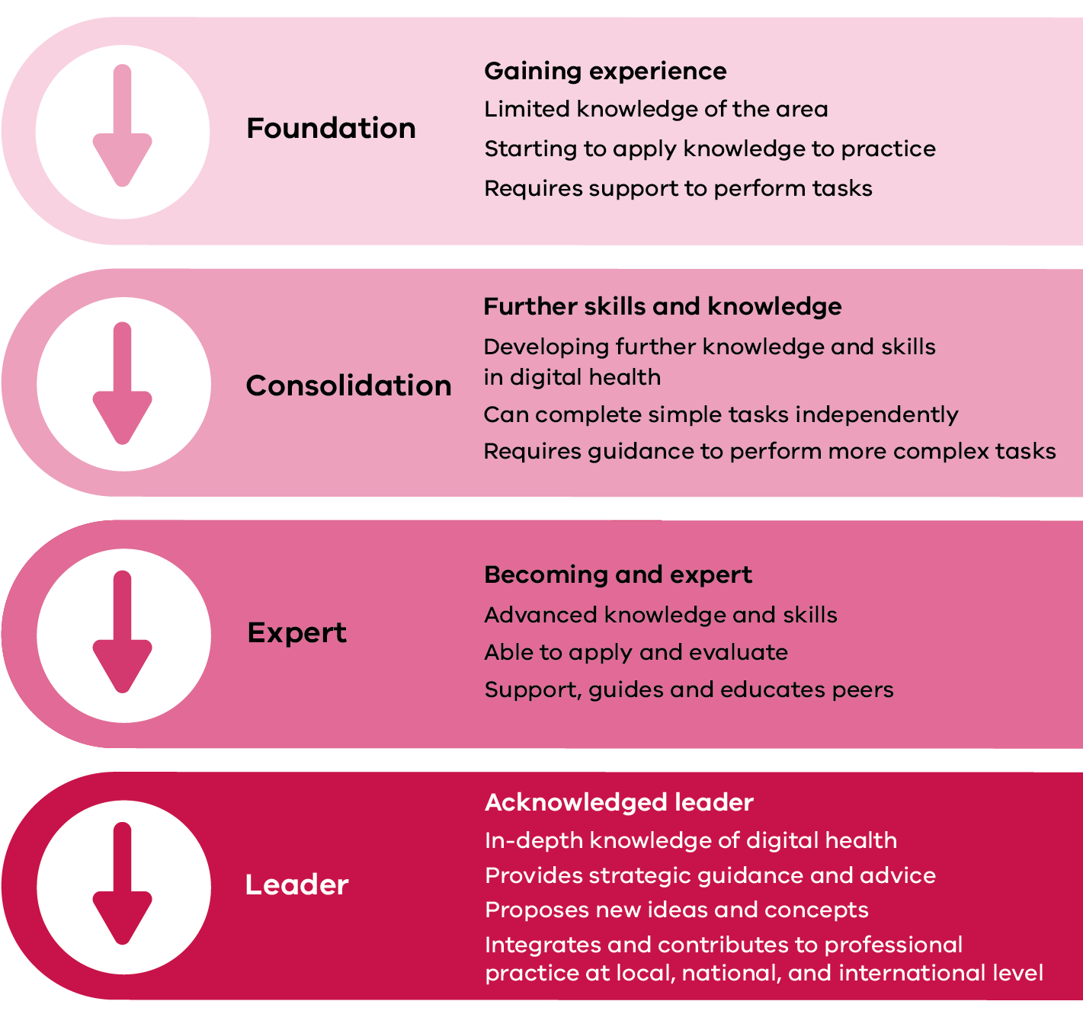

How to use the capability framework and self-evaluation tool
Figures 2 and 3 explain how to use the framework and the self-evaluation tool.

Figure 2: How to use the capability framework
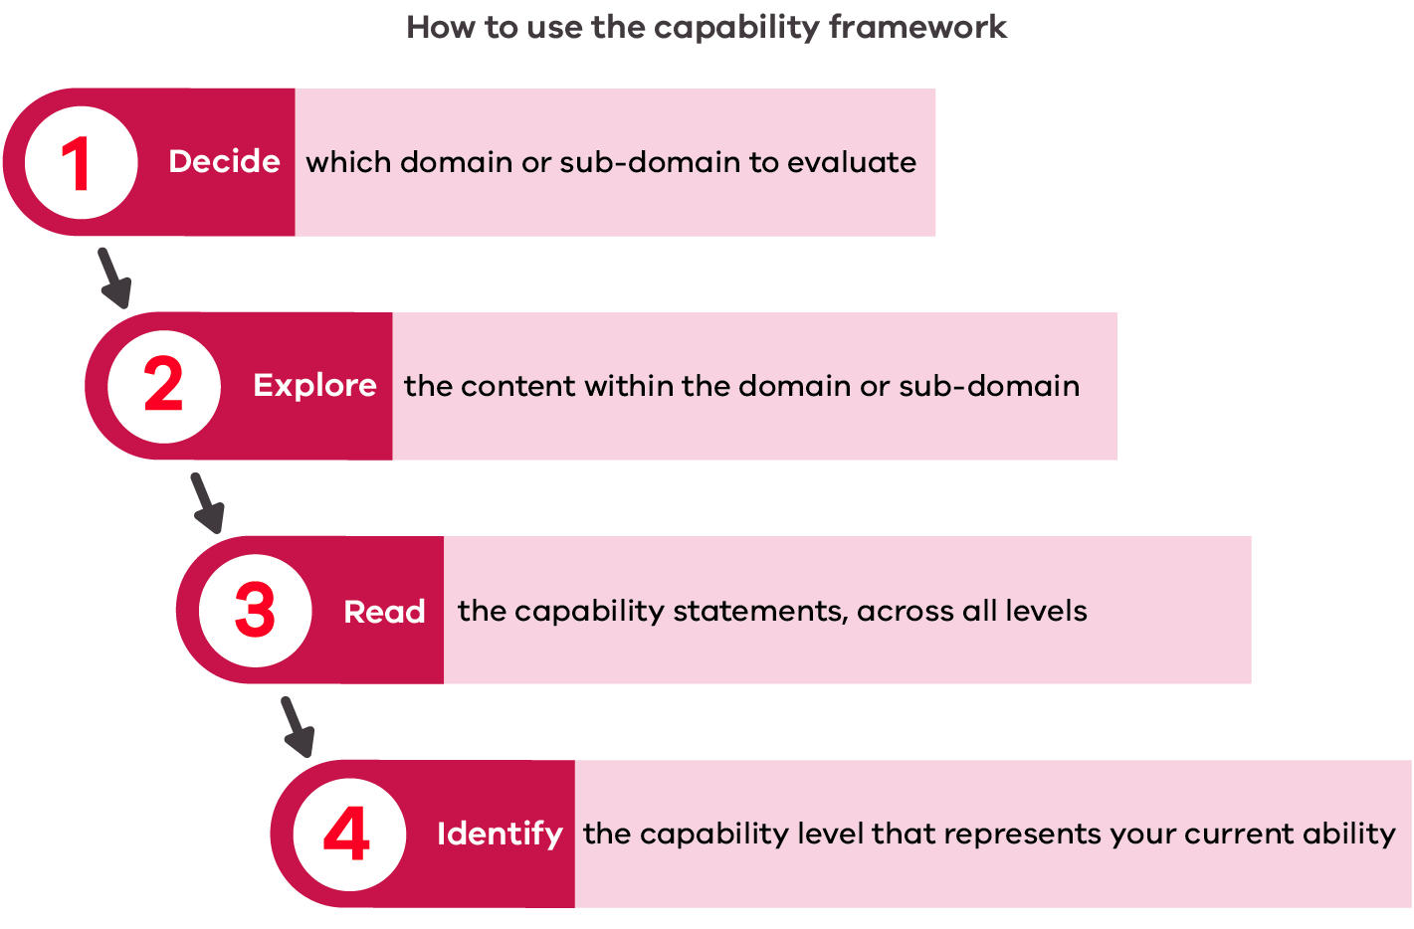

Figure 3: How to use the self-evaluation tool and documentation
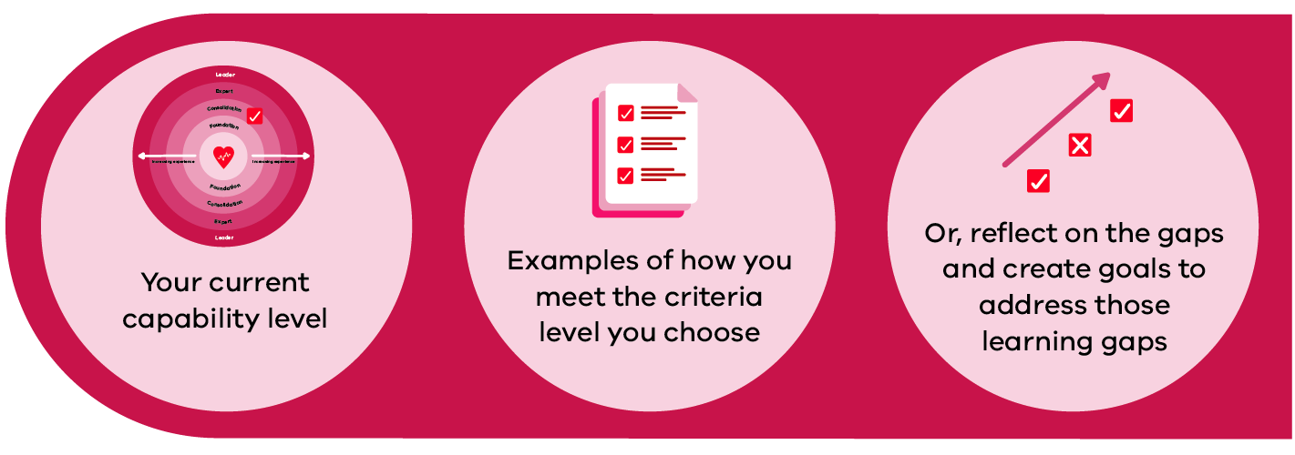
Note: If a user does not meet the foundation level for a statement, the comments section can be completed to identify the gap and goals to achieve this level.

Next steps
Once you have identified your areas of strength and gaps in knowledge and abilities, you can take steps to address these. For example, use in a performance review or discussion with a supervisor, team leader or manager or tailor your professional development opportunities to meet identified gaps.
You can also use the capability framework to gain more detail and understanding of the expectations of each domain and subdomain across each level.
Full name: | Click or tap here to enter text. |  |  | Date |  | Click or tap to enter a date.
Domain 1: The Digital Workplace
Capability statements |  | F | C | E | L |  | Comments/ examples
1.1 Technology and Tools
- Use a variety of different digital health technologies in the providing care |  | ☐ | ☐ | ☐ | ☐
- Identify the appropriate digital health technologies for different clinical situations and associated risks |  | ☐ | ☐ | ☐ | ☐
- Use technical knowledge to problem-solve and resolve technical challenges |  | ☐ | ☐ | ☐ | ☐
1.2 Legislation, policies and procedures
- Comply with digital health legislation |  | ☐ | ☐ | ☐ | ☐
- Comply with organisational digital health policies |  | ☐ | ☐ | ☐ | ☐
- Understand digital copyright and intellectual property rules and regulations |  | ☐ | ☐ | ☐ | ☐
1.3 Digital health governance
- Understand and adhere to the principles of data and information systems governance |  | ☐ | ☐ | ☐ | ☐
- Understand potential legal and ethical challenges associated with digital health technologies |  | ☐ | ☐ | ☐ | ☐
- Recognise digital situations or events that compromise organisational security or reputation |  | ☐ | ☐ | ☐ | ☒

Full name: | Click or tap here to enter text. |  |  | Date |  | Click or tap to enter a date.
Domain 2: Digital Professionalism
Capability statements |  | F | C | E | L |  | Comments/ examples
2.1 Digital profile
- Understand and develop a professional digital identity (or identities) that positively represents the individual health professional and their organisation |  | ☐ | ☐ | ☐ | ☐
- Understand the benefits, potential risks and impacts of your digital footprint |  | ☐ | ☐ | ☐ | ☐
- Promote and safeguard digital identity, including protecting organisational and personal login credentials |  | ☐ | ☐ | ☐ | ☐
2.2 Professional and ethical responsibilities
- Maintain positive, respectful and ethical behaviour when using digital health technologies |  | ☐ | ☐ | ☐ | ☐
- Use digital health technologies appropriate to professional role, duties and scope of practice |  | ☐ | ☐ | ☐ | ☐
2.3 Communication
- Use digital health technologies to provide accurate and timely communication |  | ☐ | ☐ | ☐ | ☐
- Communicate using digital health technologies in an appropriate and professional manner, and recognise inappropriate or harmful communication |  | ☐ | ☐ | ☐ | ☐
2.4 Collaboration
- Appropriately use digital health technologies to collaborate with other health professionals |  | ☐ | ☐ | ☐ | ☐
- Actively participate in and across collaborative digital networks |  | ☐ | ☐ | ☐ | ☐
- Use digital health technologies to engage and collaborate with consumers and the public |  | ☐ | ☐ | ☐ | ☐
2.5 Patient-centred care
- Appropriately use digital health technologies to provide patient care and assist patients or consumers to access and use these technologies |  | ☐ | ☐ | ☐ | ☐
- Use digital health technologies to educate patients or consumers |  | ☐ | ☐ | ☐ | ☐
- Facilitate health literacy and informed decision-making in partnership with patients or consumers |  | ☐ | ☐ | ☐ | ☐
2.6 Professional development
- Source relevant literature on current and emerging digital health technologies within professional and work contexts |  | ☐ | ☐ | ☐ | ☐
- Use digital or online resources to participate in, manage and monitor continuing professional development (CPD) |  | ☐ | ☐ | ☐ | ☐

Full name: | Click or tap here to enter text. |  |  | Date |  |  | Click or tap to enter a date.
Domain 3: Data and informatics
Capability statements |  | F | C |  | E | L |  | Comments/ examples
3.1 Data concepts and characteristics
- Understand why, how and when data is used in healthcare and the need for quality data input |  | ☐ | ☐ |  | ☐ | ☐
- Understand and recognise different data sources and structures and associated benefits, risks and limitations |  | ☐ | ☐ |  | ☐ | ☐
3.2 Data integrity and the data lifecycle
- Understand the data lifecycle |  | ☐ | ☐ |  | ☐ | ☐
- Understand and recognise the role of data integrity in healthcare |  | ☐ | ☐ |  | ☐ | ☐
- Understand system interoperability and its impact on data in health care |  | ☐ | ☐ |  | ☐ | ☐
3.3 Analytical concepts
- Understand data terminology and descriptive statistics |  | ☐ | ☐ |  | ☐ | ☐
- Use data analytic tools and apply data analysis methods to healthcare data to improve clinical care or service delivery |  | ☐ | ☐ |  | ☐ | ☐
3.4 Knowledge creation
- Access, interpret and critically evaluate data from various digital sources to apply in professional practice and service delivery |  | ☐ | ☐ |  | ☐ | ☐
- Use data to inform best practice |  | ☐ | ☐ |  | ☐ | ☐
- Display data in a visual way to communicate finding |  | ☐ | ☐ |  | ☐ | ☐

Full name: | Click or tap here to enter text. |  |  | Date |  |  | Click or tap to enter a date.
Domain 4: Digital Transformation
Capability statements |  | F | C |  | E | L |  | Comments/ examples
4.1 Innovation
- Recognise the potential of digital health to improve current practice and enable new models of care |  | ☐ | ☐ |  | ☐ | ☐
- Keep up to date with current and emerging digital health technologies and innovations (including the risks and benefits) |  | ☐ | ☐ |  | ☐ | ☐
4.2 Build and test
- Adapt existing or create new evidence-based digital health resources |  | ☐ | ☐ |  | ☐ | ☐
- Consider system interoperability in the design of digital health solutions and its impact on clinical workflows |  | ☐ | ☐ |  | ☐ | ☐
- Works effectively with stakeholders to design, develop and test new digital health solutions |  | ☐ | ☐ |  | ☐ | ☐
4.3 Implementation
- Implement, use and adopt new digital health solutions |  | ☐ | ☐ |  | ☐ | ☐
- Works effectively with stakeholders to implement new digital health solutions |  | ☐ | ☐ |  | ☐ | ☐
- Identify and respond to implementation issues |  | ☐ | ☐ |  | ☐ | ☐
4.4 Evaluation
- Recognise the value of evaluating digital health solutions |  | ☐ | ☐ |  | ☐ | ☐
- Contribute to evaluation and optimisation of digital health solutions |  | ☐ | ☐ |  | ☐ | ☐

Learning Plan

Areas to develop | Action plan | Time-frame | Date achieved

