Pilot health and human
services climate change
adaptation action plan
2019–21
Department of Health and Human Services

Department of Health
Pilot health and human services climate change adaptation action plan 2019–21

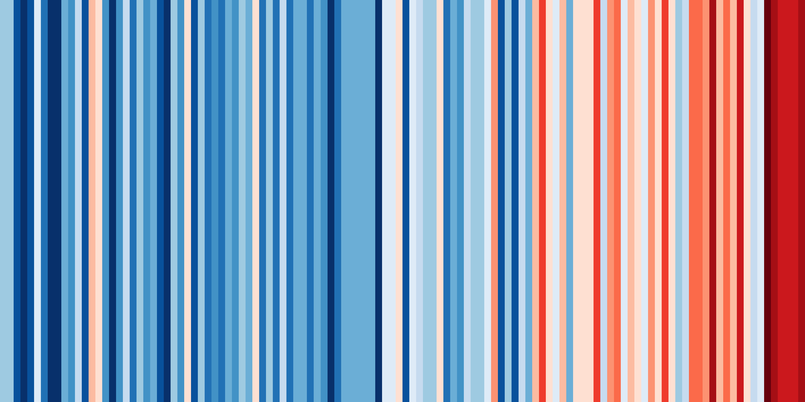
Australian Warming Stripe
The ‘warming stripe’ shows the change in average temperature from 1901 to 2018 in Australia, where each stripe represents one year. It shows a clear warming trend over the course of more than a century. Warming stripes have been made for hundreds of cities and countries, most of which display the trend in global heating.
Hawkins E 2019, Show your stripes, <https://showyourstripes.info/>.
Aboriginal acknowledgement
The Victorian Government acknowledges Victoria’s Aboriginal community and their rich culture, and pays respect to them, their culture and their Elders past, present and future. We acknowledge Aboriginal people as Australia’s first peoples and as the Traditional Owners and custodians of the land and water on which we rely. We recognise and value the ongoing contribution of Aboriginal people and communities to Victorian life and how this enriches us. We embrace the spirit of reconciliation, working towards the equality of outcomes and ensuring an equal voice.
To receive this publication in an accessible format email the Environment Team <environment@dhhs.vic.gov.au>.
Authorised and published by the Victorian Government, 1 Treasury Place, Melbourne.
© State of Victoria, Department of Health and Human Services, December 2019.
Except where otherwise indicated, the images in this publication show models and illustrative settings only, and do not necessarily depict actual services, facilities or recipients of services.
ISBN 978-1-76069-201-8 (Print)
ISBN 978-1-76069-211-7 (pdf/online/MS word)
Available on the department’s website <https://www.dhhs.vic.gov.au/publications/environmental-sustainability-strategy-department-health-and-human-services>.

Contents
Message from the Chief Health Officer 7
Executive summary 8
Introduction 8
Public health impacts 9
Climate change impacts on the health and human services system 9
Vision, milestones, action domains and outcomes 10
Vision 10
Adaptation milestones 10
Action domains and outcomes 10
Domain 1: Governance and regulation 10
Domain 2: Communication and engagement 11
Domain 3: Knowledge building 11
Domain 4: Asset readiness 12
Introduction 17
Victorian Government action on climate change 18
The Climate Change Act 2017 18
Adaptation Action Plans 18
Victoria’s climate change adaptation plan 2017–2020 19
Scope of this plan 19
The health and human services system 19
Health and human services responsibilities in climate change adaptation 19
Relationship to other systems 21
Climate change, public health and the health and human services 24
The ecological determinants of health and wellbeing 24
Climate change impacts on health and wellbeing in Victoria 25
Direct health impact: bushfires 26
Direct health impact: heatwaves 27
Indirect health impact: 2017 Ross River outbreak 30
Indirect health impact: water quality risks 31
Social determinants impact: exposure of housing to heat and cold 32
Social determinants: economic impacts of climate change 33
Climate change impacts on the health and human services system 34
Impacts on health and wellbeing outcomes 34
Climate change adaptation policies and initiatives, gap analysis and new actions 37
Vision 37
Adaptation milestones 37
Action domains and outcomes 37
Domain 1: Governance and regulation 37
Domain 2: Communication and engagement 39
Domain 3: Knowledge building 40
Domain 4: Asset readiness 41
Appendix 1: This plan and the objectives and guiding principles of the Climate Change Act 2017 44
Policy objectives of the Act 44
Guiding principles of the Act 44
Appendix 2: Department of Health and Human Services portfolio responsibilities 46
Health 46
Ambulance services 46
Housing 46
Disability 46
Ageing 46
Mental health 46
Families and children 46
Youth affairs 47
Victorian health and human services sector 47
Appendix 3: Development of this plan 48
Statutory requirements 48
Development process 48
Governance 48
Briefings on climate change, and the engagement process 49
Climate risk analysis workshops 49
Monitoring and evaluation framework 49
Appendix 4: Monitoring and evaluation framework 50
Appendix 5: Other statutes relevant to health and human services climate change adaptation 51
Scheduled Acts 51
Other relevant statutes 51
References 53

Message from the Chief Health Officer
Climate change is a global economic, social, environmental and public health issue that poses significant consequences for our health and wellbeing.
The World Health Organization has described climate change as the greatest threat to global health in the 21st century. Victoria is not immune to its increased intensity and frequency of extreme weather events, the potential spread of disease, effects on mental health, and threats to food and water supply.
The impacts of climate change on the management of health and human services and government assets, such as public housing and hospitals, affect our community and are more acutely felt by vulnerable and disadvantaged groups including the elderly, chronically ill and low-income households.
To manage and mitigate adverse impacts, Victoria needs to adapt and transition now and take purposeful steps at state, regional and local levels. Doing so will help us build resilience to shocks and stressors, ensuring the capacity of communities and the systems and structures that support them can adapt and grow.
The Victorian Government is committed to leadership on climate change and protecting the health and wellbeing of all Victorians. Victoria’s Climate Change Act – including a target of net zero emissions by 2050, and government planning for climate change adaptation – provides the foundations for lasting change.
It will enable coordination across government, industry and the community, and contribute to the necessary transition our state must make to net zero emissions and climate resilience.
The Pilot health and human services climate change adaptation plan 2019–21 will assist the sector to embed climate change considerations into policies, planning, guidelines and operations, and respond to the risks posed to public health and wellbeing.
Most importantly, climate change adaptation will ensure that our health and human services continue to provide a high standard of service to Victorians and preserve the community’s health, wellbeing and safety.
Our health is closely linked to the environment we live in. By working together, we can better address the complex challenges that climate change presents, safeguard our prosperity, and ensure Victoria continues to be one of the most sustainable and liveable places in the world.
Dr. Brett Sutton, MMBS MPHTM, FAFPHM, FRSPH, FACTM, MFTM
Victorian Chief Health Officer
Victorian Chief Human Biosecurity Officer

Executive summary

Introduction
Climate change has been described by the World Health Organization (2015) as the greatest threat to global health in the 21st century.
The effects of climate change are already being experienced across Victoria, including higher average temperatures and reduced rainfall. Reducing our greenhouse gas emissions will help lessen the impact of climate change, but it will not prevent it – some degree of climate change is already locked in.
At the current rate of global heating, our planet could cross critical thresholds into irreversible, life-threatening climate change as soon as 2030 (IPCC 2018), or, according to some studies, much sooner (Henley and King 2017; Jacob et al. 2018; Schurer et al. 2018; Xu and Ramanathan 2017). The unfolding climate crisis requires an immediate response to protect the health, safety and wellbeing of Victorians, now and into the future.
The Victorian Government has passed the Climate Change Act 2017, establishing a legislative framework for action on climate change. The Act creates a legislative obligation for government departments to conduct system-based adaptation planning, with a focus on systems that are vulnerable to climate change or are essential to ensure Victoria is prepared.
The Act defines the health and human services system as ‘the services and assets primarily engaged in protecting human health from disease resulting from or associated with communicable disease, food, water or the environment’, and ‘the services and assets which provide human physical and mental health care, social support and assistance’.
The first planning and implementation period is 31 October 2021 to 31 October 2026.
The Department of Health and Human Services is piloting the implementation of the Health and human services climate change adaptation action plan 2019–21 (adaptation action plan) in advance of statutory requirements, recognising the urgency for action, and to share the insights of its experience with other Victorian Government departments and agencies in the lead-up to the mandatory period. This plan, which applies to the period November 2019 to 31 October 2021, is the product of that commitment.
The department is also preparing an emissions reduction plan to reduce greenhouse gas emissions from the department, and health and human service funded agencies. Together, the emissions reduction plan and the adaptation action plan will form an integrated climate change strategy, recognising that action in both these domains is urgently needed to protect the health and wellbeing of Victorians from the climate crisis.

Public health impacts
The direct and indirect impacts of climate change are likely to exacerbate existing public health risks and represent an unacceptably high and potentially catastrophic risk to human health (Watts et al. 2015). Without urgent action, its effects on public health and the determinants of health will continue to spread beyond localised and contemporary impacts – populations worldwide and future generations will all experience its multiple, increased risks, and its many and varied impacts. A clear feature of the climate crisis, which must be avoided, is its disproportionate impact on vulnerable and disadvantaged groups, and the risk of economic impacts entrenching and increasing social and economic inequality.
Direct impacts, caused by exposure to more frequent and intense extreme weather events such as bushfires, droughts, floods and heatwaves, include hypo- and hyperthermia, heat stress, injury, trauma and death. Indirect impacts, mediated through natural and human systems affected by climate change, include vector-borne diseases (those transmitted from vectors such as mosquitos to humans) and zoonotic diseases (those transmitted from animals to humans), water-borne diseases (resulting from exposure to harmful algae and pathogenic microorganisms affecting drinking water, recreational water including aquatic facilities, and water supplied for agricultural and domestic use), food-borne diseases (such as salmonellosis) and contaminants (such as mycotoxins), air pollution and airborne pollen.
The determinants of health and wellbeing, including social determinants such as housing and the built environment (Lalonde 1974), are affected by climate change. Extreme heat can increase indoor temperature, and extreme weather events can affect transport, health and human services and employment, each affecting community health and wellbeing. Furthermore, climate change may have an adverse impact on the economy (Garnaut 2008), which could lead to unemployment, stress, social exclusion and increases in food insecurity. Older people, young children, people with medical conditions, people with mental illness, people experiencing homelessness, people with a disability, culturally and linguistically diverse groups, and low-income households can be more sensitive to these impacts.

Climate change impacts on the health and human services system
The health and human services system, its workforce, services and built assets are not immune from climate change (Fuenfgeld et al. 2013; QCOSS 2010; Hawe P 2009). The increased exposure to more frequent and intense extreme weather events will increase the system’s vulnerability to a range of risks, including:
- more frequent surges in client demand
- disruption of workforce attendance at their workplace
- psychosocial impacts on staff
- damage to built assets from, for example, floods, storms, and bushfires
- disruption or failure of service infrastructure such as telecommunications, transport, electricity, and water supplies
- disruption of supply chains.

Vision, milestones, action domains and outcomes

Vision
A health and human services system resilient to climate change and ecologically sustainable, achieving the best health, wellbeing and safety of all Victorians so that they can live a life that they value.

Adaptation milestones
The following table describes the short, medium and long-term milestones and timeframe for progress on climate change adaptation in the health and human services.
Timeframe | Milestone
Short term: 2019–21 | Integration of climate change adaptation into relevant areas of governance, policy, planning and processes is in progress. Adaptation responses are being prioritised, designed, costed and planned.
Medium term: 2021–25 | Consideration of climate change adaptation is part of the business as usual approach to decision making. Implementation of priority adaptation programs is underway.
Long term: 2026–30 | The health and human services continue to provide a high standard of service to Victorians, are resilient to climate change, ecologically sustainable, and contribute to the liveability of our places and wellbeing of our community.

Action domains and outcomes
The plan sets out four action domains identifying the required areas of adaptation activity. There are 21 actions across the four domains to be achieved in the 2019–21 period. The actions represent the first steps towards climate change adaptation over the long term. The accompanying statement of adaptation outcomes in each domain describe the system changes sought over the term of milestone implementation described above.

Domain 1: Governance and regulation

Outcomes
- Health and human services strategies, policies, plans and processes incorporate and respond to climate change.
- Regulations incorporate and respond to climate change risks.
- Health and human services boards understand and manage the risks posed by climate change.

Actions 2019–21
Action 1: Support cross-jurisdictional work to protect community health and wellbeing from the impacts of climate change through the Australian Health Protection Principal Committee and its subcommittees.
Action 2: Contribute to whole-of-Victorian-Government planning to ensure that the impacts of climate change on public health are considered and opportunities to protect the community are identified.
Action 3: Review the Health services strategic planning guidelines to ensure health services’ strategic plans address climate change risks.
Action 4: Advise health service boards to ensure they understand and manage the risks of climate change.
Action 5: Include climate change in Regional and Local Area Health Partnership planning and policy development.
Action 6: Review and update the Municipal public health and wellbeing planning: having regard to climate change guidelines to promote and strengthen consideration of climate change and its impact on health by local government in their planning and implementation of municipal public health and wellbeing activities.
Action 7: Survey councils to assess the extent to which actions to address the health impacts of climate change have been included in their municipal public health and wellbeing plans in accordance with their requirements under the Climate Change Act 2017.
Action 8: Incorporate additional climate change indicators into the Victorian public health and wellbeing outcomes framework.
Action 9: Review and update the Water quality guidelines for public aquatic facilities: managing public health risks, and the aquatic facility provisions in the Public Health and Wellbeing Regulations 2009 to ensure they reflect a risk-based approach to regulation.

Domain 2: Communication and engagement

Outcomes
- Health and human services professionals and other partners have the knowledge and skills to effectively plan for climate change and its consequences for their clients, assets, services and workplaces.
- Victorians are aware of the risks that climate change poses to their health and wellbeing and the actions they can take to protect themselves and their families.
- The department, its clients, staff and partners co-design relevant adaptation and resilience solutions.

Actions 2019–21
Action 10: Provide information to senior Victorians about climate change and health and wellbeing.
Action 11: Raise staff awareness in clinical mental health services regarding climate change and how to plan for resilience.
Action 12: Implement public health campaigns relevant to staying healthy in a changing climate, including implementing campaigns related to healthy swimming, food safety, vector-borne disease prevention and mitigation and travel health.

Domain 3: Knowledge building

Outcomes
- The health and human services sector has the capacity to predict climate change risks and population vulnerabilities, to communicate these risks in a timely manner, and to design effective interventions to protect and improve public health, exposed regions, at-risk groups and vulnerable populations.

Actions 2019–21
Action 13: Analyse the cost of health impacts caused by climate change effects on Victorian housing.
Action 14: Develop vulnerability maps of exposed regions, places, at-risk groups and vulnerable populations.
Action 15: Investigate how food-borne and water-borne pathogens and contaminants, for example Salmonella in food and opportunistic pathogens in water supplies, are influenced by climate factors such as extreme weather events, particularly high temperatures and humidity.

Domain 4: Asset readiness

Outcomes
- Health and human services assets are resilient to climate change and protect the health and safety of housing residents, and health services’ patients and staff.

Actions 2019–21

Health services
Action 16: Prepare guidance to inform health services of potential climate risk to infrastructure.
Action 17: Integrate climate adaptation into business cases, guidelines for sustainability in healthcare capital works, hospital essential engineering services guidelines and health service environmental management planning.
Action 18: Collect and analyse data on the energy security of public health facilities.
Action 19: Advocate for changes to hospital design standards to actively consider climate change.

Public housing
Action 20: Incorporate climate change into policies, plans and processes and embed a response to climate change in operational procedures.
Action 21: Develop a climate change transition plan for public housing to achieve adaptation and emission reduction outcomes.

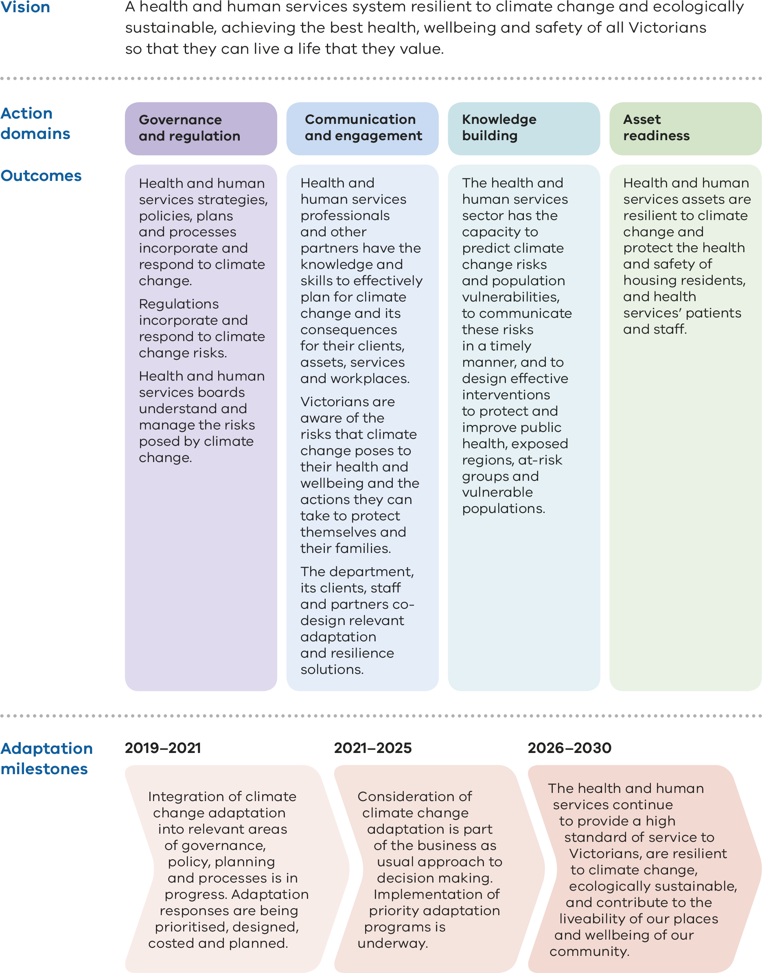

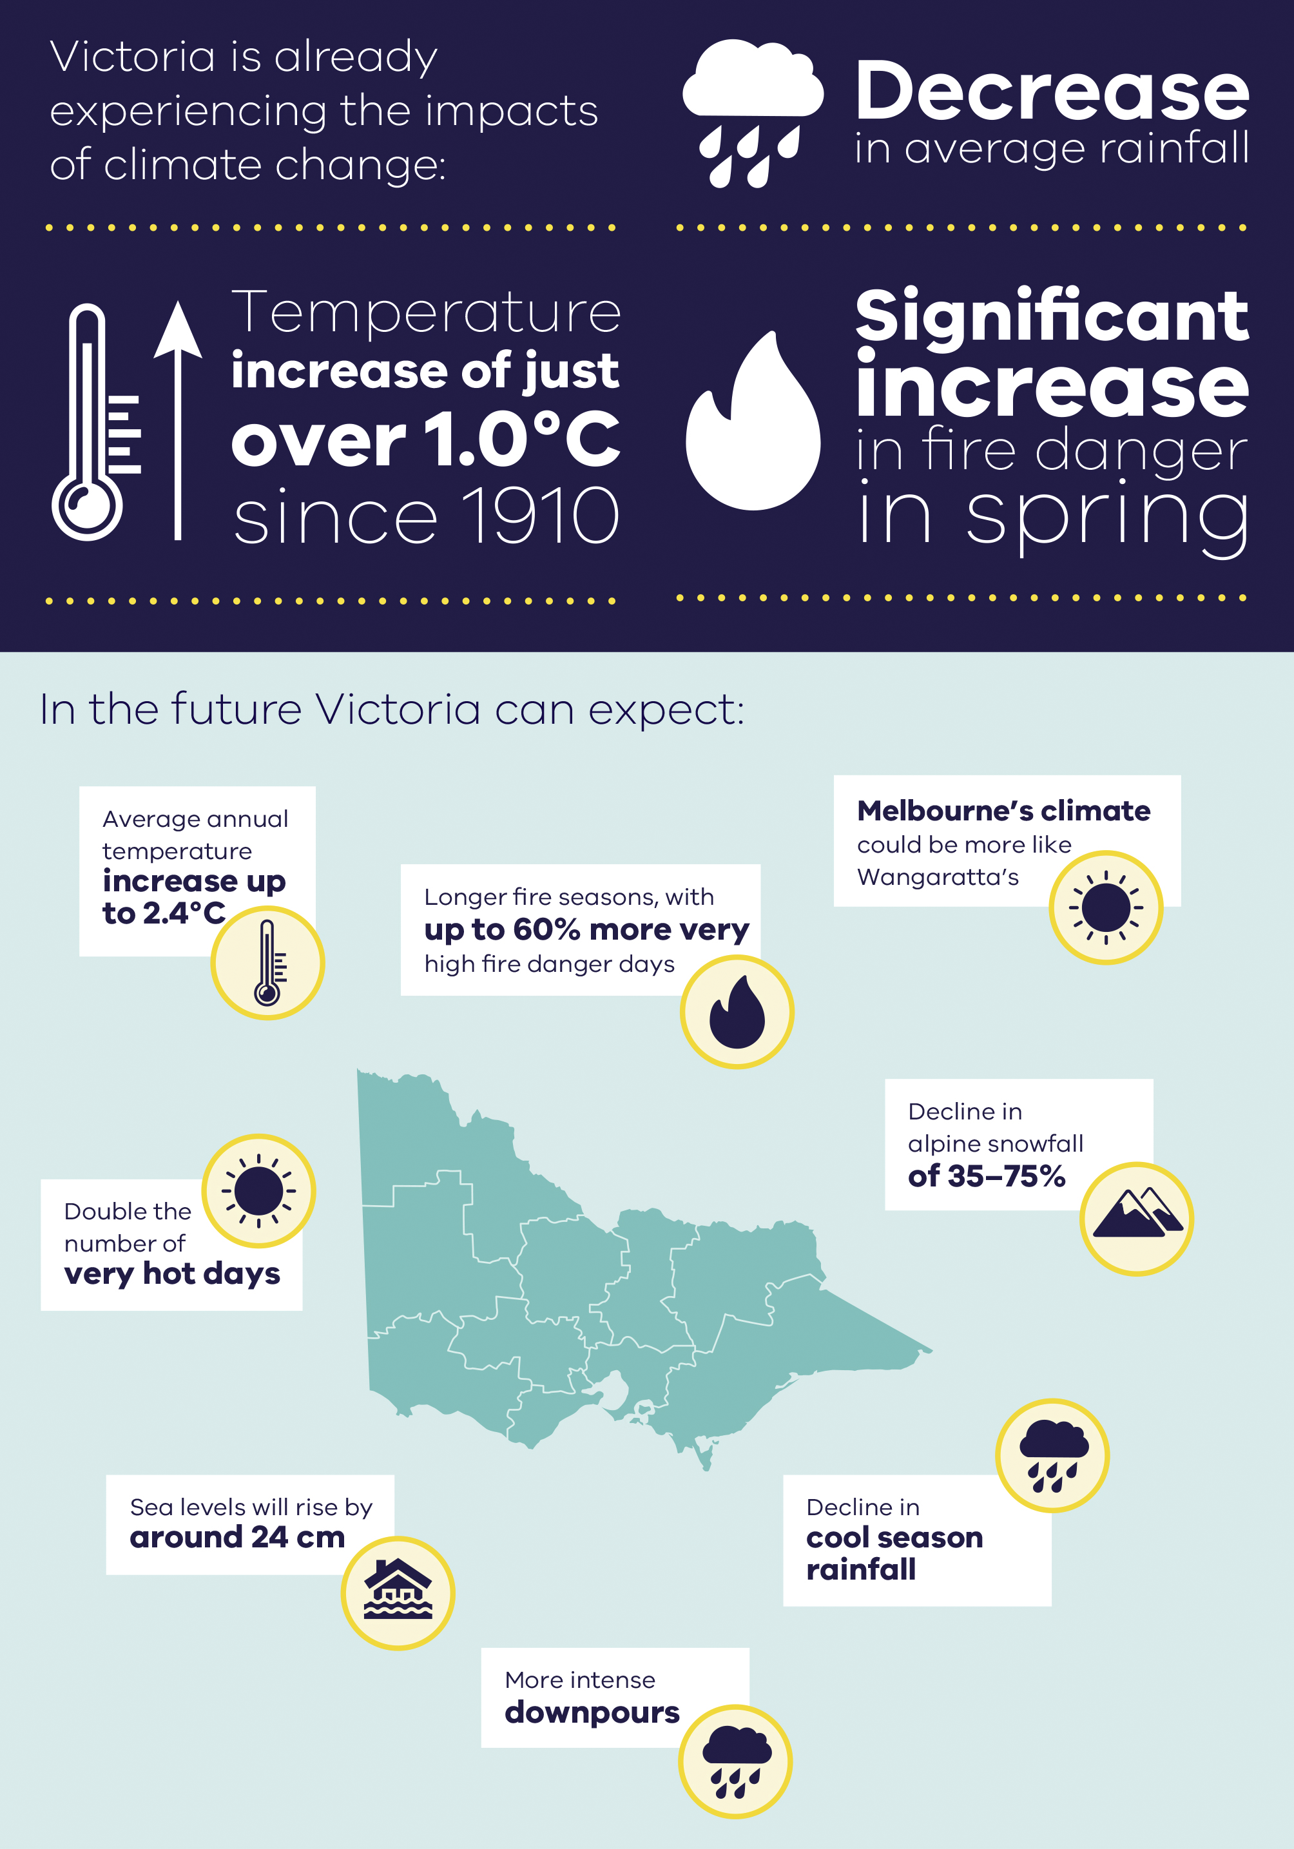
Observed and projected impacts of climate changes for Victoria out to 2050s under high emissions compared to 1986–2005.
Victoria’s average temperature has increased
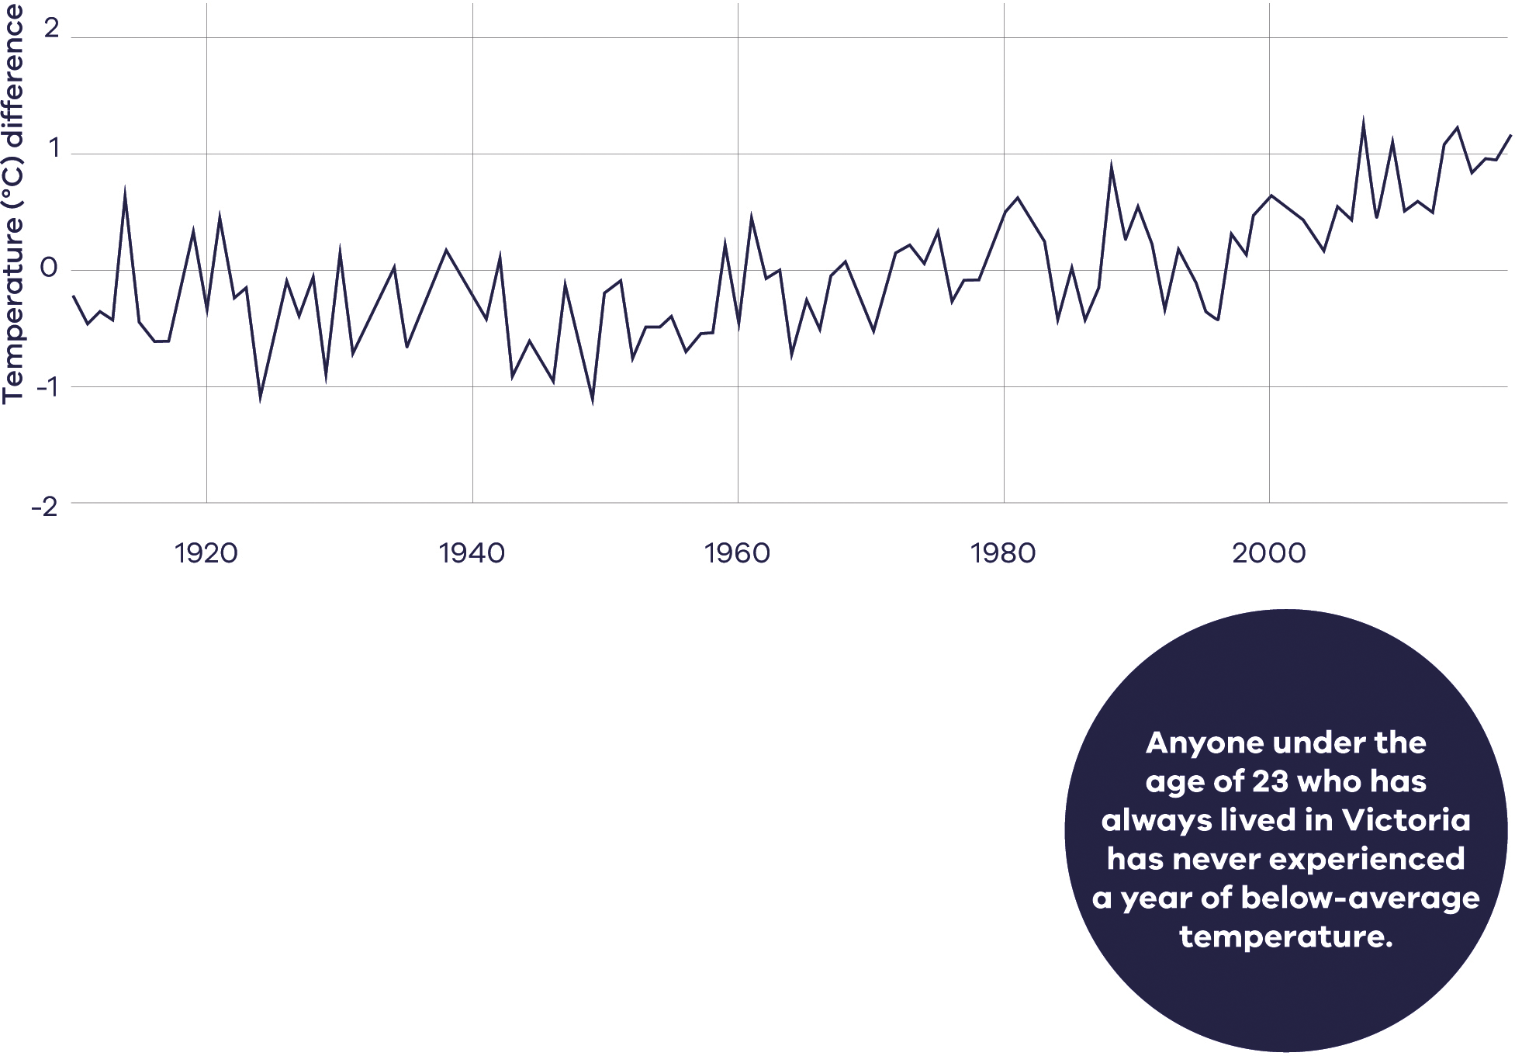
Observed average annual temperature in Victoria from 1910–2018 compared to the 1961–1990 baseline average (CSIRO, 2019).
Observed temperature in Victoria is tracking towards the upper limit of projections
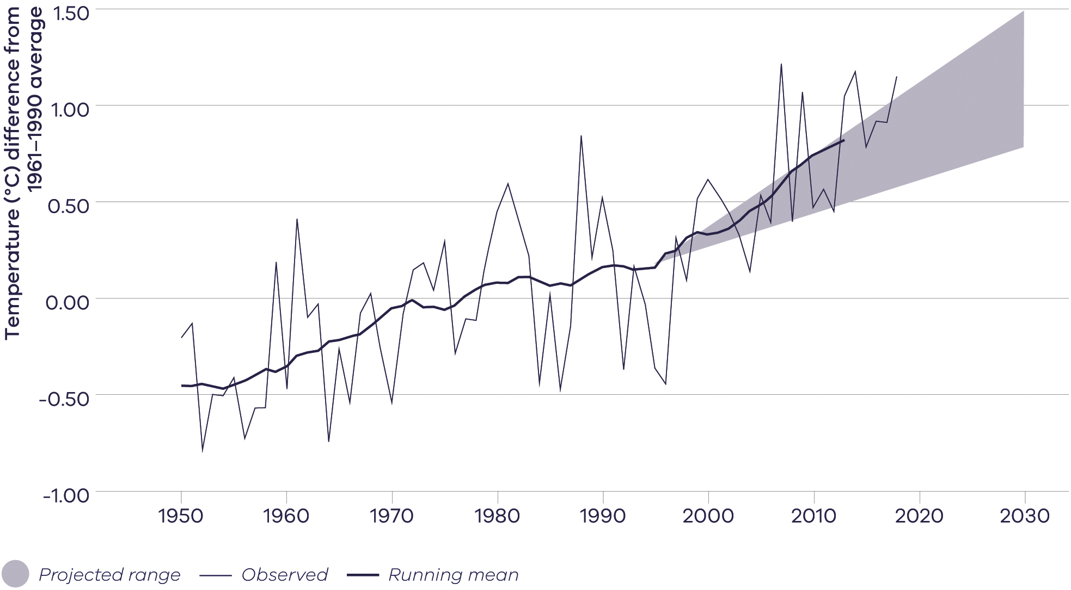
Comparison of the observed average annual temperatures for Victoria with the projected range of change. Shown are observed temperature difference from 1961–1990 average (thin black line) plus the 10-year running average (thicker line), and the projected temperature change to 2030 across climate models and emissions scenarios (relative to a 1986–2005 baseline period) (CSIRO, 2019).

Introduction
Climate change has been described by the World Health Organization (2015) as the greatest threat to global health in the 21st century.
The effects of climate change are already being experienced across Victoria, including higher average temperatures and reduced rainfall. Reducing our greenhouse gas emissions will help lessen the impact of climate change, but it will not prevent it – some degree of climate change is already locked in.
International agreements are aimed at preventing dangerous climate change. Although ‘dangerous’ can be viewed as a subjective term, there is scientific consensus that dangerous climate change will occur when global average temperatures increase by between 1.5 and 2° C above pre-industrial levels.
At the current rate of global greenhouse gas emissions, the planet is likely to reach 1.5° C warming between 2030 and 2052 (IPCC 2018). Some recent studies, however, show that the 1.5° C threshold could be reached within a decade (Henley and King 2017; Jacob et al. 2018; Schurer et al. 2018; Xu and Ramanathan 2017).
The unfolding climate crisis requires an immediate response to protect the health, safety and wellbeing of Victorians, now and into the future.
Without urgent action, its effects on public health and the determinants of health will continue to spread beyond localised and contemporary impacts – populations worldwide and future generations will all experience its multiple, increased risks, and its many and varied impacts. A clear feature of the climate crisis, which must be avoided, is its disproportionate impact on vulnerable and disadvantaged groups, and the risk of economic impacts entrenching and increasing social and economic inequality.
The impacts of climate change – such as increased frequency and intensity of heatwaves, bushfires, flooding and storm surges – affect public health, services, and infrastructure. Worldwide, between 100,000 and 200,000 deaths were attributable annually to the effects of climate change over the past decade (Spickett, Katscherian and Brown 2015). Climate change impacts include more heat-related deaths (especially among the elderly and disadvantaged), increased mental health effects and changing disease occurrence. Climate change impacts on infrastructure, such as public housing and health services, increase maintenance and repair costs and can create service disruptions (Victorian Government 2015). All these impacts add stress to health and human services.
Victoria is not immune to these effects. Victoria has become warmer, in line with global temperatures rising by about 1° C over the past century, and rainfall has declined since the 1950s, especially in autumn. Victorian temperatures are expected to continue to increase, leading to more hot days and heat waves, fewer frosts, and less rainfall in winter and spring south of the Great Dividing Range, less rainfall in autumn, winter and spring north of the Divide, more frequent and more intense downpours, harsher fire weather and longer fire seasons, and rising sea levels (Victorian Government 2015). Consequently, the health and human services system will have to adapt to maintain and improve its resilience in the face of climate change.
Adaptation to climate change requires a systemic approach to preparing for actual and expected changes to minimise harm, act on opportunities, and cope with the consequences (Victorian Government 2017). Such strategic and planned adaptation to long-term climate change differs from responding to year-to-year climate variability or ongoing disaster risk management. Moreover, an important part of planning for adaptation to climate change is building the capacity of organisations, processes and people to change.
The challenge of climate change adaptation adds to the task of managing a diverse and complex health and human services system that delivers high-quality services to Victorians.
Population and labour market growth mean that there is more demand for services. Victoria is experiencing significant changes to population settlement, with new growth areas emerging in the west, north, south-east and in inner Melbourne, and changes in Victoria’s demographics, such as in profiles of age, ethnicity, health and wellbeing. These changes are driving a redistribution and reconfiguration of services, and a recognition that the service mix needed in the future will be different from what people need now. Victorians also have changing expectations and preferences about the services they receive, with a growing preference for more personalised services, more choice and greater co-design and shared decision making.
The Department of Health and Human Services recognises these challenges and is leading climate change adaptation in health and human services. This pilot plan is the first step in a long-term process of building resilience to climate change. It will help the sector to further embed climate change considerations into policies, planning and operations, and to respond to the significant risks climate change poses to health and wellbeing and the health and human services system. In parallel with this plan, the department is also preparing an emissions reduction plan to reduce greenhouse gas emissions in the department, and in health and human services funded agencies. Together, the emissions reduction plan and the adaptation action plan will form an integrated climate change strategy, recognising that action in both these domains is urgently needed to protect the health and wellbeing of Victorians from the climate crisis.

Victorian Government action on climate change

The Climate Change Act 2017

Adaptation Action Plans
In February 2017, the Victorian Government passed the Climate Change Act 2017 (the Act). The Act creates a legislative obligation for government departments to conduct system-based planning for adaptation, focusing on systems that are vulnerable to climate change, or are essential to ensure Victoria is prepared. Systems-based planning, used in several overseas jurisdictions, enables a targeted response to climate change, focused on the unique characteristics and needs of a system.
The purpose of an adaptation action plan is to build the state’s resilience and help Victorians plan for the inevitable impacts of climate change. Adaptation actions will continue to evolve as climate change impacts and solutions change and will draw on the most up-to-date information and tools available.
Adaptation Action Plans must be prepared every five years for the following systems:
- built environment
- education and training
- health and human services
- natural environment
- primary production
- transport
- water cycle
  - any other prescribed system.
The first planning and implementation period is from 31 October 2021 to 31 October 2026.
Appendix 1 contains more information about how this plan aligns with the objectives and guiding principles of the Climate Change Act 2017.

Victoria’s climate change adaptation plan 2017–2020
In 2016, the Victorian Government released Victoria's climate change adaptation plan 2017–2020. The plan’s priority areas for action are to more effectively manage climate change risks to government-owned assets and services, help the community understand and manage the risks and impacts of climate change, and encourage adaptation action across all policy areas and sectors of the economy. Sectors addressed in the plan include the health and human services, emergency management, natural environment, agriculture, water and the built environment.
One initiative of the plan is for certain sectors to pilot the development and implementation of an adaptation action plan. The purpose of the pilot program is to learn about the implementation of this new requirement for system-based adaptation planning and share the lessons with other Victorian Government departments and agencies required to develop adaptation action plans under the Act. This plan, which applies to the period from 30 November 2019 to 31 October 2021, is the product of that commitment.

Scope of this plan

The health and human services system
The Act defines the health and human services system as, ‘the services and assets primarily engaged in protecting human health from disease resulting from or associated with communicable disease, food, water or the environment’, and ‘the services and assets which provide human physical and mental health care, social support and assistance’.
The Department of Health and Human Services (the department) is responsible for developing and delivering policies, programs and services that support the health, wellbeing and safety of all Victorians. The department performs the roles of steward, system manager and agent. It performs the role of steward through the development, implementation and oversight of policy; system management by the provision of funding and the administration of regulation; and the role of agent by the direct delivery of services, building capacity and exercising influence.
The department focuses on outcomes for the people who rely on its services and activities, and specifically that Victorians are healthy and well, safe and secure, have the capabilities to participate in, and are connected to, culture and community. Appendix 2 has more detail about our portfolio responsibilities.

Health and human services responsibilities in climate change adaptation
Responsibility for climate change adaptation in the health and human services is devolved across the sector according to the scope of management accountability.
Table 1: Responsibility for climate change adaptation in the health and human services
Entity | Responsibility in climate change adaptation
Department of Health and Human Services | - Implements the requirements of the Climate Change Act 2017.  - Leads on the development and implementation of an Adaptation Action Plan for the health and human services system.  - Provides direction and guidance on adaptation to funded agencies.  - Ensures that adaptation requirements are incorporated into relevant policy, plans, guidelines and standards.  - Ensures that adaptation needs are considered in funding for capital works, operations and services.  - Works to minimise the impact of emergencies on the health and wellbeing of communities and individuals, especially those most at risk.  - Ensures the community is protected from new and increased threats to health and wellbeing.
Hospitals and health services | - Manages climate change risks to their assets, services, clients, and staff.
Community service organisations | - Manages climate change risks to their assets, services, clients, and staff.
Local government | - Manages climate change risks to their assets, services, clients, staff.  - Incorporates consideration of climate change into municipal health and wellbeing plans.  - Facilitates emergency management planning at the local level and coordinates relief and recovery support for affected communities.

Relationship to other systems
The health and human services system has interdependencies with other systems listed in the Act. Many health and wellbeing outcomes are dependent upon the sound management, operation and adaptation of these systems.
Table 2: Health and human services system interdependencies with other systems listed in the Act
 | Health and human services | Water | Natural environment | Primary production | Built environment | Education and training | Transport
System definition | The services and assets primarily engaged in protecting human health from disease resulting from or associated with communicable disease, food, water or the environment; and the services and assets which provide human physical and mental health care, social support and assistance. | The collection, storage, treatment, delivery and supply of all water sources, sewerage, drainage services, and flood management services. | Land, water over that land, and the soils and biodiversity associated with that land; coastal water and the land under those waters, and the ecological processes and systems associated with the things set out above. | The growing and cultivation of horticultural and other crops, including plantation forestry and farm forestry; and the controlled breeding, raising or farming of animals, and the infrastructure, workforce and communities supporting the above. | The places and structures built or developed for human occupations, use and enjoyment, including cities, buildings, urban spaces, housing and infrastructure, and how people interact with that system. | The services and assets primarily engaged in the planning, development, provision and support of education and training, including future workplace skills and needs. | All the components for the movement of people and goods, including physical components, transport networks, facilities and vehicles and services components, including passenger, freight and other transport services to move people and goods.
Interaction with public health and the health and human services system |  | Water services provide reliable, safe, high quality drinking water, water for primary production and sewerage waste treatment, essential for good public health and wellbeing. | The natural environment provides clean air, water, soil, places of recreation, and other ecological determinants of health and wellbeing. | Primary production provides a wide variety of high quality, nutritious and affordable foods in a safe and quality-controlled environment. It also provides many raw materials for industry and indispensable products such as clothing. Animals are managed responsibly to ensure they and their products are safe for human consumption, and that risks are responded to rapidly. | The built environment provides housing, workplaces and service infrastructure for energy and water. The location and quality of housing, workplaces and the urban environment is a major determinant of health and wellbeing. | Education and training provide a pathway to employment, personal development, and social connectedness, which are determinants of health and wellbeing. The system trains health and human services practitioners to a high standard. | Transport provides access to employment, education and recreation. By enabling social connectedness and social participation, it is a significant determinant of health and wellbeing.
Climate change risks to public health and health and human services |  | Climate change is affecting water supplies and services. Reduced rainfall and increasing temperatures have reduced water supply and quality. Examples include the changed extent and seasonality of algal blooms in water supplies, and emerging pathogens that may impact aquatic facility risk management. Sea level rise could affect stormwater and sewerage infrastructure. | Climate change is altering habitats and accelerating species extinction. It will increasingly disrupt ecosystems and compromise the life supporting services they provide. | Climate change is affecting primary production. This could reduce access to affordable, nutritious foods, and increase food insecurity. The livelihood of rural and regional communities is being affected, with consequential health and wellbeing impacts. | The built environment is exposed to more frequent and extreme weather events, such as flood, bushfires and heatwaves. Most housing is not suited to a changing climate, particularly extreme heat, presenting a risk to health and wellbeing. | Extreme weather can damage education infrastructure and disrupt services. Climate change causes economic costs, which are likely to increase over time. Economic impacts could affect employment, access to education, and increase disadvantage, compromising health and wellbeing. | Extreme weather can damage transport infrastructure and disrupt services, compromising access and participation.

Climate change, public health and the health and human services

The ecological determinants of health and wellbeing
Our understanding of the determinants of health and wellbeing encompasses the social determinants of health and wellbeing, including early childhood experiences, education, employment, income, social and economic status, housing and geography, social support networks and access and use of health services (Marmot and Wilkinson 2003).
All these determinants exist and operate within the domain of human systems, which are nested in and dependent upon the Earth’s natural ecosystems. The ultimate determinant of human health, therefore, is the health of the environment.
People’s health and wellbeing depend on many essential ecological processes and natural resources. Human survival fundamentally relies on a diversity of other species and ecosystems, each of which in turn are interdependent. In other words, ecosystem-based ‘goods and services’ – the most important of which include oxygen, water, food, fuel, various natural resources, the ozone layer and a habitable climate – are the ecological determinants of health.
The Earth’s ecosystems operate within boundaries that allow life to thrive. By crossing these boundaries, we increase the risk of destabilising the system to the extent that it may collapse. There is increasing evidence that human activities threaten the resilience of some Earth systems by exceeding their safe operating boundaries (Steffen et al. 2015; Diaz et al. 2019). The global climate faces ‘tipping points’, which represent thresholds that, when exceeded, can lead to large changes in the state of the system.
Due to the dependencies of human health on the environment, managing risks to public health needs to consider the natural world, and specifically to target the health challenges of human-induced global climate change, resource depletion, ecotoxicity and loss of biodiversity. Global threats to the ecological determinants of health and wellbeing, such as climate change and biodiversity loss, have a bearing on the management of Victoria’s natural environment, our role in responding to climate change, and the health and wellbeing outcomes for Victorians. Climate change also affects the social determinants of health and wellbeing – such as education, employment and housing – in ways that mean greater risks to disadvantaged and vulnerable people.
An understanding of the social and environmental determinants of health and wellbeing is embedded in the department’s approach to the provision of health and human services. The Public Health and Wellbeing Act 2008 requires the department to establish and maintain comprehensive information that includes the determinants of individual health and public health and wellbeing. It further requires municipal health and wellbeing plans to include an examination of data about health determinants in each municipal district.
The Public Health and Wellbeing Act 2008 also requires the preparation of the Victorian public health and wellbeing plan. The Victorian public health and wellbeing plan 2019–2023 has a new focus on climate change and its risks to health and wellbeing, and it sets out actions to address those risks.
The Pilot health and human services climate change adaptation action plan 2019–21 is an opportunity to further extend the department’s response to climate change by laying the foundation for building long-term resilience to climate change through adaptation in the health and human services.

Climate change impacts on health and wellbeing in Victoria
The direct and indirect impacts of climate change are likely to exacerbate existing public health risks and represent an unacceptably high and potentially catastrophic risk to human health (Figure 1) (Watts et al. 2015).
Direct impacts, caused by exposure to more frequent and intense extreme weather events such as bushfires, droughts, floods and heatwaves, may include hypo- and hyperthermia, heat stress, injury, trauma and death. Indirect impacts, mediated through natural and human systems affected by climate change, include vector-borne diseases (those transmitted by vectors such as mosquitoes to humans) and zoonotic diseases (those transmitted from animal to humans), water-borne diseases (resulting from exposure to harmful algae and pathogenic microorganisms affecting drinking water, recreational water including aquatic facilities, and water supplied for agricultural and domestic use), food-borne diseases (such as salmonellosis) and contaminants (such as mycotoxins), air pollution and airborne pollen.
The determinants of health and wellbeing, including social determinants such as housing and the built environment (Lalonde 1974), are affected by climate change. Extreme heat can increase indoor temperature, and extreme weather events can affect transport, health and human services, and employment, each affecting community health and wellbeing. Climate change may have an adverse impact on the economy (Garnaut 2008), which could lead to unemployment, stress, social exclusion and increases in food insecurity. Older people, young children, people with medical conditions, people with mental illness, people experiencing homelessness, people with a disability, culturally and linguistically diverse groups, and low-income households can be more sensitive to these impacts.
Ignoring climate change may damage world economic growth and create risks of significant disruptions to social activity (Stern and Stern 2007). In Australia, real wages and gross national product would all decline under an unmitigated climate change scenario (Garnaut 2008).
The following discussion of health and wellbeing impacts is not comprehensive but aims to illustrate the categories of impact and their implications for public health and the health and human services system.
Figure 1 describes the categories of health and wellbeing impacts, including those that are direct, indirect, and those that affect the social determinants of health and wellbeing.
Figure 1: Direct and indirect effects of climate change on health and wellbeing (Watts et al. 2015)
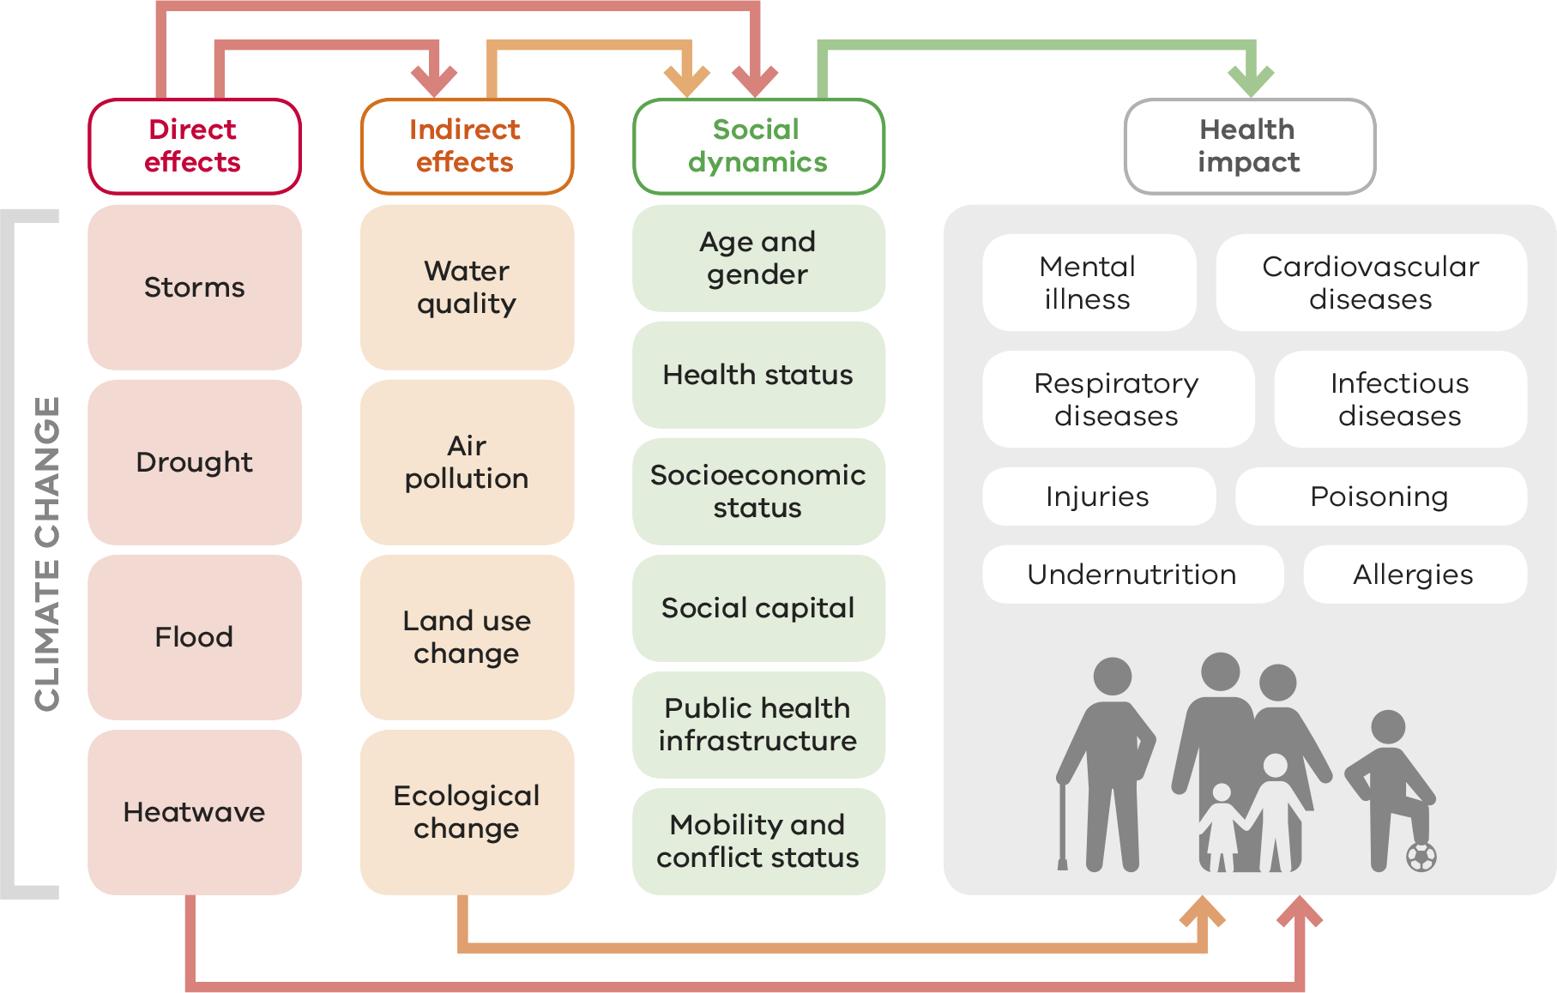

Direct health impact: bushfires
Extreme fire weather has increased in recent decades in southern and eastern Australia, with an associated increase in the length of the fire season (Bureau of Meteorology, 2018).
Figure 2: Trends from 1978 to 2017 in the annual (July to June) sum of the daily Forest Fire Danger Index (FFDI) – an indicator of the severity of fire weather conditions
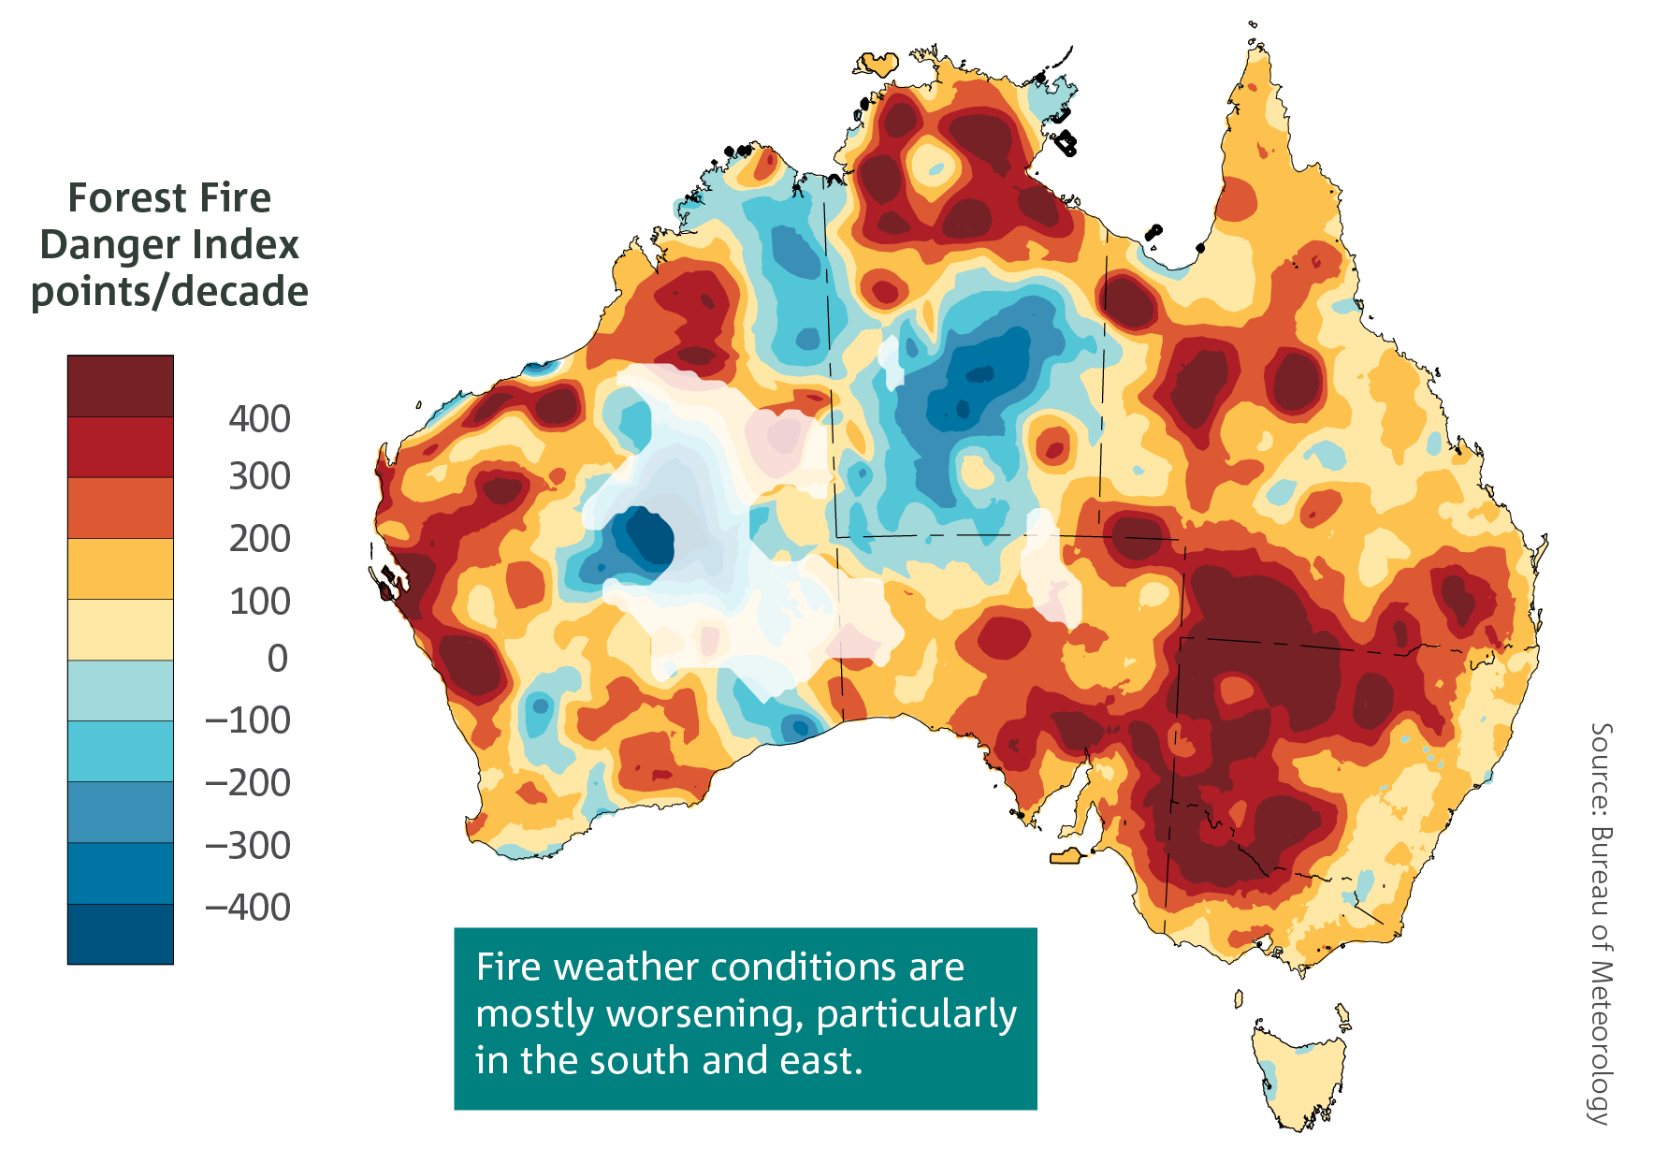
Positive trends, shown in the yellow to red colours, are indicative of an increasing length and intensity of the fire weather season. A trend of 300 FFDI points per decade is equivalent to an average trend of 30 FFDI points per year. Areas where there are sparse data coverage such as central parts of Western Australia are faded. Source: Bureau of Meteorology 2018.
Fires are expected to increase in intensity and frequency. In Southeast Australia, the frequency of very high and extreme fire danger is likely to rise from historical levels, and fire season length is likely to be extended (Lucas et al. 2007).
Table 3: Fire frequency by 2020 and 2050 (Lucas et al. 2007)
Fire intensity | Frequency increase by 2020 | Frequency increase by 2050
Very high | 10–30% | 15–65%
Extreme | 20–100% | 100–300%
The direct health impacts of bushfires include death, injury and trauma (Parliament of Victoria 2009). For example, the 2009 Black Saturday bushfires were responsible for 173 deaths, 414 hospital presentations for burns, smoke inhalation and physical trauma, 89 admissions (Cameron et al. 2009) and more than 5,000 first aid treatments (Parliament of Victoria 2010).
High concentrations of smoke contribute to increasing hospital presentations for asthma, so projected increases in fire frequency may lead to increased rates of asthma exacerbations (Hennessy et al. 2007).
Bushfires can cause social dislocation, reduce community cohesion and family health, and increase the likelihood of aggression and family violence. For example, the Black Saturday bushfires increased the incidence and severity of family violence for more than 50 per cent of women interviewed in affected shires (Deloitte Access Economics 2016), and the department and community services organisations responded to increased incidences of post-traumatic stress, depression and anxiety (Parliament of Victoria 2016).
Climate change can magnify the risks to health and mental health. The increased frequency and intensity of fires are likely to place stresses on service provision and could exacerbate personal and structural barriers experienced by vulnerable groups who access mental health care.

Direct health impact: heatwaves
Heatwaves represent the disaster responsible for the most deaths in Australia (other than epidemic), accounting for 2,887 deaths between 1890 and 2013 (Australian Emergency Management Institute 2013). Heat-related deaths due to increased hot days and heatwaves are likely to be one of the most significant health impacts of global warming, with the bulk of increased rates experienced in temperate cities (Hennessy et al. 2007). In Victoria, during the heatwave of 2009 there were 374 excess deaths (Department of Health 2009); likewise, during the 2014 heatwave event there were 167 excess deaths (Department of Health 2014). There may be an extra 400 deaths per year in Victoria by 2050 due to heatwaves if no adaptation measures are taken (Keating and Handmer 2013). Increased incidence of heatwaves due to climate change in Victoria by 2050 could cause $6.4 billion in losses due to mortality (Keating and Handmer 2013).
Most heatwave deaths occur in people with pre-existing cardiovascular disease (heart attack and stroke) or chronic respiratory diseases. People living in urban environments are at greater risk than those in non-urban regions. Thermally inefficient housing and the urban heat island effect – whereby inner urban environments, with high thermal mass and low ventilation, absorb and retain heat – amplify and extend the rise in temperatures, especially overnight (McMichael et al. 2006).
Figure 3: Extreme temperature days 1910–2015
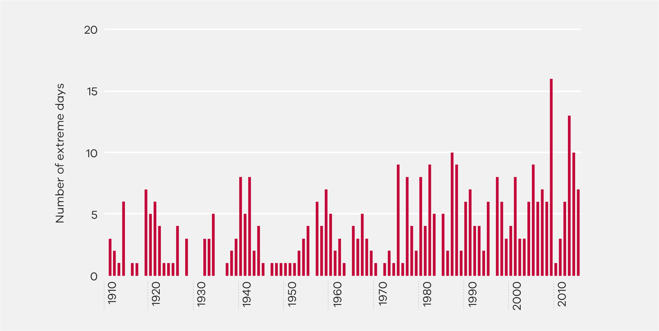
Number of days each year where the Victorian area-averaged daily mean temperature is unusually warm. Extreme days are those above the 99th percentile of each month from the years 1910-2015. Bureau of Meteorology 2018.
Hot days may double by the 2050s
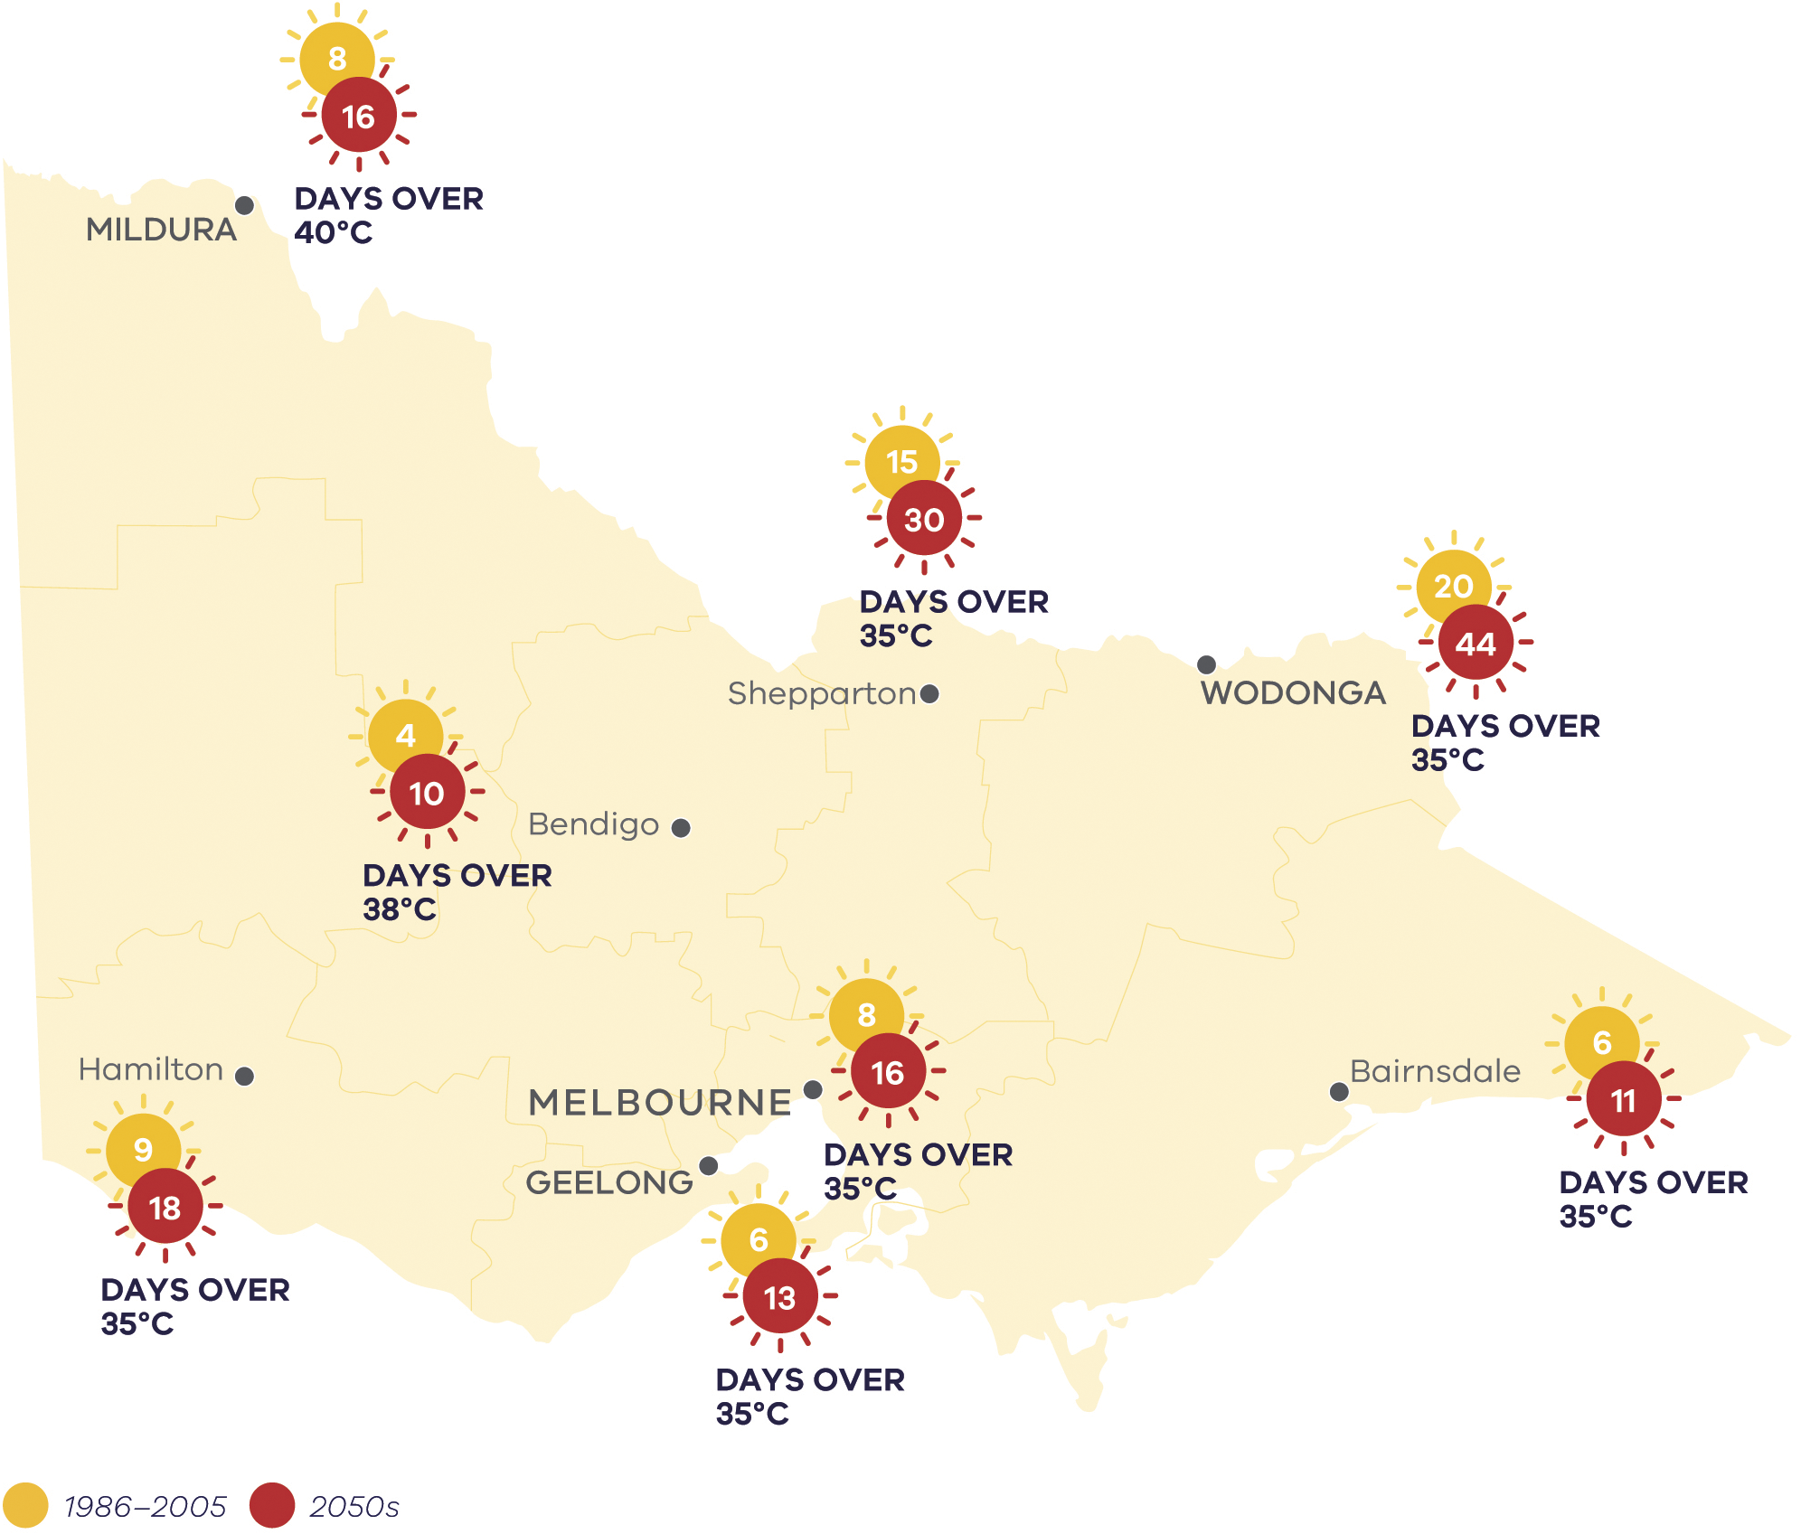
Comparison of the median number of hot days per year currently (between 1986 and 2005) and in the 2050s under high emissions (RCP 8.5). Hot days have maximum temperature greater than the thresholds of 35°C, 38°C and 40°C for locations across Victoria (CSIRO, 2019).

Indirect health impact: 2017 Ross River outbreak
Climate change is likely to alter the geographic range and seasonality of some mosquito-borne diseases. An increased variability in Ross River virus in temperate and semi-arid regions and increased risk of dengue fever in both tropical and temperate latitudes is likely (Hennessy et al. 2007). Figure 4 shows the record incidence of Ross River virus in 2016–17 relative to the previous 10 years.
Figure 4: The incidence of Ross River virus
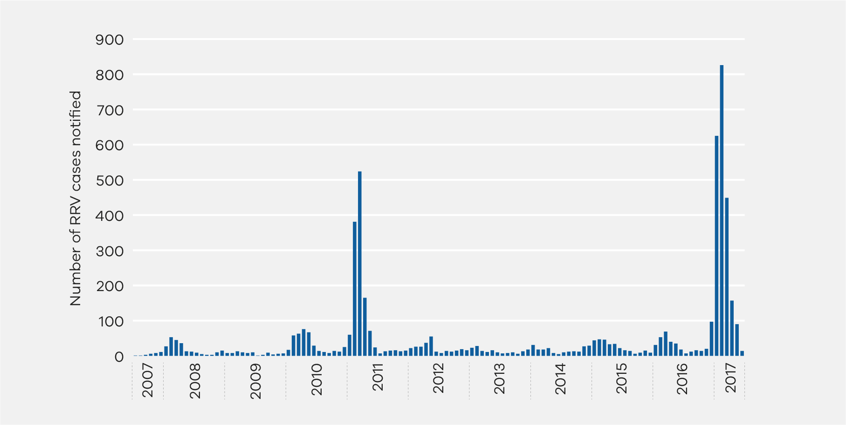
Source: Health Protection Branch (Department of Health and Human Services 2018)
Climate change is predicted to increase rainfall variability, which can lead to more flooding.
In September 2016, above-average rainfall occurred in Australia. This rainfall anomaly led to widespread flooding across large parts of Victoria, particularly in the north-east and north-west. Above average rainfall also occurred during the following month, causing the flooding to persist or reoccur in some areas. Persistent standing water, coupled with warmer weather in the ensuing months, led to ideal mosquito breeding conditions in large parts of the state. On-field reports from selected local government areas indicated that mosquito abundance was high.
The Department of Health and Human Services funded an enhanced public health action plan to mitigate and manage the anticipated Ross River Virus outbreak, including disease surveillance and control measures, and a public messaging campaign called Beat the Bite to inform the public about the risks of mosquito-borne diseases, and to provide health advice relating to personal protective measures to avoid mosquito bites.
Despite implementing an extensive public health action plan in response to the flooding event, Victoria experienced the largest Ross River Virus outbreak since 1993. Between October 2016 and April 2017, there were 1,974 human cases reported, which was nearly 10 times greater than the historical mean of 204 cases per year.
As the incidence of flooding and warmer climate conditions increases in Victoria, it is very likely that outbreaks of Ross River virus and other endemic vector-borne diseases such as Barmah Forest virus and Murray Valley encephalitis will increase. This, coupled with the migration of previously unseen vectors capable of carrying other pathogens, are a major concern.

Indirect health impact: water quality risks
Climate change is threatening the quality of Victoria’s water, resulting in increased risks to human health. Historically, the cool season (April to October) provides most of the runoff to Victoria’s rivers. There has been a marked reduction in cool season rainfall over the past 30 years, interspersed with the occasional extremely wet year, such as 2010. Total inflows to the Melbourne Water supply systems from 1996 to 2015 were the lowest 20-year inflows on record, with a reduction of 25 per cent relative to the historical record going back more than 100 years (Hope et al. 2017).
There is a consistent drying trend, which means below average rainfall has been recorded most years since the late 1990s except for 2010 and 2011 (influenced by strong La Niña events) and 2016 (influenced by a strong negative Indian Ocean Dipole). Since 2013, below average rainfall conditions have dominated the climate and extended the overall drying pattern affecting the state.
The drying of Victoria's climate has become increasingly apparent since the mid-1990s, with only four of the last twenty years above the 1961 to 1990 average. The decline in cool season rainfall has consequences for agriculture and water quality (Bureau of Meteorology 2018).
Figure 5: April to October rainfall deciles for the last 20 years (1999 to 2018)
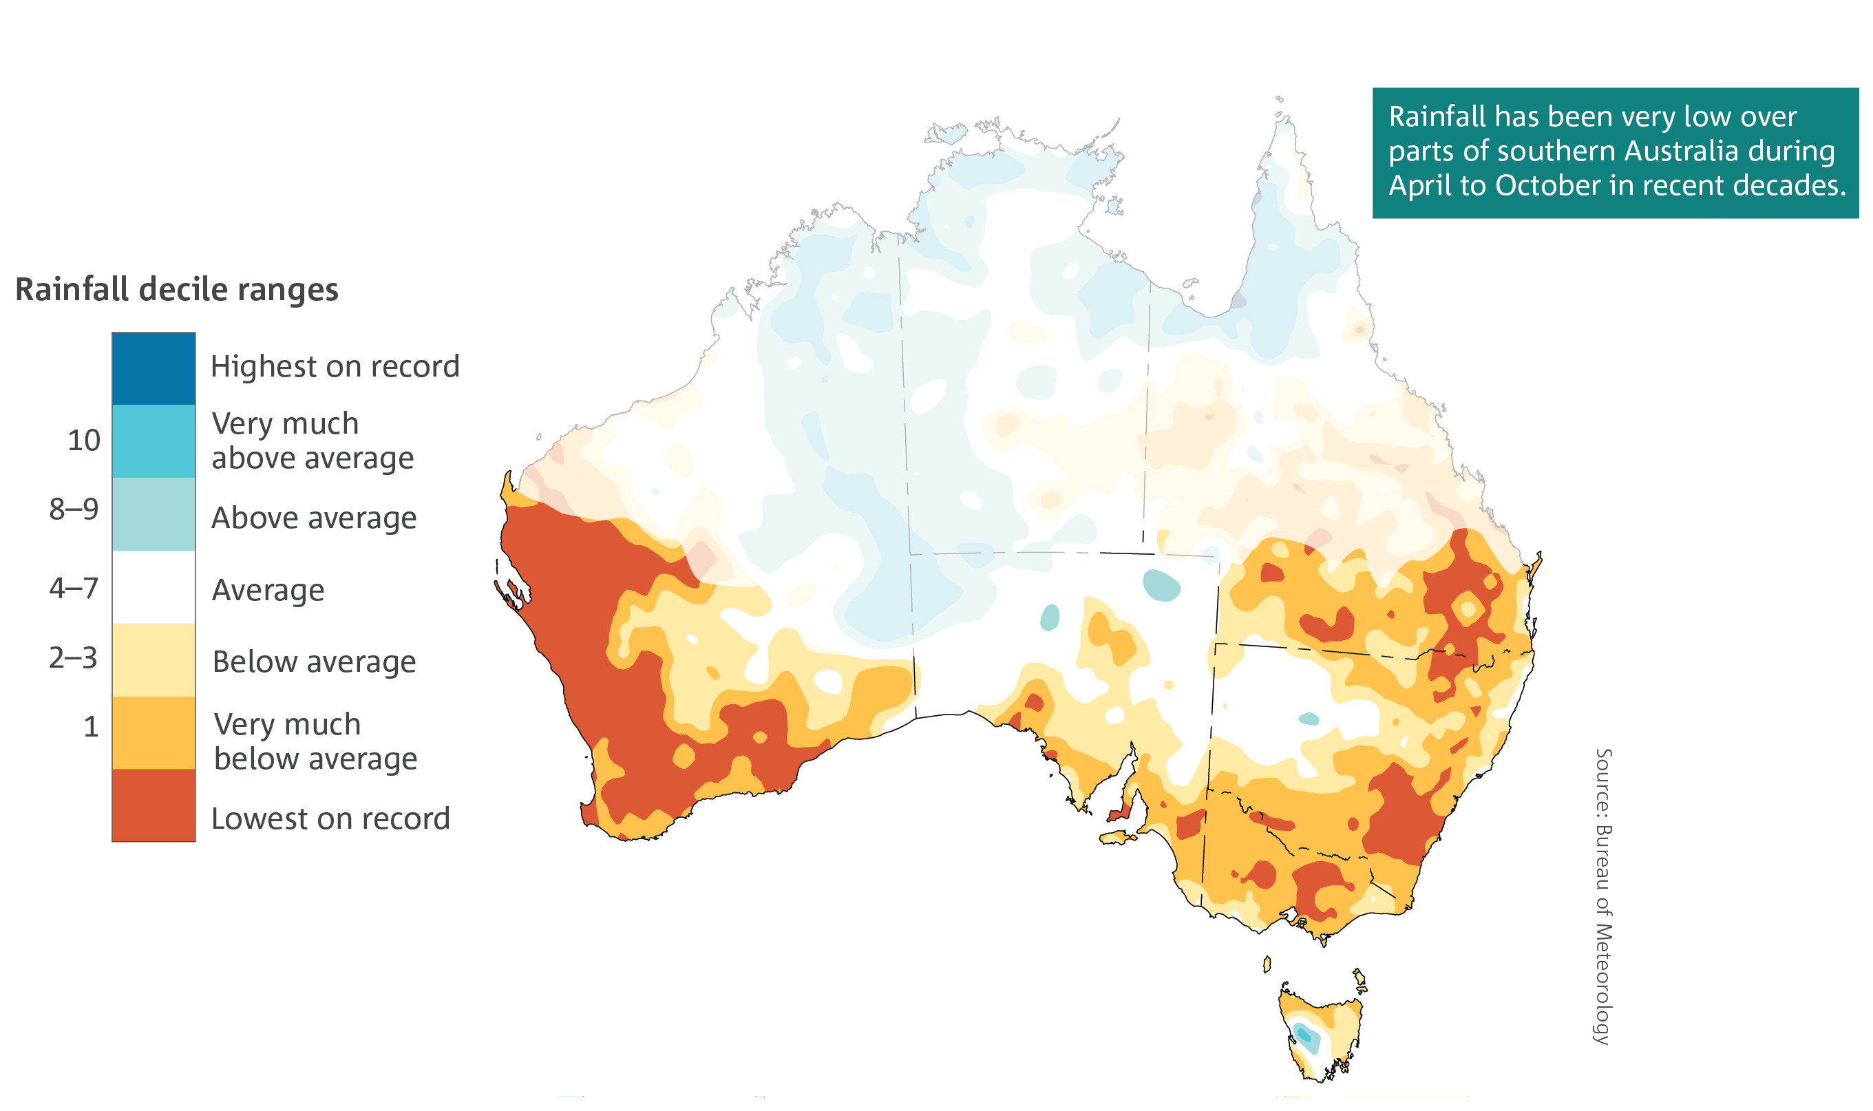
The map shows recent period rainfall compared to the record since 1900 (Bureau of Meteorology 2018).
Droughts and rising water temperatures can alter the quality of drinking and recreational water. Increased temperatures lead to an increased risk of harmful algae, expansion of the range of previously climatically restricted pathogens and vectors, and emerging pathogens. Higher temperatures may accelerate the formation of biofilm and the prevalence of opportunistic pathogens (such as Pseudomonas aeruginosa) in the water supply network. Some species of harmful algae can produce chemical compounds that impact drinking water supplies, commonly imparting a musty odour and taste. More significantly, some species sometimes produce toxins that have serious health implications for humans, animals, birds and livestock if they are consumed, inhaled or come into contact with the skin (DELWP 2018). For example, in 2019 the drinking water supplies of two Victorian communities were disrupted due to algal blooms. Algal blooms impacting on water supplies is likely to occur more frequently in future.
Higher temperatures may lead to more frequent bushfires that destabilise topsoil, which can wash into water supplies. Floods can wash sediment, nutrients, human and animal waste and chemicals into water supplies and receiving waters, in some extreme cases rendering drinking water sources unusable for months or even years.
Deterioration of water quality has serious implications for human health. Contaminated water exposes Victorians to the risk of gastrointestinal illness, and in some cases death, as well as ear, nose and throat infections, and dermatitis.
Projected annual rainfall decline by the 2050s
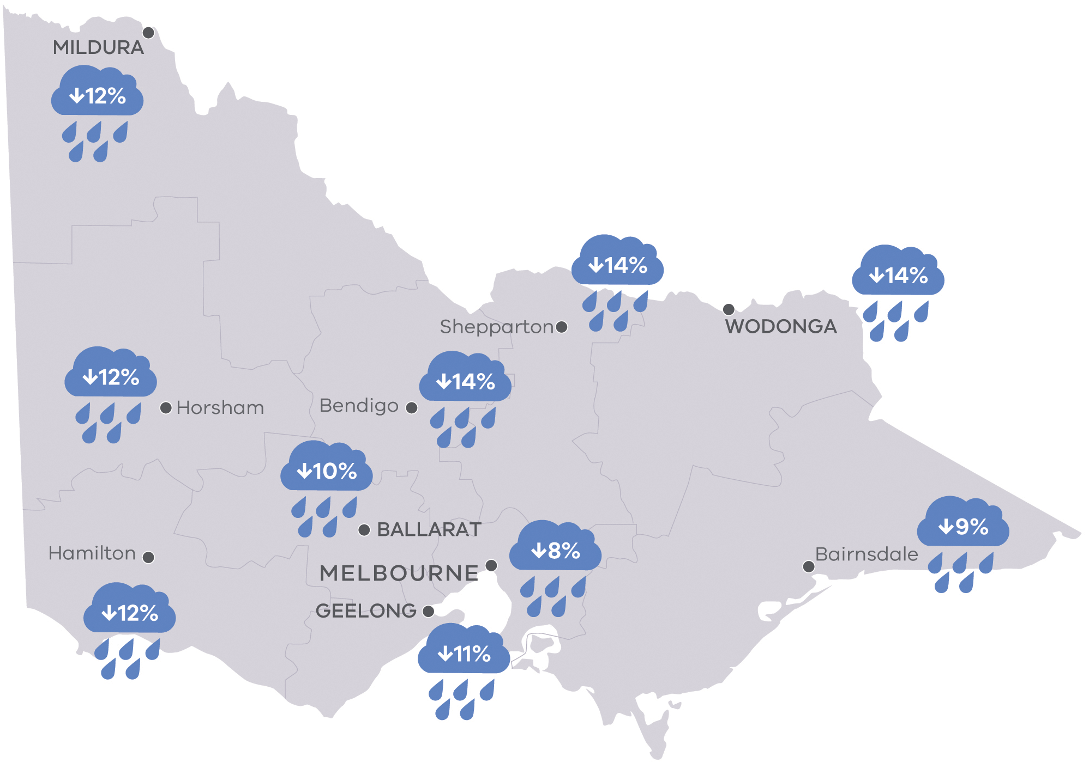
Average decline in annual rainfall in percent for locations across Victoria for the 2050s under high emissions scenario (RCP 8.5) compared to 1986–2005. Source (CSIRO, 2019).

Social determinants impact: exposure of housing to heat and cold
Housing is a significant social determinant of health and wellbeing, influencing indoor temperature and exposure to temperature extremes. People sensitive to heat may experience health effects such as heat cramps, exhaustion and heat stroke when indoor temperature and humidity exceed safe levels (Department of Health and Human Services 2017). Most Victorian housing is not designed to suit a changing climate, and residents are likely to experience extended periods of unsafe indoor temperatures during hot days and heatwaves (Department of Health and Human Services 2017).
Areas in Melbourne’s north and west and in the southeast growth corridor are among those most exposed and hottest during a heatwave. They also have higher concentrations of low-income households. The risk of heat stress is particularly great in north-west Victoria.
The risk of heat health impacts increases with lower income and education, social isolation, disability, and age (the very young or old). These risk factors represent many attributes of the social determinants of health and wellbeing, and many are twice as prevalent in low income households (Barnett et al. 2013).
Figure 6: Heat distribution in Melbourne during 2009 heatwave (left) and distribution of low-income households (right)
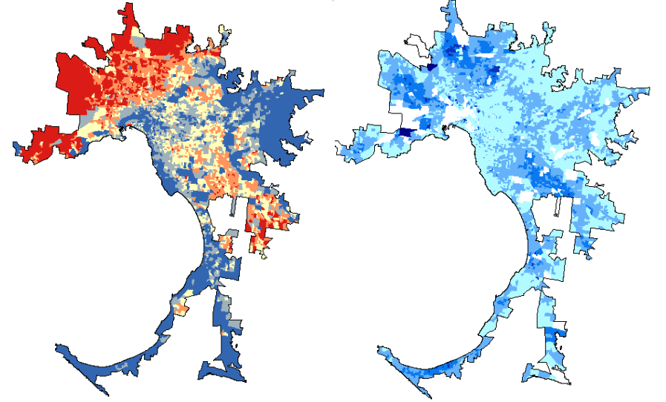
The left map shows the distribution of daytime surface air temperature during the heatwave of 2009, where red is hotter and blue cooler. The right map shows the distribution of household income; darker blue areas show lower income households. These maps show that areas where low income households are concentrated (in the north and west of Melbourne and in the south-eastern growth corridor) are most exposed to heat on hot days and heatwaves (Barnett et al. 2013).
Exposure to cold is also a health risk, leading to impacts such as cardiovascular stress, inflammatory responses, bronchoconstriction and respiratory infection (Gasparrini et al. 2015). For low-income households, the poor thermal performance of housing in winter means that a greater portion of income must be spent to keep houses warm. Low-income households are known to curtail heating when it is unaffordable (VCOSS 2016). The poor thermal performance of housing is a likely contributor to health impacts in winter, on hot days and during heat waves.

Social determinants: economic impacts of climate change
Climate change has been described as the greatest and widest-ranging market failure ever seen. The evidence shows that ignoring climate change will eventually damage world economic growth and create risks of major disruption to world economic and social activity on a similar scale to the world wars and great depression of the 20th century (Stern and Stern 2007).
Economic damage from extreme weather is on the rise and will very likely continue to increase, providing major challenges for adaptation. For example, risks to major infrastructure are likely to increase by 2030 as designed tolerance for extreme events are exceeded more frequently (Hennessy et al. 2007).
‘[Worldwide, t]he total cost of business as usual climate change is equivalent to a 20% reduction in current global per-capita consumption, now and forever. Distributional judgments, a concern with living standards beyond those elements reflected in GDP, and modern approaches to uncertainty all suggest that the appropriate estimate of damages may well lie in the upper part of the range 5–20%’ (Stern, p. 143).
A 2013 study found that increased incidence of bushfire due to climate change in Victoria would cause an additional $1.4 billion in economic losses to agriculture above a no-climate change scenario by 2050, and the Victorian timber industry would experience an additional $2.8 billion loss. The study calculated $6.4 billion in losses due to mortality by heatwave by 2050 (Keating and Handmer 2013).
A 2019 study found that the Australian property market is expected to lose $571 billion in value by 2030, and the accumulated loss of wealth due to reduced agricultural productivity and labour productivity because of climate change is projected to exceed $19 billion by 2030 and $211 billion by 2050 (Steffen et al. 2019).
Should climate change harm the economy, it could lead to unemployment, homelessness, stress, social exclusion and increases in food insecurity, with consequent adverse health and wellbeing outcomes.
Our near region has large populations exposed and vulnerable to the effects of climate change, raising the likelihood of increased humanitarian crises, social dislocation, mass migration and refugees. This will likely pose challenges to the Victorian health and human services as they respond to the needs of people displaced from their homelands due to natural disasters driven by climate change (Dunlop and Spratt 2017).

Climate change impacts on the health and human services system
The health and human services system, its workforce, services, and built assets, are not immune from climate change (Fuenfgeld et al. 2013; QCOSS 2010; Hawe 2009). The exposure to more frequent and intense extreme weather events will increase the system’s vulnerability to a range of risks, including:
- more frequent surges in client demand
- disruption of workforce access to their workplace
- psychosocial impacts on staff
- damage to built assets from, for example, floods, storms, and bushfires
- disruption or failure of service infrastructure such as telecommunications, transport, electricity, and water supplies
- disruption of supply chains.

Impacts on health and wellbeing outcomes
Across the Victorian Government, there is an increased focus and effort on measuring and reporting the outcomes of services and interventions. The department’s outcomes framework articulates the health and wellbeing outcomes for Victorians, and the results by which it will measure its efforts.
The departmental outcomes framework focuses on outcomes for people who rely on its services and activities, and the system-level results sought from the health and human services reforms being implemented.
The framework and the results and measures that support it have been designed to answer questions including how much the department did, how well it performed, and whether the results aligned with what the people accessing its services and programs want and value.
Table 4 illustrates the ways in which climate change risks and impacts are likely to affect public health and human services outcomes. The table is not exhaustive; it provides an indication of the source of likely impacts (direct, indirect, social determinant) and examples of the pathway from the source to health and wellbeing impact.
Table 4: Climate change risks and likely impact on health and human services outcomes
 | Health and wellbeing outcomes | Impact sources
 | Victorians have good physical health | Multiple impact pathways are likely to compromise physical health outcomes. Direct sources include mortality, injury or trauma from natural disaster events. Indirect sources include mortality or illness from water contamination or vector-borne disease. Social determinant sources include poor thermal protection in housing, urban heat island effect, degradation of sport and recreation facilities and reduced economic status.
 | Victorians have good mental health | Multiple pathways are likely to compromise mental health outcomes. Examples of direct sources include trauma and dislocation caused by natural disasters. Social determinant sources include reduced economic status or unemployment due to economic shock or affected businesses or industries.
 | Victorians act to protect and promote health | Many Victorians are unaware of the links between climate change and health and wellbeing. Lack of knowledge and skills or access to enabling supports could compromise the ability of Victorians to protect their health and wellbeing from impacts.
 | Victorians live free from violence and abuse | Direct sources include violence and abuse associated with natural disaster events, which are becoming more frequent and extreme. Social determinant sources include violence and abuse associated with economic stress and unemployment.
 | Victorians have suitable and stable housing | Direct sources include structural damage to housing from natural disasters. Social determinant sources include housing design which is unsuited to a rapidly changing climate, particularly increased hot days and heatwaves.
 | Victorians benefit economically from strong health, human services and sport and recreation sectors | The health and human services system, its workforce, services, and built assets are subject to a range of impacts, with associated economic consequences. Direct sources include damage to built assets, demand surges, disruption of workforce access to their workplace and staff trauma due to natural disasters. Indirect sources include demand surges due to outbreaks of food, water or vector-borne diseases. Sport and recreation facilities are likely to experience increased damage and degradation due to the increased frequency and intensity of natural disasters.
 | Victorians participate in the economy and have financial security | Multiple pathways are likely to compromise economic participation. Direct and indirect sources include the disruption or failure of businesses due to natural disaster, or outbreak of water or vector-borne diseases. Social determinant sources include economic shock, unemployment and food insecurity linked to low household income.
 | Victorians are socially engaged and live in inclusive communities | Direct sources include damage and disruption to transport, compromising accessibility to community and employment, and social dislocation due to natural disaster. Social determinant sources include economic shock, reduced social status and unemployment.
 | Services are appropriate and accessible in the right place, at the right time | The health and human services system, its workforce, services, and built assets are subject to a range of impacts, which are likely to compromise service accessibility and right place and time delivery. Direct sources include damage to built assets, demand surges, disruption of workforce access to their workplace and staff trauma due to natural disasters. Indirect sources include demand surges due to outbreaks of water or vector-borne diseases.
 | Services are efficient and sustainable | The health and human services system, its workforce, services, and built assets are subject to a range of impacts, which are likely to compromise the efficient delivery of services. Direct sources include damage to built assets, transport services, demand surges, failure of workforce access and staff trauma due to natural disasters. Indirect sources include demand surges due to outbreaks of water or vector-borne diseases.

Climate change adaptation policies and initiatives, gap analysis and new actions
This section provides a high-level overview of the department’s policies and initiatives related to climate change adaptation, assesses the state of adaptation planning, and identifies areas for further action by the department.

Vision
A health and human services system resilient to climate change and ecologically sustainable, achieving the best health, wellbeing and safety of all Victorians so that they can live a life that they value.

Adaptation milestones
The following describes the short, medium and long-term milestones and timeframe for progress on climate change adaptation in the health and human services.
Table 5: Health and human services climate change adaptation milestones and timeframe
Timeframe | Milestone
Short term: 2019–21 | Integration of climate change adaptation into relevant areas of governance, policy, planning and processes is in progress. Adaptation responses are being prioritised, designed, costed and planned.
Medium term: 2021–25 | Consideration of climate change adaptation is part of the business as usual approach to decision making. Implementation of priority adaptation programs is underway.
Long term: 2026–30 | The health and human services continue to provide a high standard of service to Victorians, are resilient to climate change, ecologically sustainable, and contribute to the liveability of our places and wellbeing of our community.

Action domains and outcomes
The plan sets out four action domains identifying areas of adaptation activity. There are 21 actions across the four domains to be achieved in the 2019–21 period. The actions represent the first steps towards climate change adaptation over the long term. The accompanying statement of adaptation outcomes in each domain describe the system changes sought over the term of milestone implementation described above.

Domain 1: Governance and regulation
The department is responsible for developing and delivering policies, programs and services that support the health, wellbeing and safety of all Victorians. The department provides stewardship of the systems and outcomes in health, and human services. Health and human service providers are responsible for governance, policy and planning for their organisations and the services and outcomes they provide.
The Climate Change Act 2017 requires that government endeavours to ensure relevant decisions, policies, plans and process appropriately take account of climate change. There is considerable scope for the health and human services to achieve adaptation outcomes by embedding the consideration of climate change into relevant guidelines, policy, planning and processes.

Outcomes
- Health and human services strategies, policies, plans and processes incorporate and respond to climate change.
- Regulations incorporate and respond to climate change risks.
- The boards of health and human services providers understand and manage the risks posed by climate change.

What we are doing
The department recently published the Public health and wellbeing plan 2019–23, which includes ‘taking action on climate change and its impacts on health’ as a key focus area. It aims to build community safety and resilience to the public health impacts of climate change, decrease its health impacts, and support action to reduce greenhouse gas emissions, which also has health co-benefits.
Business continuity planning ensures the department has in place an effective management system to ensure its critical business activities continue or are restored as a priority following a disruption. The Business continuity policy and framework sets out methodology and processes within the business continuity management system. The Crisis communications plan describes the department’s communications roles, responsibilities and arrangements in place to inform staff, community and the sector during a crisis or business continuity incident.
Victoria has coordinated governance and planning arrangements to prepare for, respond to and recover from emergencies. These arrangements are articulated in the Emergency management manual Victoria. The arrangements for responding to an emergency are described in the State emergency response plan.
The State health emergency response plan is a subplan of the State emergency response plan and outlines arrangements for managing and responding to health emergencies in Victoria. A health emergency, as defined by State health emergency response plan, includes an incident or emerging risk to the health of community members, from whatever cause, that requires a significant and coordinated effort to ensure the health system can effectively respond and mitigate adverse health consequences for communities. The State health emergency response plan enables the department, Ambulance Victoria and the broader health system to respond to any health emergency.
The State health emergency response plan and its supporting operational plans, protocols and guidelines are collectively referred to as the State health emergency response arrangements. The State Health emergency response arrangements supports the health system to remain flexible and responsive during health emergencies.
The department’s Heat health plan for Victoria reflects the principles of the State health emergency response plan. It outlines how the Department of Health and Human Services, together with local government and the health and human services sector, can promote public health and wellbeing before and during periods of extreme heat.
The department administers several regulatory frameworks for areas that may be affected by climate change, including the Safe Drinking Water Act 2003 and supporting regulations, and the Food Safety Act 1984. These frameworks provide a risk-based approach for managing public health, including risks that may be posed by climate change.
Actions to protect the health of Victorians from the impacts of climate change cross multiple government portfolio areas, including water, planning, agriculture, environment and energy. Consequently, the department works in partnership with these portfolio areas on climate-related initiatives.
Cross-portfolio actions include:
- supporting the Victorian water industry in mapping and adapting to potential climate risks, in conjunction with the Department of Environment, Land, Water and Planning, and other government departments and stakeholders
- supporting local governments, Department of Environment, Land, Water and Planning and the Environment Protection Authority in their oversight of recreational water bodies by maintaining the currency of guidance for aquatic facilities and recreational water bodies
- supporting the review of the National Health and Medical Research Council Guidelines for managing risks in recreational water
- collaborating with Emergency Management Victoria, the Environment Protection Authority, and response agencies to review and improve the state-level framework for protecting public health from contaminants in smoke and emissions from significant or long-duration fires
- collaborating with the Office of the Chief Veterinary Officer (Department of Jobs, Precincts and Regions), Worksafe, the Environment Protection Authority and the state’s public health reference laboratories to manage vector-borne and zoonotic disease investigations through the lens of interconnected human, animal and environmental health (OneHealth approach).

Actions 2019–21
Action 1: Support cross-jurisdictional work to protect community health and wellbeing from the impacts of climate change through the Australian Health Protection Principal Committee and its subcommittees.
Action 2: Contribute to whole-of-Victorian-Government planning to ensure that the impacts of climate change on public health are considered and opportunities to protect the community are identified.
Action 3: Review the Health services strategic planning guidelines to ensure health services strategic plans address climate change risks.
Action 4: Advise health service boards to ensure they understand and manage the risks of climate change.
Action 5: Include climate change in Regional and Local Area Health Partnership planning and policy development.
Action 6: Review and update the Municipal public health and wellbeing planning: having regard to climate change guidelines to promote and strengthen consideration of climate change and its impact on health by local government in their planning and implementation of municipal public health and wellbeing activities.
Action 7: Survey councils to assess the extent to which actions to address the health impacts of climate change have been included in their municipal public health and wellbeing plans in accordance with their requirements under the Climate Change Act 2017.
Action 8: Incorporate additional climate change indicators into the Victorian public health and wellbeing outcomes framework.
Action 9: Review and update the Water quality guidelines for public aquatic facilities: managing public health risks, and the aquatic facility provisions in the Public Health and Wellbeing Regulations 2009 to ensure they reflect a risk-based approach to regulation.

Domain 2: Communication and engagement
The design and delivery of health and human services relies upon effective communication and engagement between partners, stakeholders and the Victorian public. The department is committed to engagement with patients, clients, victim survivors, staff, funded agencies and community members to design and improve health and human services. Preventive health relies upon ongoing engagement to empower people to make choices that promote good physical and mental health and help them stay connected to their culture and community. Collaboration, information and education are essential to progress a person-centred approach to services and care, enabling people to manage their condition or situation and to engage as equal partners in planning, developing and monitoring care.
In responding to climate change, health and human services professionals will need the right information, knowledge and skills to understand the risks to public health and services and the available options for managing those risks.

Outcomes
- Health and human services professionals and other partners have the knowledge and skills to effectively plan for climate change and its consequences for their clients, assets, services and workplaces.
- Victorians are aware of the risks that climate change poses to their health and wellbeing and the actions they can take to protect themselves and their families.
- The department, its clients, staff and partners co-design relevant adaptation and resilience solutions.

What we are doing
The department has recently published a new climate change and health webpage <https://www.betterhealth.vic.gov.au/health/healthyliving/climate-change-and-health> on the Better Health Channel that includes community information and animated videos on the topics of climate change and health, extreme weather events, staying healthy in a changing climate, and the health co-benefits of climate change mitigation.
The Community Services Climate Resilience Program, which ran from 2015 to 2017, aimed to improve planning for climate change resilience in funded agencies. Sixty-five organisations participated in the program, which included public hospitals and health services, local governments, and community service organisations. The program was funded by the department and the Commonwealth Government, through the Natural Disaster Resilience Grants Scheme. The lessons and insights from the program will guide the department’s approach to further engagement on climate change across the health and human services.
The department recognises that high social capital is vital for creating resilient communities able to manage stresses, adapt and respond to disasters and emergencies. Social infrastructure funded by the department, like neighbourhood houses, can contribute to local communities being able to plan for, manage and respond to these issues and have an important role in assisting the most vulnerable members of our communities.

Actions 2019–21
Action 10: Provide information to senior Victorians about climate change and health and wellbeing.
Action 11: Raise staff awareness in clinical mental health services regarding climate change and how to plan for resilience.
Action 12: Implement public health campaigns relevant to staying healthy in a changing climate, including implementing campaigns related to healthy swimming, food safety, vector-borne disease prevention and mitigation, and travel health.

Domain 3: Knowledge building
The department is responsible for the collection, management and use of data for modelling and providing demand forecasts for health and human services, such as hospitals, community health services, mental health services, public health and health protection, child protection and family violence services. The department analyses and forecasts the health and human services workforce capability enabling workforce planning and development, and conducts economic analysis to cost services and support financial planning. Data collection, surveillance monitoring and analysis are essential for the ongoing protection of water quality, food safety, and the prediction, prevention and control of disease, such as pandemic influenza, antimicrobial resistant pathogens, and endemic diseases such as zoonotic diseases (such as Leptospirosis, and Q fever), vector-borne diseases (such as Ross River virus) and the potential for emergence of pathogens due to changing climate conditions. The department plays a lead role in Victoria in conducting surveillance on communicable diseases and other specified conditions to identify, manage and respond to outbreaks to prevent the spread of disease and further exposure.
The department works closely with other government departments and agencies, including the Environment Protection Authority, Agriculture Victoria, the Department of Education and Training, Department of Transport, Department of Justice and Community Safety, the Bureau of Meteorology, and the university sector to ensure that responses are multisectoral and relevant. To support the collaborative approach to addressing climate change risks, there is considerable scope to incorporate climate change into modelling and forecasting capabilities, to undertake vulnerability assessments for regions and at-risk and vulnerable groups and to improve understanding of the demand and cost implications of climate change on the health and human services.

Outcome
- The health and human services have the capacity to predict climate change risks and population vulnerabilities, to communicate these risks in a timely manner, and to design effective interventions to protect and improve public health, exposed regions, at-risk groups and vulnerable populations.

What we are doing

Health services vulnerability assessment
The Victorian Health and Human Services Building Authority has assessed the vulnerability to climate change of health infrastructure, determining the costs of asset damage associated with increased exposure to natural disasters due to climate change.

Public housing vulnerability assessment
The department has assessed the climate change vulnerability of public housing exposure to heat, bushfire, flood, sea-level rise and soil moisture change. The assessment examines the costs associated with climate change impacts and estimates the cost and best timing of adaptation action. The assessment provides a useful guide for strategic asset management and the response to climate change risk.

Actions 2019–21
Action 13: Analyse the cost of health impacts caused by climate change effects on Victorian housing.
Action 14: Develop vulnerability maps of exposed regions, places, at-risk groups and vulnerable populations.
Action 15: Investigate how food-borne and water-borne pathogens and contaminants, for example Salmonella in food and opportunistic pathogens in water supplies are influenced by climate factors such as extreme weather events, particularly high temperatures and humidity.

Domain 4: Asset readiness
The department has a capital asset portfolio of approximately $50 billion. It owns and manages around 64,000 public housing assets, and funds about 20,000 social housing units. The department funds and regulates the public health system, which includes 126 public hospitals and health services with a wide range of acute, subacute and mental health services, residential aged care services, 86 community health services and 260 ambulance response stations. Asset readiness recognises the department’s substantive built asset holdings and the significant dependencies of workforces, services, programs and client outcomes upon public housing and health services.
Climate change poses numerous risks to infrastructure, which, if not considered when locating, designing, building and maintaining assets, is likely to reduce their life and increase costs over their life-cycle. Risks include inundation due to sea level rise, riverine and inland flooding, soil contraction shifting foundations, extreme windstorms, bushfire and smoke damage, and hot days and heatwaves, legionella growth and amplification of other pathogens and microbes, all of which can affect air conditioning units, chillers, and emergency generators, posing risks to people’s comfort, health and lives.

Outcome
Health and human services assets are resilient to climate change and protect the health and safety of housing residents, and health services’ patients and staff.

What we are doing

Health services
The Victorian Health and Human Service Building Authority is reviewing sustainability guidelines for its capital works to include adaptation to climate change, and reviewing essential engineering guidelines to include adaptation to climate change.

Public housing

7-star new build
The Director of Housing design guidelines has been updated to stipulate a preference for all-electric building designs with solar and improved energy efficiency to 7-star NATHERS rating in new builds, where feasible. Consequently, new public housing is being built at a higher standard than the 6-star requirement in Victoria.
The guidelines seek to optimise thermal comfort and energy efficiency for the occupants of new public housing dwellings and recommends that thermal comfort and utility costs should be considered when proposing dwelling designs, as these are important determinants of health and social outcomes for occupants. The department’s research has demonstrated that such designs increase occupant comfort, improve the environmental performance of the dwelling and reduce operating costs.

Energy smart public housing
The EnergySmart Public Housing Project is delivering a variety of initiatives to 1,500 public housing dwellings, including appliance and thermal shell upgrades, behavioural interventions and Victorian Residential Scorecard Assessments. In addition to delivering cost savings and thermal comfort benefits for participating tenants, the project findings will help build knowledge on the energy efficiency of public housing stock, energy and emissions reduction opportunities for the broader public housing portfolio, and the benefits of improved thermal comfort for tenants. The program aims to achieve annual emission reduction of 2,112 tonnes of CO₂ equivalent per year.

Highrise retrofit program
The program upgrades public housing high-rise units with improved windows and window frames, external wall insulation, weather stripping and self-sealing kitchen exhaust fans. These upgrades significantly increase the energy efficiency rating of the units and reduce greenhouse gas emissions.

Climate-adapted housing
The climate adapted housing project is trialling three two-bedroom dwellings designed to maintain safe thermal comfort during heatwaves, over winter and under changing climate conditions. The designs minimise costs associated with improved thermal performance. The dwellings have been designed so that, with only small variation, they can be suited to all Victorian climate zones. The project will monitor and evaluate the performance of the dwellings for two years. The performance evaluation will inform the design of climate adapted new builds in public and social housing.

Actions 2019–21

Health services
Action 16: Prepare guidance to inform health services of potential climate risk to infrastructure.
Action 17: Integrate climate adaptation into business cases, guidelines for sustainability in healthcare capital works, hospital essential engineering services guidelines and health service environmental management planning.
Action 18: Collect and analyse data on the energy security of public health facilities.
Action 19: Advocate for changes to hospital design standards to actively consider climate change.

Public housing
Action 20: Incorporate climate change into policies, plans and processes and embed a response to climate change in operational procedures.
Action 21: Develop a climate change transition plan for public housing to achieve adaptation and emission reduction outcomes.

Maladaptation
The department will work to avoid activities that lead to maladaptation, which is defined as action taken ostensibly to avoid or reduce vulnerability to climate change but that adversely affects, or increases the vulnerability of other systems, sectors or social groups. Maladaptation can lead to increased emissions of greenhouse gases, reduce the incentives to adapt, disproportionately burden the most vulnerable, further entrench and extend social and economic inequities, be expensive, or set pathways that limit future choices.

Appendix 1: This plan and the objectives and guiding principles of the Climate Change Act 2017

Policy objectives of the Act
The Climate Change Act 2017 includes five objectives. This plan addresses objectives 2 and 5.
Table 6: Policy objectives of the Climate Change Act 2017 addressed in this plan
Objectives of the Climate Change Act 2017 | Addressed in this plan
Reduce the state’s greenhouse gas emissions consistent with the long-term emissions reduction target and interim emissions reduction targets. | No
Build the resilience of the state’s infrastructure, built environment and communities through effective adaptation and disaster preparedness action. | Yes
Manage the state’s natural resources, ecosystems and biodiversity to promote their resilience. | No
Promote and support the state’s regions, industries and communities to adjust to the changes involved in the transition to a net zero greenhouse gas emissions economy, including capturing new opportunities and addressing any impacts arising from the need to reduce greenhouse gas emissions across the economy. | No
Support vulnerable communities and promote social justice and intergenerational equity. | Yes
The first and fourth objectives (and partially the third objective) will be addressed by the department’s contribution to the whole-of-government emissions reduction pledge to meet interim emission reduction targets and achieve net zero emissions. The third objective is currently supported directly by the department’s environmental management of resources such as energy, water and waste, indirectly through joint initiatives with other departments, particularly the Department of Environment, Land, Water and Planning, and by advocacy through several forums and channels. Adaptation Action Planning across government is an opportunity for greater coordination of effort to achieve outcomes against this objective.

Guiding principles of the Act
The Act contains six high level principles that must be used in any decision made by the government, and in any policy, program or process developed or implemented. Table 7 shows the relationship between the principles and this plan’s objectives.

Table 7: The relationship between the Climate Change Act 2017 principles and the objectives of the Pilot health and human services climate change adaptation action plan 2019–21
Guiding principle | Governance and regulation | Communication and engagement | Knowledge building | Asset readiness
Informed decision making. Actions should be based on a comprehensive analysis of the best practicably available information about the potential impacts of climate change. Actions should consider the potential contribution to the state’s greenhouse gas emissions. | Yes | Yes | Yes | Yes
Principle of integrated decision-making. Actions should integrate the competing long-term, medium-term and short-term environmental, economic, health and other social considerations relating to climate change to ensure that all relevant issues are taken into consideration, there is a proper examination of all the issues, and any actions are cost effective. | Yes | Yes | Yes | Yes
Risk management. Actions should be based on an assessment of the likelihood, consequence and risks of climate change. It is a guiding principle of the Act that a lack of full scientific certainty should not be used as a reason to postpone the taking of action. | Yes | Yes | Yes | Yes
Equity. Actions should create opportunities for the present and future generations to increase their capacities to adapt to climate change, particularly the capacities of those people most vulnerable to the potential impacts of climate change. | Yes | Yes | Yes | Yes
Community engagement. Actions should include providing appropriate information and opportunities to the community. Actions should be developed with adequate consultation with the community. | Yes | Yes | Yes | Yes
Compatibility. Actions should seek to promote a coherent policy framework within the state and seek to achieve cohesion with the climate change actions of other states, the Commonwealth, other countries and international bodies. | Yes | Yes | Yes | Yes

Appendix 2: Department of Health and Human Services portfolio responsibilities

Health
The health system provides all Victorians with services to address their health needs. It focuses on holistic care that addresses health conditions at the local level. In addition to its health systems stewardship, the department’s responsibilities include the development and implementation of primary prevention measures to reduce the rate of disease across the Victorian population, managing public health risks to protect the health and wellbeing of the community, and to reduce inequalities in health and wellbeing between population groups and locations.

Ambulance services
Ambulance services provide emergency and non-emergency ambulance services to contribute to integrated and accessible health and community services for all Victorians.

Housing
The department provides housing assistance to Victorians experiencing disadvantage, including long-term housing assistance in the form of public or community housing, private rental assistance, and home ownership and renovation assistance. The department also works to reduce homelessness by increasing and improving the supply of crisis and long-term housing options in Victoria – particularly for those who need support to get their lives back on track.

Disability
The department works in partnership with people with a disability, their families and carers to provide support. One of the department’s key priorities is managing the implementation of the National Disability Insurance Scheme (NDIS) and its interface with the health services system, child protection and housing.

Ageing
This portfolio addresses the increasing needs of Victoria’s ageing population, with a focus on the participation of seniors, wellbeing and health promotion, and appropriate high-quality services that enable older Victorians to remain independent for as long as possible.

Mental health
Mental health services support Victorians experiencing or affected by mental health problems or substance misuse, as well as their families and carers. This portfolio is responsible for mental health and drugs policy, planning, strategy, and programs that deliver prevention, early intervention, treatment and support.

Families and children
To ensure the safety and wellbeing of children, young people and families, the department funds a range of early intervention, statutory and support services. Support for vulnerable children and families is closely connected to other services to strengthen families and communities.

Youth affairs
The department aims to improve social and economic inclusion for young people experiencing social and economic disadvantage, and to reconnect them with community, education and employment.

Victorian health and human services sector
The Victorian health and human services sector plays a vital role in keeping Victorians safe and healthy.
The public health system includes 126 public hospitals and health services with a wide range of acute, sub-acute and mental health services, residential aged care services, 86 community health services and 260 ambulance response stations.
Human services encompass a range of support and initiatives that address Victorians’ needs for housing, disability, family and child services. These services are often needed in times of crisis when people are at their most vulnerable. Many of these services are provided by over 2,000 agencies funded by the department.

Appendix 3: Development of this plan

Statutory requirements
The Act requires that adaptation action plans include:
- a statement of the roles and responsibilities of the Government of Victoria and other governments, persons and bodies in relation to the relevant system
- an assessment, in relation to the relevant system, of the extent to which existing policies of the Government of Victoria address the statement of priorities of the climate change strategy
- if identified, a list of further actions over the next five years that could address the statement of priorities of the climate change strategy
  - a report on the implementation and effectiveness, at the time the plan is prepared, of any previous adaptation action plan prepared by the relevant Minister.
The plan may also include a summary of any other climate change implications for the relevant system, including risks or vulnerabilities not included in the statement of priorities, and any actions to address those implications.
This pilot Adaptation Action Plan largely follows the content obligations set out under the Act, but differs in that it has been developed in advance of statutory requirements. The Victorian climate change strategy and its priorities for adaptation and emissions reduction is yet to be developed. The focus of this plan, therefore, is on climate change implications for the health and human services, and the department’s first steps taken to address those implications.
This plan applies to the period from November 2019 to 31 October 2021, after which the first mandatory Adaptation Action Plan must come into effect.
The department’s intention is for this pilot Adaptation Action Plan and subsequent plans to be complemented by an Emissions Reduction Plan, which will detail how the health and human services will contribute to whole-of-government emissions reduction. Together, these plans will form a Health and Human Services Climate Change Strategy, which will guide the Department of Health and Human Services and the health and human services sector in its response to climate change.

Development process
The pilot plan was developed using a collaborative engagement process with approximately 300 representatives from the department, metropolitan and regional health services, and peak and professional associations. Developing the plan included establishing governance, briefing department staff about climate change risks, conducting climate change risk workshops, securing approval for actions, and developing a monitoring and evaluation framework.

Governance
The climate change reference group, established in August 2017, provides governance over climate change matters within the department and oversight of the pilot Adaptation Action Plan development. The reference group is chaired by the Chief Health Officer and comprises members from various departmental portfolios and Victorian regions. It also provides guidance on the development of the department’s emissions reduction plan.

Briefings on climate change, and the engagement process
While department staff are experts on the management of health and human services, there are knowledge gaps as to how climate change might affect public health and the health and human services. Development of the plan required an improved understanding of climate change risks so that staff could make an informed evaluation of them and make decisions about appropriate actions to address the risks.
The department undertook a literature review and risk analysis of climate change impacts on its various policy and program areas, on its considerable infrastructure, and on health and human services. The analysis provided the basis for more targeted engagement activities with department staff, hospitals and peak organisations. The department prepared 18 briefing papers in consultation with branches, each with tailored information on the climate change risks to business areas, places and regions.
Concurrently, branches received briefings on the plan development process and were invited to participate in the climate change risk workshops.

Climate risk analysis workshops
The department conducted nine climate risk workshops with department staff and representatives of eleven health services. The workshops analysed climate change risks to public health and the health and human services, documented risk abatement measures, and identified new climate change adaptation actions. Following these workshops, the department conducted an integration workshop to address interrelationships and shared responsibilities for adaptation across the health and human services. Finally, the department invited representatives from 35 peak organisations to discuss climate change risks, and to identify opportunities to respond to those risks. Content from the workshops was consolidated into adaptation actions for inclusion in this plan.

Monitoring and evaluation framework
The monitoring and evaluation framework tracks progress towards the implementation of actions associated with the plan and overall adaptation of the health and human services system. The framework, in Appendix 4, provides the basis for evaluation of the quality of adaptation activities.

Appendix 4: Monitoring and evaluation framework
Adaptation to climate change requires a systemic approach to preparing for actual and expected changes to minimise harm, act on opportunities, and cope with the consequences (Victorian Government 2017, p.7). Such strategic and planned adaptation to long-term climate change differs from responding to year-to-year climate variability or ongoing disaster risk management. Moreover, an important part of adapting to climate change is building the capacity of organisations, processes and people to change.
Progress toward the implementation of adaptation actions in the health and human services will be monitored, evaluated and reported, according to the requirements of the department and the Climate Change Act 2017.
The department is developing a monitoring and evaluation framework for this plan and subsequent Adaptation Action Plans. This framework will be linked to statewide reporting frameworks for adaptation, and to other relevant risk reporting and attestation frameworks.
The monitoring and evaluation framework will track progress towards the implementation of actions, their effectiveness in achieving the plan’s objectives, and overall adaptation undertaken by the health and human services system.
Figure 7: Features of the monitoring and evaluation framework
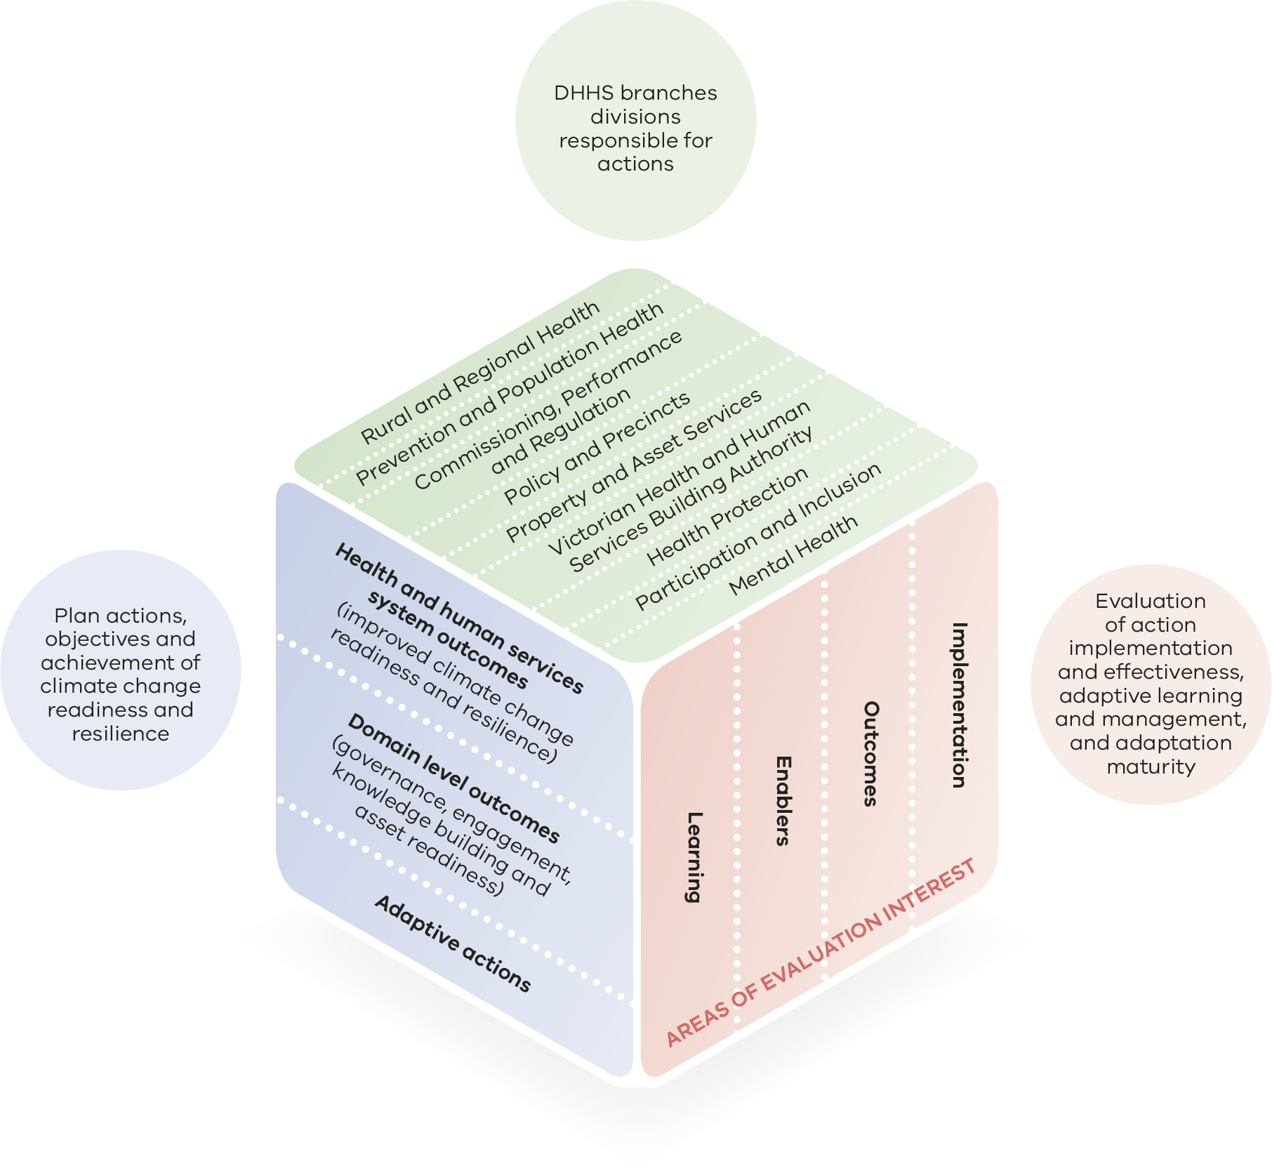

Appendix 5: Other statutes relevant to health and human services climate change adaptation

Scheduled Acts
There are several Victorian statutes scheduled under the Climate Change Act 2017, which activates the requirement to consider how decisions made under those statutes contribute to greenhouse gas emissions and have regard to the potential impacts of climate change relevant to the decision or action.
Two sections of the Public Health and Wellbeing Act 2008 are scheduled under the Climate Change Act 2017.
Section 26 requires councils to regularly prepare a Municipal Public Health and Wellbeing Plan. The Municipal Public Health and Wellbeing Plan describes how councils will work in partnership with the Department of Health and Human Services and other agencies undertaking public health initiatives, projects and programs to accomplish identified goals and strategies.
Section 49 requires the preparation of a State Public Health and Wellbeing Plan. The department has prepared the Victorian Public Health and Wellbeing Plan 2019–2023, which includes ‘taking action on climate change and its impacts on health’ as a key focus area. It aims to build community safety and resilience to the public health impacts of climate change, decrease its health impacts, and support action to reduce greenhouse gas emissions, which will also have health co-benefits.

Other relevant statutes
The Emergency Management Act 2013 seeks an efficient emergency management system that minimises the likelihood, effect and consequences of emergencies. The Act requires production of a rolling three-year Emergency Management Strategic Action Plan that includes a work program for each agency. Emergency management in Victoria is implemented by the emergency management sector as an ‘all communities, all emergencies’ approach, including those caused by weather.
The priorities in the Victorian Emergency Management Strategic Action Plan (Update #3 2018-2021) include building and empowering community leadership and developing awareness; sharing responsibility and self-reliance to strengthen resilience; and enhancing the capability and capacity of local governments to meet their obligations in the management of emergencies.
The department’s emergency responsibilities include:
- control agency for public health emergencies
- health coordination
- provision of relief services (financial assistance, psychosocial support and emergency accommodation)
- coordination of state-wide social recovery
Part 7A of the Emergency Management Act 2013 (Emergency Management Amendment (Critical Infrastructure Resilience) Act 2014) and the Emergency Management (Critical Infrastructure Resilience) Regulations 2015 provide for emergency risk management arrangements for critical infrastructure resilience, including planning, conducting exercises, monitoring and validation (audit). Each sector has a Sector Resilience Network, which provides a forum for government and industry to identify and address risks, challenges, dependencies and interdependencies, opportunities, and better practices to assess and improve resilience across the sector. The Department of Health and Human Services is the responsible portfolio department for the health sector and the Health Sector Resilience Network and the development of a Health Sector Resilience Plan.
The department administers several regulatory frameworks for areas that may be affected by climate change, including the Safe Drinking Water Act 2003 and supporting regulations, and the Food Safety Act 1984. These frameworks provide a risk-based approach for managing public health, including risks that may be posed by climate change.
The Financial Management Act 1994 aims to improve financial administration of the public sector; make better provision for the accountability of the public sector; and provide for annual reporting to the parliament by departments and public sector bodies. The Act requires departments and public bodies to maintain a register of assets held or managed; and develop, implement and keep under review a risk management strategy. Climate change presents a range of emerging risks to assets and their management.
The Public Administration Act 2004 aims to provide a framework for good governance in the public sector and in public administration generally in Victoria. The Act sets out the duty of care and diligence required by public servants in the execution of their duties. Understanding and acting on climate change risks are considered an appropriate exercise of duty of care and diligence, and public sector employees are increasingly likely to be scrutinised and accountable for climate change risk management (Dibley et al. 2019).

References
Australian Emergency Management Institute 2013.
Barnett G, Beaty RM, Chen D, McFallen S, Meyers J, Nguyen M, Ren Z, Spinks A and Wang X 2013, Pathways to climate adapted and healthy low income housing, National Climate Adaptation Research Facility, Gold Coast, p. 101.
Bureau of Meteorology 2018, State of the climate 2018, Bureau of Meteorology and CSIRO, Australian Government, viewed 2 July 2019, <http://www.bom.gov.au/state-of-the-climate/State-of-the-Climate-2018.pdf>.
Cameron PA, Mitra B, Fitzgerald M, Scheinkestel CD, Stripp A, Batey C, Niggemeyer L, Truesdale M, Holman P, Mehra R and Wasiak J 2009, ‘Black Saturday: the immediate impact of the February 2009 bushfires in Victoria, Australia’, Medical Journal of Australia, vol. 191, no. 1, pp.11–16, viewed 2 July 2019, <https://www.mja.com.au/journal/2009/191/1/black-saturday-immediate-impact-february-2009-bushfires-victoria-australia>.
CSIRO 2019, Victorian Climate Projections 2019: Technical Report, Aspendale, Australia, CSIRO Climate Science Centre, <https://www.climatechange.vic.gov.au/__data/assets/pdf_file/0016/435121/Vic-Climate-Projections-2019-Technical-Report.pdf>.
Deloitte Access Economics 2016, The economic cost of the social impact of natural disasters.
DELWP 2018, Blue-green algae circular: algal management framework, viewed 2 July 2019, <https://www.water.vic.gov.au/waterways-and-catchments/rivers-estuaries-and-waterways/blue-green-algae>.
Department of Health 2009, January 2009 heatwave in Victoria: an assessment of the health impacts, State of Victoria, viewed 3 October 2019, <https://www2.health.vic.gov.au/about/publications/researchandreports/January-2009-Heatwave-in-Victoria-an-Assessment-of-Health-Impacts>.
Department of Health 2014, The health impacts of the January 2014 heatwave in Victoria, State of Victoria, viewed 3 October 2019 <https://www2.health.vic.gov.au/about/publications/researchandreports/health-impacts-january-2014-heatwave>
Department of Health and Human Services 2017, Solar and retrofit study, prepared by Moreland Energy Foundation and Point Advisory.
Department of Health and Human Services 2019, Public health and wellbeing plan 2019–23, viewed 26 September 2019, <https://www2.health.vic.gov.au/about/health-strategies/public-health-wellbeing-plan>.
Diaz S et al. 2019, Summary for policy makers of the global assessment report on biodiversity and ecosystem services, Intergovernmental Science-Policy Platform on Biodiversity and Ecosystem Services.
Dibley A, Hurley S and Sheppard J 2019, Public authority directors’ duties and climate change discussion paper: managing the latent financial and governance risks, Centre for Policy Development.
Dunlop and Spratt 2017, Disaster alley: climate change, conflict and risk, Breakthrough Institute, viewed 23 August 2019, <https://www.breakthroughonline.org.au/publications>.
Fuenfgeld et al. 2013, Climate change adaptation in the primary health and community welfare sectors in Victoria, RMIT.
Garnaut R 2008, The Garnaut climate change review: final report, Cambridge University Press, viewed 2 July 2019, <www.garnautreview.org.au>.
Gasparrini A, Guo Y, Hashizume M, Lavigne E, Zanobetti A, Schwartz J, Tobias A, Tong S, Rocklöv J, Forsberg B and Leone M 2015, ‘Mortality risk attributable to high and low ambient temperature: a multicountry observational study’, The Lancet, vol. 386, no. 9991, pp. 369–75.
Hawe P 2009, Community recovery after the February 2009 Victorian bushfires: an evidence check rapid review brokered by the Sax Institute for the Public Health Branch, Victorian Department of Community Services.
Henley BJ and King AD 2017, ‘Trajectories toward the 1.5 C Paris target: modulation by the Interdecadal Pacific Oscillation’, Geophysical Research Letters, vol. 44, no. 9, pp. 4256–62, viewed 2 July 2019, <https://agupubs.onlinelibrary.wiley.com/doi/full/10.1002/2017GL073480>.
Hennessy K, Fitzharris B, Bates BC, Harvey N, Hughes L, Salinger J and Warrick R 2007, ‘Australia and New Zealand, climate change 2007: impacts, adaptation and vulnerability’, contribution of Working Group II to the Fourth Assessment Report of the Intergovernmental Panel on Climate Change, Parry ML, Canziani OF, Palutikof JP, van der Linden PJ and Hanson CE eds, Cambridge University Press, Cambridge, UK, pp. 507–40.
Hope P, Timbal B, Hendon H, Ekström M, Potter N 2017, A synthesis of findings from the Victorian Climate Initiative (VicCI), Bureau of Meteorology, Australia.
IPCC 2018, Global warming of 1.5°C, an IPCC special report on the impacts of global warming of 1.5°C above pre-industrial levels and related global greenhouse gas emission pathways, in the context of strengthening the global response to the threat of climate change, sustainable development, and efforts to eradicate poverty. Summary for policy makers, viewed 2 July 2019, <http://report.ipcc.ch/sr15/pdf/sr15_spm_final.pdf>.
Jacob D, Kotova L, Teichmann C, Sobolowski SP, Vautard R, Donnelly C, Koutroulis AG, Grillakis MG, Tsanis IK, Damm A and Sakalli A 2018, ‘Climate impacts in Europe under +1.5 C global warming’, Earth's Future, vol. 6, no. 2, pp. 264–85, viewed 2 July 2019, <https://agupubs.onlinelibrary.wiley.com/doi/full/10.1002/2017EF000710> [accessed 20 July 2018].
Keating A and Handmer J 2013, Future potential losses from extremes under climate change: the case of Victoria, Australia, Victorian Centre for Climate Change Adaptation Research, Melbourne.
Lalonde M 1974, A new perspective on the health of Canadians: a working document, viewed 2 July 2019, <https://repository.library.georgetown.edu/handle/10822/767116>.
Lucas C, Hennessy K, Mills G and Bathols J 2007, Bushfire weather in southeast Australia: recent trends and projected climate change impacts, viewed 2 July 2019, <http://www.climateinstitute.org.au/verve/_resources/fullreportbushfire.pdf>.
Marmot M and Wilkinson R 2003, Social determinants of health: the solid facts, 2nd ed., World Health Organisation Regional Office for Europe, Copenhagen, viewed 2 July 2019, <http://www.euro.who.int/__data/assets/pdf_file/0005/98438/e81384.pdf>.
McMichael AJ, Woodruff RE and Hales S 2006, ‘Climate change and human health: present and future risks’, The Lancet, vol. 367, no. 9513, pp. 859–69.
Parliament of Victoria 2009, 2009 Victorian Bushfires Royal Commission, State of Victoria, viewed 2 July 2019, <http://royalcommission.vic.gov.au/finaldocuments/summary/HR/VBRC_Summary_HR.pdf>.
Parliament of Victoria 2010, 2009 Victorian Bushfires Royal Commission: relief and recovery, vol. 2, ch 8, viewed 2 July 2019, <http://royalcommission.vic.gov.au/finaldocuments/volume-2/PF/VBRC_Vol2_Chapter08_PF.pdf>, p. 329.
Parliament of Victoria 2016, Royal Commission into Family Violence report and recommendations vol. 1, State of Victoria, viewed 2 July 2019, <http://www.rcfv.com.au/MediaLibraries/RCFamilyViolence/Reports/Final/RCFV-Vol-I.pdf>, p. 23.
QCOSS 2010, Submission to the Queensland Floods Commission of Inquiry Community Sector, climate change and environmental sustainability, Victorian Council of Social Services, briefing paper, 15 September 2010.
Schurer AP, Cowtan K, Hawkins E, Mann ME, Scott V and Tett SFB 2018, ‘Interpretations of the Paris climate target’, Nature Geoscience, vol. 11, no. 4, p. 220, viewed 2 July 2019, <https://www.nature.com/articles/s41561-018-0086-8>.
Spickett J, Katscherian D and Brown H 2015, Climate change, vulnerability and health: a guide to assessing and addressing the health impacts, World Health Organization Collaborating Centre for Environmental Health Impact Assessment, Curtin University.
Steffen W, Richardson K, Rockström J, Cornell SE, Fetzer I, Bennett EM, Biggs R, Carpenter SR, De Vries W, De Wit CA and Folke C 2015, ‘Planetary boundaries: guiding human development on a changing planet’, Science, vol. 347, no. 6223, p.1259855, doi:10.1126/science.1259855.
Steffen W et al. 2019, Compound costs: how climate change is damaging Australia’s economy, Climate Council, viewed 2 July 2019, <https://www.climatecouncil.org.au/wp-content/uploads/2019/05/costs-of-climate-change-report-v3.pdf>.
Stern N and Stern NH 2007, The economics of climate change: the Stern review, Cambridge University Press.
VCOSS 2016, Extreme heat and vulnerable Victorian households, viewed 2 July 2019, <https://vcoss.org.au/analysis/extreme-heat-and-vulnerable-victorian-households-2/>.
Victorian Government 2015, Climate-ready Victoria, viewed 2 July 2019, <https://www.climatechange.vic.gov.au/data/assets/pdffile/0018/60750/Statewide-Victoria.pdf>.
Victorian Government 2017, Victoria’s climate change adaptation plan 2017–20, <https://www.parliament.vic.gov.au/file_uploads/Climate_Change_Adaptation_Plan_080217_B0zm1V3s.pdf>, p. 7.
Watts N, Adger WN, Agnolucci P, Blackstock J, Byass P, Cai W, Chaytor S, Colbourn T, Collins M, Cooper A and Cox PM 2015, ‘Health and climate change: policy responses to protect public health’, The Lancet, vol. 386, no. 10006, pp. 1861–1914, viewed 2 July 2019, <http://dx.doi.org/10.1016/S0140-6736(15)60854-6>.
World Health Organization 2015, Climate change and human health, viewed 1 April 2019, <https://www.who.int/globalchange/global-campaign/cop21/en/>.
Xu Y and Ramanathan V 2017, ‘Well below 2 °C: mitigation strategies for avoiding dangerous to catastrophic climate changes’, Proceedings of the National Academy of Sciences, vol. 114, no. 39, pp. 10315–323, viewed 2 July 2019, <http://www.pnas.org/content/early/2017/09/14/1618481114.short>.

