Radiation safety regulator plan on a page
Radiation safety regulator plan March 2018 – June 2019

This document summarises the key elements of the Radiation safety regulator plan. The plan provides the context the regulator works within and an overview of its regulatory framework and activities. This is supported by the Better regulatory practice framework: January 2018–June 2019, which provides a process for risk-based and accountable regulatory practice, and improved regulatory performance in the health and human services sector. The regulator plan and framework are available on Regulatory practice framework <https://www.dhhs.vic.gov.au/better-regulatory-practice-framework>.

Outcomes
The Radiation Team’s work is focused on protecting the Victorian community (including both occupationally exposed persons and the general public) and the environment from the harmful effects of radiation.
The Radiation Team achieves this protection by:
- licensing radiation practices and persons who use radiation sources.
- increasing the understanding of licence holders about the potential health risks
- enforcing relevant radiation protection requirements.

Who we regulate
There are approximately 2,600 active management licences operating at over 3,500 sites across Victoria. There are also over 14,000 active use licences. Regulated entities include companies, organisations and individuals that conduct ‘radiation practices’, or wish to construct a radiation facility.
Radiation Act 2005
Radiation Regulations 2017.

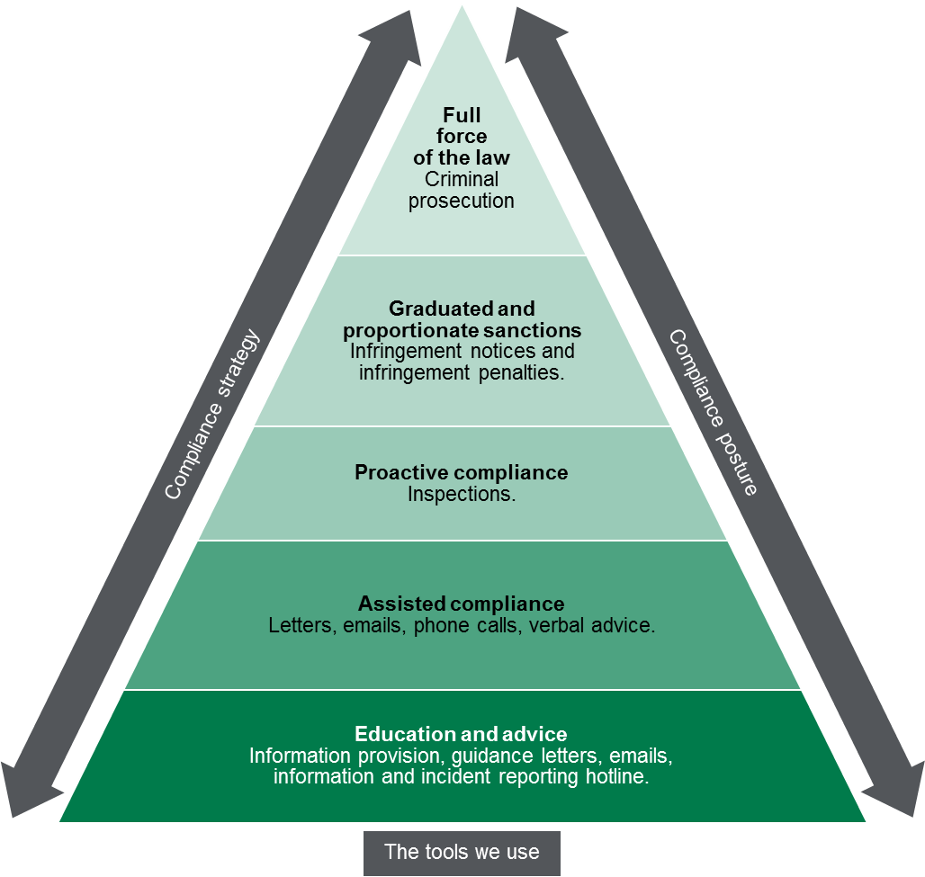

Contribution story
By working with groups such as the Cancer Council and medical specialist colleges, the Radiation Team has worked to continually enforce the ban on commercial tanning, reduce CT dose levels particularly for children, and reduce the theft of portable density moisture gauges.
The outcome is a reduction in radiation exposure. An important part of the Radiation Team’s role is to limit the unjustified use of radiation sources and to apply the principles of radiation protection to achieve the intended outcome.

Measuring our impacts
The Radiation Team monitors how it contributes to reducing harm from radiation by monitoring and reporting on a range of indicators including:
- the investigations of illegal commercial tanning salons
- the number of inspections. The Key Performance Indicator of 480 inspections per year is a Victorian Budget Paper 3 measure.
- the percentage of incident reports involving high-risk radiation practices that are investigated.

Diagram text
This figure is an enforcement pyramid. The figure seeks to demonstrate that the unit will use the full range of tools available to it in line with the risks that they are seeking to manage. The enforcement pyramid illustrates a graduated and proportionate enforcement approach. The bottom of the pyramid outlines the lighter touch interventions such as advice and persuasion and ‘warning letters’, through to licence cancellation at the top of the pyramid, where regulated parties deliberately work against intended outcomes and intend to evade compliance obligations.

To receive this publication in an accessible format phone 1300 767 469, using the National Relay Service 13 36 77 if required, or email the Radiation team <radiation.safety@dhhs.vic.gov.au>.
Authorised and published by the Victorian Government, 1 Treasury Place, Melbourne.
© State of Victoria, Department of Health and Human Services, March 2018.
ISBN 978-1-76069-325-1 (online)
Available at Regulatory practice framework <https://www.dhhs.vic.gov.au/better-regulatory-practice-framework>

