Better regulatory practice framework

To receive this publication in an accessible format, phone Regulatory Practice Improvement team on 03 9096 5073, using the National Relay Service 13 36 77 if required.
Authorised and published by the Victorian Government, 1 Treasury Place, Melbourne.
© State of Victoria, Department of Health and Human Services, March 2018.
ISBN 978-1-76069-316-9 (online)
Available at Regulatory practice framework <https://www.dhhs.vic.gov.au/better-regulatory-practice-framework>
(1802030 figure 3)

Foreword
The Department of Health and Human Services (‘the department’) aspires for all Victorians to be healthy, safe and able to lead a life they value. To deliver these outcomes, the department has responsibility for developing and delivering policies, programs and services that support and enhance the health and wellbeing of all Victorians. This includes providing services directly to the community, funding services to deliver vital health and human services and partnering with other parts of the Victorian public service, federal and local governments and communities.
The department plays a vital role as a regulator through administering legislation that covers thousands of professionals, organisations and businesses that support the health and wellbeing of Victorians. These regulatory responsibilities are very broad – from restaurants to private hospitals, to foster carers and public swimming pools.
There are parts of the department with these critical regulatory roles that are responsible for regulatory policy and advice, as well as administering and enforcing legislation. Many staff in these areas are national leaders in their area of expertise.
The department’s units with regulatory roles are generally small, highly skilled units within a large organisation that emphasises service delivery. It is important that areas within the department that undertake a regulatory role in the context of funded services are separated from areas within the department that undertake service delivery or contract management roles for these same services.
There are significant opportunities for the community, industry and the department to benefit from improvements to the effectiveness and efficiency of the department’s regulatory practice. This framework is the first of its kind within the department, and aims to set out a clear and transparent statement about how the department’s regulators will bring a systemic, risk-based approach to its regulatory activities. I commend this framework to all regulators within the department and those they regulate.

Kym Peake
Secretary
Contents
Foreword 3
1. Introduction 1
1.1 The role of regulation in health and human services 1
1.2 Audience for this document 1
1.3 The department’s regulators 3
1.4 Working with co-regulators 4
2. Purpose of this document 5
2.1 Statements of Expectations 6
3. Regulatory practice principles 7
4. Defining regulatory outcomes 8
5. Developing regulatory interventions 10
5.1 Understanding risk 10
5.2 Describing risk 10
5.3 Rating risk 11
5.4 Determining compliance posture 12
6. Using compliance tools 14
6.1 Guidance and support 15
6.2 Assisted compliance 15
6.3 Proactive compliance 15
6.4 Graduated and proportionate sanctions 16
6.5 Full force of the law 16
7. Measuring performance 18
7.1 The contribution story 19
8. Informing and working with stakeholders 20
Appendix A: Developing strategic responses to industry-wide regulatory risks 21
A.1 Identifying and describing risks 21
A.2 Assessing risk 22
A.3 Allocating resources 22
Appendix B: Performance Reporting Framework 23
B1 Overview 23
B2 Standalone measures of performance 23
B3 The contribution story 24
B4 Reporting on regulator performance 24
Appendix C: Working with stakeholders 27
C1 Defining stakeholders 27
C2 Ongoing engagement with key stakeholders 27
C3 Operational collaboration 28
C4 Broader consultation and engagement 28
Glossary 30

1. Introduction

1.1 The role of regulation in health and human services
The various units with regulatory functions within the department play a vital role in working towards a state that is free of the avoidable burden of disease and injury so that all Victorians can enjoy the highest attainable standards of health, wellbeing and safety at every age.
In pursuing this vision, the department often simultaneously plays the role of:
- System steward – that is, how we oversee and develop policy
- System manager – that is, how we design systems through funding and regulation
- Agent – that is, how we deliver services and build capacity amongst organisations.
This framework has been designed to provide units with regulatory functions (‘departmental regulators’) with a clear and effective framework to perform those functions. The department’s regulatory functions are a key part of its role as a steward and system manager.
Not only are the regulators responsible for various activities and functions, but the department as a whole must also manage competing priorities and roles. In some cases, one area of the department performs the role of regulator of a funded agency, while other areas undertake a service delivery or contract management role for that funded agency. Information may be sourced from other areas of the department undertaking different functions – such as those that have a funding relationship with an agency – and may be used to support regulatory roles and functions.
Given the various functions of the department, those in regulatory roles must be clear about their authority and responsibility for undertaking enforcement and other regulatory responses. These relationships and activities are managed carefully within the department to ensure that no one person or team is responsible for more than one of these functions.
The department’s regulators recognise that regulatory best practice is essential to achieving their outcomes, but that the extent of a regulator’s regulatory role relative to its non-regulatory roles varies from regulator to regulator. The department’s regulators work to balance different roles, with a focus on achieving outcomes for the Victorian community. Regulators work to continuously improve regulatory practice and their regulatory approach.

1.2 Audience for this document
This document targets three main audiences: regulated entities, the Victorian community and the decision makers and staff of the department’s regulators. It aims to achieve the following objectives for each of these audiences:
- Regulated entities – Providing a clear statement of how regulated parties can expect the department’s regulators to undertake their regulatory functions, including health practitioners, businesses, and not-for-profit providers. It is also aimed at representatives of regulated entities, such as peak bodies.
- Victorian community – Allowing those that regulation is intended to protect (for example, clients of regulated entities) and the Victorian community to understand the decision-making processes that the department follows to deliver outcomes (for example, aiming to achieve equal access to human services for all).
- Decision-makers and staff of the department’s regulators – Establishing a clear framework through which the department’s regulators can operate, and articulating how this can complement the department’s other roles; for example, its service delivery and contract manager roles.

1.3 The department’s regulators
This framework must be used by all units in the department’s portfolios that have a regulatory function. The Victorian Government has outlined its definition for a ‘business regulator’ as follows:
‘A State Government entity (either independent or within a department) that derives, from primary or subordinate legislation, one or more of the following powers in relation to businesses and occupations:
        - inspections;
        - regulatory advice to a third party;
        - licensing;
        - accreditation; and
          - standards monitoring and enforcement.
The regulatory activities of some bodies that fit in this definition of a business regulator are not their sole or primary activities…’
Some of the department’s regulators undertake most of these activities, while others only undertake a subset.
The department’s regulators use different regulatory mechanisms to achieve their outcomes. For example, some regulators licence every service provider, receive regular reporting from those they regulate and have the capacity to issue infringement notices, issue directions and enter into enforceable undertakings. Other regulators rely on notifications, and broad powers of direction, but do not licence or register industry participants.
Most of the department’s regulators also achieve outcomes by combining formal regulatory tools (those where they exercise powers conferred on them through legislation) with other tools to achieve the intended outcomes. For example, providing information to providers or community members, undertaking promotional campaigns and providing training to regulated entities and/or their clients. This is consistent with an integrated approach to achieving outcomes, and is consistent with strategies adopted by other Victorian Government regulators.
The department’s regulators also undertake a number of important roles that are closely linked to their regulatory functions. In particular, the department has a range of incident response functions (for example, responding to a radiation incident or a communicable disease outbreak). The department’s regulators recognise that their regulatory functions – such as powers to compel individuals or businesses to provide certain information, powers to enter a premises, or powers to direct third parties to undertake certain actions – are complementary to some of the department’s other functions, such as incident response. For example, regulatory activities performed as part of ‘business as usual’ are likely to minimise the likelihood of an incident occurring, and once an incident has occurred, regulatory powers are likely to be used to minimise the immediate impact of the incident. Further, insights about the context and circumstances regarding the incident are likely to inform how a regulator undertakes future activities.
Recognising how these complementary functions work together is critical to enable the department to help manage risks and respond appropriately to incidents through the exercise of regulatory powers. In developing an incident response, the regulators collaborate with one another to ensure that the most appropriate tools are being used to achieve the desired outcomes. This is consistent with the regulators’ approach when developing a regulatory response.

1.4 Working with co-regulators
The department’s regulators understand the importance of working closely with all stakeholders, and outline their approaches in more detail in their respective Regulator Plans (see ‘Appendix C: Working with stakeholders’ for more detail).
Many of the department’s regulators undertake their regulatory functions in cooperation with key stakeholders, particularly co-regulators. The department’s regulators work closely with regulators in local government, other Victorian Government departments and independent Commonwealth and State regulators, both in Victoria and inter-state.
The department’s regulators also work closely with a range of stakeholders who have a critical role in providing information about the behaviour of regulated parties. Many of the department’s regulators work with highly skilled parties (for example, practitioners such as pharmacists and medical practitioners, or other professionals such as food safety auditors) and often rely on these parties to achieve the desired outcomes. For example, medical practitioners have a statutory obligation to notify the department in relation to certain cases of communicable diseases.
The department’s regulators seek to engage and cooperate openly and actively with key stakeholders, but where the regulators identify individuals, sub-groups or behaviours that are inconsistent with the stated outcomes, regulators respond in a graduated way.

Local government
In many cases, local government has a statutory responsibility to perform certain functions (such as registering food premises) on behalf of government. In this context departmental regulators have a role in setting overall policy, and also have a relationship with local government, that is responsible for undertaking regulatory functions (for example, enforcement activity related to tobacco control). The department will tailor how it works with local government based on the nature of the risk, the range of non-regulatory tools available (for example, funding arrangements and capability building), and the powers provided in the relevant legislative frameworks.
Where department regulators work with local government, as with any co-regulators, the department’s regulators understand that the community has expectations about the outcomes that they expect ‘government’ to achieve (for example, ‘providing all Victorians with equal access to health and human services’ or ‘ensuring safe drinking water’). These expectations are rarely guided by the jurisdictional roles, functions or operating models selected by ‘government’ – such as differentiating between ‘local government’ and ‘state government’. Therefore, the department’s regulators work with co-regulators and other stakeholders to achieve community outcomes.

2. Purpose of this document
The purpose of the Better Regulatory Practice Framework (the framework) is to provide a clear focus on regulatory outcomes, demonstrate a risk-based approach to regulation, inform organisational improvement and improve engagement with stakeholders. This framework draws on better regulatory practice approaches from international, national and state regulatory guidelines.
This framework has been tailored to the department’s regulatory environment. It provides a process for regulators to implement risk-based and accountable regulatory practice, and improve regulatory performance in the health and human services sector.
This document provides an overarching framework that will apply to all of the department’s regulators. It attempts to provide clarity and consistency across the department’s regulators.
The following diagram outlines the context for this document. The document will complement the Regulator Plans that outline each regulator’s outcomes, key risks, regulatory tools, and the way regulators measure performance. The development of the Regulator Plans have been informed by this framework.
Figure 1: Document purpose
Table 5. 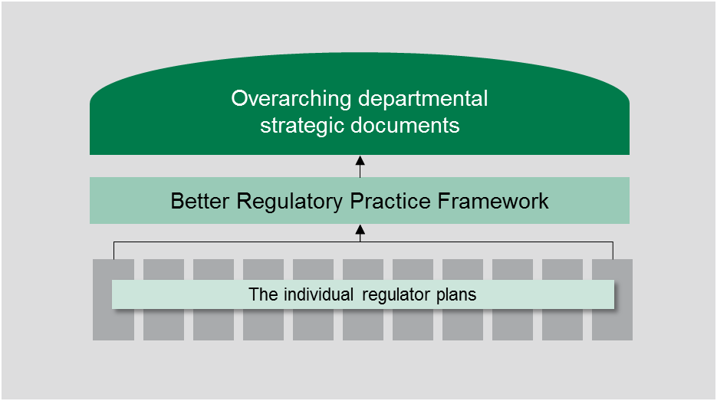
This framework aims to:
- promote a systematic, risk-based approach to regulation
- improve regulatory performance and accountability
- enable consistent oversight and support by the department.

This framework has been designed to assist the department’s regulators to use a risk-based, outcomes-focused and intelligence-led approach to managing both case-level and industry-wide risk, while noting that it is seldom possible to eliminate all risks. By supporting a more structured and consistent approach, the department aims to assist its regulators to maximise their prevention of avoidable harms to the health, wellbeing and safety of Victorians.
The framework has been designed to increase the level of rigour and consistency in relation to regulatory approaches and practices, and will be reviewed as appropriate in order to provide the department with ongoing capability to ensure better oversight and coordination.

2.1 Statements of Expectations
The Victorian Government has developed the Statement of Expectations Framework for Regulators, which requires each minister to establish clear expectations for regulator performance within their respective Ministerial portfolio. This whole-of-government initiative aims to promote greater efficiency and effectiveness in the administration and enforcement of regulation in Victoria. The framework is aimed at improving performance along the regulatory cycle, and allows for the creation of ‘good regulatory practice plans’ that assists the implementation, administration and enforcement of regulation. The statements are important in driving continuous improvement in regulatory business processes and practices.
As outlined in the principles (on the following page), the department’s regulators are committed to continually working to be more efficient in their regulatory activities. An important element of risk-based regulation is appropriately targeting finite resources, involving allocating resources toward changing behaviours or activities that pose the greatest risk to the health, safety and wellbeing of Victorians. The Better regulatory practice framework acts as a guide for the department’s regulators, assisting them to be more consistently risk-based and efficient in achieving their outcomes.
The department’s regulators have individual regulator plans. These plans are updated:
- every two years – in line with the requirement for ministers to develop and re-issue Ministerial Statements of Expectations every two years; or
- where key legislative changes are made that will impact on regulatory functions and the currency of the regulator plans.

3. Regulatory practice principles
In order to achieve the department’s outcomes, the regulators’ approach to their regulatory roles is informed by regulatory practice principles. Consistent with better regulatory practice approaches interstate and internationally, the department’s regulators apply the following principles:
Table 1: Regulatory practice principles
Principle | Commitment
Collaborative | Where the various departmental regulatory regimes, and those of other agencies, intersect, the regulators will work together to maximise effectiveness and minimise regulatory burden. Regulators will also cooperate and engage with internal and external stakeholders, including interstate counterparts and those representing various client groups within the Victorian community.
Consistent | The regulators will work to provide a consistent experience for regulated entities and the community. Regulatory responses will be predictable (meaning that, to the extent possible, regulators provide similar responses in similar circumstances - consistent with policy) and where possible standardised, following clear processes and delivering consistent results. This will ensure that individuals / organisations are treated fairly, and that the regulators are objective in their decision-making.
Efficient | The regulators will allocate resources in a proportionate way that aims to most efficiently achieve outcomes, considering the direct and indirect impacts on the relevant sectors. This includes minimising unnecessary administrative burden and any adverse impact of regulatory actions on businesses to a level that is not justifiable to achieve regulatory outcomes.
Intelligence-led | The regulators will analyse incoming intelligence and data in order to allow them to be responsive and accurate when assessing risk and undertaking compliance activities.
Outcomes-focussed | Processes and decision-making will be driven by outcomes, and the regulators will be effective in achieving their regulatory objectives. Progress against outcomes will be measured to ensure continuous improvement.
Proportionate | The work undertaken by regulators should be proportionate to the risk being addressed. The principle of proportionality should guide regulators decisions in relation to the level of resources assigned to manage a particular risk, the regulatory tools used and enforcement activities.
Risk-based | The regulators will be proactive in identifying, assessing and responding to risk, prioritising and targeting resources toward specific groups or behaviours that pose the greatest risk to the department’s outcomes.
Transparent | The regulators will be open in their decision-making and processes, documenting decisions appropriately, including the justification for decisions. The regulators will aim to assist regulated parties to understand the decision-making processes, areas of focus and performance. Regulators will follow standard reporting requirements, enabling the department to monitor and oversee the performance of its regulators.

4. Defining regulatory outcomes
The department outlines a number of outcomes in the Victorian public health and wellbeing outcomes framework, which aims to clearly define the health and human services outcomes that we seek to achieve, and to demonstrate the progress and contribution that we make towards these outcomes. This framework provides a transparent approach to monitoring and reporting progress in the department’s collective efforts to achieve better health and wellbeing, and aligns with the intent of the Public Health and Wellbeing Act 2008. The outcomes defined in this framework are:
- Victorians have good physical health
- Victorians live free from abuse and violence
- Victorians participate in learning and education
- Victorians are socially engaged and live in inclusive communities
- Victorians belong to resilient and liveable communities.
Regulatory activities undertaken by the department’s regulators contribute to these outcomes. The department’s regulators define the outcomes that they aim to achieve, which are consistent with the department’s wider departmental outcomes. These outcomes identify ways in which the department’s regulators can prevent avoidable harms in their respective regulatory areas.
To achieve meaningful outcomes, the department’s regulators review their activities as part of the annual planning process.
For example, an effective outcome for a regulator could be ‘reducing the rates of latent cancer in the Victorian community through educational campaigns to increase community awareness and prevent unnecessary exposure to ionising radiation.’ This outcome is outlined in a way that defines the harm that the regulation is intended to reduce, the target group (beneficiaries) and the actions. It is important that regulators define an outcome that relates to their regulatory activities and is consistent with the Department of Health and Human Services’ aspiration for all Victorians to be healthy, safe and able to lead a life they value.
One element of the department’s individual Regulator Plans is a requirement for regulators to define and document regulatory outcomes that are appropriate to their individual regulatory context.

Table 2: Defining outcomes – key actions
Key action | Explanation | Example
Outcomes | The regulators develop clear outcome statements, taking into consideration the legislation they administer, and whole of Government strategic directions. Outcomes should be linked to minimising avoidable harms. To achieve this, regulators will regularly ask themselves ‘What changes in the community are we seeking to achieve, and how do these changes help Victorians?’ | ‘Reducing the proportion of regular smokers in the Victorian population through enforcing smoking bans in public spaces’.
Objectives | The regulators develop well-defined, measurable objectives that are linked to outcomes, in order to provide clarity and allow progress in achieving outcomes to be monitored. To do this, regulators ask themselves ‘What are we seeking to achieve to contribute to our outcomes?’ | ‘To change smoking behaviour by increasing awareness about the harm associated with smoking, thereby contributing to reducing the proportion of regular smokers in the Victorian population’.
Jurisdiction and scope | The regulators define the boundaries and limitations of the scope in order to narrow and target their focus. To do this, regulators consider ‘What are the intersections and overlaps with the role of other Victorian and national regulators, and what is our residual role in contributing to outcomes? What would the community expect us to be doing to support the realisation of these outcomes?’ | ‘To change smoking behaviours the department works closely with other regulatory agencies, local governments and stakeholders. Working collaboratively helps to inform the development of regulatory approaches’
The outcomes the department’s regulators seek to achieve drive their regulatory approach, including how they focus their resources and apply their regulatory tools.

5. Developing regulatory interventions
Consistent with a risk-based approach, the department’s regulators acknowledge that Government cannot regulate to remove all risks or all contributing factors. The regulatory responses undertaken by the regulators depends on the level of regulatory risk, the compliance posture of the regulated entity and the likely impact of the regulatory intervention. For further discussion of the approach to dealing with risk in a regulatory context, refer to ‘Appendix A: Developing strategic responses to industry-wide regulatory risks’.

5.1 Understanding risk
In developing its regulatory response, the department’s regulators consider the risk arising from the behaviour of the entity or entities that they regulate or seek to influence (for example, where they seek to influence the behaviour of clients or a service provider).
Risks are framed in terms of the outcomes that the regulator is trying to achieve, and are rated in terms of the likelihood of the risk occurring, and the consequence of the impact if it were to occur. The regulators clearly delineate between ‘regulatory risks’ which are risks to the outcomes a regulator is seeking to achieve (the focus of this framework), and ‘corporate risks’ which are internal considerations (not the focus of this framework):
- Regulatory risk refers to actions or behaviours that have the potential to adversely impact on regulatory outcomes. For example, there is a major, uncontrolled outbreak of Legionnaire’s disease in Victoria that causes multiple deaths.
- Corporate risk refers to actions or behaviours that have the potential to adversely impact on an organisation. This would include for example, the risk of one of the department’s business units failing to document the underlying rationale behind a major decision, which then results in criticism of the department by a section of the community.
Risk can be both dynamic and static. Dynamic (or emerging risks) are those that are changing or dependent on other factors, while static risk are those that are ongoing/unchanging . The department’s regulators are aware of all types of risk, and in the case of dynamic risk, they are aware of the factors that influence those risks or may increase the likelihood of the risks occurring. In order to determine the level of risk and to guide the regulators in determining the extent to which a response is required, they measure the likelihood and consequence of the risk occurring. In measuring likelihood, dynamic risks may need to be re-assessed when their environment changes and the key influencing factors should be accounted for in the assessment.
Regulators access qualitative and quantitative information to inform their assessment of risk and work with stakeholders such as co-regulators where appropriate.

5.2 Describing risk
When one of the regulators is notified of an emerging risk (or proactively detects the risk), the risk is described and documented in a clear and consistent way.
When describing a risk, the risk is recorded using the following structure: cause, event, harm. It is important to note that where risks have multiple causes, regulators document these and consider the significance of each causal factor in contributing to the risk.
For more detail on identifying and describing risk, see ‘Appendix A: Developing strategic responses to industry-wide regulatory risks’.

5.3 Rating risk
An important part of regulatory better practice is the analysis and assessment of risk to determine where to effectively channel resources. An informed risk assessment allows the department’s regulators to respond to the risk in a proportionate way. Part of the risk analysis involves assigning the risks with a rating, as shown below. First, the risk is rated against a likelihood and consequence table, which aims to ask the following questions:

How likely is the risk to occur?
The risk’s probability is determined. This assessment asks the question: how likely is the risk to occur? This provides staff with a rating based on the likelihood of the risk eventuating, as shown in the table below.
Table 3: Indicative probability rating
Indicative probability | Likelihood | Rating as it applies to the overall risk rating
Once in >3 years | Rare (10%) | Negligible
Once in 3 years | Unlikely (30%) | Minor
Once a year | Possible (50%) | Moderate
Once per month | Likely (70%) | Major
Once per week | Almost certain (90%) | Extreme

If the risk was to occur, how significant would the impacts be?
The risk is then rated against a ‘consequence’ table, which seeks to ask the question: if the risk was to eventuate, what would be the level of harm? This provides staff with a rating based on the level of seriousness or consequence surrounding the risk, as shown in the table below.
Table 4: Consequence and risk rating
Type of risk | Consequence | Consequence | Consequence | Consequence | Consequence
Human  (injury, deaths, security incident, etc.) | Minor injury | Injury | Multiple injuries | Death or disabling injuries | Multiple deaths or disabling injury
Financial  (such as cost increase, financial liability.) | <$50,000 | Up to $100,000 | Up to $250,000 | Up to $5,000,000 | >$5,000,000
Credibility of regulator  (public enquiry/concern) | No public concern, routine reporting | Minimal public interest, special reporting | Sustained local public concern, inquiry | Broader public interest, public inquiry | Significant public concern about an event
Services  (such as clients not served, operational interruption.) | No service disruption | Minimal service disruption | Total service cessation for a week | Disruption of multiple services over several weeks | Total cessation of multiple services for several months
Rating as it applies to the overall risk rating | Negligible | Minor | Moderate | Major | Extreme
The answers to these questions are used to provide the risk with an overall rating.

Overall risk rating
In order to obtain the overall rating, the probability and consequence ratings are cross-matched against the risk matrix (as shown below). This rating then guides regulators in their decision-making process, assisting them to prioritise the way that they use their resources and regulatory tools.
Table 5: Overall risk rating
Consequence | Negligible (5%) | Minor  (10%) | Moderate (20%) | Major  (40%) | Extreme (80%)
Extreme | Medium | High | High | Critical | Critical
Major | Medium | Medium | High | High | Critical
Moderate | Low | Medium | Medium | High | High
Minor | Low | Low | Medium | Medium | High
Negligible | Low | Low | Low | Medium | Medium
The above analysis is forward looking or predictive, as the department’s regulators seek to prevent risks from eventuating rather than simply responding to incidents that occur. It also focuses on risks that may arise from the actions of regulated entities or those who the regulation is intended to protect – that is, the specific risks to the regulatory outcomes.
Separate but related risks relate to failures in internal controls (corporate risks), such as failures in information technology systems, or occupational health and safety risks that affect the staff of regulators. Although these risks impair the department’s ability to achieve regulatory outcomes, corporate risk is not the focus of this document.
In addition, regulators may work with co-regulators and other tiers of government, such as local government, to achieve regulatory outcomes. Where regulators rely on local government and other agencies to achieve regulatory outcomes, they may have a limited ability to influence these agents to act in a manner that is consistent with achieving regulatory outcomes. In this analysis, the department’s regulators are focused on the behaviours and activities displayed by regulated entities, not that of co-regulators and other tiers of government.

5.4 Determining compliance posture
In developing a regulatory intervention, the department’s regulators consider the compliance posture of the regulated entity (or entities). Compliance posture is the willingness of the organisation/individual to work with the regulator to achieve the regulatory outcomes; this includes their compliance history (for example, have they complied and worked cooperatively with the regulator in the past?) and the context surrounding the behaviour or action (for example, what are the drivers behind the entity not working towards the regulator’s outcomes? are they trying to do the ‘right’ thing?).
When designing compliance strategies and applying the appropriate tools to achieve compliance, the department’s regulators consider the behavioural characteristics of the regulated party. They can generally be broadly categorised as entities or individuals whose behaviour indicates they are:
- Willing to and able to comply and take all reasonable steps to do so – the majority of entities or individuals that the department regulates will be in this category.
- Willing to comply but unintentionally fail to do so – some entities will generally seek to comply but occasionally make errors or misunderstand what is required. Other entities seek to comply but through lack of capability or capacity, frequently are unable to meet the requirements.
- Prepared to test the boundaries of the law in order to minimise compliance obligations – these entities will do the bare minimum necessary to comply, and may occasionally ‘cut corners’ on issues of technical compliance.
- Deliberately avoid compliance obligations and, perhaps, harm those the department aims to protect – a minority of entities regulated by the department will deliberatively break the law, and actively seek to avoid detection.
Where organisations have failed to comply in the first instance and are demonstrating they are willing and able to change, the department’s regulators consider using approaches that assist the entity to achieve outcomes rather than reverting immediately to a purely punitive approach (such as prosecution).

6. Using compliance tools
The department’s regulators develop regulatory interventions that take into account the full range of available compliance tools. The regulators develop regulatory interventions that are consistent with the components outlined in the previous section; level of risk and compliance posture. As a general rule, this means that where there are:
- Low-levels of risk, regulators use lower-level interventions, such as education and advice to assist the regulated entities to comply. Regulators use lower-level interventions as often as possible, and always when it is likely to achieve the desired outcomes.
- Moderate levels of risk, regulators use middle-level interventions, such as inspections, audits and infringement notices. These are often used when a regulated entity needs added incentives to comply.
- High-levels of risk, regulators use high-level interventions, such as criminal prosecutions and revoking licenses or registrations. These interventions are generally used when compliance posture demonstrates that a regulated entity is either deliberately non-compliant, or alternatively, where a regulated entity demonstrates repeated non-compliance, regardless of its intention to comply.
The diagram below summarises the compliance tools available to the department’s regulators, and places it within the context of the overall types of regulatory intervention.
Figure 2: Regulatory tools
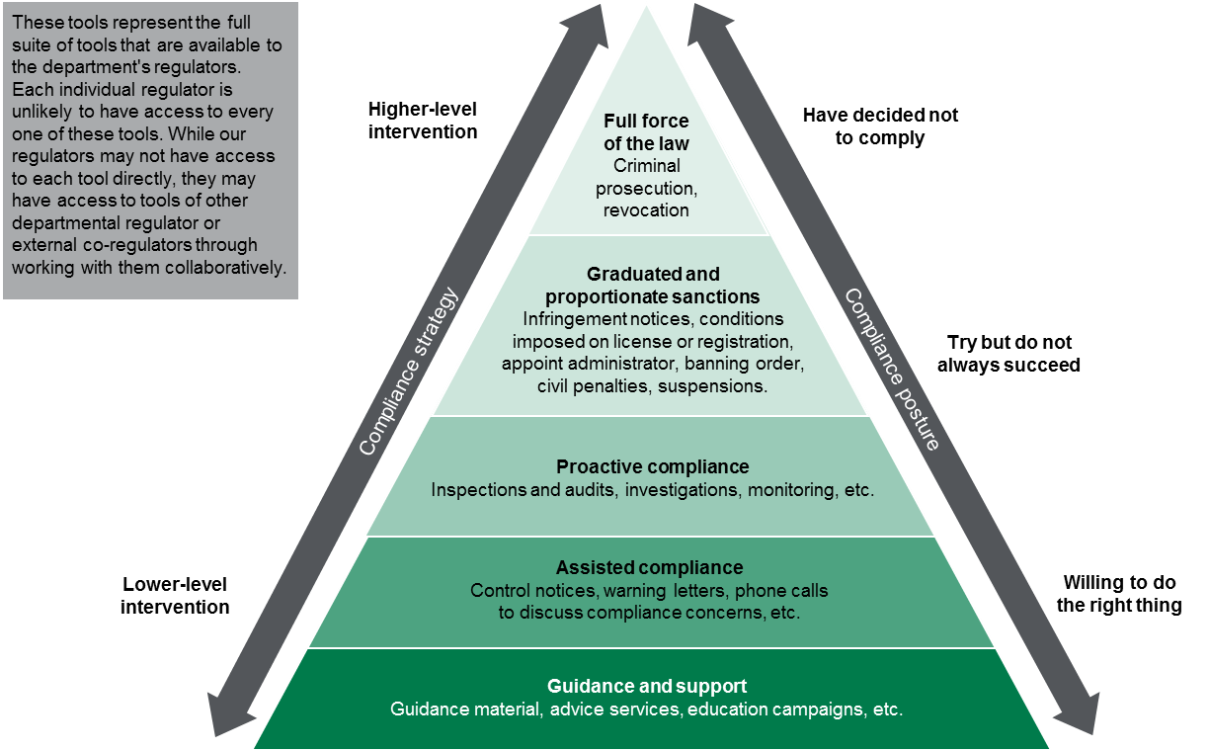

The above diagram demonstrates all of the compliance tools that may be available to the department’s regulators. It is important to note that regulators are unlikely to have the full range of tools within their own individual unit, and regulators must understand:
- the extent and limitations of their compliance tools
- the complementary compliance tools of external agencies, such as co-regulators, that could be used as part of a coordinated response
- the non-compliance tools that are available to deliver outcomes (for example, through funding various programs and services).

6.1 Guidance and support
The department’s regulators aim to raise awareness and inform regulated entities and the Victorian community in relation to the standards that service providers require to ensure health, safety and wellbeing. Guidance and support involves facilitating compliance by regulated entities, therefore promoting the department’s aspirations for a state in which Victorians can enjoy the highest attainable standards of health, wellbeing and safety at every age.
Compliance tools at the lower level end of regulatory intervention include education campaigns, engagement and advice, and guidance material. The department recognises that education and raising awareness are effective approaches to enabling and encouraging compliance in line with regulatory outcomes. The regulators ensure that they are effectively communicating with the Victorian community and regulated entities at all times. These activities assist with maximising compliance as they help to ensure that regulated entities are aware of their legislative obligations and what they are required to do to comply with these obligations.

6.2 Assisted compliance
The next level of intervention involves assisting organisations to comply with specific laws and regulations administered by individual regulators. These activities include:
- Preventing non-compliance:
    - A dedicated telephone line enabling regulated entities to seek guidance from the department’s regulators in relation to their legislative obligations.
    - Education campaigns to provide the public and regulated entities with clear information about a particular risk (this may include information on their website, or issuing emails/letter, as well as providing regulated entities with the necessary tools and templates to facilitate compliance).
- Responding to non-compliance:
    - Issuing notices to regulated entities in relation to breaches of particular legislative provisions.
    - Issuing warning letters to regulated entities in relation to non-compliance.
    - Undertaking site visits – either in response to a complaint about non-compliance or as part of a planned program of inspections, that have a focus on providing information to regulated entities about their obligations.
These compliance tools are intended to promote compliance through changing regulated entities’ behaviour, or informing regulated entities of their statutory duties and obligations.
The department encourages the regulators to take an informative approach to regulatory responses. This involves informing regulated entities in relation to non-compliance and providing these entities with the information necessary to change their behaviour.

6.3 Proactive compliance
Proactive compliance involves activities such as inspections, audits and investigations. These are a part of the regulators’ standard activities, but are often targeted toward an identified harmful behaviour across a sector, or a specific entity that the regulator considers may be non-compliant in a way that is harmful to the community. For example, particular dispensing patterns by pharmacists.
This level of intervention is useful for regulated entities that may be reluctant to comply with their statutory obligations. If non-compliant behaviour is repeated and/or lower level interventions have not been successful, inspections and investigations can be a useful tool to encourage compliance. Inspections and investigations can also be used to collect intelligence (as well as regular audits), or as a part of the regulatory monitoring and evaluation process.
Some regulators are required to conduct audits and/or inspections as a part of their ongoing activity. In these circumstances, officers who are authorised to undertake inspections (‘authorised officers’), and regulators more generally, are encouraged to maintain transparent, ongoing communication with regulated entities in relation to their regulatory responsibilities. This avoids a perception of being unnecessarily punitive. The regulators also use incoming intelligence in order to target their audits and inspections toward specific entities or behaviours in order to maximise compliance within the context of finite resources.
Investigations can be used to determine whether there has been a breach of legislation, and to determine the extent of the impact or harm that has been caused (or is likely to be caused) as a result. Investigations also collect evidence that may inform prosecutions, and so as to deter further non-compliant behaviour. The level of resources required for the investigation will be determined by the circumstances of the particular incident or behaviour (taking into account factors such as the level of risk and the compliance posture of the entity involved).

6.4 Graduated and proportionate sanctions
Where a regulated entity demonstrates a sustained pattern of non-compliance – regardless of its willingness to comply, or the lower level enforcement options are considered insufficient relative to the harm of the non-compliance identified, regulators can impose sanctions that are appropriate to the level of risk.
The tools available at this stage vary from issuing infringement notices or imposing conditions on licenses or registrations, through to appointing an administrator or suspending a license or registration. These tools are designed to drive behaviour change in regulated entities when there is deliberate or repeated non-compliance. Tools such as appointing an administrator and/or other civil penalties may be used where lower level sanctions have not been effective, and the non-compliance poses a serious risk to public health, safety and wellbeing. The department encourages regulators to have attempted other lower level enforcement responses before this level of enforcement is undertaken. However, the department acknowledges that, in some circumstances, this level of intervention is necessary.
Sanctions are implemented in proportion to the ongoing risk, taking into account the compliance posture of the regulated entity and the associated level of risk or harm to the Victorian community.

6.5 Full force of the law
Prosecuting a regulated entity or revoking its registration or license represent the highest level of regulatory intervention. These compliance tools are generally used by the regulators as a last resort where other enforcement actions have proved ineffective. A range of factors may inform the department’s decision to prosecute a regulated entity or revoke its registration or license. These include:
- The regulated entities’ compliance history, including any past non-compliance (this includes the regulated entity’ response to previous compliance interventions such as information and advice)
- The motivation for non-compliance – for example, whether there was any financial or other benefit that was, or could be, obtained through non-compliance
- Whether the regulated entities’ behaviour was a significant or serious breach of the relevant Act; taking into account the level of non-compliance (both in terms of the individual entity and any widespread behaviour of other organisations/individuals)
- The level of harm or detriment caused to public health, safety or wellbeing.

Revocation
Permanently revoking a licence or registration removes the ability for an organisation or individual to operate as a service provider in the Victorian community. The department’s regulators give the holders of licenses or registrations adequate warning before deciding whether to proceed with revoking the license or registration, by giving notice of the intention to revoke and the grounds for this decision.
Regulated entities are given reasonable opportunities to demonstrate and provide evidence as to why the revocation should not occur, and any decision to revoke a licence or registration will take into account these submissions.

Prosecution
Prosecutions seek to provide an appropriate sanction in relation to the harmful behaviour, or non-compliance, and act as a deterrent both for the alleged offender and any other regulated entity engaging in the behaviour. Prosecution can be used for its demonstration effect, where a particular case of non-compliance is targeted in order to send a message to other regulated entities about the consequences of non-compliance.
The department is currently finalising a prosecutions policy that its regulators will have regard to when determining whether to proceed with a prosecution.

7. Measuring performance
The department’s regulators strive to continually improve their processes and effectiveness as regulatory authorities in the health and human services sector. The regulators use indicators of performance in order to:
- Understand the relationship between their activities and the outcomes that they seek to influence
- Support communication with stakeholders about effectiveness
- Support continuous improvement in the effectiveness of their activities over time.
The department’s regulators use indicators that are clearly linked to the outcomes that they are trying to achieve. Where appropriate, indicators used by regulators include appropriate measures (such as ‘proportion of adults and adolescents who smoke’) and targets (such as ‘30 per cent decrease in smoking by adults by 2025 from 2011-12 baseline’).
In developing indicators, regulators distinguish between indicators of outputs, quality of outputs and outcomes, and strive to use indicators of quality of outputs and outcome indicators as much as possible:
- Outputs refer to the activities undertaken by the regulator - for example, ‘issued 400 improvement notices under the Radiation Act 2005 in relation to radiation practices or users of radiation sources’.
- Quality of outputs refer to the quality of the activities undertaken by the regulator, which provide an indication of how the regulator’s activities contribute to its outcomes. This could include for example, ‘60 per cent of organisations who received advice from the regulator responded that it was “helpful” or “very helpful”.’
- Outcome indicators refer to indicators of the results of those actions, or the impact the regulatory response had on society in line with a regulator’s outcomes. This could include for example, ‘over the last five years, there was a five per cent reduction in the smoking rate in Victoria’.
The department’s Victorian Public Health and Wellbeing Outcomes Framework outlines the relationship between the work regulators undertake (inputs, process and outputs) and outcomes. As shown below:
Figure 3: Measuring outcomes
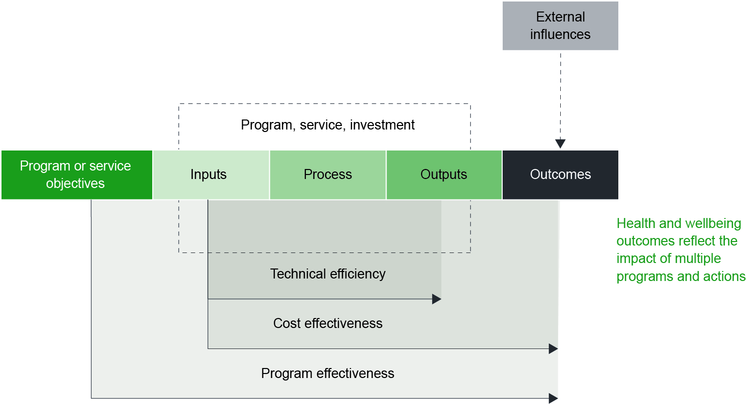
Source: Department of Health and Human Services Victorian Public Health and Wellbeing Outcomes Framework
The above diagram demonstrates the way that program effectiveness, cost effectiveness and technical efficiency of the department’s programs contribute to outcomes. The extent to which a program (or in this case regulatory response) contributes to its outcomes, or achieves its objectives, depends on the level of effectiveness and efficiency of the program (for example, were resources allocated in an efficient way? was the response appropriate or effective in changing behaviour?).
As shown in the above diagram, external influences (which are outside of the regulator’s control) also have an impact on outcomes. In order to measure progress made against outcomes while taking into account the impact of external influences, regulators develop, document and communicate their contribution story in the Regulator Plans.

7.1 The contribution story
Outcomes are often subject to external influences that can make it difficult to determine the extent to which the regulator’s activities and outputs contribute to outcomes. For example, one of the outcomes that the department’s regulation of tobacco aims to achieve is to ‘prevent young people from becoming smokers’. Although the actions undertaken towards this outcome may assist in preventing young people from smoking, there may be other factors that are largely outside this part of the department’s control that also influence this outcome, such as the influence of their peers or parents. In order to address this issue, the regulators write a contribution story. The contribution story outlines how the regulator’s actions influence a regulatory outcome, and acknowledges and documents that a range of other factors, outside the regulator’s control, can also impact on outcomes.
A contribution story is useful for understanding the way that regulatory activities are associated with short, intermediate and long-term outcomes. When considering the impact of their interventions on regulatory outcomes, the regulators holistically consider all the evidence available to them to determine the initiative’s degree of contribution to the outcome.
For more detail on the contribution story and the approach to understanding the department’s contribution to outcomes, see ‘Appendix B: Performance Reporting Framework’.

8. Informing and working with stakeholders
The department’s regulators recognise the importance of collaboration and cooperation in achieving their regulatory outcomes. Open and active communication with each other, external co-regulators and other key stakeholders is used as a tool for effective regulation and continual improvement.
The regulators identify and collaborate with key stakeholders in order to:
- gain intelligence
- share ideas and resources
- coordinate a response
  - gain feedback.
Through actively maintaining two-way communication, the department’s regulators are able to assist one another in responding to risks as well as seeking feedback to inform continuous improvement.
The department’s regulators are committed to open and transparent communication and consultation with stakeholders in a way that informs regulatory practice. This is distinct from any consultation the department undertakes to inform legislative or policy change.
Further detail on the regulators’ approaches to working with stakeholders is available in ‘Appendix C: Working with stakeholders.

Appendix A: Developing strategic responses to industry-wide regulatory risks
There are various types of risks, and it is important to define ‘risk’ in this context. This framework is primarily concerned with regulatory risk - the risk that regulators are required to manage.
- Corporate risk refers to actions or behaviours that have the potential to adversely impact an organisation. This would include for example, the risk of one of the department’s business units failing to document the underlying rationale behind a major decision, which then results in criticism of the department by a section of the community. This is not the type of risk that is relevant to this document. The department identifies and manages corporate risks through the corporate risk plan.
- Regulatory risk refers to actions or behaviours that have the potential to adversely impact regulatory outcomes. For example, there is a major, uncontrolled outbreak of Legionnaire’s disease in Victoria that causes multiple deaths. This is the type of risk that is relevant to regulators, and the focus of this document.
Regulatory risk refers to a potential obstruction to regulatory outcomes, as defined for each regulator. Each regulator has different risks that it is responsible for managing, which are detailed in the individual Regulator Plans.
When referring to regulatory risk, there are both case-level risks and industry-wide risks.
- Case-level risk generally refers to an individual, a specific business or organisation. For example, a restaurant does not serve food that is safe for human consumption, in breach of the Food Act 1984, resulting in three individuals contracting a food borne illness. Regulators focus on case-level risks when undertaking day-to-day operational regulatory activities, such as responding to a complaint.
- Industry-wide risk refers to a risk that is manifested on a wide scale across a range of individuals, businesses or organisations. For example, cooling towers in rural Victoria are not compliant with relevant standards, which could lead to outbreaks of Legionella amongst rural communities. Regulators focus on industry-wide risks when considering how best to achieve their strategic outcomes and objectives.
The two types of regulatory risk are not exclusive, as case-level risks inform industry-wide risks and vice versa. This framework has been developed to assist staff with both types of risk, as the same general guidelines apply regardless of the level/scale of the risk.
The sections below describe how the department’s regulators identify and assess industry-wide regulatory risks.

A.1 Identifying and describing risks
Identifying risks as they emerge in a consistently proactive and responsive manner is crucial to achieving outcomes. It is for this reason that the department’s regulators follow a clear and consistent process when identifying regulatory risks.
Risks can be identified in the following ways:
- Non-compliance reported by members of the community: reports of non-compliance by members of the community are important in assisting the regulators to systematically identify areas of risk.
- Collaborating with other agencies: the regulators work closely with one another and externally with other agencies, including external co-regulators to coordinate efforts and limit overlap or gaps in regulation.
- Proactively identifying risk: regulators’ activities include monitoring compliance that can lead to breaches being detected through the analysis of intelligence. Intelligence can be found through a range of activities such as site visits and inspections, audits and a range of internal and external data sources.
If the risk aligns with the individual regulator’s regulatory outcomes and objectives then the description is recorded and used to inform the risk assessment.
Identifying risk: key actions
  - Describe the risk in terms of cause, event, harm.
  - Record the risk.
  - If the risk aligns with regulatory outcomes and objectives then pursue a risk assessment.

A.2 Assessing risk
Risks are assessed in order to determine the level of risk associated with a certain action or behaviour, which then assists the regulator to make a decision about the most appropriate response. This ensures that available resources are allocated to activities that will have a greater contribution towards the regulator’s outcomes.

A.3 Allocating resources
In order to be risk-based, the regulators allocate resources to initiatives, regulated entities and behaviours that pose the highest risk to regulatory outcomes. This principle applies in the risk assessment process. For some higher risks, it may be necessary to assess individual risks, while for lower level risks, this may not be necessary. An important part of prioritising resources is knowing when to accept risks rather than continuing with risk assessment.
The department understands the importance of making optimal use of the available compliance tools to achieve its regulatory outcomes. When responding to risk, the regulators allocate their resources in proportion to the severity of the risk and the complexity of the regulated entity and associated behaviours. The regulators consider:
- The risk assessment findings: the risk rating and compliance posture of the regulated entity.
- The desired outcomes: what is it that the regulator is trying to achieve?
- The range of compliance tools available: examine the pros and cons of each compliance tool in order to determine those tools that have the greatest benefits relative to their costs.
- The likelihood of success: the likely impact that the intervention will have in contributing to outcomes.
- Implementation: the most appropriate individual/team/regulator to implement the regulatory response.
Treating risk
Key questions to consider:
  - What compliance tools are available?
  - Which tools would be most effective in achieving the desired outcomes?
  - Is there a more efficient way to achieve the same outcomes?
  - If your business unit does not have the most appropriate tools, who do you need to contact in order to gain access to these tools?
  - Who is the most appropriate team or individual to implement this response?

Appendix B: Performance Reporting Framework

B1 Overview
The department aims to facilitate effective internal management so that its regulators can demonstrate their contribution towards regulatory outcomes in a way that is cost effective and focuses on continuous improvement.
The department is committed to monitoring and reporting regulator performance to support continuous improvement rather than simply reporting on activities (for example, the number of licences issued). The monitoring and reporting framework should assist regulators to:
- Understand performance in a way that enables more informed engagement with key internal and external stakeholders
- Improve performance management frameworks over time that are better aligned with regulatory outcomes
- Use monitoring and reporting to continually strengthen their approach by:
    - fostering a culture of continuous improvement
    - improving the cost effectiveness of initiatives through informed and targeted design
    - reducing administrative burden on regulated entities
      - promoting better compliance outcomes through a more effective regulatory approach.
There are two components of the department’s Performance Reporting Framework:
- Standalone measures of performance
- The contribution story.
The standalone measures of performance and the contribution story are published publicly every two years as they are updated in the regulator’s plan.

B2 Standalone measures of performance
The department understands the importance of continuous improvement, and consistently monitors regulatory performance. In order to determine the effectiveness of the regulators’ performance, regulators establish a small number of performance measures against which they report regularly on their websites (this will be at least annually for external audiences). Wherever possible, regulators should use outcome measures that are defined in the department’s published outcomes framework. This will assist in linking the work of the regulators to the wider outcomes the department is trying to achieve.
The small number of performance measures are agreed by the departmental Executive as a part of its consideration of each regulator plan. These measures should be as closely aligned with outcomes as possible. Progress against these measures will be published annually on regulators’ websites or in the regulator’s published annual report to ensure accountability and transparency. Progress against standalone measures should be measured against previous years where available (at least the past two years) in order to capture movement and longer term contributions towards outcomes.

B3 The contribution story
As part of monitoring and reporting outcomes, the department’s regulators create a contribution story that should incorporate (as far as is reasonable) and provide context to the standalone performance measures outlined above. The contribution story should include:
- An explanation of why the regulator focused on the particular outcome
- The measures used to assess the initiative’s success (including, as far as is reasonable, the standalone measures mentioned above)
- A description of the intervention(s)
- A description of the intervention’s impact on the outcomes, and
- Proposed future regulatory activities, such as any longer term monitoring or developing a maintenance plan.
- Documenting and describing some causal factors that may contribute to a regulatory outcome, that are beyond the regulator’s sphere of influence.
A contribution story is useful for understanding the way in which regulatory activities are associated with short, intermediate and long-term outcomes. When considering the impact of their interventions on regulatory outcomes, the regulators holistically consider all the evidence available to them to determine the initiative’s degree of contribution to the outcome.

B4 Reporting on regulator performance
The department understands the importance of having clear oversight over the processes and performance of its regulators. Therefore, the regulators regularly report to the department and externally on the progress that they make toward contributing to outcomes.
The diagram below demonstrates the annual reporting cycle that each of the regulators follow:
Figure 4: Annual reporting process
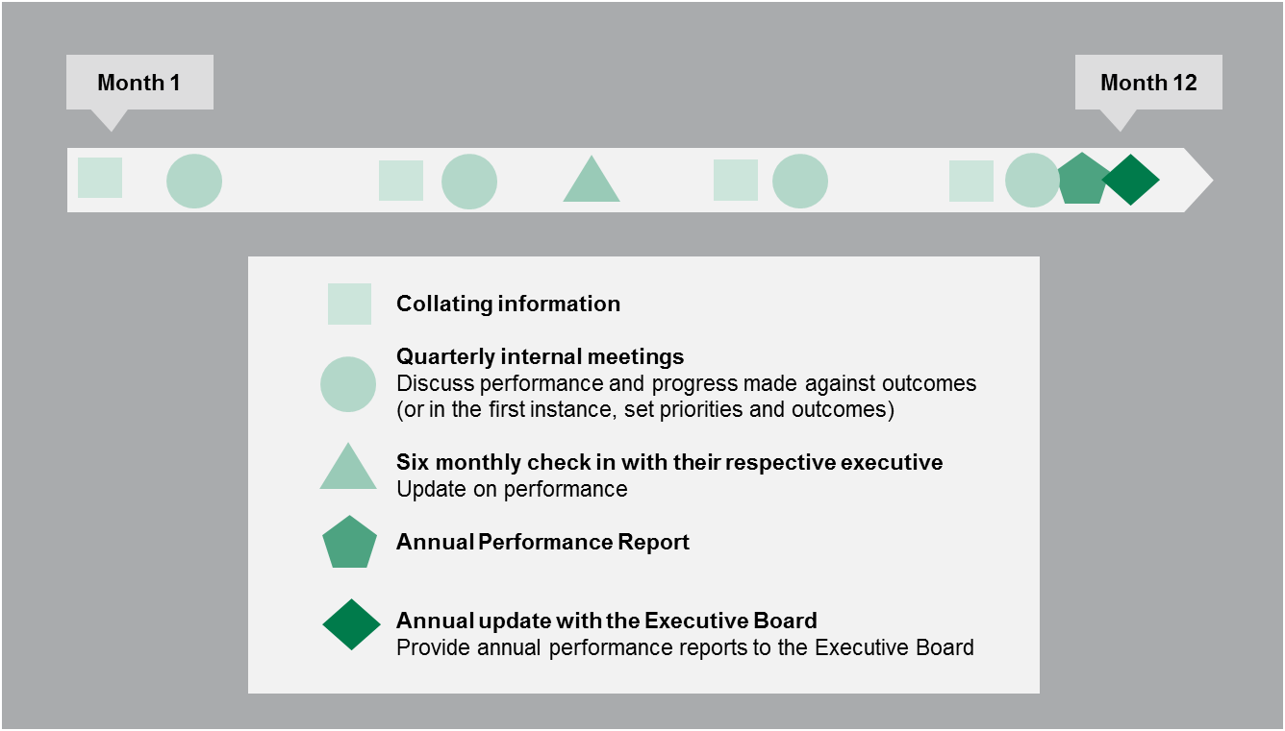

This process involves:
- Quarterly internal check-ins: in which the regulators discuss their own performance against the small number of standalone measures. At this stage, the regulators think about the contribution story and consider how their actions have been contributing towards their stated outcomes. As a minimum, regulators should arrange to speak with a small number of key stakeholder representative groups over the course of the quarter to discuss key issues, including opportunities to improve performance of the regulator (for example, ways to strengthen the effectiveness of education campaigns).
- Six monthly check in with their responsible executive: The regulators present a summary of progress made against outcomes, and discuss other strategic issues (such as developing or emerging risks or key insights from stakeholders).
- Annual update to the Executive Board: The regulators will provide their annual performance reports (referenced below) to the department’s Board. The reporting ensures transparency and holds the regulators accountable for contributing to outcomes.
In order to best prepare for these meetings, the regulators follow an annual planning cycle:
Figure 5: Annual planning cycle
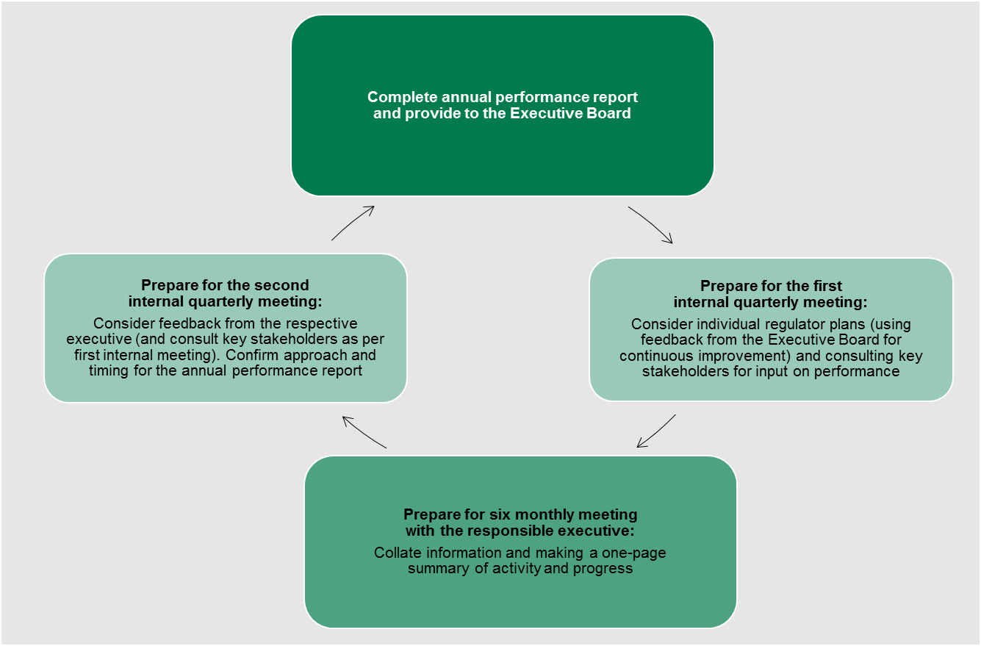
Developing the annual performance report involves collating information and insights gained throughout the year. This report is a short 1–2 page summary of progress made against outcomes in relation to previous years, which is provided to the Executive Board for consideration. It is important to capture movement in order to determine the progress of the regulator over time, and to refer to data from the past three to five years (where available). Although this may be challenging for some regulators (who are newly formed or have not yet put in place systems to enable such data collection and analysis), over time, regulators will have access to important qualitative and quantitative information. The regulators are also encouraged to include their contribution story, findings from evaluations completed during the period and/or case studies, to demonstrate how their regulatory actions have had a direct and practical impact.

The annual performance report will be drawn on by each regulator to prepare a short summary of their performance during the year. This summary will outline the regulator’s performance and progress made against outcomes, including the small number of standalone performance measures outlined in their Regulator Plan. These summaries are made publically available via the respective regulators’ websites or in regulators’ published annual report.
This cycle has been designed in order to align with the development of the regulators’ annual reporting process. Information gathered in this cycle can be used to inform the development of the respective annual reports, and vice versa.

Appendix C: Working with stakeholders
The department’s regulators recognise the importance of collaboration and cooperation in achieving their regulatory outcomes. Open and active communication with one another and the department, as well as with co-regulators and other key stakeholders, is used as a tool for effective regulation and continual improvement.
Key stakeholders are identified and worked with in order to:
- gain intelligence
- share ideas and resources
- coordinate a response
- gain feedback.
Through actively maintaining two-way communication, the department’s regulators are able to assist one another in responding to risks as well as seeking feedback to inform continuous improvement.

C1 Defining stakeholders
The department’s regulators think strategically about stakeholder engagement across the health and human services portfolio. This involves consideration of stakeholders in metropolitan and regional areas, as well as those who may be disengaged or time-poor. In order to consider what may be the most effective approach to engage and interact with key stakeholders, the regulators design stakeholder engagement plans. These guide the regulators in consideration of:
- the interests of the stakeholder (for example, if it is a peak body, this stakeholder may have a range of priorities)
- how to best engage with the stakeholder (for example, through using existing communications undertaken by peak bodies or other areas of the department, or through individual meetings or formal communication)
- how stakeholders will respond (for example, peak bodies may inform their members on behalf of the department’s regulators in response to communication by regulators).
The stakeholder engagement plan stratifies different types of stakeholders into broad categories such as regulated entities, the Victorian community, co-regulators, peak bodies and government. The type of stakeholder, its interests and interactions with the regulator and other parties will determine the way in which the department’s regulators engage. Understanding the various stakeholders and the best ways to engage is important for clear and effective communication.

C2 Ongoing engagement with key stakeholders
Regulators will consult appropriately with key stakeholders in order to inform their regulatory activities, including when defining their outcomes, identifying risks to those outcomes and subsequent monitoring of outcomes to assess whether regulatory objectives are being achieved.
Where possible, in order to allow for ongoing effective communication, the regulators consult with key stakeholders (such as regulated entities) through the department’s existing forums. Where the established channels of communication are insufficient or ineffective, the regulators create forums that are tailored to the stakeholders and their preferred methods of engagement.
The department’s regulators identify a small group of stakeholders with whom they consult more frequently. This should include stakeholder representatives (such as peak bodies) where possible and related regulators (such as accredited auditors). The group is determined by the regulator in line with its regulatory purpose and objectives, as well as its jurisdiction and scope. Communication with this group may be verbal and slightly less formal, and may include for example half-yearly meetings or establishing an industry reference group. Where this group includes related regulators, consultation will build collaboration across the regulators, and give them a forum from which to discuss regulatory approaches and evaluate their effectiveness.

C3 Operational collaboration
As part of their operational activities, regulators often interact with co-regulators and other key stakeholders (such as WorkSafe). For example, in order to enforce the drugs and poisons regulatory framework, the department often works with Victoria Police which supports regulators that are undertaking certain enforcement responses where practitioners have misused high-risk drugs.
In order to effectively achieve outcomes, the regulators aim to clearly define jurisdiction and scope, and use this to establish a shared understanding of their responsibilities and accountabilities. The department’s regulators support strong governance arrangements with external bodies that share regulatory responsibilities. Memorandums of understanding can be an effective approach to building collaboration, and these do not need to be overly detailed or prescriptive to achieve their purpose. However, in some instances, memorandums of understanding are not appropriate as they may impose real or perceived excessive formality or onerousness on the signatories to the agreement.
Regulators will initiate regular meetings or at a minimum, ad hoc consultation with co-regulators to discuss common issues. The regulators also aim to openly share information with their co-regulators, and to take a collaborative approach to undertaking regulatory activities (for example, through coordinating education activities and prosecutions).
Within the department, the regulators collaborate to share knowledge, promote consistency of regulatory practices and support co-ordinated contributions to the whole of government Regulatory Reform Program. The department’s Regulators’ Working Group and community of practice provide important forums to support collaboration between its regulators.

C4 Broader consultation and engagement
The department encourages compliance and provides its regulated entities with the information and assistance they need in order to maximise compliance with new and existing legislative obligations. This can be through the active provision of information (in the form of education campaigns or issuing letters/notices), or by providing readily accessible information on their websites.
In certain circumstances, the department’s regulators may be required to inform a large subset of the population (for example, all doctors or all smokers) or work with large numbers of people (for example responding to 20,000 enquiries about a certain prescription medication), or as part of compliance activities.
Regulators provide useful, timely and accurate information about legislative obligations that can be accessed by all regulated entities. This has implications both in terms of informing individual entities, but also informing regulated entities more broadly. For example, if there was an outbreak of Legionella in a rural town, relevant regulators would provide useful, timely and accurate advice to individual regulated entities immediately involved. Regulators would also provide information to regulated entities more broadly regarding the incident or any insights from the incident to assist other regulated entities to prevent further outbreaks of Legionnaires disease.
Regulators also provide useful, timely and accurate information where they are working with regulated entities in other capacities. For example, when undertaking an audit, the authorised officer will, as far as is reasonable, take an informative and constructive approach to following up on any identified breaches. In undertaking any follow-up action, the regulators will, as far as is reasonable, ensure that the regulated entity is informed as soon as possible of any significant developments (for example, the intended approach the department intends to take), and that matters of non-compliance are addressed in a way that assists the entity to comply rather than appearing punitive.
The individual regulator stakeholder engagement plans include more detail regarding the individual approaches of the regulators to managing stakeholder engagement.
Senior managers are responsible for developing and implementing the stakeholder plans, which will be authorised by the responsible director and deputy secretary.

Glossary
Term | Definition
Case-level risk | Refers to an individual, a specific business or organisation in relation to a specific activity or behaviour.
Compliance posture | The intent and capability of the regulated entity, taking into account its compliance history and willingness to align its behaviour to contribute to the regulator’s outcomes.
Corporate risk | Actions or behaviours that have the potential to adversely impact internal operations of an organisation. For the department, these risks are identified and managed through its corporate risk plan.
Co-regulator | Any national, other State and Territory, or Victorian regulator that has complementary objectives or functions, and/or the same regulated entities. For example, the Australian Health Practitioner Regulation Agency, WorkSafe and the Federal or Victorian Police.
Developing risk | A regulatory risk that the regulator may not have yet identified; or has identified but has not yet implemented a developed regulatory response. Also known as an ‘emerging risk’.
Dynamic risk | A risk that is influenced by many factors, and may change from period to period.
Enforcement tools | The actions or resources that regulators use in order to manage or respond to risk (for example a warning letter or undertaking inspections).
Industry-wide risk | Refers to a risk across a range of businesses or organisations, often in relation to a sub-section of the relevant industry or a cross-industry behaviour.
Managed risk | A regulatory risk that the regulator has identified and is monitoring. It may be at an acceptable level of risk or it may implement controls in order to reduce it to an acceptable level.
Outcomes | The change in the community that the regulator is seeking to achieve, which should be specifically related to harms (including physical harms, emotional harms, economic or financial harms, psychological harms, environmental harms and social harms).
Regulated entities | The organisations (including service providers and other agencies) or individuals that the department’s regulators are responsible for regulating.
Regulator | A State Government entity (either independent or within a department) that derives, from primary or subordinate legislation, one or more of the following powers in relation to businesses and occupations:  - licensing  - accreditation  - inspections  - monitoring standards  - regulatory advice to third parties and  - enforcement.  Some regulators also develop regulation or standards, but this function is not the focus of this framework.
Regulatory risk | Actions or behaviours that have the potential to adversely impact on regulatory outcomes.
Static risk | A risk that remains relatively unchanging over time.

Diagram text
Figure 1 - Document purpose
This figure outlines the purpose and context of the framework. The individual regulator plans are underpinned by the framework, and both the framework and the regulator plans are informed by over-arching departmental strategic documents.
Table 5 - Overall risk rating
Table five illustrates how overall risk rating is calculated. The consequences range from negligible, minor to extreme, represented on the x axis. On the y axis, likelihood is represented from negligible, to minor through to extreme. For example, where a risk has a major or extreme consequence with a major or extreme likelihood, the risk rating has a critical risk rating and therefore requires appropriate risk mitigation.
Figure 2 - Regulator tools
This figure is an enforcement pyramid. The figure seeks to demonstrate that the department will use the full range of tools available to it in line with the risks that it is seeking to manage. The enforcement pyramid illustrates a graduated and proportionate enforcement approach. The bottom of the pyramid outlines the lighter touch interventions such as guidance material and advice services to regulated parties, through to criminal prosecution at the top of the pyramid, where regulated parties deliberately work against intended outcomes and intend to evade compliance obligations.
Figure 3 - Measuring outcomes
This figure describes:
- how to measure the effectiveness of a program or service;
- measures or indicators that could be collected on the inputs allocated to deliver the service (for example resources or dollars);
- how effective the process is to deliver the service (such as timeliness of responding to an inquiry);
- outputs delivered as part of the services (such as number of inspections, phone calls answered); and
- the outcomes achieved by undertaking the program or service (such as improved health outcomes).
While data can be collected on all measures the focus should be on measuring outcomes as this is the best indication of the effectiveness of the program or service.
Figure 4 - Annual reporting process
This figure demonstrates the annual reporting cycle that each of the regulators follow. During the cycle information is collated, there are quarterly internal meetings, six monthly ‘check ins’ with respective executives, an annual performance report and an annual update to the department’s Executive Board.
Figure 5 - Annual planning cycle
The annual planning cycle comprises of quarterly meetings and six monthly meetings the responsible executive and a complete annual performance report which it provides to the department’s Executive Board.

Department of Health and Human Services 2016, Victorian Public Health and Wellbeing Outcomes Framework, Victorian Government
Department of Health and Human Services 2016, Strategic plan, Victorian Government.
Department of Treasury and Finance 2017, Statement of Expectations Framework for Regulators, Victorian Government.
As noted in the 2017 Emergency Management Victoria, State Health Emergency Response Plan (p6), incident responses can include health emergencies such as biological and radioactive incidents, retail food contamination, water contamination and human diseases.
The department is not unique in this respect, with other agencies having both regulatory and incident response functions, including the Environmental Protection Authority and the fire brigades.
Local Government also administers legislation on behalf of other Victorian Government regulators, including in relation to regulation of domestic animals, noise from domestic activity and building sites, traffic controls, and building and planning.
For example, drawing on the Organisation for Economic Co-operation and Development’s (OECD) Risk and Regulatory Policy: Improving the Governance of Risk and NSW Department of Finance, Services and Innovation’s Guidance for regulators to implement outcomes and risk‑based regulation.
Department of Treasury and Finance 2017, Statement of Expectations Framework for Regulators, Victorian Government.
Department of Health and Human Services 2016, Victorian public health and wellbeing outcomes framework, Victorian Government.
Wherever possible, the department’s regulators will use and/or draw on the outcomes outlined in the Department of Health and Human Services’ Strategic plan to demonstrate that they are contributing to their defined outcomes. For example, reducing the incidents of avoidable harm in Victorian hospitals or reducing deaths resulting from misuse of prescription medicines.
Organisation for Economic Co-operation and Development (OECD) 2010, Risk and Regulatory Policy: Improving the Governance of Risk.
Corporate risks are identified and managed through the department’s corporate risk plan.
Department of Finance, Services and Innovation 2016, Guidance for regulators to implement outcomes and risk‑based regulation, NSW Government.
Adapted from the 2016 Department of Health and Human Services Risk Management Policy and Framework.
Adapted from the 2016 Department of Health and Human Services Risk Management Policy and Framework.
Adapted from the 2016 Department of Health and Human Services Risk Management Policy and Framework.
In times of incident response, the risk rating process focuses on the consequence table, given that the risk has already occurred. When assessing the seriousness of an incident, the consequence table is used with additional considerations such as scale: the number of people affected, size of the geographical area and urgency. See the Emergency Management Victoria 2017 State Health Emergency Response Plan (p29) for more detail.
Organisation for Economic Co-operation and Development (OECD) 2000, OECD Guiding Principles for Regulatory Quality and Performance.
Director of Public Prosecutions Victoria, Policy of the Director of Public Prosecutions for Victoria, Victorian Government.
Department of Health and Human Services 2016, Victorian Public Health and Wellbeing Outcomes Framework, Victorian Government.
Director of Public Prosecutions Victoria, Policy of the Director of Public Prosecutions for Victoria, Victorian Government.
Environment Protection Authority 2011, Compliance and Enforcement Policy, Victorian Government.
Environment Protection Authority 2016, Compliance and Enforcement: Prosecutions, available at Environment Protection Authority Victoria: <http://www.epa.vic.gov.au/our-work/compliance-and-enforcement/epa-sanctions/prosecutions>
Department of Health and Human Services 2016, Victorian Public Health and Wellbeing Outcomes Framework, Victorian Government.
Department of Finance, Services and Innovation 2016, Guidance for Regulators to Implement Outcomes and Risk-Based Regulation, NSW Government.
Australian Tax Office 2009, Developing Effective Compliance Strategies, Australian Government.
See Administering regulation: Achieving the right balance, 2014, Australian National Audit Office, pages 27–29.
Extract from Guidance for regulators to implement outcomes and risk based regulation, NSW Department of Premier and Cabinet, 2nd edition, October 2016.
Refers to directors, assistant directors, or the Deputy Chief Health Officer or the Chief Health Officer.
Department of Finance, Services and Innovation 2016, Guidance for Regulators to Implement Outcomes and Risk-Based Regulation, NSW Government.

