Communicable disease regulator plan
March 2018 – June 2019

To receive this publication in an accessible format 1300 651 160, using the National Relay Service 13 36 77 if required, or email the Communicable Disease Section <infectious.diseases@dhhs.vic.gov.au>
Authorised and published by the Victorian Government, 1 Treasury Place, Melbourne.
© State of Victoria, Department of Health and Human Services, March 2018.
ISBN/ISSN 978-1-76069-322-0 (online)
Available at Regulatory practice framework <https://www.dhhs.vic.gov.au/better-regulatory-practice-framework>

Contents
Introduction 4
Purpose of document 4
Document content 4
Principles 5
Regulator’s context 6
Regulatory framework 6
Regulatory activities 7
Complementary activities 8
Defining outcomes 9
Risk overview 10
Assessing and treating risks 10
Identified risks 11
Regulatory tools 14
Measuring performance 15
Our contribution story 15
Direct indicators 15
Stakeholder engagement 17
Ongoing communications 17
Planned activities 17
Key stakeholders 17

Introduction

Purpose of document
The Department of Health and Human Services (the department) administers numerous Acts and regulations aimed at promoting health and wellbeing, and protecting vulnerable clients. It has 11 internal business units and three statutory bodies that are recognised by the Department of Treasury and Finance as regulators of business and not for profit organisations.
An individual regulatory plan has been developed for each of the 11 internal business unit regulators. These documents are developed in line with the conceptual framework outlined in the department’s Better regulatory practice framework <https://www.dhhs.vic.gov.au/better-regulatory-practice-framework>.
This is the first consolidated regulator plan that the unit has developed and published. If you have any feedback on the plan, please email the Communicable Disease Section <infectious.diseases@dhhs.vic.gov.au>.
This plan is effective until 30 June 2019. It will then be updated:
- every two years – in line with the requirement for Ministers to develop and re-issue Ministerial Statement of Expectations every two years; or
- where key legislative changes are made that will impact on regulatory functions and the currency of the regulator plans.

Document content
This regulator plan relates to Communicable Disease Section, comprising:
- Communicable Disease Prevention and Control
- Communicable Disease Epidemiology and Surveillance, Immunisation
- Partner Notification and Support Unit
  - Public Health Medical Unit.
The structure of the regulator plan document includes:
- outcomes
- risk assessment and risk management strategy
- demonstrating impacts
- stakeholder engagement
    - overview of approach
    - key stakeholders (co-regulators)
    - key activities.

Principles
In order to achieve the department’s outcomes, the regulators’ approach to their regulatory roles is informed by regulatory practice principles. Consistent with better regulatory practice approaches interstate and internationally, the department’s regulators apply the following principles:
Table 1: Regulatory practice principles
Principle | Commitment
Collaborative | Where the various departmental regulatory regimes, and those of other agencies, intersect, the regulators will work together to maximise effectiveness and minimise regulatory burden. Regulators will also cooperate and engage with internal and external stakeholders, including interstate counterparts and those representing various client groups within the Victorian community.
Consistent | The regulators will work to provide a consistent experience for regulated entities and the community. Regulatory responses will be predictable (meaning that, to the extent possible, regulators provide similar responses in similar circumstances - consistent with policy) and where possible standardised, following clear processes and delivering consistent results. This will ensure that individuals / organisations are treated fairly, and that the regulators are objective in their decision-making.
Efficient | The regulators will allocate resources in a proportionate way that aims to most efficiently achieve outcomes, considering the direct and indirect impacts on the relevant sectors. This includes minimising unnecessary administrative burden and any adverse impact of regulatory actions on businesses to a level that is not justifiable to achieve regulatory outcomes.
Intelligence-led | The regulators will analyse incoming intelligence and data in order to allow them to be responsive and accurate when assessing risk and undertaking compliance activities.
Outcomes-focussed | Processes and decision-making will be driven by outcomes, and the regulators will be effective in achieving their regulatory objectives. Progress against outcomes will be measured to ensure continuous improvement.
Proportionate | The work undertaken by regulators should be proportionate to the risk being addressed. The principle of proportionality should guide regulators decisions in relation to the level of resources assigned to manage a particular risk, the regulatory tools used and enforcement activities.
Risk-based | The regulators will be proactive in identifying, assessing and responding to risk, prioritising and targeting resources toward specific groups or behaviours that pose the greatest risk to the department’s outcomes.
Transparent | The regulators will be open in their decision-making and processes, documenting decisions appropriately, including the justification for decisions. The regulators will aim to assist regulated parties to understand the decision-making processes, areas of focus and performance. Regulators will follow standard reporting requirements, enabling the department to monitor and oversee the performance of its regulators.

Regulator’s context

Regulatory framework
The overarching purpose of the Communicable Disease Section is to reduce the incidence of preventable communicable disease; to promote and protect the public health of all Victorians by monitoring, detecting and investigating notifiable conditions; and to manage communicable disease outbreaks. The legislation administered by the Communicable Disease Section to achieve these outcomes is the Public Health and Wellbeing Act 2008, the Biosecurity Act 2005, the Emergency Management Act 2013 and the Public Health and Wellbeing Regulations 2009 (the Regulations).
Communicable disease prevention regulation
Under this framework, medical practitioners and laboratories are required to notify the department of notifiable conditions as listed in Schedule 4 of the Public Health and Welbeing Regulations 2009. As of August 2017, there are over 70 notifiable conditions that are categorised into four groupings:
A – These are communicable diseases that pose a significant health risk and require an immediate public health response. This group includes pandemic viruses, polio, measles, legionella, SARS, invasive meningococcal disease , cholera and some food and water borne outbreaks. Group A conditions require immediate notification by telephone on clinical suspicion, followed by written notification within five days.
B – Conditions that do not require an immediate response but are still regarded to have public health significance. This group includes tuberculosis, tetanus, chicken pox, mumps malaria, and hepatitis b/c/d. Group B conditions require written notification within five days of diagnosis.
C - Sexually transmitted infections (excluding HIV/AIDS), including chlamydia, syphilis and gonococcal infection. Group C conditions require written notification within five days of diagnosis.
D – HIV/AIDS; detailed information is required to be notified in writing within five days of diagnosis.
In 2016, over 70,000 cases of notifiable conditions were assessed by the department.
The department’s response to these cases, regarding how they are monitored and detected and the appropriate public health response, is set out in the operational protocol created for each condition. Operational protocols are proportionate to the risk that each condition poses.

Prescribed accommodation and personal services premises regulation
The Communicable Disease Section provides regulatory guidance and support to the 79 Victorian local government authorities that regulate:
- personal care and body art business premises, including beauty therapy, colonic irrigation, hairdressing, tattooing and skin penetration
  - public and shared accommodation such as rooming houses, backpackers’ hostels, hotels, motels, student accommodation and school camps.
The Public Health and Wellbeing Regulations 2009 prescribe mandatory health and hygiene standards for regulated premises and require them to be registered with the relevant local government authority Environmental Health Officers in local government authority health departments monitor and enforce compliance.
The Communicable Disease Section develops and reviews the regulated standards and publishes guidance for regulated businesses and local government to support compliance and enforcement. The Communicable Disease Section also works through health protection officers in departmental divisions to provide infection control advice and information to local government authorities and businesses. It also works with the department’s legal and regulatory policy officers to support local government authorities’ compliance monitoring and enforcement activities.

Groups we rely on to undertake our regulatory function
The Communicable Disease Section works with several co-regulators who have complementary objectives or functions, and/or regulate the same entities. These include:
- the Water Program, Food Safety Unit, Legionella and Environmental health teams within the Health Protection Branch
- Safer Care Victoria and Health and Wellbeing division
- and Australian Health Practitioner Regulator Agency (AHPRA), local governments, the Chief Veterinary Office and the Environmental Protection Agency external to the department.
This cooperative activity can involve sharing information, joint investigations, cooperative education programs delivered to regulated entities.
Medical practitioners and pathology services are the front line for notifiable conditions. The department relies upon their prompt and comprehensive notification in order to enable timely and appropriate public health response.
Personal care and body art businesses are also regulated for safety and consumer protection purposes by a range of co-regulators within the department such as:
- the Drugs, Poisons and Controlled Substances Branch
- Private Hospitals and Day Procedure Centres Unit
- Radiation Safety Unit
  - Safer Care Victoria
And external bodies such as:
- Consumer Affairs Victoria
- the Health Complaints Commissioner
- the Australian Health Practitioner Regulator Agency.
Prescribed accommodation is also regulated for fire and life safety, amenity and residents’ and operators’ rights by a number of co-regulators including, Consumer Affairs Victoria, local government authorities building and planning departments and the Victorian Building Authority.

Regulatory activities
The Communicable Disease Section undertakes the following key regulatory activities:
- Monitoring notifications: The Communicable Disease Section audits notifications every second year to inform Victorian public health staff and notifiers of notification practices in Victoria and identify notifier and system factors that need improvement. Findings are used to increase efficiency of disease notification in Victoria.
- Enforcement: The Communicable Disease Section has the ability to provide a graduated, proportionate response where doctors or laboratories are shown to fail to notify in a timely manner. The Communicable Disease Section undertakes minimal enforcement activity, as the objective of notification, investigation and follow up is primarily to enable monitoring, surveillance and managing the risks of any potential disease outbreaks. Enforcement penalties are nonetheless available where General Practitioners or laboratories fail to notify the department in relation to certain categories of diseases, resulting in adverse public health outcomes.
- Regulatory advice to third parties: The Communicable Disease Section:
    - publishes guidance for regulated businesses and Local Government Authorities to support compliance and enforcement
    - works with health protection officers in departmental Divisions to provide infection control advice and information to Local Government Authorities and regulated businesses and;
    - works with departmental legal and regulatory units to support Local Government Authorities’ compliance monitoring and enforcement activities.

Complementary activities
Notification data are used to monitor disease epidemiology, detect and manage disease outbreaks, inform the need for public health interventions and monitor the impact of these interventions, and inform public health policy.

Defining outcomes
Table 2: Defining outcomes
Regulatory scheme | Outcomes
Regulation of communicable disease notifications | To reduce the spread of notifiable communicable disease, through timely notification of high quality data that enables an appropriate and robust public health response.
Regulation of prescribed accommodation and registered premises | To reduce and prevent the transmission of infectious disease in personal care and body art and accommodation businesses, through:  - setting appropriate infection prevention and control standards  - providing registered businesses with information to enhance their infection prevention and control standards  - working with Local Government Authorities to improve the quality of their monitoring and enforcement activities.

Risk overview
This section includes a risk assessment and risk management strategy which identifies and prioritises a small number of key risks to the regulators outcomes.
Identified risks
This section outlines risks relating to specific groups of entities or behaviours, which stem directly from the outcomes and objectives identified. The key risk that we have identified for regulation of communicable disease notifications is:
- The event of inadequate notifications provided by medical practitioners and pathology services , which reduces the ability to:
        - monitor disease epidemiology
        - detect and manage individual cases and disease outbreaks
        - inform and monitor public health interventions and
        - inform public health policy,
leading to preventable disease in individuals and/or the spread of preventable communicable disease in the Victorian Community.
The key risk that we have identified for regulation of prescribed accommodation, personal care and body art business premises is:
- Inadequate maintenance of hygiene in public and shared accommodation, personal care and body art business premises (cause), which results in the increased risk of transmission of communicable disease (event) leading to the increased likelihood of preventable cases and outbreaks of disease (harm).

Assessing and treating risks
This section demonstrates how the department responds to risk.
The risk rating process involves assessing the extent of the risk as well as the associated levels of harm, as shown below.
Table 3: Overall risk rating
Consequence | Likelihood:  Negligible (5%) | Likelihood: Minor  (10%) | Likelihood: Moderate (20%) | Likelihood: Major  (40%) | Likelihood: Extreme (80%)
Extreme | Medium | High | High | Critical | Critical
Major | Medium | Medium | High | High | Critical
Moderate | Low | Medium | Medium | High | High
Minor | Low | Low | Medium | Medium | High
Negligible | Low | Low | Low | Medium | Medium

Identified risks

Risk 1
Likelihood | Consequence | Rating
Frequent | Moderate | High
Inadequate notifications provided by medical practitioners and pathology services, which reduces the ability to:
- monitor disease epidemiology
- detect and manage disease outbreaks
- inform and monitor public health interventions and
  - inform public health policy,
leading to the preventable disease in individuals and/or the spread of preventable communicable disease in the Victorian Community.

Extent of the risk
The risk of failing to notify a case varies greatly by condition. For example, failure to notify a case of measles is almost certain to result in further cases of measles in the community, leading to hospitalisations and threatening our national elimination status. Failure to notify cases of influenza or chlamydia is unlikely to change the status of secondary cases, as the high burden of these diseases means there is minimal immediate action taken. Notification of these conditions is still important to monitor the disease epidemiology and the effectiveness of large scale public health prevention programs.

Ongoing controls
Chief Health Officer alerts – the Chief Health Officer provides health alerts and health advisories to the health sector in response to identified and emergent issues.
Education – the Communicable Disease Section provides daily education to laboratories and medical practitioners on notification practices as part of daily notification processes. The Communicable Disease Section also provides education through presentations at medical practitioner and infection control seminars and university lectures. Feedback is provided to practitioners via publishing the biannual audit of notifications. Formal feedback is provided to the laboratories through the laboratory liaison committee.
Media – the Chief Health Officer provides health advice via media releases in response to identified and emergent issues.

Planned changes in controls for 2017-18
Electronic laboratory reporting (ELR) and on-line forms for medical practitioners (Smartforms) – the Health Protection Branch has a project underway that will enable the receipt of electronic reports from pathology services and other notifiers with clinical data processing systems. ELR will allow direct notification from laboratories to the department’s database and improve the timeliness, accuracy and completeness of reports, and remove the need for manual processing for a significant proportion of the notifications. Other notifiers with suitable systems, such as patient management systems used by medical practitioners in general practice will be able to utilise direct reporting via the Smartforms on-line system. The initial phase of ELR is expected to be finalised by the end of 2017. By this time one of the department’s reference laboratories will be notifying electronically. Other laboratories will then progressively implement ELR, with two additional laboratories expected to be using ELR by the end of 2018. The use of smartforms by General Practitioners is also being implemented, with a suite of forms across most disease groups anticipated to be accessible on line by the end of 2018.
Stakeholder engagement – the engagement of the infectious diseases specialty area will be increased through the creation of an infectious diseases clinical network, which is a joint initiative between the Health Protection Branch and Safer Care Victoria.
This stakeholder engagement will then facilitate the consideration of graduated responses to high significance failures of notification from infectious diseases teams, starting with letters of warning and escalating to fines or penalty units. .
The Communicable Disease Section is also currently undertaking work and consultations with key stakeholders in relation to a proposal regarding dual notification of certain notifiable conditions. To this end the department has consulted stakeholders in relation to whether in their view some conditions:
- that are currently required to be notified by General Practitioners and laboratories, should continue to be notifiable by both parties, or
  - could be subject to a single notification to the department, by laboratories.
The Government will subsequently consider any potential risks as well as the benefits of the proposal, including the outcomes of the consultation process.

Risk 2
Likelihood | Consequence | Rating
Frequent | Minor | Medium
Inadequate maintenance of hygiene in public and shared accommodation, personal care and body art business premises which results in the increased risk of transmission of communicable disease leading to the increased likelihood of preventable cases and outbreaks of disease.

Extent of the risk
- Higher risk settings (likelihood increased):
    - rooming houses/low cost accommodation for vulnerable groups, for example, international students and people at high risk of homelessness
    - tattooing and body art premises
    - seasonal accommodation for vulnerable workers, for example migrants and temporary visa holders.
- Higher risk conditions (consequences increased):
    - blood-borne viruses (in tattooing and skin penetration premises)
    - tuberculosis (in overcrowded and unhygienic accommodation).
- Specific groups of entities or behaviours:
    - unscrupulous operators of unregistered rooming houses or hostels
    - rogue labour hire and accommodation providers targeting vulnerable workers
    - unregistered tattooists, body piercers and tattoo-removal services
    - skin ‘clinics’ and semi-surgical services operating without medical supervision and performing high risk procedures.

Ongoing controls
- Advice and information to Local Government Authorities’ Environmental Health Officers
    - Infection Control Guidelines for Personal Care and Body Art Industry
    - Public Health and Wellbeing Act Handbook for Local Government Authorities’ Environmental Health Officers
- Regular and ongoing liaison with Local Government Authorities via DHHS Divisions

Planned changes in controls for 2017-18
- Revised Infection Control Guidelines for Personal Care and Body Art Industry currently under development
- Sunset Review of Public Health and Wellbeing Regulations (expire in late 2019)

Regulatory tools
This section includes an overview of departmental regulation, illustrating the full suite of tools available to Communicable Disease Prevention and Control, including prosecutions when necessary.
Figure 1: Regulatory tools
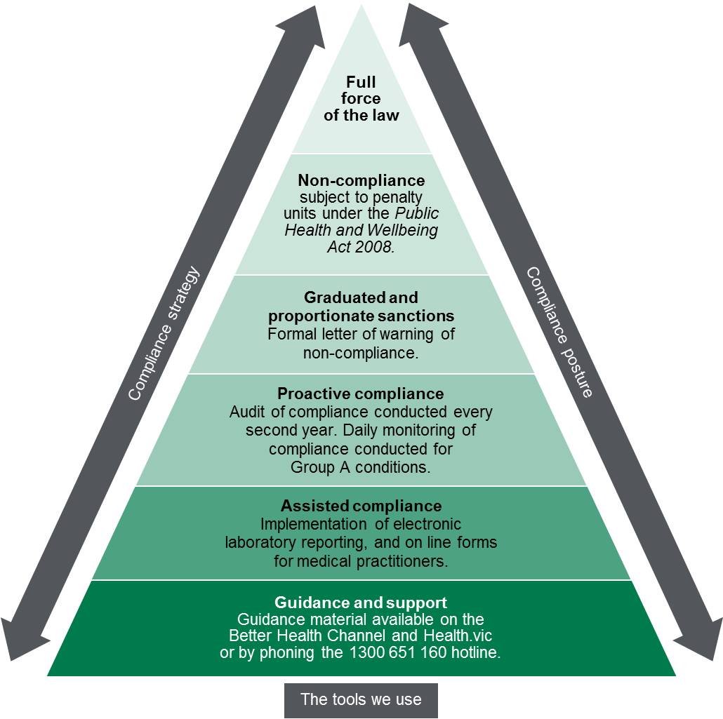

Measuring performance
This section sets out our understanding of how the activities that we undertake, as targeted by the identification and assessment of risks, contribute to our outcomes.

Our contribution story
The Communicable Disease Section collects, investigates, analyses and responds to notifications in accordance with detailed protocols for each condition. In this work the Communicable Disease Section collaborates with a large number of co-regulators and agencies with regulatory, health protection and prevention roles and responsibilities to respond to cases and outbreaks and address population level risk.
The Communicable Disease Section also works closely with Local Government Authorities that administer regulation of personal service and body art business premises and prescribed accommodation to support their compliance monitoring and enforcement of regulated infection prevention and control standards.

Direct indicators
In this section, we have outlined a small number of indicators that can be used to guide our activity and evaluate our effectiveness. To the extent possible, our indicators demonstrate our contributions to the outcomes that we are trying to achieve, rather than simply the activities that we are undertaking.
The section on the following page sets out the measures that we use to indicate success against our outcomes.

Table 4: Measures used to indicate success against outcomes
Indicator | Baseline  2013 | Target | 2015 actual | 2017 actual | 2019 actual
Communicable disease notifications
Proportion of required notifications received from doctors | 46% | 100% | N/A | N/A | N/A
Proportion of required notifications received from laboratories | 94% | 100% | N/A | N/A | N/A
Prescribed accommodation and registered premises

Stakeholder engagement

Ongoing communications

Communicable Disease Section
The Communicable Disease Section undertakes day-to-day operational communication regarding regulatory activities. This includes:
- Education: The Communicable Disease Section conducts new training and provides written advice for General Practitioners and laboratories when new guidelines are written (e.g. Guidelines on Carbapenemase-producing Enterobacteriaeceae (CPE) management); and additional training and provision of advice when protocols and guidelines are updated. Written advice was provided to doctors, laboratories and peak bodies prior to the introduction of the Public Health and Wellbeing Act, and the Public Health and Wellbeing Regulations in 2010.
- Training public health officers: All Public Health Officers employed by the Communicable Disease Section are authorised under the Public Health and Wellbeing Act. Some officers are also authorised under the Food Act. Some authorised officers also undertake formal training such as administrative law and investigations training.
- Public Health Officers provide guidance and advice to doctors and laboratories on a daily basis by telephone during routine notification processes.
- The Communicable Disease Section, together with the Communications team and other Prevention Units, have a suite of regular communications activity which is undertaken on a seasonal basis for particular diseases, for example influenza updates to residential aged care facilities, public messaging about food safety over the Christmas period, safe sex messaging around Mardi Gras time.

Planned activities
Upon completion of the dual notification project and following any amendments to the regulations, a large-scale engagement and education campaign will be undertaken to raise awareness of the changes.

Key stakeholders
Table 5: List of key stakeholders
Key stakeholders | Type
Australian Department of Health | Co-regulator
World Health Organisation | Co-regulator
Local Government Authorities | Co-regulators
DHHS Food Safety, Water and Legionella Units  DHHS Divisions | Co-regulator
Health Services | Regulated entities
Pathology Services | Regulated entities
Medical Practitioners | Regulated entities
Department of Education and Training Victoria | Co-regulator
Work Safe | Co-regulator
Consumer Affairs Victoria | Co-regulator
Accommodation businesses | Regulated entities
Personal service and body art businesses | Regulated entities
General public

Diagram text
Figure 1. Regulatory tools
This figure is an enforcement pyramid. The figure seeks to demonstrate that the unit will use the full range of tools available to it in line with the risks that they are seeking to manage. The enforcement pyramid illustrates a graduated and proportionate enforcement approach. The bottom of the pyramid outlines the lighter touch interventions such as education and advice to regulated parties, through to prosecution at the top of the pyramid, where regulated parties deliberately work against intended outcomes and intend to evade compliance obligations.

Note that this proportion reflects that some notifiable conditions do not require notification by both doctors and laboratories. This is being addressed by the dual notification project, described above. Following implementation of changes to the number of conditions that require dual notification (notification by both laboratory and doctor) and the subsequent education campaign, this proportion should increase markedly.
Note that this proportion reflects that some notifiable conditions do not require notification by both doctors and laboratories. This is being addressed by the dual notification project, described above. Following implementation of changes to the number of conditions that require dual notification (notification by both laboratory and doctor) and the subsequent education campaign, this proportion should increase markedly.
Measures relating to prescribed accommodation and registered premises will be published once supporting information is collected in the next 1 to 2 years. These include the following: a) proportion of personal services and body art business reporting that the Infection Prevention and Control Guidelines effectively addressed their issues and b) proportion of Local Government Authorities’ Environmental Health Officers reporting the PHWA Handbook effectively addressed their issues.

