COVID-19 Compliance and Enforcement Policy
Guidelines for exercising compliance and enforcement powers and functions under the Public Health and Wellbeing Act 2008 in response to the COVID-19 pandemic
OFFICIAL
Contents
Definitions and abbreviations 2
Introduction and legislative context 3
Principles 5
Key pillars underpinning COVID-19 compliance and enforcement 7
Pillar 1: Public health driven 9
Using compliance activities to promote public health 9
Communications must cater to community needs 9
Pillar 2: Risk-based decision-making 10
Taking a risk-based approach 10
Establishing clear compliance priorities 10
Assessing risk 11
Proportionality 11
Pillar 3: Graduated responses 13
Graduated responses 13
Use of discretion when choosing enforcement action 13
Protests and demonstrations 14
Pillar 4: Mindful of individual and community circumstances 15
Identifying and assessing the needs of vulnerable people and communities 15
Applying special circumstances 16
Guidance on compliance and enforcement options 18
Tools for promoting and generating compliance 18
Tools for enforcement 19
Hierarchy of compliance and enforcement responses 19
Continuous improvement 21
Review process 22

Definitions and abbreviations
PHW Act | Public Health and Wellbeing Act 2008 (Vic).
Regulations | Public Health and Wellbeing Regulations 2019 (Vic).
Charter of Human Rights | Charter of Human Rights and Responsibilities Act 2006 (Vic).
Authorised Officer or AOs | A person appointed by the Secretary under section 30 of the PHW Act, and with the obligations and powers set out in Part 9 of the PHW Act.
Authorised persons | Authorised persons refer collectively to all AOs, Victorian police assisting AOs, and other persons performing formal compliance and enforcement functions under the PHW Act as part of the response to the COVID-19 pandemic, but for clarity, does not include persons requested to assist AOs with contact tracing activities.
CHO | Chief Health Officer, meaning the person appointed as Chief Health Officer under section 20 of the PHW Act.
Infringements Act | Infringements Act 2006 (Vic).
DH | Department of Health.
Infringements | For the purpose of section 209 of the PHW Act, an offence against a provision set out in Column 2 of the Tables in Schedule 8 of the Regulations is a prescribed offence for which an infringement notice may be served.

Introduction and legislative context
On 15 December 2021, the Premier declared a pandemic in relation to the COVID-19 pandemic under Part 8A of the Public Health and Wellbeing Act (Vic) 2008 (the PHW Act). This declaration enables the Minister for Health to issue pandemic orders that may place obligations on business and individuals in Victoria to protect public health. Persons may be authorised under the PHW Act to support compliance with, and enforcement of, the pandemic orders. The declaration was extended on 15 January 2022 and will likely continue until at least 12 April 2022.
Under section 231A of the PHW Act, the Secretary of the Department of Health (DH) may make and publish a compliance and enforcement policy (Policy) to guide how persons involved in compliance and enforcement functions can:
- promote compliance with, and enforcement of the PHW Act powers including emergency, public health risk and pandemic management powers;
- in relation to the COVID-19 pandemic, consider the impacts of the performance of those functions upon vulnerable persons and communities; and
- consider other matters relevant to compliance and enforcement, including the issuing of infringement notices.
Under subsection 231A(7), the Secretary of DH must publish a Policy relating to the COVID-19 pandemic no later than 90 days after commencement of section 231A. This Policy must promote compliance with, and enforcement of, the PHW Act or specified provisions of the Act in its application to the COVID-19 pandemic. This Policy must also set out guidance on how persons involved in compliance and enforcement functions in relation to the COVID-19 pandemic are to consider the impacts of the performance of those functions upon vulnerable persons and communities.
Application of the Policy
Under subsection 231A(6) any person who performs a function or exercises a power under the PHW Act must have regard to any applicable policy in performing the function or exercising the power.
This Policy applies to any authorised person who performs a function or exercises a power under the PHW Act as part of the response to the COVID-19 pandemic. While each cohort of authorised persons under the PHW Act will have differing breadth of powers and obligations, each authorised person should consider how this Policy relates to their duties when undertaking their role.
No part of this Policy is to be taken to be an enforcement agency guideline or policy for the purposes of section 9 of the Infringements Act 2006 (Vic).
Purpose of the Policy
This Policy provides a guiding framework for all authorised persons undertaking enforcement and compliance activities relating to the COVID-19 pandemic and aims to support them to achieve better public health outcomes. This Policy places compliance and enforcement in a public health context, framing activities as important in preventing the spread of disease and protecting vulnerable persons and communities, rather than using a punitive approach to enforcing laws and regulations.
The Policy has been informed both by lessons learnt in compliance and enforcement activities since the beginning of the COVID-19 pandemic and by best practice approaches. Overall, this Policy was designed to be adopted by authorised persons to better support the Victorian community to comply with pandemic orders, while recognising the need for proportionate, fair and compassionate enforcement to ensure vulnerable persons and communities are not disproportionately impacted during a pandemic.
The Policy supports compliance and enforcement activities by:
- instructing authorised persons to prioritise public health outcomes when performing their functions under the PHW Act;
- guiding how authorised persons make proportionate and equitable decisions in response to non-compliance;
- encouraging initial use of the least restrictive or punitive response to non-compliance, and escalation only as necessary;
- informing authorised persons about how to consider impacts of compliance and enforcement activities on vulnerable persons and communities; and
- increasing transparency around enforcement activities, so that the Victorian community understands the role and obligations of authorised persons, the importance of compliance with pandemic orders, and can have confidence in how pandemic orders will be enforced.
This Policy contains overarching guidance that sits alongside more detailed operational frameworks that already support compliance and enforcement activities across different workforces and different government departments. While these differ in application and content to suit different operational objectives, this Policy aims to guide all activities towards a more consistent approach across government. To support this, the Policy is pitched at a high-level and structured around:
- four pillars for authorised persons to have regard to when exercising powers in response to public health risk;
- factors to consider when undertaking compliance and enforcement activities in relation to vulnerable persons and communities; and
- general guidance on the use of compliance and enforcement tools available.

Principles
This section of the Policy sets out the principles to which authorised persons must have regard when exercising their powers and functions to ensure compliance with, and enforcement of, pandemic orders in relation to the COVID-19 pandemic, including principles in the PHW Act, objectives of the new pandemic-specific Part, and human rights considerations.
Principles in the PHW Act
The PHW Act sets out principles to be followed when exercising powers or functions under the Act. Section 4 of the PHW Act provides that in the administration of the PHW Act and in seeking to achieve the objectives of the PHW Act, regard should be given to the principles set out in sections 5 to 11A. These principles are outlined at Table 1.
Table 1: Principles of the Public Health and Wellbeing Act 2008
Principle | Application (as set out from Part 2 of the PHW Act)
Principle of evidence-based decision-making | Decisions are made using relevant and reliable evidence for the most effective and efficient use of resources and interventions to promote and protect public health.
Precautionary principle | If a public health risk poses a serious threat, lack of scientific certainty should not be used as a reason for postponing measures to prevent or control risk.
Principle of primacy of prevention | Prevention is preferred over remedial measures. That means capacity building and other health-promotion activities are central to reducing differences in health status and promoting health.
Principle of accountability | Persons engaged in the administration of the PHW Act should as far as reasonably practicable ensure decisions are transparent, systematic and appropriate. The public, including individuals and businesses, should be given access to reliable information in appropriate formats to facilitate better understanding of public health issues, and an opportunity to participate in policy and program development.
Principle of proportionality | Decisions made and actions taken should be proportionate to the public health risk sought to be prevented, minimise of controlled, and should not be made or taken in an arbitrary manner.
Principle of collaboration | Public health and wellbeing, at the Victorian, national and international levels, can be enhanced through collaboration between these levels of government and industry, business, communities and individuals.
Note: All authorised persons that are exercising powers or functions under the PHW Act must have regard to these principles, particularly when engaging in activities to promote compliance with pandemic orders, or when making decisions about how to respond to non-compliance.
The objectives of the PHW Act are to achieve the highest standard of public health and wellbeing by protecting public health and preventing disease, illness, injury, disability or premature death, promoting conditions in which persons can be healthy, and reducing inequalities in the state of public health and wellbeing. The principles in the PHW Act assist to ensure that these objectives are achieved.
New Objectives in Part 8A of the PHW Act
The Public Health and Wellbeing Amendment (Pandemic Management) Bill 2021 introduced new objectives to Part 8A of the PHW Act which focus on protecting the public health and wellbeing of Victorians.
Section 165A(1) provides that the objective of Part 8A is to establish a regulatory framework for:
- preventing and managing the serious risk to life, public health and wellbeing presented by the outbreak or spread of pandemics and diseases of pandemic potential;
- supporting proactive and responsive decision-making for the purposes of preventing and managing the outbreak or spread of pandemics and diseases of pandemic potential;
- ensuring that decisions made, and actions taken under this Part are informed by public health advice and other relevant information including, but not limited to, advice given by the Chief Health Officer;
- promoting transparency and accountability in relation to decisions made and actions taken under this Part; and
- safeguarding contact tracing information that is collected when a pandemic declaration is in force.
In addition to the above guiding principles, section 165A(2) of the PHW Act provides that the Parliament of Victoria recognises the importance of protecting human rights in managing the serious risk to life, public health and wellbeing presented by the outbreak or spread of pandemics and diseases of pandemic potential. The Act clarifies that the intention of Parliament is that nothing in Part 8A displaces the operation of the Charter of Human Rights.
All authorised persons that are exercising powers or functions under Part 8A must have regard to these new objectives and the need to consider the Charter of Human Rights, particularly when engaging in activities to promote compliance with pandemic orders, or when making decisions about how to respond to non-compliance.

Key pillars underpinning COVID-19 compliance and enforcement
The Policy introduces four new key pillars that should underpin the approach taken by authorised persons to ensure compliance with, and enforcement of, pandemic orders in relation to the COVID-19 pandemic. These pillars are designed to minimise punitive approaches to non-compliance and instead focus on maximising public health outcomes in the community.
Authorised persons should refer to the four key pillars in combination with the principles outlined in Table 1, when exercising their powers or functions under the PHW Act in relation to the COVID-19 pandemic. This will contribute to ensuring consistency across compliance and enforcement activities and better support authorised persons to promote public health outcomes.
The four key pillars are:
- Pillar 1: Public health driven – ensuring the best public health outcomes are at the forefront of any enforcement and compliance activity.
- Pillar 2: Risk-based decision-making – judgements are made in line with public health risks and other prevalent risks at any given time.
- Pillar 3: Graduated responses – supporting a broadly consistent decision-making and escalation approach, ensuring that punitive options such as issuing infringements and criminal proceedings are a last resort and for the most severe breaches.
- Pillar 4: Mindful of individual and community circumstances – ensuring all Victorians understand their shared rights and obligations in relation to pandemic management and reducing the unintended consequences and disproportionate impacts of compliance and enforcement decisions on vulnerable people and communities.

Using the key pillars
The four key pillars are intended to provide additional guidance to authorised persons when exercising their powers and functions, to ensure consistency with the principles and intent of the PHW Act. This guidance does not however intend to limit operational discretion.
The appropriate application of this Policy will be determined on a case-by-case basis. For example, when undertaking compliance and enforcement activities related to businesses, rather than individuals.
Table 2 outlines some factors that may be considered by persons exercising discretion and making enforcement decisions.

Table 2: Factors for consideration when assessing use of enforcement tools
General compliance and enforcement factors | Individual factors
Public health context and desired outcomes under Pillar 1: nature of the public health risk that the breach poses to the broader community, industry, or integrity of the regulatory framework. | Nature and severity of the conduct​: whether the conduct is best managed with guidance, support or, where the breach/non-compliance is severe, other enforcement options.
Risk-based decision making under Pillar 2: includes assessment of the:  - severity of the potential consequence;  - likelihood of that consequence eventuating; and  - consideration of a proportionate response taking into account the non-compliance. | Culpability of the parties involved: whether the conduct was intentional, negligent, or accidental, and whether it was conducted with awareness of the restrictions, requirements or offences.
Graduated response under Pillar 3: considering the lowest enforcement tool necessary to achieve a desired outcome and increasing only as required, depending on the extent/severity of the risk. | Compliance history​: whether the individual or business has a history of non-compliance and breaches and scope/extent of the non-compliance.
Considering context of enforcement and community expectations under Pillar 4: determining appropriateness of the action after considering community expectations and enforcement context. | Human rights considerations: including those protected in the Charter of Human Rights.
Application of guiding principles of compliance and enforcement policy: proportionality; evidence-based decision-making; accountability and collaboration. | Compliance history: whether the individual or business have indicated their willingness to cooperate and comply.
Compliance and enforcement posture of the organisation: for example, whether there is a ‘blitz’ on a particular issue or if there are low rates of community transmission, therefore enforcement more likely to be reduced. | Whether it involves children and young persons: the capacity of the child or young person to ​have committed an offence.
Costs associated in using a particular enforcement mechanism: particularly for more administratively onerous enforcement, compared with the potential benefits of using that mechanism. | Vulnerability status of the person: (see Pillar 4 below).
Deterrence: effect of deterrence on the individual and of the community in general. | Whether any special circumstances or exceptions may apply.

Pillar 1: Public health driven
Key points:
- Compliance and enforcement activities should aim to achieve the best public health outcome.
- Increasing understanding of the public health risks posed by COVID-19 is the first compliance activity undertaken.
- Authorised persons should understand the public health risk posed by the pandemic disease and the appropriate mitigation strategies.

Using compliance activities to promote public health
Pandemic management aims to protect the health and lives of Victorians against the serious risk posed by pandemic diseases or diseases of pandemic potential, including the COVID-19 pandemic. Throughout COVID-19, expert public health advice has remained at the core of decision-making and has driven operational priorities. The Victorian Government’s response is informed by the Chief Health Officer and public health advisors, epidemiological modelling, and infectious disease experts. This knowledge is then conveyed to the community through pandemic orders, communications materials, and compliance activities by authorised persons.
That is why public health messaging is the first layer of compliance activities that the DH undertakes. This messaging, when clear, accessible and informative, better ensures compliance with and community support for public health measures. This approach reduces the need for further compliance and enforcement activities at a later point when behaviour may pose a higher level of risk.
In addition to this strategy, businesses may be required to display signage outlining government restrictions on trading to facilitate safe business practices and public compliance, and community and health services may be required to provide information on use of masks or the symptoms of COVID-19 to clients when treating them. When monitoring compliance, authorised persons may choose to support a non-compliant business with providing access to these resources and messaging, before escalating to enforcement activities (see also Pillar 3 on graduated responses).

Communications must cater to community needs
Clear and effective communication is an essential tool in the Victorian Government’s management of the COVID-19 pandemic. Access to quality documents and services that are tailored and in multiple languages is central to the Victorian Government’s successful engagement with communities about public health measures.
The Department of Health works in partnership with other departments, agencies and a range of organisations and community group leaders to develop effective public health messaging that supports and informs local communities of all backgrounds. DH also employs staff, including AOs, that are representative of the communities they serve, to provide a pathway for clearer communication. Authorised persons monitoring compliance with pandemic orders should consider and adjust their communications with the public to better meet community needs and support positive health outcomes.

Pillar 2: Risk-based decision-making
Key points:
- Risk assessments help guide a graduated approach to enforcement.
- Risk-based decision making can apply to any situation, large or small, discrete or systemic.
- Assessing risk is the key to ensuring a proportionate response.

Taking a risk-based approach
Making decisions on the basis of risk is a key role of authorised persons. Given risk is often circumstantial and dynamic, ensuring authorised persons are well-equipped to assess and make risk-based decisions is a key pillar of this Policy.
The intended outcome of the approach is not the elimination of risk. However, authorised persons should use:
- evidence-based decision-making to accurately assess risk and determine appropriate risk-based approaches; and
- an outcomes-based approach to make decisions that lead to the most efficient and effective regulatory actions and outcome;
- a risk-based approach to identify the narrow instances where enforcement is required for non-compliance; and
- a risk-based approach to prioritise resources for promoting and supporting compliance.

Establishing clear compliance priorities
When responding to non-compliance, the key priority should be responding to activities or behaviours that present the greatest level of risk to public health. To do this, prioritisation needs to be based on the best available intelligence and data to inform and contextualise priorities, including but not limited to the following factors:
- actions that place any person at risk of significant harm;
- matters demonstrating deliberate disregard for the law;
- matters that are associated with a person or business with a history of compliance
issues; and
- systemic or industry wide compliance issues.
Taking action based on these factors means that the community is better protected from the most blatant and high-risk breaches. Proactively identifying these factors will facilitate enforcement prioritisation and ensure resources are better tailored to the level of risk. Therefore, efforts should be dedicated towards improving the capacity to detect and respond to these factors through monitoring and surveillance, intelligence gathering and data analysis, targeted campaigns, and routine and random inspections and audits.
Compliance priorities should also strike a balance between activities that are in response to non-compliance, and activities that aim to prevent non-compliance from occurring in the first place, such as proactive campaigns to reduce the risk of non-compliance.

Assessing risk
Risk assessment is a very common framework for determining proportionate actions to take in response to non-compliance. A risk assessment approach supports the decision-making process and assists with prioritising compliance and enforcement efforts and resources. Table 3 outlines how the risk(s) posed by non-compliance can be assessed by the likelihood of a consequence and the severity of consequence, ranging from negligible to extreme.
Table 3: Overall risk matrix
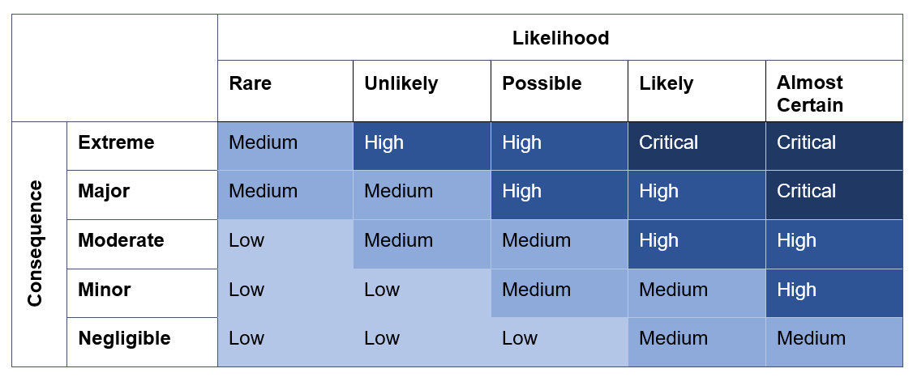
Assessing risk in the context of the COVID-19 pandemic means that there should be additional consideration of the severity of the public health risk posed, the level of culpability of the parties involved, and the potential impact to public health that may eventuate from non-compliance. Authorised persons are tasked with finding the proportionate and most effective response, taking into account these factors, to prevent, minimise or control the risk.
Generally, the more intrusive enforcement tools and severe enforcement responses are justified when they are being used to address situations where the risk(s) associated with non-compliance are the highest. In contrast, where the risk(s) associated with non-compliance are relatively low, less intrusive enforcement tools and lighter enforcement responses should be used.
Risk definitions for Table 3:
Critical. Requires active management to reduce level of risk to an acceptable level. Risk information must be escalated immediately.
High. Requires regular monitoring and should be reduced as much as is practicable. Risk information may be escalated.
Medium. Requires periodic monitoring. Reduce level of risk (current) where practicable or cost effective.
Low. Can be managed by existing/routine procedures.

Proportionality
There is no set formula that dictates the correct action to take in every situation that may arise. An informed risk assessment framework allows authorised persons to choose the appropriate action in a proportionate manner. Proportionality helps ensure that responses are just, equitable, and that there is an appropriate balance between the level of risk and the response.
A proportionate response to non-compliance in the context of the COVID-19 pandemic needs to consider a range of factors. Factors may relate to both the health impact of non-compliance or the flagrance of the offence, such as:
- the severity of non-compliance
- presence or absence of a reasonable excuse
- risk assessment of the behaviour in line with Table 3
- the level of community transmission being recorded at that time
- the severity of the disease circulating and expected impact of exacerbated spread or risk of outbreaks.
For example, a proportionate action taken during a time of high community transmission may be different to one taken during a time of no or low community transmission. This ensures that responses are also public health driven.
Serious cases of non-compliance may require consideration of whether to take more punitive measures, such as issuing an infringement notice. Proportionality seeks to prevent over-enforcement or over-policing and overly punitive responses. But there are also situations when a proportionate response may be the most punitive or restrictive option available. Proportionality ensures that the chosen enforcement tool and measures used, individually or in combination, respond to the severity of the risk and seriousness of the breach of law, while achieving the desired public health outcome.

Pillar 3: Graduated responses
Key points:
- The least restrictive action should be taken first, and escalation should only occur if necessary and proportionate.
- Graduated responses are underpinned by discretion and consideration of a range of factors.
- Graduated enforcement is designed to minimise the enforcement measures taken and prevent punitive approaches when inappropriate or unlikely to result in better public health outcomes.

Graduated responses
Regardless of the approach taken, when choosing an enforcement measure optimising public health outcomes should be the key priority. Using a graduated escalation framework to guide enforcement decisions supports the use of the lowest enforcement tool necessary to achieve the desired outcome.
Figure 1 demonstrates the ‘compliance and enforcement hierarchy’, including the options of tools that can be used along with their respective levels of intervention. Authorised persons can escalate their response up the hierarchy according to the proportionality and risk-based considerations mentioned above. They may also consider other factors, such as the apparent willingness to improve and comply, the compliance history of the person or business, or frequency of issues arising.
Most actions will be focussed on the lowest parts of the enforcement hierarchy.
Figure 1: Compliance and enforcement levels pyramid
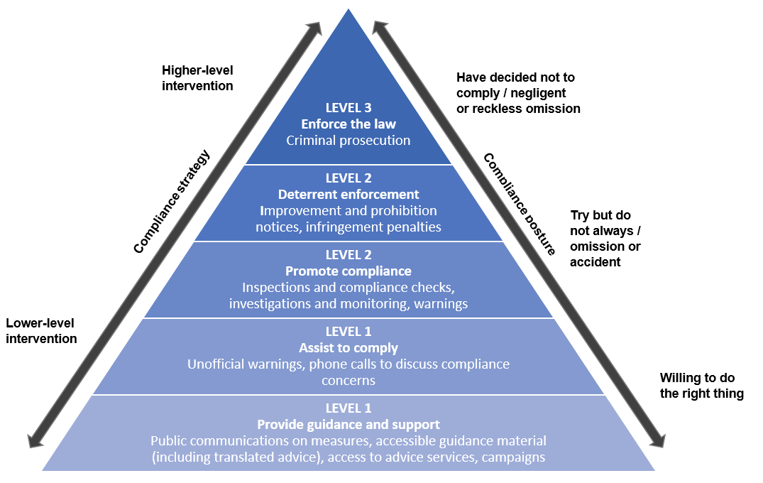

Use of discretion when choosing enforcement action
Graduated enforcement responses are underpinned by the exercise of discretion. Authorised persons regularly use their discretion when selecting the most proportional compliance or enforcement action to take. Compliance and enforcement actions are most effective when they raise public health awareness and encourage behavioural change, which both improves compliance rates and secures long-term public health improvements. While both specific and general deterrence play a role in encouraging compliance, it should be the aim of authorised persons to promote deterrence through lower-level interventions.
The aim of any enforcement action taken by authorised persons should be to ensure that the sanction applied reflects the severity of the breach (proportionality). Authorised persons may also consider further factors as relevant, including the level of culpability of the parties involved, the likely effectiveness of sanctions, the need to prevent future non-compliance or the need to optimise public health outcomes. This holistic assessment of situations takes into careful consideration not only the breach, but the needs of the individual, business or community from the compliance or enforcement action.
The first response to non-compliance should aim to adequately mitigate the risk to public health, while minimising the impact on the person or business. Enforcement options should escalate to more punitive measures only when there is a deliberate or continued failure to comply – as outlined by the Proportionality section above. Ongoing or serious non-compliance without reasonable excuse will typically attract action proportionate to Level 2 or 3 at Figure 1 outlines some factors that may be considered by persons exercising discretion and making enforcement decisions.
Many enforcement tools can have a punitive impact on the community. For example, prohibition notices issued to businesses may temporarily close their premises to address immediate risks to public health but will also impose a financial loss on the business through lost trade.
When exercising discretion, authorised persons should also refer to Charter of Human Rights considerations and the Attorney Generals’ Guidelines to the Infringement Act 2006.

Protests and demonstrations
In Victoria, the freedom of expression and right to assemble are enshrined in the Charter of Human Rights. Throughout the COVID-19 pandemic some human rights protected by the Charter of Human Rights have been impinged upon when mandating measures needed to protect the community’s right to life. Protests and public demonstrations have presented significant public health challenges. The need to facilitate the fundamental right to and role of demonstrations in democracy has had to be balanced against the risks of spreading COVID-19 to attendees, enforcement officers working in response and the Victorian community. The infectious nature of COVID-19 has meant temporary and proportionate restrictions on gatherings and movement have been necessary at times.
A further consideration is achieving the right balance between the need to protect public health by monitoring and supporting compliance with the relevant orders, while respecting the rights enshrined in the Charter of Human Rights. Compliance and enforcement officers are experienced in balancing these as a fundamental part of their functions. The principle of proportionality and the need to take a graduated approach to enforcement supports this careful balance, aiming to ensure the least restrictive approach necessary to achieve a compliance outcome is used in the context of protests. To be lawful and consistent with democratic and human rights principles, any restrictions on protest rights should be limited to what is reasonably necessary to protect public health and should remain in force only for as long as is reasonably necessary.
Overall, authorised persons who are engaged in overseeing protests should take reasonable steps to proactively facilitate safe protest activities.

Pillar 4: Mindful of individual and community circumstances
Key points:
- The community is a partner in promoting compliance and enforcement.
- Authorised persons should consider how their compliance and enforcement decisions impact vulnerable persons and communities.
Section 231(7) of the PHW Act requires this Policy to guide how authorised persons, performing compliance and enforcement functions as part of the response to the COVID-19 pandemic, consider how their performance of those functions affects vulnerable persons and communities.
Stakeholder feedback has highlighted the need to avoid unfairly treating, stigmatising, or criminalising specific communities. While any such consequences are usually unintentional, the impact on these communities can exacerbate existing challenges and be detrimental to the desired public health outcome. Any approach needs to be grounded in achieving greater equity via exercising discretion and compassion at the time compliance activities are undertaken. Achieving a better outcome for vulnerable communities will result in better public health outcomes for both those communities and the broader Victorian community. This approach places emphasis on informing people to ensure they understand what is expected of them, and supporting and empowering people to take ownership of their obligations.
Further to the key pillars of this Policy and the principles under the Act, authorised persons should endeavour to prevent over-policing or targeting of vulnerable cohorts, including Aboriginal and Torres Strait Islander communities and people from culturally and linguistically diverse backgrounds. Authorised persons should also take proportionate compliance and enforcement actions when working with vulnerable persons or communities. Risk assessments may look different when working with vulnerable communities because the impacts of measures may be disproportionate than in other circumstances. For example, the impact of taking a punitive enforcement measure on a community already experiencing higher rates of police activity, may be more significant and therefore, less desirable.
Assessing vulnerability, particularly in enforcement contexts where a person may have already engaged in serious non-compliance can be challenging. That is why compliance strategies, including effective communication, is particularly critical for these communities.

Identifying and assessing the needs of vulnerable people and communities
There are some established norms that are already in use in compliance and enforcement policies when assessing the needs and vulnerability of a person or group. This assessment is important when making compliance and enforcement decisions, as there may be reason to take an alternate compliance and enforcement approach or undertake internal reviews of decisions. While many of these factors may not necessarily be apparent to authorised persons when assessing an incident, should any of the factors be observed, suspected or raised, they may become relevant to the response.
- Aboriginal and Torres Strait Islander: many First Nations people have complex and varied needs, some of which include functional dependency, disability, poor physical health, mental illness, substance use, traumatic events, economic hardship and safety.
- Age: children and young people may not be able to fully comprehend the context of the public health requirements and may not have developed the capacity or the knowledge to understand the wider implications.
- Physical or psychological abuse and trauma: victims of abuse, torture, rape, slavery, slavery-like practices such as forced labour and forced marriage, human trafficking or other serious forms of psychological, physical or sexual violence.
- Sensory impairment: vision or hearing loss which prevents interaction with others and difficulties in accessing information.
- Older age and frailty: disorders of older age including memory loss and inability to cope with complex decision making; sensory and mobility problems which prevent new information being accessed and new learning.
- Mental illness or emotional disorder: episodes of mental ill health which seriously affect mood (bipolar disorder, depressive illness), grief and loss reactions, depression, thought disorder and difficulties with complex reasoning.
- Intellectual, developmental and learning disabilities: disability present from an early age either from genetic conditions or early brain injury (e.g. meningitis) or illness or nutrition of mother during pregnancy (e.g. rubella, foetal alcohol syndrome) which affect ability to learn and develop intellectual functioning.
- Physical disability: problems with mobility and muscle movement, (e.g. paralysis, cerebral palsy) which do not generally affect psychological or intellectual functioning.
- Experiencing family or domestic violence: safety of individuals is always of paramount importance when it comes to compliance with orders.
- Acquired brain injury: neurological disorders as a consequence of trauma to the head and/or brain.
- Culturally and linguistically diverse communities: people from multicultural communities, particularly where their main language is not English, as this can result in inadvertent non-compliance.
This list is not exhaustive. Other factors, or a combination of factors, may alter either the appropriate compliance or enforcement response, or an individual’s compliance with pandemic orders or response to enforcement actions. In particular, social and cultural factors are less observable and may have secondary impacts on the interactions with authorised persons. An additional factor might be a person’s lived experience engaging with government or authority. The central issue for consideration is whether a person’s capacity to comply is impaired or limited, taking into account the entirety of the person’s circumstances.

Applying special circumstances
The Infringements Act allows for the recognition of special circumstances to ensure that certain members of the community are not unfairly processed through the criminal justice system. These are to be taken into account when applications involving special circumstances are being considered by review officers. Recent amendments to the Infringements Act have broadened the ‘special circumstances’ test to improve access and outcomes for vulnerable people seeking review of an infringement notice. These will apply to both pandemic and non-pandemic related infringements. Special circumstances identified are as follows:
- a mental or intellectual disability, disorder, disease, or illness where the disability, disorder, disease or illness contributes to the person having a significantly reduced capacity to:
  - understand that conduct constitutes an offence; or
  - control conduct that constitutes an offence; or
- a serious addiction to drugs, alcohol, or a volatile substance within the meaning of section 57 of the Drugs, Poisons and Controlled Substances Act 1981 where the serious addiction contributes to the person having a significantly reduced capacity to:
  - understand that conduct constitutes an offence; or
  - control conduct that constitutes an offence; or
- homelessness determined in accordance with the prescribed criteria (if any) where the homelessness contributes to the person having a significantly reduced capacity to control conduct that constitutes an offence; or
- family violence within the meaning of section 5 of the Family Violence Protection Act 2008 where the person is a victim of family violence, and the family violence contributes to the person having a significantly reduced capacity to control conduct that constitutes an offence; or
- circumstances experienced by the person that:
  - are long-term in nature; and
  - make it impracticable for the person to pay the infringement penalty and any applicable fees or otherwise deal with the infringement notice under this Act or the Fines Reform Act 2014; and
  - do not solely or predominantly relate to the person's financial circumstances.
Authorised persons should exercise discretion not to serve an infringement notice where it is clear that the person has special circumstances, as defined above, at the time of the alleged offence.
Authorised persons should also refer to relevant agency-specific guidance for further direction on the appropriateness of issuing infringements to people who may have special circumstances at the time of the alleged conduct.

Guidance on compliance and enforcement options
This section of the Policy sets out the options for compliance and enforcement tools and activities that authorised persons may use when exercising their powers and functions. This section also provides guidance on how to use these tools consistently with the principles outlined in Table 1, and to ensure that vulnerable persons and communities are not disproportionately impacted.

Tools for promoting and generating compliance
Generating compliance is a critical role of DH, AOs and all persons exercising powers and performing functions under the Act. A range of compliance activities and tools are available to increase compliance with pandemic orders and public health measures, including but not limited to the following:
Inform and educate the community
Raise awareness of relevant public health advice and how to stay safe when COVID-19 transmission is occurring in the community, current restriction settings, the specific activities that may increase or mitigate health risks, and the role of authorised persons. This will often take place in an evolving environment and requires a dynamic approach by authorised persons.
Collaborate with industry and community leaders to distribute information
Support the community and industry to understand and comply by providing accessible and relevant health and restrictions information. This needs to be tailored and appropriate for specific groups, for example translated information for linguistically diverse groups on infection control measures. By doing this, community and industry are included in compliance and can take ownership of the response.
Support to comply
Build partnerships and trust throughout the community to ensure that information and guidance is considered credible and important. Supporting the community to comply goes above and beyond provision of guidance, as it empowers them to address barriers to compliance, enabling the community to improve its capability to identify and mitigate public health risks.
Monitor compliance and enforce when necessary
Collect and analyse data to determine the level of compliance within the community and industry to maintain an acceptable level of non-compliance.
Encourage higher performance
Work with community and industry leaders and partners to encourage higher performance. This includes promoting best practice to inform industry practices and improve future standards. Authorised persons should be committed to continuous improvement.
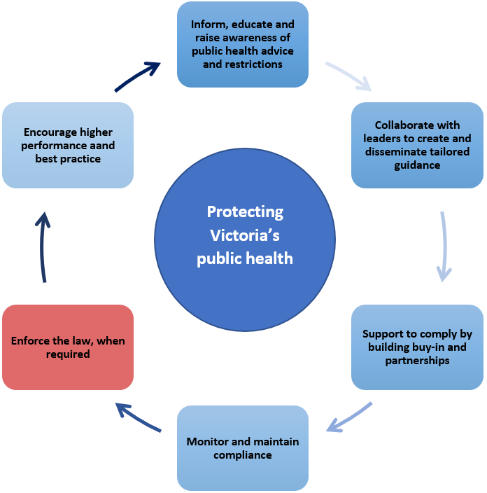
Figure 2 provides an overview of the roles and activities that DH undertakes as part of its compliance and enforcement mandate.
Figure 2: Compliance cycle and pathway to enforcement

Tools for enforcement
Enforcement tools may be required when compliance activities do not generate enough impact or achieve desired outcomes. Enforcement tools range in their deterrence effectiveness. Some provide a softer touch to nudge compliance behaviours, while others provide directly enforce the law and pursue an appropriate penalty for non-compliance. Enforcement tools include official warnings, improvement notices, infringement notices, prohibition notices, injunctive relief, or prosecution.
In some circumstances simply raising awareness of breaches, whether or not supported by unofficial warnings, best deliver the desired deterrence outcome. For example, when the breach is caused by omission, rather than intent. Whereas in circumstances where the person deliberately fails to comply, an infringement notice may be more appropriate and likely to achieve the desired enforcement outcome.
Punitive approaches are often unlikely to achieve positive outcomes and may even be at odds with the public health advice. That said, it is important that tools can be exercised where necessary with discretion and proportionality. Consideration of these enforcement tools should therefore include the principles outlined in Table 1 and aim to use the tool of least impact first to achieve the best public health outcome, before escalating.

Hierarchy of compliance and enforcement responses
Table 4 provides an overview of the three levels of compliance and enforcement activities, and the typical responses to be taken by authorised persons in those circumstances. The three levels demonstrate a suggested escalation of responses, but represent the continuum of responses available, including from informing/advising to support compliance (Level 1) to moderate levels of enforcement including official warnings and infringements (Level 2), and up to prosecution for serious offending (Level 3).
Table 4: Compliance and enforcement options aligned to the three levels of intervention
Compliance and enforcement options
Level 1
No Action | AOs may exercise their discretion not to take any further action in an isolated and/or low risk incident (in terms of public health and safety) of non-compliance. This discretion maybe used where the breach involves a minor matter and AOs are satisfied the non-compliance is more appropriately addressed without intervention.
Compliance information | In some cases, involving low-risk non-compliance, AOs may provide information or access to educational material to support future compliance. This information includes the provision of guidance notes and general information, which are located on the DH website.
Unofficial warning | There are situations and circumstances involving low-risk non-compliances that have traits of potential re-offending. AOs may find it appropriate to provide informal warnings to prevent future non-compliance.
Level 2
Official Warning | This tool relates to breaches that are deemed to be low risk with little immediate public health detriment, of a technical or administrative nature and/or involve mitigating factors.
Improvement Notice | An improvement notice(s) may be issued where the breach is a prescribed offence, but the breach does not pose an immediate, serious and large-scale community risk to public health. The breach can be remedied by the alleged offender taking steps to put in place a compliant system of work.
Infringement Notice | Infringement notice(s) may be issued where there is prima facie evidence that a breach of a prescribed offence has occurred and there is no reasonable excuse. This is generally used when it is not deemed to be of a level that requires a court appearance or disciplinary action, that is, the breach is of a less serious nature and there are no mitigating or aggravating factors, but there is a high level of public concern about the intensity of the issue. Infringement notices should not be issued unless the AO issuing the notice has had a conversation with the person about the offence and ascertained whether the above factors apply before issuing the notice.
Level 3
Prohibition Notice | A prohibition notice may be issued if there has been a contravention of the Act or associated regulations which is serious and has created an immediate and imminent risk to large scale public health. A prohibition notice requires an alleged offender to cease carrying on an unsafe activity.
Injunctive Relief | DH seeks injunctive action in the Magistrates’ Court when the conduct of an alleged offender is serious in nature and is ongoing, where there is prima facie evidence that a breach has occurred, and prompt action is required to protect public health.
Prosecution | DH seeks criminal prosecutions in the Magistrates’ Court when the conduct of an alleged offender is serious in nature, where there is prima facie evidence that a breach has occurred, there was no reasonable excuse, and the breach of the law was conscious and deliberate.
The most appropriate level is determined through analysis of the risk, proportionality, circumstances of the person offending, and the desired outcome. The options outlined in Table 4 should be considered alongside factors for consideration when using enforcement tools in Table 2.

Continuous improvement
The Department of Health is committed to having a public health-oriented compliance and enforcement system that is adequately resourced and responsive to the changing risks of pandemic-related events. This means ensuring that authorised persons are well-prepared, knowledgeable, agile, and adept at making effective compliance and enforcement decisions in line with this Policy.
All compliance and enforcement activities in response to the COVID-19 pandemic should be subjected to continuous review and improvement. Specific review processes are to be determined by the agencies and teams operating under this framework. As a baseline this includes strong documentation of decisions and actions taken in a structured and clear way, so that reviews of processes can be informed by experiences of those on the ground.
This continuous review and reflection will better promote accountability and ensure that a holistic approach to supporting community compliance is maintained. In particular providing the best possible information and education to people in the community as the first response. This will ensure that core compliance and enforcement activities reflect best practice, that responses are community-minded, and that interventions minimise the use of enforcement tools where possible.

Review process
Review of infringement notices
People can request a review of their fines and request special circumstances consideration by visiting: https://online.fines.vic.gov.au/Support/Special-circumstances or calling (03) 9200 8222.
Persons experiencing financial hardship are now eligible to apply to the Director, Fines Victoria for a reduced infringement penalty for on-the-spot fines related to breach of pandemic orders or breach of Chief Health Officer Directions under the state of emergency. This newly established mechanism acts to implement one of the key recommendations of the Fine Reform Advisory Board in its 2020 report on the fines system.
Responding to critical stakeholder feedback that COVID-19 restrictions and fines have had a disproportionate impact on vulnerable communities and those experiencing financial hardship, the PHW Regulations have changed to reflect lower infringement penalties reflected committed to by Government.
Review pathways of the decisions of authorised officers
There are several pathways available for review of decisions made by authorised officers. These include:
- making a complaint to the Secretary and Chief Health Officer under section 185 of the PHW Act;
- making a complaint to the Victorian Ombudsman under section 16 of the Ombudsman Act 1973;
- applying for review to the Victorian Civil and Administrative Tribunal (VCAT) under sections 122, 204 or 207 of the PHW Act; and
- judicial review by the Supreme Court of Victoria.
The internal review process under section 185 allows any person to make a complaint about the exercise of power by an Authorised Officer operating under the Act or Regulations. This complaint goes to the Secretary or relevant Council who must investigate and report on any complaints made under the section.
VCAT has limited power to review certain decisions made by the Chief Health Officer, Secretary and Councils public health risk and emergency powers under the PHW Act. This includes persons who have been made subject to a health order. Likewise, persons who have applied for an internal review by the Secretary and are dissatisfied by the decision can apply to VCAT as an appeals mechanism.
The Ombudsman is empowered to investigate administrative action taken by an authority within the meaning of the Ombudsman Act 1973, including the conduct, decisions and exercise of power by Authorised Officers and others performing functions under the PHW Act. The newly established Pandemic Declaration Accountability and Oversight Committee of Parliament is also able to refer matters relating to the pandemic response for investigation by the Ombudsman.
To receive this document in another format, phone insert phone number, using the National Relay Service 13 36 77 if required, or email insert contact or business name, then make the word ‘email’ and the contact or business name into a hyperlink of the email address <CE.Directorate@health.vic.gov.au>.
Authorised and published by the Victorian Government, 1 Treasury Place, Melbourne.
© State of Victoria, Australia, Department of Health, March 2022.
Except where otherwise indicated, the images in this document show models and illustrative settings only, and do not necessarily depict actual services, facilities or recipients of services. This document may contain images of deceased Aboriginal and Torres Strait Islander peoples.
In this document, ‘Aboriginal’ refers to both Aboriginal and Torres Strait Islander people. ‘Indigenous’ or ‘Koori/Koorie’ is retained when part of the title of a report, program or quotation.
Available at insert web site or web page name and make this the hyperlink <https://www.health.vic.gov.au/publications/covid-19-compliance-and-enforcement-policy>

