Drugs and poisons regulator plan
March 2018 – June 2019

To receive this publication in an accessible format phone 1300 364 545, using the National Relay Service 13 36 77 if required, or email Drugs and Poisons Regulation Branch <dpcs@dhhs.vic.gov.au>.
Authorised and published by the Victorian Government, 1 Treasury Place, Melbourne.
© State of Victoria, Department of Health and Human Services, March 2018.
ISBN/ISSN 978-1-76069-326-8 (online)
Available at Regulatory practice framework <https://www.dhhs.vic.gov.au/better-regulatory-practice-framework>
(1802030)

Contents
Introduction 4
Purpose of document 4
Document content 4
Principles 5
Regulator’s context 6
Regulatory framework 6
Co-regulators 6
Regulatory activities 7
Complementary activities 10
Defining outcomes 11
Risk overview 12
Identified risks 12
Assessing and treating risks 13
Identified risks 14
Compliance tools 19
Measuring performance 20
The contribution story 20
Further evidence we plan to gather to strengthen our contribution story 20
Our direct indicators 20
Stakeholder engagement 22
Ongoing communications 22
Planned communication activities 22
Glossary 24

Introduction

Purpose of document
The Department of Health and Human Services (the department) administers numerous Acts and regulations aimed at promoting the health and wellbeing of the Victorian community, and protecting the population of Victoria, including, vulnerable clients. It has 11 internal business units and three statutory bodies that are recognised by the Department of Treasury and Finance as regulators of business and not for profit organisations.
An individual regulator plan has been developed for each of the 11 internal business unit regulators. These documents are developed in line with the conceptual framework outlined in department’s Better regulatory practice framework <https://www.dhhs.vic.gov.au/better-regulatory-practice-framework>.
The purpose of this regulator plan is to describe the activities of Drugs and Poisons Regulation Branch and the risk management approach it takes to regulation and compliance.

Document content
This regulator plan relates to the Drugs and Poisons Regulation Branch (Branch). The structure of the regulator plan document includes:
- outcomes
- risk assessment and risk management strategy
- demonstrating impacts
- stakeholder engagement
    - overview of approach
    - key stakeholders (co-regulators)
    - key activities.
The plan will remain in place until 30 June 2019, and will then be reviewed and updated every two years, consistent with the time frames for the Ministerial Statement of Expectations for regulators.
This is the first consolidated Regulator Plan that the unit has developed and published. If you have any feedback on the plan, please email Drugs and Poisons Regulation <commentsdpr@dhhs.vic.gov.au>. This plan is effective until 30 June 2019. It will then be updated:
- every two years – in line with the requirement for Ministers to develop and re-issue Ministerial Statement of Expectations every two years; and
- where key legislative changes are made that will impact on regulatory functions and the currency of the Regulator Plans.

Principles
In order to achieve the department’s outcomes, Drugs and Poisons Regulation undertakes its regulatory role as informed by better regulatory practice principles. Consistent with better regulatory practice approaches interstate and internationally, the Branch seeks to apply the following principles:
Table 1: Regulatory practice principles
Principle | Commitment
Collaborative | Where the various departmental regulatory regimes, and those of other agencies, intersect, the regulators will work together to maximise effectiveness and minimise regulatory burden. Regulators will also cooperate and engage with internal and external stakeholders, including interstate counterparts and those representing various client groups within the Victorian community.
Consistent | The regulators will work to provide a consistent experience for regulated entities and the community. Regulatory responses will be predictable (meaning that, to the extent possible, regulators provide similar responses in similar circumstances - consistent with policy) and where possible standardised, following clear processes and delivering consistent results. This will ensure that individuals / organisations are treated fairly, and that the regulators are objective in their decision-making.
Efficient | The regulators will allocate resources in a proportionate way that aims to most efficiently achieve outcomes, considering the direct and indirect impacts on the relevant sectors. This includes minimising unnecessary administrative burden and any adverse impact of regulatory actions on businesses to a level that is not justifiable to achieve regulatory outcomes.
Intelligence-led | The regulators will analyse incoming intelligence and data in order to allow them to be responsive and accurate when assessing risk and undertaking compliance activities.
Outcomes-focussed | Processes and decision-making will be driven by outcomes, and the regulators will be effective in achieving their regulatory objectives. Progress against outcomes will be measured to ensure continuous improvement.
Proportionate | The work undertaken by regulators should be proportionate to the risk being addressed. The principle of proportionality should guide regulators decisions in relation to the level of resources assigned to manage a particular risk, the regulatory tools used and enforcement activities.
Risk-based | The regulators will be proactive in identifying, assessing and responding to risk, prioritising and targeting resources toward specific groups or behaviours that pose the greatest risk to the department’s outcomes.
Transparent | The regulators will be open in their decision-making and processes, documenting decisions appropriately, including the justification for decisions. The regulators will aim to assist regulated parties to understand the decision-making processes, areas of focus and performance. Regulators will follow standard reporting requirements, enabling the department to monitor and oversee the performance of its regulators.

Regulator’s context
Scheduled medicines and poisons can cause a range of harms if they are misused. These harms can include poisoning, addiction and death. More Victorians have died from prescription drug overdose than the road toll in the last five years. Of these, over 40 per cent were caused by opioids. Over the last ten years, there has been a rapid rise in the prescribing of opioids, despite increasing evidence of serious harm in long-term use.
The Drugs and Poisons Regulation Branch (the Branch) aims to reduce the likelihood of this harm by assessing and monitoring key points in the medicines and poisons supply chain, from the point of manufacture to the supply of medicine to the patient, or to an organization conducting research on the substance. It also promotes evidence-based prescribing practices through its policy for issuing schedule 8 permits <https://www2.health.vic.gov.au/public-health/drugs-and-poisons/treatment-approvals/schedule-8-permits-and-notifications>.
The Branch does this by administering a risk-based regulatory framework which focuses its resources on reducing activities that can cause the most harm to the community. The Branch currently regulates around 1,600 licences and permit holders from industry, health services and research facilities that possess or supply scheduled medicines and poisons. It assesses over 60,000 treatment permit applications from registered health practitioners to regulate the prescribing of the most potentially harmful Schedule 8 medicines each year. It also continuously monitors the prescribing and supply of scheduled medicine by health practitioners to identify and address unsafe and unlawful conduct.

Regulatory framework
The Branch’s legislative functions are administered under the Drugs, Poisons and Controlled Substances Act 1981 (Act), the Drugs, Poisons and Controlled Substances Regulations 2017 (regulations) and the Therapeutic Goods (Victoria) Act 2010.
The key purpose of the Act is to protect the Victorian public from harm by regulating the manufacture, distribution, supply and administration of scheduled medicines and poisons. Scheduled medicines and poisons are those included in the schedules of the national Poisons Standard (Standard for the Uniform Scheduling of Medicines and Poisons). The Poisons Standard is adopted by reference in the Act. In working to protect public health and safety, the Branch seeks to prevent accidental poisoning, deliberate poisoning, medicinal misadventure with toxic substances and diversion for abuse, or manufacture of substances of abuse.
The Act acknowledges that a broad range of scheduled substances should be made available, within appropriate controls. Certain categories of persons, including health practitioners and organisations are authorised to possess scheduled substances under the Act. The Branch issues licences and permits to various organisations, including health services, industry and educational and research facilities for that purpose. It is the responsibility of these organisations and individuals to meet all the legislative and policy requirements. The Branch assists these entities to understand their obligations through its publicly available documents, educational presentations and advice throughout the application process, or when they become a licence, permit, treatment permit or warrant holder.

Co-regulators
The Branch works with a number of co-regulators who have complementary aims or functions, or regulate the same entities. These include the Commonwealth and other state and territory health authorities, Victoria Police, the Australian Health Practitioners Regulation Agency (AHPRA) and the Victorian Pharmacy Authority. Co-operative activity can involve sharing information, joint investigations and co-operative educational activities.

Regulatory activities
The Branch undertakes the following key regulatory activities shown in Diagram 1:
Figure 1: Drugs and Poisons Regulation policy framework
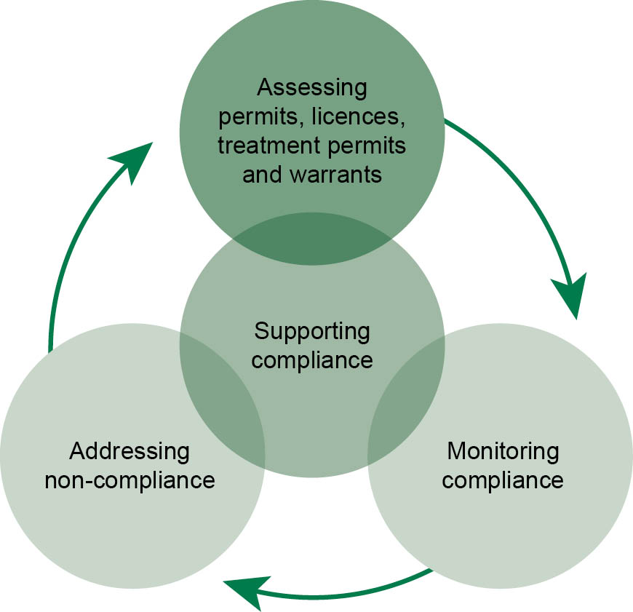

Assessing licences and permits
Licences and permits are issued to complying organisations including health services such as hospitals, industry (including wholesalers and manufacturers), and research and educational institutions to manufacture, sell, supply, obtain and use scheduled medicines and poisons.
Before a licence or permit can be issued, the applicant must submit an application to the Branch. The applicant is required to show how it will comply with the relevant legislative and policy requirements. As part of the assessment of the application, the Branch inspects the premises to be used for the proposed activities to ensure that they comply with legislative requirements.
In 2016, the Branch assessed 180 licences and permits (including 90 new applicants) against the following requirements:
- Can be described as ‘fit and proper persons’ to conduct activities involving drugs and poisons,
- Have premises that appear ‘suitable, sanitary and adequately equipped’ to conduct its proposed activities,
- Have confirmed that they will comply with the requirements of the Act, the regulations, conditions of the licence or permit and the policy requirements of the Branch.

Assessing treatment permits and warrants
Treatment permits are issued to registered health practitioners (general practitioners, medical specialists and nurse practitioners) on application, to allow the prescribing of a range of Schedule 8 medicines, such as potent analgesics and opioid replacement therapies like methadone. Schedule 8 medicines are the most high-risk prescription medicines. Warrants are issued to certain medical specialists to regulate the prescribing of particular Schedule 4 medicines, such as thalidomide.
In 2016-17 the Branch independently assessed over 60,000 treatment permit applications, issuing over 54,000 treatment permits. Treatment permit applications are triaged and assessed according to the potential risk of harm to the patient. The following factors are taken into consideration when assessing potential risk of harm:
- Whether there is already an existing permit or permit application from a different prescriber.
- The risk profile of the Schedule 8 medicines the health practitioner is applying to prescribe: certain medicines have a narrow therapeutic profile (the distance between an ineffective dose and a toxic dose) making them especially risky, for example, methadone.
- The formulation of the Schedule 8 medicine (e.g. injections pose a greater risk of addiction than oral formulations)
- The patient’s medical history, including the use of pharmacotherapy and any drug dependence history.
- The prescriber’s current Australian Health Practitioner Regulation Agency registration status, notably any conditions placed on the prescriber.
  - Evidence of efficacy of the medicine for the indication that the prescriber intends to treat.
Treatment permits enable the Branch to co-ordinate the prescribing of Schedule 8 medicines in order to reduce inappropriate and unsafe prescribing, concurrent prescribing and ‘prescription shopping’ activities. Inappropriate and unsafe prescribing is a particular problem with opioids. There is limited evidence for the efficacy of their long-term use and increasing evidence of harm from these medicines. These risks are addressed through:
- Promotion of evidence-based prescribing and education of prescribers by the Branch’s Drugs and Poisons Officers, particularly during the application process.
  - The forthcoming implementation of Real Time Prescription Monitoring to reduce the likelihood of prescription shopping and concurrent prescribing.
Prescribers are also required to notify the Branch when they believe that a patient requesting drugs of dependence is a drug dependent person in order to enable future prescribers to make a more informed clinical assessment of the patient.
Warrants are issued to medical specialists to regulate the prescribing of certain high-risk medicines, such as thalidomide. Warrants are only issued to practitioners who hold qualifications and expertise in relevant medical specialities.

Supporting compliance
The Branch engages and supports licence and permit holders and health practitioners by operating a telephone inquiry line which enables discussion of all compliance requirements. The Branch takes over 25,000 calls a year, mostly from prescribers before and during the process of applying for a Schedule 8 treatment permit. It also takes many calls relating to licences and permits from manufacturers, health services and research and educational entities. The Branch also supports compliance by sending out information directly to prescribers, or liaising with peak bodies to remind them of their members’ legislative requirements. Educational presentations are provided to various groups of health practitioners and the Branch also maintains a website containing information, application forms, instructions, capacity to offer feedback to the Branch and linkages to other useful websites. It also provides advice during site visits about how organizations and individuals can comply with the legislative requirements.

Monitoring compliance
The Branch undertakes a number of measures to detect non-compliance by registered health practitioners. These include desk top reviews and audits of records of supply and administration of medicines within the lawful chain of supply as well as targeted and ad hoc prescription-monitoring visits to pharmacies. In 2017, dispensing records for selected medicines from around four per cent of Victorian pharmacies were subject to an audit. Community pharmacies and medical and veterinary clinics are also audited periodically by Drugs and Poisons Field Officers.
Complaints or information are also received from health practitioners, other agencies and the general public sporadically, including mandatory notifications related to excessive prescribing, forged prescriptions, false representation, discrepancies and lost or stolen medicines. Approximately 150 of these were received in 2016.
The Branch also conducts approximately 180 routine targeted reviews of compliance of licence and permit holders each year. These are prioritised for review in accordance with the likelihood of harm. This involves a review of licence and permit holders’ compliance procedures and can include a re-inspection of their premises. Licence and permit holders are targeted for monitoring through a number of risk-based criteria including any current compliance issues that are brought to the attention of the department, the entity’s history of compliance, the level of toxicity of the substances that the entity utilises and the length of time since the last review. There are currently over 1,600 licences and permits that are reviewed periodically.

Addressing non-compliance
The Branch undertakes a spectrum of enforcement actions with all permit and licence holders and registered health practitioners, which escalate from giving advice and guidance over minor breaches of legislation, through to instigating legal prosecution of serious and deliberate breaches of legislation. In deciding how non-compliance is addressed, the Branch takes into account the risk of harm to health and the likelihood of non-compliance continuing. In a recent 5-year period there were 33 prosecutions and 151 matters were also referred to the Australian Health Practitioners Regulation Agency (AHPRA) for further action. Diagram 2 on the following page shows how non-compliance is addressed:
Figure 2: Addressing health practitioner non-compliance
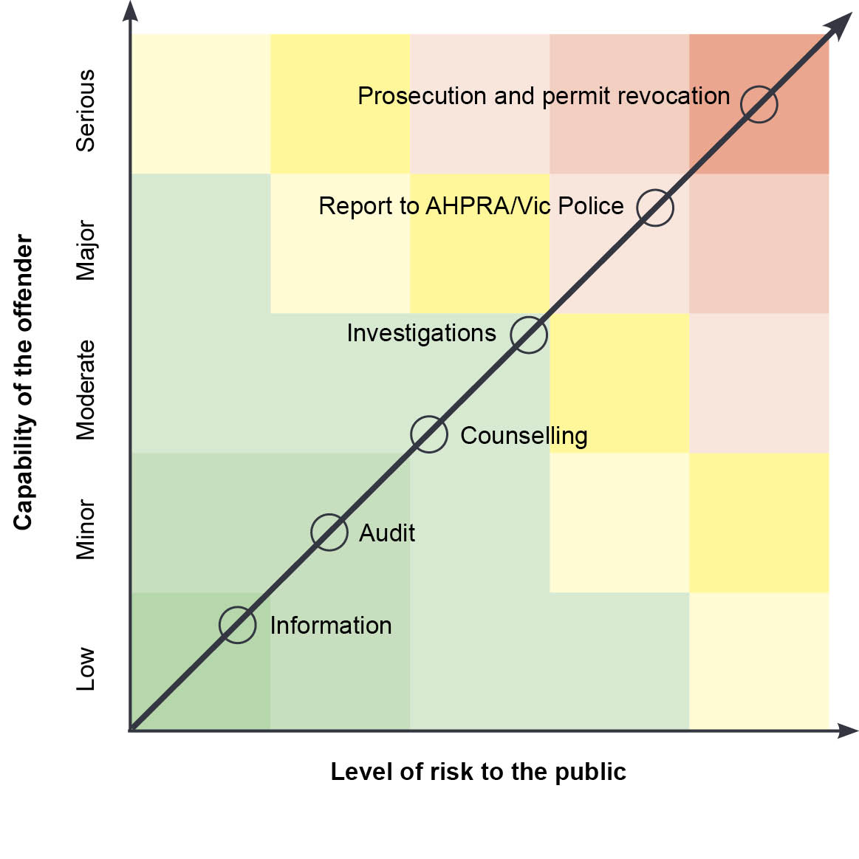

Complementary activities
Beyond its regulatory role, the Branch also undertakes a number of non-regulatory activities. These activities are not governed by the Act, but contribute to improving the health and wellbeing of Victorians by reducing the likelihood of harm caused by the misuse of medicines and poisons.
The Branch purchases services from Australia’s network of poisons information centres. In 2016 there were 52,000 phone calls to these services. These centres provide expert advice to health professionals and the general public on the management of accidental and intentional poisonings. They also conduct toxico-vigilance, research and professional education to enhance the capacity of the health system to reduce risk and harm from poisoning.
The Branch is also involved in policy and program work, including representing Victoria in national advisory committees that assist the Commonwealth Department of Health in making the scheduling decisions for medicines and poisons contained in the Poisons Standard, which forms the basis for most risk-management considerations associated with our compliance activities. The scheduling process determines the appropriate level of public accessibility to medicines and poisons, influencing the level of control on access that is implemented by each state and territory government. Those scheduling decisions are regularly published in the national Poisons Standard and are adopted by reference in the Act.

Defining outcomes
This section includes a summary of the outcomes to which Drugs and Poisons Regulation contributes.
Table 2: Defining outcomes
Regulatory scheme | Outcomes | Objectives
Regulation of medicines, poisons and controlled substances | Reduce the likelihood of harm from scheduled medicines and poisons to the Victorian public by supporting safe and appropriate access. | - Providing risk-based assessment of applications for:  - permits and licences to possess or supply scheduled medicines and poisons to health services, industry and research and educational facilities, and  - treatment permits and warrants to health practitioners, in accordance with legislative and policy requirements.  - Educating and supporting licence and permit holders such as hospitals and industry, and registered health practitioners to improve compliance with legislative and policy requirements to promote the safe storage, supply and use of medicines and poisons.  - Targeted monitoring compliance activities, including risk-based desk top audits, site inspections and investigations.  - Monitoring compliance with regulatory standards for labelling, packaging, storage and advertising of medicines and poisons.  - Better equipping Victoria to minimise drug-related harm caused by prescription shopping and excessive prescribing through the implementation of Real Time Prescription Monitoring.  - 6 Addressing non-compliant activity by applying enforcement strategies, including advice and direction, counselling, revocation of licences and permits, prosecution and referral to health practitioner registration bodies for further sanctions, according to the likelihood and extent of harm.

Risk overview
This section includes a risk assessment and risk management strategy which identifies and prioritises a small number of key risks to Drugs and Poisons Regulation achieving a reduction in the likelihood of harm from medicines and poisons.

Identified risks
This section outlines the critical or high risks relating to specific behaviours or entities which stem directly from the identified outcomes and objectives. These are:
- Patients seeking multiple prescriptions, including by ‘prescription shopping’, and a lack of accessible real-time information for practitioners about patient’s prescriptions (cause) results in patients deliberately or inadvertently obtaining excessive quantities of drugs (event) which can lead to higher risk of abuse or diversion of scheduled medicines (harm).
- The event of negligent or unscrupulous permit or licence holders including health services, industry or registered health practitioners (cause), unlawfully prescribing or supplying scheduled medicines and also potentially enabling the manufacture of illicit drugs for trafficking (event), leading to an increase in drug-related harm (harm).
- Lack of updated and accurate information and support (cause) undermines the capacity of licence and permit holders and health practitioners to comply with the legislative and policy requirements appropriately, (event) resulting in medicine or poison related harms which may include addiction, poisoning or death (harm).
- Lack of knowledge of legislative requirements and regulatory standards for labelling, packaging and storage of medicines and poisons by industry, (cause) resulting in non-compliant or inadequate procedures, (event) increasing the risk of poisoning (harm).
Adequately managing these risks is critical to the Branch being able to reduce the likelihood of the harms of medicine or poison misuse. Accordingly, the Branch focusses its effort and resources on managing these, and takes an active approach to prevent these events from occurring through the assessment of treatment permits, and licences and permits, and through active monitoring, education and enforcement.
Other, lesser risks to the community concerning medicines and poisons are addressed at the time of the event to lessen the impact of any associated harms. This includes our role in medicines and poisons recalls or shortages and non-compliant labelling of medicines or poisons.
In order to manage these risks, over the next 12 months the branch will:
- Develop a communications strategy, which will include updating the branch website to improve information about the requirements of the legislation.
- Update compliance documents to better align resources to risk.
- Conduct targeted desk top auditing of licences and permits to identify and act on non-compliance.

Assessing and treating risks
This section demonstrates how Drugs and Poisons Regulation assesses and responds to risk. It focusses greater effort and resources on risks with a critical or high rating. The risk is assessed against the risk matrix (shown below), and given a risk rating.
Table 3: Overall risk rating
Consequence | Likelihood:  Negligible (5%) | Likelihood: Minor  (10%) | Likelihood: Moderate (20%) | Likelihood: Major  (40%) | Likelihood: Extreme (80%)
Extreme | Medium | High | High | Critical | Critical
Major | Medium | Medium | High | High | Critical
Moderate | Low | Medium | Medium | High | High
Minor | Low | Low | Medium | Medium | High
Negligible | Low | Low | Low | Medium | Medium

Identified risks

Risk 1
Likelihood | Consequence | Rating
Major | Major | High
Patients seeking multiple prescriptions and a lack of accessible real-time information for practitioners about patient’s prescriptions results in patients obtaining excessive quantities of medicines, which leads to higher risk of abuse or diversion of scheduled medicines.

Extent of the risk
Of the 60,000 applications for Schedule 8 treatment permits and Schedule 4 warrants received annually, approximately 3,000 (5 per cent) were initially rejected in 2016-17 on the grounds that the Branch held a record that the patient was already being prescribed the required medicine by another health practitioner. While some of these cases may have been the result of innocent mistake or inadvertently unwise use of medicines, it is likely that a significant proportion represented deliberate prescription shopping activity by patients.
Prescription shopping is one key source by which scheduled medicines are accessed and diverted for non-therapeutic misuse and abuse, frequently resulting in drug dependence, death and other drug-related harm.

Specific groups of entities or behaviours
Under the Act, registered health practitioners are required to notify the Branch when they have reason to believe that a patient who is seeking a drug of dependence is a drug dependent person. This information is used to alert the Branch when assessing any future application for Schedule 8 medicine for the particular patient.

Ongoing controls
Where a patient has presented a prescription evidently accessed through prescription shopping activities, non-compliant prescribing practices may also be suspected. Accordingly, the health practitioner may be subject to investigation by the Branch. This may involve risk-based investigations and inspections of health practitioners’ clinics.
A number of regulatory tools are used to halt any identified non-compliance and to enforce future compliance by the health practitioner. These range in severity from giving advice and guidance in the case of minor and unintentional non-compliance, through to cancellation of treatment permits and possible prosecution in the case of serious and deliberate acts of non-compliance, especially where these were repeated.
The legislation also requires health practitioners to notify the Branch when scheduled medicines are stolen and when patients attempt to obtain drugs by false representation, including by means of forged prescriptions.

Planned changes in controls for 2017-18
The Branch will implement a communication strategy, including updating information on its website, education and using behavioural insights to change behaviour in specific regions.
The Branch will also conduct targeted desk top auditing, focusing on medicines that are likely to cause the most harm to the community, to identify and act on non-compliance and update policies and activities to better target resources to areas of greatest risk.
In 2018-19, Real Time Prescription Monitoring will be implemented in Victoria. This will significantly enhance the current treatment permit system. It will enable health practitioners to avoid prescribing in excess of therapeutic need by allowing them to check the patient’s current medication status and history, in order to make an informed decision about prescribing any medicine. It will also enable pharmacists to avoid dispensing medicine in excess of therapeutic need by checking the patient’s medication status and history before dispensing a prescription. It is expected that Real Time Prescription Monitoring will be very effective in reducing medicine-related harms by minimising prescription shopping activities.

Risk 2
Likelihood | Consequence | Rating
Major | Major | High
The event of permit or licence holders or registered health practitioners, unlawfully prescribing or supplying scheduled medicines and also potentially allowing the manufacturing of illicit drugs for trafficking, leading to an increase in drug-related harm.

Extent of the risk
Intelligence from pharmacists, other health practitioners and the general public, targeted or ad hoc prescription-monitoring activities and other sources of information continue to reveal non-compliant prescribing practices. Many health practitioners fail to comply with their legislated responsibility to apply for Schedule 8 treatment permits or warrants, as well as with other regulatory requirements. There have been examples of health practitioners who have unlawfully prescribed or supplied pharmaceuticals to individuals for non-therapeutic purposes. There have also been many examples of health practitioners who have illicitly abused and have become dependent on scheduled medicines.
Periodic inspections of licence and permit holders, such as hospitals, wholesale distributors, research and educational facilities, also often identify examples of non-compliance with the regulations. This includes those concerning storage, security and record-keeping, which could indicate or result in the theft of pharmaceuticals, causing a serious risk of drug-related harm to the Victorian community.

Ongoing controls
Where non-compliant prescribing and dispensing practices are identified, the health practitioners are subject to investigation. This may involve risk-based inspections of health practitioners’ clinics. Unlawful prescribing and dispensing practices are also often identified when the Branch inspects the dispensing records of pharmacies.
Periodic and ad hoc inspections of licence and permit holders are also carried out. These are targeted through risk-based criteria, taking into consideration the entity’s history of compliance, any current compliance issues that have been brought to the attention of the department, the level of toxicity of the substances that the entity utilises, as well as the length of time since the last review.
A series of regulatory tools is used to halt any identified non-compliance and enforce future compliance by the licence or permit holder or registered health practitioner. These range in severity from giving advice and guidance, either verbally or in writing, in the case of minor and unintentional non-compliance; through to cancellation of licences, permits or warrants and possible prosecution in the case of serious and deliberate acts of non-compliance, especially where repeated. For registered health practitioners, referral to the relevant registration board through the Australian Health Practitioner Regulation Agency, might also result in cancellation, or the imposition of conditions on the practitioner’s professional registration.

Planned changes in controls for 2017-18
In 2017-18 the Branch will increase its focus on targeted desk top auditing. However, in 2018-19, Real Time Prescription Monitoring will be implemented in Victoria. This will significantly enhance the current treatment permit system.
Real Time Prescription Monitoring is expected to significantly increase the Branch’s capacity for monitoring unsafe and unlawful behaviour.
The Branch will also implement a communication strategy, including updating information on its website, education and using behavioural insights to change behaviour in specific regions.

Risk 3
Likelihood | Consequence | Rating
Moderate | Moderate | Moderate
Lack of updated and accurate information and support undermines the capacity of licence and permit holders and registered health practitioners to comply with the legislative and policy requirements appropriately, resulting in drug-related harms.

Extent of the risk
There are currently over 1,600 entities that hold department licences and permits to manufacture, possess, sell, supply or use scheduled medicines and poisons. Over 60,000 applications for Schedule 8 treatment permits are lodged each year by health practitioners. Several other stakeholders also contact the Branch for information or advice on issues relating to medicines and poisons.
The Act and its regulations are complex and sometimes difficult to comprehend. Policy may also change periodically. Accordingly, all stakeholders may require assistance, through accurate, updated information and support concerning matters relating to medicines and poisons.

Ongoing controls
The Branch provides a telephone inquiry line that receives over 25,000 calls per year from the broad range of stakeholders, for information on matters related to medicines and poisons.
The Branch hosts a website that contains a significant amount of updated information, the forms required to apply for licences, permits and warrants, instructions, capacity to offer feedback and comments to the Branch, and linkages to other useful websites. The branch website received approximately 220,000 visits per year in 2016-17.
Branch officers also conduct educational presentations for health practitioners on aspects of the legislation and policy to ensure more appropriate and effective knowledge of matters related to medicines and poisons.

Planned changes in controls for 2017-18
The Branch will implement a new communication strategy that will include updating the format and information on its website. The Branch’s regular information sessions will also be reviewed and updated to ensure improved compliance with legislative and policy requirements, with the aim of reducing risk to the Victorian community.
The Branch will also conduct targeted desk top auditing, focusing on medicines that are likely to cause the most harm to the community, to identify and act on non-compliance. It will also update policies and activities to better target resources to areas of greatest risk.

Risk 4
Likelihood | Consequence | Rating
Moderate | Moderate | Moderate
Negligence or lack of knowledge of legislative requirements by industry of regulatory standards for labelling, packaging and storage of medicines and poisons, resulting in non-compliant or inadequate procedures, increasing the risk of poisoning.

Extent of the risk
All manufacturers and wholesalers of medicines and poisons are required to comply with the legislative requirements concerning the labelling, packaging and storage of medicines and poisons, which are designed to reduce the likelihood of the risk of poisoning. Currently over 1600 licence and permit holders are subject to these requirements. Non-compliance with the legislative requirements is often identified during site inspections. Most of these are minor breaches of the Act.

Ongoing controls
Licence and permit holders are reviewed periodically on risk-based criteria that take into consideration any current compliance issues that have been brought to the attention of the department, the entity’s history of compliance, the level of toxicity of the substances that the entity utilises and the length of time since the last inspection.

Planned changes in controls for 2017-18
Increase the knowledge-base of licence and permit holders about labelling and packaging and the need to appropriately store and secure scheduled medicines and poisons and target high-risk non-compliance by implementing a communication strategy, including updating information on its website, education and using behavioural insights to change behaviour in specific regions.
The Branch will conduct targeted desk-top auditing, focusing on medicines that are likely to cause the most harm to the community, to identify and act on non-compliance. It will also update policies and activities to better target resources to areas of greatest risk.
Smartforms will continue to be embedded in the website to help to make requirements clearer to applicants.

Compliance tools
This section includes an overview of regulation, illustrating the full suite of tools available to the Drugs and Poisons Regulation to manage compliance.
The Branch undertakes a spectrum of enforcement actions with all licence and permit holders and registered health practitioners. These range from risk-based assessment of applications and giving advice and guidance to enhance compliance when minor breaches are identified, through to instigating legal prosecution of serious and deliberate breaches of legislation. The range of enforcement tools is illustrated in the following diagram:
Figure 3: Regulatory tools
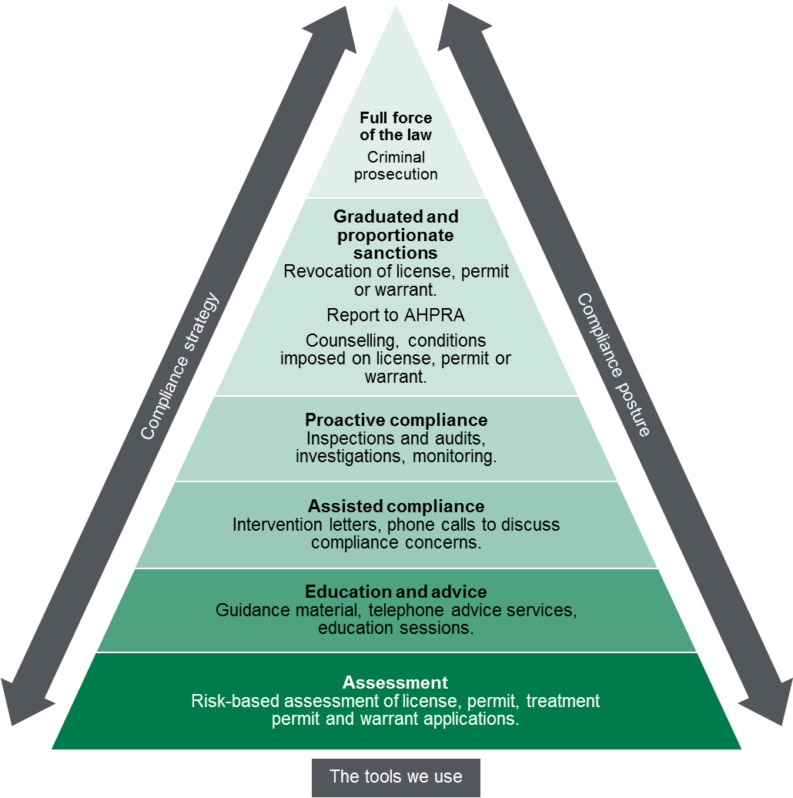

Measuring performance

The contribution story
In 2015, 453 Victorians died from drug overdose, which was more than double the fatal road toll in the same year. Most overdose deaths were a result of a mixture of drugs used together, which includes prescription medicines, illicit drugs and alcohol.
There are a number of factors that contribute to drug overdose deaths, including the availability of illicit drugs and socioeconomic factors. However, prescription medicines play a role in about 80 per cent of overdose deaths in Victoria each year.
The Branch aims to help reduce overdose deaths by regulating how medicines are manufactured and supplied and also how Schedule 8 medicines are prescribed to patients.

Further evidence we plan to gather to strengthen our contribution story
After the introduction of Real Time Prescription Monitoring in 2018-19, the Branch will have the ability to measure the number of ‘prescription shopping’ events. It will then be able to establish an evidence-based baseline measure and track the effect on prescription shopping over time.

Our direct indicators
In this section, we have outlined a small number of indicators that can be used to guide our activity and evaluate our effectiveness. To the extent possible, these indicators demonstrate our contribution to the outcome that we are trying to achieve, rather than simply the activities that we are undertaking.

Outcome
Reduce the likelihood of harm from scheduled medicines and poisons to the Victorian public by supporting safe and appropriate access.
This section sets out measures that we use to indicate success against our desired outcome.
Table 4: Measures used to indicate success against outcomes
Indicator | Current baseline | Target | 2016–17 actual | 2017–18 actual
Percentage of pharmacotherapy treatment permits issued within designated timelines (usually one business day). | 100% | 100% | 98%
Percentage of treatment permits to prescribe Schedule 8 medicine assessed within 4 weeks following receipt of an application | 75% | 75%
Percentage of new licences and permits issued for manufacture, use or supply of medicines and poisons within six weeks following receipt of required information. | 100% | 100%
Percentage of correctly assessed treatment permit applications | 100% | 100%
Potentially unsafe prescribing of Schedule 8 medicines identified and avoided | TBA | TBA
Increased number of prescription shopping events identified (After the establishment of RTPM in 2018-19) | TBA | TBA
Percentage of identified non-compliant activities addressed | 100% | 100%

Stakeholder engagement

Ongoing communications
Drugs and Poisons Regulation frequently interacts with a broad range of stakeholders. The most prominent stakeholders and how we interact with them are listed below (refer to table). The key communication activities can be grouped into the following:
- Education: educate applicants for treatment permits and warrants, licences and permits about the requirements to ensure reduction of the likelihood of harms caused by medicine and poisons misuse. Phone calls, educational presentations and site inspections provide opportunities for applicants to learn about our framework.
- Intelligence sharing: The Branch is in frequent contact with other regulators to identify and act on non-compliance, including Victoria Police and the Australian Health Practitioners Regulation Agency.
- Intervention: the Branch communicates with those who are contributing to the misuse of medicines or poisons. This may be through one-to-one counselling, or letters, where it is felt the behaviour can be changed.

Planned communication activities
A key risk identified is that some regulated entities and individuals do not fully understand their obligation to protect the community from misuse of medicines and poisons. The Branch will develop and implement a communications strategy to remedy this.
The strategy will include updating the website. The strategy will also target registered health practitioners to ensure an understanding of the requirement to seek a treatment permit.
Table 5: List of key stakeholders
Key stakeholders | Type | Why and how
Registered health practitioners | Registered entity | - Regulate the prescribing and supply of Schedule 8 and Schedule 4 medicines.  - Engage by telephone, website and letter.
Licence and permit holders (Health services, industry, research and educational entities) | Registered entity | - Regulate the safety of manufacturing, possession, sale, supply or use of scheduled medicines and poisons.  - Engage by telephone, website and inspection visits.
Community pharmacies and licensed suppliers | Source of intelligence | - Examine records of transaction to obtain information about possibly unlawful or excessive supply.  - Engage by telephone, website and inspection visits.
Australian Medical Association  Royal Australian College of General Practitioners  Pharmacy Guild of Australia  Pharmaceutical Society of Australia | Peak body | - Consultation on policy and program as required.  - Engage by telephone and letter.
Victorian Pharmacy Authority | Co-regulator | - Gain insight into pharmacists’ dispensing practices through regular meetings.  - Engage by regular meetings.
Australian Health Practitioners Regulation Agency (AHPRA)  Veterinary Practitioners Registration Board of Victoria | Co-regulator | - Investigate possible breaches of professional conduct or performance standards, identified by the Branch in the course of its investigations.  - Engage by telephone and letter.
Commonwealth Department of Health Therapeutic Goods Administration | Co-regulator | - Participate on committees that schedule medicines and poisons in the national Poisons Standard.  - Engage by committees, telephone and letter.
Victoria Police | Source of intelligence and Co-regulator | - Investigate possible criminal activity identified by the Branch in the course of its investigations. Support for police investigations.  - Engage by telephone and letter.
Victorian community | Source of intelligence and target for support and protection | - Educate and support the public to adopt better medication practices. Investigate their information about non-compliant drug practices and attempt to reduce the incidence of unsafe prescription shopping activities.  - Engage by telephone, website and letter.

Glossary
Term | Definition
Act | The Drugs, Poisons and Controlled Substances Act 1981 (Act)
Co-regulator | Any national, other State and Territory, or Victorian regulator that has complementary objectives or functions, and/or the same regulated entities. For example, the Australian Health Practitioner Regulation Agency (AHPRA), or Victoria Police.
Drugs of dependence | Substances listed in Schedule 11 of the Act. These have been identified as substances that can cause drug dependence and are at greater risk of trafficking and unlawful diversion. Schedule 11 contains substances that are also listed in Schedules 9, 8, 4 and 3 of the Standard for the Uniform Scheduling of Medicines and Poisons (Poisons Standard).
Licence | An authorisation issued by the department under the Act to industry to manufacture, sell or supply scheduled medicines and poisons.
Permit | An authorisation issued by the department under the Act to health services, industry, research and educational facilities to possess and use scheduled medicines and poisons.
Schedule 8 medicine | Known as ‘Controlled Drugs’. Substances listed in Schedule 8 of the national Poisons Standard are the most strictly regulated prescription medicines. Schedule 8 includes the most potent opioid analgesics, like oxycodone and fentanyl, and opioid replacement therapies such as methadone.
Schedule 4 medicine | Known as ‘Prescription Only Medicine’ or ‘Prescription Animal Remedy’. Substances listed in Schedule 4 of the Poisons Standard include a broad array of medicines that are available with a medical prescription. They also include a number of specified, high-risk medicines for which a specialist health practitioner will need to apply to the department for a warrant.
Treatment permit | An authorisation issued to a health practitioner by the department under the Act, to prescribe Schedule 8 medicines. Its purpose is to confirm that the department has no record of any other health practitioner currently prescribing the proposed Schedule 8 medicine to the patient who is the subject of the application.
Warrant | An authorisation issued by the department under the Act to a health practitioner who has the appropriate specialist qualifications and expertise to prescribe specified high-risk Schedule 4 medicines, such as thalidomide, to a particular patient.

Diagram text
Figure 1: Drugs and Poisons Regulation policy framework
This figure depicts the key regulatory activities the Branch undertakes. These are:
- Assessing permits, licences, treatment permits and warrants;
- Monitoring compliance; and
- Addressing non- compliance.
These activities all support compliance.
Figure 2: Addressing health practitioner non-compliance
This figure describes the enforcement actions the Branch can undertake in response to non-compliance by health practitioners. The X axis relates to the capability of the offender ranging from low to serious. The Y axis relates to the level of risk to the public. The enforcement response is proportionate to the capability of the offender and the level of risk to the public. Depending on these two variables, the response ranges from providing information to health practitioners through to prosecution and revoking a practitioner’s permit.
Figure 3: Regulatory tools
This figure is an enforcement pyramid. The figure seeks to demonstrate that the Branch will use the full range of tools available to it in line with the risks that they are seeking to manage. The enforcement pyramid illustrates a graduated and proportionate enforcement approach. The bottom of the pyramid outlines the lighter touch interventions such as assessment, through to criminal prosecution at the top of the pyramid, where regulated parties deliberately work against intended outcomes and intend to evade compliance obligations.

Hon Jill Hennessy MP (28 July 2017), Media release.
Monheit, B, Pietrzak, D and Hocking S ((2016). Prescription drug abuse – a timely update. Australian Family Physician Vol 45, N. 12, December 2016.
Noble, M (2012). ‘Analgesic; chronic pain’ eTherapeutic Guidelines.
Wachholtz, A, et al 2015. Drug and Alcohol Dependence 2015, 146: 1–6
Australian Family December 2016, Physician Substance Use, ‘Prescription drug abuse – A timely update’ <http://www.racgp.org.au/afp/2016/december/prescription-drug-abuse-a-timely-update/>
Australian Family December 2016, Physician Substance Use, ‘Prescription drug abuse – A timely update’ <http://www.racgp.org.au/afp/2016/december/prescription-drug-abuse-a-timely-update/>

