Drugs and poisons regulator plan on a page
Drugs and poisons regulator plan March 2018 – June 2019

This document summarises the key elements of the Drugs and poisons regulator plan. The plan provides the context the regulator works within and an overview of its regulatory framework and activities. This is supported by the Better regulatory practice framework: January 2018–June 2019, which provides a process for risk-based and accountable regulatory practice, and improved regulatory performance in the health and human services sector. The regulator plan and framework are available on Regulatory practice framework <https://www.dhhs.vic.gov.au/better-regulatory-practice-framework>.

Outcome
Reducing the likelihood of harm to the Victorian public from scheduled medicines and poisons by supporting safe and appropriate access.

Identified risks
- Patients seeking multiple prescriptions while prescribers lack real-time information, leading to a risk of misuse and overdose.
- Prescribers and licence and permit holders unlawfully prescribing or supplying scheduled medicines.
- Lack of adequate information and support to assist compliance with the legislation and policy, resulting in access to excessive amounts of scheduled medicines.
- Lack of knowledge of requirements for labelling and packaging of medicines, leading to a risk of poisoning.

Who we regulate
Industry, health services and research facilities: 1,600 license and permit holders that possess or supply scheduled medicines and poisons.
Medical practitioners: 60,000 treatment permit applications assessed each year.

Who we work with
- Victorian community
- Peak bodies: Pharmacy Guild, Pharmaceutical Society of Australia, Australian Medical Association, Royal Australian College of General Practitioners.
- Intelligence sources: Victoria Police, the Victorian community and registered pharmacists.
- Co-regulators: Commonwealth Therapeutic Goods Administration, Australian Health Practitioners Regulation Agency (AHPRA) and the Veterinary Practitioners Registration Board of Victoria.

Drugs and Poisons and Controlled Substances Act 1981.

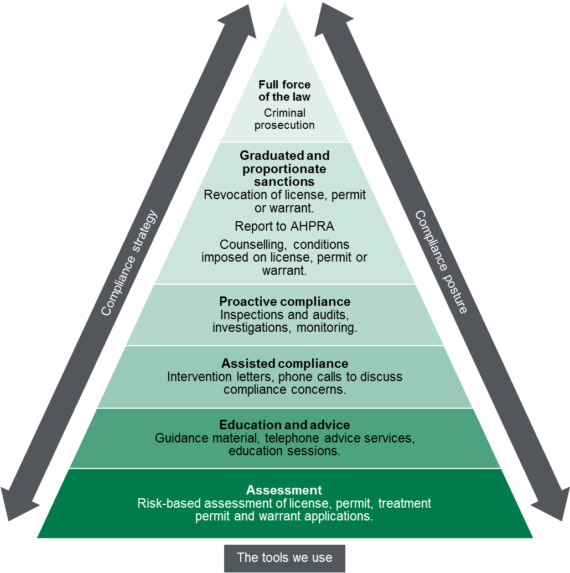

Contribution story
Over the last decade there has been an exponential increase in the abuse of opioid analgesics and other drugs. An estimated five per cent of Australians have misused pharmaceuticals in the last 12 months.
The Drugs and Poisons Regulation Branch aims to reduce the likelihood of this harm by regulating and monitoring key points in the supply chain of medicines and poisons.

Measuring our impacts
Our impact is measured by the following:
- pharmacotherapy treatment permits issued within designated timelines (one business day).
- treatment permits to prescribe Schedule 8 medicine assessed within 4 weeks following receipt of an application
- new licences and permits issued for manufacture, use or supply of medicines and poisons within six weeks following receipt of required information.
- potentially unsafe prescribing of Schedule 8 medicine identified and avoided
- reduced average dose of opioids prescribed
- increased number of prescription shopping events identified (After establishment of RTPM in 2018-19)
- identified non-compliant activities addressed.

Diagram text
Regulatory tools
This figure is an enforcement pyramid. The figure seeks to demonstrate that the Branch will use the full range of tools available to it in line with the risks that they are seeking to manage. The enforcement pyramid illustrates a graduated and proportionate enforcement approach. The bottom of the pyramid outlines the lighter touch interventions such as assessment, through to criminal prosecution at the top of the pyramid, where regulated parties deliberately work against intended outcomes and intend to evade compliance obligations.

To receive this publication in an accessible format phone 1300 364 545, using the National Relay Service 13 36 77 if required, or email Drugs and Poisons Regulation branch < dpcs@dhhs.vic.gov.au>.
Authorised and published by the Victorian Government, 1 Treasury Place, Melbourne.
© State of Victoria, Department of Health and Human Services, March 2018.
ISBN/ISSN 978-1-76069-327-5 (online)
Available at Regulatory practice framework <https://www.dhhs.vic.gov.au/better-regulatory-practice-framework>

