Food safety regulator plan on a page
Food safety regulator plan March 2018 – June 2019

This document summarises the key elements of the Food safety regulator plan. The plan provides the context the regulator works within and an overview of its regulatory framework and activities. This is supported by the Better regulatory practice framework: January 2018–June 2019, which provides a process for risk-based and accountable regulatory practice, and improved regulatory performance in the health and human services sector. The regulator plan and framework are available on Regulatory practice framework <https://www.dhhs.vic.gov.au/better-regulatory-practice-framework>.

Outcomes
The Food Safety Unit’s aim is to facilitate the sale of food that is safe and suitable for human consumption, and reduce the likelihood of misleading conduct in connection with the sale of food.
The unit achieves this through:
- providing timely information and guidance to local government, food safety auditors and authorised analysts
- development and registration of food safety program templates
- approval of food safety auditors
- authorisation of analysts
- responding to food safety incidents and events in a timely manner.

Who we regulate
The Food Act 1984 applies to most food businesses in Victoria including manufacturers, retailers, cafés and restaurants, as well as facilities that serve food such as hospitals and aged care facilities.

Who we work with
The Food Safety Unit works with several co-regulators such as the Department of Economic Development, Jobs, Transport and Resources, PrimeSafe, Dairy Food Safety Victoria, and Victoria’s 79 local governments. In Victoria, local governments are responsible for registration, compliance monitoring and enforcement activities for food businesses under the
Food Act.
Food Act 1984
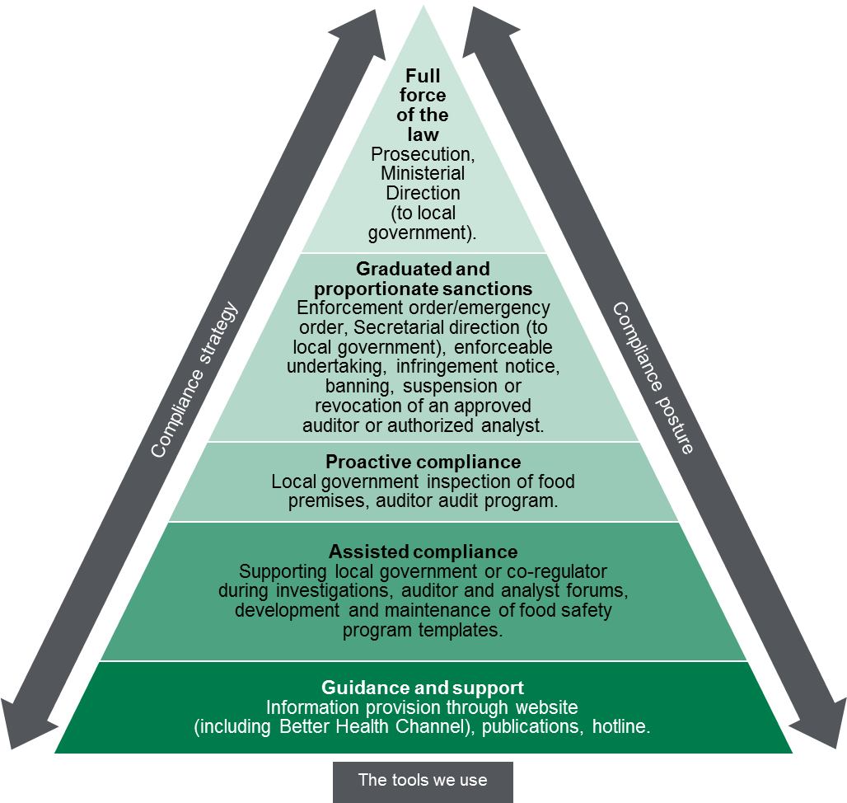

Contribution story
The Food Safety Unit understand that public health risks are present within different food businesses. Therefore timely information and guidance provided to key stakeholders is of paramount importance. The unit provides guidance and tools such as the Food Safety Unit developed and registered food safety program templates to help facilitate communication of new and emerging food safety issues to local government and food businesses.
The Food Safety Unit works to reduce the burden of disease associated with the sale of food, however this contribution is part of a broader system of influencers such as local government and other co-regulators

Measuring our impacts
The Food Safety Unit monitors how it contributes to reducing public health risks associated with the sale of food by reporting on a number of indicators. These include:
- improved knowledge and satisfaction of attendees to Food Safety Unit workshops, presentations and forums
- monitoring the percentage of phone calls made to the Food Safety Unit hotline answered satisfactorily
- percentage of approved auditors audited annually
- percentage of food safety program template registration applications actioned within five business days

Diagram text
Regulatory tools
This figure is an enforcement pyramid. The figure seeks to demonstrate that the unit will use the full range of tools available to it in line with the risks that they are seeking to manage. The enforcement pyramid illustrates a graduated and proportionate enforcement approach. The bottom of the pyramid outlines the lighter touch interventions such as guidance and support to regulated parties, through to prosecution at the top of the pyramid, where regulated parties deliberately work against intended outcomes and intend to evade compliance obligations.

To receive this publication in an accessible format phone 1300 767 469, using the National Relay Service 13 36 77 if required, or email Food Safety Unit foodsafety@dhhs.vic.gov.au, or call 1300 364 352.
Authorised and published by the Victorian Government, 1 Treasury Place, Melbourne.
© State of Victoria, Department of Health and Human Services, March 2018.
ISBN/ISSN 978-1-76069-329-9 (online)
Available at Regulatory practice framework <https://www.dhhs.vic.gov.au/better-regulatory-practice-framework>

