Legionella regulator plan
March 2018 – June 2019

To receive this publication in an accessible format phone 1300 767 469, using the National Relay Service 13 36 77 if required, or email the Environmental Health Regulation and Compliance, Legionella Team <legionella@dhhs.vic.gov.au>
Authorised and published by the Victorian Government, 1 Treasury Place, Melbourne.
© State of Victoria, Department of Health and Human Services, March 2018.
ISBN 978-1-76069-330-5 (online)
Available at Regulatory practice framework <https://www.dhhs.vic.gov.au/better-regulatory-practice-framework>.

Contents
Introduction 4
Purpose of document 4
Document content 4
Principles 5
Regulator’s context 6
Regulatory framework 6
Regulatory activities 7
Complementary activities 7
Defining outcomes 8
Risk overview 9
Identified risks 9
Assessing and treating risks 9
Identified risks 10
Regulatory tools 14
Measuring performance 15
Our contribution story 15
Direct indicators 15
Stakeholder engagement 16
Ongoing communications 16
Planned communication activities 16
Stakeholders 16
Glossary 17

Introduction

Purpose of document
The Department of Health and Human Services (the department) administers numerous Acts and regulations aimed at promoting health and wellbeing, and protecting the population of Victoria including vulnerable clients. It has 11 internal business units and three statutory bodies that are recognised by the Department of Treasury and Finance as regulators of business and not for profit organisations.
This regulator plan was developed in line with the conceptual framework outlined in the department’s Better regulatory practice framework <https://www.dhhs.vic.gov.au/better-regulatory-practice-framework>.
This document represents the first consolidated regulator plan that the Legionella Team has developed and published. If you have any feedback on the plan, then please email Environmental Health Regulation and Compliance, Legionella Team <legionella@dhhs.vic.gov.au>.
This plan is effective until 30 June 2019 and will then be updated:
- every two years – in line with the requirement for Ministers to develop and re-issue Ministerial Statement of Expectations every two years; or
- when key legislative changes are made that will affect regulatory functions and the currency of the regulator plans.

Document content
This regulator plan relates to the Environmental Health Regulation and Compliance – Legionella Team. The structure of the regulator plan document includes:
- outcomes
- risk assessment and risk management strategy
- demonstrating impacts
- stakeholder engagement
    - overview of approach
    - key stakeholders (co-regulators)
    - key activities.

Principles
In order to achieve the department’s outcomes, the regulators’ approach to their regulatory roles is informed by regulatory practice principles. Consistent with better regulatory practice approaches interstate and internationally, the department’s regulators apply the following principles:
Table 1: Regulatory practice principles
Principle | Commitment
Collaborative | Where the various departmental regulatory regimes, and those of other agencies, intersect, the regulators will work together to maximise effectiveness and minimise regulatory burden. Regulators will also cooperate and engage with internal and external stakeholders, including interstate counterparts and those representing various client groups within the Victorian community.
Consistent | The regulators will work to provide a consistent experience for key stakeholders and the community. Regulatory responses will be predictable (meaning that, to the extent possible, regulators provide similar responses in similar circumstances - consistent with policy) and where possible standardised, following clear processes and delivering consistent results. This will ensure that individuals/organisations are treated fairly, and that the regulators are objective in their decision-making.
Efficient | The regulators will allocate resources in a way that aims to most efficiently achieve outcomes, considering the direct and indirect impacts across society. This includes minimising unnecessary administrative burden and any adverse impact of regulatory actions on businesses to a level that is justifiable to achieve the community’s outcomes.
Intelligence-led | The regulators will analyse incoming intelligence and data in order to allow them to be responsive and accurate when assessing risk and undertaking compliance activities.
Outcomes-focussed | Processes and decision-making will be driven by outcomes, and the regulators will be effective in achieving their regulatory objectives. Progress against outcomes will be measured to ensure continuous improvement.
Proportionate | The work undertaken by regulators should be proportionate to the risk being addressed. The principle of proportionality should guide regulators decisions in relation to the level of resources assigned to manage a particular risk, the regulatory tools used and enforcement activities.
Risk-based | The regulators will be proactive and responsive in identifying, assessing and responding to risk, prioritising and targeting resources toward specific groups or behaviours that pose the greatest risk to the department’s outcomes.
Transparent | The regulators will be open in their decision-making and processes, documenting decisions appropriately, including the justification for decisions. The regulators will aim to assist regulated parties to understand the decision-making processes, areas of focus and performance. Regulators will follow standard reporting requirements, enabling the department to monitor and oversee the performance of its regulators.

Regulator’s context
This section outlines the context that the regulator operates within, including its regulatory framework and a brief overview of its activities.

Regulatory framework
The Legionella Team is responsible for administering legislation in relation to both cooling towers and water delivery systems (which includes any shower plumbing, bath, pipes, water heaters, bathing facilities, water storage tanks or vehicle washing equipment used to store, deliver, transmit, treat or mix water) in certain premises. The team operates under:
- Part 7, Division 1 – Cooling tower systems of the Public Health and Wellbeing Act 2008 and the Public Health and Wellbeing Regulations 2009
- Part 7, Division 2 – Water delivery systems of the Public Health and Wellbeing Regulations 2009.

Regulated entities – cooling towers
In Victoria all land owners on which a cooling tower is in operation are required to register the cooling tower with the department, with 1, 2 or 3 year registrations available. There are approximately 3,215 cooling tower systems on 1,907 sites throughout Victoria. The Legionella Team conducts over 1,000 inspections of cooling tower systems each year. These ‘Targeted Inspections’ focus on sites that are linked to cases of legionellosis, have failed to register or renew the registration of the cooling tower system, where there has been a failure to audit the risk management plan or where the audit of the risk management plan has identified a problem.
Cooling tower regulated entities include owners who hold land upon which a cooling tower operates, as well as those involved in operating cooling towers, such as property facility managers or engineers.
This group is diverse and the facilities they manage can vary in size, for example ranging from domestic homeowners to those responsible for large industrial sites.

Regulated entities – water delivery systems
Regulated entities under this scheme are the ‘responsible person,’ who is the person or an organisation that own, manage or control a water delivery system (i.e. shower, plumbing, bath, pipes, water heaters, water storage tanks or vehicle washing equipment) on any of the following premises:
- aged care services (residential and community care facilities)
- health services and health service establishments (day procedure centres, multipurpose service, public and private hospitals, supported residential service)
- correctional services (prisons, community and regional centres, and services)
- registered funded agencies
  - commercial vehicle washes.
The size of the premises and organisations varies. These services are spread across metropolitan, regional and rural Victoria.

Groups we rely on to undertake our regulatory function
Risk Management Plan auditors are certified by the department to undertake mandatory third party audits of cooling tower risk management plans. This is to ensure that plans appropriately address the five critical risks in cooling tower systems. There are 69 active auditors and there is an electronic notification system for all audits completed. Audit results are loaded into a database and the Legionella Team are notified of non-compliant audits, triggering a field inspection.
External co-regulators that share responsibilities in this area are the Victorian Building Authority and Worksafe Victoria. Important co-regulators within the Department of Health and Human Services are the Victorian Health and Human Services Building Authority, Commissioning Performance & Regulation and Communicable Disease Prevention and Control.

Regulatory activities
The Legionella Team undertakes the following key activities:
- Supporting compliance: The team provides accurate, evidence-based and authoritative advice to stakeholders on a range of topics including legislative, registration and auditing requirements, risk management plans, and other relevant concerns (e.g. use of recycled water in cooling towers). Stakeholders can access information from the department’s website, telephone conversation and from emails and letters sent out each year to all cooling tower system operators.
- Ensuring high-quality audits are undertaken by auditors: The team maintains a register of approved auditors. The Legionella Team has designed a training course in conjunction with Melbourne Polytechnic that must be completed by auditors seeking certification. Communication with auditors includes email communication, the department’s website, and telephone discussion.
- Monitoring compliance: The team inspects over 1,000 cooling tower sites each year, with targeted inspections conducted at sites where there is an indication of non-compliance; the cooling tower has recently come into operation; or there has been a case of legionellosis associated with the site. The primary objective of the inspection is to ensure compliance with the legislation. The inspection process also facilitates stakeholder feedback relating to the legislation and can highlight any new technology or changes to the industry.
- Addressing non-compliance: The team undertakes enforcement actions through a request in writing, improvement and prohibition notices, formal warning, infringement notices and prosecutions.

A current project that the team is undertaking to improve their regulatory activities is:
- A project to provide water delivery system stakeholders with information on how they can comply with the regulations, further technical advice and the development of an audit program that the Legionella Team will undertake.

Complementary activities
The Legionella Team regularly undertakes non-regulatory, complementary activities such as providing expertise in relation to investigations of cases, clusters and outbreaks of legionellosis, and follow up preventative guidance.

Defining outcomes
This section includes a summary of the outcomes to which the team contributes.
Table 2: Defining outcomes
Regulatory scheme | Outcomes | Objectives
Regulation of cooling tower systems | To minimise the impact of legionellosis on the Victorian community, by reducing:  - illness in the community  - service disruption that impacts the community and businesses. | - Increase compliance with legislative requirements by maintaining a program of targeted and risk-based inspections.  - Better equip regulated entities to comply with requirements through implementing a communication strategy focused on managing the risks of Legionella.
Regulation of water delivery systems | To minimise the impact of legionellosis on the Victorian community, particularly vulnerable populations in health and aged care facilities, by reducing:  - illness within vulnerable populations in health and aged care facilities  - service disruption at health and aged care facilities. | - Increase compliance with requirements by undertaking risk-based inspections.  - Better equip regulated entities to comply with requirements through implementing a communication strategy focused on managing the risks of Legionella.

Risk overview
This section includes a risk assessment and risk management strategy, which identifies and prioritises a small number of key risks to the regulators outcomes.

Identified risks
This section outlines risks relating to specific groups of entities or behaviours, which stem directly from the outcomes and objectives identified. The key risks we have identified are:
- Facility managers have a lack of knowledge and skills regarding cooling tower management (cause), resulting in Legionella growth within the poorly maintained cooling tower system (event), which leads to case(s) of legionellosis (harm).
- Lack of awareness of the importance of designing and installing cooling tower systems to reduce the risk of Legionella growth (cause), resulting in installation of cooling towers that provide ideal conditions for Legionella growth (event) and subsequent case(s) of legionellosis (harm).
- Facility managers have a lack of awareness or competing priorities relating to water delivery systems (cause), resulting in Legionella growth within the poorly maintained water delivery systems (event), which leads to case(s) of legionellosis (harm).
- Lack of awareness of the importance of designing and installing water delivery systems to reduce the risk of Legionella growth (cause), resulting in installation of water delivery systems that provide ideal conditions for Legionella growth (event) and subsequent case(s) of legionellosis (harm).

Assessing and treating risks
This section demonstrates how the team assesses and responds to risk; the risk is assessed against the risk matrix (as shown below), and given a risk rating.
Table 3: Overall risk rating
Consequence | Negligible (5%) | Minor  (10%) | Moderate (20%) | Major  (40%) | Extreme (80%)
Extreme | Medium | High | High | Critical | Critical
Major | Medium | Medium | High | High | Critical
Moderate | Low | Medium | Medium | High | High
Minor | Low | Low | Medium | Medium | High
Negligible | Low | Low | Low | Medium | Medium

Identified risks

Risk 1
Likelihood | Consequence | Rating
Minor | Major | Medium
Facility managers have a lack of knowledge and skills regarding cooling tower management (cause), resulting in Legionella growth within the poorly maintained cooling tower system (event), which leads to case(s) of legionellosis (harm).

Extent of the risk
There are approximately 3,215 cooling tower systems on 1,907 sites throughout Victoria. The Legionella Team considers that the lack of an annual audit could indicate poor system maintenance. The average percentage of cooling tower systems that were not audited in 2015 and 2016 was 4.4%. The rating of this risk was assessed as medium because of the minor likelihood of non- compliance (4.4% not undertaking an annual audit) and the possible major consequence of a case of legionellosis.

Ongoing controls
Department-certified auditors assess the risk management plans of cooling towers systems annually. The Legionella Team conducts over 1,000 inspections of cooling tower systems each year. These inspections are targeted at sites that:
- fail to audit the risk management plan
- where the audit has identified a problem
  - failure to register or renew the registration of the cooling tower system
The Legionella Team also conducts inspections in response to cases of legionellosis.
The Legionella Team has developed a compliance plan that identifies where the team will focus their compliance activities for the year.

Planned changes in controls for 2017-18
A communication strategy focused on improving understanding of facility managers on managing the risks of Legionella. This will include writing to cooling tower operators who did not undertake an annual audit in 2016-17 in order to inform them of their obligations under the legislation relating to annual audits.

Risk 2
Likelihood | Consequence | Rating
Moderate | Minor | Medium
Lack of awareness of the importance of designing and installing cooling tower systems to reduce the risk of Legionella growth (cause), resulting in installation of cooling towers that provide ideal conditions for Legionella growth (event) and subsequent case(s) of legionellosis (harm).

Extent of the risk
In 2016 there were 89 new cooling tower systems installed in Victoria. The rating of this risk was assessed as medium because, although, the likelihood is moderate the consequence is minor because water treatment technics can be employed to minimise the risk of Legionella growth.

Ongoing controls
The Victorian Building Authority is responsible for ensuring cooling tower systems are designed and installed in accordance with relevant codes. The Victorian Building Authority consults with the team about potential changes to the codes.

Planned changes in controls for 2017-18
The Legionella Team will consult with stakeholders about potential changes that could be made to legislation that would improve the design and installation requirements for cooling tower systems. This will be part of the sunset review of the current Public Health and Wellbeing Regulations 2009.

Risk 3
Likelihood | Consequence | Rating
Minor | Major | Medium
Facility managers have a lack of awareness or competing priorities relating to water delivery systems (cause), resulting in Legionella growth within the poorly maintained water delivery systems (event), which leads to case(s) of legionellosis (harm).

Extent of the risk
In Victoria there are: 1326 aged care facilities; 57 metropolitan hospitals; 69 rural hospitals; 84 private hospitals.
This risk is rated as medium. Health and aged care facilities should have plans in place to ensure that water delivery systems are maintained and that testing and disinfection procedures are followed. Very low numbers of cases of legionellosis are associated with these types of facilities. However, there are severe consequences for older and immune-compromised people from contracting legionellosis.

Ongoing controls
The Legionella Team investigates all cases of legionellosis that are associated with health and aged care facilities.
The team investigates and provides preventative guidance to facilities that notify the department of an environmental Legionella detection in a water sample taken from a water delivery system.

Planned changes in controls for 2017-18
A communication strategy focused on improving the understanding of facility managers regarding managing of the risks of Legionella. This will include sending a letter to all hospitals that provides information on how to ensure compliance with the regulatory requirements and enHealth guidelines.

Risk 1
Likelihood | Consequence | Rating
Moderate | Minor | Medium
Lack of awareness of the importance of designing and installing water delivery systems to reduce the risk of Legionella growth (cause), resulting in installation of water delivery systems that provide ideal conditions for Legionella growth (event) and subsequent case(s) of legionellosis (harm).

Extent of the risk
The rating of this risk was assessed as medium because, although, the likelihood is moderate the consequence is minor because water treatment technics can be employed to minimise the risk of Legionella growth.
Health and aged care facilities should have plans in place to ensure that water delivery systems are maintained and that testing and disinfection procedures are followed. Very low numbers of cases of legionellosis are associated with these types of facilities. However, there may be severe consequences for older and immunocompromised people from contracting the disease.

Ongoing controls
The Victorian Building Authority is responsible for ensuring that water delivery systems are designed and installed in accordance with relevant codes. The Victorian Building Authority consults with the team about potential changes to the codes.

Planned changes in controls for 2017-18
A communication strategy focused on improving the understanding of facility managers regarding managing of the risks of Legionella. This will include sending a letter to all hospitals that provides information on how to ensure compliance with the regulatory requirements and enHealth guidelines.
The Legionella Team will consult with stakeholders, including co-regulators about potential changes that could be made to legislation to improve the design and installation water delivery systems (part of the sunset review of the current Public Health and Wellbeing Regulations 2009).

Regulatory tools
This section includes an overview of departmental regulation, illustrating the full suite of tools available to the team, including prosecutions when necessary.
Figure 1: Regulatory tools
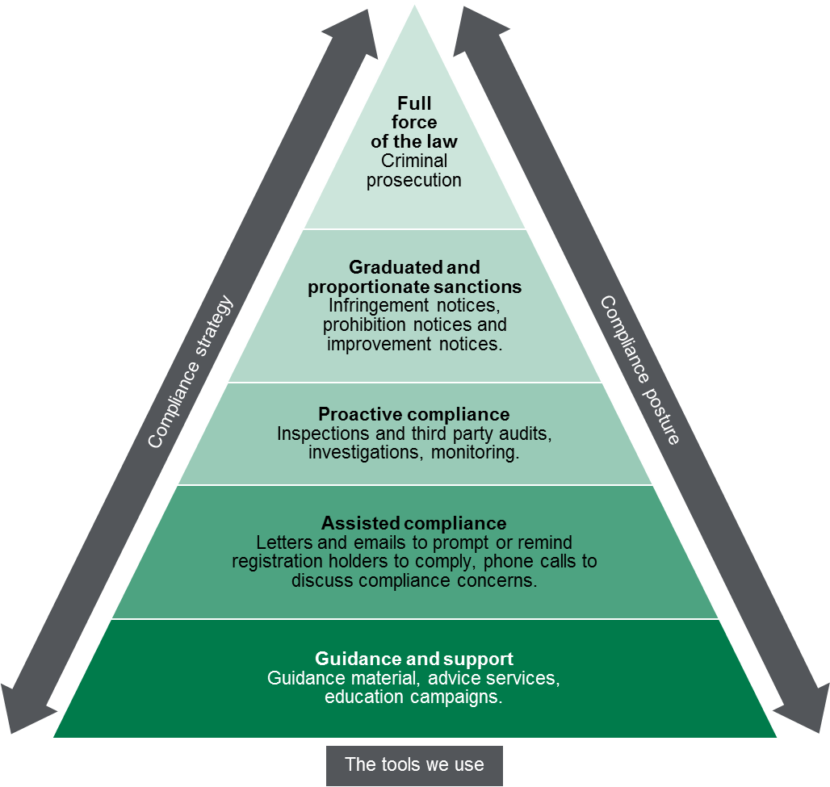

Measuring performance
This section sets out our understanding of how the activities that we undertake, as targeted by the identification and assessment of risks, contribute to our outcomes.

Our contribution story
This section sets out the long-term outcome indicators that we contribute to, as part of a broader system of influencers. We recognise that we contribute to these outcomes, as part of a system of influences both within, and external to the department.
The Legionella Team enforces legislation that has the objective of minimising the impact of legionellosis on the community. The team undertakes precautionary compliance activities in the form of field inspections of cooling tower systems and water delivery systems.
The Legionella Team conducts over 1,000 inspections of cooling tower systems each year. These ‘Targeted Inspections’ focus on sites that are linked to cases of legionellosis, have failed to register or renew the registration of the cooling tower system, where there has been a failure to audit the risk management plan or where the audit of the risk management plan has identified a problem. The team employs risk-based approaches to investigating and responding to environmental Legionella detections in water delivery systems in health and aged care facilities to ensure a safe environment for vulnerable patients and residents.
Therefore, the Legionella Team are continually working to ensure effective preventative measures are in place, including high-quality audits and development of a high quality academic course that must be completed by auditors seeking certification.
The team also investigates cases of legionellosis with the goal of preventing any further cases associated with a particular source. Investigations are conducted in response to the reporting of legionellosis to the Department of Health and Human Services (a Group A notifiable condition).

Direct indicators
This section outlines a small number of indicators used to guide our activities, and to the extent possible, demonstrate our contributions to the outcomes the team is trying to achieve.
This table below sets out the measures that we use to indicate success against our outcomes.
Table 4: Measures used to indicate success against outcomes
Indicator | Current baseline | Target | 2015-16 actual | 2016-17 actual | 2017-18 actual
Rate of legionellosis cases per 100,000 population in Victoria
Proportion of registered cooling tower systems undergoing an audit annually |  | 90%
Number of inspections of cooling towers conducted annually |  | 1,000

Stakeholder engagement

Ongoing communications
Our team undertakes day-to-day operational communication regarding regulatory activities. This includes:
- Accessing intelligence on Legionella outbreaks: Receiving information from the department’s Communicable Disease Protection and Control regarding exposure sites associated with legionellosis case and outbreaks, to inform our environmental investigation and response activities.
- Accessing intelligence on regulated entity behaviour: Working with auditors in order to receive intelligence on compliance behaviour of regulated entities to inform our inspection activity.
- Undertaking inspections: Provide advice and assist cooling tower operators to comply with requirements.
- Writing to Hospitals: Provide advice to assist hospitals comply with legislative requirements.

Planned communication activities
In 2017-18, the key stakeholder activities:
- Commence consultation and engagement as part of the sunset review into the current Legionella control regulations in the Public Health and Wellbeing Regulations 2009.
- Work with industry groups representing infection control staff, hospital engineers and health care facility managers to improve awareness and skills in the management of water delivery systems to reduce the risks associated with Legionella. This will complement the letter we are sending to all health care facilities reminding them of their obligations under the regulations.

Stakeholders
Table 5: List of key stakeholders
Key stakeholders | Type
Water treatment service providers | Regulated entities
Auditors | Co-regulator (accredited by the Department)
Building managers | Regulated entities
Medical practitioners | Source of intelligence
Communicable Disease Prevention and Control | Source of intelligence
Communicable Disease Epidemiology and Surveillance | Source of intelligence
Victorian Building Authority | Co-regulator
Microbiological Diagnostic Unit Public Health Laboratory | Source of intelligence
Victorian Infectious Disease Reference Laboratory | Source of intelligence
Hospitals | Regulated entities

Glossary
Term | Definition
Compliance posture | The intent and capability of the regulated entity; taking into account its compliance history and willingness to work with the regulator to align its behaviour to contribute to the regulator’s outcomes.
Co-regulator | Any national, other State and Territory, or Victorian regulator that has complementary objectives or functions, and/or the same regulated entities. For example, Australian Health Practitioner Regulation Agency, WorkSafe and the Federal or Victorian Police.
Legionellosis | An acute infection caused by the Legionella bacteria with two distinct clinical manifestations: Legionnaires’ disease and Pontiac fever. Symptoms may include fever, dry cough, malaise, myalgia, vomiting and diarrhoea. However, Legionnaires’ disease tends to be more severe with pneumonia; Pontiac fever tends to be a self-limiting febrile illness and does not progress to pneumonia or death.
Outcomes | The change in the community that the regulator is seeking to achieve, which should be specifically related to harms (including physical harms, emotional harms, financial harms, psychological harms etc.).
Regulated entities | Refers to organisations, individuals, service providers and other agencies that the department’s regulators are responsible for regulating.
Regulator | A State Government entity (either independent or within a department) that derives, from primary or subordinate legislation, one or more of the following powers in relation to businesses and occupations: licensing, accreditation, inspections, standards monitoring, regulatory advice to third parties and enforcement.

Diagram text
Figure 1: Regulatory tools
This figure is an enforcement pyramid. The figure seeks to demonstrate that the unit will use the full range of tools available to it in line with the risks that they are seeking to manage. The enforcement pyramid illustrates a graduated and proportionate enforcement approach. The bottom of the pyramid outlines the lighter touch interventions such as guidance and support to regulated parties, through to criminal prosecution at the top of the pyramid, where regulated parties deliberately work against intended outcomes and intend to evade compliance obligations.

Five Critical Risks: Stagnant water, Nutrient growth, Poor water quality, Deficiencies in a cooling tower system and Location and access.
Rate of Legionella pneumophila infection per 100,000 for the 12-month period calculated using ABS 2010 estimated resident population (preliminary total 5,545,932)
Number of cooling tower systems audited once per calendar year divided by the total number of cooling tower systems in Victoria (not including cooling tower systems in domestic and dairy farms as specified in dairy industry’s risk management plan)
Number of cooling tower inspections conducted annually (BP3 measure)
Heymann, D. 2008, Control of Communicable Disease Manual, 19th Edition. Maryland USA.

