Pest control regulator plan
March 2018 – June 2019

To receive this publication in an accessible format phone1300 767 469 , using the National Relay Service 13 36 77 if required, or email the Pest Control Team <pestcontrol@dhhs.vic.gov.au>
Authorised and published by the Victorian Government, 1 Treasury Place, Melbourne.
© State of Victoria, Department of Health and Human Services, March 2018.
ISBN 978-1-76069-332-9 (online)
Available at Regulatory practice framework <https://www.dhhs.vic.gov.au/better-regulatory-practice-framework>

Contents
Introduction 4
Purpose of document 4
Document content 4
Principles 5
Regulator’s context 6
Regulatory framework 6
Regulatory activities 7
Complimentary activities 7
Defining outcomes 8
Risk overview 9
Assessing and treating risks 9
Identified risks 10
Regulatory tools 13
Measuring performance 14
The contribution story 14
Direct indicators 15
Stakeholder engagement 16
Ongoing communications 16
Planned communication activities 16
Stakeholders 16
Glossary 17

Introduction

Purpose of document
The Department of Health and Human Services (the department) administers numerous Acts and regulations aimed at promoting the health and wellbeing of the Victorian community, and protecting the population of Victoria, including vulnerable clients. It has 11 internal business units and three statutory bodies that are recognised by the Department of Treasury and Finance as regulators of business and not for profit organisations.
This regulator plan was developed in line with the conceptual framework outlined in the department’s Better regulatory practice framework <https://www.dhhs.vic.gov.au/better-regulatory-practice-framework>.
This is the first consolidated regulator plan that the unit has developed and published. If you have any feedback on the plan, please email the Pest Control Team <pestcontrol@dhhs.vic.gov.au>.
This plan is effective until 30 June 2019 and will then be updated:
- every two years – in line with the requirement for Ministers to develop and re-issue Ministerial Statement of Expectations every two years; or
- when key legislative changes are made that will affect regulatory functions and the currency of the regulator plans.

Document content
This regulator plan relates to the Environmental Health Regulation and Compliance, Pest Control Team. The structure of the regulator plan document includes:
- outcomes
- risk assessment and risk management strategy
- demonstrating impacts
- stakeholder engagement
    - overview of approach
    - key stakeholders including co-regulators
    - key activities.

Principles
In order to achieve the department’s outcomes, the regulators’ approach to their regulatory roles is informed by regulatory practice principles. Consistent with better regulatory practice approaches interstate and internationally, the department’s regulators apply the following principles:
Table 1: Regulatory practice principles
Principle | Commitment
Collaborative | Where the various departmental regulatory regimes, and those of other agencies, intersect, the regulators will work together to maximise effectiveness and minimise regulatory burden. Regulators will also cooperate and engage with internal and external stakeholders, including interstate counterparts and those representing various client groups within the Victorian community.
Consistent | The regulators will work to provide a consistent experience for key stakeholders and the community. Regulatory responses will be predictable (meaning that, to the extent possible, regulators provide similar responses in similar circumstances - consistent with policy) and where possible standardised, following clear processes and delivering consistent results. This will ensure that individuals/organisations are treated fairly, and that the regulators are objective in their decision-making.
Efficient | The regulators will allocate resources in a way that aims to most efficiently achieve outcomes, considering the direct and indirect impacts across society. This includes minimising unnecessary administrative burden and any adverse impact of regulatory actions on businesses to a level that is justifiable to achieve the community’s outcomes.
Intelligence-led | The regulators will analyse incoming intelligence and data in order to allow them to be responsive and accurate when assessing risk and undertaking compliance activities.
Outcomes-focussed | Processes and decision-making will be driven by outcomes, and the regulators will be effective in achieving their regulatory objectives. Progress against outcomes will be measured to ensure continuous improvement.
Proportionate | The work undertaken by regulators should be proportionate to the risk being addressed. The principle of proportionality should guide regulators decisions in relation to the level of resources assigned to manage a particular risk, the regulatory tools used and enforcement activities.
Risk-based | The regulators will be proactive and responsive in identifying, assessing and responding to risk, prioritising and targeting resources toward specific groups or behaviours that pose the greatest risk to the department’s outcomes.
Transparent | The regulators will be open in their decision-making and processes, documenting decisions appropriately, including the justification for decisions. The regulators will aim to assist regulated parties to understand the decision-making processes, areas of focus and performance. Regulators will follow standard reporting requirements, enabling the department to monitor and oversee the performance of its regulators.

Regulator’s context
This section outlines the context that the regulator operates within, including its regulatory framework and a brief overview of its activities.

Regulatory framework
The Pest Control Team is responsible for administering legislation in relation to the use of pesticides, which most commonly relates to pest control operators. The Pest Control Team administer:
- Part 7, Division 2 of the Public Health and Wellbeing Act 2008
  - Part 8 of the Public Health and Wellbeing Regulations 2009
The Pest Control Team administer this legislation with the intention of protecting the Victorian community from potential health risks associated with the use of pesticides in commercial (including food manufacturing and preparation premises) and residential situations. Pest control operators use substantial quantities of pesticides from a variety of chemical classes throughout metropolitan, rural and regional areas.
In Victoria, individuals who apply pesticides commercially (for fee reward), are required to hold a licence under the relevant legislation and comply with a number of conditions. There are approximately 1334 pest control operators currently holding a valid licence to use pesticides in Victoria.

Groups we rely on to undertake our regulatory function
The Pest Control Team works with a number of other authorities whose functions also include the regulation of pesticides and the control of pests. This includes:
- the Department of Economic Development Jobs Transport and Resources, responsible for agricultural and horticultural pesticide use, with whom there is a memorandum of understanding to avoid dual licensing and minimise regulatory overlap
- the Australian Pesticides and Veterinary Medicines Authority who have responsibility for registering agvet products and their regulation up to and including the point of retail sale
- the Environmental Protection Authority where pesticides impact the environment
- the Department of Land Water and Planning who have responsibility for issuing licences to control wildlife
  - Worksafe where pesticides present a workplace risk.
The Pest Control Team collaborates with these agencies in the form of information sharing, cooperative education programs (which has included joint fact sheets and roadshows), research projects, and joint investigations.
Local councils investigate incidents of nuisance under the Public Health and Wellbeing Act which may include inappropriate pesticide application or pest infestation. Complaints received by the Pest Control Team which relate to a nuisance are referred to the appropriate local council for follow up. Conversely complaints received by councils which relate to a potential breach of the pest control licensing provisions are referred to the Pest Control Team for investigation.
The use of pesticides is regulated independently in each state and territory of Australia. Victoria regularly engages with state and territory authorities to address issues of national importance, administer mutual recognition of licences and seek opportunities for regulatory harmonisation.

Regulatory activities
The Pest Control Team undertakes the following key activities:
- Licensing of (commercial/domestic) pest control operators: Licensing of the pest control industry aims to protect pest control operators, consumers, members of the public and the environment from the harmful effects of pesticides. This is achieved through mandatory minimum training requirements and compulsory minimum regulatory standards regarding safe handling and application of pesticides.
- Education and awareness activities: The Pest Control Team seek to achieve compliance by, supporting regulated entities through the provision of information, and educating the public. The Pest Control Team have developed a suite of community awareness brochures which address the risks associated with pesticide use and highlight the importance of using a licensed operator. The team’s 1300 information line and dedicated email address are also available for more specific enquires from the public.
- Supporting compliance: The Pest Control Team seek to support the industry in achieving compliance through the provision of technical notes interpreting legislative requirements, industry specific newsletters, licensing guidelines, adaptable templates, developing risk assessment plans, state-wide roadshows, a 1300 information line and maintenance of a website. The Pest Control Team also regularly present the legislation and licensing units to students undertaking training at Melbourne Polytechnic TAFE and provide a representative to attend peak industry body meetings.
- Monitoring compliance: The Pest Control Team conducts routine inspections of licensed pest control operators to ensure that minimum standards set out for industry are met and compliance with legislative requirements is achieved. Inspections also serve as an educational tool through which the team can assist regulated entities to comply and identify emerging industry issues. Targeted inspections occur where there is an indication of non-compliance as a result of a complaint or in the case of a previous unsatisfactory outcome. The Team also monitors various advertising channels and follows up suspected unlicensed entities.
  - Addressing non-compliance: The Pest Control Team investigate breaches of the pest control provisions of the legislation including reports of unlicensed pest control operators and inappropriate application of pesticides. Where other more informal regulatory activities have failed to achieve compliance, the team can issue warnings, improvement, prohibition, and infringement notices, and has undertaken a number of successful prosecutions. Enforcement action is undertaken in a graduated and proportionate manner, commensurate to the (actual or potential) risk.
The current projects that the Pest Control Team will undertake to improve their regulatory activities include:
- An education campaign focussed on increasing community awareness of the risks associated with the use of pesticides, the purpose of the pest control licensing and steps that people can take to protect their health from use of pesticides, will be delivered utilising the internet and social media.

Complimentary activities
The Pest Control Team undertakes complimentary activities such as providing expertise in relation to pesticide use impact studies.

Defining outcomes
This section includes a summary of the outcomes to which the team contributes.
Table 2: Defining outcomes
Regulatory scheme | Outcomes | Objectives
Regulation of (commercial/domestic) pesticide use | To minimise the adverse health impacts associated with the use of pesticides on the Victorian community, pest control operators and the environment | The outcome is achieved through:  - Educating pest control operators and the public of the health risks and legislative requirements regarding the use of pesticides.  - Monitoring compliance of licensed pest control operators with legislative requirements by undertaking routine and targeted inspections.  - Addressing non-compliance through graduated and proportionate enforcement measures (such as fines).

Risk overview
This section includes a risk assessment and risk management strategy which identifies and prioritises a small number of key risks to the regulator’s outcome.
Identified risks
This section outlines risks relating to specific groups of entities or behaviours, which stem directly from the outcomes and objectives identified. The key risks that we have identified are:
- A lack of training on the part of the pest control operator (cause), results in the inappropriate application of pesticides (event), which leads to a contamination of the environment or exposure of the public (harm).
- Complacency on the part of the pest control operator (cause), results in the inappropriate application of pesticides (event), which leads to a contamination of the environment or exposure of the public (harm).
- Lack of consumer knowledge (cause), results in residents being exposed to a pesticide (event), and leads to short term health implications such as skin irritation, headaches or vomiting (harm).

Assessing and treating risks
This section demonstrates how the Pest Control Team assesses and then responds to risk; the risk is assessed against the risk matrix (as shown below), and given a risk rating.
The risk rating process involves assessing the extent of the risk as well as the associated levels of harm, as shown below.
Table 3: Overall risk rating
Consequence | Likelihood:  Negligible (5%) | Likelihood: Minor  (10%) | Likelihood: Moderate (20%) | Likelihood: Major  (40%) | Likelihood: Extreme (80%)
Extreme | Medium | High | High | Critical | Critical
Major | Medium | Medium | High | High | Critical
Moderate | Low | Medium | Medium | High | High
Minor | Low | Low | Medium | Medium | High
Negligible | Low | Low | Low | Medium | Medium

Identified risks

Risk 1
Likelihood | Consequence | Rating
Minor | Moderate | Medium
A lack of training on the part of the pest control operator, results in the inappropriate application of pesticides, which leads to a contamination of the environment or exposure of the public.

Extent of the risk
Pest control operators use substantial quantities of pesticides from a variety of chemical classes, many of which are highly toxic, to control pests in residential and commercial settings. Pesticides can cause serious health effects when used incorrectly.
The Pest Control Team are aware that unlicensed pest control operators may not have undergone mandatory training in the safe handling and application of pesticides. In addition if they are not complying with the licensing requirements they may also be contravening the minimum conditions set out in the legislation. However as there is no direct correlation between unlicensed pest control operators and adverse health effects the rating of this risk was assessed as medium.

Ongoing controls
The following activities are undertaken by the Pest Control Team on an ongoing basis to manage risk:
- Licensing of pest control operators – ensuring training of pest control operators in the minimum standards regarding safe handling and application of pesticides
- Addressing non-compliance – investigating breaches of the pest control provisions of the legislation including reports of unlicensed pest control operators and inappropriate application of pesticides
- Education and awareness activities - supporting regulated entities through the provision of information, and educating the public

Planned changes in controls for 2017–18
The Pest Control Team will continue to monitor various advertising channels to identify suspected unlicensed entities offering pest control services.
An education campaign focussed on increasing community awareness of the risks associated with the use of pesticides, the purpose of the pest control licensing and steps that people can take to protect their health from use of pesticides, will be delivered utilising the internet and social media.

Risk 2
Likelihood | Consequence | Rating
Minor | Moderate | Medium
Complacency on the part of the pest control operator, results in the inappropriate application of pesticides, which leads to a contamination of the environment or exposure of the public.

Extent of the risk
There are approximately 1330 pest control operators currently licensed to operate in Victoria. Pest control operators use substantial quantities of pesticides from a variety of chemical classes, many of which are highly toxic, to control pests in residential and commercial settings. Pesticides can cause serious health effects when used incorrectly.
The Pest Control Team consider a lack of awareness of the risks associated with pesticide use to be responsible for complacency by pest control operators, which may result in a higher risk of adverse health effects. In addition pest control operators may also be complacent in complying with the minimum conditions for the safe handling and application of pesticides set out in the legislation.
Through past investigations, the Pest Control Team have found that the most common inappropriate pesticide applications relate to providing insufficient precautionary advice to clients, contravening label ‘do not’ statements and failing to select the lowest toxicity, safest form of a product. The rating of this risk was assessed as medium. Although pesticide exposure is a moderate consequence the likelihood of a trained pest control operators being complacent regarding application is minor.

Ongoing controls
The following activities are undertaken by the Pest Control Team on an ongoing basis to manage risk:
- Licensing of pest control operators – ensuring training of pest control operators in the minimum standards regarding safe handling and application of pesticides
- Supporting compliance – through the provision of information, advice and template documentation to pest control operators
- Monitoring compliance – through routine and targeted inspections
- Addressing non-compliance – investigating breaches of the pest control provisions of the legislation including reports of unlicensed pest control operators and inappropriate application of pesticides
- Education and awareness activities - supporting regulated entities through the provision of information, and educating the public

Planned changes in controls for 2017–18
New national harmonised minimum units of competency for the safe handling and application of pesticides are being considered as part of the sunset review of the Public Health and Wellbeing Regulations 2009.
The Pest Control Team will undertake a review of all of its technical notes developed for industry.
An education campaign focussed on increasing community awareness of the risks associated with the use of pesticides, the purpose of the pest control licensing and steps that people can take to protect their health from use of pesticides, will be delivered utilising the internet and social media.

Risk 3
Likelihood | Consequence | Rating
Minor | Major | Medium
Lack of consumer knowledge results in residents being exposed to a pesticide that may lead to short term health implications.

Extent of the risk
Pest control operators use substantial quantities of pesticides from a variety of chemical classes, many of which are highly toxic to control pests, in residential and commercial settings. Pesticides can cause serious health effects when appropriate precautions are not taken.
The Pest Control Team are aware that a lack of public understanding of the risks associated with the use of pesticides can lead to complacency on the part of the individual engaging the pest control operator which may result in a higher risk of adverse health effects occurring. In addition, the requirement for pest control operators to be licensed and the importance of using a licensed operator is not common knowledge.
The consequence of short term health implications such as skin irritation, headaches or vomiting is considered to be high. The likelihood of consumer exposure to pesticides due to a lack of knowledge is minor, therefore the overall risk rating is assessed as medium.

Ongoing controls
The following activities are undertaken by the Pest Control Team on an ongoing basis to manage risk:
- Licensing of pest control operators – ensuring training of puest control operators in the minimum standards regarding safe handling and application of pesticides
- Education and awareness activities - supporting regulated entities through the provision of information, and educating the public

Planned changes in controls for 2017–18
An education campaign focussed on increasing community awareness of the risks associated with the use of pesticides, the purpose of the pest control licensing and steps that people can take to protect their health from use of pesticides, will be delivered utilising the internet and social media.

Regulatory tools
This section includes an overview of departmental regulation, illustrating the full suite of tools available to the Pest Control Team , including prosecutions when necessary.
Figure 1: Regulatory tools
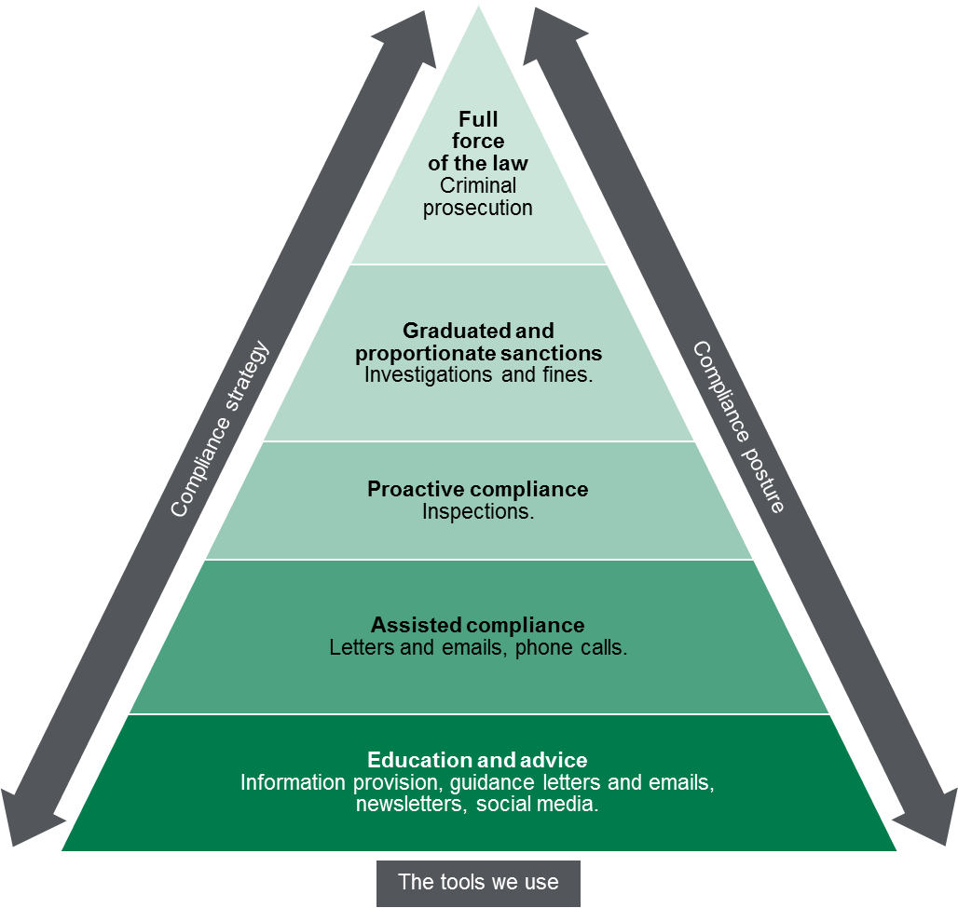

Measuring performance
This section sets out our understanding of how the activities that we undertake, as targeted by the identification and assessment of risks, contribute to our outcomes.

The contribution story
This section sets out the long-term outcome indicators that we contribute to as part of broader system of influencers. The Pest Control Team recognises that it contributes to these outcomes, as part of a system of influences both within the department and external to the department.
Pest control operators use substantial quantities of pesticides from a variety of chemical classes throughout metropolitan and regional areas. Pesticides can cause serious health effects when used incorrectly.
The Pest Control Team administers legislation with the objective of protecting the Victorian community from potential health risks associated with the use of pesticides in commercial and residential situations.
It does this through a combination of licensing, by ensuring training in the safe handling and application of pesticides, supporting regulated entities to comply with minimum standards, monitoring compliance, educating the public and investigating legislative breaches. The outcome is increased awareness of the risks associated with the use of pesticides, understanding the purpose of pest control licensing and the steps that people can take to protect their health when using pesticides.
The Pest Control Team recognise that while it influences its regulatory outcomes and objectives, there are other external factors that also contribute to its regulatory outcomes.

Direct indicators
In this section, we have outlined a small number of indicators that can be used to guide our activity and evaluate our effectiveness. To the extent possible, our indicators demonstrate our contributions to the outcomes that we are trying to achieve, rather than simply the activities that we are undertaking.
The Pest Control Team does not have influence over all pesticide use activities or incidents of pesticide contamination and can only measure the indicators that it is able to influence.
The table below sets out the measures that Pest Control use to indicate success against our outcomes.
Table 4: Measures used to indicate success against outcomes
Indicator | Current baseline | Target | 2015–16 actual | 2016–17 actual | 2017–18 actual
Percentage of licence holders that have been surveyed who, following a compliance inspection, report that they understand:  - The non-compliances identified during the inspection; and  - What actions need to be taken to address the non-compliance. |  | > 75%
Percentage of attendees at training courses who responded that the information provided was ‘extremely useful’ or ‘very useful |  | > 75%
Percentage of callers to the 1300 number who responded that the information provided was ‘extremely useful’ or ‘very useful |  | > 75%

Stakeholder engagement

Ongoing communications
Our team undertakes day-to-day operational communication regarding regulatory activities. This includes:
- Informing the general public and assisting regulated entities to comply: Through the provision of information in the form of brochures, newsletters, and technical notes, available on our website, and responding to queries to our 1300 information line and dedicated email address. This aims to educate the public and pest control operators of the health risks associated with the use of pesticides, the purpose of pest control licensing and precautions required for the protection of health, as well as the minimum standards and legislative requirements expected around its application.
- Accessing intelligence on inappropriate application of pesticides and unlicensed pest control operators: Through investigations and working with key stakeholders, as well as the wider Environmental Health and Compliance team, to inform our response activity.
- Supporting compliance: Working with pest control operators to provide helpful advice and supporting materials to assist them in complying with their legislative requirements through conducting routine inspections, regularly presenting to pest control students at Melbourne Polytechnic TAFE, and attending peak industry body meetings.

Planned communication activities
In 2017–18, the key stakeholder activity which we will undertake to address the risks to our outcomes will be:
- Commencing consultation and engagement as part of the review into the current regulations relating to pest control which sunset in 2019 which includes consideration of new national harmonised minimum units of competency for the safe handling and application of pesticides.
- Development of an education campaign focussed on increasing community awareness of the risks associated with the use of pesticides, the purpose of pest control licensing and precautions for the protection of health utilising the internet and social media.

Stakeholders
Table 5: List of key stakeholders
Key stakeholders | Type
Pest control operators | Regulated entities and source of intelligence
General public | Source of intelligence and beneficiary of regulation
Environmental Protection Authority | Source of intelligence and co-regulator
Department of Environment Land Water and Planning | Co-regulator and Source of intelligence
Drugs and Poisons | Source of intelligence and co-regulator
Australian Environmental Pest Managers Association | Peak body
Melbourne Polytechnic | Training provider for regulated entities
Department of Economic Development Jobs Transport and Resources | Co-regulator and Source of intelligence
Australian Pesticides and Veterinary Medicines Authority | Co-regulator - Source of intelligence
Worksafe | Co-regulator - Source of intelligence

Glossary
Term | Definition
Pest control operator | A person who carries on, or holds themselves out in any way as carrying on, the business of controlling, destroying or repelling pests.
Nuisance | Liable to be dangerous to health or offensive.
Co-regulator | Any national, other State and Territory, or Victorian regulator that has complementary objectives or functions, and/or the same regulated entities. For example, Australian Health Practitioner Regulation Agency, WorkSafe and the Federal or Victorian Police.

