Radiation safety regulator plan
March 2018 – June 2019

To receive this publication in an accessible format phone 1300 767 469, using the National Relay Service 13 36 77 if required, or email the Radiation team <radiation.safety@dhhs.vic.gov.au>
Authorised and published by the Victorian Government, 1 Treasury Place, Melbourne.
© State of Victoria, Department of Health and Human Services, March2018.
ISBN 978-1-76069-324-4 (online)
Available at Regulatory practice framework <https://www.dhhs.vic.gov.au/better-regulatory-practice-framework>

Contents
Introduction 4
Purpose of document 4
Document content 4
Principles 5
Regulator’s context 6
Regulatory framework 6
Regulatory activities 7
Complementary activities 8
Defining outcomes 9
Risk overview 10
Assessing and treating risks 10
Identified risks 11
Regulatory tools 15
Measuring performance 16
The contribution story 16
Direct indicators 16
Stakeholder engagement 17
Ongoing communications 17
Planned communication activities 17
Glossary 18

Introduction

Purpose of document
The Department of Health and Human Services (the department) administers numerous Acts and regulations aimed at promoting the health and wellbeing of the Victorian community and protecting the population of Victoria. It has 11 internal business units and three statutory bodies that are recognised by the Department of Treasury and Finance as regulators of business and not for profit organisations.
This regulator plan was developed in line with the conceptual framework outlined in the department’s Better regulatory practice framework <https://www.dhhs.vic.gov.au/better-regulatory-practice-framework>.
This document represents the first consolidated regulator plan that the Radiation team has developed and published. If you have any feedback on the plan, then please email the Radiation team <radiation.safety@dhhs.vic.gov.au>.
This plan is effective until 30 June 2019. It will then be updated:
- every two years – in line with the requirement for ministers to develop and re-issue Ministerial Statements of Expectations every two years; or
  - where key legislative changes are made that will impact on regulatory functions and the currency of the regulator plans.

Document content
This regulator plan relates to the Environmental Health Regulation and Compliance, Radiation team. The structure of the regulator plan document includes:
- outcomes
- risk assessment and risk management strategy
- demonstrating impacts
- stakeholder engagement
    - overview of approach
    - key stakeholders, including co-regulators
    - key activities.

Principles
In order to achieve the department’s outcomes, the regulators undertake their regulatory roles as informed by better regulatory practice principles. Consistent with better regulatory practice approaches interstate and internationally, the Environmental Health Regulation and Compliance, Radiation team seeks to apply the following principles:
Table 1: Regulatory practice principles
Principle | Commitment
Collaborative | Where the various departmental regulatory regimes, and those of other agencies, intersect, the regulators will work together to maximise effectiveness and minimise regulatory burden. Regulators will also cooperate and engage with internal and external stakeholders, including interstate counterparts and those representing various client groups within the Victorian community.
Consistent | The regulators will work to provide a consistent experience for regulated entities and the community. Regulatory responses will be predictable (meaning that, to the extent possible, regulators provide similar responses in similar circumstances - consistent with policy) and where possible standardised, following clear processes and delivering consistent results. This will ensure that individuals / organisations are treated fairly, and that the regulators are objective in their decision-making.
Efficient | The regulators will allocate resources in a proportionate way that aims to most efficiently achieve outcomes, considering the direct and indirect impacts on the relevant sectors. This includes minimising unnecessary administrative burden and any adverse impact of regulatory actions on businesses to a level that is not justifiable to achieve regulatory outcomes.
Intelligence-led | The regulators will analyse incoming intelligence and data in order to allow them to be responsive and accurate when assessing risk and undertaking compliance activities.
Outcomes-focussed | Processes and decision-making will be driven by outcomes, and the regulators will be effective in achieving their regulatory objectives. Progress against outcomes will be measured to ensure continuous improvement.
Proportionate | The work undertaken by regulators should be proportionate to the risk being addressed. The principle of proportionality should guide regulators decisions in relation to the level of resources assigned to manage a particular risk, the regulatory tools used and enforcement activities.
Risk-based | The regulators will be proactive in identifying, assessing and responding to risk, prioritising and targeting resources toward specific groups or behaviours that pose the greatest risk to the department’s outcomes.
Transparent | The regulators will be open in their decision-making and processes, documenting decisions appropriately, including the justification for decisions. The regulators will aim to assist regulated parties to understand the decision-making processes, areas of focus and performance. Regulators will follow standard reporting requirements, enabling the department to monitor and oversee the performance of its regulators.

Regulator’s context
This section outlines the context that the regulator operates within, including its regulatory framework and a brief overview of its activities.

Regulatory framework
The Radiation Team is responsible for administering legislation in relation to the harmful effects of radiation (which includes sources such as X-ray units and radioactive material). The Radiation Team operates under the following legislation:
- The Radiation Act 2005 (the Act)
  - The Radiation Regulations 2017 (the Regulations).
Under the Act and Regulations, the Radiation Team regulates radiation practices and individuals authorised to use radiation sources in order to protect the health of workers, the community, and the environment from the harmful effects of radiation.
The Radiation Team’s main purpose is to protect the health and safety of all persons and the environment from the harmful effects of radiation by regulating radiation practices, the use of radiation sources, and the testing of certain diagnostic X-ray apparatus. In addition, the Radiation Team assesses particular sites against approved security plans in relation to some types of radioactive material.
The Radiation Act 2005 establishes a licensing regime for:
- Companies and organisations that, and individuals who, conduct ‘radiation practices’: This licence is called a ‘management licence’ and authorises the conduct of a specific radiation practice such as possession of X-ray units or radioactive material for a specific purpose at a specified location. There are approximately 2,600 active management licences operating at over 3,500 sites across Victoria.
- Individuals who use radiation sources such as X-ray units or radioactive material: This licence is called a ‘use licence’. There are over 14,000 active use licences. A use licence allows a person to use a radiation source that is authorised to be possessed by a management licence.
- Approved testers: These are individuals who have been approved by the department to issue certificates of compliance indicating that a particular medical diagnostic X-ray unit has been tested and met Victorian radiation safety standards.
- Facility construction licences: These licences are required by a company or organisation that, or an individual who, wishes to construct a radiation facility.
  - Approved assessors: These are individuals who have been approved by the department to issue certificates of compliance indicating that a security plan or transport security plan meets Victorian security standards.
The uses of radiation are varied; as radiation is used in different forms for different purposes (such as medical use, dental use, industrial use and veterinary use). There are a diverse range of sectors associated with the use or management of radiation in Victoria. There are over 15,000 radiation licence holders registered with the department in sectors ranging from medical, dentistry and veterinary to mining, transport, and industrial radiography.
The Radiation Team is made up of members authorised under the Act who have the necessary experience and expertise to administer the Act.

Groups relied on to undertake our regulatory function
The Radiation Team is supported by the Registration and Licensing Team and the Systems & Databases Team within the Environmental Health Regulation and Compliance Unit. These teams provide a support role to the Radiation Team that is essential for ensuring the department fulfils its legislative requirements regarding registration, licensing, and the collection and reporting of information. The department also obtains advice from the Radiation Advisory Committee, which is an expert group appointed by the Minister for Health in Victoria.
The Radiation Team works with several co-regulators who have complementary objectives or functions, and/or regulate the same entities. These co-regulators include the Australian Radiation Protection and Nuclear Safety Agency (ARPANSA), Australian Health Practitioners Regulatory Agency (AHPRA), Environmental Protection Authority (EPA), the Victorian Pharmacy Authority, and Worksafe. This cooperative activity can involve sharing information, undertaking joint investigations, and delivering cooperative education programs to regulated entities.

Regulatory activities
The Radiation Team undertakes the following key regulatory activities:

Supporting compliance
- The team uses mail outs to provide licence holders with the information that they need, or to prompt them to comply. For example, mail outs are often used to remind the regulated entities that they need to renew their licence, or to inform them of any changes in the conditions of their licence. This information is also provided by email where licence holders have confirmed their email addresses.
- The Radiation Team is in the process of setting up an email newsletter, which will enable general radiation information to be distributed to stakeholders.
- The Radiation Team also makes itself available to respond to emails as required.
- A Radiation Hotline is available for stakeholders to call when they have a query or need to report an issue.
- The Radiation Team has a website hosted by the department that provides licence holders and other stakeholders (such as the general public) with relevant information.

Monitoring compliance
- Inspections are a large part of the work that the Radiation Team undertakes and are performed with the intention of assessing compliance, providing advice, and promoting compliance. The Radiation Team has a target or Key Performance Indicator for undertaking 480 inspections per year.
- The team also has a radiation licensing database that allows monitoring of licences and provides the team with the information needed to engage with regulated entities as required.

Addressing non-compliance
- The Radiation Team prioritises a consistent response to non-compliances identified during a compliance inspection.

Advice in relation to regulatory activities
- There is a Radiation Advisory Committee that considers, advises and reports to the Minister for Health or Secretary of the Department of Health and Human Services on any matter relating to the administration of the Act or Regulations.
- The Radiation Team is represented on the National Radiation Health Committee which advises the Chief Executive Officer of the Australian Radiation Protection and Nuclear Safety Agency and the Radiation Health and Safety Advisory Council on matters relating to radiation protection, including formulating draft national policies, codes and standards for consideration by the Commonwealth, states and territories.
- The Radiation Team contributes to the development of national Codes and Standards in conjunction with Commonwealth Agencies such as Australian Radiation Protection and Nuclear Safety Agency and the Department of Industries and Science.

Complementary activities
Incident response is a critical component of the Radiation Team’s work. This role includes appropriately planning for, identifying, assessing, and responding to incidents that could result in harm from radiation.
The Radiation Team’s regulatory function complements this incident response role through minimising risks associated with radiation. Similarly, information gleaned from incident responses supports the Radiation Team’s regulatory role by assisting it to refine risk assessments.

Defining outcomes
This section includes a summary of the outcomes to which the team contributes.
Table2: Defining outcomes
Regulatory regime | Outcomes | Objectives
Regulation of radiation | To protect the Victorian community (including persons exposed through their work and the general public) and the environment from the harmful effects of radiation | The outcome is achieved by:  - Ensuring that a licence is issued only following a complete assessment including the justification of the proposed radiation practice or the proposed use of a radiation source.  - Reducing unnecessary exposure to radiation by improving the understanding of licence holders regarding radiation safety and satisfying compliance requirements.  - Reducing unnecessary exposure to radiation for persons exposed through their work, for members of the public, and for the environment through the monitoring of compliance and the enforcement of relevant radiation protection requirements.

Risk overview
This section includes a risk assessment and risk management strategy which identifies and prioritises a small number of key risks to the regulators outcomes.
Identified risks
This section outlines risks relating to specific groups of entities or behaviours, which stem directly from the outcomes and objectives identified. The key risks that we have identified are:
- Inadequate training (cause), which may result in the failure to follow the necessary safety requirements (event), leading to potentially harmful levels of radiation exposure (harm).
- Inadequate shielding of authorised radiation practices (cause), which may result in radiation exposure (event), which is greater than prescribed limits (harm).
- Prolonged or inadequate storage of radioactive material (cause), which could result in the loss or abandonment of radioactive materials (event), which may result in unnecessary radiation exposure (harm).
- Unjustified radiation practices or use of a radiation sources (cause), may result in unnecessary radiation exposure (event), which leads to a net harm that outweighs any benefit gained (harm).

Assessing and treating risks
This section demonstrates how the Radiation Team responds to risk.
The risk rating process involves assessing the extent of the risk as well as the associated levels of harm, as shown below.
Table 3: Overall risk rating
Consequence | Likelihood:  Negligible (5%) | Likelihood: Minor  (10%) | Likelihood: Moderate (20%) | Likelihood: Major  (40%) | Likelihood: Extreme (80%)
Extreme | Medium | High | High | Critical | Critical
Major | Medium | Medium | High | High | Critical
Moderate | Low | Medium | Medium | High | High
Minor | Low | Low | Medium | Medium | High
Negligible | Low | Low | Low | Medium | Medium

Identified risks

Risk 1
Likelihood | Consequence | Rating
Major | Moderate | High
Inadequate training, which may result in the failure to follow the necessary safety requirements, leading to potentially harmful levels of radiation exposure.

Extent of the risk
Because of the range of types of radiation sources and the large number of radiation sources used in the medical sector, the training of the operator required to use the radiation sources correctly or optimally also varies. Some of the radiation sources used produce high levels of radiation that could be delivered to a patient for a prolonged period. In particular, fluoroscopic X-ray apparatus used during interventional procedures carries a significant risk of delivering unnecessarily high doses of radiation to a patient if the radiation exposure parameters and the position of the radiation beam are not appropriately determined. That is, unnecessary radiation exposure occurs because the exposure is not optimised. In addition to the higher than necessary radiation exposure of the patient, the operator of the X-ray apparatus and other staff members involved with the interventional procedure could also be exposed to unnecessary radiation when the X-ray apparatus is not used correctly or optimally.
Furthermore, the incorrect use of fluoroscopic X-ray apparatus may result in some patients receiving radiation burns in extreme cases.
Management Licence holders are required to provide incident reports to the department when a prescribed incident has or is suspected to have occurred. The Radiation Team reviews these reports and has identified a risk where patients could be receiving higher than necessary radiation doses during medical procedures.

Ongoing controls
The following controls are undertaken by the Radiation Team on an ongoing basis:
- Risk-based inspections that include assessment of optimisation procedures.
- Review of incoming incident reports.
- Providing information through the website, emails and letters.

Risk 2
Likelihood | Consequence | Rating
Major | Moderate | High
Inadequate shielding of authorised radiation practices, which may result in radiation exposure that is greater than prescribed limits.

Extent of the risk
The department authorises the possession of diagnostic and therapeutic X-ray apparatus which have a significant potential to cause unnecessary public and occupational radiation exposure. It is therefore imperative that the premises in which the apparatus is used are fit for purpose, including the construction, design and shielding of the premises. A shielding assessment is required by a practice to determine what shielding, layout and construction is required for a particular radiation practice to be safely conducted.
Radiation shielding may be inadequate due to the work load of the radiation source increasing over time, occupancy of the adjacent rooms changing or the incorrect type of shielding material being installed. These factors combined could lead to radiation exposure that is greater than prescribed limits.

Ongoing controls
The following controls are undertaken by the Radiation Team on an ongoing basis:
- Risk-based inspections that include assessment of shielding.
- Radiation area monitoring.
- Providing information through the website, emails and letters.

Planned changes in controls for 2017–18
Comprehensive shielding guidelines will be developed and will be available on the website to assist licence holders in ensuring that adequate shielding is in place.

Risk 3
Likelihood | Consequence | Rating
Moderate | Moderate | Medium
Prolonged or inadequate storage of radioactive material, which could result in the loss or abandonment of radioactive materials, which may result in unnecessary radiation exposure.

Extent of the risk
There are times when a radiation source that was authorised to be possessed for a particular purpose is no longer required for that purpose. In these situations, the radiation source might be taken out of service and placed in storage, possibly awaiting disposal.
The cost associated with disposal or a lack of disposal options increases the risk of the radiation source being placed permanently in storage. In these circumstances, the storage might not be adequate for the purpose. For example, the store might not have adequate shielding to ensure that radiation safety outcomes are realised or have inadequate labelling for ensuring appropriate recognition of storage.
These factors combined could lead to the unintended disposal, the loss, or the abandonment of the radiation source. These problems are likely to arise if companies are liquidated or undergo significant restructure.

Ongoing controls
The following controls are undertaken by the Radiation Team on an ongoing basis:
- Risk-based inspections that include an audit of radiation sources placed in storage.
- Providing information through the website, emails and letters.

Risk 4
Likelihood | Consequence | Rating
Major | Moderate | High
Unjustified radiation practices or use of radiation sources can result in unnecessary radiation exposure that outweighs any benefit gained.

Extent of the risk
One of the foundations of the radiation protection of patients is the justification of medical exposures. The justification process requires that a medical procedure is not performed unless it produces sufficient benefit to the exposed individuals or to society to offset the radiation detriment it causes. In medical use of radiation, the benefit can be the potential diagnostic information resulting from the medical exposure. The detriment is the harm caused by exposure to ionising radiation. Radiation exposure has the potential to cause detriments such as an increased chance of cancer in the exposed individual and/or harmful tissue reactions or in rare circumstances, localised burning of the skin.

Ongoing controls
The following controls are undertaken by the Radiation Team on an ongoing basis:
- Risk-based inspections that include an assessment of the documentation that describes the justification of radiation procedures.
- Providing information through the website, emails and letters.

Regulatory tools
This section includes an overview of departmental regulation, illustrating the full suite of tools available to the Radiation Team.
Figure 1: Regulatory tools
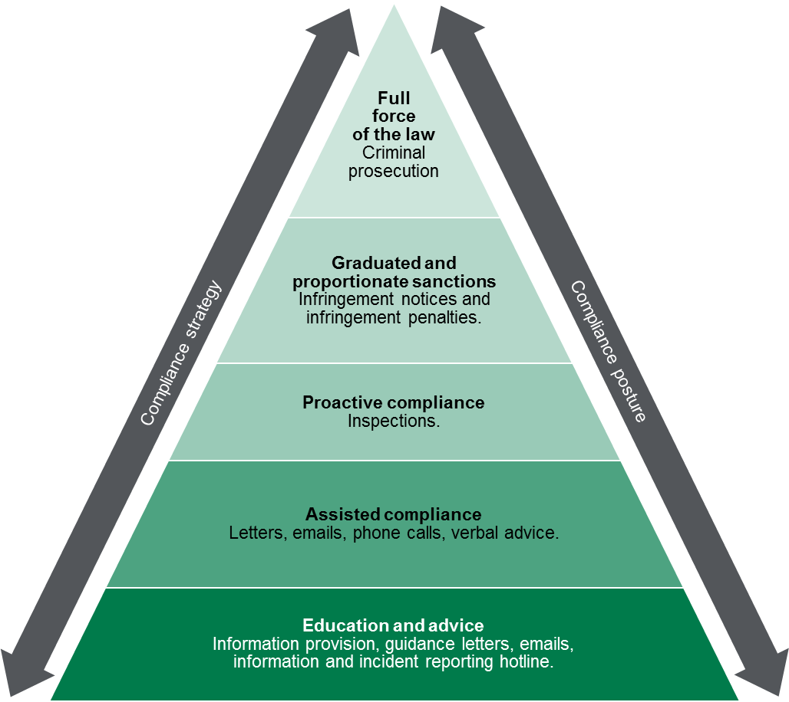

Measuring performance
This section sets out our understanding of how the activities that we undertake, as targeted by the identification and assessment of risks, contribute to our outcomes.

The contribution story
This section sets out the long-term outcome indicators that we contribute to as part of a broader system of influencers. We recognise that we contribute to these outcomes, as part of a system of influences both within the department and external to the department.
By working with groups such as the Cancer Council, the medical specialist colleges, and the relevant industry groups, the Radiation Team has worked to continually enforce the ban on commercial tanning, to reduce Computed Tomography (CT) dose levels particularly for children, and to review the use of Dual-energy X-ray absorptiometry (DEXA) units in the sports and fitness industry.
The outcome is a reduction in radiation exposure. Our role is also to limit the unjustified use of radiation sources and apply the principles of radiation protection to achieve the intended outcome.

Direct indicators
In this section, we have outlined a small number of indicators that can be used to guide our activity and evaluate our effectiveness. To the extent possible, our indicators demonstrate our contributions to the outcomes that we are trying to achieve, rather than simply the activities that we are undertaking.
The table below sets out the measures that we use to indicate success against our outcomes.
Table 4: Measures used to indicate success against outcomes
Indicator | Current baseline | Target | 2015–16 actual | 2016–17 actual | 2017–18 actual
Percentage of allegations of illegal commercial tanning activity that are investigated. | 100% | 100%
Number of inspections | 480 | 480 | 444 | 483
Percentage of incident reports involving high risk radiation practices that are investigated. |  | 100%
Percentage of licence holders that have been surveyed who, following a compliance inspection, report that they understand:  The non-compliances identified during the inspection; and  What actions need to be taken to address the non-compliance. |  | > 75%
All licensed DEXA practices performing body composition analysis have a new licence condition requiring compliance with justification pertaining specifically to body composition procedures. | 0 | All licence holders | 0 | 0

Stakeholder engagement

Ongoing communications
Our team undertakes day-to-day operational communication regarding regulatory activities. This includes:
- Informing the general public and assisting regulated entities to comply: The Radiation Hotline and other educational activities assist regulated entities to be aware of their compliance obligations and aim to inform the general public on radiation safety.
- Accessing intelligence on radiation incidents: Working with the Registration & Licensing Team and the Systems & Databases Team within the Environmental Health Regulation and Compliance Unit. The Radiation Hotline also provides a forum through which the Radiation Team can be alerted to an incident.
- Accessing intelligence on regulated entity behaviour: Both working with the teams mentioned above and assessing information found in ongoing inspections or through incident reports.
- Undertaking inspections: Working with regulated entities to monitor and ensure the safe use of radiation, by providing helpful advice and assisting them to comply with requirements.

Planned communication activities
In 2017–18, the key stakeholder activity which the Radiation Team will undertake to address the risks to its outcomes will be:
- Design and undertake a survey following compliance inspections of licence holders to determine their levels of understanding after the inspection. The survey will include questions that aim to find out; if the licence holder knows they are compliant/non-compliant; whether they found the inspection to be useful in understanding the nature of any non-compliance; and, whether they have the necessary resources to remedy any non-compliance.
- The Radiation Team will also focus on working with stakeholders in the radiation therapy sector in order to implement necessary regulatory controls pertaining to quality assurance in external beam radiation therapy.
Table 5: List of key stakeholders
Key stakeholders | Type
Management licence holders | Regulated entities and individuals
Use license holders | Regulated individuals
Approved testers | Regulated individuals
Approved assessors | Regulated individuals
Committees (e.g. Ministerial Radiation Advisory Committee, National Radiation Health Committee) | Source of intelligence and policy advice
Cancer Council Victoria | Related information provider
The Royal Australian and New Zealand College of Radiologists | Source of intelligence
Australian Radiation Protection and Nuclear Safety Agency | Code and Standard development framework manager
Regulators in other Australian jurisdictions | National Uniformity Partners
Councils | Source of intelligence

Glossary
Term | Definition
ARPANSA | Australian Radiation Protection & Nuclear Safety Agency
Co-regulator | Any national, other State and Territory, or Victorian regulator that has complementary objectives or functions, and/or the same regulated entities. For example, Australian Health Practitioner Regulation Agency, WorkSafe and the Federal or Victorian Police.

This Key Performance Indicator is a Victorian Budget Paper 3 measure.
Shielding refers to the physical barriers between the radiation and a person who might be exposed to the radiation.
Fluoroscopic X-ray apparatus (also known as fluoroscopy) is a type of medical imaging that uses X-rays to obtain real-time moving images of the interior of an object. In its primary application of medical imaging, it allows a physician to see the internal structure and function of a patient, so that the pumping action of the heart or the motion of swallowing, for example, can be watched.
Computed tomography is a form of medical imaging that makes use of computer-processed combinations of many X-ray measurements taken from different angles to produce cross-sectional (tomographic) images (virtual "slices") of specific areas of a scanned object, allowing the user to see inside the object without cutting.
Dual-energy X-ray absorptiometry involves two X-ray beams, with different energy levels, being aimed at the patient. In the most common use, it is used to measure bone mineral density. It is also used to measure total body composition and fat content.

