Standards and regulation regulator plan
March 2018 – June 2019

To receive this publication in an accessible format phone (03) 9096 2745, using the National Relay Service 13 36 77 if required, or email <hsstandards@dhhs.vic.gov.au>
Authorised and published by the Victorian Government, 1 Treasury Place, Melbourne.
© State of Victoria, Department of Health and Human Services, March 2018.
ISBN/ISSN 978-1-76069-334-3 (online)
Available at Regulatory practice framework <https://www.dhhs.vic.gov.au/better-regulatory-practice-framework>

Contents
Introduction 4
Purpose of document 4
Document content 4
Principles 5
Regulator’s context 6
Regulatory framework 6
Regulatory activities 7
Complementary activities 8
Interface between contract management and regulation 8
Defining outcomes 10
Risk overview 11
Assessing and treating risks 11
Identified risks 12
Regulatory tools 18
Measuring performance 19
The contribution story 19
Further evidence we plan to gather to strengthen our contribution story 19
Direct indicators 19
Stakeholder engagement 21
Ongoing communications 21
Planned communication activities 21
Stakeholders 22
Glossary 23

Introduction

Purpose of document
The Department of Health and Human Services (the department) administers numerous Acts and regulations aimed at promoting the health and wellbeing of the Victorian community, and protecting the population of Victoria, including, vulnerable clients. It has 11 internal business units and three statutory bodies that are recognised by the Department of Treasury and Finance as regulators of business and not for profit organisations.
An individual Regulator Plan has been developed for each of the 11 internal business unit regulators. These documents are developed in line with the conceptual framework outlined in the department’s Better regulatory practice framework <https://www.dhhs.vic.gov.au/better-regulatory-practice-framework>.
This is the first consolidated regulator plan that Standards and Regulation has developed and published. If you have any feedback on the plan, please email hsstandards@dhhs.vic.gov.au.
This plan will be updated:
- every two years – in line with the requirement for Ministers to develop and re-issue Ministerial Statement of Expectations every two years; or
- where key legislative changes are made that will impact on regulatory functions and the currency of the regulator plans.

Document content
This regulator plan relates to Standards and Regulation . The structure of the Regulator Plan document includes:
- outcomes
- risk assessment and risk management strategy
- demonstrating impacts
- stakeholder engagement
    - overview of approach
    - key stakeholders (co-regulators)
    - key activities.

Principles
In order to achieve the department’s outcomes, the regulators undertake their regulatory roles as informed by better regulatory practice principles. Consistent with better regulatory practice approaches interstate and internationally, Standards and Regulation seeks to apply the following principles:
Table 1: Regulatory practice principles
Principle | Commitment
Collaborative | Where the various departmental regulatory regimes, and those of other agencies, intersect, the regulators will work together to maximise effectiveness and minimise regulatory burden. Regulators will also cooperate and engage with internal and external stakeholders, including interstate counterparts and those representing various client groups within the Victorian community.
Consistent | The regulators will work to provide a consistent experience for regulated entities and the community. Regulatory responses will be predictable (meaning that, to the extent possible, regulators provide similar responses in similar circumstances - consistent with policy) and where possible standardised, following clear processes and delivering consistent results. This will ensure that individuals / organisations are treated fairly, and that the regulators are objective in their decision-making.
Efficient | The regulators will allocate resources in a proportionate way that aims to most efficiently achieve outcomes, considering the direct and indirect impacts on the relevant sectors. This includes minimising unnecessary administrative burden and any adverse impact of regulatory actions on businesses to a level that is not justifiable to achieve regulatory outcomes.
Intelligence-led | The regulators will analyse incoming intelligence and data in order to allow them to be responsive and accurate when assessing risk and undertaking compliance activities.
Outcomes-focussed | Processes and decision-making will be driven by outcomes, and the regulators will be effective in achieving their regulatory objectives. Progress against outcomes will be measured to ensure continuous improvement.
Proportionate | The work undertaken by regulators should be proportionate to the risk being addressed. The principle of proportionality should guide regulators decisions in relation to the level of resources assigned to manage a particular risk, the regulatory tools used and enforcement activities.
Risk-based | The regulators will be proactive in identifying, assessing and responding to risk, prioritising and targeting resources toward specific groups or behaviours that pose the greatest risk to the department’s outcomes.
Transparent | The regulators will be open in their decision-making and processes, documenting decisions appropriately, including the justification for decisions. The regulators will aim to assist regulated parties to understand the decision-making processes, areas of focus and performance. Regulators will follow standard reporting requirements, enabling the department to monitor and oversee the performance of its regulators.

Regulator’s context
This section outlines the context that the regulator operates within, including its regulatory framework and a brief overview of its activities.

Regulatory framework
Standards and Regulation is responsible for administering legislation that aims to protect the Victorian community and those accessing human services, through regulating human service providers. Standards and Regulation operates under the Children, Youth and Families Act 2005 and the Disability Act 2006.
Under these Acts, organisations are required to meet the Human Services Standards.
Organisations that are funded or registered by the department for in-scope direct client services are required to achieve and maintain certification against these Human Services Standards every three years.
The Human Services Standards represent a single set of service quality standards for registered service providers and department-managed services. The Human Services Standards comprise of four service delivery standards and one governance and management standard of a department endorsed independent review body.
The key elements of the Human Services Standards are:
- Empowerment – People’s rights are promoted and upheld;
- Access and engagement – People’s right to access transparent, equitable and integrated services is promoted and upheld;
- Wellbeing – People’s right to wellbeing and safety is promoted and upheld;
- Participation – People’s right to choice, decision making and to actively participate as a valued member of their community is promoted and upheld; and
  - Governance and management – organisations must be effectively governed and managed at all times.
Organisations funded by the department are required to meet the Human Services Standards as an essential term of their Service Agreement.
Standards and Regulation oversees these requirements for funded and registered organisations that provide in-scope direct client services including children, youth and family services; disability services, homelessness assistance services; youth justice services; and family violence and sexual assault services.
There are approximately 600 organisations that are subject to the Human Services Standards. The Children, Youth and Families Act and the Disability Act require the department to maintain and publish a register of disability service providers and a register of community services.
- Register of disability service providers <https://providers.dhhs.vic.gov.au/registration-requirements-disability-service-providers>.
- Register of community services <https://providers.dhhs.vic.gov.au/register-community-services>.

Groups relied on to undertake our regulatory function
Standards and Regulation regulator works with several co-regulators who have complementary objectives or functions, and/or regulate the same entities. These include Housing Registrar, Disability Services Commissioner and National Disability Insurance Agency. Standards and Regulation also works closely with areas within the department including the Office of Senior Practitioner, Safeguarding and Disability Supports (Child Safe Standards, Reportable Conduct Scheme and Carer’s register), Performance and Reporting (Unannounced audits), Executive Services and Oversight (Disability Worker Exclusion Scheme), operational divisions, program and policy areas such as National Disability Insurance Scheme Branch and corporate services.
This can involve sharing information in relation to regulated entities.
As a part of an organisation’s accreditation process department-endorsed independent review bodies conduct the reviews against the Human Services Standards as a part of an organisation’s accreditation process. The independent review bodies are required to provide copies of accreditation review reports to the department. Standards and Regulation also educates the independent review bodies on the Human Services Standards, and provides these bodies with the market/sector and legislative context necessary to undertake rigorous reviews of the regulated entities.

Regulatory activities
Standards and Regulation undertakes the following key regulatory activities:
- Supporting compliance:
    - The team facilitate workshops for service providers around Victoria that aim to assist them in preparing for an independent review or undertaking a self-assessment process.
    - The team also facilitates an annual Quality forum for service providers to share experiences, provide feedback and gain information to support compliance.
    - The team operates a helpdesk (telephone and email) that provides information about registration, the Human Services Standards and relevant obligations.
    - A wide range of policies and tools are available on the department’s website.
      - In response to a review report where there are significant concerns identified as part of an audit, or in circumstances where there may be conflicts between the needs of the department and the organisation, Standards and Regulation may call a conference. Conferences are used where Standards and Regulation needs to take an active role in supporting the organisation to meet their obligations under the Human Services Standards. Key stakeholders that would be invited to attend the conference may include the regulated entity and relevant departmental staff.
- Monitoring compliance:
    - Standards and Regulation monitors compliance with the Human Services Standards to ensure Service Agreement and registration obligations are met.
    - If there are any notifiable issues identified, the person who identified the notifiable issue immediately contacts Standards and Regulation and the team responds accordingly.
    - Multiple existing data sources that exist within the department (such as incident reporting, service delivery tracking and notifiable issues identified during an independent review) are regularly analysed, and organisations are assigned a risk rating. Organisations rated as high risk are subject to increased oversight, accountability and monitoring.
- Addressing non-compliance:
    - Standards and Regulation directly contacts an organisation (for example, through issuing written notices) in order to inform them of a non-compliance and the required action that they must take to address the issue.
    - Where there is continued non-compliance or a particularly high risk, the team may use graduated sanctions (such as imposing conditions on the organisation’s registration) in order to encourage compliance.
    - The team can revoke the registration of an organisation where there is a non-compliance, or where the Service Agreement with the organisation is terminated (or where funding is ceased for activities within scope of registration).

Complementary activities
In addition to regulation of services under the Acts, Standards and Regulation regulates organisations that are not required to be registered under either Act but are required under their Service Agreement with the department to comply with the Human Services Standards.
The department-managed services (that is services directly provided by the department) are also monitored by Standards and Regulation. This is because these services are required to meet the Human Services Standards four service delivery standards. The Disability Act and Children, Youth and Families Act also refer to the department as a service provider even though it cannot be registered under the Acts.

Whereas in the cases above the organisations are not required to be registered under an Act, the Human Services Standards are a regulatory tool due to being gazetted under the Acts. Although there are fewer tools the Unit can use where a provider is not registered, it can still take or require action to be taken by such providers.

Interface between contract management and regulation
Whereas Standards and Regulation is the regulator, the role of divisional staff is predominately contract management. However, divisional staff support regulatory activity and can provide information and advice to support regulatory decision making.
Standards and Regulation may be notified of issues that may affected a regulated entities’ ability to comply in a range of ways including, but not limited to:
- departmental staff that monitor performance, for example:
    - breaches of legislation, the Human Services Standards or relevant policy requirements identified through routine performance monitoring and contract management;
    - systemic incident reporting issues relating to Human Services Standards;
      - advice of breach by organisation to the departmental staff;
- self-reports from the funded/registered sector.
- departmental staff with authority under relevant legislation, for example:
    - breaches of the carers register requirements under the Children, Youth and Families Act
    - breaches of restrictive intervention obligations under the Disability Act
    - poor Community Visitors report outcomes under the Disability Act
- the Disability Services Commissioner; and
  - other regulators or statutory authorities where there is an agreed information sharing protocol.
The following figure provides an overview of allocation of responsibilities within the department in relation to oversight of organisations.

Figure 1. Allocation of responsibilities in relation to oversight of organisations
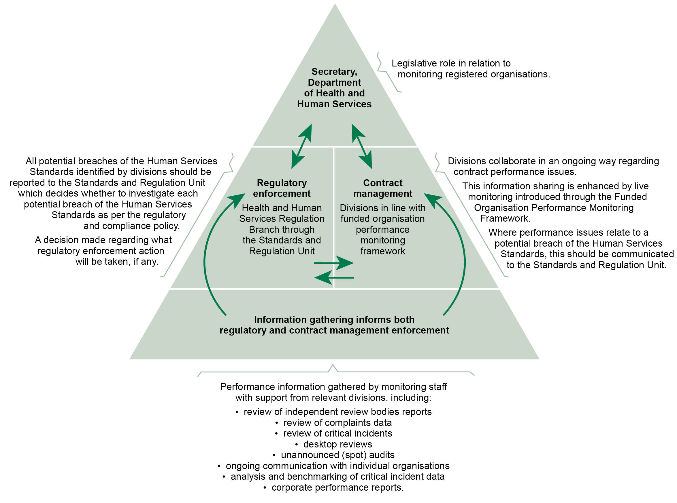

Defining outcomes
This section includes a summary of the outcomes to which the team contributes.
Table 2: Defining outcomes
Regulatory regime | Outcomes
Regulation of human services | To prevent poor service delivery, that impacts the physical, emotional and cultural safety and wellbeing of people accessing in-scope human services in Victoria. This is achieved by requiring compliance with the Human Services Standards.

Risk overview
This section includes a risk assessment and risk management strategy which identifies and prioritises a small number of key risks to the regulators outcomes.
Identified risks
This section outlines risks relating to specific groups of entities or behaviours, which stem directly from the outcomes and objectives identified. The key risks that we have identified are:
- Lack of sufficient safety screening in regulated entities can lead to inappropriate staff working with people which can lead to risk of abuse, neglect and harm of people.
- Poor policy, procedure and practice in regulated entities around medication management can lead to incorrect medication administration which is harmful to people’s health.
- Inappropriate and unauthorised restrictive intervention processes and lack of Restrictive Intervention Data System (RIDS) reporting in regulated entities can lead to inappropriate use of restrictive intervention impacting the people’s safety and wellbeing.
- Non-disclosures or false or inaccurate information provided to the department by potential providers in a self-assessment, can lead to the department registering poor quality regulated entities which can lead to people being put at risk of abuse, neglect and harm.
- Non-disclosures or false or inaccurate information provided to the department by regulated entities, either prior to independent review or when submitting a self-assessment due to being exempt from independent review, can lead to independent reviewers or regulators failure to identify and report on critical deficiencies. This can lead to people being put at risk of abuse, neglect and harm.
- Insufficient knowledge and expertise of independent reviewers can lead to failure to identify and report to the department on regulated entities’ critical deficiencies which can lead to people being put at risk of abuse, neglect and harm.

Assessing and treating risks
This section demonstrates how Standards and Regulation assesses and then responds to risk; the risk is assessed against the risk matrix (as shown below), and given a risk rating.
Table 3: Overall risk rating
Consequence | Likelihood:  Negligible (5%) | Likelihood: Minor  (10%) | Likelihood: Moderate (20%) | Likelihood: Major  (40%) | Likelihood: Extreme (80%)
Extreme | Medium | High | High | Critical | Critical
Major | Medium | Medium | High | High | Critical
Moderate | Low | Medium | Medium | High | High
Minor | Low | Low | Medium | Medium | High
Negligible | Low | Low | Low | Medium | Medium
The risk rating process involves assessing the extent of the risk as well as the associated levels of harm, as shown below.

Identified risks

Risk 1
Likelihood | Consequence | Rating
Likely | Major | Very high
Lack of sufficient safety screening in regulated entities can lead to inappropriate staff working with people which can lead to risk of abuse, neglect and harm of people.

Extent of the risk
In 2016–17 there were approximately 20 occasions of regulated entities non-compliance with the department’s safety screening policies captured through Standards and Regulation’s notifiable issues process. Failure to comply with safety screening processes such as Police Record Checks, International Police Record Checks, Working with Children Check and the Carer’s register can lead to staff abusing clients.

Specific groups of entities or behaviours
Nil.

Ongoing controls
Standards and Regulation will ensure the relevant departmental program areas are advised when there is a breach identified for example. In all cases the safety screening policy area of the department should be advised of breaches and specific program areas such as the unit responsible for the carer’s register should be advised of relevant breaches.
Standards and Regulation will ensure all non-compliances are addressed as they arise and will use a strengthened regulatory response, based on the regulatory tools on page 18, where multiple or repeat breaches occur.

Planned changes in controls for 2017–18
Standards and Regulation will strengthen the relationship with relevant program areas, such as those identified above, to ensure responsible policy owners are aware of the issues so they may better target their communication and education efforts.

Risk 2
Likelihood | Consequence | Rating
Likely | Major | Very high
Poor policy, procedure and practice in regulated entities around medication management can lead to incorrect medication administration which is harmful to people’s health.

Extent of the risk
In 2016–17 there were approximately seven occasions where regulated entities did not comply with the department’s medication management policies captured through Standards and Regulation’s notifiable issues process. Failure to comply with medication management policies can lead to staff not administering medication as required or prescribed resulting in harm to the client.

Specific groups of entities or behaviours
Nil.

Ongoing controls
Standards and Regulation will ensure the relevant departmental program areas, such as the Office of Professional Practice and relevant disability program staff are advised when there is a breach identified of medication management issues.
Standards and Regulation will ensure all non-compliances are addressed as they arise and will use a strengthened regulatory response, based on the regulatory tools on page 18, where multiple or repeat breaches occur.

Planned changes in controls for 2017–18
Standards and Regulation will strengthen the relationship with relevant program areas, such as those identified above, to ensure:
- responsible policy officers in the department are aware of the issues so they may better target their communication and education efforts
- co-regulators, such as the Office of Professional Practice, can take action as required.

Risk 3
Likelihood | Consequence | Rating
Likely | Major | Very high
Inappropriate and unauthorised restrictive intervention processes and lack of Restrictive Intervention Data System (RIDS) reporting in regulated entities can lead to inappropriate use of restrictive intervention impacting people’s safety and wellbeing.

Extent of the risk
In 2016-17 there were approximately six occasions where regulated entities did not comply with the department’s restrictive intervention processes or there was a lack of Restrictive Intervention Data System (RIDS) reporting that was captured through the Unit’s notifiable issues process. Failure to comply with restrictive intervention processes and/or Restrictive Intervention Data System (RIDS) reporting can lead to clients being inappropriately restrained resulting in harm to the client.

Specific groups of entities or behaviours
Nil.

Ongoing controls
Standards and Regulation will ensure the relevant departmental program areas, such as the Office of Professional Practice and relevant disability program staff are advised when there is a breach identified of restrictive intervention processes and RIDS reporting.
Standard and Regulation will ensure all non-compliances are addressed as they arise and use a strengthened regulatory response, based on the regulatory tools on page 18, where multiple or repeat breaches occur.

Planned changes in controls for 2017–18
Standards and Regulation will strengthen the relationship with relevant program areas, such as those identified above, to ensure:
- responsible policy owners are aware of the issues so they may better target their communication and education efforts
- co-regulators, such as the Office of Professional Practice, can take action as required.

Risk 4
Likelihood | Consequence | Rating
Likely | Major | Very high
Non-disclosures or false or inaccurate information provided to the department by potential providers in a self-assessment, can lead to the department registering poor quality regulated entities which can lead to people being put at risk of abuse, neglect and harm.

Extent of the risk
Standards and Regulation is aware that self-assessments are by nature, completed by the regulated entity and it relies on appropriate disclosure of information by the regulated entities to ensure a sound review is undertaken.
In 2016-17 there was one known occasion where a provider gave inaccurate information in its self-assessment, and the provider was registered by the department. Subsequently it was identified the provider was not operating in accordance with departmental policy or legislative requirements which resulted in its registration being revoked by the department.
Further there have been a number of self-assessments that have been returned to the potential provider by Standards and Regulation for obvious inaccuracies such as sole traders referring to a Board of Management staff meetings and so on. This demonstrates the potential for these types of occurrences in any given year.

Specific groups of entities or behaviours
This type of risk has been particularly identified in relation to new regulated entities entering the disability sector.

Ongoing controls
Standards and Regulation will continue to ensure guiding documentation is available to regulated entities to promote submission of accurate self-assessments.
Where Standards and Regulation has concerns it will request further evidence such as the regulated entity being requested to provide relevant documentation or respond to a non-disclosure of information.
Standards and Regulation will continue to review and strengthen the declarations in the registration application and self-assessment documents.

Planned changes in controls for 2017–18
Standards and Regulation will review the self-assessment format.

Risk 5
Likelihood | Consequence | Rating
Possible | Medium | Medium
Non-disclosures or false or inaccurate information provided to the department by regulated entities, either prior to independent review or when submitting a self-assessment due to being exempt from independent review, can lead to independent reviewers or regulators failure to identify and report on critical deficiencies. This can lead to people being put at risk of abuse, neglect and harm.

Extent of the risk
Standards and Regulation is aware that independent reviews of regulated entities are of their systems and processes. The quality of these reviews rely on disclosure of information by regulated entities. Further, as noted above, self-assessments are completed by the regulated entity and rely on disclosure of information by the regulated entities to ensure the information is accurate and thorough. This to enables the regulator to analyse the information provided and to respond accordingly.
In 2016–17 there were three known occasions where regulated entities gave inaccurate information in either its independent review or self-assessment that led regulatory action being taken.
Further there have been a number of occasions where regulated entities failed to ensure all in scope activities were included in the independent review. This can result in people being put at risk of harm in program specific areas that have not been reviewed. Where this is identified Standards and Regulation draws the matter to the attention of relevant parties including the review body and the regulated entity to ensure the service is reviewed. To date there have not been any instances identified of in scope activities being omitted from self-assessments.
This demonstrates the potential for occurrences of this in any given year.

Specific groups of entities or behaviours
Nil.

Ongoing controls
Standards and Regulation will continue to ensure guiding documentation is available to regulated entities and independent review bodies to ensure thorough self-assessments and independent reviews.
Where Standards and Regulation has concerns it may request a further review of the regulated entity. Where self-assessments are being completed by providers, further evidence such as the regulated entity being requested to provide relevant documentation or respond to a non-disclosure of information may be requested.
Standards and Regulation will continue to review and strengthen the declarations section in the self-assessment document.
Standards and Regulation will continue to work with the independent review bodies in relation to this risk and ensure the pre-audit issues process continues along with ensuring quality reports are obtained.

Planned changes in controls for 2017–18
Nil.

Risk 6
Likelihood | Consequence | Rating
Possible | Major | High
Insufficient knowledge and expertise of independent reviewers can lead to failure to identify and report to the department on regulated entities’ critical deficiencies which can lead to people being put at risk of abuse, neglect and harm.

Extent of the risk
Standards and Regulation is aware there are multiple in-scope services requiring the reviewers to have a broad knowledge base. In addition, the reviews against the Human Services Standards are a snapshot in time review of systems and processes rather than a forensic examination of the regulated entity. While there have been no specific cases identified in 2016–17 in relation to this risk there remains a strong possibility of this occurring due to changes of reviewers and regulated sectors.
Standards and Regulation will manage this risk through its ongoing controls identified below.

Specific groups of entities or behaviours
Nil.

Ongoing controls
Standards and Regulation will continue to provide regular training for department-endorsed independent review bodies and facilitate quarterly independent review body moderation forums to ensure reviewers have the appropriate expertise to conduct the reviews.

Planned changes in controls for 2017–18
Standards and Regulation will review the Deed of Agreement held with applicable independent review bodies and the Joint Accreditation System of Australia and New Zealand (JAS-ANZ) Scheme, which some of the department-endorsed independent review bodies operate under, to clarify and strengthen the department’s expectations of independent review bodies and reviews against the Human Services Standards.

Regulatory tools
This section includes an overview of departmental regulation, illustrating the full suite of tools available to Standards and Regulation, including revocations of registration when necessary.
Figure 2: Regulatory tools
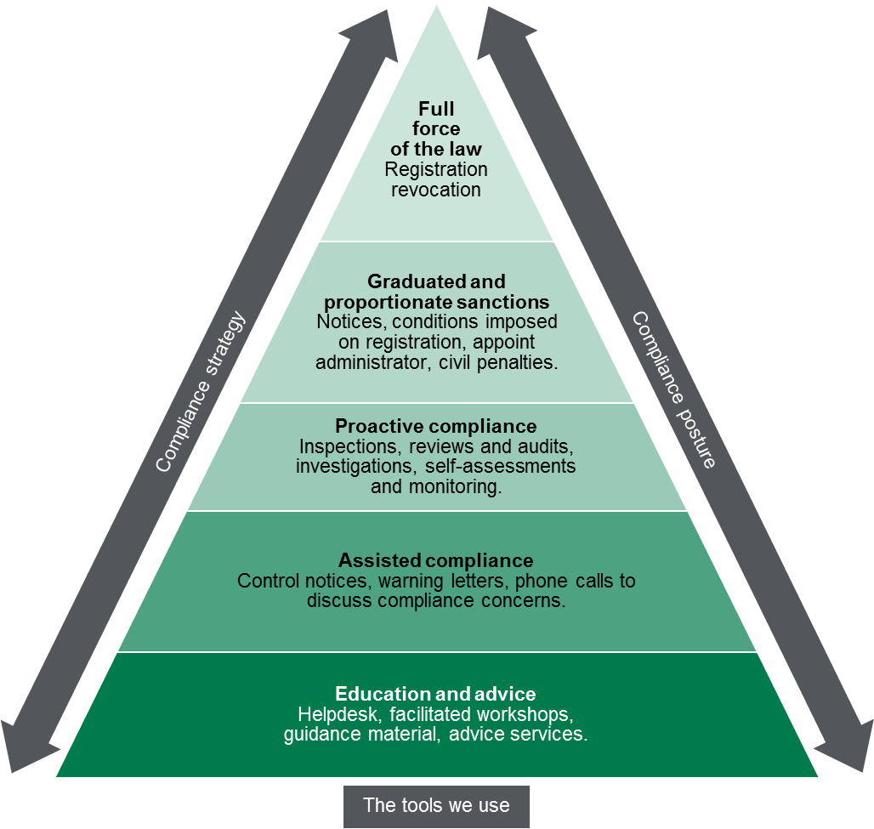

Measuring performance
This section sets out our understanding of how the activities that we undertake, as targeted by the identification and assessment of risks, contribute to Standards and Regulation’s outcomes.

The contribution story
This section sets out the long-term outcome indicators that Standards and Regulation contributes to as part of a broader system of influencers. Standards and Regulation recognises that it contributes to these outcomes, as part of a system of influences both within the department and external to the department.
Standards and Regulation was established in July 2011 in response to concerns raised in 2010, by both the Ombudsman Victoria and Victorian Auditor General, about the potential conflict of interest where the regulation section of the department is located with the service provision section of the department. This separation was achieved through the establishment of Standards and Regulation.
The registration of providers and monitoring compliance with the Human Services Standards are the main focus of regulatory activity for Standards and Regulation.
Standards and Regulation acts in the public interest to ensure:
- the lives of vulnerable Victorians accessing in scope human services are enhanced through the improvement of their safety and wellbeing, and the reduction of risk of harm
- the rights of clients are promoted and protected
- people can actively participate in their lives as valued members of the community
- regulated entities meet the Human Services Standards and comply with their statutory obligations under the Children, Youth and Families Act and Disability Act to ensure delivery of quality services resulting in enhanced outcomes for clients

Further evidence we plan to gather to strengthen our contribution story
While feedback has been received and actioned in the past, Standards and Regulation will now formally track the feedback received from helpdesk calls and facilitated workshops.

Direct indicators
In this section, Standards and Regulation has outlined a small number of indicators that can be used to guide its activity and evaluate its effectiveness. To the extent possible, Standards and Regulation indicators demonstrate its contributions to the outcomes that it is trying to achieve, rather than simply the activities that it is undertaking.
The table below on the following page sets out the measures that Standards and Regulation uses to indicate success against our outcomes.

Table 4: Measures used to indicate success against outcomes
Indicator | Current baseline | Target | 2015–16 actual | 2016–17 actual | 2017–18 actual
Reduction in number of notifiable issues found during independent reviews in relation to safety screening | 19 | <19 | 19 | 19 | Not yet available
Reduction in number of notifiable issues found during independent reviews in relation to medication mismanagement6 | 7 | <7 | 4 | 7 | As above
Reduction in number of notifiable issues found during independent reviews in relation to unauthorised or inappropriate restrictive interventions6 | 6 | <6 | 3 | 6 | As above
Reduction in the number of non-conformances measured through independent review body surveys | 80 | <80 | NA | 397 | As above
Proportion of survey respondents who found the workshops beneficial | 50% | 50% | NA | 96% | As above
Proportion of survey respondents who found the regulator assistance and information beneficial through the annual survey | 50% | 50% | NA | 83% | 82%
Number of registrations approved within six weeks of receiving completed application | 0 | 75% | NA | NA | Not yet available

Other sources of evidence to indicate performance
Standards and Regulation also reports on other figures not included in this document, for example, in the Department of Health and Human Services annual report, the number of registrations, revocations and organisations in scope of the Human Services Standards are reported.

Stakeholder engagement

Ongoing communications
The team undertakes day-to-day operational communication regarding regulatory activities. This includes:
- Assisting regulated entities to comply: Standards and Regulation maintains a helpdesk, through which people can access information about registration, the Human Services Standards and their legislative obligations. Standards and Regulation also informs or reminds regulated entities of their registration obligations through issuing letters and notices. Standards and Regulation also has all the key policies and tools available on the department’s website, and delivers facilitated workshops around Victoria. These workshops aim to support regulated entities to prepare for an independent review, or to complete a self-assessment.
- Accessing intelligence on regulated entity behaviour: Standards and Regulation engages independent review bodies to assess regulated entities’ compliance with the Human Services Standards. These third party bodies are responsible for reporting their findings to Standards and Regulation, who will then use this information to inform their regulatory activities. Standards and Regulation also considers all information that it receives from regulated entities when processing the information provided to it as a part of the application (or renewal) process for registration with the department.
- Monitoring the behaviour of regulated entities: As well as engaging independent review bodies, Standards and Regulation requires completion of self-assessment reports and quality improvement plans in circumstances where a regulated entity is exempt from independent review (dependent on the level of funding and their activities). The self-assessment and quality improvement plans require regulated entities to demonstrate their compliance with the Human Services Standards, which is then reviewed by Standards and Regulation.
- Continual improvement of the team’s regulatory activities: Standards and Regulation coordinates a quarterly quality reference group, which is made up of representatives from funded and registered regulated entities as well as peak bodies. It also coordinates a quarterly independent review body moderation forum. The intent of these meetings is to provide direction, advice and guidance as well as sharing information and feedback regarding the implementation of the Human Services Standards and regulation activities. Standards and Regulation also maintains a website and provides quarterly email updates, facilitates training workshops, has an online survey, and facilitates an annual quality forum, all to support regulated entities in meeting their regulatory obligations. Standards and Regulation also meets regularly with departmental staff regarding regulated entities regulatory requirements.

Planned communication activities
In 2017–18, the key stakeholder activity which Standards and Regulation will undertake to address the risks to its outcomes will be:
- Working with regulated National Disability Insurance Scheme (NDIS) providers through service provider information sessions. The sessions will be co-facilitated with operational division staff and NDIS Branch to ensure newly registered, or to be registered, National Disability Insurance Agency (NDIA) providers receive and understand their obligations as a registered provider. At least one session will be held during this financial year and further sessions will be organised as the need arises.
- Working with internal stakeholders (such as operational divisions, central program areas) in relation to disentanglement, sharing information and ensuring ability to provide effective responses and outcomes, such as by meeting with these areas as required.

Stakeholders
Table 5: List of key stakeholders
Key stakeholders | Type
Service providers that are registered with the department | Regulated entities
Independent review bodies | Source of intelligence
Departmental central program areas | Source of intelligence and policy advice
Departmental operational divisions and co-regulators | Co-regulators and source of intelligence
National Disability Insurance Agency | Co-regulator
Disability Services Commissioner | Co-regulator
Peak bodies | Source of intelligence

Glossary
Term | Definition
Co-regulator | A co-regulator is a national, other State and Territory, and Victorian regulator who has complementary objectives or functions, and/or regulate the same entities. Examples include AHPRA, WorkSafe, and the Federal and Victorian Police.
Department | Means the Department of Health and Human Services (Victoria).
Harm | Means physical harm, sexual harm, emotional harm, neglect.
Health and wellbeing | Means ensuring all aspects of health (both physical and mental), nutritional, developmental, cultural and social needs are being met.
Human Services Standards | Means the Department of Health and Human Services Standards as gazetted under the Children, Youth and Families Act 2005 and the Disability Act 2006.
In Scope | Means activities in scope of independent review or registration as applicable.
Register(s) | Means:  - the Register of disability service providers referred to in section 46 of the Disability Act 2006; and/or  - the Register of community services referred to in section 54 of the Children, Youth and Families Act 2005.
Registration | Means registration under the Children, Youth and Families Act 2005 and/or the Disability Act 2006.
Regulated entity | Means for the purpose of this document, an organisation that is in scope of the Human Services Standards.
Safety | Means physical, emotional and cultural safety.
Secretary | Means the Secretary of the Department of Health and Human Services  In this policy, where a power of the ‘Secretary’ is referred to, this is also a reference to that power exercised by the Secretary’s delegate/s.
Standards and Regulation | Means the Standards and Regulation Unit in the Department of Health and Human Services, which manages quality, compliance and registration functions of the Secretary of the Department of Health and Human Services, the contact details for which are included in this document.

Figure text
Figure 1. Allocation of responsibilities in relation to oversight of organisations
This figure is a triangle that depicts the allocation of responsibilities within the department in relation to oversight of organisations.
The figure illustrates how information gathered from regulated parties informs how the department can both manage risks by:
- enforcing existing contractual conditions between the entity and the department; and
- using the enforcement mechanisms outlined in the human services standards and the units compliance policy.
The bottom of the triangle relates to information gathering that informs both regulatory and contract management enforcement. Arrows lead from the bottom part to the middle part of the triangle.
The middle part of the triangle refers to contract management on the right, and regulatory enforcement on the left. Arrows point in both directions between regulatory enforcement and contract management.
The top part of the triangle relates to the Secretary of the department. Arrows point in both directions between the Secretary of the department and regulatory enforcement, and the Secretary of the department and contract management.
Figure 2. Regulatory tools
This figure is an enforcement pyramid. The figure seeks to demonstrate that the unit will use the full range of tools available to it in line with the risks that they are seeking to manage. The enforcement pyramid illustrates a graduated and proportionate enforcement approach. The bottom of the pyramid outlines the lighter touch interventions such as education and advice to regulated parties, through to revoking a registration at the top of the pyramid, where regulated parties deliberately work against intended outcomes and intend to evade compliance obligations.

Governance and management standards are established and upheld by department-endorsed independent review bodies
Refer to the Human Services Standards policy
For a full list of the declarations, refer to the Policy, procedures and forms for registration of Department of Health and Human Services funded disability service providers and community services available at: https://providers.dhhs.vic.gov.au
For a list of the declarations in the self-assessment, refer to the Human Services Standards self-assessment report and quality improvement plan available at: https://providers.dhhs.vic.gov.au
For further information refer to the independent review body information on the Human Services Standards webpage at: http://providers.dhhs.vic.gov.au/human-services-standards
A reduction or increase in figures may be impacted by external influences changes in reporting.
Survey is twice yearly. This figure is only for part year due to date introduced.
The result of 96% was based on combining the average responses from two workshops.
Not previously measured.

