Water Unit regulator plan on a page
March 2018–June 2019

This document summarises the key elements of the Water Unit regulator plan. The plan provides the context the regulator works within and an overview of its regulatory framework and activities. This is supported by the Better regulatory practice framework: January 2018–June 2019, which provides a process for risk-based and accountable regulatory practice, and improved regulatory performance in the health and human services sector. The regulator plan and framework are available on Better regulatory practice framework <https://www.dhhs.vic.gov.au/better-regulatory-practice-framework>.

Outcomes
The Water Unit’s work is focused on two separate overarching outcomes: the provision of safe drinking water supplies by water agencies and maintaining water quality at public aquatic facilities to reduce the incidence of water-borne illness.
The Water Unit achieves these outcomes through administering the Safe Drinking Water Act 2003, the Safe Drinking Water Regulations 2015, the Health (Fluoridation) Act 1973 and through the provision of advice to local government and aquatic facility operators.

Who we regulate
We regulate state-owned urban and rural water businesses, alpine resort management boards and Parks Victoria as water suppliers and water storage managers. These are collectively referred to as water agencies, and are regulated through the safe drinking water regulatory framework.
Local council Environmental Health Officers are relied upon to directly regulate public aquatic facilities, which include swimming pools and spas, under the Public Health and Wellbeing Act 2008.

Who we work with
The Water Unit interacts with a broad range of stakeholders to help deliver outcomes, including water agencies, aquatic facility operators, auditors, industry associations, local government and other state government agencies.
Safe Drinking Water Act 2003
Safe Drinking Water Regulations 2015
Health (Fluoridation) Act 1973
Public Health and Wellbeing Act 2008
Public Health and Wellbeing Regulations 2009

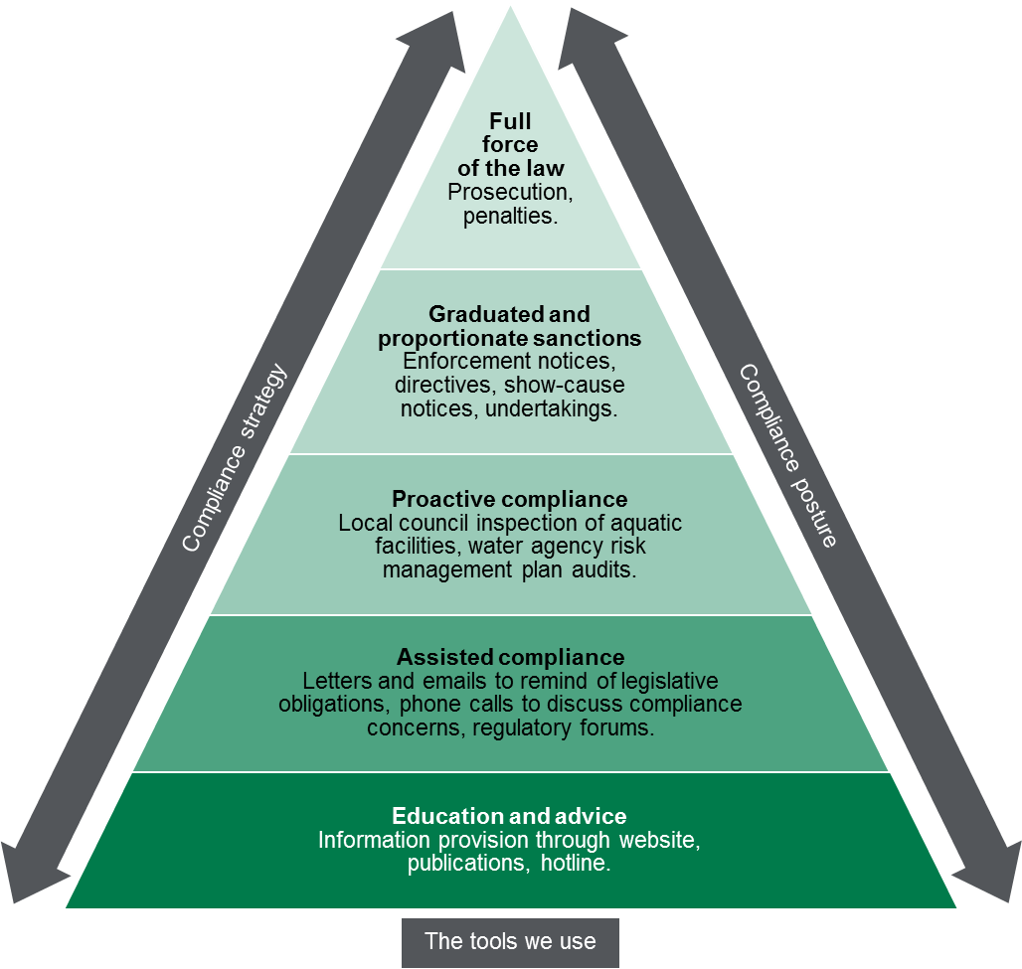

Contribution story
Water agencies supply water to approximately 95 per cent of the Victorian population. The Water Unit protects the public from water-borne illness through effective oversight of the safe drinking water regulatory framework.
Over 90 per cent of the Victorian population has access to fluoridated drinking water, reducing tooth decay and lowering rates of hospital admission for dental treatment. Children living in areas without water fluoridation have 59 per cent higher rates of admission to hospital for dental treatment.
A Victorian study has found association between swimming in public swimming pools and illness from the water-borne parasite Cryptosporidium. Effective regulation of water quality and risk management at aquatic facilities is essential to reduce the incidence of water-borne illness.

Measuring our impacts
The Water Unit monitors its performance in achieving the overarching outcomes. Indicators include:
- water agency compliance with risk management plan requirements
- water agency compliance with the E. coli water quality standard
- time taken by aquatic facilities to implement actions in response to cryptosporidiosis outbreaks.

Diagram text
This figure is an enforcement pyramid. The figure seeks to demonstrate that the Water Unit will use the full range of tools available to it in line with the risks that they are seeking to manage. The enforcement pyramid illustrates a graduated and proportionate enforcement approach. The bottom of the pyramid outlines the lighter touch interventions such as education and advice to regulated parties, through to prosecution at the top of the pyramid, where regulated parties deliberately work against intended outcomes and intend to evade compliance obligations.

To receive this publication in an accessible format phone 1300 761 874, using the National Relay Service 13 36 77 if required, or email the Water Unit at <water@dhhs.vic.gov.au>
Authorised and published by the Victorian Government, 1 Treasury Place, Melbourne.
© State of Victoria, Department of Health and Human Services, March 2018.
ISBN/ISSN 978-1-76069-341-1 (online)
Available at Regulatory practice framework <https://www.dhhs.vic.gov.au/better-regulatory-practice-framework>

