Victorian Alcohol and Drug Collection
VADC Bulletin 2021-22
Edition 19: 29 March 2022
OFFICIAL

VADC Bulletins must be read in conjunction with the VADC Data Specification, available here
VADC documentation - health vic
Contents
1. VADC Specifications for 2022-23 2
2. Clarification on VADC 2022-23 Proposal 13 – Minor change to pseudocode of AOD177 2
3. Update to legacy mental health terminology 3
4. Update to Guide of Use for ACSO Identifier. 4
5. Table 5.b Validations in VADC data specification 2021-22 5
6. Service Provider Contact List 5
7. Data Quality review on ACSO Identifier 5
8. Data Quality review on Indigenous status 5

1. VADC Specifications for 2022-23
We are pleased to advise the VADC Data Specification for 2022-23 and VADC Compilation and Submission Specification for 2022-23 are now available.
These documents will be published shortly at Link to VADC Annual Changes.
If you have any questions about the VADC Specifications for 2022-23, please email: vadc_data@health.vic.gov.au

2. Clarification on VADC 2022-23 Proposal 13 – Minor change to pseudocode of AOD177
There was a typographical error with the pseudo code of AOD177 in the specification of Proposal 13. The change is to remove the ‘!’ in the pseudo code of AOD177 (a description of the change is shown in Table 1 and Table 2 below). The correct pseudo code for AOD177 has been incorporated in the VADC Data Specification 2022-23.
Table 1 – Before correction
ID | Edit name/description | Data elements | Pseudo code/rule | Source | Status
AOD177 | Maltreatment code OR Maltreatment perpetrator not recorded for person of concern where family violence recorded  Only applies when Report Period >= 072021 | Event – maltreatment code  Event – maltreatment perpetrator  Event – family violence  Contact-relationship to client | Event-Family Violence = 2 AND [Contact - relationship to client = 0 OR Event-service stream != (Table 3 Activity Type = R)]  AND [( Event-Maltreatment code IN (null,0,9) OR Event-Maltreatment Perp NOT in (0,1,2,3) )] | DH | warning

Table 2 – After correction
ID | Edit name/description | Data elements | Pseudo code/rule | Source | Status
AOD177 | Maltreatment code OR Maltreatment perpetrator not recorded for person of concern where family violence recorded  Only applies when Report Period >= 072021 | Event – maltreatment code  Event – maltreatment perpetrator  Event – family violence  Contact-relationship to client | Event-Family Violence = 2 AND [Contact - relationship to client = 0 OR Event-service stream = (Table 3 Activity Type = R)]  AND [( Event-Maltreatment code IN (null,0,9) OR Event-Maltreatment Perp NOT in (0,1,2,3) )] | DH | warning

3. Update to legacy mental health terminology
The ICD Technical Group (ITG) has released the Twelfth edition of the diagnosis code list ICD10 --AM/ACHI/ACS, which is effective from 1 July 2022 to 30 June 2025. Changes to the mental health terminology has been incorporated to the classification. The revised terminology has been added to the VADC data specification 2022-23 for the data element Mental Health Diagnosis in section 5.1.15. A description of the change is shown below.
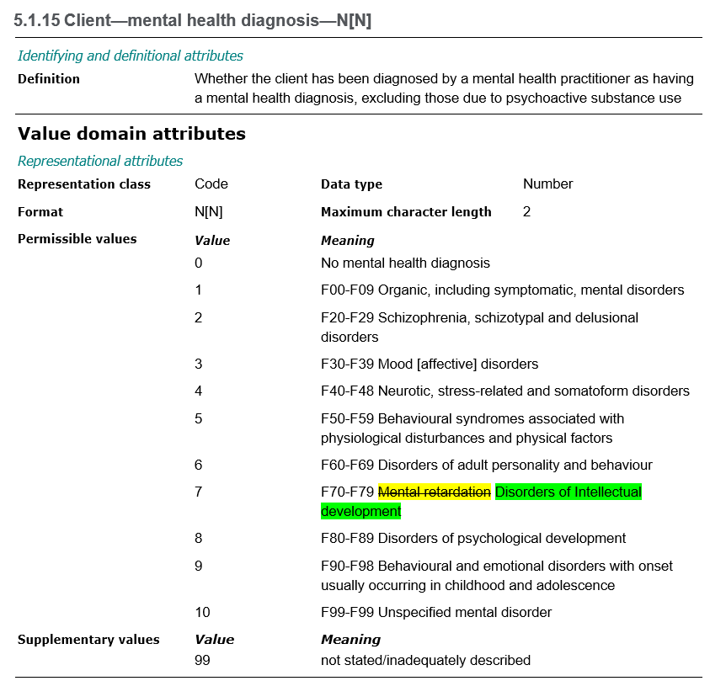

4. Update to Guide of Use for ACSO Identifier.
To remove any ambiguity when referring to the ‘event ID’ in the Guide of Use of section 5.7.1 of VADC data specification 2021-22, ‘event ID’ has been replaced with ‘ACSO-COATS event ID’ as shown below. This change will be reflected in the VADC data specification 2022-23.

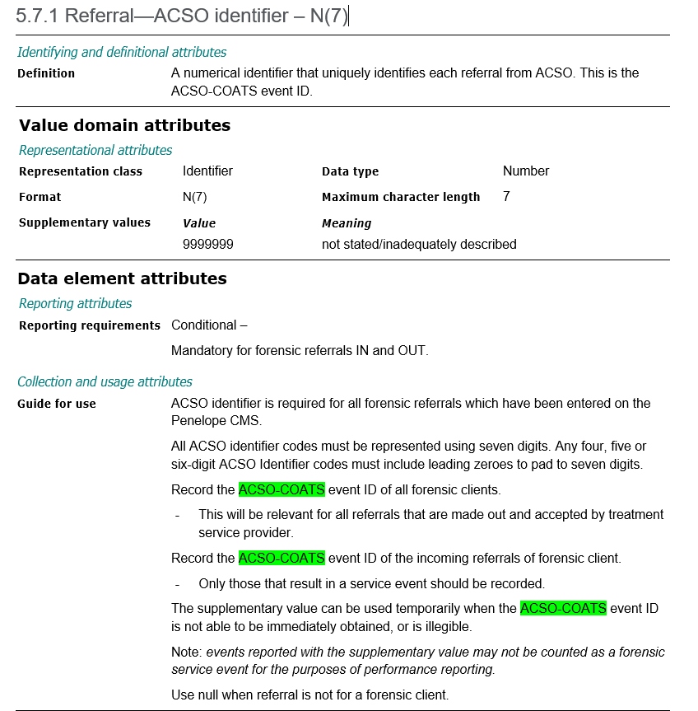

5. Table 5.b Validations in VADC data specification 2021-22
We have corrected a typographical error in the status description in Table 5.b of Section 6 of the VADC data specification 2021-22. The status description for each of the validations in Table 5.b has been corrected to only show as either a warning or error. This is shown below and has been incorporated in the VADC data specification 2022-23.

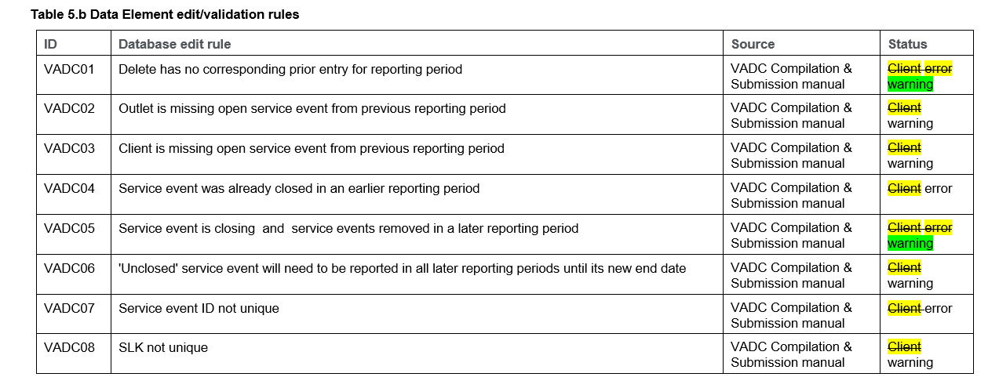

6. Service Provider Contact List
In the near future the VADC data team will contact Service Providers and Consortium leads to verify that the contact information on file is correct and up to date.

7. Data Quality review on ACSO Identifier
We have undertaken a Data Quality (DQ) review on the ACSO Identifier and reached out to the relevant services for clarification. Thank you to the services who have responded to date on the outcomes of the DQ review of the ACSO Identifier and resubmitted data as necessary.

8. Data Quality review on Indigenous status
A Data Quality (DQ) review is currently underway to identify services reporting unusually high supplementary values for the indigenous status. It will also cover any unusual trends in the indigenous status where services deal with specific service types.
Upon completion of the DQ activity, we will be in contact with the relevant services to review and discuss any concerns.

To receive this document in another format email: vadc_data@health.vic.gov.au

Authorised and published by the Victorian Government, 1 Treasury Place, Melbourne.
© State of Victoria, Australia, Department of Health, March 2022

