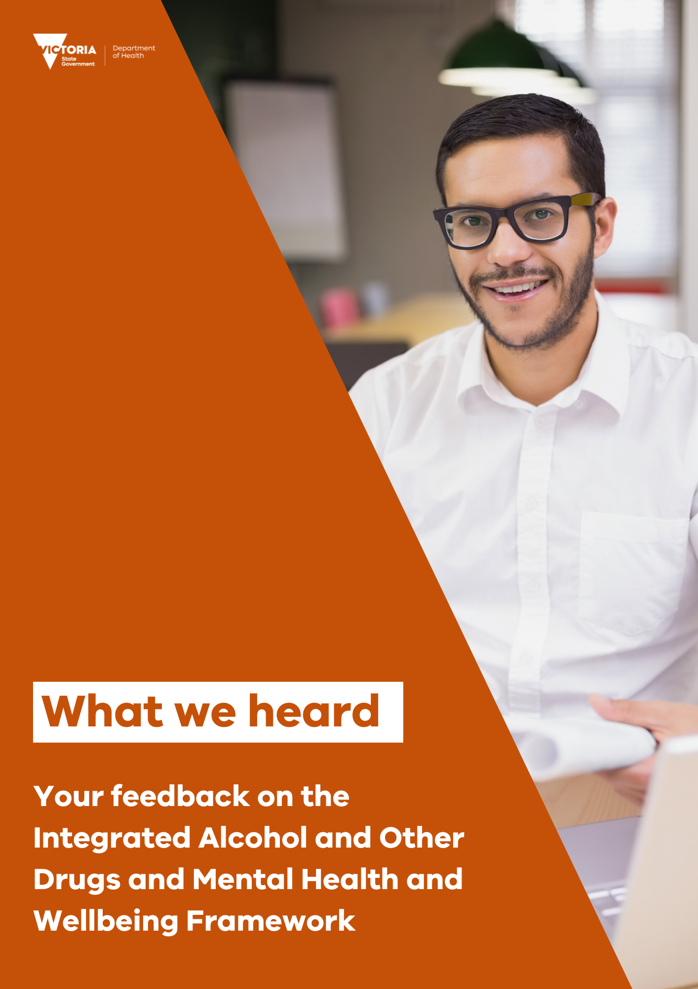

Background
Why we are developing an Integrated Framework
The Integrated Alcohol and Other Drugs and Mental Health and Wellbeing Framework (the Integrated Framework) will support implementation of recommendations 35 and 36 of the Royal Commission into Victoria’s Mental Health System.
Recommendation 35: By the end of 2022, ensure that all mental health and wellbeing services, across all age-based systems and service types:
- provide integrated treatment, care and support to people living with mental illness and substance use or addiction; and do not exclude people living with substance use or addiction from accessing treatment, care and support.
Recommendation 36: Establish a new statewide specialist service for people living with mental illness and substance use or addiction to:
- undertake research; support workforce education and training; provide primary consultation to people with the highest intensity support needs; and provide secondary consultation to workforce; and
- increase the number of addiction specialists in Victoria.
In practice, the Integrated Framework will: ​
- provide a common understanding of integrated treatment, care and support in the mental health and wellbeing system for those with co-occurring substance use or addiction needs
- guide the delivery of services for people living with co-occurring mental illness and substance use or addiction with key principles to inform models of care and governance adapted to local context, setting the expectation for future measures of success and consistency across services.

What we’ve done so far
Update from the first phase of consultation
The Department of Health (the department) conducted a first phase of consultation with support from the Victorian Alcohol and Drug Association (VAADA) and the Self Help Addiction Resource Centre (SHARC) for key engagement activities across the mental health and wellbeing and alcohol and other drugs (AOD) sectors and for those with lived and living experience, their families, carers and supporters.
We asked participants to share their opinions and perspectives about the strengths of the current system and their feedback on the draft principles, conceptual model and AOD treatment types for the Area and Local Mental Health and Wellbeing Services.
The department received feedback from 41 different stakeholders on the Integrated Framework through a number of channels:
- SHARC provided lived and living experience feedback sourced from roundtable discussions held in early September 2021 with 23 participants and an online survey with 25 respondents
- VAADA provided AOD sector feedback from consultations with 119 people from 61 agencies in August and September 2021
- Adult and Youth Area Mental Health Services provided insights through targeted, collaborative discussions and written feedback in response to the consultation paper.
Additionally, the Mental Health and Wellbeing Division’s newly formed AOD Expert Advisory Group (EAG) and AOD Lived and Living Experience Advisory Group (LLEAG) have provided ongoing guidance throughout this initial engagement.

What we heard
The department deeply appreciates the time and effort that went into the feedback provided during the first phase of consultation from the AOD and mental health and wellbeing sectors, consumers, their families, carers and supporters. Your expertise is crucial to understanding the system’s current state, and the changes required to provide Victorians with the treatment, care and support they want, where and when they need it.
Some feedback we received was broader than the Integrated Framework scope, and where required and appropriate, feedback has been shared with other project streams across the department’s Mental Health and Wellbeing Division to consider through other mechanisms.
Key themes heard throughout consultation on the Integrated Framework
In response to questions we asked about the strengths and enablers of the current system, the draft principles, conceptual model, and AOD treatment types in Area and Local Mental Health and Wellbeing Services, we heard that:
- the draft principles were largely supported
- continuity of treatment, care and support, relationship building, safe community spaces, trauma-informed practice and group and individual programs and wellbeing activities should all be key features of integrated treatment, care and support moving forward
- the four-quadrant conceptual model was not supported by most stakeholders and it was broadly recommended that the model not be adopted. There was a strong preference for an alternative consumer-focused model, aligned with existing best practice models
- harm reduction was viewed as having an important role to play in the future mental health and wellbeing system
- there is a need to strengthen the perspectives of people with lived and living experience across all aspects of the Integrated Framework to ensure that consumers are at the heart of decision making
- essential enablers to the delivery of integrated treatment, care and support included:
- streamlined intake, assessment and screening processes and tools
- easy and clear referral pathways
- effective communication, collaboration and information sharing at the worker, service and system levels
- a system that promotes and supports therapeutic connections with workers, where a safe and trusted space has been developed
- care coordination, case management and care navigators to support and guide people through the service system, including liaising with other services and workers
- integrated treatment, care and support needs to be inclusive of a person’s universal whole needs, including addressing experiences of trauma, physical health needs, housing, socioeconomic status and social determinants of health
- there needs to be a clear definition of integration to clarify expectations and support a shared understanding among the sectors, people with lived and living experience, families, carers and supporters
- consideration needs to be given to how service providers will be held to account for delivering on the expectations outlined in the Integrated Framework
- the important role that families, carers and supporters play must be recognised and supported, while also respecting the preferences of consumers.

Next steps
Plan for the second phase of consultation
A second phase of consultation with key stakeholders is planned for February and March 2022.¹ Human-Centred Design engagement with people who have lived and living experience of mental illness and substance use or addiction will provide deeper insights on targeted components of the Integrated Framework.
We will be engaging with stakeholders and partners across the mental health and wellbeing and AOD sectors on a draft Integrated Framework. The draft Integrated Framework will incorporate what we heard through consultation.
We are keen to continue to hear the perspectives from both the mental health and wellbeing and AOD sectors on what integrated treatment, care and support should look like and how this will shape the shared vision for our future system.

The consultation process may be adapted or revised pending ongoing impacts of COVID-19 on department and sector staff resources, and the community.

To receive this document in another format, email aod.enquiries@health.vic.gov.au
Authorised and published by the Victorian Government, 1 Treasury Place, Melbourne.
© State of Victoria, Australia, Department of Health, May 2022.
In this document, ‘Aboriginal’ refers to both Aboriginal and Torres Strait Islander people. ‘Indigenous’ or ‘Koori/Koorie’ is retained when part of the title of a report, program or quotation.
ISBN 978-1-76096-804-5 (pdf/online/MS word)
Available at www.health.vic.gov.au <http://www.health.vic.gov.au>

