Guidelines for use of face masks
Community information

This information has been developed by the Department of Health to provide advice on the use of P2 and N95 face masks in fire affected areas.

Are all face masks the same?
No. Ordinary paper dust masks, surgical masks, handkerchiefs or bandannas do not protect you from fine particles in the air. P2 and N95 masks both help reduce inhalation of these particles

Will a P2 or N95 mask provide total protection?
No. P2 and N95 masks don’t provide complete protection. They do not remove or protect against carbon monoxide.

What are the benefits of wearing a P2 or N95 mask?
Fitted properly, a P2 or N95 mask can filter out some of the fine particles in the air. Make sure the mask is fitted properly and a good seal has been achieved.
The mask should be sealed over the bridge of the nose and mouth, and there should be no gaps between the mask and face.
Men should be clean shaven to get a good seal. See page 2 for a fit guide.

How long can I wear the mask?
The mask should be disposed of after four hours of continuous wear or when it becomes moist.
Masks should be replaced after each use.
For high particle exposures, the mask will load up with particles and become harder to breathe through. If you notice this restriction, change the mask.
If the filter is damaged in any way, e.g. the straps are broken, you need to replace it

.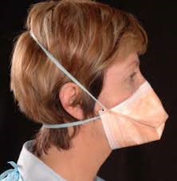
P2 non-ventilated mask

Are there any problems with P2 or N95 masks?
P2 and N95 masks can be very hot and uncomfortable and can make it harder for you to breathe normally. If the mask isn’t fitted properly or becomes loaded up with dust particles from extended use, it will be less effective

Is there anyone who shouldn’t wear a P2 or N95 mask?
Anyone with a pre-existing heart or lung condition should try to seek medical advice before using a face mask.
These masks are not designed for children.

What else can I do to protect my family from the smoke and ash?

- Avoid all outdoor physical activity.
- Anyone with a heart or lung condition should take their medication as prescribed by their doctor.
- People with asthma should follow their asthma management plan.
- Switch air-conditioners to recirculate. If they do not have that function, turn them off. Try to take an air-conditioned break elsewhere if it is safe to do so and your home is uncomfortable.
- Reduce activities that affect indoor air quality, like smoking cigarettes, burning candles or vacuuming

Where can I get more information?
- Visit www.emergency.vic.gov.au for updates on air quality information and what actions you need to take. Air quality information is also available at the EPA AirWatch website www.epa.vic.gov.au/EPAAirWatch .
- Call the VicEmergency Hotline on 1800 226 226 for updated incident information as well as access to support services.
- Keep up to date with community newsletters produced by the local Incident Control Centre, which are available at www.emergency.vic.gov.au or at local relief centres.
- Check the EPA website for general information on Smoke and Your Health at www.epa.vic.gov.au/your-environment/air/smoke

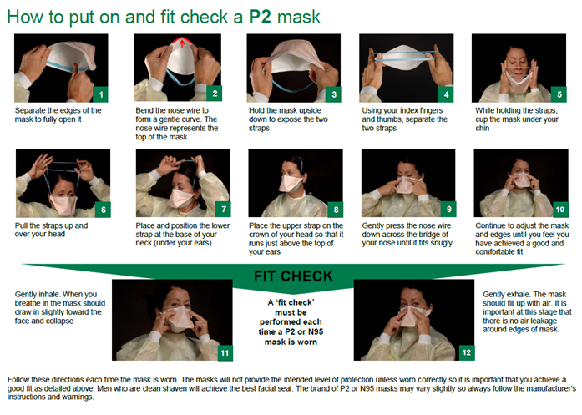

To receive this document in another format, phone 1300 761 874, using the National Relay Service 13 36 77 if required, or email Environmental Health Unit, <Environmental.HealthUnit@health.vic.gov.au>.
Authorised and published by the Victorian Government, 1 Treasury Place, Melbourne.
© State of Victoria, Australia, Department of Health, February 2021.
Available at Community Factsheets – Bushfires <https://www.health.vic.gov.au/emergency-type/community-factsheets-bushfires >

