What we learned: Integrated treatment, care and support.
Developing Guidance for the Mental Health and Wellbeing and Alcohol and Other Drug Sectors
OFFICIAL

To receive this document in another format, email <aod.enquiries@health.vic.gov.au>.
Authorised and published by the Victorian Government, 1 Treasury Place, Melbourne.
© State of Victoria, Australia, Department of Health, July 2022
ISBN 978-1-76096-918-9 (pdf/online/MS word)
Except where otherwise indicated, the images in this document show models and illustrative settings only, and do not necessarily depict actual services, facilities or recipients of services.
In this document, ‘Aboriginal’ refers to both Aboriginal and Torres Strait Islander people. ‘Indigenous’ or ‘Koori/Koorie’ is retained when part of the title of a report, program or quotation.
Available at the Department of Health website <https://www.health.vic.gov.au/mental-health-reform/recommendation-35>

Introduction
This document summarises collaborative work undertaken by the Department of Health (the department) and a range of stakeholders to develop the Integrated treatment care and support for people with co-occurring needs: Guidance for Victorian mental health and wellbeing and alcohol and other drug services (the Guidance) and associated Workplan: Integrated treatment, care and support workplan (the Workplan) and Future experiences: Integrated treatment, care and support. It describes how we engaged, who we engaged with, and what we learned.
Across our engagement activities, stakeholders consistently told us that:
- good integrated treatment, care and support is safe, genuine, instils a sense of hope and empowers people with lived and living experience to take meaningful action
- a good service experience is welcoming, hopeful, timely and offers a coordinated response to a person’s co-occurring mental illness and substance use or addiction
- a person-centred approach is critical and that seamless, coordinated care needs to be delivered in line with people’s individual preferences, strengths and goals
- tangible, practical mechanisms are needed to ensure that integrated treatment, care and support works in practice and is embedded across whole-of-system reforms
- making integrated treatment, care and support happen is everybody’s business and relies on strong cross-sector collaboration.
Collectively, these insights have helped us to shape the vision, principles and expectations of the Guidance and enabling reform activity through the associated Workplan.
Together with the What We Heard report produced in 2021, we hope this document provides a useful point of reference for those stakeholders who lent their valuable time and expertise to the task, and for readers of the Guidance.

Context
The Royal Commission into Victoria’s Mental Health System (Royal Commission) final report envisages a future system in which people with co-occurring mental illness and substance use or addiction are provided comprehensive and integrated treatment, care and support that best meets their needs and preferences.
To realise this vision, the Royal Commission recommended that by the end of 2022, the department ensures that all mental health and wellbeing services, across all age-based systems, including crisis services, community-based services, and bed-based services:
- provide integrated treatment, care and support to people with co-occurring mental illness and substance use or addiction; and
- do not exclude people with co-occurring substance use or addiction from accessing treatment, care and support.
To support those involved in designing and delivering integrated treatment, care and support, the department has prepared the Guidance. This was supported by consultation with workers and service providers across the mental health and wellbeing and alcohol and other drug (AOD) sectors, people with lived and living experience, key experts and consumer, family, workforce and sector peaks.

Summary of engagement activities to support the development of the Guidance
As per figure 1 below, the department and a diverse range of stakeholders worked together in a variety of ways to develop the structure and content of the Guidance. An important first step was talking to people with lived and living experience of co-occurring mental illness and substance use or addiction to understand what they wanted services to understand about their needs and expectations.

Figure 1: Overview of stakeholder engagement activities
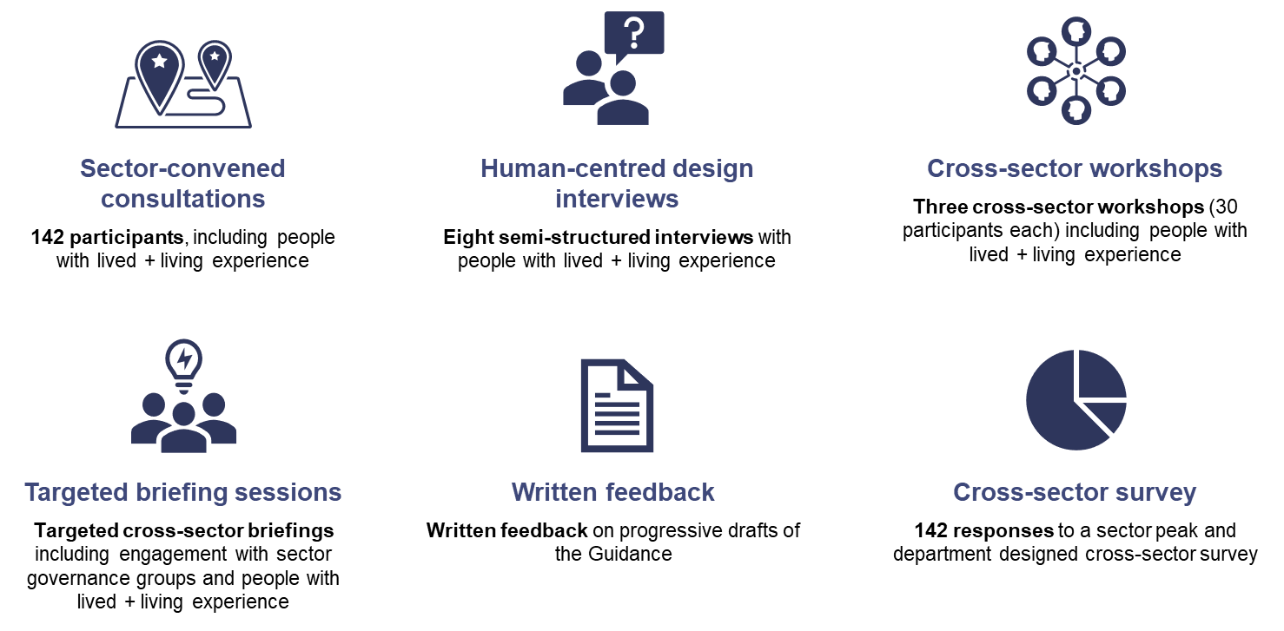

Lived and living experience interviews – what good integrated treatment, care and support looks like
Consistent with the What We Heard 2021 report, the department worked with the Self Help Addiction Resource Centre (SHARC) to conduct human centred design interviews with consumers of Victorian mental health and wellbeing and AOD services and their families and supporters. Understanding people’s experiences helped us develop a vision for integrated treatment, care and support within the Guidance.
The interviews focused on personal perspectives of the current system and hopes for the future. In these interviews, we heard a common story: gaps in service provision and uncoordinated care leading people back to square one. These challenges were felt most deeply among regional Victorians who found options for welcoming and helpful services to be slim and quickly exhausted:
“They weren’t communicating ... And I just felt like people were kind of like ‘oh no this person can do this, and that person can do that,’ then I go to those people, and they’d be like ‘no, no, this person should be doing it’ and I was just kind of getting sent around in circles.”
The interviewees told us that the Guidance needs to make explicit that consumer choice, control and decision-making about their treatment, care and support is paramount. Interviewees were also clear that meaningful co-design opportunities are critical to ensure that consumers, their families and supporters, can contribute their distinct expertise to the planning, design, delivery and evaluation of service and system reforms.
Interviewees also shared:
- their experiences of what constitutes ‘good help’, and the way help is offered
- that families and supporters can play a critical role in the treatment, care and support journey of the person they are supporting but are often missing from the equation
- that they felt let down by uncoordinated care and experienced challenges in accessing and moving between services
- one of the most important characteristics of ‘good help’ was non-judgement to alleviate the impact of stigma experienced in seeking support.
“When you're accessing a service and you have … drug and alcohol dependency, and you're kind of looked at like you're like a piece of dirt, it changes your whole self-worth, it changes the way that you view the world, it changes the way that you'd be with services like it may make you never want to access services again.”
These insights formed the foundation of the principles and expectations of services in supporting people with co-occurring mental illness and substance use or addiction, as articulated in the Guidance. The Guidance aims to achieve a future in which all people with co-occurring mental illness and substance use or addiction enjoy their best health and wellbeing, with equitable access to integrated treatment, care and support that meets their needs and preferences and proactively involves families and supporters.

Practitioner workshops – building on the vision
The insights described above were used to frame discussion in three workshops with practitioner experts, service managers and people with lived and living experience from across both the mental health and wellbeing and AOD systems.
The workshops aimed to develop a shared understanding, vision, and objectives for integrated treatment, care and support. The rich cross sector collaboration and co-learning that occurred supported the ongoing development of the principles and expectations outlined in the Guidance.
Through the workshops we learned that a good service experience is welcoming, offers respect and non-judgement; provides person-centred care driven by a person’s preferences and goals; and is accessible:
“Just showing that they care, so even if they can't empathise with my situation, showing compassion towards my situation, and actually showing that they understand what I’m going through, they understand that it's a difficult time.”
The Guidance takes the approach that, regardless of whether a person seeks support for their co-occurring mental illness and substance use or addiction in the mental health and wellbeing or AOD system, they will be met with a welcoming and compassionate approach, based on a philosophy of ‘how can we help?’ Through these workshops, the Guidance began taking shape, comprising key principles of integrated treatment, care and support and broad obligations of services and workers.

Targeted briefings – Guidance framing, and change enablers
Targeted briefings were held with stakeholders across the mental health and wellbeing and AOD sectors. This included a range of practitioner, lived and living experience, academics and advisory groups, and cross-sector briefings.
These groups advised us on key considerations in framing the Guidance, and what kinds of enablers we should prioritise in the forward Workplan. Stakeholders consistently recommended that the Workplan include the development of tangible, practical ways to ensure that integrated treatment, care and support will work in practice. Stakeholders also wanted to have a clear sense of how whole-of-system reform would support integrated treatment, care and support.
One of the key themes emerging from targeted briefings was the need for leadership to champion change and support strong relationship building between sectors – both modelling change and providing the tools for workers to do the same.
These insights informed the beginnings of our Workplan that details a range of enabling activities that people with lived and living experience, workers, services providers and the department will collectively undertake to bring to life the Guidance’s vision for people with co-occurring needs, and their families and supporters.

Draft testing – cross-sectoral, multi-perspective testing of the vision
The department sought feedback on the draft Guidance from the mental health and wellbeing and AOD sectors and experts, including people with lived and living experience.
The key mechanism for receiving feedback was through a survey co-designed with peaks and experts. We received over 140 responses, including many thoughtful free-text responses. These were invaluable in ensuring that the department was informed by multiple perspectives on the draft Guidance and implementation planning.
Across 51 questions, including via a lived and living experience stream, respondents provided us with insight into the current state of integrated treatment, care and support, and what enabling activity would be required to meet the principles and expectations set out in the Guidance. The survey included specific questions regarding the delivery of integrated treatment, care and support in different settings and workforces.
As a result of what we learned through this testing, the Guidance now articulates expectations of service providers’ when supporting people with co-occurring needs and their families and supporters. These expectations pick up key themes from the survey responses including:
- services need to be culturally safe and competent
- consumers should have access to a diverse range of evidence-based treatment, care, and support options
- system navigational supports and care coordination will ensure continuity of care
- family and supporter specific supports should be available at first contact.
Survey respondents were also keen to tell us that making integrated treatment, care and support happen is everybody’s business. This feedback shaped our approach to ensuring that all mental health and wellbeing reforms are tailored to support accessible, seamless, consistent, and timely integrated care for people with cooccurring needs and their families and supporters through:
- increased collaboration and communication across mental health and wellbeing and AOD systems is required, including shared understandings, approaches, and tools (e.g., clear, and consistent protocols and systems for information sharing).
- supporting accessibility and consistent experiences for people with co-occurring mental illness and substance use or addiction requires multiple entry points, various delivery modes and visibility.
- resourcing mental health and wellbeing and AOD services (and workers) to deliver equitable and timely best practice integrated treatment, care and support.
- ensuring evaluation, accountability processes and continuous quality improvement measures in our new system incorporate integrated treatment, care and support.
- supporting culture change to reduce stigma – including through evidence-based change management processes to support sectors to transition to integrated treatment, care and support.
- working to support a shared understanding of integrated treatment, care and support across allied services, including first responders.

Conclusion – continuing the learning
In preparing the Guidance, the department has aimed to reflect the collective and diverse views of stakeholders who have contributed significant time and effort to the development of the Guidance. This expertise has been crucial to understanding the system’s current state, and the changes required to provide people with co-occurring mental illness and substance use or addiction and their families and supporters, with the treatment, care and support they want, where and when they need it.
As noted, we are only at the very beginning of our reform journey. There are a range of enabling activities that people with lived and living experience, workers, services providers and the department will collectively undertake to bring to life our vision for people with co-occurring needs, and their families and supporters. These activities will be delivered through considered stakeholder engagement, including:
- continued effort to align with other reform initiatives
- working with existing governance and advisory structures, along with other key stakeholders, to ensure that integrated treatment, care and support reform effort is being appropriately managed at a systems, service and worker level
- the design of the statewide service for people living with mental illness and substance use or addiction to provide support to, and build the capability of, the mental health and wellbeing and AOD systems to deliver integrated treatment, care and support
- the development of more detailed implementation advice and related products to support services and workers to achieve our shared vision for people with co-occurring needs and their families and supporters
Engagement will be crucial in our next steps to support mental health and wellbeing and AOD services on the journey to integrated practice. Next steps outlined in the Guidance will be driven by collaboration with people with lived and living experience, workers, and service providers to ensure that stakeholders remain on the journey to reach our shared vision.
While this new approach to integrated practice will contribute to the design and implementation of the broader system reform agenda, the vision for integrated treatment, care and support will also need to be carried through stakeholder engagement activities of these reform initiatives. There are engagement opportunities across all reforms, and we encourage stakeholders from both sectors to participate through the calendar of engagement opportunities available on the Department of Health’s website.

Acknowledgments
We would like to acknowledge the generous contribution of all stakeholders in the development of the Guidance. This work has been achieved with the rich and diverse perspectives of the mental health and wellbeing and AOD sectors and lived and living experience peak bodies including Victorian Alcohol and Drug Association (VAADA), Mental Health Victoria, Victorian Mental Illness Awareness Council (VMIAC), Tandem, the Victorian Aboriginal Community Controlled Health Organisation (VACCHO), Harm Reduction Victoria and the Self Help Addiction Resource Centre (SHARC).
The Guidance has also been informed by the many member organisations of these peak bodies, key experts, union representatives and enriched with the expertise of the Victorian Dual Diagnosis Initiative and people with lived and living experience and our First Nations communities.
Your expertise has been crucial to understanding the system’s current state, and the changes required to provide people with co-occurring mental illness and substance use or addiction and their families and supporters, with the treatment, care and support they want, where and when they need it.

The department conducted an initial phase of consultation with support from the Victorian Alcohol and Drug Association (VAADA) and the Self Help Addiction Resource Centre (SHARC) delivering key engagement activities across the mental health and wellbeing and alcohol and other drugs (AOD) sectors and for people with lived and living experience and their families and supporters. Stakeholders provided feedback on the draft conceptual model of integrated treatment, care and support and offered perspectives about the strengths of the current system. The What We Heard report provided an update on initial consultation activities, feedback received and next steps for engagement. The What We Heard report can be accessed here: https://www.health.vic.gov.au/mental-health-reform/recommendation-35.
VAADA led the development of the survey with support from Mental Health Victoria, SHARC, Tandem, the Victorian Mental Illness Awareness Council, the Victorian Healthcare Association, the Mental Health and Wellbeing Division’s Human Centred Design Hub, Lived Experience branch, Systems Management branch and the AOD Strategy team.
https://www.health.vic.gov.au/mental-health-wellbeing-reform/calendar-of-engagement-opportunities

