The Alfred’s high-quality end-of-trip facilities
4.4 – Sustainable transport in health care
Contents
Case study 1
Highlights 3

Case study
As one of Melbourne’s largest hospitals, The Alfred has parking pressures – not only for staff who drive but also for people who ride.
Back in 2014, bikes cluttering walkways and chained to railings were becoming a potential work safety and access issue. This was the impetus to transform the hospital’s existing bike parking into award-winning end-of-trip facilities.
A survey of people who were currently riding collected valuable data on the demand for riding to work, as well as riders’ needs. This helped support a business case that was developed and approved over 18 months.
Upgrading facilities is a significant capital cost. However, The Alfred’s executive supported the compelling case that improving staff health and wellbeing, and reducing car parking pressures by encouraging more people to ride would outweigh these costs.
An architect was appointed to design the facility to ensure it was high quality and made best use of the space. 19 car spaces were converted to 300 bike spaces, 237 lockers, and showers and change facilities – all in the one location.
A huge mural of a bicycle makes it obvious where to enter the end-of-trip facility. Access is completely separate from cars, which makes it easier for both riders and drivers.
Figure 1: Entrance to The Alfred's end-of-trip facilities
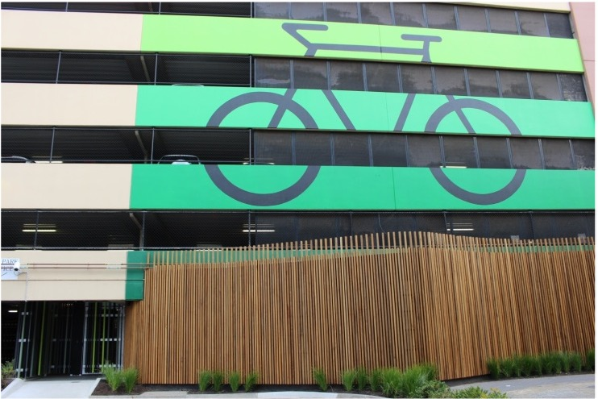
It is also secure and all users are registered. Its location near the car park office provides useful oversight and makes it feel safer for riders.
Everyone who applies for parking fills out the same form, whether they want a car park or a secure bike rack. This makes the option to ride visible to all staff.
People pay to use the facility – one dollar a week for entry and three to four dollars for a locker. In exchange their bike is secure and dry, they have a towel service, shampoo and hairdryers and plenty of space to store their clothes. And a great way to end their ride into work.
Converting 19 car spaces into bike parking now gives over 600 registered users secure parking and lockers.
Figure 2: Outside the shower and changing facilities
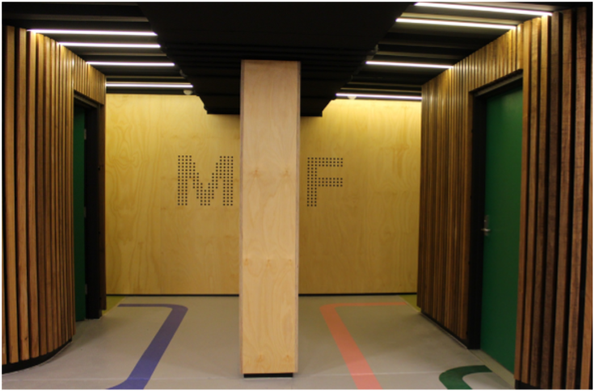

Highlights
- Fee for service – pre-tax charges for parking and lockers go back into operational costs and to procure more lockers
- Co-payment approach builds ownership and ensures high-demand lockers are being used
- Registered access makes the facility secure
- Easy application process makes it a visible option for all staff
- High quality facilities make it an attractive, feasible, and effortless option for staff to undertake active travel to and from work
- Regular evaluation from staff show high levels of satisfaction
Figure 3: Secure bike racks
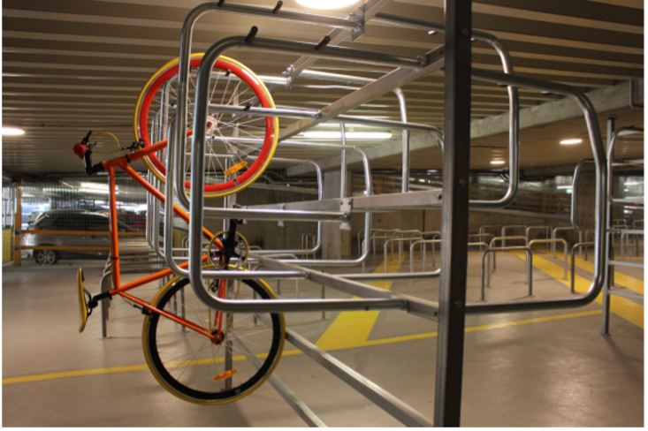

To receive this document in another format, phone 9595 2898, using the National Relay Service 13 36 77 if required, or email sustainability <sustainability@health.vic.gov.au>.
Authorised and published by the Victorian Government, 1 Treasury Place, Melbourne.
© State of Victoria, Australia, Department of Health, August 2022.
Refer to the main reference document ISBN 978-1-76096-951-6 (pdf/online/MS word)
Available at Department of Health website <www.health.vic.gov.au/sustainability>

