Hospital travel plan case studies
1.1 – Sustainable transport in health care
Contents
Introduction 1
Liverpool Hospital, Sydney 1
Hawkes Bay District Health Board, New Zealand 2
QEII Medical Centre Pert 3
Other hospital travel plan case studies 4

Introduction
A workplace travel plan applies a mix of tailored measures that respond to a location’s transport access options and the specific organisational context of a workplace (which includes its culture, attitudes and needs of its employees) to increase the use of sustainable travel options for commuting to work.
These three case studies of hospital travel plans illustrate the integrated approach of successful workplace travel plans across metropolitan, suburban and regional settings.

Liverpool Hospital, Sydney
- A major acute care hospital in an outer suburban growth area.
- 4,000 staff (at time of project).
- Travel plan delivered over three years from 2012 to 2014.
- Executive commitment from the health service
- A three-year funded program.
- Led by a coordinator and supported by a coordination committee (health promotion team).
- No changes to parking management as a disincentive to drive.
- Main actions included:
  - new end of trip facilities
  - carpooling
  - events
  - an access guide (excerpt shown in Figure 1)
  - individual journey planning sessions for interested staff
  - a clear brand – ‘Staff travel choices’.
- Drive alone rates dropped from 83 per cent to 70 per cent in three years (10 per cent drop in the first year).
- Success evaluated with annual staff travel surveys – statistically robust evaluation of change in travel (travel plan was part of a PhD study).
- Study conclusion: ‘A workplace travel plan which only included strategies to encourage active travel to work achieved small but significant increases in active travel.’
Figure 1: Excerpt from Liverpool Hospital access guide
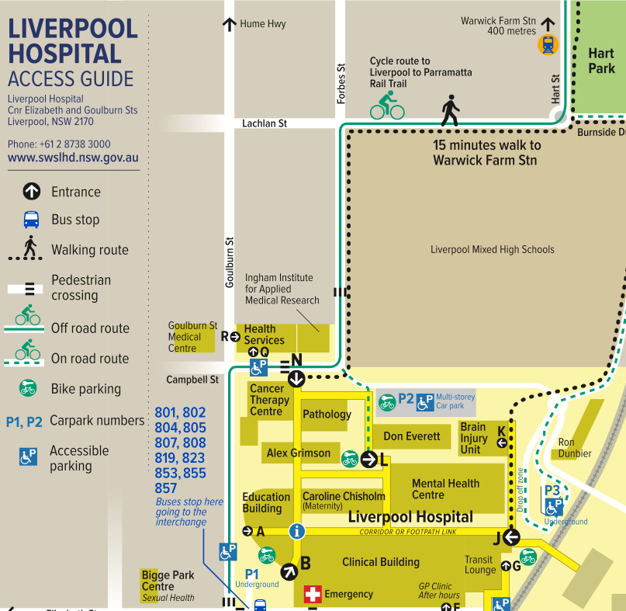

Hawkes Bay District Health Board, New Zealand
- A major regional hospital with over 3000 staff.
- Travel plan implemented over four years from 2015 to 2018.
- Changed focus from parking provision to transport access.
- Program funded by introducing a small daily staff parking charge.
- Sustainability officer appointed to lead program.
- Actions included:
  - small public transport subsidy for bus travel and end of trip facilities
  - staff access guide.
- ‘Go well’ campaign to promote access options – used on all travel plan materials
Figure 2: Go Well sign
- To keep the campaign positive and inclusive, messages focused on choice and making it easier – ‘However you choose to get here, we want to make it easier.’
- Drive-alone travel dropped from 78 per cent to 60 per cent of total trips.
- Annual parking complaints dropped from 88 to zero.

QEII Medical Centre, Perth
- Travel plan implemented from 2006 (5,000 staff at the start and up to 8,000 during the six-year implementation).
- Central city hospital – greater travel choice compared to suburban and regional settings.
- Comprehensive parking management (reduced number of staff car parks available on-site)
  - access to parking divided into three priority groups based on need – Priority group 2 includes green commuters, registered carpooling staff and staff whose journey is not served by public transport (see Table 1)
  - policy developed in consultation with staff
  - permits renewed annually
  - relatively complex to manage.
- Funding and promotion of other travel options (increased bus services, carpooling and so on)
- 2015 research findings comparing QEII and adjacent Hollywood Private Hospital implementing travel plans over six years:
  - QEII drive alone reduced from 85 per cent to 43 per cent
  - Hollywood Private drive alone down from 80 per cent to 75 per cent.
- Over 10 years later, QEII access program has a lower profile with less promotion.
Table 1: Categories for parking priority at QEII Medical Centre
Group | Description
Priority group 1 | Designated parking area.  - Regular shift workers starting before 7 am or end after 6:30 pm  - Staff who are on-call, medical consultants and other permit holders  - Staff approved by QEIIMC parking permit appeals committee
Priority group 2 | Designated parking area.  - Green commuters (use other modes at least 60 per cent of the working week)  - Registered carpooling staff (two or more arrive together)  - Staff with demonstrated primary carer needs  - Staff whose journey to site is not serviced by public transport
Priority group 3 | Restricted access to parking areas.  - Staff who work between 7 am and 6:30 pm  - If insufficient car spaces – priority given to staff with the greatest time differential between driving and using public transport

Other hospital travel plan case studies
Hospital travel plan case studies | Link and description
Global Green and Healthy Hospitals (GGHH) Transportation case studies | Available on the GGHH website's Case studies from GGHH members page – under ‘Transportation’ <https://www.greenhospitals.net/case-studies-transportation>
Mater Services South Brisbane Transport Actions – ‘Transport at Mater Health Services’ | Available on the GGHH website's Case studies from GGHH members page – under ‘Transportation’ <https://www.greenhospitals.net/case-studies-transportation>
Lismore Hospital case study | Available on Northern NSW LHD website's Lismore Base Hospital Precinct draft travel plan page <https://nnswlhd.health.nsw.gov.au/blog/2015/08/25/lismore-base-hospital-precinct-draft-travel-plan>
Royal North Shore – Workplace travel plan 2016 to 2018 | Clear and easy to read.  Available on the Northern NSW LHD website's Active travel page – under ‘Workplace travel plans’ <https://www.nslhd.health.nsw.gov.au/HealthPromotion/Pages/ActiveTravel.aspx>.
Northern Beaches Health Service – Workforce travel plan | Simple 3-page travel plan.  Available on the Northern NSW LHD website's Active travel page – under ‘Workplace travel plans’ <https://www.nslhd.health.nsw.gov.au/HealthPromotion/Pages/ActiveTravel.aspx>.
Transport for NSW Hospital travel plan case studies 2018 | PDF of hospital travel plan case study summaries accessible at <http://data.mysydney.nsw.gov.au/files/Hospital+travel+plan+case+studies.pdf>
Hawkes Bay District Health Board, NZ – ‘Go Well travel’ campaign and supporting travel plan | Available on the GGHH website's Case studies from GGHH members page – under ‘Transportation’ <https://www.greenhospitals.net/case-studies-transportation>

To receive this document in another format, phone 9595 2898, using the National Relay Service 13 36 77 if required, or email sustainability <sustainability@health.vic.gov.au>.
Authorised and published by the Victorian Government, 1 Treasury Place, Melbourne.
© State of Victoria, Australia, Department of Health, August 2022.
Refer to the main reference document ISBN 978-1-76096-951-6 (pdf/online/MS word)
Available at Department of Health website <www.health.vic.gov.au/sustainability>

Petrunoff N et al, 2015 Carrots and sticks vs carrots: Comparing approaches to workplace travel plans using disincentives for driving and incentives for active travel, Journal of Transport & Health

