Sustainability in healthcare update
Edition # 36, August 2022

Hospital travel plan guide for Victorian health services
The Sustainable Transport in Healthcare project was completed over 2020-21 and key resources are now available to support hospitals to develop sustainable travel plans and the deliverables in the Five-year environmental sustainability strategy. The project was conducted in partnership with Peninsula Health and Eastern Health and included the development of travel plans at four sites (Frankston Hospital, Rosebud Hospital, Maroondah Hospital and Lilydale Health Service) and the development of a framework and tools to be used by all health services.
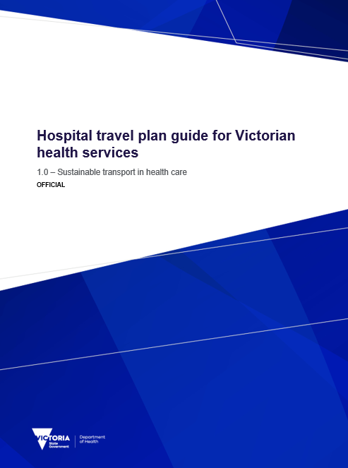
Western District Health Service kindly agreed to test the framework to ensure it is appliable to a rural health service and provided invaluable feedback.
The framework enables health services to identify the type of travel plan approach based on the organisation’s size and resourcing. These include passive, active and comprehensive approaches.
The framework and toolkit are now available on the department’s website. All resources have been combined into a single document for ease of review and are also available as individual documents. These can be downloaded and customised to your health services branding as required and selected based on the approach your health service chooses to take.
For those of you who are familiar with the Sample action plan template (which enables you to select key actions as part of your Environmental Management Plan), a similar Sustainable Transport tool has also been developed. This tool enables the selection of key actions that your health service can focus on for the transport section of your Environmental Management Plan based on your available resources.
A big thank you to the project partners and all involved: the commitment to delivering project outcomes over a difficult period has been outstanding.
The resources can be accessed from the Department of Health’s website <https://www.health.vic.gov.au/planning-infrastructure/transport>.
For further information contact sarah.bending@health.vic.gov.au

Zero emissions vehicle (ZEV) program update
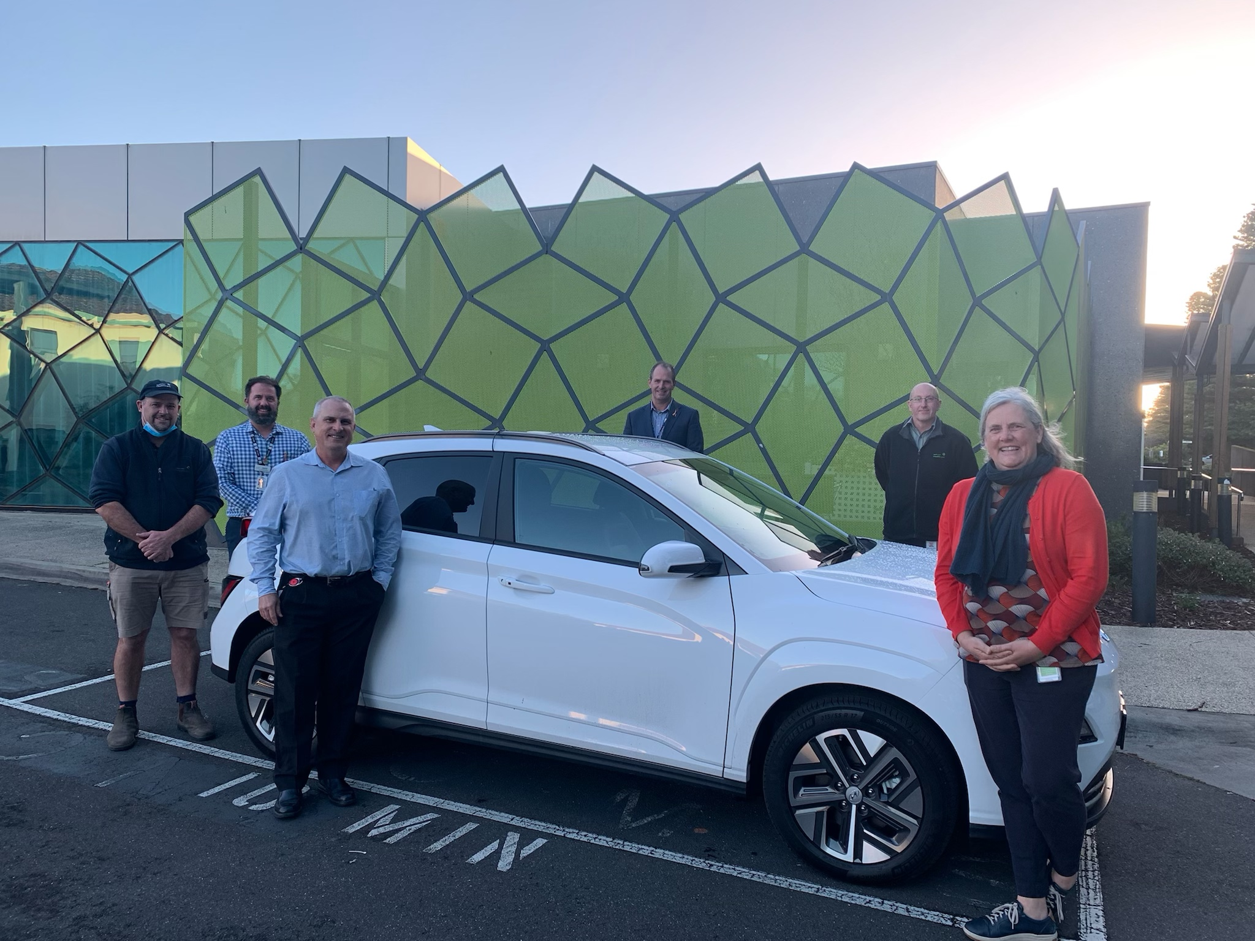
The Zero Emission Vehicle (ZEV) program will transition 400 vehicles in the Victorian Government Fleet to ZEVs by 30 June 2023 together with associated infrastructure upgrades, with a $15 million investment from the 2021-22 State Budget. The program is led by the Department of Treasury and Finance (DTF) working with the department and health services for health and departmental sites.
Image 1 (Image from left to right) South West Healthcare’s Operations Manager Benjamin Manuell, Executive Director Redevelopment and Infrastructure Jamie Brennan, Buildings and Infrastructure Manager Stuart Blignaut, CEO Craig Fraser, Fleet Officer Tim van der Starre and Environmental Sustainability Officer Elvira Hewson with the new Hyundai Kona fleet car.
A new milestone was reached in the project with Warrnambool Base Hospital receiving 16 new Hyundai Kona battery electric vehicles – supporting South West Healthcare nurses to provide services to regional communities. Replacing existing petrol vehicles used by community and palliative care nurses to provide vital care for patients at home, the new ZEVs have an impressive 480km maximum range that enables Warrnambool nurses to travel long-haul return trips without charging enroute.
Benefiting Warrnambool Base Hospital through ongoing cost savings, the ZEVs have much lower maintenance and running costs than petrol or diesel equivalents – freeing up funds for other crucial health services.
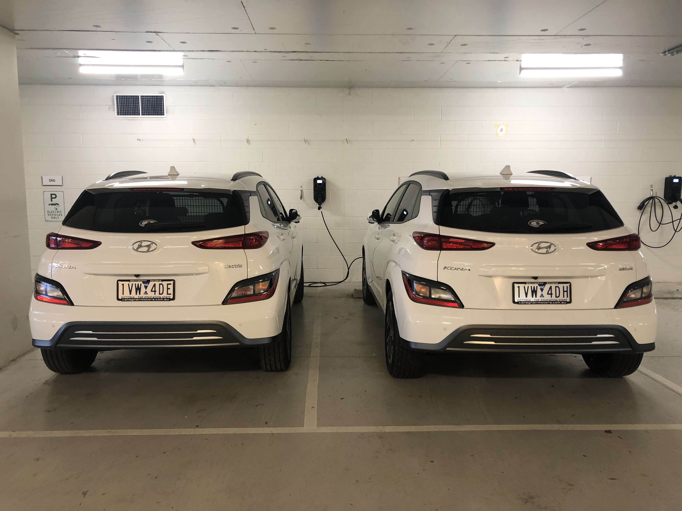
All 400 ZEVs in the Victorian Government fleet will include a dedicated charging station, while Warrnambool Base Hospital has also received a 50kW fast charger that delivers a 100km range in only 15 minutes charge time.
Image 2 – Hyundai Konas parked within the new charging bays at South West Healthcare
Fast-tracking the Victorian Government fleet’s ZEV transition, the Victorian based company JET Charge has been awarded the contract to supply and install a charging network across government-owned and leased buildings, with charging stations manufactured here in Victoria.
To help spark community interest in the take-up of sustainable transport, the Victorian Government’s $15 million investment also allows for the 400 ZEVs to be available for public purchase at the end of their lease period. The Victorian Government has also invested $5 million in grants to expand the publicly accessible fast-charging network at key tourist destinations and high use locations across Victoria. Locations can be seen on the DELWP website.< https://www.energy.vic.gov.au/grants/destination-charging-across-victoria-grant-program>.
The other health sites are still going through final stages of evaluation, as noted in previous updates, and will be updated in the next edition of the Sustainability in healthcare update.
Further information is available on ZEVs on the Department of Health, Environment, Land and Planning website < https://www.energy.vic.gov.au/renewable-energy/zero-emissions-vehicles> and on the DTF website < https://www.dtf.vic.gov.au/zero-emissions-vehicle-program>

Australian Health Leadership Roundtable on Climate Action
The department attended the Australian Health Leadership Roundtable on Climate Action, which took place on 29th June 2022. The roundtable The Roundtable was co-hosted by the World Health Organization (WHO) and the Climate and Health Alliance (CAHA) and was attended by ministers and senior health officials from the Commonwealth and all state and territory governments.
The Roundtable brought together health ministries from federal, state, and territory governments to explore opportunities to align the healthcare sector with Australia’s climate goals.

Introduction of FRD24 expansion
The Victorian Government has introduced a significant uplift to environmental reporting requirements to help track the commitment to reach net zero emissions for the state by 2050. This includes expanding the scope and application of Financial Reporting Direction (FRD) 24, which came into effect 1 July 2022 for the 2022-2023 reporting year.
The department is working with the Department of Environment, Land, Water and Planning on arrangements for the 2022-23 transition year, with the expectation that an updated environmental management system will be available to health services from 1 July 2023.
During this phase the department will be working to update its suite of related materials. The Policy and Funding Guidelines 2021-22 include a note on the transitional arrangements which are available from the Department of Health’s website <https://www.health.vic.gov.au/policy-and-funding-guidelines-for-health-services.
DELWP is also working through developing the following resources including any customisation with individual portfolios as follows:
- Development of inclusions for the Model Report for Departments
- Updates to portfolio reporting guidance
- FRD 24 data reporting tool
- Training webinars and videos
The department is currently going through a procurement process to engage a supplier to provide a state-wide environmental data management system from 1 July 2023 to enable compliant reporting for the 23-24 year. The system adopted will be required to meet the relevant reporting requirements of FRD24. The existing environmental data management system will continue operating under its existing contract up until 30 June 2023.
Further information on the new FRD can be found on the Department, Treasury and Finance website <https://www.dtf.vic.gov.au/financial-reporting-policy/financial-reporting-directions-and-guidance>.
For further information please contact sarah.bending@health.vic.gov.au or if it relates to EDMS email edms@health.vic.gov.au.

EDMS and annual reporting guidelines
All health services are required to report environmental performance data in their annual reports, as required under the annual reporting guideline introduced in 2021. The data for this is available by running the public environment report in the departments environmental data management system (EDMS) for 2021-22 – this will provide health services with three years of environmental data for their annual report.
Communications have been sent to health services EDMS contacts regarding EDMS and providing an update on timelines ahead of the annual reporting cycle.
Note that the Environmental Reporting guidelines, which state health services can choose where they report, has been succeeded by the annual reporting guideline introduced in 2021. Whilst health services are welcome to produce a stand-alone report, this does not replace the requirement to report into the annual report.
As of 25 July, data in the EDMS was ready for annual reporting, except for hospital fleet data which is still being sourced from VicFleet. If you need to find out who your EDMS contact is, please email Aaron.Hoare@health.vic.gov.au.
New Melton Hospital to be all-electric
The 2022-23 State budget committed more than $900 million to deliver a new Melton Hospital by 2029. The hospital will be designed as Victoria's first all-electric hospital powered by 100 per cent renewable electricity. This supports the Victorian Government’s commitment to reduce carbon emissions from its operations and reduce gas use across the State's public health portfolio. The hospital’s design will focus on sustainability initiatives such as maximising on-site solar generation, high-performing facades, efficient plant and equipment, and integration of green spaces within the hospital precinct.
More information on the project can be found on the VHBA website <https://www.vhba.vic.gov.au/health/hospitals/new-melton-hospital>.
New sustainability requirements for the Regional Health Infrastructure Fund
The Victorian Health Building Authority has increased the sustainability and climate adaptation requirements for submissions into the 2022-23 Regional Health Infrastructure Fund. This includes requirements to implement specified sustainability initiatives for certain types of projects and the availability of a sustainability allowance to deliver initiatives above standard practice.
More information on the Regional Health Infrastructure Fund is available on the VHBA website <https://www.vhba.vic.gov.au/health/regional-facilities/regional-health-infrastructure-fund>.

Barwon South-West Environmental Sustainability network
The Barwon South-West Environmental Sustainability network was established in March 2022. This included the establishment of the first Regional Environmental Sustainability Manager for the Barwon South-West Health Service Partnership working with the regional public health services, with Kylie McIntyre appointed to this role. The role was established as a result of the regional CEO Council recognising the need for support amongst the health care services for their environmental programs and identified some key areas where a regional officer could assist. The role is currently funded until 30 June 2023 through the Regional Health Service Partnership (HSP) program of work.
Anaesthetic and medical gases working group
An anaesthetic gases working group has been established under the Environmental Sustainability Strategy Strategic Advisory Group (SAG), with representatives Australian Health Leadership Roundtable on Climate Action from the department, Safer Care Victoria, Australian Nurses and Midwifery Federation (ANMF Vic), Victorian Perioperative Consultative Council (VPCC) and Safety and Quality Committee, Australian and New Zealand College of Anaesthetists, Society of Anaesthetists, Health Share Victoria, Doctors for the Environment and public health services.
One of the key purposes for the group is to provide advice to the SAG on the reporting of anaesthetic and medical gases and opportunities for reducing the environmental impacts associated with the use of anaesthetic and medical gases in Victorian public hospitals. The group is expected to commence the key work in the final quarter of 2022 and deliver its findings to the Strategic Advisory Group in the first half of 2023.
For further information contact sarah.bending@health.vic.gov.au

Global Green and Healthy Hospitals (GGHH) Network
The department encourages public health services to join GGHH and access the many benefits provided through the network which include networking and support from a community of sustainable healthcare colleagues across Australia, New Zealand and globally. There are resources available which have been developed specifically for healthcare sustainability and opportunities for international recognition for environmental achievements.
If you have any questions or would like support becoming a member please contact Stephanie Caruso, CAHA Sustainable Healthcare Program Manager & GGHH Pacific Region Coordinator. For more information visit the GGHH website < https://www.caha.org.au/globalgreen_healthyhospitals1>.

Key contacts
Enquiries can be emailed to sustainability <sustainability@health.vic.gov.au>, or alternatively please see the contacts below.
Infrastructure Policy – Environment and climate change team
Susan Harvey / Artemisia Kousis | Managers, Environment and Climate Change (Job-share) |  | Susan.harvey@health.vic.gov.au, Artemisia.kousis@health.vic.gov.au
Sarah Bending | Senior Environmental Programs Advisor | 9595 2898 | Sarah.Bending@health.vic.gov.au
VHBA – Sustainability in capital projects, environmental data and energy programs
Tiernan Humphrys | Manager Environmental Sustainability | 9456 3104 | Tiernan.Humphrys@health.vic.gov.au
Julian Freeland | Resource Efficiency | 9456 3229 | Julian.Freeland@health.vic.gov.au
Aaron Hoare | Sustainability Project Officer | 8850 6979 | Aaron.Hoare@health.vic.gov.au
To receive this document in another format, phone 9595 2898, using the National Relay Service 13 36 77 if required, or email sustainability <sustainability@health.vic.gov.au>.
Authorised and published by the Victorian Government, 1 Treasury Place, Melbourne.
© State of Victoria, Australia, Department of Health.
August 2022, ISSN 2207-0893 (Online)(pdf)
Available at the department’s website <www.health.vic.gov.au/ sustainability>
To receive this publication in an accessible format phone 9595 2898 using the National Relay Service 13 36 77 if required, or email <sustainability@health.vic.gov.au>

