Travel plan assessment tool
2.0 – Sustainable transport in health care
Contents
Introduction 1
1. Staff numbers 2
2. Location 2
3. Transport access 3
4. Travel-related issues 4
5. Organisational success factors 4
Assessment 5

Introduction
This assessment tool helps a health service to review the interacting factors that will guide its decision to develop either a passive, active or comprehensive travel plan for a specific workplace (hospital or other health service facility). Unique factors at some sites may warrant extra initiatives be delivered within a level, such as passive+ and active+.
This is a qualitative assessment to inform the approach and effort of a workplace travel plan.
To complete this assessment, first collect and analyse data relating to:
- how staff travel
- local transport context
- your organisation's capacity to support an effective travel plan.
Refer to steps in the Travel plan guide and toolkit resources to help with your analysis and assessment.

1. Staff numbers
The ‘default’ level travel plan is based on the total number of staff. This level may go up or down (such as passive to passive+ or active), depending on other factors in this assessment.
Input:
- Total staff EFT (equivalent full time) primarily based at the workplace (hospital or health service site).
Number of staff | Default level
Less than 50 | Passive
50 to 249 | Passive+
250 to 749 | Active
750 to 2,000 | Active+
Over 2,000 | Comprehensive
Note: A small workplace is unlikely to develop more than a passive plan unless many staff live close by and there are very strong organisational factors (such as resources, staff interest and leadership).

2. Location
Geographic location broadly influences the opportunity for change (due to variation in transport options and the ease of car travel).
Locations:
- regional town or city
- metropolitan fringe or outer suburban
- inner or middle metropolitan.

3. Transport access
Two locational factors further influence the opportunity for change:
- public transport availability
- staff proximity to work.
Inputs:
- staff home location analysis – percentage of staff within five kilometres
- site audit desktop review of public transport access.
Transport access | Location | Assessment
Less than 20 per cent of staff within 5 km and limited public transport | - regional town or city  - metropolitan fringe or outer suburban | Reduce level
Over 20 per cent of staff within 5 km or  some public transport access (such as train less than 1.2 km) | - regional town or city  - metropolitan fringe or outer suburban | Maintain level
Less than 10 per cent of staff within 5 km and limited public transport (such as train over 1.2 km, no or few buses) | Inner or middle metropolitan | Reduce level
Over 10 per cent of staff within 5 km or  good public transport (such as train less than 1.2 km and buses) | Inner or middle metropolitan | Maintain level
Over 20 per cent of staff within 5 km or  very good public transport (train, tram, buses) | Inner or middle metropolitan | Increase level

4. Travel-related issues
How significant are travel-related issues for the workplace and staff?
Inputs:
- Human resources area and parking management stakeholders.
- Staff survey – proportion of off-site parking, satisfaction with current travel, proportion of short travel times (under 30 minutes), amount of parking complaints.
- Pressures on car parking: long waiting lists, limited availability, high proportion off-site parking, leasing external parking.
- Projected growth (development or expansion plans).
- Staff experience – ease of travel and satisfaction with current travel, free parking.
Significance of issues | Assessment
High level of issues | Maintain level
Low level of issues | Reduce level

5. Organisational success factors
Your organisation’s capacity and motivation to implement a travel plan. Order of factors reflects their relative importance
- Travel plan coordinator: Person with capacity to lead the plan, 0.2 to 0.4 EFT for active plan. Working group to support.
- Resources: Dedicated funding and independence to implement. What budget and staff are available for implementation?
- Leadership: Executive endorsement and commitment to implement. How supportive are they? IS there an executive champion?
- Outcomes focused: Responds to a clear need and interest – such as managing growth, sustainability and health policies?
- Employee relevance: Staff see value or are interested in encouraging non-car travel (reflected in survey comments).
- Presence and engagement: Able to support change with regular communications. Communications team is supportive and has capacity to participate.

Assessment
Assess the overall strengths and weaknesses of each of the factors. Also consider the potential to strengthen each factor. Then determine whether to reduce, maintain or increase the plan level.
- Plot the assessment outcome for ‘Opportunity for Change’
Figure 1: Opportunity for change
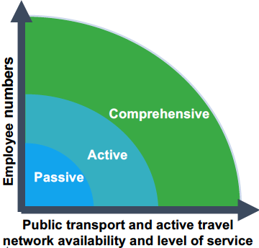
- Plot the assessment outcome for ‘Organisational success factors’
Figure 2: Organisational success factors
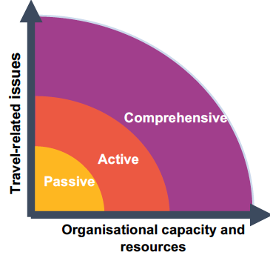
- Overall assessment: Compare assessment outcomes for opportunity for change and organisation capacity to determine travel plan level.

To receive this document in another format, phone 9595 2898, using the National Relay Service 13 36 77 if required, or email sustainability <sustainability@health.vic.gov.au>.
Authorised and published by the Victorian Government, 1 Treasury Place, Melbourne.
© State of Victoria, Australia, Department of Health, August 2022.
Refer to the main reference document ISBN 978-1-76096-951-6 (pdf/online/MS word)
Available at Department of Health website <www.health.vic.gov.au/sustainability>

