Allied Health Clinical Supervision Agreement Template
Guidelines to support an Agreement

- Introduction
The Allied Health Clinical Supervision Agreement is a supporting resource for the Victorian Allied Health Clinical Supervision Framework (VAHCSF). This resource has been developed to assist clinical supervisors and supervisees to complete the Clinical Supervision Agreement.

This resource aligns with the Victorian Allied Health Clinical Supervision Module 2: Getting started with clinical supervision which has been developed to assist allied health workers in completing a Clinical Supervision Agreement and establishing a clinical supervision relationship. Completing this module will assist supervisees and clinical supervisors to develop a Clinical Supervision Agreement.

Why practice clinical supervision
“Clinical supervision is a key component for the provision of safe and high quality patient care and allied health worker wellbeing.”
VAHCSF, p 20.

Why the clinical supervision relationship is important
“An effective clinical supervision relationship, based on mutual trust and respect between the clinical supervisors and supervisee, promotes an environment that optimises the learning and support functions of clinical supervision.”
VAHCSF, p. 18.

Outlining the purpose of a Clinical Supervision Agreement
A clinical supervision agreement provides a framework for the parameters of the clinical supervision relationship, including the roles and responsibilities of the supervisee and clinical supervisor. Developing the agreement enables the supervisee and clinical supervisor to discuss and negotiate a shared understanding of the learning goals for the supervisee and the boundaries and practicalities of clinical supervision.
How the Clinical Supervision Agreement supports best practice clinical supervision
The VAHCSF outlines models of clinical supervision for allied health, including those developed by Kadushin and Proctor which are summarised in figure one. The three domains of clinical supervision are intended to be overlapping and complementary.

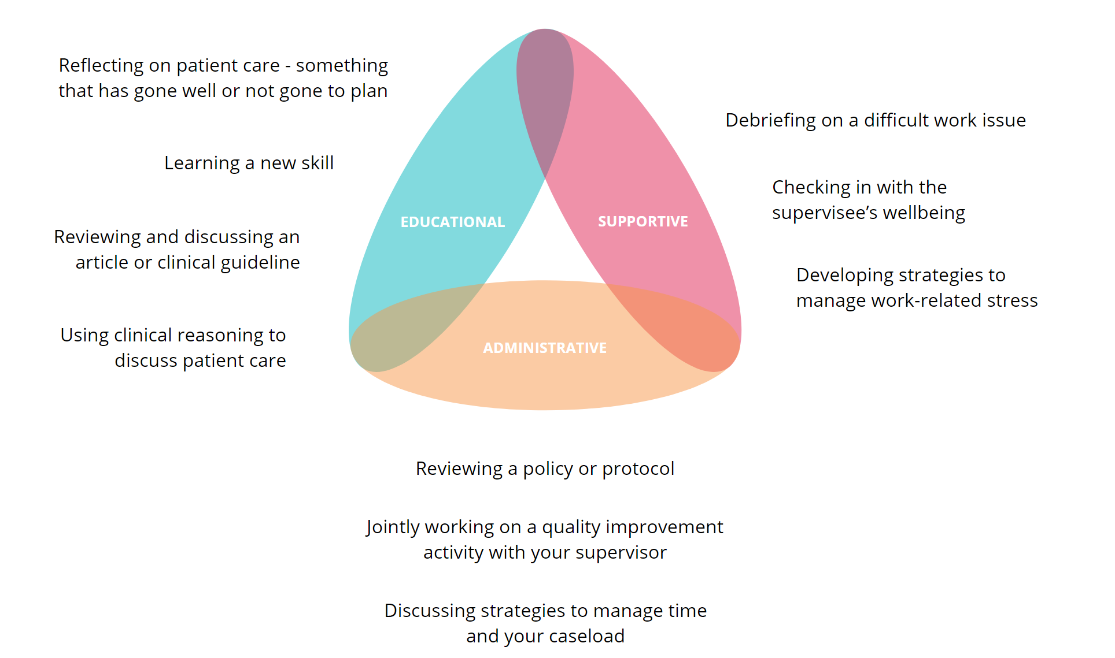

Figure 1: The three domains of Clinical Supervision

The structure of the Allied Health Clinical Supervision Agreement assists clinical supervisors and supervisees to consider each of these domains when setting out how to work together to meet the supervisee’s learning and support needs in clinical supervision.
Part A. Supervision Context and Expectations relates to the Administrative function.
Part B. Supervisee Learning relates to the Educational function.
Part C. Supervisee Professional Support and Wellbeing relates to the Supportive function.
Part D. Supervision Process outlines the practicalities for supervision, including evaluation and how feedback will be provided.

- Step by step guide to sections of the Clinical Supervision Agreement
Date of agreement and formal review dates
The first section of the template provides space to document the date of the agreement and to set a planned date for the agreement to be reviewed.
The Clinical Supervision Agreement should be reviewed on a regular basis by the clinical supervisor and supervisee to ensure that the agreed expectations for clinical supervision are being met. The review may be formal and at a set time, such as after 12 months or at the beginning of a new role or rotation. Reviews may also be “informal” to review smaller portions of the agreement such as the frequency of sessions, reviewing the supervisee learning goals or evaluating how clinical supervision is going.

Part A. Supervision Context and Expectations
Clinical supervision and the clinical supervision relationship are influenced by factors such as the requirements of the work role, organisational expectations including policies and procedures, professional standards for clinical practice and other professional relationships and support in place for the supervisee.
It is essential that the clinical supervisor understands the supervisee’s professional role, and that this understanding is used to guide how clinical supervision is provided. In some areas dual relationships may impact on the clinical supervision relationship and the boundaries of clinical supervision. Examples of this are where a clinical supervisor also has operational management responsibilities for the supervisee, or where a supervisee and supervisor are operationally responsible to a program and professionally responsible to a discipline.
The purpose of this section of the Clinical Supervision Agreement is to encourage the supervisee and supervisor to consider the organisational and professional contexts in which clinical supervision occurs.
Prompts for discussion may include some or all of the following:

Part B. Supervisee Learning
The purpose of this section of the Clinical Supervision Agreement is to discuss the supervisee’s learning needs and to develop a plan for how these will be addressed in clinical supervision. Consideration should be given to the supervisee’s experience, knowledge, learning preferences and role requirements.
The methods used in clinical supervision will be influenced both by the developmental level of the supervisee and their practice setting. For example, a graduate who is still developing skills and competencies may require more direct guidance, such as co-treatment or observation at the point of care. More experienced supervisees will often benefit from more facilitative or self-directed approaches.
The supervisee’s learning goals should be documented, preferably using a SMART format. Reference should be made to the supervisee’s development plan from the performance review process, where available, with discussion about how elements of this plan may be addressed within clinical supervision.
Prompts for discussion may include some or all of the following:

Some useful resources to assist clinical supervisors and supervisees after working through these questions include:

- Pages 19 & 20 of The Superguide from HETI on developing learning goals
- Learning preference questionnaires such as Honey and Mumford or VARK).

Part C. Supervisee Professional Support and Wellbeing
Clinical supervision should be used to support the supervisee’s professional wellbeing, helping them to deal with work-related challenges and stress and to build professional resilience.
The clinical supervisor and supervisee may discuss expectations for the boundaries of the supportive function within clinical supervision, such as how to ensure that clinical supervision does not become personal counselling and how to link the supportive function with supervisee learning.
Prompts for discussion may include some or all of the following:

Part D. Supervision Process
The next section of the Clinical Supervision Agreement outlines the process and practicalities for clinical supervision.

Setting the focus and agenda for supervision
Prompts for discussion may include some or all of the following:

Feedback
Feedback is an essential component of clinical supervision. Feedback should be a two way discussion that encourages self-assessment, reflection, evaluation of the clinical supervision relationship and should be linked to opportunities for future learning. It can be useful to discuss the supervisee’s preferences for how feedback will be provided, and how both parties will raise and discuss difficult issues that may surface in clinical supervision.
Some useful resources to assist clinical supervisors and supervisees with the feedback process include:
- Pendleton’s Model of feedback
- Principles of effective feedback.
These are both outlined in Victorian Allied Health Clinical Supervision Module 3: Practicing effective point of care supervision.
Prompts for discussion may include some or all of:

Evaluation
Evaluating clinical supervision helps ensure it is meeting the learning and support needs of the supervisee, and that the clinical supervision relationship is on track. Evaluation may be informal or formal; focus on a single session or sessions over a period of time; or focus on the clinical supervision relationship. Informal methods include reviewing progress against the supervisee learning goals, discussing what worked well/what could be improved on at the end of a session or reviewing the clinical supervision agreement and discussing whether the agreement is being met. There are a number of more formal tools listed in the resources section.

Prompts for discussion may include some or all of:

In addition to the process outlined in the Victorian Allied Health Clinical Supervision Module 2, a useful resource to assist clinical supervisors and supervisees to evaluate supervision is The Superguide from HETI; pages 18 & 77 suggest several ways, and a feedback form, to evaluate supervision.

Part E. Practicalities for supervision
Practicalities for clinical supervision including frequency and duration of sessions, availability of the clinical supervisor, and options for remote access and processes for documentation should be agreed to when the clinical supervision relationship is being established. While many of these practicalities will be determined by the standards for clinical supervision set in organisational policies and protocols and/or professional standards, where possible these should be tailored to meet the learning and support needs of the supervisee.
It is also important to reach agreement on how documentation of supervision will be carried out, where the documentation will be maintained considering whether it will be in hard copy of electronic, and who will have ready access to the documentation of supervision.
A critical element of supervision being a safe space is the understanding that anything discussed will remain confidential between the supervisee and supervisor. Exceptions to this would be where there is agreement to disclose relevant information, or where risks to patient or staff safety are identified.

Part F. Informal Review of Clinical Supervision and Associated Updates
The Clinical Supervision Agreement should be reviewed on a regular basis by the clinical supervisor and supervisee to ensure that the agreed expectations for clinical supervision are being met. This section of the agreement provides the opportunity to document the outcome of those reviews, including any changes to the Clinical Supervision Agreement that might occur.

To receive this publication in an accessible format phone (03) 9096 7324,
using the National Relay Service 13 36 77 if required, or alliedhealthworkforce@health.vic.gov.au

Authorised and published by the Victorian Government, 1 Treasury Place, Melbourne.
© State of Victoria, Department of Health, Oct 2022.
Available at the Department of Health website < https://www.health.vic.gov.au/allied-health-workforce/victorian-allied-health-clinical-supervision-framework>.

