Mental Health Bulletin 69
Autism Spectrum Disorder Coordinator: CMI-ODS Data reporting update
Note: This bulletin supersedes Bulletin 59
OFFICIAL

Contents
Autism Spectrum Disorder (ASD) Coordinator 1
Background 1
Adult Area Mental Health Services 1
CMI/ODS data reporting 2
Autism Assessments 2
Contact activity data reporting 2
Specialty service development 2
CAMHS/CYMHS ASD Coordinator Program setup: 3
Adult ASD Coordinator Program setup: 3
Further information 4
Appendix 1 5

Autism Spectrum Disorder (ASD) Coordinator

Background

Adult Area Mental Health Services
In January 2020 a 12-month pilot program commenced with funding sourced from the launch of the 2019 Victorian Autism Plan for an ASD Coordinator to work within adult mental health services one day per week.
The expansion of the ASD Coordinators into adult AMHS was in addition to the existing ASD Coordinator services operating within CAMHS/CYMHS which were established and operating with recurrent funding since 2010. The adult services were initially block funded.

CMI/ODS data reporting

Autism Assessments
An assessment of ASD seeks to determine the level of functioning, support needs and diagnostic status of the individual being assessed. This coordinated process commences with a referral and concludes with the sharing of the assessment findings with the client and a referral for any required supports.

From 01 January 2022, where a referral for an ASD has been received, when the consumer is registered then services are to:
- Add a task “Assessment - Autism Spectrum Disorder (ASD)”
- Select the subcentre/team that received the ASD Assessment referral (commences)
Note – this would be the subcentre that the ASD program is linked to
- *Record the “Due date” of the task as the date the ASD assessment request was received
- Save
See also Appendix 1.

*If Autism has been set up as a subcentre rather than a program attached to an existing community team and a referral is received for a consumer who is not yet registered, it is recommended that the ‘due date’ of the task should be the date of registration.
Once the ASD Assessment has concluded, record the conclusion date as “Completed Date” for the above created task. It is optional for services to record tasks for ASD referral for assessments received prior to 01/01/22.

Contact activity data reporting

Specialty service development
ASD Coordinators have been approved to record contact type C, code 6 (specialty service development). This is in recognition that this service is funded to provide specialist type community mental health services which significantly build an area Mental Health Service’s capacity to provide mental health support to a target population. Please refer to the Program Management Circular, Contact Data Definitions (Bulletins and Program Management Circulars (PMC) (health.vic.gov.au)

Please note: As mentioned above, initially the ASD Coordinator in adult AMHS were block funded, however, this has now changed and the funding source for the adult program should now be amended as shown below.

CAMHS/CYMHS ASD Coordinator Program setup:
Note – Must be linked to a subcentre where OM setting is CAMHS Community
Note – No change to set up
PROGRAM
Description | Classification | Program Type | Target Population | AMHS | Fund Source | Start Date
 | Community | Comm, Clin Spec Autism Spec Disorder - CAMHS | Autism |  | 15026 - Child & Adolescent Assessment Treatment & Liaison

Adult ASD Coordinator Program setup:
Note – Must be linked to a subcentre where OM setting is Adult Community
Note – change in funding source
PROGRAM
Description | Classification | Program Type | Target Population | AMHS | Fund Source | Start Date
 | Community | Comm, Clin Spec Autism Spec Disorder - Adult | Autism |  | 15008 – Adult Integrated Community Service | 01/07/2022  (block funding ceased on this date)

If Autism is set up as a subcentre rather than a program attached to an existing subcentre, the expectation is that outcome measures would be collected.
The start date shown above is the date that block funding for adult ASD services changed from block funding. If have already set up your adult autism service please update the funding source only.

Further information
This bulletin has been developed by the Mental Health and Drugs Data team. For further information, please email: MHDReporting@health.vic.gov.au

To receive this publication in an accessible format please email MHD Reporting <MHDReporting@health.vic.gov.au>
Authorised and published by the Victorian Government, 1 Treasury Place, Melbourne.
ISSN 2653-620X - Online (pdf/word)
Available at Bulletins and Program Management Circulars (PMC) - https://www.health.vic.gov.au/research-and-reporting/bulletins-and-program-management-circulars-pmc>
© State of Victoria, Department of Health and Human Services, October 2022

Appendix 1 – How to add an ASD Assessment Task

Select task and choose Assessment – Autism Spectrum Disorder
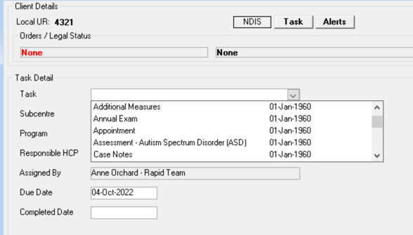

Enter relevant task detail & save
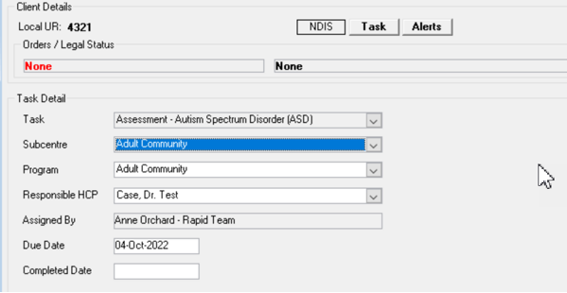
The ‘Due Date’ is to be the date of referral for registered consumers or consumers who were not registered at the time of referral, the due date would reflect the registration date.

To complete the task after entering the referral date, from the summary screen, click on Edit task
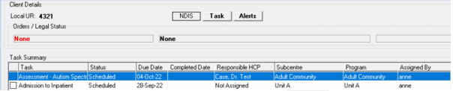

In the detail screen add the completed date & save.
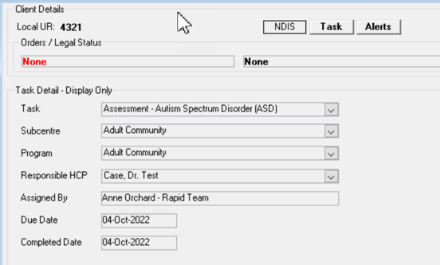

The summary screen is now showing the completed task
