Mental Health Bulletin 71
Lived Experience Workforce (LEW)
OFFICIAL

Purpose and Scope
To provide guidance on set up in CMI/ODS to capture contact data by the Lived Experience Workforce.

Overview
As part of the Royal Commission into Mental Health Recommendations, the Lived Experience Workforce (LEW) has an important role in reform planning and delivery.

The Royal Commission recommended in developing system-wide roles for the full and effective participation of people with lived experience of mental illness or psychological distress (Recommendation 28).

CMI/ODS activity reporting can be enhanced through the use of specific and consistent user profiles for its workforce. This supports privacy requirements, accurate collection of information and data for research/service improvement.
At a service level CMI data also provides individual service providers with an opportunity to review and improve.
The LEW workforce incorporates;
- Consumer workers
- Family/carer workers
- Peer workforce
- Expanding post discharge support

Activity Data Reporting
The Lived Experience Workforce (LEW) will be expected to add contacts to CMI/ODS and it is important to ensure the correct HCP Discipline is assigned to this workforce. Currently Carer Worker and Consumer Worker are identified in the HCP table and these can now be re-assigned to LEW Worker as shown below:
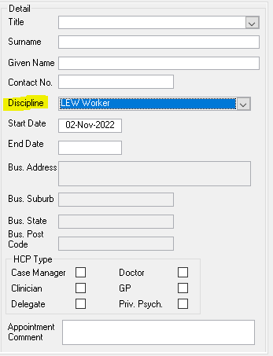
The start date of LEW Worker is 11th December 2015 which should coincide with the commencement date of Carer Worker and Consumer Worker so should not cause a problem if changing the discipline of existing carer/consumer workers.
At this time the HCP Type is unable to be amended to reflect the non-clinical nature of the work of the lived experience workforce therefore it is recommended that the HCP Type of clinician be assigned until this can be amended.

Assigning Roles to Lived Experience Workers
To assign a role in CMI, go to Administration, Profile Maintenance.
Choose LEW Worker to assign the various functions within CMI that this team can access (see below as an example):

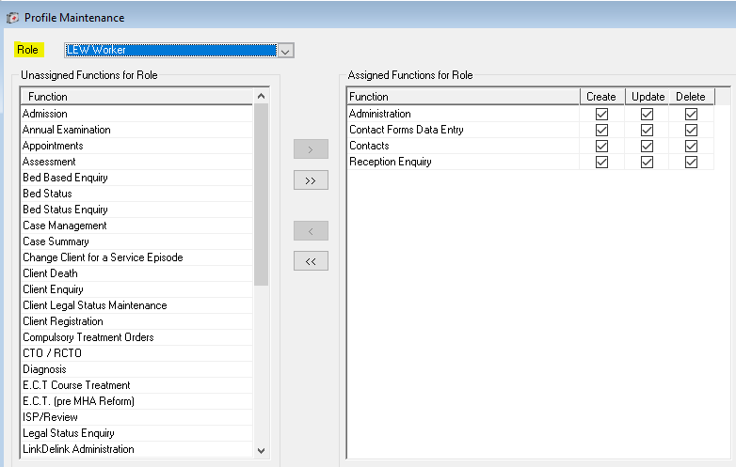

The lived experience team members may require access to the following functions:
- Client enquiry
- Contacts forms data entry
- Contacts
- Screening register
- Admission
- Case summary
- Nominated person

For More Information

Further information about the correct use of CMI/ODS can be found on the Victorian Government’s website. In particular, see the sections on; Registration of Clients, CMI/ODS Service Contacts and Subcentre/Program Maintenance. https://www.health.vic.gov.au/research-and-reporting/bulletins-and-program-management-circulars-pmc

For any queries relating to data reporting or program setup please email: MHDReporting@health.vic.gov.au
To receive this publication in an accessible format please email MHD Reporting <MHDReporting@health.vic.gov.au>
Authorised and published by the Victorian Government, 1 Treasury Place, Melbourne.
ISSN 2653-620X - Online (pdf/word)
Available at Bulletins and Program Management Circulars (PMC) - https://www.health.vic.gov.au/research-and-reporting/bulletins-and-program-management-circulars-pmc>
© State of Victoria, Department of Health and Human Services, November 2022

