Specifications for revisions to the Agency Information Management System (AIMS) for 2023-24
December 2022
OFFICIAL

To receive this document in another format, email HDSS help desk <HDSS.helpdesk@health.vic.gov.au>.
Authorised and published by the Victorian Government, 1 Treasury Place, Melbourne.
© State of Victoria, Australia, Department of Health, December 2022.
Available at HDSS annual changes < https://www.health.vic.gov.au/data-reporting/annual-changes>

Contents
Executive Summary 4
Introduction 4
Orientation to this document 4
Outcome of proposals 5
Specifications for changes for 2023-24 6
Modify the Daily Capacity and Occupancy Register (DCOR) 6
Amendment to Public Hospital Beds (A3) form 8
New collection – Statutory Duty of Candour (SDC) 9

Executive Summary
The revisions for the Agency Information Management System (AIMS) for 2023-24 are summarised below:
New data collection
- Statutory Duty of Candour (SDC) data collection
Changes to existing data collections
- Amend A3 Public Hospital Beds
- Amend Daily Capacity and Occupancy Register (DCOR)

Introduction
Each year the Department of Health review the Agency Information Management System (AIMS) to ensure that the data collection supports the department’s business objectives, including national reporting obligations, and reflects changes in hospital funding and service provision arrangements for the coming financial year.
Comments provided by the health sector in response to Proposals for revisions to the AIMS for 2023-24 have been considered, and where possible, suggestions have been accommodated, resulting in changes to, or withdrawal of, some proposals.
The revisions set out in this document are complete as at the date of publication. Where further changes are required during the year, for example to data validation rules or supporting documentation, these will be advised via the HDSS Bulletin or the responsible program team.
An updated AIMS manual will be published in due course. Until then, the current AIMS manual and subsequent HDSS Bulletins and collection reporting guides, together with this document, form the data submission specifications for 2023-24.
Victorian health services must ensure they report in accordance with the revised specifications and ensure reporting capability is achieved to maintain compliance with reporting timeframes set out in the relevant Department of Health policy and funding guidelines or the relevant legislation.

Orientation to this document
- New data elements are marked as (new).
- Changes to existing data elements are highlighted in green
- Redundant values and definitions relating to existing elements are struck through.
- Comments relating only to the proposal document appear in [square brackets and italics].
- New validations are marked ### if number has not yet been allocated
- Validations to be changed are marked * when listed as part of a data element or below a validation table.
- Changes are shown under the appropriate manual section headings

Outcome of proposals
Proposal 1 – Extend reporting deadline for January
The proposal was withdrawn.
Proposal 9 – Discontinue Daily Elective Surgery Activity (DESA) reporting
The proposal was withdrawn.
Proposal 10 – Modify the Daily Capacity and Occupancy Register (DCOR)
The proposal proceeds.
Proposal 11 – Collect specialised palliative care beds on A3 Public Hospital Beds form
The proposal proceeds.
Proposal 12 – Cease S10, S11, S11A, S12 reporting for health services reporting patient level non-admitted activity
The proposal was withdrawn.
Proposal 13 – New collection – Statutory Duty of Candour (SDC)
The proposal proceeds.

Specifications for changes for 2023-24

Modify the Daily Capacity and Occupancy Register (DCOR)
Details of change | Modify the Daily Capacity and Occupancy Register (DCOR) as follows:  Remove the following data items:  - Decommissioned stock – number of beds/spaces, for each bed category  - Current occupancy – Beds occupied by suspected COVID-19 patients, for each bed category  - Staff capacity impacted by COVID-19 by five staff categories for each Critical care and ED bed category, and in total for all other bed categories  Add a data item for Staff capacity impacted by COVID-19:  - To have the same definition as used for the five staff categories being removed  - To be reported for all staff categories together  - To be reported for each Critical care and ED bed category, and in total for all other bed categories  Amend due time for reporting:  - from 11.00 am each business day for the prior day’s data, and to report data for Friday, Saturday and Sunday by 11.00 am on the following Monday; to  - complete reporting of data for each day in the preceding week by 1.00 pm each Monday, or continue to report data each day, at the discretion of the health service, provided all data are reported by 1.00 pm each Monday  Amend the Reporting guide for existing data item ‘Current operational capacity’ to emphasise that:  - for DCOR reporting, ‘operational capacity’ is not the same as ‘funded places’; and  - that ‘operational capacity’ is to be reported accurately for each date, reflecting changes to staffing and/or equipment capacity, as they occur.  A representation of the DCOR form, highlighting the data item changes, is on the next page.
Data definitions | Data definitions are available in the COVID-19 Daily Capacity and Occupancy Register Reporting guidelines, accessible at the HDSS website < https://www.health.vic.gov.au/data-reporting/health-data-standards-and-systems-communications> , which should be read in conjunction with this Specifications document until the updated AIMS manual is released.

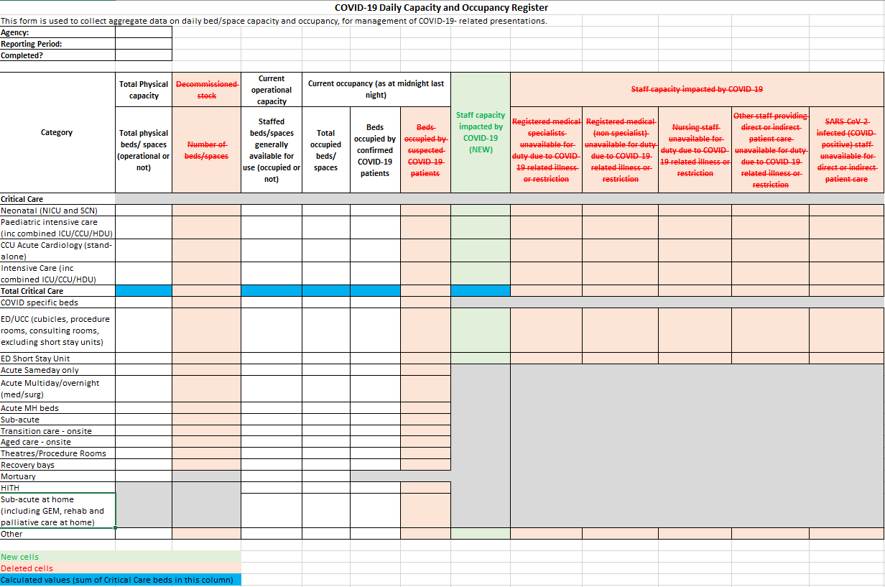

Amendment to Public Hospital Beds (A3) form
Details of change | Amend the A3 Public Hospital Beds form to collect the number overnight (staffed) specialised palliative care beds separately from the total number of all other subacute beds.  Currently the total number of subacute overnight (staffed) beds are collected, which includes the number of specialised palliative care beds. The change requires splitting the subacute beds into two streams:  - Subacute beds (excluding palliative care)  - Subacute beds (specialised palliative care)  The total of these two fields will provide the number of subacute beds, as currently reported.  No other change is being made to the reporting parameters or requirements for the A3 form.
Data definitions | Subacute beds (excluding specialised palliative care):  Beds dedicated for providing subacute services, including rehabilitation, geriatric evaluation and management, palliative care, geriatric respite and maintenance care. Include on-site beds only.  Exclude Subacute specialised palliative care beds, hospital in the home (HITH), rehabilitation in the home (RITH), transition care beds, Transition Support Unit (TSU) beds, off-site maintenance care beds, residential nursing home, hostel and other non-acute residential beds.  Subacute beds (specialised palliative care):  Overnight beds dedicated for providing inpatient palliative care.  Exclude admitted palliative care at home, same day beds, and other subacute beds.
Sample A3 form showing amendments
Validation: Total subacute beds will be a derived value: it will be the sum of Subacute (excluding specialised palliative care) and Subacute (specialised palliative care)

New collection – Statutory Duty of Candour (SDC)
Details of change | Introduce a new data collection to report Statutory Duty of Candour (SDC).  Effective from 30 November 2022, the Health Legislation Amendment (Quality and Safety) Act 2022, requires relevant health service entities to undertake Statutory Duty of Candour (SDC) processes within 50-75 working days of the occurrence of a ‘serious adverse patient safety event’ (SAPSE).  The SDC builds on the mandatory obligations of the Australian Open Disclosure Framework, ensuring patients, their families or carers are apologised to and communicated with openly and honestly when a SAPSE has occurred.  The SDC data collection will report key performance metrics to allow relevant health service entities to monitor compliance with their legal obligations. Safer Care Victoria will monitor the uptake of SDC practice using this data collection.  For SAPSE events occurring on and from 1 January 2023, reporting of SDC processes is voluntary/optional. For SAPSEs occurring on and from 1 July 2023, reporting of SDC aligned performance measures is mandatory for relevant health service entities.  Agencies to report to SDC:  The scope of the SDC includes relevant ‘health service entities’:  - a public health service  - a public hospital  - a multi purpose service  - a denominational hospital  - a private hospital  - a day procedure centre  - an ambulance service within the meaning of the Ambulance Services Act 1986  - a non-emergency patient transport service within the meaning of the Non-Emergency Patient Transport and First Aid Services Act 2003, and  - the Victorian Institute of Forensic Mental Health established by section 328 of the Mental Health Act 2014.  Agency level for SDC reporting:  SDC data is to be reported:  - at campus level for Victorian public hospitals and health services, including denominational and multi-purpose hospitals, and private hospitals and registered day procedure centres  - at whole-of-entity level for those other health service entities that are not hospitals or registered day procedure centres, but which are required to undertake SDC processes under the legislation  Reporting due date, frequency and period:  SDC data is to be reported:  - at quarterly intervals  - by the 14th day of the month after the end of each calendar quarter (eg by 14 July for SDCs occurring between 1 January and 31 March inclusive)  - for SAPSEs that occur in one quarter and the SDCs conducted in that quarter and the following quarter, arising from those SAPSEs  Reporting will be voluntary/optional initially, with mandatory reporting to begin with SAPSEs occurring from 1 July 2023:  - Voluntary/optional reporting can commence for SAPSEs occurring in January to March 2023, and SDCs for these conducted during January to June 2023, to be reported by 14 July 2023;  - Voluntary/optional reporting can also be submitted for SAPSEs occurring in April to June 2023, and SDCs for these conducted during April to September 2023, to be reported by 14 October 2023;  - Mandatory reporting to commence for SAPSEs occurring in July to September 2023, and SDCs for these conducted during July to December 2023, to be reported by 14 January 2024;  - Thereafter, mandatory reporting to continue for all relevant agencies for SAPSEs occurring within each calendar quarter, and for the SDCs for those SAPSEs conducted in the six months beginning on the first day of the calendar quarter, to be reported by the 14th day of the month after the end of the six month SDC activity period.  Data to be reported  - for the following metrics:  - Number of SAPSE occurring within the 3 month reporting period  - For these SAPSE:  - Instances where SDC was commenced within the 6 month reporting period  - Instances where SDC was completed within the 6 month reporting period  - Instances where patient opted out of that SDC within the 6 month reporting period  Other information resources  Health service entities should also refer to relevant regulations for more details of the definitions of SAPSE and SDC.  To support health service entities in establishing SDC processes, Safer Care Victoria has compiled a range of resources < https://www.safercare.vic.gov.au/support-training/adverse-event-review-and-response/duty-of-candour> .  Questions regarding definitions, or data to be reported to the SDC data collection, can be directed to the Safer Care Victoria project team by email <dutyofcandour@health.vic.gov.au>
Data definitions | The following data items are to be reported in the SDC form:  Number of SAPSE  - Total number of SAPSE that occurred at the health service within the quarter  Instances where SDC was commenced  - Of the total number of SAPSE that occurred in the quarter being reported, the total number for which the SDC had commenced with the patient or their next-of-kin/ family/carer by the end of the quarter after the quarter in which the SAPSE occurred  Instances where SDC was completed  - Of the total number of SAPSE that occurred in the quarter being reported, the total number for which the SDC had been completed with the patient or their next-of-kin/ family/carer by the end of the quarter after the quarter in which the SAPSE occurred  Instances where the patient/NOK/carer opted out of the SDC  - Of the total number of SAPSE that occurred in the quarter being reported, the total number for which the patient or their next-of-kin/ family/carer opted out of the SDC process by the end of the quarter after the quarter in which the SAPSE occurred
Reporting guidelines | - SAPSE will be equivalent to ISR 1 and 2, severe and moderate harm, in the Victorian Health Incident Management System (VHIMS).  - To be reported as a SAPSE, the event must meet the definition of SAPSE within relevant regulations under the Health Services Act 1988.  - A SAPSE will also be equivalent to valid clinical incidents with ISR 1 & 2, severe and moderate harm in Victorian Health Incident Management System (VHIMS)  - Commencement date of SDC must be the date when the SAPSE was identified by the health service entity  - Completion date of SDC must be the date the report was provided to the patient/next-of-kin/family/carer. ‘Complete’ must be agreed upon between all parties, which could take an extended amount of time.  - Instances where the patient/next-of-kin/family/carer opted out of the SDC process must be identified by a signed declaration as per the Health Services Act 1988.

