Emergency use group O red blood cells (RBC)
- Provide transfusion laboratory with as much patient information as you can – sex, age, name (if available) + clinical information.
- Take pretransfusion sample prior to transfusion of emergency use group O RBC. Send to transfusion laboratory ASAP.
- Use ABO group matched/crossmatch compatible blood when possible.
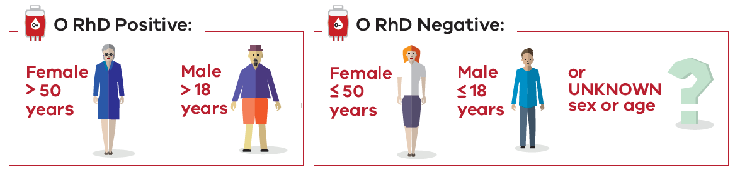
To receive this document in another format, phone 03 9694 0102, using the National Relay Service 13 36 77 if required, or email Blood Matters <bloodmatters@redcrossblood.org.au>.
Authorised and published by the Victorian Government, 1 Treasury Place, Melbourne.
© State of Victoria, Australia, Department of Health, January 2023.
Available at Blood Matters Program website <https://www.health.vic.gov.au/patient-care/blood-matters-program>

